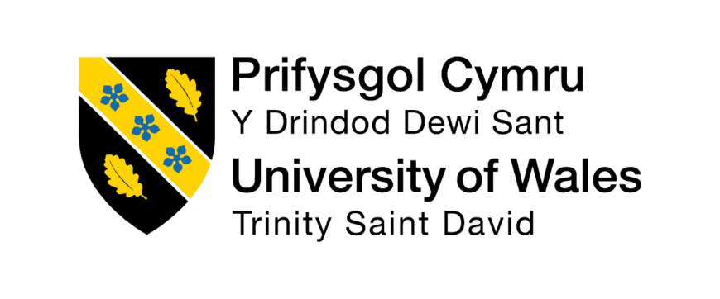
Module: Human Capital Management
Module Code: LCMB7023
Assessment Component 1: Individual Report
Designing a Human Capital Architecture for Strategic Renewal
Student Name: Ankit Gopalbhai Rabari
Student Id:2535776

Executive Summary
In this report, the human capital problems at Helios Urban Mobility are assessed and strategic recommendations to boost organisational performance suggested. It provides a critical comparison of the notion of traditional onboarding and strategic organisational socialisation, and suggests a framework organisation that enhances organisational commitment, engagement, and graduate retention. Also, a unified human capital framework that encompasses creative ways of job design offers workforce flexibility, life-long learning and innovation of the organisation. Thoughts on responsible AI-assisted HR decision-making are also displayed in the report, and a personal approach to developing skills to become a strategic leader in the future. All these suggestions would reinforce ethical human resource management, organisational resilience, adaptability of the workforce and long-term strategic renewal of Helios in a dynamic business environment.

Table of Contents
Introduction 4
Task A: Strategy Organisational Socialisation 4
Comparing the Conventional Onboarding versus Strategic Organisational Socialisation 4
Helios Strategic Socialisation Framework 6
Creating Organisational Citizens 8
Task B: Strategic Job Design 9
The need to change the present job design 9
Job Design Theories: Critical Evaluation 9
Recommended Human Capital Architecture 12
The Way the Design Innovates 13
Task C: Reflective Report 14
Ethical Application of AI in HR Decision-Making 14
Personal Capability Development Plan 14
Reflection 15
Conclusion 16
Reference list 17
Appendices 22
Appendix 1: Strategic Organisational Socialisation Framework for Helios Urban Mobility 22
Appendix 2: SMART Action Plan 24

Introduction
Helios Urban Mobility works on AI-powered solutions of smart transportation in London, Berlin, and Singapore. The organisation supports innovative urban mobility, and infrastructure analytics, with 450 employees. Nonetheless, poor onboarding, lengthy ramp-up timeframes, waning engagement, and drop-out rates of graduates are barriers to organisational success. In this report, there is development of strategic socialisation architecture, innovative job designs and development of personal capability solutions. These interrelated human capital issues are critically considered in sequential strategic suggestions as discussed in the following sections.

Task A: Strategy Organisational Socialisation

Comparing the Conventional Onboarding versus Strategic Organisational Socialisation
The traditional onboarding process is primarily used to present organisational policies and procedures and the immediate job responsibilities (Godinho et al., 2023). This strategy emphasizes administrative effectiveness over long-term integration and dedication of the employees. As a result, Helios will undergo increased adjustment time and substandard labour productivity. Boikanyo (2024) has analysed structured experiences on enhancing employee commitment, identity as well as organisational understanding through strategic organisational socialisation. The framework created by Van Maanen and Schein encourages continuous organisational integration outside the orientation (Obeng et al., 2025). Thus, strategic socialisation produces a greater level of organisational commitment and quicker cultural acclimatisation in comparison with conventional onboarding.
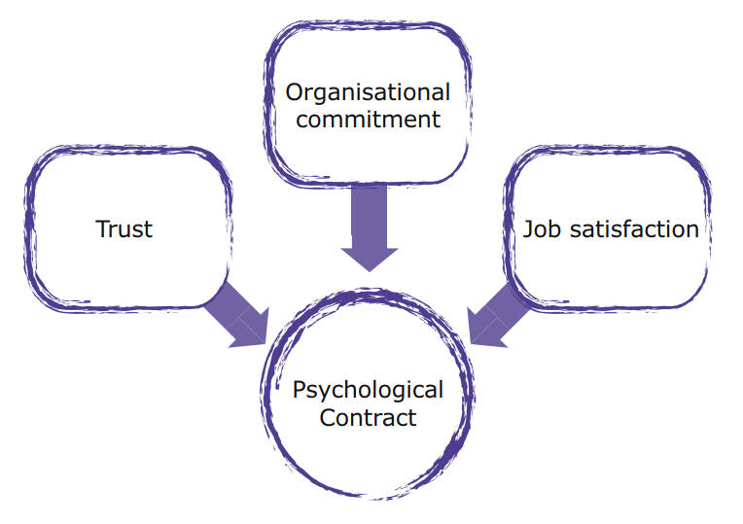
Figure 1: Psychological Contract Theory
(Source: Scouting Matters, 2021)
Reciprocal relationship development further draws a line between strategic socialisation and conventional onboarding as spelt out by the Psychological Contract Theory (Sarkin Gardi Ibrahim, Binti Yusof and Izwar Bin Ibrahim, 2022). Conventional onboarding often focuses on organisational requirements without considering the changing employee demands. As a result, fulfilment of psychological expectations is usually minimised causing diminution of engagement, trust and organisational commitment. By 2023, employee engagement in the world was still at 23% and dropped to 21% in 2024, indicating that organisations continue to face issues relating to employee commitment (Gallup, 2025). The concept of strategic socialisation supports these issues by strengthening communication, growth prospects and mutual organisational obligations in the process of employment.
The construction Theory of Identity proves significant disparities between the two approaches as well. The classic onboarding approach usually takes the employees as occupants of roles with predetermined organisational duties (Mitschelen and Kauffeld, 2025). On the other hand, according to Nadeem Ahmed Awan and Abbas (2024) strategic socialisation promotes the workers to build relevant organisational identities by constant interaction, cooperation and organisational values. This point of view gains particular importance in view of the fact that the employee engagement at Helios is lower at only 54% and the turnover of graduates is high [Refer to case study].
Relative to onboarding, traditional onboarding aids temporary operating adaptation, and strategic organisational socialisation generates a long-term psychological commitment, professional identity, and organisational citizenship (Somu and Ali, 2025). Thus, strategic socialisation offers a more sustainable solution to the Helios due to its simultaneous consideration of the prolonged adjustment and decreasing levels of engagement and graduate retention as well as intensifying the long-term organisational performance.

Helios Strategic Socialisation Framework
Helios needs a formal system of socialisation that goes beyond orientation when joining an organisation through orientation to on-going organisational melting. The simulated method enhances the assimilation of employees and also minimizes the ramped-up length and attrition of graduates. Based on research conducted, onboarding programmes have been shown to enhance retention of new employees by 82%, and productivity by more than 70% which has significant organisational impacts (Zucker, 2021). Consequently, every of the offered stages solves the Helios-specific challenges of the organisation in a strategic manner.
Pre-boarding
The pre-boarding stage ought to entrench good organisational relations prior to the actual employees taking employment (van Giffen et al., 2026). Digital welcoming materials, AI-powered learning tools, and allocating buddies, as well as introductions of managers, minimise these uncertainties and explain organisational expectations. These activities consolidate the psychological contractual development by establishing early communication and establishing trust and mutual commitment. As a result, the employees will turn out to be more self-assured, ready, and connected with the organisation compared to the onboarding techniques of the past.
First Week
Strategic priorities and anticipated behaviours at the workplace are communicated through leadership interactions, organisational values workshops, role clarification and culture immersion activities in the first week. Identity Construction Theory implies that long-term social interaction may lead to enhanced organisational identification more permanently compared to remote induction programmes (Sarala et al., 2025). As such, there is more belonging, collaboration and commitment among employees towards long term organisational performance.
First 90 Days
Kanungo (2025) has analysed that mentoring facilitates rapid learning and cross-functional working expands the knowledge base and creativity of an organisation. Frequent development feedback strengthens mutual organisational commitment as any form of agreed contract is in line with Psychological Contract Theory. This will result in progressive levels of competence, participation and flexibility among employees and shorter adjustment durations.
Year One
The first-year phase must solidify dedication with the aid of leadership creation, experimentation issues, occupational classification, and ongoing performance mentoring. Such initiatives show long-term organisational investment beyond the initial adjustment as stimulating the promotion of professional growth and internal mobility [Refer to Appendix 1]. In comparison to the conventional onboarding process, the ongoing socialisation but not the old process fosters sustained organisational identification, retention and organisational citizenship. Thus, this holistic system is a strategic redress to the issues of Helios engagement, productivity, and graduate retention.

Creating Organisational Citizens
Organisational Identification
The organisational identification emerges as the employees identify with the organisational strategic purpose of Helios. Ongoing communication, learning together, and experiences enhance belonging, commitment, and organisational citizenship behaviours (Khairy et al., 2023). A high organisational identification lessens graduate departure rates and enhances engagement, cooperation and overall organisational performance.
Ethical Professionalism
Ethical professionalism demands leaders who show integrity, fairness, accountability, responsible organisational decision making (Scholl, Mederer and Scholl, 2023). According to Gupta (2024) human responsiveness requires that human judgement must remain and that responsible AI must bolster transparent recruitment, performance management and employee development. Therefore, ethical leadership enhances the level of trust among employees, professional behaviour and confidence in organisational decision-making, attendance to long term commitment of employees and effectiveness of an organisation in the long-run.
Business Activism
Business activism helps to increase the contributions of employees beyond the operational duties into larger organisational and societal value-generation (George and Schillebeeckx, 2022). The HR view of Ulrich urges the employees to be strategic partners facilitating organisational change by innovating and working together. Stakeholder Capitalism also enhances a blend between organisational success and the wellbeing of employees, environmental sustainability and societal influence (Mhlanga, 2022). The promotion of employee voice will allow innovative solutions and enhance organisational responsiveness to new business challenges. All of these initiatives build an adaptive organisational culture that helps facilitate innovation, sustainable competitiveness, talent retention, and long-term strategic benefit to Helios.

Task B: Strategic Job Design

The need to change the present job design
The current job design at Helios is no longer effective in enabling sustainable engagement, innovation, as well as graduate retention in high-energy business contexts. Long ramps-up times and decreased employee engagement display lack of flexibility, development and learning in roles. Rigid job structures tend to limit knowledge transfer among organisational functions and inhibit autonomy (Bratianu et al., 2023). Accordingly, Helios needs an effective job design that fosters lifelong learning, employee empowerment, and internal employee mobility. This kind of transformation boosts organisational flexibility of the work force as well as increasing competence of innovation and organisational competitiveness over the long term.

Job Design Theories: Critical Evaluation
The traditional job design focuses on the fixed responsibilities, standardisation of processes and efficiency (Parker and Grote, 2022). Even though these structures enhance consistency, they usually hamper employee autonomy, creativity, and unending capability development. By extension, strict roles result in less engagement and less organisational responsiveness in fast paced industries, such as the technology-driven environment experienced at Helios.
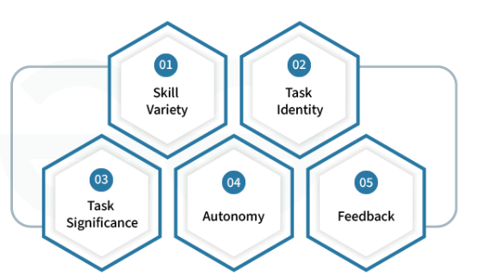
Figure 2: Job Characteristics
(Source: GeeksforGeeks, 2024)
Cotič et al. (2025) have analysed that the Job Characteristics Model attempts to curb these restrictions by making use of skill variety, identification of tasks, importance of tasks, autonomy and feedback to help in increasing intrinsic motivation. The model produces more meaningful work experiences than the traditional job design, enhancing performance and engagement by employees. Nevertheless, job design control at managerial level is a major constraint since workers are not given much control on how to reshape duties to suit emerging organisational needs.
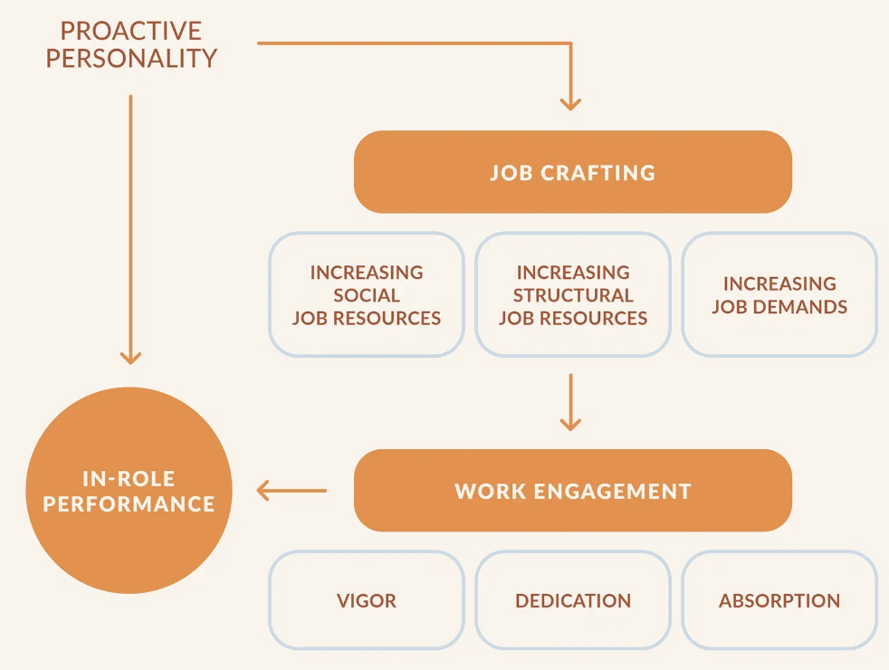
Figure 3: Job Crafting
(Source: Moore, 2019)
On the contrary, Job Crafting Theory provides the employees with the power to transform the roles, relations and work perceptions based on their personal strengths as well as the organisational requirements (Yeşilkaya and Yıldız, 2022). This is more ownership-focused, flexible and engages the psychology as compared to manager directed role design. However, it could result in uncoordinated responsibilities due to excessive flexibility that would not be coordinated and governed by effective managers.
Skills-Based Architecture expands the organisational flexibility of companies by focusing on the capabilities to work before considering job-descriptions, and enabling the deployment of a capability-based workforce to changing strategic priorities (Aleksandra Müller et al., 2024). Internal Talent Marketplaces further enhance this strategy by aligning employees with cross-functional projects and developmental opportunities, to improve the organisational agility and graduate retention. Nonetheless, the two strategies involve considerable investment in technology, open governance and ongoing capability measurement.
When put together, all these complementary strategies allow Helios to be more agile in its workforce, offer a higher level of engagement and innovation and also long-term retention of talents than using each job design theory individually.

Recommended Human Capital Architecture
Helios needs to adopt a holistic human capital structure that reflects the workforce competencies and the changes in organisational goals. According to Lee (2024), this architecture fosters institutional learning, internal mobility and strategic use of talent as opposed to the traditional job designs. Both aspects serve to develop sustainable workforce and enhance organisational flexibility and innovativeness.
The structure must commence with recruitment to hire applicants who display learning agility and digital capacity, collaborative behaviours and innovation capacity. The acquisition of flexible talent creates greater bases to the future growth of the organisations in comparison with emphasizing on technical credentials (Jooss et al., 2023).
After the recruitment process, thorough skills mapping that will include technical, behavioural, leadership and digital abilities of the employees should be conducted. Visibility of the skills allows achieving workforce planning based on evidence and detecting the gaps in the capacities that need specific development. This leads to alignment of organisational resources to both present and future strategic priorities.
A skill-based AI-enabled platform must then study the ability profiles and suggest individualised tracks of learning, as well as suggest opposite developmental prospects. In contrast to the conventional learning system, AI constantly adjusts employee capability profiles, enabling informed talent decisions without overturning managerial decisions (Faqihi and Miah, 2023).
The mentioned competencies ought to then provide an internal talent marketplace, allowing employees to have access to cross-functional assignments, innovation projects, and topical developmental opportunities. The mobility that is based on capability enhances the knowledge sharing and minimises the reliance on outside recruitment to meet new organisational demands.
Then the employees are expected to participate in job crafting, which will provide opportunities to actively adapt to tasks based on personal strengths and organisational needs. Koeswayo, Haryanto and Handoyo (2024) have elaborated that reduced control promotes ownership, motivation, and purposeful work and enhances responsiveness of the organisation to evolving business needs.
Capability development should be enforced with continuous learning that will be reinforced by mentoring, online learning, professional coaching and leadership programmes. The resulting improvement in capabilities, in turn, spur organisational creativity as it will contribute to better cooperation, innovative problem solving, and integration of knowledge. This is then followed by increased career mobility due to innovation, promoting growth within than out. This composite architecture therefore empowers employee retention as well as creating sustainable competitive advantage through a constantly changing human capital.

The Way the Design Innovates
The suggested human capital architecture fosters innovation by enhancing intrinsic motivation by fostering autonomy, skill variety, and self-improvement chances. As it is shown in the Job Characteristics Model, enriched jobs enhance motivation, engagement, and innovative performance among employees. Job crafting also promotes proactive problem-solving by allowing the employees to match the tasks with organisational priorities and personal strengths (Abuzaid et al., 2024). At the same time, internal talent markets support the knowledge sharing process by enabling cross-functional cooperation, enhancing the organisational learning and agility in the workforce. The constant ability build-up is critical since 39% of the fundamental skill of employees will be the one that will have to be changed by the year 2030 (World Economic Forum, 2025). Moreover, organisations are spending on employee education to realise increased retention and internal mobility. As a result, the proposed architecture enhances innovation, retention of graduates, involvement of employees and long-lasting organisational competitiveness. Furthermore, improved workforce agility allows the Helios to take a proactive response, responding to technological and market changes. Strategic capability development also enhances organisational resilience through incessant innovation and readiness to lead in the future. Thus, the integrated architecture defines a sustainable advantage of human capital assisting in the long-term organisational development and competitiveness.

Task C: Reflective Report

Ethical Application of AI in HR Decision-Making
I am aware that AI has the potential to make HR decision-making much easier and more efficient, accurate, and evidence-driven. Compared to the conventional method, AIs are able to analyse massive workforce data, determine talent trends, rely on AI to support recruitment decisions, and learn workers on a personalised basis (Lambros Roumbanis, 2025). Nonetheless, overdependence on AI can put in place algorithmic bias, transparency, and other crucial contextual elements affecting human behaviour. In turn, the HR specialists should be more critical about AI-generated recommendations and not blindly follow them. I think that ethical judgement is crucial as employment decisions determine the career, wellbeing and trust of employees to organisations. Moreover, as debated by Olan et al. (2022) open AI mechanisms must be capable of providing proper explanation of how recommendations are developed so that employees may be capable of comprehending the organisational decisions and questioning them when necessary. Instead, AI will be treated as a decision-support tool, rather than a decision-maker to have ongoing human control over recruitment, performance management, and talent development. This moderation fosters transparency, responsibility and responsible organisational decision making and upholds professionalism.

Personal Capability Development Plan
My career objective is to become an evidence-based strategic HR professional who leads the organisational transformation by evidence-based human capital practices. To meet this aspiration, lifelong learning as an HR professional means that in many respects analytical skills, digital ability, ethical judgement and global business acumen are combined and refined over time to aid the organisation in competing effectively.
The SMART development plan proposed below systematically covers competencies that are in line with my long term career goals. The capabilities of workforce decision-making and strategic planning will be improved by strengthening data literacy and people analytics. Gaining expertise in AI augmentation shall ensure ethical consideration through the use of AI in a responsible manner that does not compromise ethical judgment and human control (Vagan Terziyan et al., 2025). Increasing strategic influencing skills will enhance stakeholder involvement and effectiveness in change management within organisations. The development of international HR knowledge will enhance my capacity to handle multicultural work forces in global situations. Moreover, responsible governance will be enhanced with the help of ethical leadership, as well as digital transformation capabilities that will facilitate innovative HR practices. All SMART goals will focus on a 25% to 35% increase in competencies in achievable timeframes and allow me to increase my professional development in realistic steps and fit me with responsibilities of strategic leader roles [Refer to Appendix 2].

Reflection
The completion of this development plan has reinforced my knowledge of the fact that good HR leaders have to engage in lifelong learning and professional flexibility. I understand that changes in technology, employee diversity, and organisational expectations necessitate continuous growth in capabilities, as well as in my professional life. Hence, I will appraise my professional advancement on a regular basis, renew vital skills, and want to ensure that I practice lifelong learning. This promise will see me contribute strategically, be ethical and generate sustainable organisational value in future job opportunities in the global human resource management.

Conclusion
This report suggested organisational socialisation strategy, new forms of job structure, AI-enhanced responsible HR practices, and focused capability building of the Helios. These combined suggestions empower employee interactions, organisational commitment, workforce agility, and equitable choices and aids ongoing learning and innovations. Together, the suggested strategies will contribute to the optimal results in graduate retention, organisational flexibility, and leadership potential, which have proven to be the durable human capital base that contributes to the renewal of the long-term strategic framework and sustainable competitive edge of Helios.

Reference list
Abuzaid, A.N., Ghadi, M.Y., Madadha, Saif-aldeen Marwan and Alateeq, Manal Mohammad (2024). The Effect of Ethical Leadership on Innovative Work Behaviors: A Mediating–Moderating Model of Psychological Empowerment, Job Crafting, Proactive Personality, and Person–Organization Fit. Administrative Sciences, [online] 14(9), p.191. doi: 10.3390/admsci14090191
Aleksandra Müller, Wurm, S., Willecke, P., Petrovic, O., Herfs, W. and Brecher, C. (2024). Design of a Flexible Skill-Based Process Control System Considering Process-Relevant Properties. Machines, 12(2), pp.142–142. doi: 10.3390/machines12020142
Boikanyo, D.H. (2024). The Role of Employee Behavior and Organizational Culture in Strategy Implementation and Performance in a VUCA World. [online] Www.intechopen.com. Available at: https://www.intechopen.com/chapters/88691 [Accessed 15 July 2026].
Bratianu, C., Mocanu, R., Stanescu, D.F. and Bejinaru, R. (2023). The Impact of Knowledge Hiding on Entrepreneurial Orientation: The Mediating Role of Factual Autonomy. Sustainability, [online] 15(17), p.13057. doi: 10.3390/su151713057
Cotič, L.P., Man, M.M.K., Soga, L.R., Konstantopoulou, A. and Lodorfos, G. (2025). Job Characteristics for Work Engagement: Autonomy, Feedback, Skill Variety, Task Identity, and Task Significance. Global Business and Organizational Excellence. doi: 10.1002/joe.22295
Faqihi, A. and Miah, S.J. (2023). Artificial Intelligence-Driven Talent Management System: Exploring the Risks and Options for Constructing a Theoretical Foundation. Journal of Risk and Financial Management, [online] 16(1), p.31. doi: 10.3390/jrfm16010031
Gallup, I. (2025). Global Employee Engagement Drops for Only the Second Time in 12 Years, Costing the World’s Economy US$438 Billion. [online] Prnewswire.com. Available at: https://www.prnewswire.com/news-releases/global-employee-engagement-drops-for-only-the-second-time-in-12-years-costing-the-worlds-economy-us438-billion-302434901.html [Accessed 15 July 2026].
GeeksforGeeks (2024). Job Diagnostic Survey (JDS) by Hackman and Oldham. [online] GeeksforGeeks. Available at: https://www.geeksforgeeks.org/hr/job-diagnostic-survey-jds-by-hackman-and-oldham/ [Accessed 15 July 2026].
George, G. and Schillebeeckx, S.J.D. (2022). Digital transformation, sustainability, and purpose in the multinational enterprise. Journal of World Business, 57(3), p.101326. doi: https://doi.org/10.1016/j.jwb.2022.101326
Godinho, T., Reis, I.P., Carvalho, R. and Martinho, F. (2023). Onboarding Handbook: An Indispensable Tool for Onboarding Processes. Administrative Sciences, 13(3). doi: 10.3390/admsci13030079
Gupta, R. (2024). Impact of Artificial Intelligence (AI) on Human Resource Management (HRM). IJFMR240321444, [online] 6(3). Available at: https://pdfs.semanticscholar.org/777c/20d96221f47f83130be9c5cf6a9986759917.pdf [Accessed 15 July 2026].
Jooss, S., Collings, D.G., McMackin, J. and Dickmann, M. (2023). A skills‐matching perspective on talent management: Developing strategic agility. Human Resource Management, [online] 63(1), pp.141–157. doi: 10.1002/hrm.22192
Kanungo, D. (2025). Generational Wisdom: A Framework for Leveraging Multigenerational Strengths in Modern Organizations. Contemporary Perspectives on Organizational Behaviour [Working Title]. [online] doi: 10.5772/intechopen.1009298
Khairy, H.A., Agina, M.F., Aliane, N. and Hashad, M.E. (2023). Internal Branding in Hotels: Interaction Effects of Employee Engagement, Workplace Friendship, and Organizational Citizenship Behavior. Sustainability, 15(5), p.4530. doi: 10.3390/su15054530
Koeswayo, P.S., Haryanto, H. and Handoyo, S. (2024). The impact of corporate governance, internal control and corporate reputation on employee engagement: A moderating role of leadership style. Cogent Business & Management, [online] 11(1). doi: 10.1080/23311975.2023.2296698
Lambros Roumbanis (2025). On the present-future impact of AI technologies on personnel selection and the exponential increase in meta-algorithmic judgments. Futures, 166(103538), pp.103538–103538. doi: 10.1016/j.futures.2025.103538
Lee, J. (2024). The Role of Institutional Logics in Shaping Sustainable Talent Management: A Comparative Study of Two South Korean Conglomerates. Systems, [online] 12(7), p.227. doi: 10.3390/systems12070227
Mhlanga, D. (2022). Stakeholder Capitalism, the Fourth Industrial Revolution (4IR), and Sustainable Development: Issues to Be Resolved. Sustainability, 14(7), p.3902. doi: 10.3390/su14073902
Mitschelen, A. and Kauffeld, S. (2025). Workplace learning during organizational onboarding: Integrating formal, informal, and self-regulated workplace learning. Frontiers in Organizational Psychology, 3. doi: 10.3389/forgp.2025.1569098
Moore, C. (2019). What is Job Crafting? (Incl. 5 Examples and Exercises). [online] PositivePsychology.com. Available at: https://positivepsychology.com/job-crafting/ [Accessed 15 July 2026].
Nadeem Ahmed Awan and Abbas, M. (2024). Organizational socialization strategies and newcomers” identity development: A social identity perspective. Human resource development quarterly. doi: 10.1002/hrdq.21527
Obeng, H.A., Arhinful, R., Mensah, L. and Teneng, R.C. (2025). Harmonizing Growth: Leadership Competencies’ Mediation in SMEs’ Organizational Culture and Structure Through Schein’s Model. SAGE Open, 15(3). doi: 10.1177/21582440251364954
Olan, F., Arakpogun, E.O., Suklan, J., Nakpodia, F., Damij, N. and Jayawickrama, U. (2022). Artificial Intelligence and Knowledge sharing: Contributing Factors to Organizational Performance. Journal of Business Research, 145(1), pp.605–615. doi: 10.1016/j.jbusres.2022.03.008
Parker, S.K. and Grote, G. (2022). Automation, Algorithms, and Beyond: Why Work Design Matters More than Ever in a Digital World. Applied Psychology, 71(4), pp.1171–1204. doi: https://doi.org/10.1111/apps.12241
Sarala, R.M., Post, C., Doh, J. and Muzio, D. (2025). Advancing Research on the Future of Work in the Age of Artificial Intelligence (AI). Journal of Management Studies. doi: 10.1111/joms.13195
Sarkin Gardi Ibrahim, U., Binti Yusof, R. and Izwar Bin Ibrahim, H. (2022). The Role of Employee Onboarding Training Program in Mitigating Deviant Workplace Behavior: Job Satisfaction as a Mediator. An International Journal, [online] 14(3s). Available at: https://www.gbmrjournal.com/pdf/v14n3s/V14N3s-68.pdf [Accessed 15 July 2026].
Scholl, J.A., Mederer, H.J. and Scholl, R.W. (2023). Leadership, ethics, and decision-making. Global Encyclopedia of Public Administration, Public Policy, and Governance, [online] pp.1–11. doi: 10.1007/978-3-319-31816-5_2407-1
Scouting Matters (2021). The Psychological Contract – Scouting Matters. [online] Scoutingmatters.ie. Available at: https://scoutingmatters.ie/2021/04/17/the-psychological-contract/ [Accessed 15 July 2026].
Somu, S. and Ali, N.A. (2025). Remote onboarding and beyond: Fostering organizational citizenship behavior through psychological channels. Journal of Economics and Management, 47, pp.413–448. doi: 10.22367/jem.2025.47.16
Vagan Terziyan, Timo Tiihonen, Shukla, A.K., Svitlana Gryshko, Mariia Golovianko, Oleksandr Terziyan and Vitko, O. (2025). Towards ethical evolution: Responsible autonomy of artificial intelligence across generations. AI and Ethics. doi: 10.1007/s43681-025-00759-9
van Giffen, B., Müller‐Wünsch, M., Stalgies, Y., Peppard, J. and Brenner, W. (2026). Continuous Feedback for Data‐Driven Organisational Change: Implementing <scp>OTTO</scp>“s Digital Heartbeat. Information Systems Journal. doi: 10.1111/isj.70032
World Economic Forum (2025). The Future of Jobs Report 2025. [online] World Economic Forum. Available at: https://www.weforum.org/publications/the-future-of-jobs-report-2025/in-full/3-skills-outlook/ [Accessed 15 July 2026].
Yeşilkaya, M. and Yıldız, T. (2022). What do expectations change? Optimistic expectations, job crafting, job satisfaction and a new theoretical model. International Journal of Organizational Analysis. doi: 10.1108/ijoa-01-2022-3111
Zucker, R. (2021). How to Re-Onboard Employees Who Started Remotely. [online] Harvard Business Review. Available at: https://hbr.org/2021/06/how-to-re-onboard-employees-who-started-remotely [Accessed 15 July 2026].

Appendices

Appendix 1: Strategic Organisational Socialisation Framework for Helios Urban Mobility
Stage | Key Activities | Strategic Purpose | Expected Outcomes
Pre-boarding | Digital welcome resources, AI-enabled learning platform, buddy allocation, manager introduction | Reduce uncertainty, establish psychological contracts, communicate organisational expectations, and strengthen early organisational commitment | Improved confidence, faster adjustment, stronger organisational attachment, and enhanced readiness before joining
First Week | Leadership meetings, culture immersion, organisational values workshops, role clarification | Build organisational identification, communicate strategic priorities, reinforce expected behaviours, and encourage collaboration | Greater cultural integration, stronger employee commitment, improved teamwork, and enhanced organisational belonging
First 90 Days | Mentoring, cross-functional projects, structured feedback sessions, learning milestones | Accelerate capability development, strengthen reciprocal commitment, encourage knowledge sharing, and improve adaptability | Higher competence, increased engagement, stronger innovation capability, and reduced adjustment period
Year One | Leadership development, innovation challenges, career planning, continuous performance coaching | Sustain long-term organisational commitment, promote internal mobility, develop leadership capability, and reinforce organisational citizenship | Improved retention, enhanced productivity, stronger organisational identification, continuous learning, and sustainable workforce performance

Appendix 2: SMART Action Plan
Capability | Current Level | Action | Timeline | Measurable | Achievable
Data Literacy | Intermediate | Complete advanced data analytics courses and practise HR dashboards | 6 months | Improve data analysis proficiency by 30%, evidenced through assessment scores and project completion | Complete at least 2 certified courses and apply skills in academic projects
People Analytics | Basic | Learn HR analytics tools and workforce metrics | 6 months | Increase analytical competency by 25% through successful practical exercises | Develop and analyse 3 HR analytics case studies
AI Augmentation | Intermediate | Complete AI in HR training and practise ethical AI applications | 4 months | Improve AI application skills by 35% through certification and practical tasks | Successfully complete 1 professional AI certification
Strategic Influencing | Basic | Attend leadership workshops and practise stakeholder communication | 8 months | Improve influencing capability by 30% based on mentor feedback and presentations | Deliver 4 professional presentations with positive feedback
Global HR | Basic | Study international HR practices and employment regulations | 8 months | Increase knowledge by 25% through coursework and case analyses | Complete 2 global HR courses and analyse 5 international case studies
Ethical Leadership | Intermediate | Undertake ethics training and apply ethical frameworks | 6 months | Improve ethical decision-making capability by 30% through reflective assessments | Complete 1 ethics programme and produce 3 reflective evaluations
Digital Transformation | Basic | Develop knowledge of HRIS and digital HR technologies | 8 months | Increase digital HR competency by 30% through practical system simulations | Complete 2 digital HR training programmes and demonstrate practical application

