advanced processes and materials
Comparison Between Two Non-Traditional Machining Methods with Traditional Machining Methods

Michael Cheeseman (1707473)

Executive Summary

In this report the author will investigate the comparison between two non-traditional machining processes with a traditional machining method. The comparison of these processes will be focused mainly on the aerospace industry. The author will look into what each process is with CNC Machining whether it is using a CNC Lathe or Milling Machine. Then Look into Additive manufacturing with Powder Bed Fusion using Selective laser Sintering and how it works. Then look into additive manufacturing extrusion-based system and how it uses a reservoir of material to create and build a part. The author will then compare the processes together using research gathered, to complete a conclusion with a recommendation. The author has two recommendations of for a quick rapid protype the author recommends using and extrusion-based system as this is cheap to use and easy to setup and run. But for manufacturing parts the author recommends using Powder Bed Fusion machine as it is able to produce parts in a small range of materials that extrusion-based system cannot handle.
Table of Contents
1 Executive Summary 1
2 Introduction 3
3 Findings 4
4 Conclusion 10
5 References 11
6 Appendix 1 13

Introduction

This report is going to investigate into the difference of two non-traditional machine processes which both are the form of Additive Manufacturing. These two processes will be compared with a traditional process such as CNC Machining whether that is Turning or Milling. This report will look at the Costings, geometrics and complexity of the parts that can be created, as well as the limitations to these machines. The two processes that the author has chosen to investigate and compare are a Powder bed fusion machine that uses SLS to melt and fuse the powder together, and a extrusion based system that is able to only dispense the correct amount of material that is need to create a the full part. Additive Manufacturing is a commonly known as 3d Printing or sometimes known as Rapid Prototyping.

Findings

CNC Machining
Computer numerical control machining, this type of process, known as subtractive manufacturing or a traditional method. As it uses a programmed computer program to control the removal process of material from a billet of material, like a block of metal or plastic, to create a finished part. [1] [2]
CNC machining whether they are milling machines or turning machines use the same form of method when they come to producing finished parts. In a CNC milling machine the work piece is normally fixed in on position and the tool holder will be spinning, in a CNC Lathe it is reversed as the work piece will be spinning and the tool is fixed into place. [1]
Most materials can be cut using a CNC machine as long as there are the correct tools to be able to cut the material of choice a list of material can be found in appendix 1, from the information found from [3]. Due to the CNC having to cut the material out of a billet the machines will require numerous tools to be able to create the different shapes required to create the finished part such as slot drills and undercut tools boring bars, counter ball drills and taping drills. These tools can be quite expensive depending on the amount ordered.

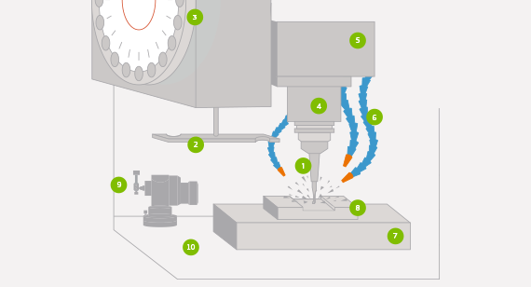
Figure 1 : Diagram of a CNC Milling Machine taken from [1]

Additive Manufacturing Powder Bed Fusion
Additive Manufacturing is commonly called 3D Printers as it creates a cross section of the desired part a layer at a time and once one layer has been completed the printer will move the part down or the head of the machine up to be able to start the next layer.
“Powder Bed Fusion uses Selective Laser Sintering” [2] to melt and fuse material powder together to create a physical representation of any CAD model. The way that this sort of machine works is to that it will first dose a layer of powder on to the powder bed or sometimes called a build plate. Once the powder layer is covering the build plate the machine’s laser will fire onto the powder. The laser path is determined by to mirrors normally called X axis Mirror and Y axis Mirror. These two mirrors control the movement of the laser beam across the bed of the machine. Once the laser has finished melting and fusing powder together the laser will be turn off and just before a new layer of powder is placed over the build plate, the plate will be lowered down by the set layer height to allow the machine to create a three-dimensional part. [2] [4]
The materials that are typically used for Powder Bed Fusion machines are “Titanium, some Stainless Steel, Alloys” [2] including Aluminium and Nickle based alloys, as well as Colbat chrome. Some manufactures of this form of Additive machine will allow their machines to be able to print in precious metals such as gold and silver [5] [6] [2].

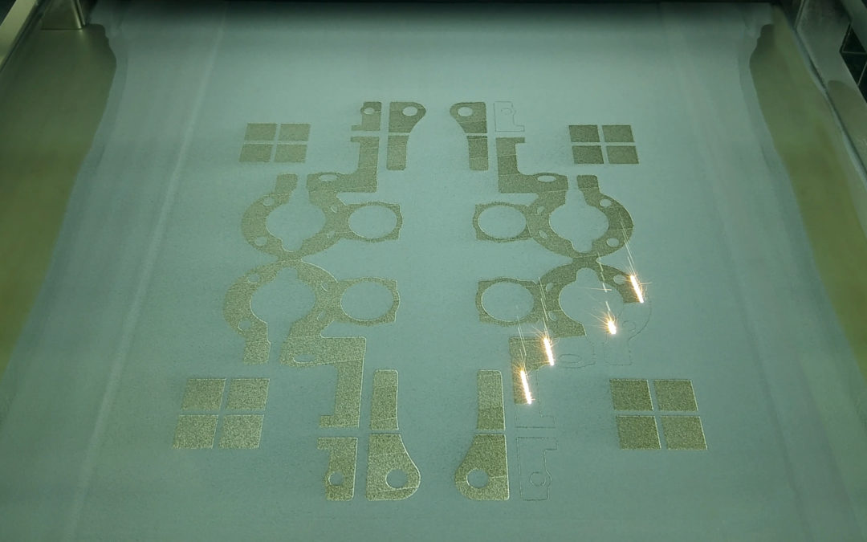
Figure 2 : Image of a RenAM 500Q firing on a bed of powder whist under build taken form [5]

Additive Manufacturing Extrusion Based System
Most Extrusion based systems use some form of a reservoir full of material whether that is a solid drum or a tank of material, this material is then forced through the head of the machine, through a nozzle and on to a build area. With the material being extruded at a constant rate the machine head will draw the shape of the cad model on a 2D plane once that section is complete either the head will move upwards, or the build plate will move downwards. [2] [7] [8]
This type of system of additive manufacturing machines is one of the most popular and affordable on the market [8]. They are one of the most easy system to use and set up from a starting price of £99 for a kit build 3D printer [9] build 3d printer this can range up to a printer from [10] which will cost £25,000. This type of printer is called “Builder Extreme 2000 pro” [10] which has a “build volume of 700 x 700 x 1700 mm” this printer is able to print in full colour and is one of the largest printers available as stated in [10]. The Material that these printers can use is mainly PLA and ABS plastics, some manufacturing companies of these type of additive machines do use these machines to print ceramics [8]. The costing of a single reel of PLA plastic can cost around £25 for a one-kilogram reel [9].
In some companies that have Education outreach programs that complete 3d printing workshops with schools and youth groups use these types of printers to create and be able to print their own designs [11].

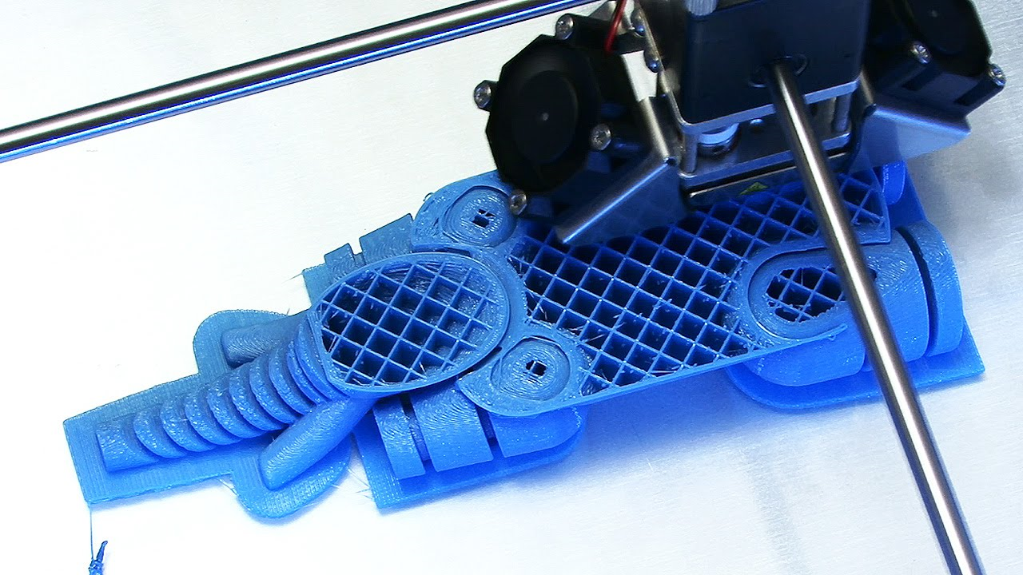
Figure 3 : Image of a Ultimaker extrusion-based system building a part [8]

Comparison of CNC with Additive Manufacturing
Most additive manufacturing machines have been designed and build on the same principle as most CNC machines, whether that they need a PC to run the machine or that they need a PC to Convert the CAD design into G and M codes through a software [1] [2] [8].
All types of additive machines adds material to some sort of build plate, the material is kept on adding until the product is fully finished, unlike where CNC where it removes material from a billet. Removing material from a billet can create a lot of waste depending on how much material is getting cut away, this make CNC wasteful. Where as in a Powder Bed Fusion Machine can reused any unspent powder by putting through a sieve system to ensure only usable powder goes through, or simply doesn’t use material like in extrusion-based system. [2] [12] [13] A company has stated that using Additive manufacturing has had an effect on their costing by their “Parts Cost are Down by 50%” [14] and that their “Scrap Cost are down to 10%” [14].
When Looking at Speed of build with any form of additive manufacturing against CNC machining to produce a single simple part CNC is normally going to be the quickest method. But where additive manufacturing is faster than CNC machining is that and Additive machine can be set once and the build can start where in CNC machining, the machine might need to be reset a few times depending on the desired shape. Additive Manufacturing can increase the speed of part creation by consolidation of multiple parts on to one build plate, although that the build plate will take long to create it would be shorter time than to have to reset a CNC Machine for every part.
[2] [13] [15]
Most Additive Manufactured parts do not need as many finishing operations as CNC machining which will reduce the planning time behind the machine time causing it to be sometimes quicker to get a part through than with CNC Process. [5] [13]
As shown in the image in Figure 4 additive manufacturing is able to create highly complex parts that would be near impossible to create with any other forms of manufacturing method including traditional method of manufacturing. One company has reported that using additive manufacturing has “Enable production of unique feature designs with enough mechanical performance” [16].
The complexity of the parts geometry has an effect on the weight of the part as shown below as the additive part will be significantly lighter than the part that was traditionally manufactured with one aerospace company claiming that they saved “64% on the part weight” [14]. In aerospace especially if there can be weight saved on a part that means that it can lead to improved fuel consumption due to the engines do not have to run as high to keep the aircraft in the air. This will lead to reduce emissions from the aircraft as well. [14] [2]

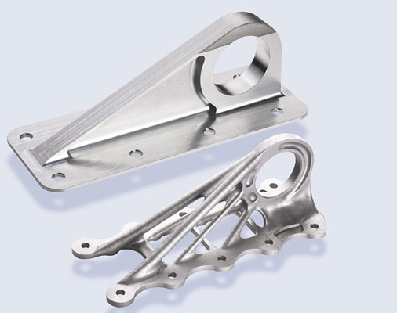
Figure 4: Image of a part for Airbus printed by GE comparing the difference of design of traditional method to additive manufacturing parts [7]

CNC machines are able to cut a wide range of materials see appendix 1 for the range of materials able to be cut on CNC machines. Compare this with Powder bed fusion where only a few sets of materials can be additively manufactured only some metals, ceramics and polymers [2] [6] [3]. Extrusion based system are only able to print in ABS and PLA Plastics [3] [2], there are a few printers on the market that are able to print in other substances such as ceramics [2] [8].
One company has report that their “Time to market as been reduced to 64%” [14] using additive manufacturing through there design and development stage.
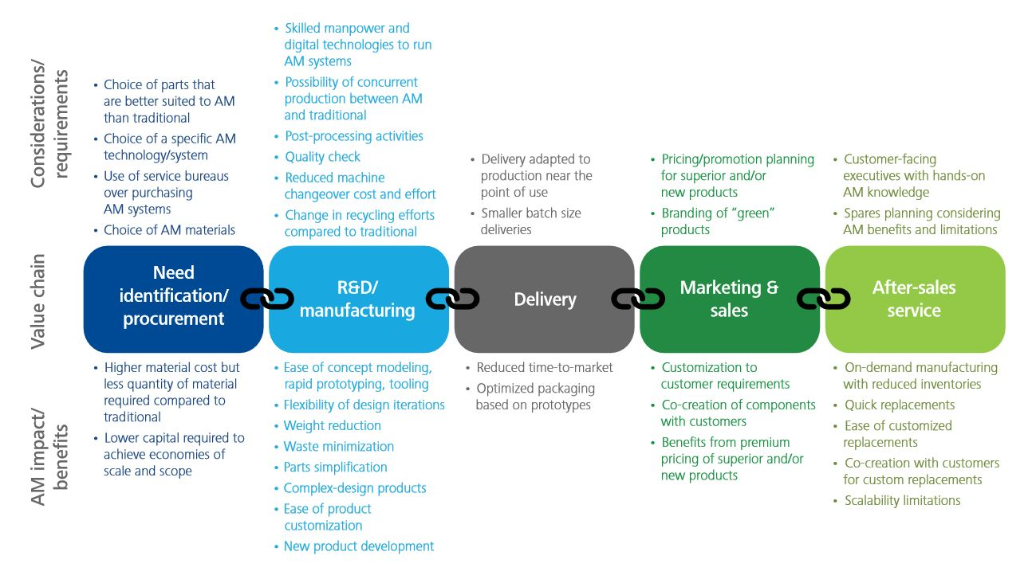
Figure 5: Flow chart showing the Impacts, Benifits, and Requirements of Additive Manufacturing at each stage of a products life [14]
Bellow in Table 1 is a matrix table showing a table comparing the difference between CNC Machining, Powder Bed Fusion and Extrusion Based System machine.
 | CNC Machining | Powder Bed Fusion | Extrusion Based System
Materials | Can Cut a Wide Range of materials depend on tools being used [1] [2] [3] | Ceramics, Metals and Polymers [2] [3] | Mostly ABS and PLA plastics [3] [2]
Operating Atmosphere | Coolant rich environment [13] | Inert Gas as powdered metal is volatile substance [5] [15] | Open atmosphere [8]
Run Cost | High [13] | High [6] [4] | Low [8]
Complexity of parts | Medium [1] | High [4] [6] | High [8] [10]
Surface Finish without finishing processes | High [1] | High [12] [17] | Medium [8] [17]
Tooling Cost | High [13] | Low [5] | Low [10]
Speed of Build | High [2] | Low [4] [5] | Medium [10] [8]
Table 1: Matrix analysis to compare the difference between CNC Machine, Powder Bed Fusion and Extrusion Based System.

Conclusion
Based on the findings and information gathered in this report Additive Manufacturing of any kind is genuinely a slower build process than CNC machining. Where additive manufacturing is able to increase the time over the CNC machine is where it can either consolidate builds onto one build plate, or unlike with CNC machining an additive machine is able to complete the full build without having to be reset. An additive machine unlike CNC machining it can create a higher complexity of builds with complex geometric shapes that a CNC machine would never be able to complete. A company has stated that using Additive manufacturing has had an effect on their costing by their “Parts Cost are Down by 50%” [14]and that their “Scrap Cost are down to 10%” [14].
From Table 2 located in appendix 1, although CNC Machining is able to machine a large verity of materials compared to powder bed fusion additive machine, and the very few materials that the extrusion-based system as that can only print in PLA and ABS plastic as well as some other polymers and ceramics. For a CNC machine to be able to machine all of these materials the machine might need specialist tools to be able to complete the job, this will cause the tooling cost to go up.
For quick and easily Rapid Prototyping of parts as a trail parts the Extrusion based system is the better choice as it can complete and trial builds without having a large cost implication. As the material cost of a 1kg reel of PLA cost around £25.
For Manufacturing Builds of components Powder Bed Fusion is the better choice even that it has a long build time it can create more advanced features that would be impossible with CNC machine. As Powder base system can recycle the unspent powder back into the machine it will cost less for material in the long term than a CNC machine.

References

[1] | Protolabs, “CNC Machining,” Protolabs, 2019. [Online]. Available: www.https://www.protolabs.co.uk/services/cnc-machining. [Accessed 11 4 2019].
[2] | I. Gibson, D. Rosen and B. Stucker, Additive Manufacturing Technologies, Neatherlands: Printforce, 2009.
[3] | Protolabs, “Manufacturing Materials,” Protolabs, 2019. [Online]. Available: https://www.protolabs.co.uk/materials/comparison-guide/?filter=cnc-machining-materials. [Accessed 11 04 2019].
[4] | GE Aviation, “Additive Manufacturing Machines,” GE, 2019. [Online]. Available: https://www.ge.com/additive/additive-manufacturing/machines. [Accessed 11 04 2019].
[5] | Renishaw, “Metal Additive Manufacturing,” Renishaw, Wotton Under Edge, 2016.
[6] | F. Fores and R. Boyer, “Additive Manufacturing for the Aerospace Industry,” Elsevier Inc., London, 2019.
[7] | S. Michelle, 3D Natives, 6 12 2018. [Online]. Available: https://www.3dnatives.com/en/additive-manufacturing-aerospace-growing-061220184/. [Accessed 12 04 2019].
[8] | Ultimaker, “Ultimaker,” 2019. [Online]. Available: https://ultimaker.com/en/explore/how-is-3d-printing-used. [Accessed 02 04 2019].
[9] | Amazon, “3D Printers,” Amazon, 10 04 2019. [Online]. Available: www.amazon.co.uk/3d-printers. [Accessed 10 04 2019].
[10] | iMakr, “Builder Extreme 2000 PRO,” iMakr, 2019. [Online]. Available: https://www.imakr.com/large-build-fdm-3d-printers/2381-builder-extreme-2000-pro.html. [Accessed 12 4 2019].
[11] | Renishaw, “Renshaw Education Outreach,” 06 2017. [Online]. Available: https://www.renishaw.com/en/workshops-for-south-wales-schools--40480. [Accessed 11 04 2019].
[12] | J. P. Kruth and P. Mercelsi, “Binding mechanisms in selective laser sinteringand selective laser melting,” Rapid Prototype, vol. 11, no. 1, pp. 26-36, 2011.
[13] | M. Lynch, “Fundermentals of CNC,” Moden Machine Shop, 4 1 1997. [Online]. Available: https://www.mmsonline.com/articles/key-cnc-concept-1the-fundamentals-of-cnc. [Accessed 12 04 2019].
[14] | J. Coykendall, M. Cotteleer, J. Holdowsky and M. Mahto, “Additive Manufacturing Takes Flight,” Deloitte University Press , Telaganna, 2014.
[15] | P. Panneerselvam, “Additive Manufacturing in Aerospace and Defecnce Sector,” Journal of Defence Studies, vol. 12, no. 1, pp. 39-60, 2018.
[16] | B. Ribic, “Metal Additive Manufacturing for Aerospace,” Research Gate, Indianpolis, 2017.
[17] | J. D. Williams and C. R. Deckard, “Advances in modeling the effects of selected parameters on the PLS process,” Rapid Protype, vol. 4, no. 2, pp. 90-100, 1998.
[18] | SAE International, “Aerospace Material Specification,” SAE International, London, 2018.
[19] | D. S. Thomas, “Economics of the U.S. Additive Manufacturing Industry,” National Instutue of Standards and Technology, vol. 1163, no. 2, pp. 61-100, 2013.

Appendix 1

Material | Material Category | Attributes | Manufacturing Process
ABS | Plastic | Cosmetic appearance | Injection Moulding
ABS | Plastic | Dimensional stability | CNC Machining
ABS | Plastic | Impact resistant
ABS-Like | Plastic | Accuracy | 3D Printing
ABS-Like | Plastic | Durability | 3D Printing
ABS-Like | Plastic | Impact resistance | 3D Printing
ABS/PC | Plastic | Cosmetic appearance | Injection Moulding
ABS/PC | Plastic | Dimensional stability | Injection Moulding
ABS/PC | Plastic | Impact resistance | Injection Moulding
Aluminium | Metal | Corrosion resistance | CNC Machining
Aluminium | Metal | High strength-to-weight ratio | 3D Printing
Aluminium | Metal | Temperature resistance
Brass | Metal | Chemical resistance | CNC Machining
Brass | Metal | Ductility | CNC Machining
Brass | Metal | Strength | CNC Machining
Carbon Steel | Metal | Soft | CNC Machining
Copper | Metal | Corrosion resistance | CNC Machining
Copper | Metal | Electrical conductivity | 3D Printing
Digital Photopolymer | Elastomer / Silicone Rubber | Durability | 3D Printing
Digital Photopolymer | Elastomer / Silicone Rubber | Flexibility | 3D Printing
Digital Photopolymer | Elastomer / Silicone Rubber | Combine Material Properties | 3D Printing
HDPE | Plastic | Durability | Injection Moulding
HDPE | Plastic | Impact resistant | CNC Machining
HDPE | Plastic | Stiffness
Inconel | Metal | High strength | 3D Printing
Inconel | Metal | Excellent High-temperature and corrosion resistance | 3D Printing
Inconel | Metal | Good tensile, fatigue, creep and rupture strength | 3D Printing
LDPE | Plastic | Crack resistance | Injection Moulding
LDPE | Plastic | Flexibility | Injection Moulding
LDPE | Plastic | Impact resistance | Injection Moulding
LSR | Silicone Rubber | Cosmetic appearance | Injection Moulding
LSR | Silicone Rubber | Durability | Injection Moulding
LSR | Silicone Rubber | Flexibility | Injection Moulding
LSR | Silicone Rubber | Temperature resistance | Injection Moulding
Miraging Steel | Metal | Good mechanical properties | 3D Printing
Miraging Steel | Metal | Hard enable | 3D Printing
Mild Steel | Metal | Good toughness and strength | CNC Machining
Mild Steel | Metal | Heat treatable | CNC Machining
Nylon | Plastic | Rigidity | Injection Moulding
Nylon | Plastic | Strength | CNC Machining
Nylon | Plastic | Temperature resistance
PA (Nylon) | Plastic | Rigidity | 3D Printing
PA (Nylon) | Plastic | Strength | 3D Printing
PA (Nylon) | Plastic | Temperature resistance | 3D Printing
PBT | Plastic | Chemical resistance | Injection Moulding
PBT | Plastic | Dimensional stability | CNC Machining
PBT | Plastic | Low moisture absorption
PC | Plastic | Dimensional stability | Injection Moulding
PC | Plastic | Impact resistance | CNC Machining
PC-Like | Plastic | Accuracy | 3D Printing
PC-Like | Plastic | Stiffness | 3D Printing
PC-Like | Plastic | Temperature tolerance | 3D Printing
PEEK | Plastic | Chemical resistance | Injection Moulding
PEEK | Plastic | Serializability | CNC Machining
PEEK | Plastic | Stiffness
PEEK | Plastic | Strength
PEI | Plastic | Heat resistance | Injection Moulding
PEI | Plastic | Impact resistance | CNC Machining
PEI | Plastic | Strength
PET | Plastic | Chemical resistance | CNC Machining
PET | Plastic | Stiffness | CNC Machining
PET | Plastic | Strength | CNC Machining
PMMA | Plastic | Optical clarity | CNC Machining
PMMA | Plastic | Rigidity | CNC Machining
POM (Acetal) | Plastic | Chemical resistance | Injection Moulding
POM (Acetal) | Plastic | Chemical resistance | CNC Machining
PP | Plastic | Chemical resistance | Injection Moulding
PP | Plastic | Solvent resistance | CNC Machining
PP-Like | Plastic | Accuracy | 3D Printing
PP-Like | Plastic | Durability | 3D Printing
PP-Like | Plastic | Flexibility | 3D Printing
PPS | Plastic | Chemical resistance | Injection Moulding
PPS | Plastic | Temperature resistance | Injection Moulding
PPSU | Plastic | High deflection temperature | CNC Machining
PPSU | Plastic | Resistance to environmental stress cracking | CNC Machining
PPSU | Plastic | Excellent thermal stability | CNC Machining
PPSU | Plastic | Good electrical properties | CNC Machining
PS | Plastic | Impact resistance | Injection Moulding
PS | Plastic | Stiffness | Injection Moulding
PSU | Plastic | Corrosion resistance | CNC Machining
PSU | Plastic | Mineral resistance | CNC Machining
PSU | Plastic | Serializability | CNC Machining
PSU | Plastic | Strength | CNC Machining
PTFE (Teflon) | Plastic | Chemical resistance | CNC Machining
PTFE (Teflon) | Plastic | Flame resistance | CNC Machining
PTFE (Teflon) | Plastic | Temperature resistance | CNC Machining
PVC | Plastic | Chemical resistance | CNC Machining
PVC | Plastic | Corrosion resistance | CNC Machining
PVC | Plastic | Flame resistance | CNC Machining
Stainless Steel | Metal | Corrosion resistance | CNC Machining
Stainless Steel | Metal | Crack resistance | 3D Printing
Titanium | Metal | Corrosion resistance | CNC Machining
Titanium | Metal | Strength | 3D Printing
Titanium | Metal | Temperature resistance
Titanium | Metal | Weight reduction
Table of materials used in different process both traditional and non-traditional taken from [3]

