University of South Wales Trinity Saint David
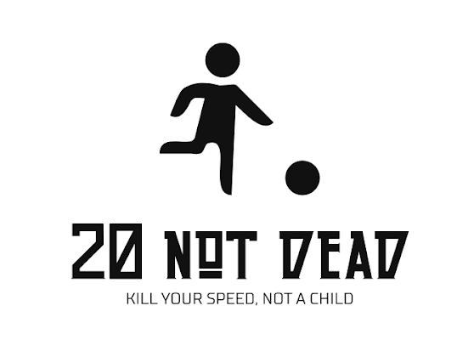
Hayley McDowall
1803475
Bronwen Williams

When we started the 20 Not Dead campaign, we set out to do only one thing, keep children safe by encouraging people to slow down and follow the speed limits. We knew this was going to be a challenge as a lot of people will agree that fighting habits, especially driving habits, is not an easy task.
Approaching the challenge, we had to decide how we were going to get our message across in a manner that did not feel like nagging or even shaming people. We decided to cater to people with moral complexes that were influenced by the innocence of children and the possibility of seriously injuring or harming a child.
Firstly, I am going to talk about the design of the logo. In the beginning we had a very friendly and harmless logo. After sitting on the idea for a while, we decided to change it to this one. Above shows the final result we created. Firstly, the image is simple, a stick figure chasing a ball. Subconsciously, we know this is a child, even though there is no label or indication that it is. Different variations of this image have been used on traffic signs, especially around schools. We did try the road sign with two people crossing the road, one of them being a child, but we felt that the lone child chasing a ball would be a better fit.
This image was mainly to create a form of guilt when it is viewed. For example, if you commonly speed in school zones, then you are not really thinking of the safety of children. The picture of the child forces people to think about child safety and thus having a deeper connection with the driver. As for the ball, this was to create a sense of innocence around a child. Normally when people speed, they do not really think about people and their lives being affected. Most people do not really think about any malicious motive when they speed. Having the ball included, creates a character for people viewing. Therefore, the image portrays an innocent child.
When discussing the tag lines, we investigated other campaigns that were not as successful. Learning form past mistakes made by others, we were able to create a simple formula to create the perfect tag line. We wanted it to be very simple wording, so that children could say or read it too. We needed to keep it short but also explain the whole seriousness of the situation. After many ideas and suggestions, 20 not dead was finally decided on.
20 not dead is not the most interesting phrase I will admit but its straight to the point and it basically speaks a thousand words in just three. We did not sugar-coat what would happen if people speed. The tag line would not work if it had a lighter theme, for example 20 not ‘maybe you’ll hit someone’ is not a very good fit. It very bluntly states, if you do not go 20 in a 20mph zone there is a chance you will kill someone. With the connecting image and the tag line you can assume that a child’s life may be lost in the situation.
Lastly, the final tag line is a little extension at the bottom that confirms the ties between the photo and the campaign name. This was added in to provide another prompt to stop people speeding. Like the campaign title, it is straight and to the point. Confirming the assumptions made by the photo of the child and the tag line, it allows everything to tie together. We created this as an overall logo with the hope that, depending on the use, we can remove the bottom line to allow for a less cluttered logo. For example, when we place the banners outside of the school, we can remove the bottom line from the logo and spread it larger across the banner. We also wanted the logo to make sense without the bottom tag line too. So, if you take away the second tag line, it does not devalue the overall logo.
The bottom tag line also gives the reader a choice, slow down and follow the speed limit or suffer with the horrible consequences. As you can see, the logo was heavily centred around children and keeping them safe.
With the logo and campaign design completed, we had to figure out a way to get this campaign off the ground. We did not have much money to spend so we very cleverly utilised our access to social media.
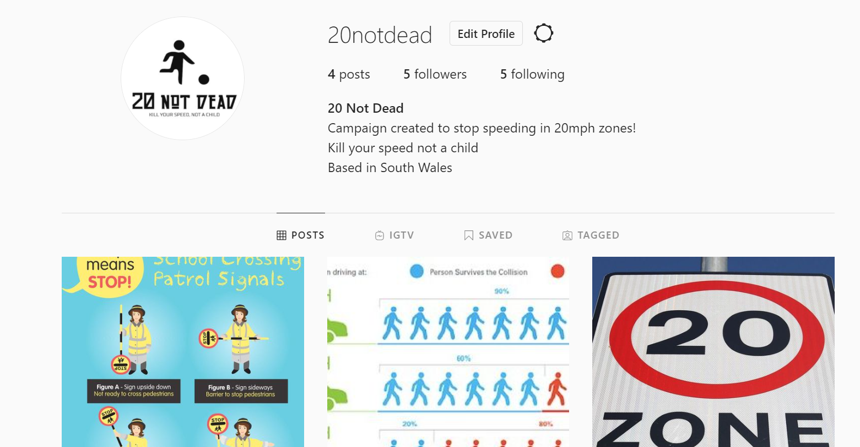
This is our Instagram page. We decided to use Instagram as our first platform to promote our campaign because of the amazing algorithm. If you register your account as a pro account, you can modify who your account gets pushed out to. This would help our campaign get off the ground. The algorithm lets us decide the gender, location and even age of the people our posts are promoted to. The most important thing here is age. To comply with Instagram’s terms of use, people under the age of 13 are not allowed to set up accounts on Instagram. Therefore, we catered our content to people over the age of 17, people who were at the legal age to drive.
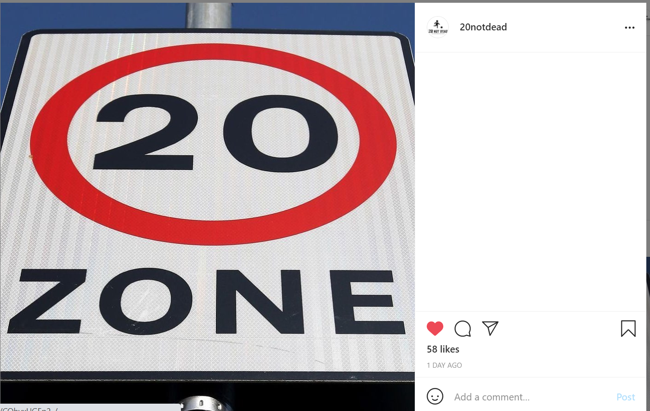
At the moment we do not have many followers, but after we set up the algorithm on one of our posts, we saw a huge increase in likes. This was just a tester one but has worked amazingly so far. We set it up to only reach 17–35-year-olds within the Llanelli area and it worked. We have now gained 58 likes on this post which means that our posts are making their way through the platform. The likes indicate to us roughly how many people have seen the post. We know there may be more people who have seen it because not everyone likes the photos they view. Furthermore, these 58 likes were an amazing start to our Instagram account.
Our Instagram also connects to Facebook as they are owned by the same company. This means we were able to set up and identical page but on the Facebook platform. This was a brilliant way for people to connect even further with us. Facebook has a feature called Facebook messenger which can directly link to Instagram messenger. This means all our communications would be in one place. Also, everything we posted on the Instagram account could also be directly posted to Facebook. This helped us manage the two platforms at once without falling behind.
A useful feature with Facebook, is groups. This means we could also create a group along with our page. With a group, people are allowed to post whatever they like, which differs from a page which would just be us posting. This means we could create more of a community with our campaign. With the Facebook page set up, we began to see a slow increase in the reach of our campaign. Reach was the most important thing to us when using these platforms. We did not really care about likes, comments and followers, all that mattered is that people were seeing our post and were able to reflect on them.
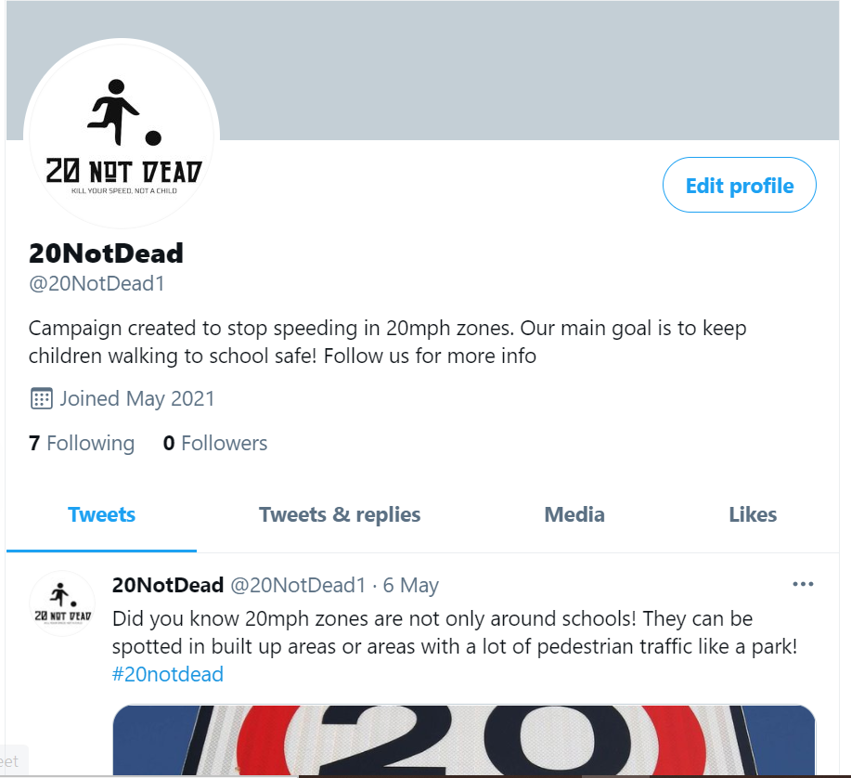
This is our Twitter page. We decided to make a Twitter, which was the last platform we made because of the use of hashtags. Hashtags are a great way of tagging interests and keywords into our post. If you click on a highlighted blue hashtag, the platform will then show you all the post that have been made with the hashtag. With the other two platforms, it was all about how we could communicate with people. Twitter will allow us to flip that and allow people to tag us can use the hashtag so they can communicate with us. Our hashtag #20notdead is used in all our twitter posts so far and has allowed us to create our own little community from this campaign. Hashtags were very important to us, not only because we could continue to spread awareness, but also because we could connect all the platforms with them. All the platforms we used can use the hashtag which includes, Facebook, Instagram, Twitter and TikTok.
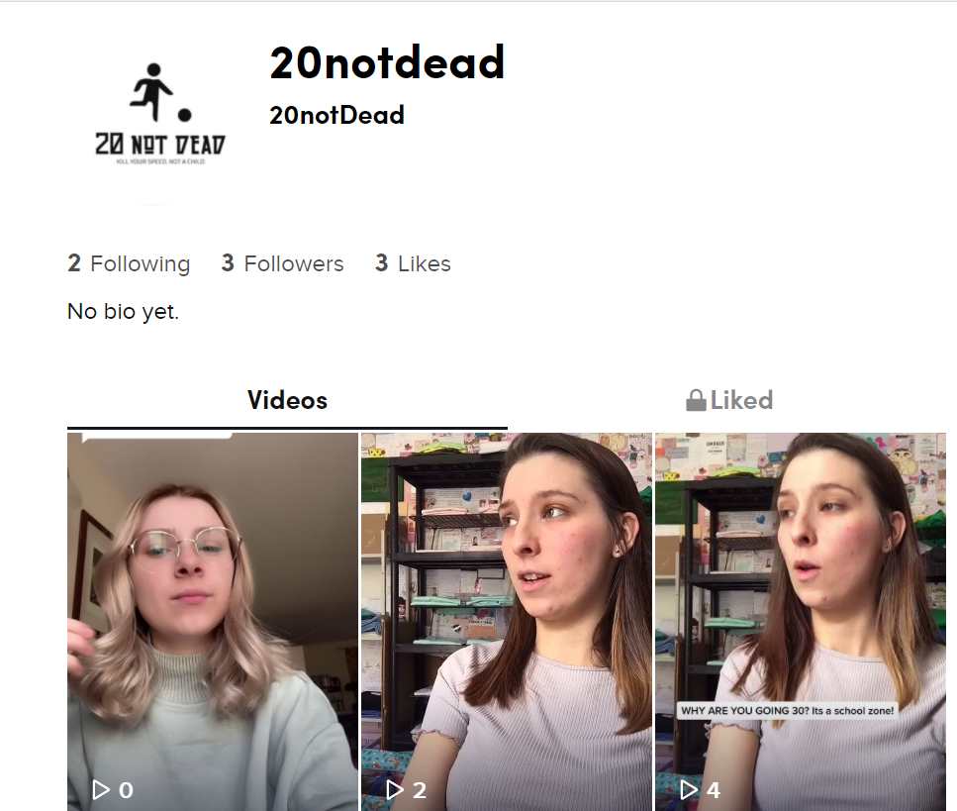
Tiktok has massively grown in success over the last two years. It is a similar app to Instagram but instead of pictures, the app only provides video content. We chose to use this app to promote our campaign for one very important reason. The best way to describe this app is a like ‘social media lottery.’ This app is completely different from the other ones we have used so far. On Instagram your feed is full of people that you follow, which creates these barriers surrounding accounts which you may not know exist. The only way of discovering new accounts on Facebook, Instagram and Twitter are to search them or have a friend share them. Which makes reaching out to people a very difficult thing to do, especially if you are a new account such as ours.
Tiktok is completely different. When you open the app, the first page you are met with is called the for you page or the FYP. This is a page completely run by TikToks personalised algorithm. For example, if you interact with a video of a dog, an interaction can be anything from a like, comment or even clicking on the user’s profile, then the for you page will learn this and send you more videos with dog in them. Once we learnt about the algorithm, we began to understand that TikTok was more of a lottery. If you are a fairly neutral account, which means you keep your content fresh and original, they it will just send it out to random people in hopes that they will like it. We only needed a few people to interact with out videos to grow. This means we must produce a mixture of content.
Our video content on Tiktok ranges from challenge videos, informative videos, and trend videos. This helps us stay relevant all while getting our campaign recognised and seen. TikTok’s growth is a little more organic than other platforms, so we will need to make a few more videos in order to catch this algorithm in the right place.
Along with this great advantage, TikTok has a Q&A feature which allows us to answer all questions through the app in video form. This is such an easy way to connect with people because, lets be honest, sometimes it makes a huge difference when you can talk to someone rather than just type.
Lastly, we have made a radio advert, this can also be integrated into podcasts, twitch ads and other audio channels. It is 20 seconds long and the script states-
Woman 1 – “20 is too slow! I always go 30!”
*Car Crash Noises*
Woman 1 – “30 was too fast! I didn’t see them!”
Woman 2 – “20 Not Dead”
This advert is hard hitting and like our tag lines, does not sugar coat the harsh reality of speeding. We wanted to create something that would stay with the listener long after the advert was finished. Therefore, we added the sound effects of the car crashing. People need to be faced with harsh truths to break habits. If this radio advert played a few times during school drop off and pick up hours, then maybe it will condition people to slow down around school areas.
When our campaign gains more traction and our social media accounts begin to grow, we will be able to buy some banners and posters to place around schools. At this point in time, social media is free, so we will use this to our full advantage and hopefully take this as far as we can without using any form of paid advertising.

