Assessment 2

Module: Data Handling and & Business Intelligence

Module code: LCBB5000 Lecturer: Gasso Mwaluseke

Individual Report

' 2 Part Analysis'

Simona Filipova Vasileva
University of Wales Trinity Saint David, London Campus,
BA Business and Management, London, United Kingdom
2030587@student.uwtsd.ac.uk

Contents
PART-1 3
The decline in Sales or Profit 3
Use of Excel for Preprocessing, analysis, and visualization of data 3
PART-2 6
Information Extraction 9
Categorization: 9
Summarization: 10
Clustering: 10
Advantages of using SPSS 10
Disadvantages of using SPSS 10
Advantages of Using MS Excel 10
Disadvantages of using MS Excel 11
Bibliography 13

PART-1

The decline in Sales or Profit
Sales Chart

Sales and Profit Chart

Use of Excel for Preprocessing, analysis, and visualization of data
During the data mining and analysis process, the first step is called "data preprocessing," and it entails converting raw data into a form that can be read and analysed by computers and machine learning techniques. In this process, raw data is transformed into a more usable format. It's not easy to make sense of raw data because it's collected from the real world and can take several forms (text, photos, videos, etc.). It is not only feasible for it to have mistakes and irregularities, but it also often does not have a regular, uniform design.
An organization can benefit greatly from data analysis because it is the process through which data is cleaned, transformed, and analyzed to yield useful, actionable information. Decision-making risks are mitigated by the technique's provision of useful insights and facts, which are typically displayed in visual aids like charts, photographs, tables, and graphs. Data analytics is a broad field that includes not just analysis but also the gathering, structuring, and storing of data as well as the methods used to delve deeper into data and to present the results, such as data visualization software. (Bose, 2018). In contrast, data analysis focuses on how to make sense of raw data by converting it into relevant statistics, facts, and explanations. Graphically representing data is at the heart of data visualization, a multidisciplinary area that aims to bridge the gap between the technical and the creative. It's a great method of communication when there's a lot of data to express, like in a time series. Excel from Microsoft provides numerous views from which to analyze your data. Several sources are possible for the data. The information can be converted to and from many different file types. Quick Analysis, Subtotals, Conditional Formatting, Formula Auditing, Inquiry Tools, Ranges, Tables, Text Functions, Date Functions, Time Functions, Financial Functions, Excel's built-in What-If Analysis, Solvers, Data Model, PowerPivot, PowerView, and PowerMap tools can be used to examine the data. (Agarwal, 2021).
Simply put, data visualization is the process of displaying information visually. It simplifies the analysis of the data. Tableau, Google Charts, Data Wrapper, and countless others are just a few of the many tools available for data visualization. It's common practice to use Excel for both spreadsheet and data visualization purposes. Let's learn how to visualize data in Excel in this tutorial. Column charts, Bar charts, Pie charts, Line charts, Area charts, Scatter charts, and Surface charts are just few of the chart kinds available in Excel.
Microsoft Excel is a wonderful tool for folks who are unfamiliar with programming when it comes to preparing and managing structured data. Excel includes capabilities and techniques that, when combined, make cleaning structured data considerably easier. Excel's multidimensional utility is a crucial aspect in every company's capacity to carry out day-to-day activities successfully, which raises the organization's inherent worth. To put it another way, a company's ability to fulfil its full potential is closely connected to its usage of Excel. Its primary goal is to gather and assess relevant information about a firm in order to support the formulation and implementation of well-informed decisions that would improve that company's market status. This would be accomplished through raising the company's market standing. The program's primary value proposition to corporations and other organisations is its ability to precisely analyse, assess, and store data, which can then be quickly updated to conform to the organization's numerous regulations and needs. There are a variety of options accessible inside it to ensure that all data is stored correctly, which will help the firm for the foreseeable future (Antignac, Scandariato and Schneider, 2016). Companies have a competitive advantage in today's fast-paced and cutthroat business world because Excel backups may be restored as frequently as needed or even completely if data is unintentionally erased. This functionality enables enterprises to recover data that has been accidentally destroyed. Microsoft Excel may also be used to generate helpful reports by utilising a variety of industry-standard and easily accessible reporting tools. This can be done using either of these two applications. Using the applications on your computer may assist you in achieving this goal. Furthermore, it enables real-time data monitoring, which reduces the possibility of human error and makes it easier to implement any necessary modifications swiftly. Both of these elements contribute to its relevance. Microsoft Excel is a crucial component not only for evaluating innovative and significant aspects, but also for conducting any research efficiently and effectively. As a result, it contributes to an improvement in the firm's performance and productivity, which, in turn, contributes to a rise in the firm's overall market value over time (Berg and Carlsson, 2019). It is simple to change the data format in Microsoft Excel to better match the needs of business owners. This gives business owners the choice to improve their organization's operations, which will ultimately benefit the organisation. Because of the importance of the data saved in Microsoft Excel by all companies currently operating on the market, Excel's built-in security protections are a must. Its security is impenetrable, and it has all of the components required by a corporation to keep its data safe and secure. Its security is unbreakable.
Let’s take an example of the “IF” Function:
This function determines whether a condition is met and then returns a value based on its findings. The following illustration illustrates how the function verifies the criteria "is 2 greater than 3." The function will return "2 > 3" if the condition is TRUE, which it is not; alternatively, it will return "2 3" if the condition is false.
“=IF(2>3,"2 > 3","2 < 3")”
Because 2 is not higher than 3, the condition evaluates to FALSE, and the response that is returned will be "2 is less than 3." (KSV Muralidhar, 2021)
Let’s take an example of the “PIVOT Table” Function
Data from a spreadsheet or database can be summarized and reorganized into a pivot table, which can then be used to generate the required report. The programme "pivots," or turns, data to see it from multiple angles, but it does not alter the spreadsheet or database itself. When working with a huge amount of data that would be tedious to calculate by hand, pivot tables come in handy. You can use a pivot table to find totals, averages, ranges, and outliers among your data. The table then presents this data in an understandable style that highlights important metrics. (Devaney, 2021).

PART-2
2.1. How many students like the vanilla flavour of ice cream?
Favorite Flavor (1: Vanilla, 2: Chocolate, 3: Strawberry)
=COUNTIF(C2:C201,"=1")
= 95
Hence, there are 95 students in total who like the Vanilla flavor of ice-cream.
2.2. How many students are Male and Female?
Male | 0
Female | 1

=COUNTIF(B2:B201,"=1")
= 109
Hence, there are total 109 females
=COUNTIF(B2:B202,"=0")
= 91
Hence, there are total 91 males
2.3. What are the Mean and Median of participants who likes chocolate and strawberry flavour ice-cream?
Chocolate | 47
Strawberry | 58
Mean | 52.5
Median | 52.5

Chocolate | =COUNTIF(C2:C201,"=2")
Strawberry | =COUNTIF(C3:C202,"=3")
Mean | =AVERAGE(L22,L23)
Median | =MEDIAN(L22,L23)

2.4. Using the dataset Ice_cream_csv provided in conjunction with SPSS, give a specific example of clustering (ex. K-Means). Show your workings with screenshots and clearly explain your results.
k-means clustering generates a cluster centred on a given centroid (cluster centers). The basic idea behind k-means cluster analysis is to minimise the squared difference between each cluster and the mean (SSE). Several other uses also exist for this technique. An example of an unsupervised clustering algorithm is K-Means. This method of clustering, unlike supervised learning, makes no use of labelled data. K-Means is used to carry out the job of grouping items into clusters that share commonalities but are still distinguishable from clusters containing other items. K can also be used as a numeral. You must tell the programme how many clusters it needs to generate. If K is 2, for instance, we know that there are two groups of people. The best or optimal value of K for the given data can be calculated using a specific method. (Mayank Banoula, 2020)
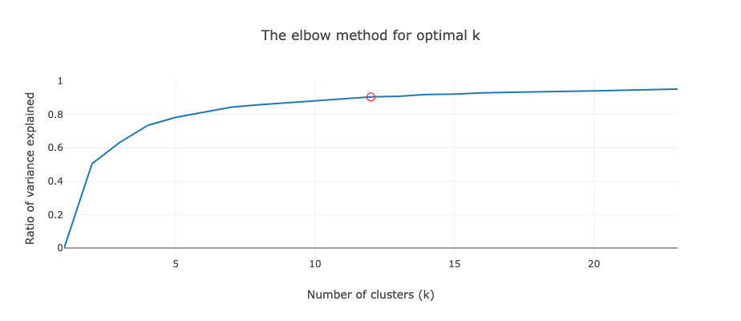
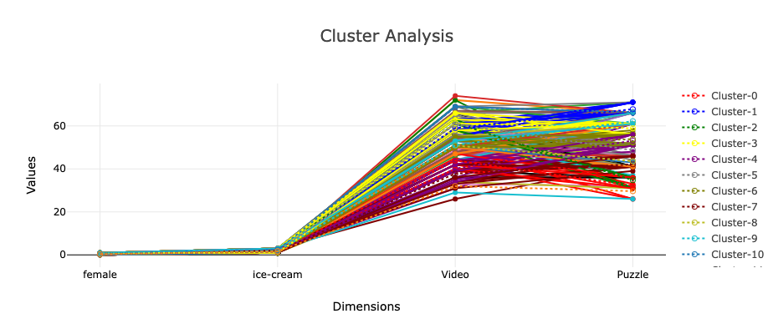

The data was divided into 12 clusters.
We chose the smallest k which explains at least 90% of the variance. (90.3367%)
Clusters: 6,3,2,6,9,3,9,0,5,6,9,3,1,8,4,6,6,3,9,8,2,10,6,3,7,0,1,5,7,8,6,3,10,2,3,1,10,10,7,4,4,5,6,8,1,5,8,5,8,6,3,8,8,1,10,7,11,5,2,4,3,10,7,7,4,0,1,0,5,0,4,3,1,10,5,0,9,1,7,4,6,2,3,3,7,1,6,4,11,3,8,5,10,4,6,5,3,10,7,3,10,3,7,6,5,4,6,0,6,1,3,4,9,3,1,7,8,1,3,4,6,6,4,8,7,3,4,8,8,11,6,6,6,8,9,10,5,4,7,9,4,6,4,7,9,9,2,4,7,7,7,3,6,9,1,1,9,9,7,1,9,6,2,3,9,0,3,0,8,8,8,9,7,5,4,9,1,8,2,5,6,4,3,9,3,1,6,0,9,9,7,8,6,4,6,4,7,6,3,9. (See the cluster column above)
Explained variance ratio: 0.9034.
SSE - The sum of squares of the distances from all the points to the centers.
SSE (Within): 4120.3643.
SSG (Between groups): 38519.0807.
SST (Total): 42639.445.
SSE by group: 313.4, 280.3529, 358.125, 397.7308, 507.3636, 316.4286, 388.7857, 655.0476, 335.6842, 381.8095, 149.6364, 36.
Centers: [0.4,1.5,43.9,32.2], [0.4706,2.2353,59,67.7647], [0.375,1.875,61.375,34.75], [0.5385,2,61.2308,58.8846], [0.6364,1.6364,40.1364,53.1364], [0.3571,1.5,60.7143,48.7143], [0.6071,1.7143,50.9643,53.8571], [0.619,1.7143,37.8095,42.1429], [0.5263,1.8421,50.8947,43.5789], [0.7619,1.7619,51.0476,62.1905], [0.3636,2.2727,68.7273,66.4545], [0.3333,1.6667,32,29.6667].
Maximum iterations: 19.
2.5. Explain the most common data mining and text mining methods that can be used in business with real-world examples
Knowing how to glean useful information from text is crucial in today's corporate environment. Companies are increasingly turning to text mining to help them make sense of the massive amounts of unstructured data they are collecting. As a direct result, companies have been able to make better business decisions and gain access to more complete company data for a plethora of uses. The technique of text mining makes use of several methods, such as text classification, entity extraction (sometimes called named entity recognition), and sentiment analysis. By doing so, businesses can unearth valuable insights, patterns, and trends that would otherwise be buried in mountains of worthless data. Its usefulness in reducing clutter and revealing previously unknown relationships has led to its widespread adoption throughout the organisation. (Selig, 2022)
Information Extraction: The vast majority of information seekers choose this method when perusing written materials. The phrase "information exchange" is used to characterise the process of gleaning useful data from massive amounts of textual data. This subfield of text mining works to extract useful information from texts that are either not well-structured or only partially so by evaluating their contents to identify entities, properties, and relationships. After data collection is complete, it is standard practise to save the information in a database for easy access. Precision and recall methods are used to confirm and assess the data' value and relevance. It is impossible to analyse text without the help of the information extraction procedure.
Categorization: One type of "supervised" learning used in text mining is one in which texts written in natural languages are grouped into predetermined subject categories. We use the term "topic modelling" to describe this method of education. Consequently, categorization, or more accurately Natural Language Processing (NLP), is the process of collecting text documents and analysing them to determine the relevant topics or indexes for each individual document. NLP is also known as Natural Language Processing (occasionally referred to as "classification"). In order to facilitate the process of extracting synonyms and abbreviations from text, the co-referencing technique, which is often employed in natural language processing, could be applied. Modern automated applications of natural language processing include spam filtering, categorisation of internet pages using hierarchical definitions, and customised ad delivery, to name a few (NLP). Categorization is a useful method for analysing textual data..
Summarization: "Text summarisation" is shorthand for the process of automatically producing a condensed version of a certain text that incorporates relevant information for the end-user. The goal of this text mining method is to condense lengthy works by analysing large data sets. The goal of these condensed versions is to stay true to the originals' spirit and message while removing excess detail. Numerous text categorization algorithms, such as decision trees, neural networks, regression models, and swarm intelligence, can be used to the task of text summarization.
Clustering: Clustering is a crucial step in the text mining process. The goal of this strategy is to identify significant themes in textual content and to classify these themes into workable "clusters" for further study. Constructing meaningful clusters from unlabeled text without prior knowledge about those groups is one of the most challenging elements of clustering. Cluster analysis is a typical text mining approach used to aid in the distribution of data or as a preprocessing step for other text mining methods. Clustering describes the most well-known text-mining technique.
2.6. Discuss the advantages and disadvantages of using SPSS and Excel using relevant practical examples and present your discussions in a table.

Advantages of using SPSS
- Accomplish in seconds what would normally take hours, or even days.
- Eliminating human computing flaws like rounding and approximation leads to greater precision.
- It paves the way for larger datasets, more extensive sampling, and additional variables.
- It frees up your brainpower for more important tasks, including figuring out how to optimize a process, analyzing data, and so on.
- SPSS is widely used in the business and social science communities to do statistical analysis.
- It has extensive database interoperability. To that end, rajit clears the way for data to be moved from one application to another. (Sharief, 2019).

Disadvantages of using SPSS
SPSS's major flaw is that it can't process a very large data set. SAS is the go-to statistical programme for medical and nursing researchers due to the sheer scale of the data sets they receive..

MS Excel

Advantages of Using MS Excel
Knowledgeable use of Microsoft Excel's data organisation and analysis tools can improve business processes and increase revenue. Whether you use it for business or to help you manage your personal databases and finances, Microsoft Excel has the tools you need to get the job done. According to 2015 data from UrbanPro.com, urban planning is a burgeoning field. To that end, this essay will focus on a few of Excel's more notable advantages:
- By leveraging Excel's powerful analytical features, users may explore huge datasets in search of meaningful patterns and insights. You can get a fast summary of your data to help with sorting and categorising it if you use the graphing features in Microsoft Excel.
- Newer versions of the Excel doc make it less of a chore to analyse massive data sets. Decision-making criteria can be swiftly and easily refined with the aid of powerful filtering, sorting, and searching tools. The combination of these features with the tables, pivot tables, and graphs can help you quickly and easily find what you need even if you have hundreds of thousands of data points. Although Microsoft Excel is at its best on cutting-edge technology, the application is flexible enough that it can be used on everything from a cheap home computer to a top-of-the-line laptop in the office.
- Using the Excel Web App, groups of people may work together in real time on a single spreadsheet. Working together makes more productive use of time and opens the door to "brainstorming" with large volumes of information. With the aid of the collaboration tools, you may make full use of the collaborative capabilities offered by Microsoft Excel. The online accessibility of the Excel Worksheet allows for convenient and hassle-free collaboration from any location, making it ideal for the constantly on-the-go business professional.

Disadvantages of using MS Excel
Microsoft has made great strides with its online programmes, but they still have a ways to go before their collaborative tools are on par with the finest in the business. To make a tool more easily accessible to several users, it is often necessary to install additional software on the PC. The online document sharing scene has been drastically transformed by Google Docs and comparable applications.
Microsoft Access is my go-to database platform since its relational features are so intuitive and fun to use. The ability to link data by shared elements greatly improves data reduction and analysis (such employee ID, stock number, etc.). Beyond its limited database functionalities and lookup tools, Microsoft Excel lacks true relational functionality.
The larger spreadsheets and binary formats made possible by Excel 2010 are useful, but they can cause the ordinary computer to slow to a crawl or even crash when utilised with a massive quantity of data. Large files are not an issue because some of the alternatives are stored in the "cloud."
While it is feasible to use forms within VBA, the average user will lack the necessary expertise to do so in a way that adds value to their spreadsheets.
While there is a large variety of graphing choices available in Microsoft Excel, customising the standard formats and combining many data sets and types of graphs is a time-consuming and nonintuitive procedure. This is a major flaw for a spreadsheet with so many useful features.

Bibliography
Agarwal, G. (2021). A Comprehensive guide to Microsoft Excel for Data Analysis. [online] Analytics Vidhya. Available at: https://www.analyticsvidhya.com/blog/2021/11/a-comprehensive-guide-on-microsoft-excel-for-data-analysis/ [Accessed 5 Jan. 2023].
Bose, B. (2018). How To Analyze Data In Excel: Simple Tips And Techniques. [online] Digital Vidya. Available at: https://www.digitalvidya.com/blog/how-to-analyze-data-in-excel/ [Accessed 5 Jan. 2023].
Devaney, E. (2021). How to Create a Pivot Table in Excel: A Step-by-Step Tutorial. [online] Hubspot.com. Available at: https://blog.hubspot.com/marketing/how-to-create-pivot-table-tutorial-ht [Accessed 5 Jan. 2023].
KSV Muralidhar (2021). Essential Functions in Excel for Data Preprocessing. [online] Medium. Available at: https://towardsdatascience.com/essential-functions-in-excel-for-data-preprocessing-140f002f3ca [Accessed 5 Jan. 2023].
Mayank Banoula (2020). K-Means Clustering Algorithm: Applications, Types, and How Does It Work? [online] Simplilearn.com. Available at: https://www.simplilearn.com/tutorials/machine-learning-tutorial/k-means-clustering-algorithm [Accessed 5 Jan. 2023].

‌

.

