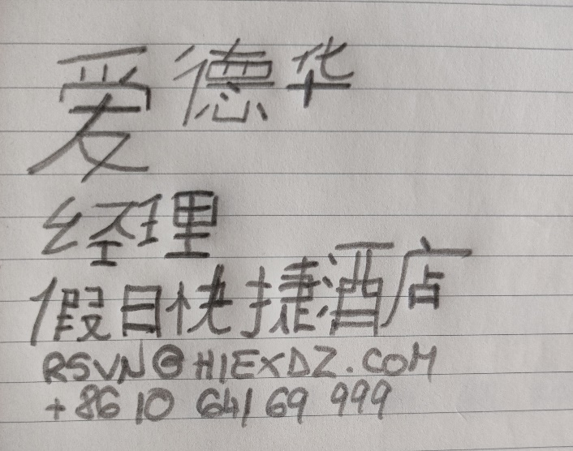

Mandarin Business Card
Eduard Slavu
2022664
Foreign Languages BMIH 5003
Jinping Li
UWTSD
. . . . . . .

