Computer Systems Assignment Virtual Machines M4X01500
Nicholas Evans – 1704662

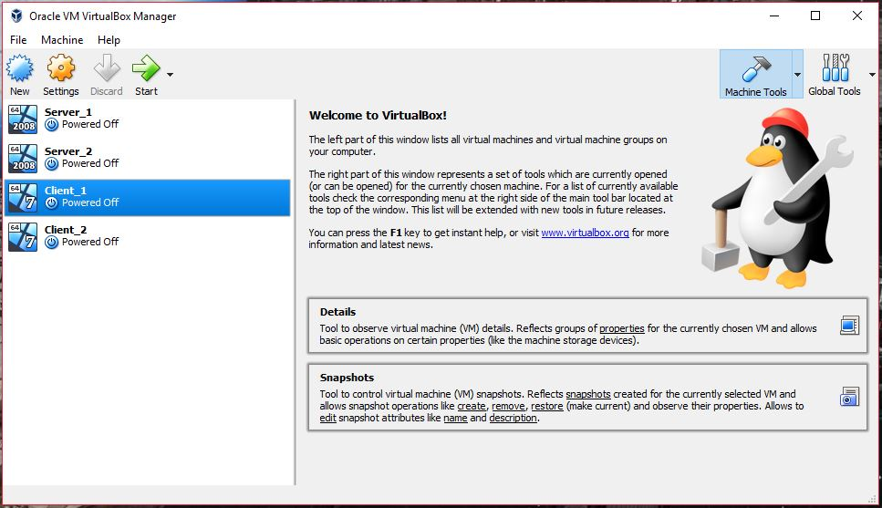
Creating server and client virtual machines using Oracle VM.

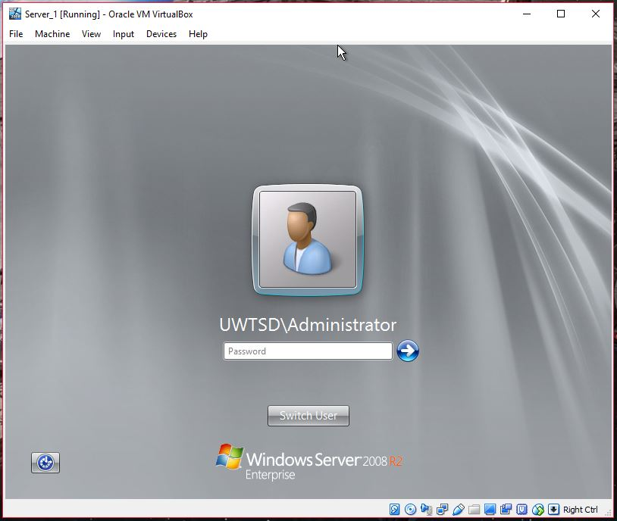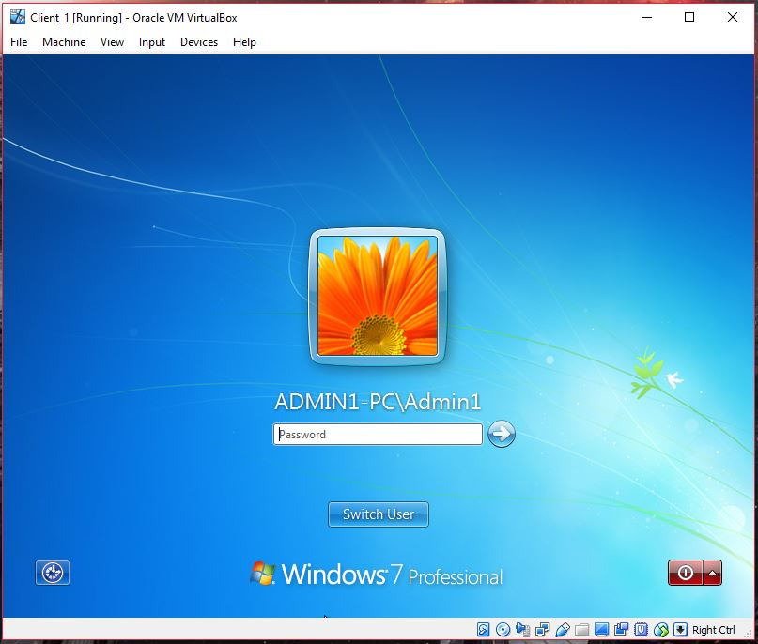
Installed Operating systems for both server and client. Also with DHCP installed.

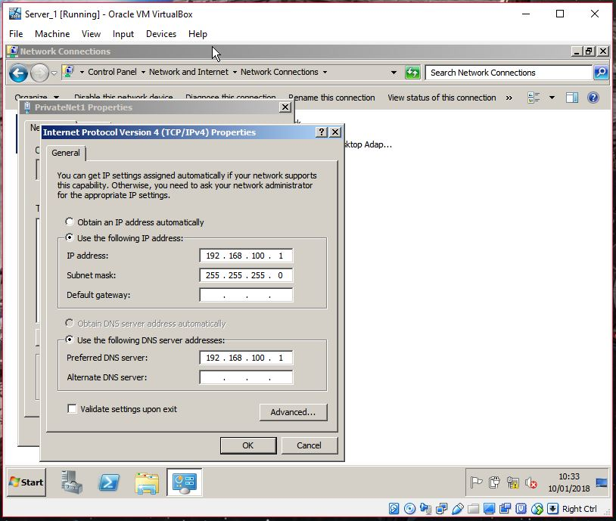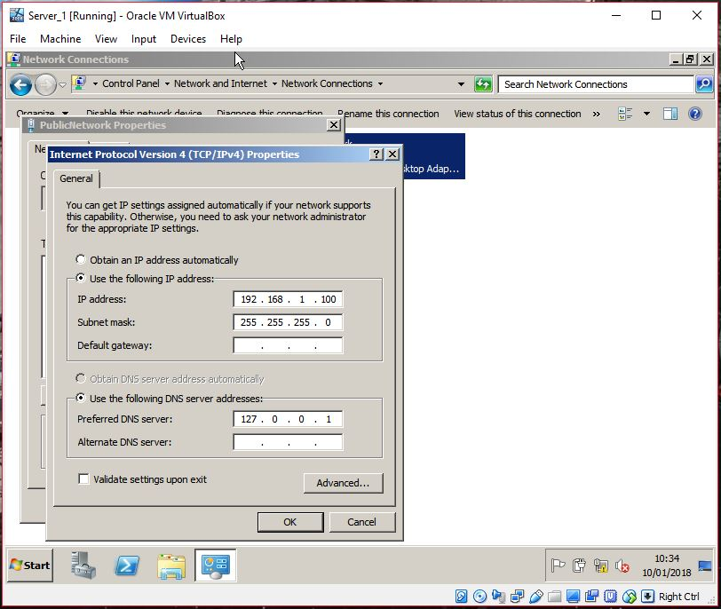
Configured IPV4 addresses for server_1.

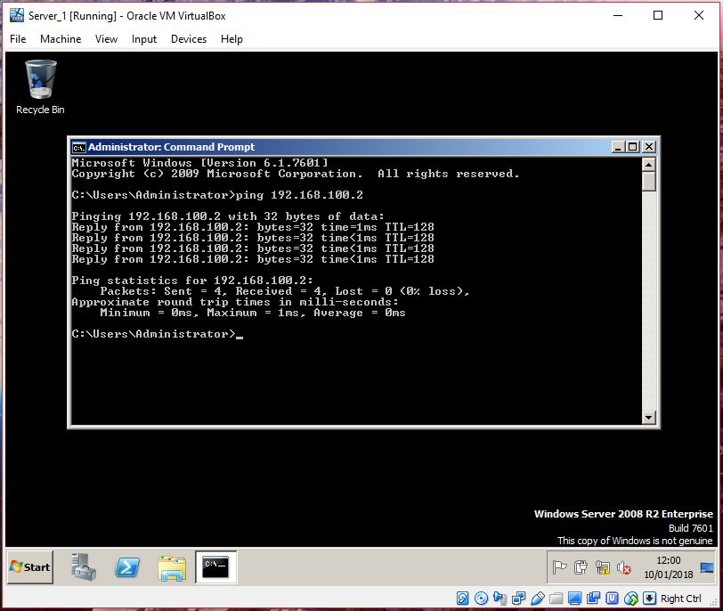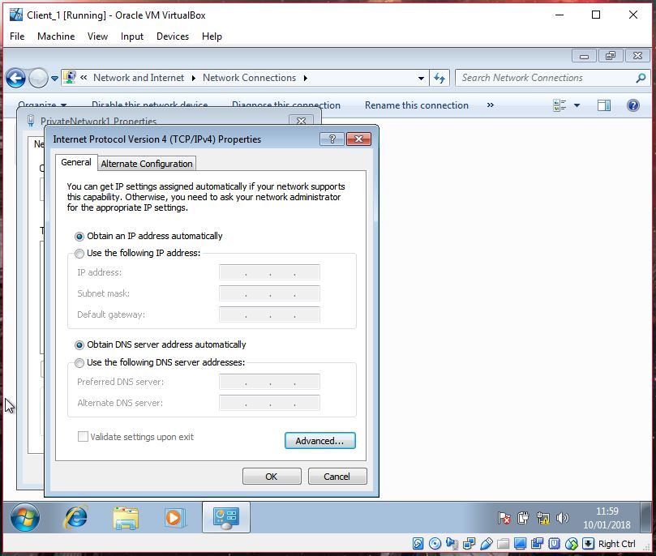
Server_1 pinging Client_1 successfully with DHCP Installed.

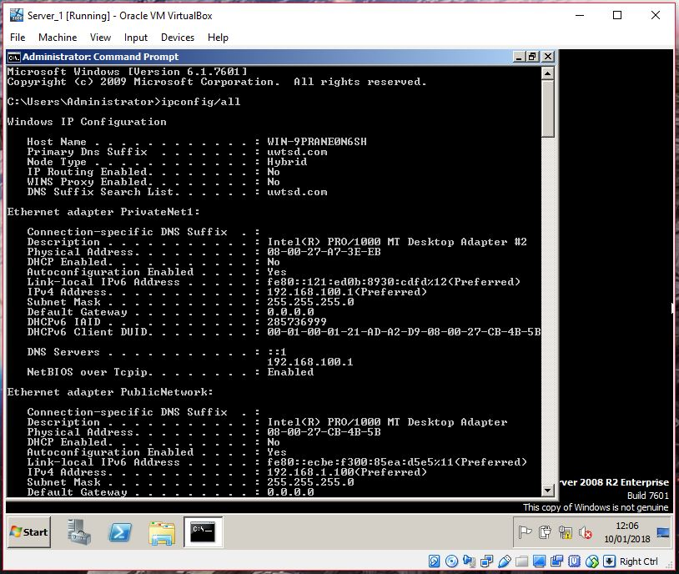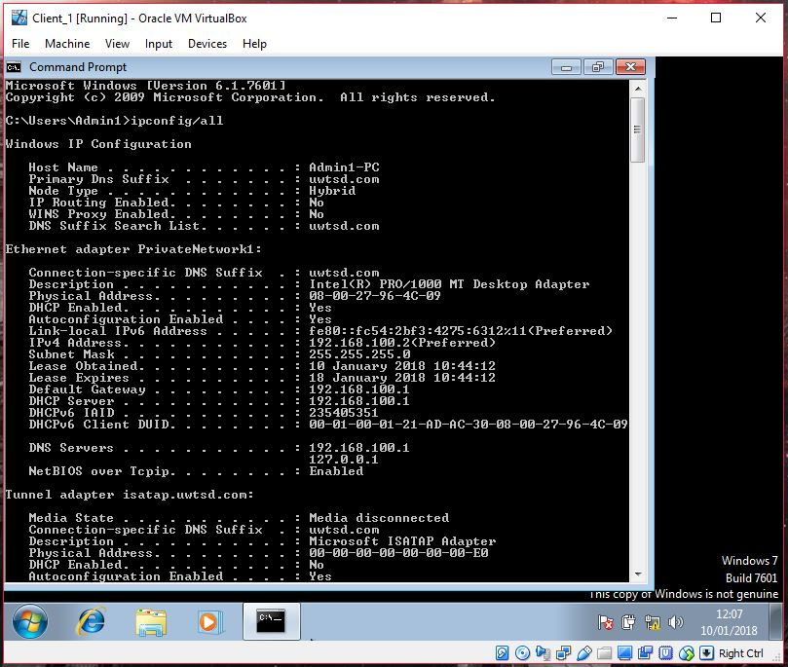
Displaying config/all for both server and client.
Observation Task 1

A). State the benefits of using Type 2 Hypervisor virtualisation software in your design. Comment on the strengths and weaknesses of the VirtualBox platform used in your network.
Advantages of type 2: In type 2 hypervisor, the OS takes care of all the hardware. That is why a type 2 hypervisor can support a wide range of hardware. Also, installing a type 2 is easier than type 1.
Disadvantage of type 2: They have more points of failure since anything that affect the stability of the base operating system can also affect the guest OS and the virtual machine. When the base OS needs a reboot, all the VM will also be rebooted. [1]

B). Explain, with use of diagrams, the significance of the following terms: Active Directory Forests, Trees, Parent and Child Domains

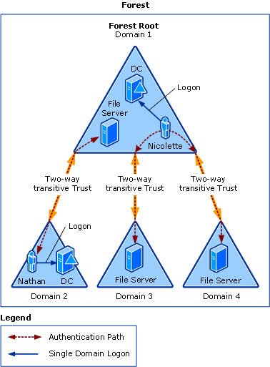[2]

C). Investigate and document the main roles and responsibilities of an Active Directory Domain Controller
Active Directory uses what is known as a multiple-master model. Domain controllers (DCs) are usually equal with each other in reading and writing directory information. However, certain roles cannot be distributed across all the DCs. This means changes can’t take place on more than one domain controller at a time, but some domain controllers do assume a single-master operations role. This is known as an operations masters in Active Directory.
The five categories of operations master roles are:
Schema Master – (one per forest) Maintains the master copy of the schema.
PDC Emulator – (one per domain) Emulates a primary domain controller for backward compatibility with Windows NT.
Domain Naming Master – (one per forest) Tracks object names throughout a forest to ensure that they’re unique. Also tracks cross-reference to objects in other directories.
Infrastructure Master – (one per domain) Tracks object references among domains and maintains a list of deleted child objects.
Relative Identifier (RID) Master – (one per domain) Tracks the assignment of SIDs (security identifiers) throughout the domain.
Usually, the first DCs that you create in the first domain assumes the operations master roles, unless directed to otherwise. But only one at a time can each hold the operation’s master role. [3]

D). What actions could we take in the event of a Domain Controller becoming unavailable?
If the unfortunate event occurs, another working domain controller will take the slack, allowing the user admin to repair/rebuild the first DCs without the worry of the everything not working.
In a catastrophic event where all domain controllers in the solution are lost, and the only backup of the Active Directory data is in the backup images, the restore process must restore each failed server in turn. This process must be performed with recent backups for all domain controllers in the solution. It will recover the Windows server operating system config; Active Directory, including the database and registry settings; and the file replication service. [4]

References

[1] | SecurityWing, 3 January 2014. [Online]. Available: https://securitywing.com/types-virtualization-technology/.
[2] | Tecknet.microsoft.com, 19 November 2014. [Online]. Available: https://technet.microsoft.com/en-us/library/cc783351(v=ws.10).aspx.
[3] | M. L. Steve Clines, "dummies.com," 09 January 2017. [Online]. Available: http://www.dummies.com/programming/networking/roles-of-the-active-directory-domain-controllers/.
[4] | "Technet.Microsoft.com," 09 January 2017. [Online]. Available: https://technet.microsoft.com/en-us/library/cc535164.aspx.

