From the point of view of your chosen academic approach, is it meaningful to speak of human progress through the ages? Is there a useful distinction to be made regarding technological, cultural and moral progress?

Progress comes from the Latin 'progressus,' meaning 'to move forward.' Though not interchangeable, it signifies a journey toward improved stages and is often associated with evolution. Progress is distinct from change. Concepts of progress vary widely across academic disciplines, with some viewing it as a departure from tradition, suggesting that anything new must be superior (Woods, 1907, pp. 779-780). Karl Marx argued that the growth of human productive capabilities is the primary driver of historical change, with social structures adapting to meet these demands (Satz, 1989).
This essay explores human progress through the academic discipline of archaeology, which uncovers and analyses material evidence to understand human evolution, culture, and daily lives. By intersecting with social anthropology and historical sciences, archaeology examines human experiences across time (Schafer-Elliott, 2016, pp. 7-9). Archaeological sites often reveal societal functions, levels of civilisation, technological advancements, and historical processes, highlighting the unique characteristics of various locations (Gramescu et al., 2021; Shanks, 1992, pp. 117-119). The essay argues that although archaeological methods can reveal and quantify technological advancements, cultural and moral progress concepts are more complex, being neither universal nor linear. The inherent contradictions between these dimensions highlight the complexities of human progress, as cultural and moral transformations are often subjective and context-dependent; therefore, they do not consistently correlate with technological developments. Technological progress does not ensure advancements in culture or morality. Usually, technological developments are interpreted through the lens of Western civilisation's idea of progress, which can marginalise alternative knowledge systems and ways of living. Different societies have varying priorities, resulting in unique definitions of progress. Indigenous cultures, for instance, have long practised sustainable living by respecting ecological limits. Throughout history, there have been advancements in technology, but these can sometimes have detrimental effects on the environment and social living standards, raising important questions of morality and ethics.
Archaeology differs from history in several ways. It encompasses the entire history of humanity, stretching back over 3 million years and is the primary means of obtaining information for more than 99% of that duration. Traditional historical sources only emerge with the advent of written documentation around 3000 BC (Renfrew and Bahn, 2020, p. 13). Archaeology offers crucial insights into the fundamental traits of human societies working with various experts from science, the humanities, and social sciences who use archaeological data to support their key arguments (Kintigh et al., 2014; Schafer-Elliott, 2016, pp. 10-14). Archaeology studies human behaviour through material culture, enhancing our understanding of human progress. Evidence, such as stone tools from 2.5 million years ago in Gona, Ethiopia, reveals developments in human behaviour over time. These excavated artefacts offer insights into environments and the evolution of behaviour. Examining variations since our divergence from other apes around seven million years ago is crucial for understanding human evolution. Archaeology complements paleoanthropology by focusing on long-term behavioural changes alongside biological factors (Tryon et al., 2010).
Human progress is a continuous journey toward well-being and satisfaction through achieving specific goals. As one objective is met, individuals pursue new ones to enhance collective welfare and strive for a sustainable society. This pursuit involves expanding knowledge, technology, and culture to improve health, communication, wealth, and freedom (Coccia, 2018). Significant advancements have been made despite the challenges posed by ongoing issues like war, hunger, and poverty. Historically, life was harsh, with an average global life expectancy of around 30 years from the Upper Palaeolithic to 1900. However, in 2019, global life expectancy reached 73.1 years, reflecting the progress made, particularly in the last two centuries (W.H.O., 2024; Tupy, 2013). While historians debate perspectives on progress, societal evolution often falls behind technology (Viney, 1999). Progress does not follow a predictable or automatic path; it arises from deliberate human efforts (Fay, 1947).
Traditional narratives often depict human history as a Newtonian or linear trajectory of advancement culminating in industrial societies (Fiori, 2012). This viewpoint highlights significant milestones, including the advent of agriculture, the emergence of civilisations, and technological revolutions. Nonetheless, archaeological findings frequently contest this perspective and reveal cycles of rise and fall rather than continuous development. History follows a non-linear course, characterised by intervals of innovation, stagnation, and decline (Gerding and Ingemark, 2021). The development of human societies and, more broadly, human history does not progress in a straight line but is primarily based on the reciprocal influences among various elements (Liritzis, 2013). Karl Marx identified five stages of socio-economic development: primitive communities, slave societies, feudalism, capitalism, and a future classless society (Hoogvelt, 1982, pp. 149-170). This linear progression was influential in the twentieth century, but history often unfolds non-linearly, with regressions and hybrid systems, meaning many societies do not fit neatly into Marx's framework.
The rise and fall of the Western Roman Empire exemplifies a non-linear historical trajectory. It collapsed due to internal chaos and external threats, particularly from the Goths and Vandals. During the fifth to seventh centuries, archaeological findings reveal a significant decline in the advanced features of Roman life, marking the end of the civilisation. Urban decline in Rome is evident as monumental structures were repurposed or neglected, and technological skills diminished. This transformation coincided with Germanic invasions, indicating that war and the breakdown of trading networks were key factors. Although Western Europe eventually recovered, it took nearly a thousand years to regain the previous levels of economic activity and living standards (Ward-Perkins, 2005).
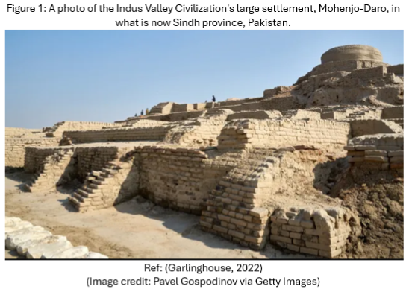
The collapse of complex societies like the Indus Valley (See Figure 1) highlights how progress can be undone, leading to the loss of advanced technology and knowledge. Archaeological evidence shows that the Bronze Age Indus civilisation was a highly sophisticated urban society that emerged in the third millennium BC, covering regions of modern-day Pakistan and India (Menon, 2019; Robinson, 2021, pp. 27-46). The Indus River civilisation had over 5 million people across 1,399 sites, with Mohenjo-Daro and Harappa housing around 30,000 and 40,000 residents, respectively (Maisels, 2001, pp. 180-181). These cities had fortified citadels, walls, gateways, and the Great Bath at Mohenjo-Daro. They also included regular housing with wells, bathrooms, and drainage systems (Robinson, 2021, pp. 46-62). The decline of the civilisation is attributed to environmental, social, and economic factors. Hydro-climatic stress from a weakened monsoon impacted urban centres like Harappa, disrupting regional networks and urban stability. This led to heightened vulnerability among marginalised communities, exacerbated by rising infections and diseases (Robbins Schug et al., 2013).
The term ‘technology’ comes from the Greek word ‘techne,’ meaning ‘art or craft.’ Modern definitions vary by discipline. While current concepts aid in understanding ancient technologies, they may misinterpret pre-industrial societies. The idea of ‘progress’ is often tied to post-Enlightenment imperialism and technological determinism, which consider non-industrialized societies as inherently flawed (Lancaster, 2016).
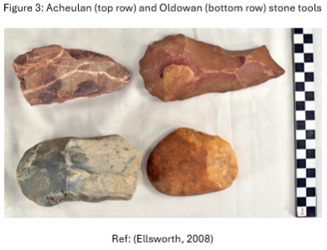
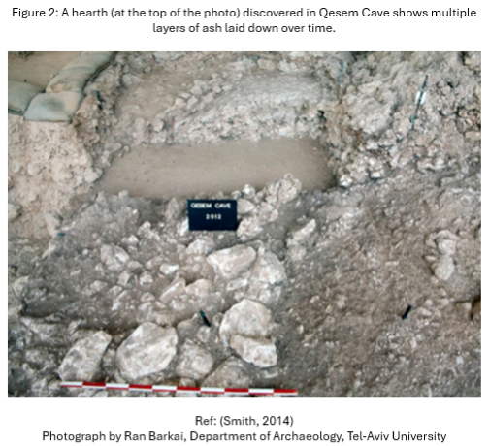
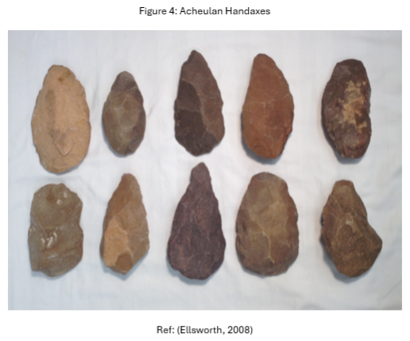
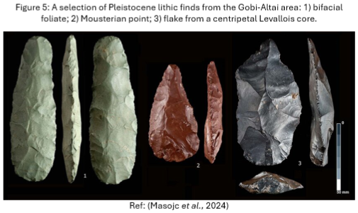
Archaeology reveals a comprehensive timeline of innovations and enhances our understanding of human progress by illuminating technological advancements. One of the earliest indications of improved foresight in our ancestors was fire control, which represents a significant technological milestone. The ability to control fire provided warmth, protection, and a means for food preparation. Evidence suggests that controlled use of fire dates back approximately 1.6 million years, with consistent usage emerging around 400,000 to 300,000 years ago. Excavations at Qesem Cave (See Figure 2) in Israel reveal a notable increase in fire usage around 300,000 years ago, indicating essential shifts in human behaviour. Archaeologists connect stone tool evidence to key questions about human evolution. Early stone tools, such as Oldowan tools (See Figure 3) (2.5 million years ago) and Acheulean axes (See Figure 4) (1.8 million years ago), highlight advanced cognitive skills. Modern individuals struggle to replicate these tools, emphasising the role of social learning in flintknapping. Around 300,000 years ago, a shift to smaller, varied tools reflected improved planning during the Middle Stone Age (Langley and Suddendorf, 2022). Lithic miniaturisation, seen in Pleistocene toolmaking (See Figure 5), involves creating small-backed tools and bladelets. It showcases the complex relationship between design and functionality, highlighting its evolutionary importance (Pargeter and Shea, 2019).
Technological progress does not automatically improve our cultural or ethical systems. Advanced weaponry has changed human morality, pushing societies to adapt to new conflict realities. While these technologies support defence, they lead to destruction and ethical dilemmas. Throughout history, weapons have significantly influenced empires and global politics, as demonstrated by the bombings of Dresden, Hiroshima, and Nagasaki during the Second World War. Today, innovations like artificial intelligence and cyber capabilities are transforming warfare dynamics, reducing certain risks but increasing the potential for military force for political purposes (Anthony, 2020). Integrating Artificial Intelligence (AI) in military contexts poses significant challenges regarding moral responsibility. Dr Elke Schwarz (2024) warns, ‘We don’t want to reach a point where AI is used to make decisions about taking a life when no human can be held responsible for that decision’, highlighting the complex implications of technological advancements on ethics.

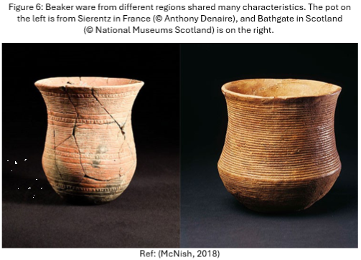
Cultural evolution is the idea that changes in human culture resemble Darwinian evolution. This means that biological methods for studying evolution can also apply to cultural change. Researchers studying cultural evolution seek to understand the complexities of culture, much like biologists explain the diversity of life (Mesoudi, 2016). Culture encompasses what the anthropologist Edward Tylor defined in 1871 as ‘knowledge, belief, art, morals, law, custom, and any other skills and practices developed by individuals as part of society’ (Renfrew and Bahn, 2020, p. 12). Archaeology uncovers cultural progress by studying symbols, rituals, and art from past societies. Significant milestones include language, structured communities, and advancements in agriculture and trade, showcasing adaptation and innovation. Cultural-historical approaches identify ancient practices like pottery making and monument construction, often classifying them under single cultures that serve as historical periods. European history features many classifications, such as the Beaker Folk of the Copper Age, known for their pottery (See Figure 6). While culture historians generally note no direct link between archaeological cultures and ethnic groups, such assumptions often persist. Today, cultural history remains a primary archaeological method, with classification essential for identifying and dating artefacts (Harris and Cipolla, 2017).
Archaeological evidence plays a vital role in studying cultural development and understanding the long-term impacts of various processes. However, we have yet to fully take advantage of archaeology's potential in this area. The anthropological and contextual data collected can inform evolutionary models in archaeology, tackling real-world complexities such as cultural, ecological, and demographic interactions. Integrating archaeology with cultural studies is essential for comprehending the long-term effects of evolutionary processes (Garvey, 2018). By examining diverse cultures throughout history, archaeology can deepen our understanding of multiculturalism, identity, colonisation, and decolonisation (Murray, 2011). Culture is inherently relative and varies significantly across different societies. The moral systems that guide interactions within these societies are also unique (Carnegie Council, 2024). However, common elements can emerge when cultures engage with one another, adopt innovations, or respond to shared challenges. A well-rounded perspective appreciates cultural expressions' distinctiveness while acknowledging the shared human experiences and influences that connect us all.
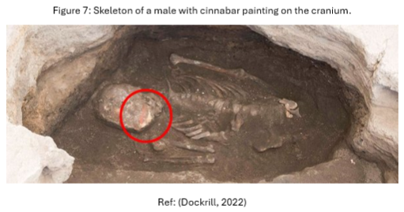
Measuring human moral progress through archaeology is a subjective concept influenced by cultural and historical contexts. Archaeological evidence, such as burial practices, provides insights into changes in human values and ethical systems. By examining how societies treated their dead, archaeologists can infer attitudes toward life, death, the afterlife, and social order, reflecting respect for individuals, communal solidarity, and moral or religious beliefs. The burial practices at Çatalhöyük, a Neolithic settlement in present-day Turkey, offer valuable insights into the moral values and social structures of one of the world's earliest urban societies. The residents of this community practised a distinctive burial tradition, where the skeletons of the deceased were painted with substances like red ochre for all, cinnabar for males, and blue-green for females (See Figure 7). The use of red ochre likely held symbolic meaning, possibly serving to ward off evil spirits or to signify important graves. Excavations have revealed that the bones were partially painted and had been excavated multiple times. Additionally, archaeological evidence found within the homes indicates the presence of intramural burial sites, with individuals showing traces of colourants that correspond to wall paintings (Cassar, 2024). These practices highlight themes of community, equality, familial connections, and reverence for the dead, reflecting a complex moral framework. Ultimately, these burial customs demonstrate how early humans navigated questions of mortality, social bonds, and spiritual continuity. This offers a glimpse into the shared moral principles of one of humanity's first urban cultures (Moses, 2004).
The concept of progress in archaeology poses challenges. Archaeologists must avoid the assumption that technological or cultural changes are inherently better. The interpretative nature of the archaeological record means views on progress vary by context and societal values. Additionally, the non-linear development of societies, which can experience innovation and decline, highlights the complexities of historical trajectories.
Progress can face setbacks. From 1815 to 1914, Europe experienced peace and improved living standards, driven by innovations like radio and aeroplanes. However, the First World War caused around 39 million deaths, reduced incomes, and undermined the Russian monarchy, paving the way for communism, which led to over 100 million deaths under the USSR. Resentment in Germany gave rise to National Socialism, resulting in the Second World War and the Holocaust, claiming about 73 million lives. The Cold War led to proxy conflicts, but technological advancements persisted, including microwaves, computers, and medical breakthroughs such as penicillin and vaccines (Tupy, 2013).
The Industrial Revolution began in 18th-century Great Britain and spread globally with innovations like iron and steel, coal, and steam engines. This era increased production efficiency, supported wealth distribution, and improved living standards as cities offered better wages. However, it also caused environmental harm through deforestation and exploitative labour practices. The relationship between cultural progress and moral development is complex; advancements often conflict with ethical considerations, as seen in both this revolution and the destructive technology of the Second World War (Tupy, 2013).
Progress is not a universal concept, often seen through a Eurocentric lens that views Western industrialisation as the pinnacle of achievement. This perspective marginalises alternative knowledge and ways of living. Different societies have varying priorities, making their definitions of progress unique. Indigenous cultures have long practised sustainable living, respecting ecological limits and understanding fair resource use, as exemplified by tribal communities in Papua New Guinea (Savage, 2021). Many modern societies thrive on exploitation and greed, while around 370 million Indigenous peoples globally are seen as sustainable alternatives to this economic system. These diverse groups emphasise local resistance to global influences, relying on their natural surroundings and prioritising social, cultural, and environmental integrity. Their lifestyle reflects a deep understanding of interconnectedness and often resists modern influences (Mazzocchi, 2006).
Archaeology is essential for understanding human progress in technology, culture, and morality. By studying material remains, we can explore how humanity has evolved. While technological and cultural advancements are evident, assessing moral progress is complex due to varying cultural and ethical standards. Progress in one area doesn't guarantee improvements in others. For example, industrialisation has advanced technology but also caused environmental and social challenges. Whether humanity has made progress depends on the values of those judging it. Though we have made strides in technology, medicine, and human rights, issues like environmental degradation and inequality persist. Focusing solely on technological advancements might suggest progress, but considering moral and ecological factors reveals a more complicated reality where progress can coexist with stagnation. Ultimately, advancing humanity requires ongoing efforts to address new challenges while balancing technological innovation with environmental care and respect for diverse cultures. We should learn from all forms of human organisation to build a sustainable future.

REFERENCES
Anthony, C. (2020) The Ethics of acquiring disruptive Military Technologies. Available at: https://repositories.lib.utexas.edu/items/688b6c77-a723-4785-9e10-c42edb885357 (Accessed: 2 December 2024).
Carnegie Council (2024) Cultural relativism. Available at: https://www.carnegiecouncil.org/explore-engage/key-terms/cultural-relativism (Accessed: 2 December 2024).
Cassar, C. (2024) The painted skeletons of Catalhoyuk: Turkey’s mysterious burial rituals. Available at: https://anthropologyreview.org/anthropology-archaeology-news/the-painted-skeletons-of-catalhoyuk-turkeys-mysterious-burial-rituals/#:~:text=its%20painted%20skeletons.-,Burial%20Rites%20at%20%C3%87atalh%C3%B6y%C3%BCk,green%20(for%20females%20only) (Accessed: 1 December 2024).
Coccia, M. (2018) ‘A Critique of Human Progress: A New Definition and Inconsistencies in Society’, Quaderni IRCrES-CNR, 4(3), pp. 51-67. Available at: https://papers.ssrn.com/sol3/papers.cfm?abstract_id=3186112 (Accessed: 30 November 2024).
Dockrill, P. (2022) People in one of the world’s oldest cities colored the bones of their dead. Available at: https://www.sciencealert.com/ancient-city-from-9-000-years-ago-buried-their-dead-in-very-mysterious-ways (Accessed: 4 December 2024).
Ellsworth, R. (2008) Oldowan and Achulean Stone Tools. Available at: https://anthromuseum.missouri.edu/e-exhibits/oldowan-and-acheulean-stone-tools (Accessed: 4 December 2024).
Fay, S. B. (1947) ‘The Idea of Progress’, The American Historical Review, 52(2), pp. 231–246. Available at: https://doi.org/10.2307/1841272
Fiori, S. (2012) ‘Adam Smith on method: Newtonianism, history, institutions, and the “invisible hand”’, Journal of the History of Economic Thought, 34(3), pp. 411–435. Available at: https://doi.org/10.1017/S1053837212000405
Garlinghouse, T. (2022) What was the Indus Valley Civilization? Available at: https://www.livescience.com/what-was-the-indus-valley-civilization (Accessed: 4 December 2024).
Garvey, R. (2018) ‘Current and potential roles of archaeology in the development of cultural evolutionary theory’, Philosophical Transactions of the Royal Society of London. Series B. Biological sciences, 373(1743), p. 20170057. Available at: https://doi.org/10.1098/rstb.2017.0057
Gerding, H. and Ingemark, D. (2021) ‘Beyond Newtonian thinking – towards a non-linear archaeology : applying chaos theory to archaeology’, Current Swedish Archaeology, 5(1), pp. 49-64. Available at: https://doi.org/10.37718/CSA.1997.04
Grămescu, A.M., Barbu, A.M.D. and Ioniță, A. (2021) ‘Criteria and Procedures of Analysis Applicable in the Evaluation of the Archaeological Heritage’, ‘Ovidius’ University Annals. Series Civil Engineering, 23(1), pp. 113–120. Available at: https://doi.org/10.2478/ouacsce-2021-0014
Harris, O.J.T. and Cipolla, C.N. (2017) Archaeological theory in the new millennium : introducing current perspectives. Milton Park, Abingdon, Oxon ; Routledge.
Hoogvelt, A.M.M. (1982) The Third World in Global Development. Palgrave, London. Available at: https://doi.org/10.1007/978-1-349-16777-7_6
Kintigh, K.W. et al. (2014) ‘Grand Challenges for Archaeology’, American Antiquity, 79(1), pp. 5–24. Available at: https://doi.org/10.7183/0002-7316.79.1.5
Lancaster, L. (2016) Technology. Available at: https://doi.org/10.1093/acrefore/9780199381135.013.6251
Langley, M.C. and Suddendorf, T. (2022) ‘Archaeological evidence for thinking about possibilities in hominin evolution’, Philosophical Transactions of the Royal Society of London. Series B. Biological sciences, 377(1866), p. 20210350. Available at: https://doi.org/10.1098/rstb.2021.0350
Liritzis, I. (2013) ‘Twelve Thousand Years of Non-Linear Cultural Evolution: The Science of Chaos in Archaeology’, Synesis: A Journal of Science, Technology, Ethics and Policy. Available at: http://www.synesisjournal.com/vol4_g/Liritzis_2013_G19-31.pdf (Accessed: 3 December 2024).
Maisels, C.K. (2001) Early civilizations of the old world : the formative histories of Egypt, the Levant, Mesopotamia, India and China. London: Routledge. Available at: https://doi.org/10.4324/9780203449509
Masojć, M. et al. (2024) ‘Palaeolakes, caves and settlement during the Pleistocene and Holocene around Tsakhiurtyn Hundi, Mongolia’, Antiquity, 98(399), p. e15:1-8. Available at: https://doi.org/10.15184/aqy.2024.44
Mazzocchi, F. (2006) ‘Western science and traditional knowledge’, EMBO Reports, 7, pp. 463-466. Available at: https://doi.org/10.1038/sj.embor.7400693
McNish, J. (2018) The Beaker people: a new population for Ancient Britain. Available at: https://www.nhm.ac.uk/discover/news/2018/february/the-beaker-people-a-new-population-for-ancient-britain.html (Accessed: 4 December 2024).
Menon, J. (2019) A Bronze Age Civilization in South Asia. Available at: https://www.sahapedia.org/bronze-age-civilization-south-asia (Accessed: 30 November 2024).
Mesoudi, A. (2016) ‘Cultural Evolution: A Review of Theory, Findings and Controversies’, Evolutionary Biology, 43(4), pp. 481–497. Available at: https://doi.org/10.1007/s11692-015-9320-0
Moses, S. (2004) The Children of Neolithic Catalhoyuk: Burial Symbolism and Social Metaphor. Available at: https://www.catalhoyuk.com/archive_reports/2004/ar04_34.html (Accessed: 1 December 2024).
Murray, T. (2011) ‘Archaeologists and Indigenous People: A Maturing Relationship?’, Annual Review of Anthropology, 40, pp. 363–78. Available at: http://www.jstor.org/stable/41287738 (Accessed: 1 December 2024).
Pargeter, J. and Shea, J.J. (2019) ‘Going big versus going small: Lithic miniaturization in hominin lithic technology’, Evolutionary Anthropology, 28(2), pp. 72–85. Available at: https://doi.org/10.1002/evan.21775
Renfrew, C. and Bahn, P.G. (2020) Archaeology : theories, methods and practice. 8th edn. London: Thames & Hudson, Limited.
Robbins Schug, G. et al. (2013) ‘Infection, disease, and biosocial processes at the end of the Indus Civilization’, PloS one, 8(12), pp. e84814. Available at: https://doi.org/10.1371/journal.pone.0084814
Robinson, A. (2021) The Indus. 3rd edn. London: Reaktion Books Ltd.
Satz, D. (1989) ‘Marxism, Materialism and Historical Progress’, Canadian Journal of Philosophy Supplementary Volume, 15, pp. 391–424. Available at: https://doi.org/10.1080/00455091.1989.10716805
Savage, V. (2021) New and old understandings of nature will be key to protecting the world’s rich labyrinth of ecosystems. Available at: https://www.acu.ac.uk/the-acu-review/lessons-in-sustainable-living/ (Accessed: 2 December 2024).
Schafer-Elliott, C. (2016) The 5 Minute Archaeologist in the Southern Levant. 1st edn. Sheffield: Equinox Publishing Ltd.
Schwarz, E. (2024) The ethical implications of AI in warfare. Available at: https://www.qmul.ac.uk/research/featured-research/the-ethical-implications-of-ai-in-warfare/ (Accessed: 2 December 2024).
Shanks, M. and Tilley, C.Y. (1993) Re-constructing archaeology: theory and practice. 2nd ed. London: Routledge.
Smith, R. (2014) Oldest known hearth found in Israel cave. Available at: https://www.nationalgeographic.com/adventure/article/140129-oldest-hearth-israel-cave-new-human-species-discovery-archaeology-science (Accessed: 4 December 2024).
Tryon, C., Pobiner, B. and Kauffman, R. (2010) ‘Archaeology and Human Evolution’, Evolution Education & Outreach, 3(3), pp. 377–386. Available at: https://doi.org/10.1007/s12052-010-0246-9
Tupy, M. (2013) Human Progress: Not inevitable, uneven, and indisputable. Available at: https://www.cato.org/commentary/human-progress-not-inevitable-uneven-indisputable (Accessed: 30 November 2024).
Viney, R. (1999) ‘Progress in history : using some ideas in theoretical physics to adapt linear and cyclical concepts of progress in history’, Historia (Three Rivers), 44(2), pp. 276–286. Available at: https://journals.co.za/doi/abs/10.10520/EJC37965 (Accessed: 30 November 2024).
Ward-Perkins, B. (2005) The end of the Roman Empire: did it collapse or was it transformed?, History Today. London: History Today Ltd, pp. 12–16. Available at: https://www.proquest.com/docview/202817654/391A10F6D77C4C60PQ/1?accountid=130472&sourcetype=Magazines (Accessed: 1 December 2024).
W.H.O. (2024) GHE: Life expectancy and healthy life expectancy. Available at: https://www.who.int/data/gho/data/themes/mortality-and-global-health-estimates/ghe-life-expectancy-and-healthy-life-expectancy (Accessed: 30 November 2024).
Woods, E.B. (1907) ‘Progress as a Sociological Concept’, The American Journal of Sociology, 12(6), pp. 779–821. Available at: https://doi.org/10.1086/211550

BIBLIOGRAPHY
Germond-Duret, C. (2016) ‘Tradition and modernity: an obsolete dichotomy? Binary thinking, Indigenous peoples and normalisation’, Third Quarterly, 37(9), pp. 1537–1558. Available at: https://doi.org/10.1080/01436597.2015.1135396
Hodder, I. and Hutson, S. (2003) Reading the past : current approaches to interpretation in archaeology. 3rd edn. Cambridge: Cambridge University Press.
Morris, I. (2015) Humanity is turning into a ‘different kind of animal,’ Stanford historian says. Available at: https://news.stanford.edu/stories/2015/03/ancient-post-human-030415 (Accessed: 30 November 2024).
Scarre, C. (2018) The human past : world prehistory and the development of human societies. 4th edn. London: Thames & Hudson.
Teltser, P.A. (1995) Evolutionary archaeology : methodological issues. 1st edn. Tucson, Ariz: University of Arizona Press.

