Sustainable Hospitality & Tourism
Management

Module Code: BMIH5006

Name: ALINA PANDREA
ID: 2226713
Tutor: LISA KNIGHT

I acknowledge that I used Google for research purpose only, Grammarly for the grammatical errors and mistakes and I also used the materials that has been provided by the university and accessed the university library.
I acknowledge that I used Google Scholar for research purpose.

Executive Summary
The following report explores the usage of sustainability initiatives such as Grey water recycling to enhance sustainability practices at IHG Hotels & Resorts UK. This could help reduce water usage of the hotel and its operations thus supporting IHG's sustainability practice. However, the obstacles include high costs and limited space by the hotel's implementation. Henceforth, the basic concept of the initiative is that it is possible to implement it in phases, using eco-financing and regulation. Social benefits include saving water, reducing carbon emissions, cutting costs, and improving the corporate image. Considering the key challenges, justified recommendations are further mentioned in the report. Moreover, despite the challenges, the initiative is feasible and cost-effective for IHG and will allow for better sustainability practices in the future.

1. Introduction

Figure 1: Logo of IHG hotel and resorts
(Source: IHG, 2021)
Sustainability being a concern in hospitality operations, IHG (InterContinental Hotels Group) Hotels & Resorts is taking some effective initiatives in its business operations. This report focuses on activities under the category of “Greener Practices,” using consideration of grey water recycling to assess areas of sustainability flanked. IHG has created its “Journey to Tomorrow” program, which states that the company aims to reduce carbon emissions, water consumption, and waste generation (IHG, 2021). The brand has generated annual revenue of around 2.16 billion USD in 2023 (Statista, 2024). However, there is still a lot that can be done. Grey water recycling holds great promise, and this paper shall compare its benefits, drawbacks, and impact on IHG’s sustainability goals.

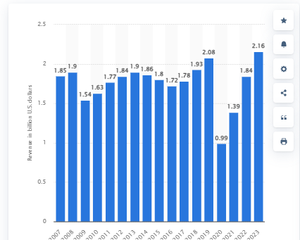
Figure 2: Revenue of IHG hotel and resorts
(Source: Statista, 2024)

2. Key Findings

2.1 Identified greener practice initiatives
The adoption of grey water recycling systems could greatly improve the water-saving initiatives of IHG Hotels & Resorts UK. Grey water reuse means the treated wastewater from showers, sinks, and laundry that is reused for purposes other than drinking water, for example, in toilets and watering plants. This not only makes it possible for hotels to recycle the water that has been used minimally and saves on fresh water (Greywater Action, 2024). Some of the major consumers are hotels where twenty litters per guest daily is used and this ranges between 100 to 400 gallons, thus there is a great potential for the reuse of grey water (Davodi, 2021).
The IHG has adopted the Grey water system through its Green Engage program by adapting hydra loop system for its water conservation (IHG, 2024a).This way IHG reduce its water consumption by 11 litters per minute with large savings and benefits to the environment particularly in geography with water deficiency (IHG, 2024b). Further, IHG has more than 200 energy solutions with the ambition of cutting carbon by up to 25% by the end of the year 2020, and 80% of hotels are involved in Green Engage System (IHG, 2024a).
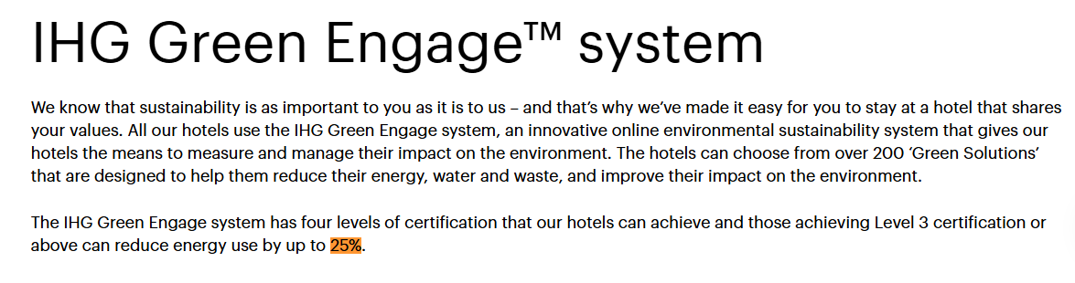
Figure 3: IHG’s reduction of carbon emission
(Source: IHG, 2024a)
Real case studies depict the role of the grey water system in such facilities as this. Based on the case of Hilton London Heathrow Airport, Grey water recycling has already been done, realising water saving of about 130 million litters per year (Water Online, 2024). This saves water, and at the same time, brings down the operating expenses of the businesses.
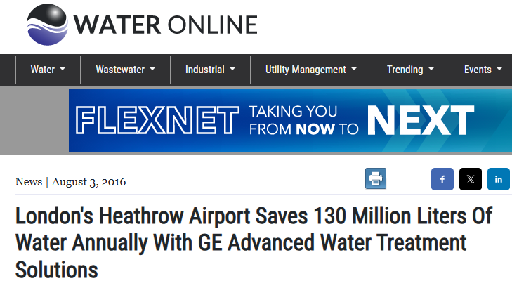
Figure 4: Heathrow Airport’s water consumption
(Source: Water Online, 2024)
Another organisation that also implemented the system was the Radisson Blu in Dubai; this also saw them reduce the use of freshwater by 60,000 cubic meters per year (Radisson Hotel Group, 2022). This case study and its review have vividly illustrated possible effective water conservation through grey water recycling in the hospitality industry. That is why the involvement of IHG in this activity is very effective because it has a large number of hotels in the UK. The potential to install grey water systems across its properties could result in a saving of hundreds of thousands and millions of litters annually in line with the local water affordability programs and cost-saving returns on investment.
In addition to its direct environmental benefit, grey water recycling is consistent with IHG’s sustainable business approach and subsumes ecologically oriented certification, such as Green Key, the international certificate for environmentally friendly hotels (Green Key, 2023). Credentials of this nature are especially valuable for attracting such guests if the accommodation supports environmentally friendly practices as many contemporary tourists do. Proactively in saving water can increase guest satisfaction and loyalty because of the belief that IHG cares for the environment.
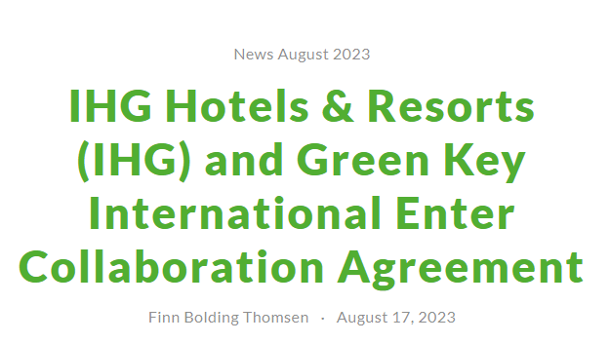
Figure 5: IHG’s Green Key Certification
(Source: Green Key, 2023)
2.2 Benefits of the initiatives
Implementing grey water recycling at IHG Hotels & Resorts UK would offer several substantial benefits:
Water Conservation:
The volume of water that could be saved from demand through grey water recycling ranging from 30 to 50% would go a long way in conserving water supplies in the region (Siang et al., 2018). For instances, IHG taking an example of implementing the Green Engage program can potentially save around 77-million-gallon water per year (Waste Water Digest, 2020).
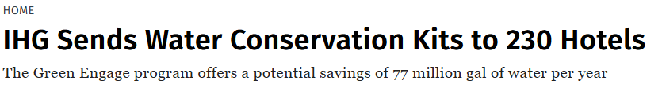
Figure 6: Potential Water conservation by IGH
(Source: Waste Water Digest, 2020)
Cost Savings:
As with any capital outlay, a grey water system costs money up front, however, this can be offset by the difference in your utility bills. In areas where water charges are high for instance, some parts of London water recycling can be hugely beneficial (Gov UK, 2023). A Hilton Garden in Dubai has cut its water bills by reducing 6,000 gallons water consumption per day (Hilton ESG, 2020). As expected, this too holds the same results even for IHG properties, more so in the competitive niches.

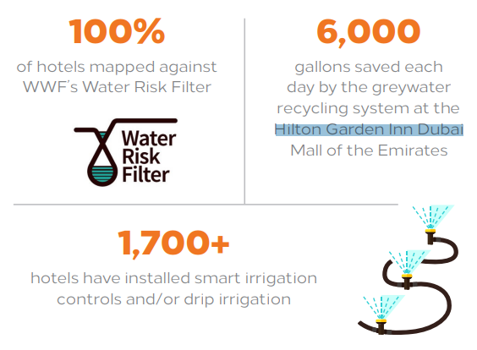
Figure 7: Water savings of Hilton Garden, Dubai
(Source: Hilton ESG, 2020)
Enhanced Brand Image:
The implementation of grey water recycling helps to promote IHG’s strategy of “Journey to tomorrow” which accentuates its conservation agenda (IHG, 2021). A global survey revealed that 49% of travellers choose sustainable lodging, while 43% are ready to overpay for environmentally friendly hotels (Global Sustainable Tourism Council, 2023). Thus, IHG can attract this segment by promoting grey water recycling, thus increasing both the brand popularity and the amount of income.

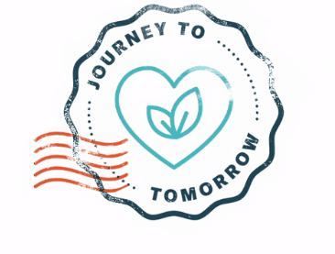
Figure 8: Journey to Tomorrow by IHG
(Source: IHG, 2021)
Environmental Impact:
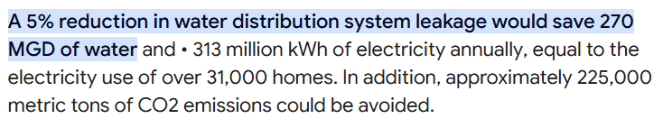
Figure 9: Relation between water conservation and carbon emission
(Source: Griffiths-Sattenspiel and Wilson, 2020)
Grey water recycling also helps in reduction of energy and resources that is used to treat and provide water hence helping the hotel in terms of the carbon footprint. Calculations show that water recycling can cut carbon emissions on water usage at a hotel for instance, saving 270 MGD of water can reduce 225,000 metric tons of carbon emission (Griffiths-Sattenspiel and Wilson, 2020). This supports IHG’s initiative to cutting carbon emissions by 46 percent by 2030 (InterContinental Hotels Group PLC, 2024).

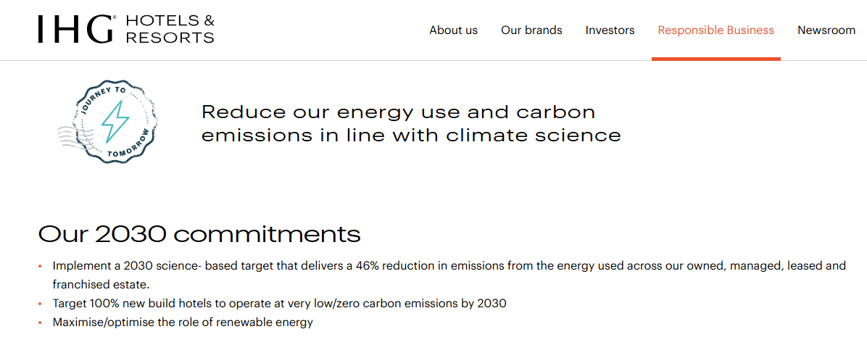
Figure 10: IHG’s target of reducing Carbon emission
(Source: InterContinental Hotels Group PLC, 2024)

2.3 Challenges in Implication
There are several challenges to the installation of grey water recycling in IHG UK properties. Initially, costs of installation may reach as high as £3,280.00 to £4,777.18 a consequence of which may prove to be a harsh reality when retrofitting older hotels (Hydraloop, 2024). Some may have costs offset by local challenges through government subsidies or the eco-financing options available in the UK.
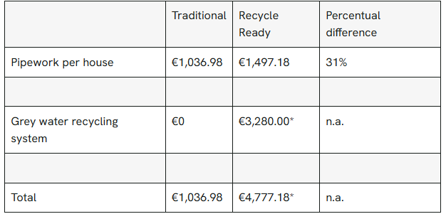
Figure 11: Cost of installing Grey Water recycling system
(Source: Hydraloop, 2024)
Older hotels, and especially those in historic buildings, face a great many challenges regarding space and infrastructure, as grey water systems require dedicated piping and tank storage. Rather considerable alterations to existing plumbing requirements may be needed during retrofitting, which may or may not be achievable, especially when altering older hotels.
Additionally, to obviate any contamination, compliance with health and safety regulations, such as the Water Supply (Water Fittings) Regulations, is imperative. Routine maintenance and monitoring must take place to comply with regulations necessary for the safety of grey water systems; these add ongoing operational costs (Water Regs UK, 2024).
Finally, there are problems with guest perceptions, as travellers feel some apprehension regarding the hygiene of recycled water systems, surveys show that 23.8% are concerned about the health implication by reusing the recycled water (Akpan, Omole and Bassey, 2020). Clear directives from pamphlets or signage could reinforce acceptance among visiting guests.

2.4 Feasibility and cost-effectiveness
The study by IHG Plc (2023) stated that the grey water recycling of IHG mainly focuses on the primary use of recycled water and produced water of the hotel estate for landscaping the sustainability practice. This strategy is feasible and cost-effective as it provides a high return on investment and ensures governmental support and eco-financing through the initiative. In addition, the cost-effective technology used for this initiative is further a sustainable process that provides affordable and sustainable influence on the operation of the hotel.

Figure 12: Feasibility and Cost-effectiveness of the Green Initiative by IHG
(Source: Created by author)
Return on Investment (ROI): Hotels invest in grey water systems by recovering their invested money back through reduced amounts of money paid as a water bill in five to ten years. For example, Premier Inn recovered money spent in six years, by installing the same water-saving systems in its chain of hotels (One Planet network, 2022).
Considering this, IHG could reduce their operational expenses by recovering the investment in the green initiative.
Governmental Support and Eco-financing: Additionally, the UK government could provide incentives to IHG by saving water to IHG. Water-saving schemes would fall within the tax relief scheme under the ECA program, thereby generally reducing expenses in IHG accounts (GOV UK, 2024). In addition, IHG could develop and collaborate with other organisations such as Waterwise UK, which would be offering support for any water-saving project.
Gradual Implementation: Furthermore, the hotel could start by installing grey-water systems in high-demand, newly built hotels as a means of equipping modern infrastructure. Such developments would then assist in spacing the costs over time based on which IHG could observe performance over time and feedback from customers before it is applied wholesale.
Cost-Effective Technology: Moreover, Grey water technology has advanced to the point where systems are affordable and compact. This will allow IHG to have diversified properties since the technology adopted is flexible in terms of the size of the hotel. Thus, it may be suitable for IHG's numerous properties and due to the flexible technology, upfront costs to IHG would be very low, as it will only incur adjustments during the installation process.

2.5 Environmental Impact
Grey water recycling at IHG Hotels & Resorts UK would lead to varied admirable environmental changes, as follows.
Reduced Water Demand: The installation of grey water recycling system can reduce 24% of water consumption in the IHG hotels, thereby accounting for a reduction in local water supply demand (One Planet network, 2022).
Reduced Carbon Production: By reusing water, energy that would have been used to heat it and treat water is minimised, thereby minimising IHG’s carbon footprint. Water savings can help IHG to reduce 6 to 7% carbon emission per occupied rooms (Inter Continental Hotels Group, 2021).
Benefit to Local Ecosystems: Reduced water extraction from local sources benefits regional ecosystems, particularly in drought-prone areas (Ward et al., 2020). Grey water systems minimise volume and shorten treatment time in the wastewater they create (Oteng-Peprah, Acheampong and deVries, 2018). This then has a lesser impact on local water treatment works and aids ecosystems in getting better.
With grey water recycling, IHG can implement 'Journey to Tomorrow' goals and further reinforce their credentials as leaders in sustainable hospitality.

3. Recommendation
Based on the challenges mentioned above, IHG Hotels & Resorts UK should undertake a phased implementation plan for grey water recycling with the following systematic approach.
- Recruitment of newly built or high-water usage properties should be done. It would further assist in controlling high installation costs and space limitation.
- A possible solution for overcoming the initial financial problem is cooperation with eco-financing programs by receiving grants from the government.
- In addition, for managing the issue and financing system safety, IHG ought to implement staff training and guest education programs to guarantee guests’ confidence in system safety.
- Lastly, schedules should be set for the frequency of maintenance so that services offered provide safety as per UK laws and are efficient.

4. Conclusion
The above report stated that applying a grey water-recycling programme in IHG Hotels & Resorts UK has the potential to improve the use of water, cost reduction and sustainability. Despite the challenges like high start-up costs, lack of space and compliance with regulations, all these obstacles can be effectively addressed through the mentioned recommendations. The systematic implementation of the grey water systems starting with water-intensive buildings and maintaining proper communication with the guests is again financially sensible and environmentally sustainable.

References
Akpan, V.E., Omole, D.O. and Bassey, D.E. (2020) ‘Assessing the public perceptions of treated wastewater reuse: opportunities and implications for urban communities in developing countries’, Heliyon, 6(10), p. e05246. Available at: https://doi.org/10.1016/j.heliyon.2020.e05246.
Davodi, H. (2021) Hotel Water Consumption Statistics & Conservation, Pure Blue Sustainability. Available at: https://purebluesustainability.com/hotel-water-consumption-statistics-conservation/ (Accessed: 4 November 2024).
Global Sustainable Tourism Council (2023) Booking.com 2023 Sustainable Travel Report, GSTC. Available at: https://www.gstcouncil.org/booking-com-2023-sustainable-travel-report/ (Accessed: 4 November 2024).
Gov UK (2023) Water Recycling - Drinking Water Inspectorate, Drinking Water Inspectorate. Available at: https://dwi.gov.uk/water-recycling/ (Accessed: 4 November 2024).
GOV UK (2024) Claim capital allowances, GOV.UK. Available at: https://www.gov.uk/capital-allowances/first-year-allowances (Accessed: 4 November 2024).
Green Key (2023) Green Key — IHG Hotels & Resorts (IHG) and Green Key International Enter Collaboration Agreement, Green Key. Available at: https://www.greenkey.global/stories-news-1/2023/8/16/ihg-hotels-amp-resorts-ihg-and-green-key-international-enter-collaboration-agreement (Accessed: 4 November 2024).
Greywater Action (2024) About Greywater Reuse, Greywater Action. Greywater Action. Available at: https://greywateraction.org/greywater-reuse/ (Accessed: 4 November 2024).
Griffiths-Sattenspiel, B. and Wilson, W. (2020) The Carbon Footprint of Water A River Network Report. Chicago State University. Available at: https://www.csu.edu/cerc/researchreports/documents/CarbonFootprintofWater-RiverNetwork-2009.pdf (Accessed: 4 November 2024).
Hilton ESG (2020) Team Members from Hilton Hawaiian Village volunteered with the Ko’olau Mountains Watershed Partnership to clear invasive species and outplant native species at the Manana Trail native forest restoration project, Hilton ESG. Available at: https://cr.hilton.com/wp-content/uploads/2020/04/Hilton-Water-Fact-Sheet.pdf (Accessed: 4 November 2024).
Hydraloop (2024) Benefits and costs of installing a grey water recycling system – Info Center, Hydraloop.com. Available at: https://info.hydraloop.com/docs/benefits-and-costs-of-installing-a-grey-water-recycling-system/ (Accessed: 4 November 2024).
IHG (2021) Journey to Tomorrow: IHG Hotels & Resorts publishes series of ambitious commitments to drive change for people, communities and the planet, InterContinental Hotels Group PLC. Available at: https://www.ihgplc.com/en/news-and-media/news-releases/2021/journey-to-tomorrow-ihg-hotels-resorts-publishes-series-of-ambitious-commitments (Accessed: 4 November 2024).
IHG (2024a) IHG, IHG. Available at: https://www.ihg.com/content/gb/en/support/green-engage (Accessed: 4 November 2024).
IHG (2024b) Water, InterContinental Hotels Group PLC. Available at: https://www.ihgplc.com/en/responsible-business/water (Accessed: 4 November 2024).
IHG Plc (2023) Welcome to your CDP Water Security Questionnaire 2023, IHG Plc. Available at: https://www.ihgplc.com/~/media/Files/I/Ihg-Plc/responsible-business/reporting/2023/cdp-water-questionnaire-2023.pdf (Accessed: 4 November 2024).
Inter Continental Hotels Group (2021) Intercontinental Hotels Group -Climate Change 2021. InterContinental Hotels Group. Available at: https://www.ihgplc.com/~/media/Files/I/Ihg-Plc/responsible-business/reporting/2021/cdp-carbon-questionnaire.pdf (Accessed: 4 November 2024).
InterContinental Hotels Group PLC (2024) Carbon and Energy, InterContinental Hotels Group PLC. Available at: https://www.ihgplc.com/en/responsible-business/carbon-and-energy (Accessed: 4 November 2024).
One Planet network (2022) Innovative Greywater Recycling in Hotels, One Planet network. Available at: https://www.oneplanetnetwork.org/knowledge-centre/resources/innovative-greywater-recycling-hotels (Accessed: 4 November 2024).
One Planet network (2022) Innovative Greywater Recycling in Hotels, One Planet network. Available at: https://www.oneplanetnetwork.org/knowledge-centre/resources/innovative-greywater-recycling-hotels (Accessed: 4 November 2024).
Oteng-Peprah, M., Acheampong, M.A. and deVries, N.K. (2018) ‘Greywater Characteristics, Treatment Systems, Reuse Strategies and User Perception—a Review’, Water, Air, & Soil Pollution, 229(8). Available at: https://doi.org/10.1007/s11270-018-3909-8.
Radisson Hotel Group (2022) RESPONSIBLE BUSINESS REPORT 2021, Radisson Hotel Group. Available at: https://media.radissonhotels.net/image/responsible-business--corporate-use-only/miscellaneous/16256-142211-m24124161.pdf (Accessed: 4 November 2024).
Siang, K.O., Leong, J.Y.C., Poh, P.E., Chong, M.N. and Lau, E.V. (2018) ‘A review of greywater recycling related issues: Challenges and future prospects in Malaysia’, Journal of Cleaner Production, 171, pp. 17–29. Available at: https://doi.org/10.1016/j.jclepro.2017.09.267.
Statista (2024) IHG: revenue 2019, Statista. Available at: https://www.statista.com/statistics/273254/revenue-of-the-intercontinental-hotels-group/ (Accessed: 4 November 2024).
Ward, P.J., de Ruiter, M.C., Mård, J., Schröter, K., Van Loon, A., Veldkamp, T., von Uexkull, N., Wanders, N., AghaKouchak, A., Arnbjerg-Nielsen, K., Capewell, L., Carmen Llasat, M., Day, R., Dewals, B., Di Baldassarre, G., Huning, L.S., Kreibich, H., Mazzoleni, M., Savelli, E. and Teutschbein, C. (2020) ‘The need to integrate flood and drought disaster risk reduction strategies’, Water Security, 11, p. 100070. Available at: https://doi.org/10.1016/j.wasec.2020.100070.
Waste Water Digest (2020) IHG Sends Water Conservation Kits to 230 Hotels, Wastewater Digest. Available at: https://www.wwdmag.com/home/news/10930363/ihg-sends-water-conservation-kits-to-230-hotels (Accessed: 4 November 2024).
Water Online (2024) London’s Heathrow Airport Saves 130 Million Liters Of Water Annually With GE Advanced Water Treatment Solutions, Wateronline.com. Available at: https://www.wateronline.com/doc/london-s-heathrow-airport-saves-water-advanced-water-treatment-solutions-0001 (Accessed: 4 November 2024).
Water Regs UK (2024) Water Regs UK Limited Why is it important to comply with the Water Supply (Water Fittings) Regulations known as byelaws in Scotland?, Water Regs UK Limited. Available at: https://www.waterregsuk.co.uk/guidance/introduction/regulation-byelaw-1/why-is-it-important/ (Accessed: 4 November 2024).

