

Student name: Muhammad Adil Nasir Khan
Student ID: 2437481
Module name: Introduction to Health and Social Care
Module code: LCHS4003
Lecturer name : Mohammed Aliyu
Contents
Task 1 3
Task 2 4
The National Health Service 4
Structure and Functioning 4
Critical Discussion 5
CONCLUSION 5
Reference 5

Task 1
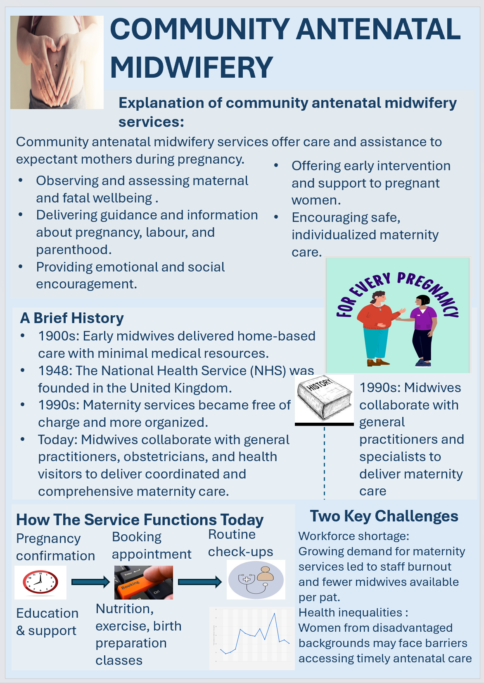

Task 2

The National Health Service
The National Health Service (NHS) was officially started on 5 July 1948. It was created after the Second World War when Britain was being rebuilt and there was a strong wish to improve the health and welfare of all citizens (History of Government, 2023). The service was formed because people believed that good healthcare should be available to everyone, not only to those who could pay for it.
The main ideas behind the NHS came from the Beveridge Report (1942). In this report, Sir William Beveridge explained that five main social problems want, Disease, Ignorance, Squalor, and Idleness had to be solved through government help and social insurance for all citizens. Based on these ideas, the Labour government led by Clement Attlee, with Aneurin Bevan as the Minister of Health, created a national system where hospitals, general practitioners, and local health services were joined together (Parliament, 1946).
It was arranged by Bevan that doctors and consultants would work for the new service by being offered fair pay and contracts (Gale, 2017). The NHS Act 1946 set out the main principles of the NHS. it should be for everyone, cover all medical needs, and be free at the time of use, funded through public taxes. These values providing care built on medical according to clinical need rather than financial capacity. (DHSC, 2023)

Structure and Functioning
Over time, the NHS has been changed and reorganised many times. During the 1990s, the internal market system was introduced to separate those who buy health services from those who provide them in order to increase efficiency (Department of Health, 1989). A major change also took place with the Health and Social Care Act 2012, which established NHS England and created Clinical Commissioning Groups managed by general practitioners (Legislation.gov.uk, 2012). Some responsibilities for public health were transferred to local authorities, and more competition between providers was encouraged (Gadsby, 2017).
In recent years, the focus has moved from competition to teamwork and partnership. The Health and Care Act 2022 brought in Integrated Care Systems across England. Each ICS includes an Integrated Care Board, which directs local budgets and services, working jointly with an Integrated Care Partnership, which plans how health and wellbeing can be improved with help from local councils (Kings Fund, 2022).
At present, the NHS in England is organised in different levels. The Department of Health and Social Care makes national health policy, while NHS England manages planning, budgets, and service delivery (NHS England, 2024). NHS Trusts and Foundation Trusts provide hospital and community services, and primary care is mostly delivered by independent contractors. The Care Quality Commission checks service quality, and the National Institute for Health and Care Excellence produces clinical support based on evidence (CQC, 2024).
A Long Term Workforce Plan was introduced in 2023 to train more doctors, nurses, and allied professionals (NHS Employers, 2023). The NHS Long-Term Plan (2019) focuses on prevention, digital innovation, and providing care closer to home (NHS, 2019). Despite these reforms, the NHS still faces long waiting lists and staff shortages (Health Foundation, 2025).

Critical Discussion
The NHS is still viewed as one of the greatest public achievements in British history. Its universal access and public funding continue to protect fairness and equality (GOV.UK, 2023). However, serious challenges have been reported. High demand, financial limits, and a lack of staff have caused longer waiting times and pressure on hospitals. Repeated changes in structure have sometimes created confusion and reduced accountability between national and local organisations (Kings Fund, 2022).
Although Integrated Care Systems are helping services to work together, progress has been slow because of funding gaps and workforce pressures. For the NHS to remain strong, long-term investment and stable leadership will be required.

CONCLUSION
The NHS was built from the vision of a fair society after World War II and continues to reflect the same principles of equal access, comprehensive care, and free treatment. Yet, to protect its future, the organisation must adjust to population growth, new technology, and rising costs while keeping its founding values alive.

Reference
- BMA (2025) NHS performance data overview 2025. London: British Medical Association. Care Quality Commission (CQC) (2024) About us. Available at: https://www.cqc.org.uk/about-us (Accessed: 3 November 2025).
- Care Quality Commission (CQC) (2025) State of Care 2024/25. London: CQC.Department of Health (1989) Working for Patients. London: HMSO.
- Department of Health and Social Care (DHSC) (2023) The NHS Constitution for England. London: DHSC. Gadsby, E. (2017) ‘Commissioning for health improvement following the 2012 Act’, BMC Public Health, 17, pp. 1–10.
- Gale, A. (2017) ‘Negotiating the creation of the NHS’, AMA Journal of Ethics, 19(9), pp. 893–897. GOV.UK (2023) The NHS Constitution for England. Available at: https://www.gov.uk/government/publications/the-nhs-constitution-for-england. (Accessed: 3 November 2025).
- NHS (2019) The NHS Long Term Plan. London: NHS England. NHS Employers (2023) NHS Long Term Workforce Plan: what employers need to know. London: NHS Employers.
- NICE (n.d.) What NICE does. Available at: https://www.nice.org.uk/what-nice-does (Accessed: 3 November 2025).
- Parliament (1946) National Health Service Act 1946. London: HMSO. UK Parliament (n.d.) Beveridge Report (1942). Available at: https://www.parliament.uk/ (Accessed: 3 November 2025).

