
University of Wales Trinity Saint David
Workplace Culture & Its Impact on Organisation Efficiency.


Paula Louise Canning - 2026605

Birmingham Campus BMSW – 5105

Khaza Ahmed

19/10/2022

CONTENTS.

Introduction P - 2
Just eats’ Structure P - 3
Summery P - 4
PESTEL Report P - 8
Five Porter Forces P - 11
Conclusion P - 14
References P - 5



INTRODUCTION.

Just eat is a is a global company online food delivery company. Of Tens of millions of customers, and with 25,000 local restaurants throughout their website and apps. They are known as a well-known marketplace that offer a food delivery service in 23 countries.
The company was founded within a separate company in 2001, in Kolding Denmark, which they had headquarters in London from 2006 until then emerging in 2020, and just eat is known to be the most successful food delivery organisation. Both companies were started by two entrepreneurs who grew their business’s to be the number one food delivery in their own home. Today just eat is the leading online food delivery outside China, but they said they haven’t stopped there as they want to be largest food company on the planet.
Within this report I will be researching and identifying the organisation’s chart and how this chart works well for their hierarchy.
I will be using the SWOT & PESTLE model to see if these model’s work’s for Just eat as an organisation.
How they also evaluate key elements of an ethnical culture/element.
Also, how I am going to incorporate my own recommendations and what I would change within the report.
Finally, a conclusion what key points I will be concentrating on the whole report.

Just eat structure

“You can order with just eat on your phone, your tablet, laptop, or computer. Once you are logged on the App or website, you just enter your postcode, pick a place to make an order from and pick whatever your heart desire, it is as easy as that.”

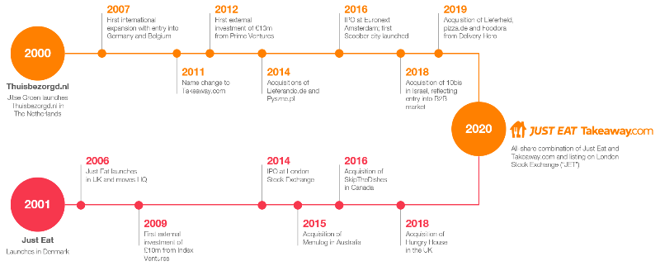

SUMMERY

This is a quick summery upon how just eat work within their structure and how it works well for them and has continued for many years, and I guess many more for the future
Just Eat acts upon an independent takeaway food outlets and customers. There service operates under its brand name in seven countries. The platform enables customers to search for their local takeaways and restaurants, place an order pay online to either pick up and collect or with delivery options at a cost. Just eat utilize a hybrid model, meaning some of its restaurant partners utilize their own delivery fleet, while with others, working together with independent contractors to fulfil orders. After the couriers are paid a pre-order fee on top of the tips thy receive. (Maydan, Nicotera,2003)
When a customer orders from their local or favourite takeaway through just eat, they are ordering through Just eat, this means that the restaurant will have minimum or any contact with their customers.
Just eat are so successful in what they are doing the model was so highly successful it took 10-15 percent commission for every order made, without any meaningful overhead. In the past few years due a little pressure from Uber eats (main competition) and Deliveroo they too have started up their own delivery service.
Working closely with their restaurants partners Just eat aim to deliver best take away services to each of their customers. Therefore, their order includes a service charge. Thy use this to make sure that the experience with just eat is the best service, they also use the website and apps so just eat can maintain a professional service.
The service is charged upon the amount the order value is. It works out to be around 5% of the order value, with only a minimum charge of 50p. and the maximum would be a charge of £1.99. (Edmondson,2014).

Just Eat Work Culture.

Life at Just eat means that there is always something new for everybody, always working on something new so it keeps them one step ahead of other rivalries so that they are looking for opportunities to make an impact. Just eat reports that I have researched stating that for their people they are consistently powering just eat employees to support each other using their eco- systems that empowers them and enables them to feel and perform at their best capability.
Just eat states that there is no one path wellbeing in their structure they are all on their own journey, meaning that we all need different things at different times. At just eat they provide a range of support that meets all their individual needs of all their employees and customers. (Altaf,2011)
Just eat also have their own mental health first aiders, there global community of mental health aiders support their mission to help create a safer environment, by being able to support and let others speak up about their struggles, there wellbeing, in an open and positive way.
“I really; like that the fact that we are building something from scratch and seeing my work come to life. Aside from the professional challenges, there is a family atmosphere here. Work is important here but there’s balance. I never give up spending my son. And everyone respects that.” (Doron Segal Lefkowitz senior front-end developer, from just eat). (Doron,2017)



Just eats organisation culture represents the specific defined policies that guide the employees and gives them a sense of direction. This is a complex system that shares beliefs and compromises values, this helps govern the employee’s behaviour in the organisation. These beliefs contribute to the unique and social environment.
The vision of just eats brief is that it is to the point, they have no dialogues to deliver their opinion to the public and their stakeholders. Just eat communicate the future with their stakeholders of their business to build and understand business strategy.
There are three levels of organizational culture – If organisational culture is presented in the form of a circle, it will have three layers. The outermost will be artifacts, middle will be the values and the beliefs, and the inner would be the underlying assumptions (Christiansen,2017)
ARTIFACTS –
Form the outermost layer of the organisation culture circle. These are the most tangible and the most visible aspects of just eats organisation culture. These can be some examples like, open door policy, office layout, and dress code for the employees. These artifacts are easily observable by the outside world, however, are hard to interpret.
VALUES –
Core values are not necessary easily observed, the just eat core values are shared goals, principles, and standards. The core goals are diversity, quality, passion, and leadership. Just eat management understand the importance of communicating with the core values so their employees can accept behaviour accordingly.
ASSUMPTIONS –
Assumptions are deeply embedded to provide a foundation to the just eat organisation culture. Employees usually remain unaware of the underlying assumptions, but they still play an important role of core values to behaviour.

It is so important for just et to understand the organizational culture today, because in this competitive environment, organizational culture plays an important role, with gaining the competitive advantage. The organizational culture of just eat make sure that they share all common purpose, so they are aligned with an organizational purpose. The explicit of behaviours and goals are deeply planted into just eats employees put efforts in the right direction this enable to give the organisation a strong commitment. (Denison,1991)
The main reasons an organisation for understanding organizational culture is.
- It acts as a strategic tool for understanding willingness to change,
- It shows how employees can relate to just eats work culture,
- Helps identify gaps between actual and desired work culture.

Just eats organizational culture use the Hofstede model, which is proposed by the seminal importance as it analyses the organisational culture of the company. The model has six dimensions as listed below:

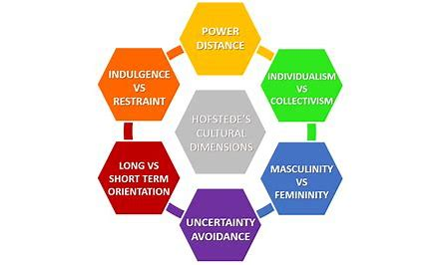
Businesstoyou.com
Hofstede Six Dimensions.

- Oriented versus goals
- Easy going work discipline- and the strict work discipline
- Local professional organizational culture
- Open systems versus closed systems
- Internal driven versus external driven
- Employee versus work orientation

The overall analysis suggest that individual culture dimensions also interact with each other, for example just eat tends to balance its means orientation and goal orientational, which is an internally driven dimension These emphasise ethics and integrity towards one dimension (internally driven culture). (Lanier,2013)

HOFSTEDE CULTUER & MODEL - STRENGTHS.
Just eat organisation culture analysed in light with Hofstede model has certain limits that must be considered whilst applying this model to understand the culture of any organizational:
- It is broad and complex, cannot be assessed based on a few dimensions,
- The close end survey responses may not be detailed about a company’s culture
- May share loose relevancy to a changed company
- Despite changes the cultural model still applied to analyse for the model to be used for any research design to identify dimensions, believed to have a high accuracy of the researchers who have applied the model. And the model is simple to use and understand which makes it easier for the organizational culture and the public. (Hofstede,2019)

CONCLUSION – ORGANIZATIONAL CULTURE
Just eat organisational culture shows that the successful businesses don’t adopt the extreme cultural organisation, but they are willing to find the right one to develop effectively and create a strong organizational culture that is widely accepted in a highly divisible workforce. When a business successfully creates the structure and culture the business strategies understand the complex understanding the value or the core values and observable behaviours, it can use the organizations positions to work strong with culture and secure their position. (G, Hofstede,2019)



PESTEL

PESTEL analysis is a strong tool that analyse the macro environment, of an organisation. Pestel stands for Political, Economic, Social, Technological, Environment, and Legal. The environment and legal factors that impact the microenvironment of just eat.
Any changes in the macro- environment factors can have a direct impact on just eat and other companies that are in the retail. That effect Porters Five Forces, there strategy and competitive landscapes. They can make an impact from individual firms’ competitive advantage overall profitability levels of the consumer industries.
PESTEL analysis provides the greatest detail about operating challenges for just eat and can face in macro environment, other than other forces. Just eat industry may be highly profitable with strong growth but it won’t be good for just eat if it an unstable political environment. (Caberera,2001).


Activewebgroup.com
Political Factors
Political factors play such a significant role in just eat long term profitability in the market or certain countries, political environments, and a political system risk. To achieve success in such a diversity across various countries is possible risks to political environments Just eat keep a close eye on analysing the following factors before investing in a certain market

- Political stability/ Retail sector in countries economy
- Risks of Military invasion
- Corruption
- Legal framework
- Anti- trust laws
- Taxation
- Wage legalisation
- Work week regulations

Economic Factors

Economic Factors can be anything like - Inflation rates, saving rates, foreign exchange, the economic cycle that can demand aggerate investment. Whilst the macro environment factors are things such as competition, competitive advantage of a firm. Just eat use the country’s economic factor for growth rate, inflation, industry, all for growth rate.
- Exchange rates
- Raise capital in local markets
- Skill level of workforce
- Economic growth rate
- Unemployment rate
- Inflation rate
- Interest rate

Social Factors

Social factors that make an impact on just eat, is the culture of an organization in an environment share with beliefs and attitudes they play a huge role in how just eat understand the customers and their market for a retail industry consumer. The social analyse or PESTEL are,

- Demographic skills and level of the population
- Structure in the power society
- Education level as a standard in the just eat industry
- Culture (gender roles, social conventions etc.)
- Attitudes
- Leisure interests – Hobbies

Technological Factors

Technology can be fast and disrupting the various industries across the board. Over the past years the industry has been transforming fast, not even giving us chance to keep up with changes. The taxi industry is catching up with us using Uber, and the car industry is moving forward with google and Tesla which have started an electric car revolution. A firm should not only do technology analysis but also with the speed of technology that is withing that industry. Technology analysis understands the impact of the following.

- Recent technology developments by just eat competitors
- Technology impact on product offering
- Impact on costs and structure
- Impact on the value chain, in consumer service sector
- Rate of technology - price

Environmental Factors

Different markets have different environmental standards, which is an impact with profitability of an organisation in their markets. Different countries have different environmental laws and liability laws. Before entering a new market or starting a new business the firm should be aware of exciting markets and should be very careful to evaluate the environmental standards that are required for that state/ country, some of the factors considered beforehand followed below.(Keyton,2011)

- Climate change
- Weather
- Air and water pollution
- Recycling
- Waste management
- Attitudes towards “Green” or ecological products
- Endangered species

Legal Factors

In many counties the legal framework and institutions are not robust enough to protect the rights of an organisation. A firm should carefully do their research before entering such markets, as this can lead to theft, over a competitive edge. Some of the just eat leadership should consider while entering a new market as followed. (Rollins,1998)

- Anti - trust law
- Discrimination law
- Copy writes / property law
- Employment law
- Health and safety law
- Data protection

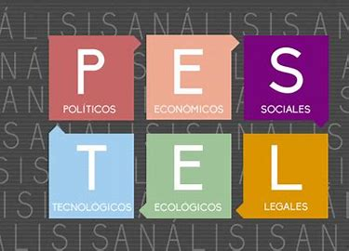

PORTERS FIVE FORCES.

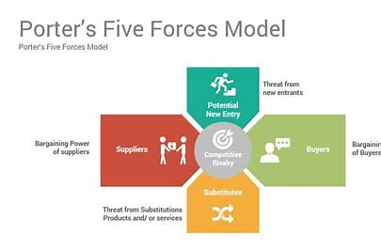
thuphamtien.blogspot.com

What are FIVE PORTERS’ FORCES, & why do Just Eat use this model.

Five Porters Forces Model is a shape strategy whom Michael Porter created the five forces, that impact on an organisation’s profitability in its industry. These five forces analysis in today’s business world which is known as the Porters Five Forces are –
- Threat - new entrants
- Bargaining power of suppliers
- Bargaining power buyers
- Treat from substitute products
- Rivalry among existing players
Five porter’s framework is a holistic framework from just analysing the present competition, it focuses on how Just eat can build a sustainable competitive advantage in the retail industry. Managers at Just eat can explore the profitable opportunities in the whole sector.
“JUST EAT PORTERS FIVE FORCES ANALYSIS FOR CONSUMER SERVICES INDUSTRY”

Threats Of New Entrants
New entrants in retail usually bring innovation, they have new ways of doing things and put pressure on Just eat through lowering prices, reducing costs and a new value for the customers. Just eat must manage all these challenges to be able to build an effective competitive edge. This is how Just eat tackle their new Entrants/ Threats –
- By introducing new products, & services. New products bring new customers, but also keeps new customers a reason to buy new products.
- By building the economies this can lower the fixed cost per units.
- Building capacities and spending money on research, and development, new entrants are less likely to enter Just eats industry, and just eat can keep defining their standards regularly. This reduces the window of extraordinary players in the industry.

Bargaining Power of Suppliers.
Just eat most of the time buy their raw materials from numerous suppliers. Suppliers in dominant position and can decrease the margins in Just eat earn in the market. Powerful suppliers in this sector use their negotiating power to higher prices from the firms in the retail field. The higher supplier has a bargaining power is that it lowers the profitability of retail.(Lakkoju,2022).
How Just eat tackle bargaining power of its suppliers –
- Building an efficient supply chain with multiple suppliers in hand.
- By experimenting with different materials, so if one material prices go up, they can shift to another.
- Developing a dedicated supplier whose business mostly depend on Just eat.

Bargaining Power of Buyers.
Buyers usually demand a lot; they usually want to buy the best of products but still want to pay the minimum price. This can put a lot of pressure on Just eat profitability in the long run. The smaller the customer base is of Just eat the higher the bargaining power of customers and their ability to increase discounts and any offers they can offer to their customers new or exciting. (Heskett,2011)
How Just eat tackle their Bargaining power of Buyers –
- Building many customers, this can reduce the power of the buyers and provide an opportunity for the sales and production process.
- By rapidly innovating new products, customers seek discounts on products then can limit the bargaining power of buyers
- New products will also reduce defection of exciting customers to Just eat to its competitors.

Threats of Substitution Products or Services.
When a new product, or service meets a similar customer in a different way, any profitability suffers. The threat of a product or service is high if it offers a unique or different product from the present offerings of the industry.
How Just eat tackle the Treat of Substitute product/services-
- Being service orientated rather than product orientated
- Understanding the core of the customer rather than the customer is buying
- By switching the cost for the customers

Rivalry Among Existing Competitors.
Just eat operate in a very competitive retail industry. This competition can take its toll on the overall long-term profitability of the organization.
How Just eat tackle their Rivalry amongst their competitors
- Building a sustainable differentiation
- A scale that it can compete better
- Collaborating with competitors to increase the market size.

Implications of Porters Five Forces Just eat
By analysing the five competitive forces Just eat can gain a complete picture of what impacts the profit margin of the organization in the retail industry. They can identify any game change early on and are able to act swiftly to respond to exploit emerging opportunity. Understanding porters five forces in detail Just eat managers can shape those forces in their favour. (Schein,2017)

Conclusion.

To sum it up the report on the on just eat explores as a giant online retailer that has taken the world by storm especially in the workplace culture, they constantly show support throughout the company not just as a company but lot of support for all their staff. If any members of staff are struggling with personal life or work life itself there is support on hand for them they can call upon for help and support which not many companies are interested in the health of there staff just wanting them to work, in our work culture nowadays people are having problems with their mental health issues so I was really happy to see that Just eat support all staff through sad times etc. I found their cultural values impeccable, with all support given to those who needs it.
In essence this report shows the emphasis on how just eat look on the internal and external approaches from management to staff and also that their suppliers by using the Porters Five Forces model this keeps just eat in control over suppliers and their competition at all costs on the whole just ate as a company have the right strategy and knowledge behind them as a company strike organisation are able to succeed within an organisation to grow in the future

References

Activebgroup.com
Altaf, A, The impact of organizational culture on organizational effectiveness, (2011) ‌
Anne Maydan Nicotera, Clinkscales, M. J., & Walker, F. R. (2003). Understanding Organization Through Culture and Structure. Routledge.

Businesstoyou.com
Cabrera, A, Cabrera, E.F, & Barajas, S The key role of organisation culture in a multi system (2001)
Christiansen, B, & Chandan, H, D (Eds) Handbook of research of organizational & diversity in modern workplace. (2017)
Denison, D, R ; & Spreitzer, G.M culture & organisational development
Doran, (2017)
‌Heskett, J. (2011). The culture cycle : how to shape the unseen force that transforms performance. Upper Saddle River, N.J.: Pearson Education.

Hofestede,G, Hofstede, G.J & MINKOV, Sturcucture of the mind. New York Mcgrow. Hill (2019)

Hofstede, Insights organisational cukture (2019)

‌Keyton, J. (2004). Communication and organizational culture : a key to understanding work experiences. Thousand Oaks, Calif. ; London: Sage.
‌
Lakkoju, S. (2022). Does Changing Workplace Culture Accelerate Work-Family Conflicts?! SSRN Electronic Journal. doi:10.2139/ssrn.4085905

Lanier, C, J, & Kirtchner, M Cultural recepity ; predicting consumption in the international beverage market, Global Journal of business research

Rollins, T. and Roberts, D. (1998). Work culture, organizational performance, and business success : measurement and management. Westport, Conn.: Quorum Books.
‌Lakkoju, S. (2022). Does Changing Workplace Culture Accelerate Work-Family Conflicts?! SSRN Electronic Journal. doi:10.2139/ssrn.4085905.
‌Schein, E.H. and Schein, P. (2017). Organizational Culture and Leadership. 5th ed. Hoboken, New Jersey Wiley.
S Chris Edmonds and Blanchard, K.H. (2014). The culture engine : a framework for driving results, inspiring your employees, and transforming your workplace. Hoboken, New Jersey: Wiley.

