

[1]

University of Wales Trinity Saint David

Installing and Managing Virtual Networked Systems

Computer Systems (M4X01500)

Richard Warwick (1809026)
Rizwan Chishti (1806547)

01.01.2019

Contents

Computer Systems (M4X01500) Title Page 1
Introduction 3
Building the machines 4
Physical address extension 6
Installing windows 8
Server Roles 10
Domain Set up 11
Active Directory 12
Local Area connection 13
Machines connected to the domain 16
Observational tasks 17
Type 2 Hypervisors 17
main roles and responsibilities of an Active Directory Domain Controller 18
What to do if a domain becomes unavailable 18
Bibliography 19

Introduction

For our Computer systems assignment myself Richard Warwick and Rizwan Chishti were given a task to create four virtual machines in Oracle VirtualBox. Following the task sheet set out for us we first created one server and one client. We then cloned each machine to have the four machines we needed to complete the task. Two Servers running Windows Server 2008 R2, two clients running Windows 7. We installed the operating systems using an ISO image on the hard drive. The task then had us manually assign IP addresses to each PC. We then used the PC console command line to use associated network commands in order to verify the correctness of the IP address configuration. We followed the task and set up server 1 as a primary domain controller and DNS. After using client1 to join the domain that we created a DHCP server on our DNS and reconfigured client1 and client2 to automatically acquire their IP addresses automatically from the server. We used the Windows Snipping Tool, and a camera phone to record screen shots to demonstrate the configurations and the network are working correctly.

Building the machines

The process of us creating server_1 and client_1.

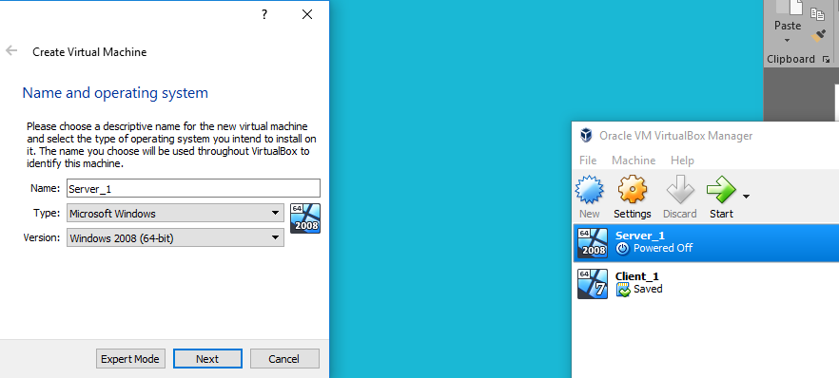

We allocated each machine with 4000mb of memory (RAM)
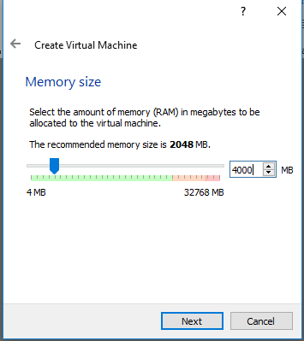

Each machine had a virtual memory (HDD) of 20 GB
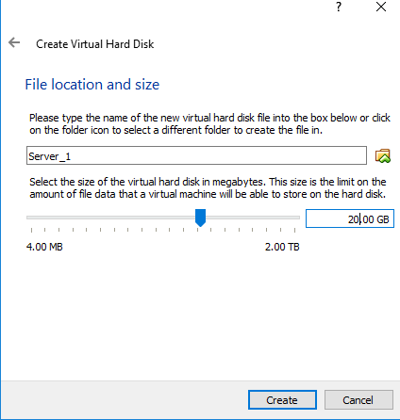

Physical address extension

In the Screenshot below, we enabled an extended feature of Oracle VM. We ticked the box to enable Physical Address Extension. If supported by the OS, This allows even average CPU units to access more than 4GB of RAM.

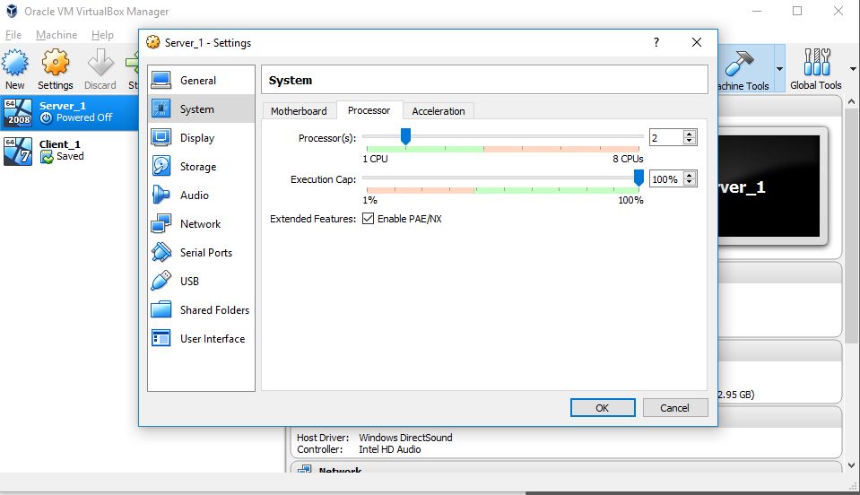

Installing windows

Our next step was to download the ISO image and store it on Server 1 to install windows server 2008 R2. We can then start up windows.
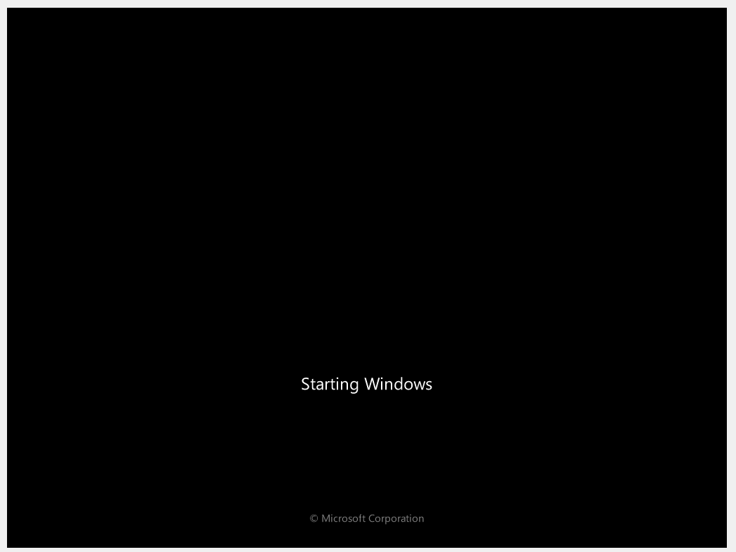
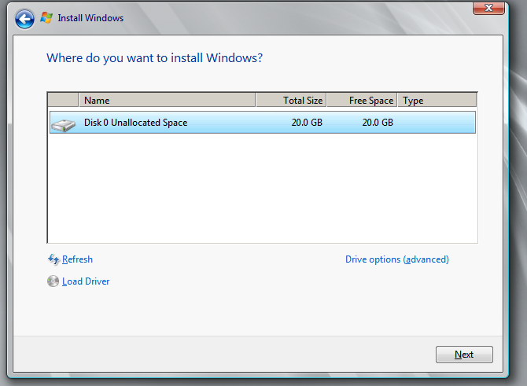
We installed windows on the 20GB disk that we created in the steps above.

Here is the OS for server 1 up and running. Once installed Windows server started automatically, we set up an admin account so that I/o of the server can now be configured. We installed the OS using an ISO image. We did this for Server 1 and Client 1.

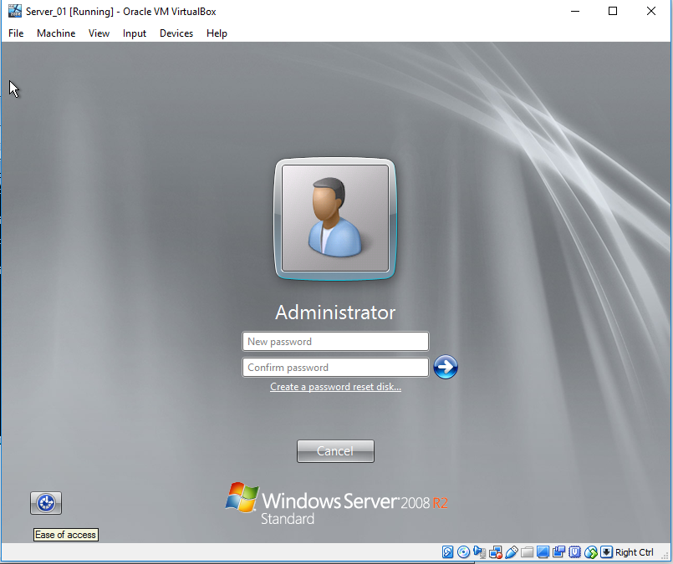

Server Roles

In the screenshot below we added Server roles using the add roles wizard from the control panel.
With the active domain services and the DNS server installed. Our server now has the ability to give IP addresses to client machines.

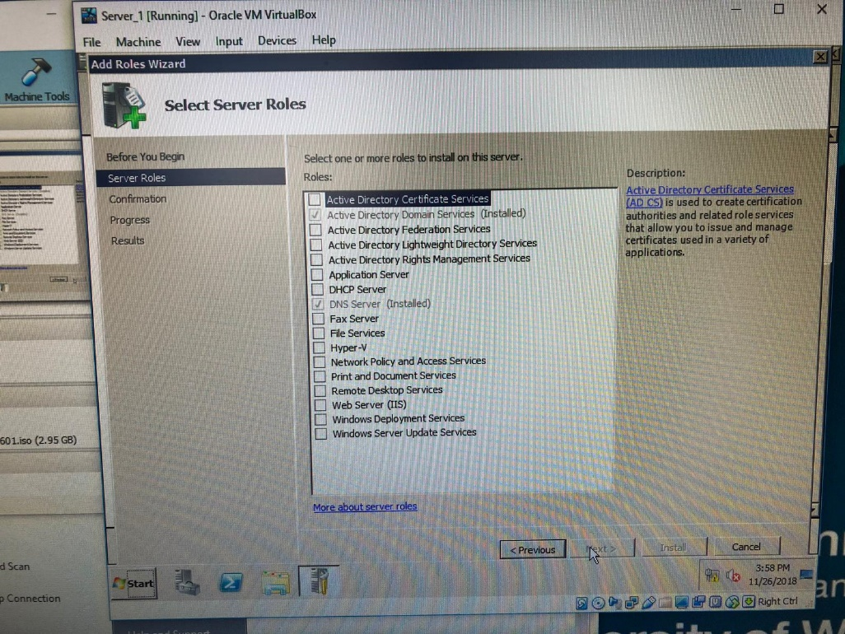

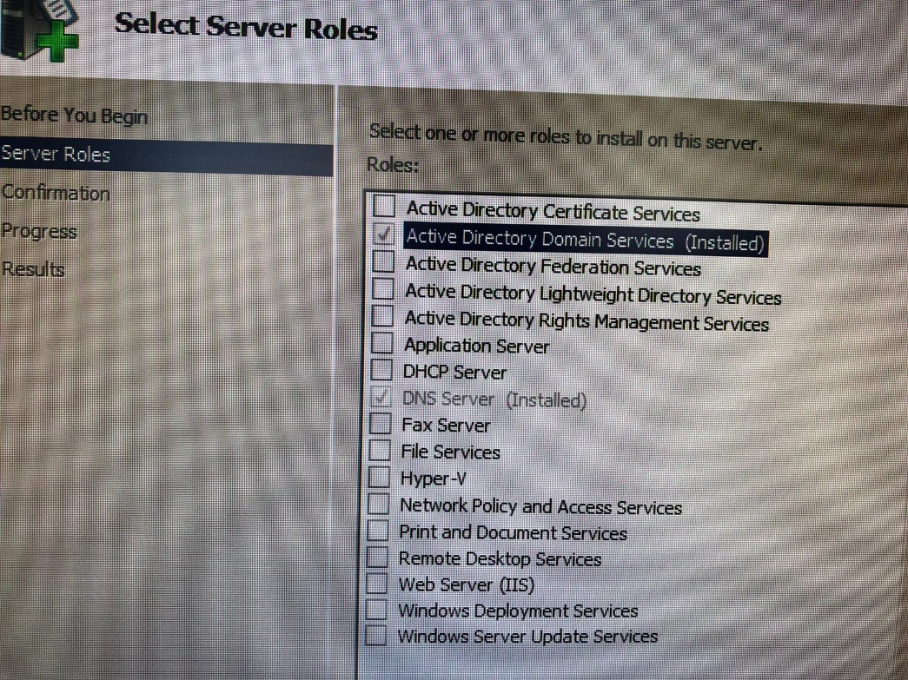
In the picture below we set up the root forest domain.

Domain Set up

In the image below our Active Directory Domain was being verified
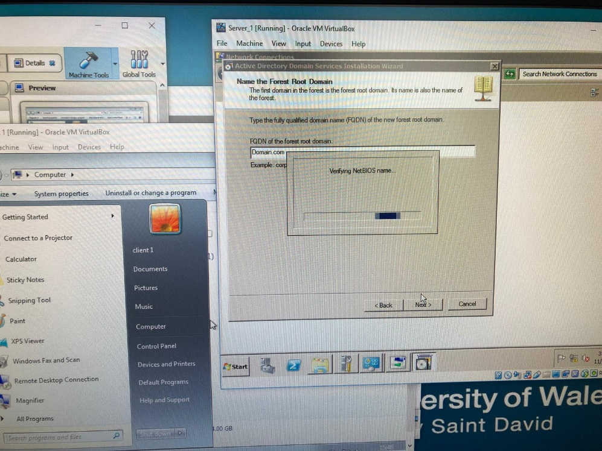
Active domain services are now installed the next step is to restart the machine
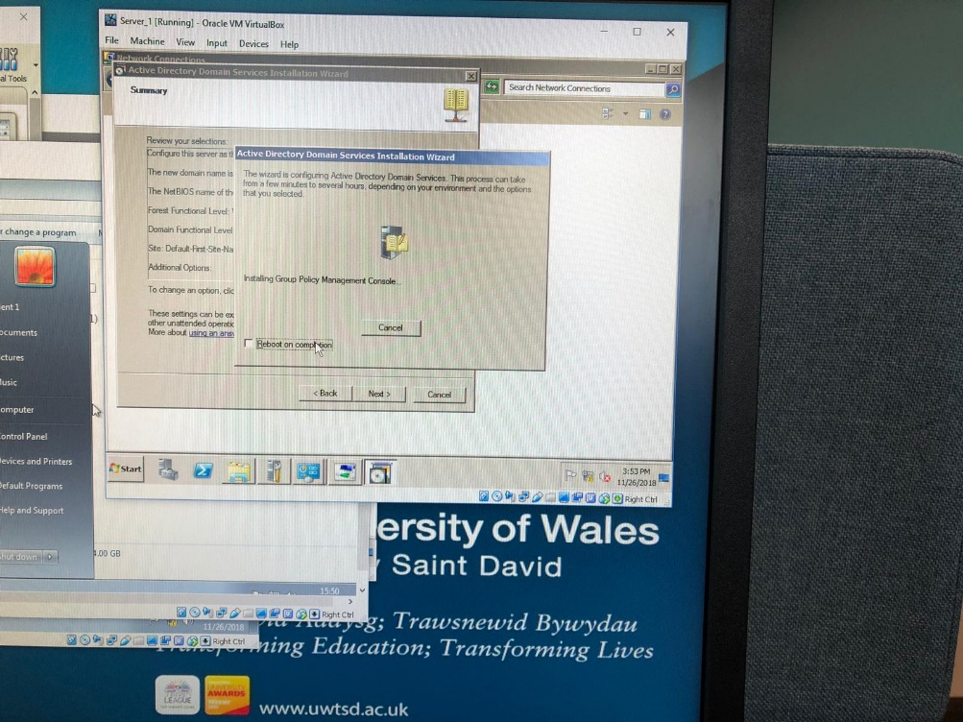

Active Directory

With the Active Directory in place DNS is activated, so we don’t have to configure a child domain controller.
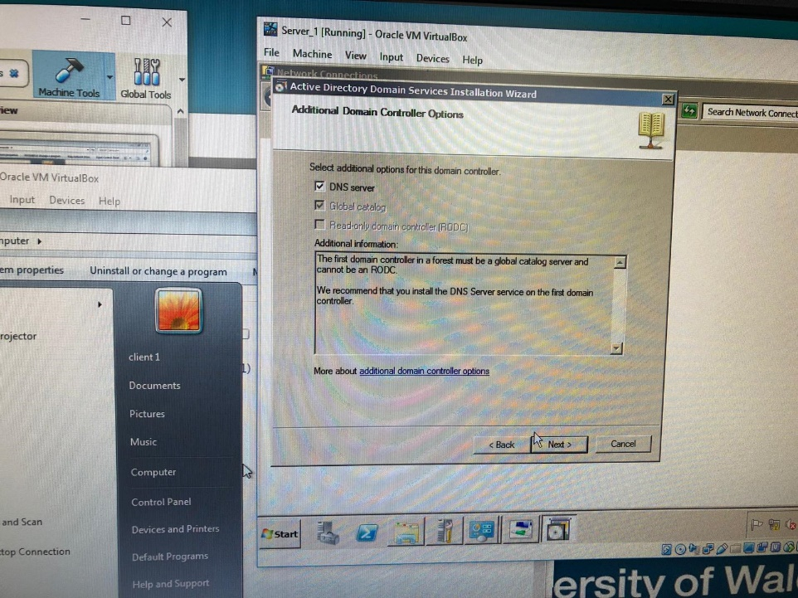

Local Area connection

Our next step is to configure the network and set up a local area connection. The first image shows us configuring the IP address, The second image shows that we are connected
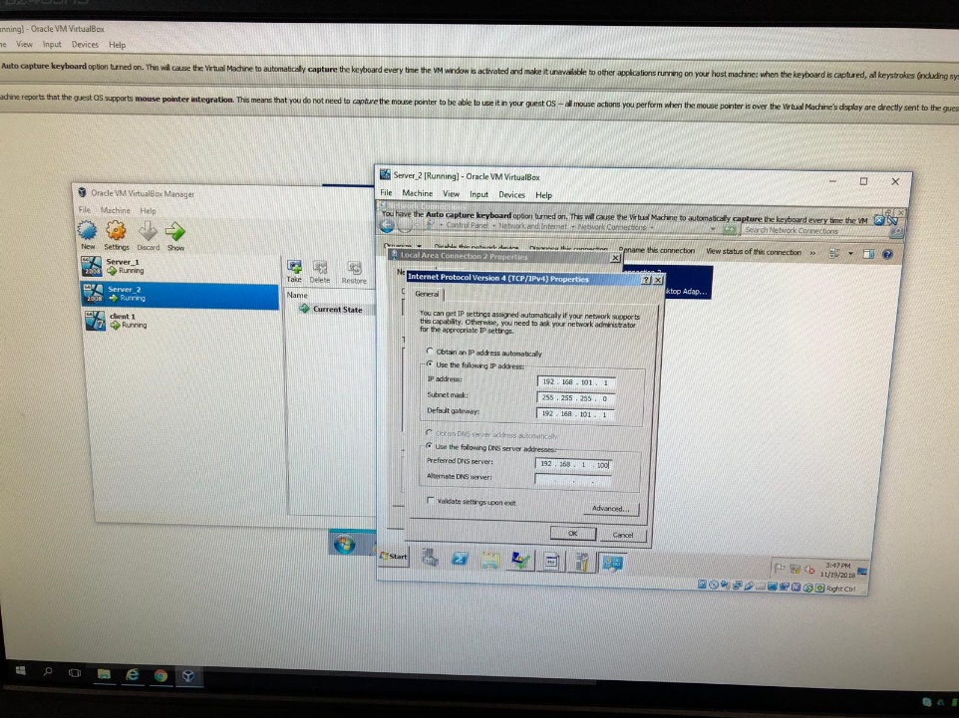

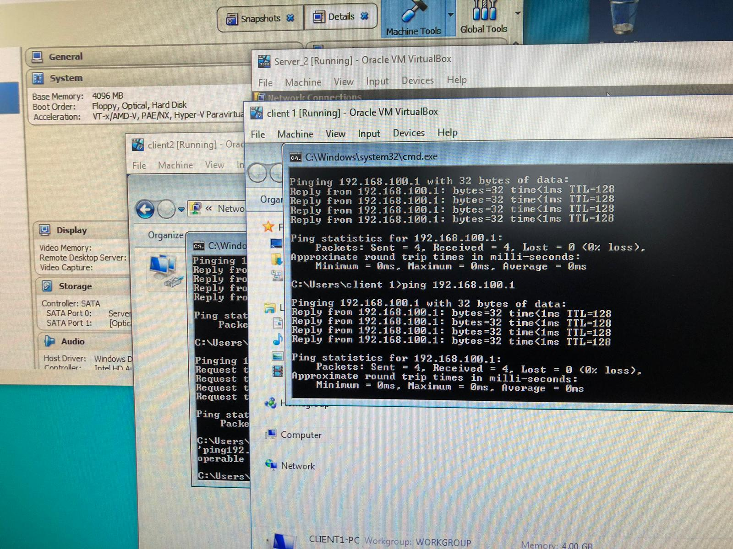

This image shows that server 2 could successfully connect to client 1. In the background, you can see that we now have a connection to client 2. At this point all machines are connected

Now that Server 1 and 2 are up and running and can connect to client 1. Our next step in the process was to clone client 1 to create client 2. As shown below
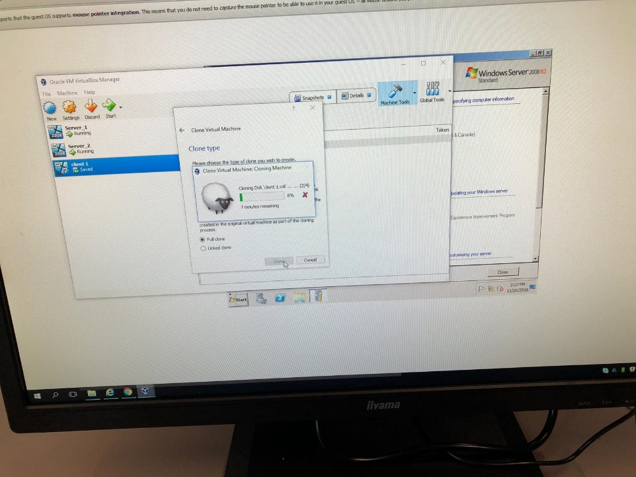

Installing windows 7 on client 2
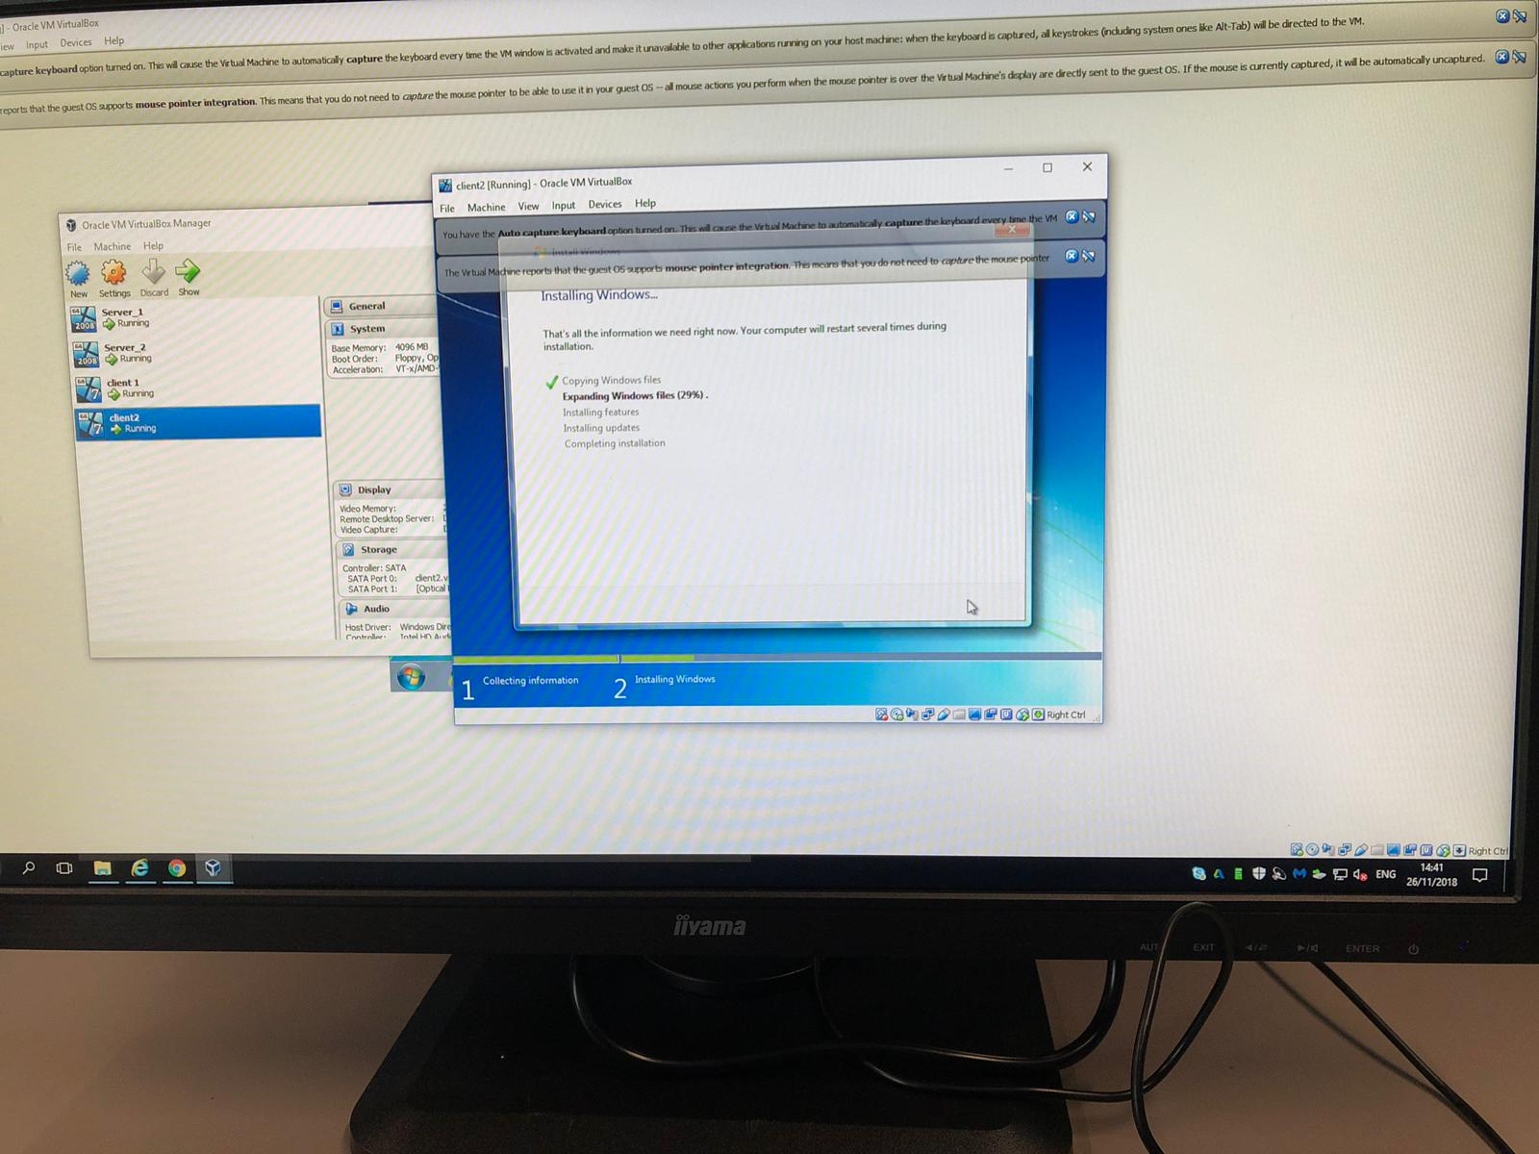

Machines connected to the domain

In the picture below, you can see that all machines are up and running successfully.

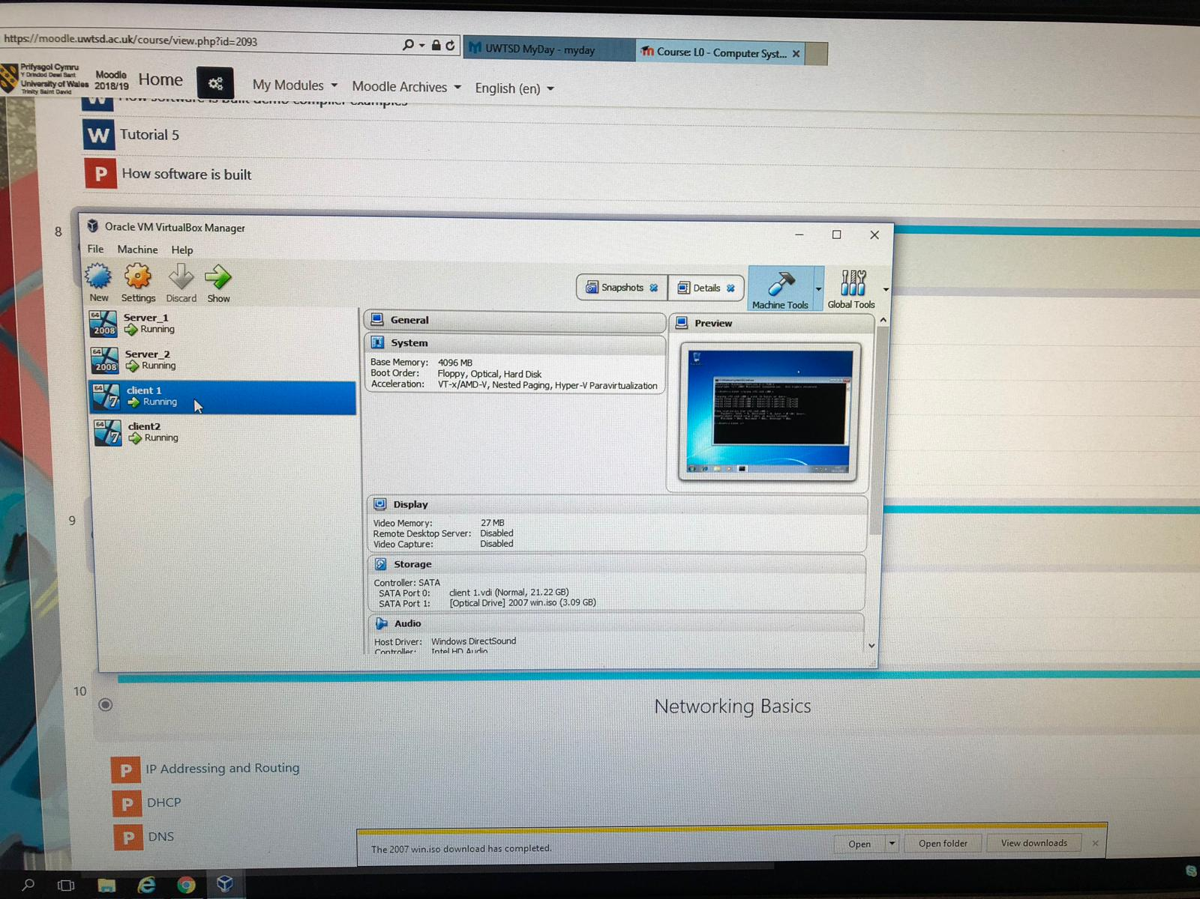

Observational tasks

Type 2 Hypervisors

In order to complete this task, we used Oracle VirtualBox. This is a Type 2 Hypervisor also known as a hosted Hypervisor. This type of hypervisor is installed on to an operating system. The Operating system opens in a window in Oracle Virtualbox and allowed us to interact with the virtual machines and configure network capabilities. For this task we only needed two servers and two clients, so a type 2 hypervisor was perfect because it uses less ram as you don’t need any management software. Virtualbox is also open source so it is free to use. Type 1 hypervisors are expensive and require more memory to operate. When using a type 2 hypervisor we had to bear in mind the amount of memory we were allocating to each server. For example, if we allocated server_1 4GB of ram, it will automatically take those 4GB of ram even if that server is not using it at that moment in time. Whilst using a type 1 hypervisor you can over allocate to each machine and because type one is built into the system it won’t use the memory unless the machines need to use it. This can be a problem when using type 2 hypervisors because you can take away too many resources from the host computer causing it to crash.

Active Directory forest

Active Directory is a process of authorization and authentication. This can be viewed in 3 levels. Forest, Tree and Domain. The Active Directory Forest is the highest level of Active directory (AD). All objects within the directory are organised into Domains, storing the objects for each single domain into a single database. These Domains are allocated a namespace within the Domain Name System (DNS). For example, our parent domain was called Domain.com, So if we were to have a child domain it may be Support.Domain.com. This child domain can also be called a subdomain, The diagram below shows this process.
[2]
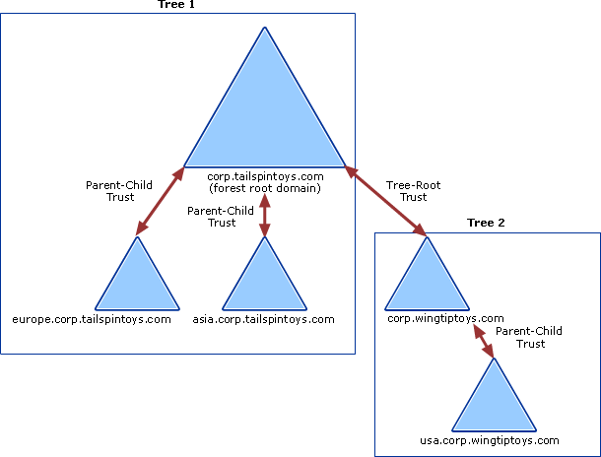

main roles and responsibilities of an Active Directory Domain Controller

The domain controller we created on server_1 automatically assumes the operations master roles in Windows Server 2008 R2. These roles are listed below:

- Schema master (one for each forest)
- PDC Emulator (one per domain) This allows backward compatibility with Windows NT
- Domain naming master (one per forest) records the names of each object within a forest and makes sure they each have a unique individual name.
- Infrastructure master (one per domain) maintains a list of deleted child objects and tracks each object within a domain
- Relative identifier (RID) master (one per domain) tracks assignment of security identifiers within a domain

What to do if a domain becomes unavailable

If a Domain controller becomes unavailable, then domain accounts would not function. This would mean we would lose DNS lookup capability. In the event of this happening we would have to go to each individual machine and rebuild the Active Directory.

Bibliography

[1] UWTSD logo Https:/www.UWTSD.ac.uk (Accessed 2019)

[2] Active Directory Diagram . https://docs.microsoft.com/en-us/previous-versions/windows/it-pro/windows-server-2003/cc773178(v=ws.10) Published 2017. (Accessed 2019)

