Digital Skills and Research Methods

STUDENT NAME – IULIAN RENTEA
STUDENT ID – 2123030
WORD COUNT - 2651
Table of Contents
1. Introduction 3
Title of the research 3
The rationale of the research 3
Aim and Objectives 3
2. Literature Review 5
Introduction 5
Various methods and techniques of effective virtual learning 5
Role of time management skills in effective virtual learning 5
Impact of virtual learning on learning experience 6
Conclusion 6
3. Methodology 7
Data collection tools and techniques 7
Sample size 7
Data analysis 7
Ethical consideration 8
3. Data Analysis 9
Primary data analysis 9
Secondary data analysis 14
Conclusion 17
Recommendations 18
References 19
List of Figures
Figure 1 10
Figure 2 11
Figure 3 12
Figure 4 13
Figure 5 14
Figure 6 Virtual learning methods 15
Figure 7 Time Management 16
Figure 8 Virtual learning on student experience 17

1. Introduction

Title of the research
Influence of Virtual Learning Environment (VLE) – Moodle on students’ learning experience at the University of Wales Trinity Saint David London Campus.

The rationale of the research
The research will be executed on the importance and impact of virtual learning on the academic experience of the students. The research will focus on the dynamic learning environment and also on the tools that are being widely used by the students (Yavich, 2017, pp.176-186). After the pandemic, educational institutions as well as students are exploring various types of virtual learning experiences. This method has both negative and positive impacts on the academic life of students. The research will focus on that and evaluate the experiences of the students in the virtual learning environment.

Aim and Objectives
Aim: To understand the role of virtual learning in enhancing the skill of time management of the students.
Objectives
1. To evaluate the various methods and techniques of effective virtual learning.
2. To analyse the role of time management skills in effective virtual learning.
3. To determine the influnece of virtual learning on the learning experience of the students.

2. Literature Review

Introduction
The following section of the research will discuss the virtual learning environment and its effectiveness in enhancing the learning experience of the students. It will also discuss the development of time management skills through the process of virtual learning.

Various methods and techniques of effective virtual learning
According to Yavich, (2017, pp.176-186), Virtual learning is one of the effective learning techniques that is gaining popularity after the Covid-19 outbreak. After the pandemic, the traditional learning process was disrupted and students starts to use various virtual learning tools to continue their education process. The major technique of virtual learning is discussion. Discussion on the subject through the web platform and tracking the flow of conversation among the students help to identify who is listening and who is not. The role-play through the web platform is also helpful. Taking and giving continuous feedback to the students also help to make the experience better.

Role of time management skills in effective virtual learning
According to Ostermeyer, (2019) Time management has an important role in effective virtual learning where the students need to manage their time wisely in attending classes and also make time for their self-study. Students can also listen to their study materials at the time commuting or doing other work. Students need to avoid getting stressed and manage everything with their online courses. Here, time management is the only solution to effectively manage everything. Students need to plan and schedule their tasks effectively to manage their time. Along with that, they need to avoid multitasking and distractions during the time of virtual learning such as surfing social media sites, games and others (Ostermeyer, 2019).

Influnece of virtual learning on learning experience
According to Cellini, (2021) The major impact of virtual learning is students get the opportunity to explore various courses online. Along with that, the students are also getting various career opportunities as they are learning a vast range of things. Students are also getting more efficient in collaborating with their classmates. The time management skills are also getting enhanced through this. Though various types of distractions are hampering their study (Cellini, 2021).

Conclusion
The above section has discussed the different techniques that are being used by virtual students. It has also discussed the effect of virtual learning on the academics of the students. It has also discussed the importance of time management in virtual learning.

3. Methodology

Tools and techniques for collecting data
There are various tools and techniques have been used to collect the data for this research. The primary and secondary data have been collected from effective sources. In order to collect the primary data, the survey link has been shared through email. Moreover, to collect secondary data help of books, journals and the internet has been used. Using the primary data the researcher can include the raw data with the research (Snyder, 2019). On the other hand, by using secondary data the researcher smooths the way of the research, by which the result of the research can reach the aims and objectives.

Sample size
The primary research has been completed with the survey online. The link to the google form has been sent to the 20 members of the University of wales. As per their opinion, the survey report has been made. The questionnaire of this survey has been related to the objectives and aim of the research to get the relevant answers from the participants. The report of the survey has been saved securely to prove its effectiveness. The members of the University of Wales have provided the answers as per their knowledge and experience. The sampling step is not necessary for the qualitative method as that has come with relevant sources.

Data analysis
Through this part, the researcher has got the result of the research. The researcher has chosen qualitative and quantitative methods to analyse the data. In order to analyse the data collected from the survey result, the researcher has used the quantitative method. On the other hand, to analyse the data that has been collected from the secondary resources qualitative method has been used. The link to the survey has been shared with 20 members of the University of Wales and the results have been calculated in the google form. As per their opinion, the pie chart shows the review of the result. This result is sampled by the sampling methods through quantitative methods (Dźwigoł and Dźwigoł-Barosz, 2018). On the other hand, the secondary data has been analysed by the qualitative method.

Ethical consideration
Ethical consideration is another important part of the research. It helps the researcher to maintain the limitations and improvements of the research. The data collected from the research have been protected by the Data Protection Act 2018. The participants of the research were not influenced to participate in the research and they got the right to leave the survey at any time. The participants have provided their own opinion in this research and no one is forced to provide the answer. On the other hand, no one can edit the samples of the research without the permission of the researcher. The researcher has to protect the samples with a valid ID and password (Zangirolami-Raimundo et al., 2018). These all factors have been maintained to do this research and get an effective result.

3. Data Analysis

Primary data analysis
Figure 1
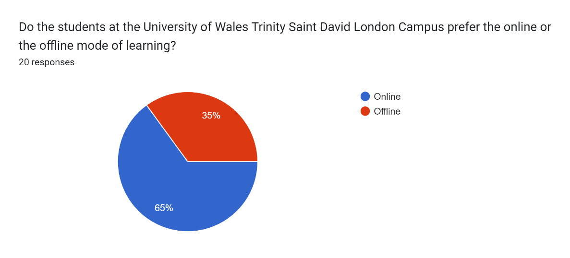
Analysis
The researcher intended to ask the respondents whether they prefer the online or the offline mode of learning at the University. Among the 20 responses, 65% of them responded that they prefer the online mode of learning more than the physical means. Whereas, the remaining 35% have said that they would like to attend classes in the offline mode.

Figure 2
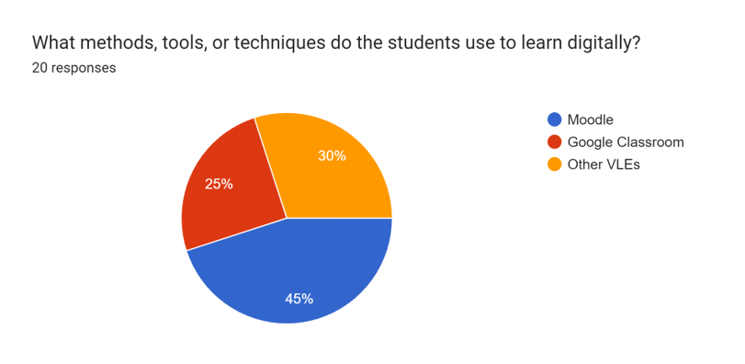
Analysis
The researcher now inquires the students about which Virtual Learning Experience (VLE) they use to learn through online means. 45% of the 20 respondents have said that they use Moodle, the digital tool which comes under VLE. Furthermore, 30% of them responded that they use other digital tools or methods to learn through online means. The remaining 25% have said that they have utilised Google Classroom for the same.

Figure 3
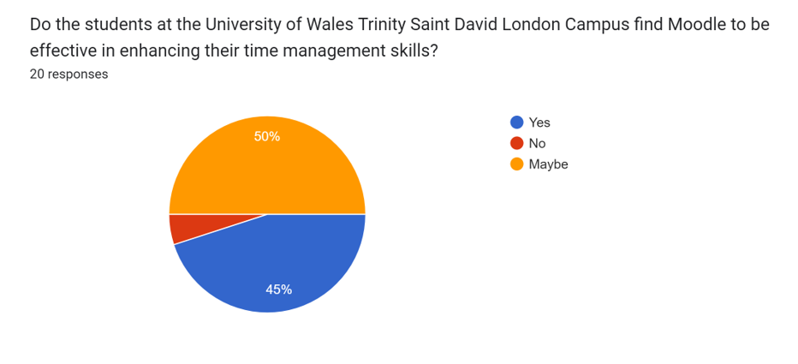
Analysis
The researcher then inquires to evaluate the effectiveness of Moodle in terms of enhancing the students’ time management skills. 45% of the students of the University of Wales Trinity Saint David London Campus have found Moodle to be effective in enhancing their time management skills. Of the remaining 55%, 50% are unsure about the results that Moodle has provided them with. Additionally, 5% of them did not find Moodle to be effective in enhancing their time management skills.

Figure 4
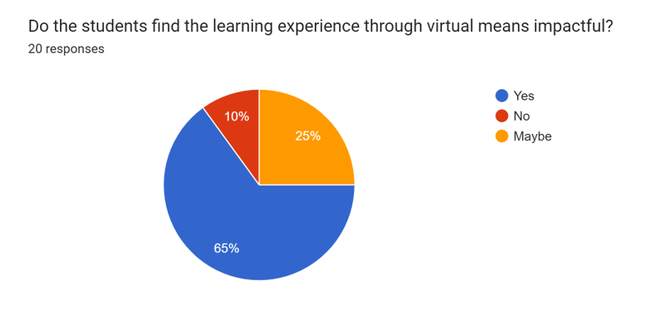
Analysis
The researcher now analyses the impact of the virtual means of learning. Through this question, the overall influence of the virtual learning experience has been inquired about. 65% of the respondents think that it has been impactful for them and that their learning experience has been positively affected. 25% of the respondents are not sure whether there has been a direct impact through the virtual way of learning. 10% of them think that it did not have a direct impact on their learning experience.

Figure 5
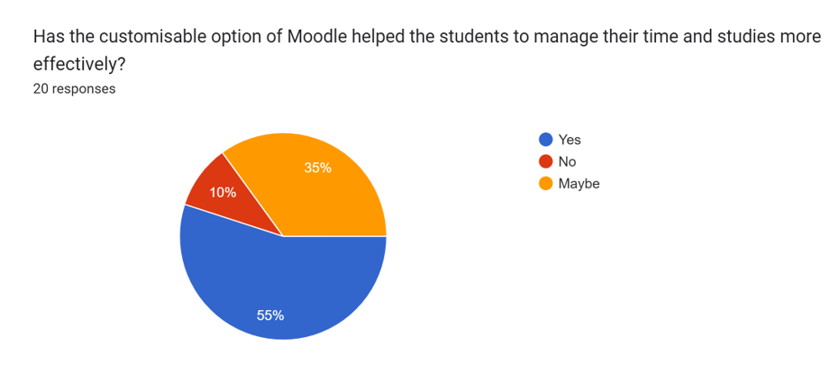
Analysis
The researcher intends to ask what features of Moodle have helped the students to manage their studies and time more adequately. 55% of the respondents think that the customisable option of Moodle has helped them in arranging their work adequately. 35% of them are not sure about the specific feature that helped them. 10% of the respondents did not find the customisable option helpful in managing their time and studies.

Secondary data analysis
Evaluate the various methods and techniques of effective virtual learning
The student of the University of Wales Trinity Saint David London Campus, use various methods to enhance their learning abilities. These days students use several techniques that help them to enhance their online or virtual learning procedure. Presentation is one of the methods that are generally used by students during their online classes. Presentation through students can easily deliver and understand all the necessary information and data (creately, 2022).
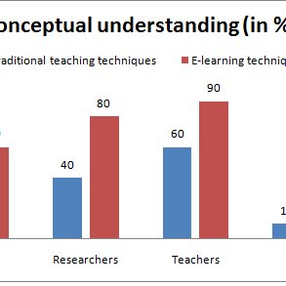
Source: (creately, 2022)
Figure 6 Virtual learning methods
That basically helps them to make their lesson or task more engaging. For that reason, students use various presentation tools, such as Prezi, Microsoft PowerPoint, Google Slides, SlideShare and many others. Moreover, an online whiteboard is also considered another technique that is basically used by students during their virtual learning. This technique through students can communicate with their teachers or lecturers without facing any kind of major difficulties. This technique through students to complete their assignments as well as do mind mapping, also can do their homework and many others. There are several websites through which this data has been collected to understand the virtual process that students use these days (Chen, 2020).
Analyse the role of time management skills in effective virtual learning
This is important for the students that they know the way to use time in an appropriate manner. In the situation of Covid -19 students moved their study method from offline to online. Their time management plays an important role which enhancing the effectiveness of education level. Teachers of the University of Wales Trinity Saint David London Campus provide a proper guideline to their students where they provide their effective work within time through virtual classes (Todorov, 2017).
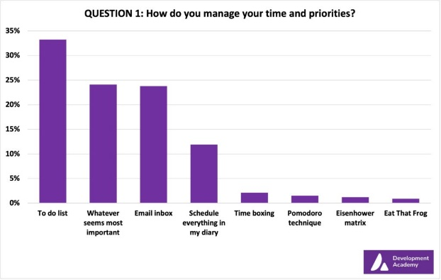
Source: (Todorov, 2017)
Figure 7 Time Management
Along with this, students need to practice their task within time and that basically helps students to provide the effective result to their teachers. There are various articles and journals through time management-related details are gathered to understand its importance (blog, 2019).
Determine the effect of virtual learning on the learning practice of the students
The process of online learning effectively helps students become more independent regarding their tasks. There are various students of the University of Wales Trinity Saint David London Campus who get several opportunities to explore their skills more in the classroom (Elshami, 2021).
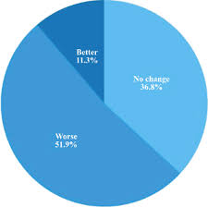
Source: (Zuo, 2021)
Figure 8 Virtual learning on student experience
Not only learning opportunities but from appropriate journals through it can be understood that students gather appropriate confidence that they can easily deal with the larger world. Moreover, articles, books and journals through this assignment have got various data regarding the impact of virtual learning (Zuo, 2021).

Conclusion
The above research report concludes on how the virtual means of learning have changed the dynamics through which students used to learn. The research concludes the outcome of the survey conducted for the primary research. Many students studying at the University of Wales Trinity Saint David London Campus have given their input to this survey. Thus, the combined result of the survey and the secondary research highlights that the impact of Moodle on the learning experience of the students has been positive.

Recommendations
1. It is highly recommended that the students should use the customisable option of Moodle to make the learning experience more effective. If the students studying at the University of Wales Trinity Saint David London Campus will customise their routine according to their routine, it will allow them to save more time and put it into completing more efficient tasks. Additionally, it will also allow them to segregate their tasks according to the deadline they need to submit them (Elshami, 2021).
2. The students are also recommended to attend classes every day and make notes even if they are using the online mood. There are several digital tools that the students can use to take down the important points professors are outlining while teaching. This will ease the process of revising and understanding the topic thoroughly later. Again, the customisable option of Moodle can be utilised to make this possible (Elshami, 2021).

References
blog, (2019). Importance of Time Management for Distance Learning Students. [Online] Available at: https://blog.mitsde.com/importance-of-time-management-for-distance-learning-students/
Cellini, S. R., (2021). How does virtual learning impact students in higher education?. [Online] Available at: https://www.brookings.edu/blog/brown-center-chalkboard/2021/08/13/how-does-virtual-learning-impact-students-in-higher-education/
Chen, C., (2020). Online Teaching Tips & Techniques for the Virtual Classroom. [Online] Available at: https://otter.ai/blog/online-teaching-strategies
creately, (2022). The Ultimate List of Effective Online Teaching Methods. [Online] Available at: https://creately.com/blog/education/online-teaching-methods/
Dźwigoł, H. and Dźwigoł-Barosz, M., (2018). Scientific research methodology in management sciences. Financial and credit activity problems of theory and practice, 2(25), pp.424-437.
Elshami, W., Taha, M.H., Abuzaid, M., Saravanan, C., Al Kawas, S. and Abdalla, M.E., (2021). Satisfaction with online learning in the new normal: perspective of students and faculty at medical and health sciences colleges. Medical Education Online, 26(1), p.1920090.
Ostermeyer, E., (2019). 5 TIME MANAGEMENT TIPS FOR ONLINE LEARNERS. [Online] Available at: https://online.hbs.edu/blog/post/time-management-for-online-students
Snyder, H., (2019). Literature review as a research methodology: An overview and guidelines. Journal of business research, 104, pp.333-339.
Todorov, G., (2017). The Importance Of Time Management In Online Learning. [Online] Available at: https://elearningindustry.com/time-management-in-online-learning-importance
Yavich, R. and Starichenko, B., (2017). Design of Education Methods in a Virtual Environment. Journal of Education and Training Studies, 5(9), pp.176-186.
Zangirolami-Raimundo, J., Echeimberg, J.D.O. and Leone, C., (2018). Research methodology topics: Cross-sectional studies. Journal of Human Growth and Development, 28(3), pp.356-360.
Zuo, M., Ma, Y., Hu, Y. and Luo, H., (2021). K-12 students’ online learning experiences during COVID-19: Lessons from China. Frontiers of Education in China, 16(1), pp.1-30.

Appendix 1
1. Do you prefer the online or the offline mode of learning at the University of Wales Trinity Saint David London Campus?
A. Online
B. Offline
2. What methods and techniques do you use to learn digitally?
A. Moodle
B. Google Classroom
C. Other VLEs
3. Have you found Moodle to be effective in enhancing your time management at the University of Wales Trinity Saint David London Campus?
A. Yes
B. No
C. Maybe
4. Have you found the learning experience through the virtual means impactful?
A. Yes
B. No
C. Maybe

5. Has the customisable option of moodle helped you to manage your time and studies more effectively?
A. Yes
B. No
C. Maybe

Appendix 2

