

Postgraduate/Distance Learning
Assignment coversheet & feedback form

THIS SHEET MUST BE THE FIRST PAGE OF THE ASSIGNMENT YOU ARE SUBMITTING (DO NOT SEND AS A SEPARATE FILE)

For completion by the student:
Student Name: Dhyaneshwar Bowman

Student University Email: 2506423@student.uwtsd.ac.uk
Module code:  HPCA 7014  Module title:  Sacred Geography | Student ID number:  2506423 |  |  | Educational support needs:  Yes (extension)
Assignment title: Is sacred space a human construct or a Natural phenomenon

Assignment due date:
12/1/26
This assignment is for the 1st 2nd 3rd 4th 5th 6th module of the degree
Plagiarism declaration
I confirm that this is my original work and that I have adhered to the University policy on plagiarism.

Artificial Intelligence (AI) declaration
For this assessment, you can use Generative AI to check your own text/creation for grammatical and syntactical mistakes, including rephrasing of your own work within specific standards.*

*See separate guidance in the MA Writing Guidelines

I confirm that I have not used any AI tools in the research and creation of this assignment, except as permitted above. I confirm that I have not presented any AI generated materials as my own work. I confirm I have copies of my drafts, notes, and other resources I used, which I may be asked to provide in evidence.

Signed: Dhyaneshwar Bowman

Assignment Mark
1st Marker’s Provisional mark
2nd Marker’s/Moderator’s provisional mark
External Examiner’s mark (if relevant)
Final Mark

NB. All marks are provisional until confirmed by the Final Examination Board.

For completion by Marker 1 :
Comments:

Marker’s signature: |  |  | Date:
For completion by Marker 2/Moderator:

Comments:

Marker’s Signature: |  | Date:
External Examiner’s comments (if relevant)

External Examiner’s Signature: |  | Date:

Is Sacred space a human Construct or a Natural phenomenon? Discuss this question through a research project with reference to works of at least three theorists.

Mother Ganga, the river, a living Goddess. A real or socially constructed phenomena?
Introduction:
The aim of this research project is to decipher whether the Ganga is sacred due to human conceptualisation or participation, or whether Her sacredness may be viewed as an ontological, natural phenomenon? Or indeed do both elements combine to insight a sort of super sacredness. And how the alarming levels of pollution effect these claims, and whether the ‘Namami Gange’ project will act to restore Her vital elements. I intend to rely heavily on my own 25years of experience with Ganga to contribute to the dialogue. I will also draw on a few theorists; with particular attention paid to Mircea Eliade (1907-1986) a Romanian Theologian who defines the sacred. ‘The sacred reveals absolute reality and at the same time makes orientation possible; hence it founds the world in the sense that it fixes the limits and establishes the order of the world.’ Emile Durkheim, a French sociologist (1858-1917); stated that ‘If among certain peoples the ideas of sacredness, the soul and God are to be explained sociologically, it should be presumed scientifically that, in principle, the same explanation is valid for all the people among whom these same ideas are found with the same essential characteristics.’ I will also bring attention to Beldon Lane, Levy Bruhl (1857-1939) and pay a brief tribute to Edmund Husserl (1859-1938). There is the connotation of an intrinsic and fundamental inherency in Eliade’s understanding of the sacred, compared to the sociological emphasis favoured by Durkheim. Henceforth both sets of criteria, regarding the sacred are covered.
The revealing article named Mother Ganga, states how ‘The Ganga, revered as a goddess in Hinduism, is more than just a river; it is the thread that weaves through India's cultural, spiritual, and ecological fabric. Originating from the lofty Himalayas and flowing over 2,500 kilometres to the Bay of Bengal, the Ganga has inspired mythology, nourished civilization, sustained millions of lives. Its divine journey, enriched by its cultural and social marvels, makes it a symbol of eternal life and purity.’ Already it is fair to acknowledge that the Ganga is admired as sacred, considered Divine and worshipped by a multiple of people worldwide. It is the source of life-giving waters to millions along Her banks and a Great source of inspiration to many millions more.
The Ganga is however heavily polluted (‘The birth of the Ganga Action Plan (GAP) can be linked to public outrage regarding pollution.’). Does this act as a form of violation and create a varying perspective to Her claims of sacredness. One of scepticism and confusion. Former PM Moodi has authorised (back in 2014) the motion of a Massive 3B$ cleanup project, ‘Namami Ganga’ (launched in 2015) is underway. Did this PM answer the calling of Ganga, to sanctify her waters? Or simply act to appease the frustration from the Indian demonstrators or was it the mounting pressure from the international community to restore the already given personhood rights of Ganga. Whatever the actual incentive, full appraisal and solidarity for this well needed stand for justice and the sanctification of Ganga.
The river Ganges stretches across a third of India. Ganga is revered and honoured as a living Goddess by 1Billion Hindu’s (believers of Sanatan Dharma) Worldwide. Which brings substantial weight behind promoting the policies designed to bring Her back to a state of purity and sanctified once more into a Being of tranquillity. So how was this pollution tolerated for so long? Is it now clear that it will not be tolerated or accepted into the future? Is it even feasible to connote purity and sacredness to a River such as Her? The disgusting waste that fills her waters from sewage drainage pipes and waste pipes/cruft pipes, alarmingly constructed by the factories along her banks; the factories around Bihar are among the worse examples of this violation. And the construction of Dams, preventing the natural flow, add to the devastating state that the Ganges is now in. Will this now be stopped? Are the plans finally in place to restore Her natural flow and beauty? Adhering to Her sacredness may act as a motivating factor behind restoring Her grace and sanctification of Her waters. Below, in Fig1: we have a picture taken of Ganga Rishikesh sides. A beautiful reflection of Her natural and inherent sacredness.
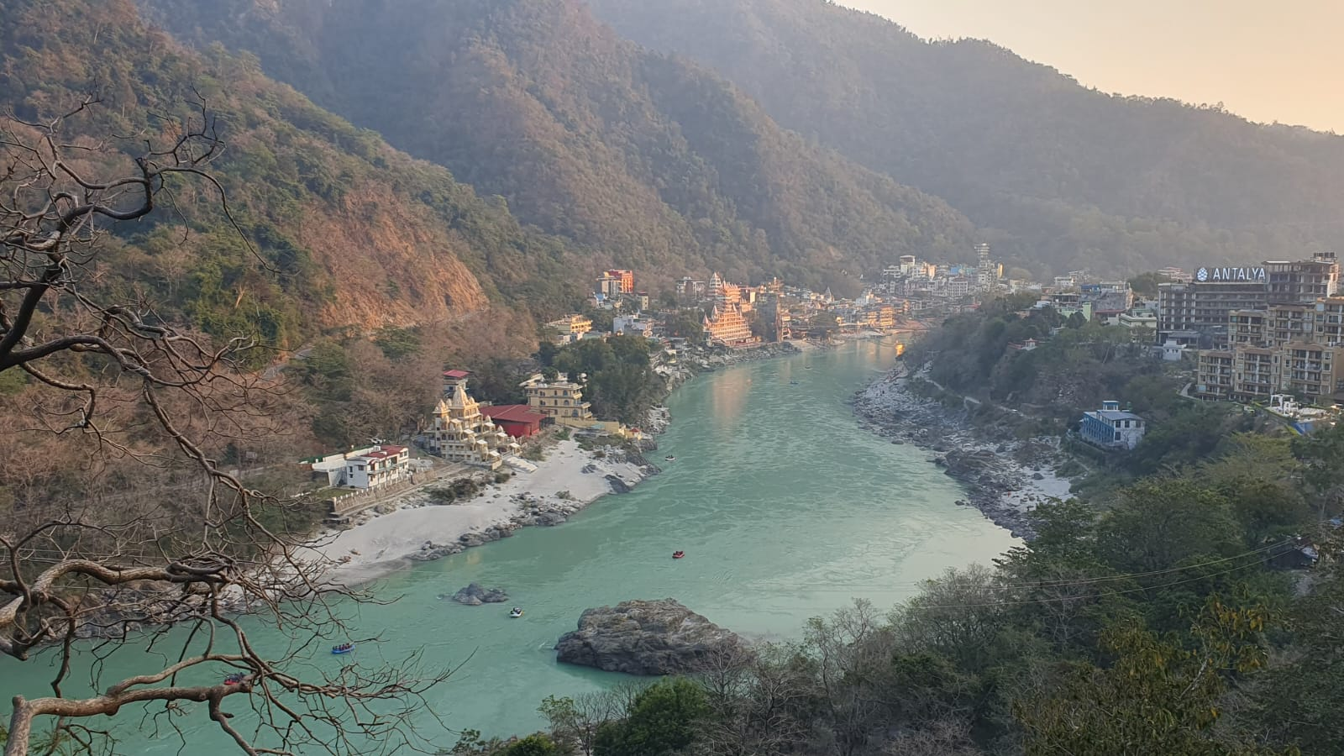 (Fig 1. Photograph: Rishikesh; taken by friend Fiaz Mir, earlier this year 4/25)
Academic Rationale:
I seek to employ Durkheimian concepts of participation and Ritual, and the concept that the location is decreed as sacred and valued as a place holding superior rights and is consequently held in high esteem due to the ‘collective consciousness’. The practise of daily ritual on the banks of the Ganges is unmatched and unique, in sheer magnitude of devotion alone. Do these rituals validate the claims that the Ganga is a living, Goddess? Below in Fig2: there is the standard daily 9pm Ganga Aarti in Kashi.
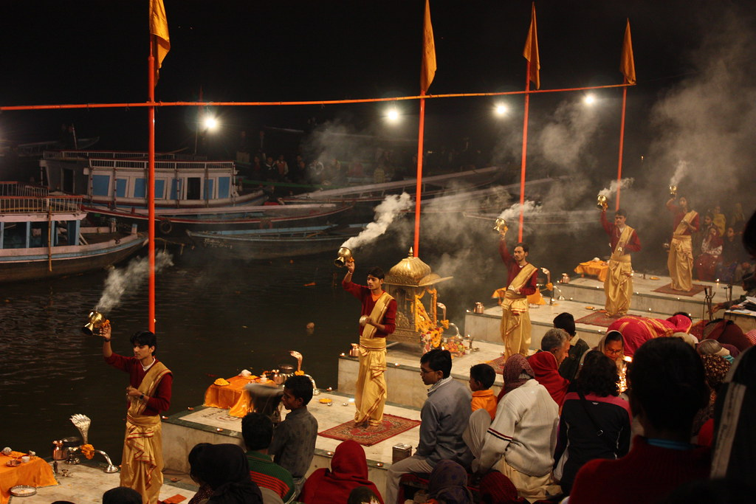
(Fig 2. Kashi: Photo taken from the internet: source CCYYSA)
I also wish to bring in the concept of chaos/complexity theory, through referring to the repetitious nature shown regarding daily ritual activity. This can be contrasted to the ways the waves, currents and stream of Ganga is constant yet with subtle variations to be viewed. May we pose the question, through the basins, or fields of influence are we able to account for the Ganga sacredness and Divinity? The answer is greatly! The extent of ritual activity, and the amount of devotion and homage bring massive weight to the forces which are present at Ganga. I shall bring in a quote from Emile Durkheim, ‘Sensual representations are in a perpetual flux; they come after each other like the waves of a river, and even during the time that they last, they do not remain the same thing. Each of them is an integral part of the precise instant when it takes place. We are never sure of again finding a perception such as we experienced it the first time; for if the thing perceived has not changed, it is we who are no longer the same.’ Therefore, deducing the fact that every experience is unique, and never to be repeated.
When explaining the natural phenomena which is Ganga. It is fitting to refer to Eliade and his concept of the Hierophany; the experience of taking a dip in the Ganga can be likened to the eruption of sacred energy or the awakening to Divinity (the Hierophany). There are also many scriptures which examine the Ganga’s blessed natural state of Divinity.

Methodology:
The Ganga is vast and encapsulates the full journey of human existence. Ranging from the Divine glaciers in the Himalaya where the Ganga gives birth; through the filth and waste of Bihar and Kanpur, continuing to pass Varanasi, the ‘Cosmic City’, where you are assured of liberation from the painful cycle of samsara/reincarnation and receive instant Mukti/liberation if you are cremated on Her banks; the flow of the Ganga continues pass Kolkata, pursuing towards the bay-of Bengal than finally being released into the India Ocean. The use of transcendental phenomenology shall be employed throughout this research project and was inspired by Edmund Husserl (1859-1938, German philosopher and founder of phenomenology) and his variation of epoche and the use of brackets. I shall be employing qualitative methods, drawing on my own phenomenological engagement with Ganga, recorded over a 25year period. I will reflect on these experiences, with regards and reference to theory, and will use them as a means to determine whether the Ganga is inherently sacred. In which aspect is She particularly sacred and in what regards; and whether the pollution and contamination, i.e. the Kanpur (dead river) effect have influence on the claims towards Her Divinity.
I also wish to pose some fundamental questions concerning Ganga. Such as ‘what is this place’, ‘what is drawn to Her’, ‘What is alien to Her’, ‘What is destructive, and what supports Ganga’. To briefly answer these questions, it is feasible to say that Ganga is a Sacred River, a spiritual magnet for millions of pilgrims. She does not differentiate or judge, hence there is nothing alien to Her. She will wash, bath and nourish without discrimination; the destructive elements are the tanneries and dams. And the Bhakta’s (devotee’s) performing ritual activity are what supports Ganga. We may also question ‘what happens in this place’, what is the nature of wholeness, which the different bodies engaged with and what do they contribute to? How does Ganga maintain Herself and what are Her homeostatic qualities’ what are the ethics surrounding Ganga, and for who is She considered sacred’. To answer these, let us mention, a great deal of ritual activity and worship occurs on the banks of Ganga. She is also a cremation ground and there are many ‘burning ghats’ along her banks. Ganga naturally maintains Herself and is fed from the glaciers in the Himalaya; there are plans in place to help clean up the waste contaminating Her waters and restore Her natural flow. The ethics are one of reverence and sanctity. Although this is seemingly contradicted by the amounts of rubbish disposed in Her, without apparent conscious realisation. Finaly, it is feasible to mention that Ganga is sacred to most. Many millions rely directly on Her for her life-giving waters and around the world there must be multiple millions of devotees who value Ganga as a living representation of a Goddess. Those who don't recognise Her sacredness may be trapped by a material evaluation of mind, a limited approach that will focus on Her brown sludgy appearance like waters and disturbing constituencies. Therefore, being in a state of disgust and judgment and failing to tribute to Her the honour of Divine Personhood. Below is Fig3 and the ‘dead river’ of Kanpur.
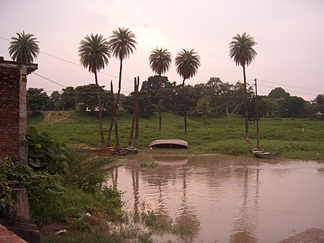
(Fig 3: Kanpur ‘the dead river’: Photo sourced from Internet)

Reflexive considerations:
In the words of Eliade, ‘the waters invariably retain their function, they disintegrate, abolish forms “wash away sins;” they are once purifying and regenerating.’ This is the function of the sacred river, to signify a new life; where all past karma is washed clean and the opportunity to start a fresh life is given birth.
Below there is a video clip of the first dip (maha Sankranti) of the Maha Kumbh Mella 2025, Prayaag, which is a 12yearly celebration taking place on the confluence of the Ganga, Yamuna and invisible (underground) Sarasvati rivers. It is a supremely powerful event; one which I have been fortunate to participate on two separate occasions, firstly in 2007 and again in 2019. There is the clear and apparent notion of Eliade’s hierophany; I distinctly remember being connected by a heavenly cord and spiritually charged and rejuvenated throughout the months spent celebrating this event; the general feeling is that of intense Divine connection. Although with a record number of 400 million pilgrims being attracted to the 2025 144year alignment (of seven planets) celebration of Maha Kumbh Mela, it is impossible to ignore Durkheim and Levy Bruhl’s concept of human participation and ritual activity; as being of equal significance. Therefore, concluding the given question is not so straightforward. As both main theories, either of the Ganga being sacred due to socially constructed efforts or as a natural phenomenon are both proven adamants, with both clarity and precision. Consequently, bringing us to the notion of being able to provide the term which fits most cohesively. The only term that could justify the position of the Ganga can therefore be noted as ‘Super Sacredness.’ A sacredness so profound as to incorporate both elements; socially constructed, and that of sacredness being of a natural phenomenon.
Below, Fig 4: is a short video from the Maha Sankrati (first dip) at this year’s Maha Kumbh Mela.
https://uowtsd-my.sharepoint.com/:v:/g/personal/2506423_student_uwtsd_ac_uk/IQAQndpMBc3TQ5QuV5rU9WyiAXzQ6d6NX6dBAa7Nc2QNlF8?nav=eyJyZWZlcnJhbEluZm8iOnsicmVmZXJyYWxBcHAiOiJPbmVEcml2ZUZvckJ1c2luZXNzIiwicmVmZXJyYWxBcHBQbGF0Zm9ybSI6IldlYiIsInJlZmVycmFsTW9kZSI6InZpZXciLCJyZWZlcnJhbFZpZXciOiJNeUZpbGVzTGlua0NvcHkifX0&e=IumoIf
(Fig 4: Video clip of Maha Kumbh Mela 2025, sourced from Gurudev)

Literature review:
Eliade says ‘The religious experience of the festival- that is, participation in the sacred- enables man periodically to live in the presence of the gods.’, the above clip (Fig 4) from the Maha Kumbh Mela is a perfect example illustrating the poignancy of Eliade’s statement. The very presence of Ganga Ma is enough to bring complete conviction into the reality of the Divine.
Sacred:
There are many ways to experience the sacred. Lucien Levy Bruhl theory of participation may also be considered as one of these paths. ’The human person exists through his sharing in the essence of the group.’ Through one’s participation, more accurately put, it is through one’s intention one can experience the Ganga in a multitude of ways. From the Divine awakening of Eliade’s hierophany, to Rudolf Otto (1869-1937) conception of experiencing the ‘numinous’ (glimpsing something beyond the veil) and ‘tremendum’ (the terrifying aspects, which may act towards the nullification of Ego); Ganga offers the full range of experiences
If one does not participate then, one may not sense any possible sacred elements in the place. This supports Beldon Lanes comment that sacred space can be walked on without being entered. To clarify further, Beldon Lane’s notion of intention; ‘You can tred upon the sacred without entering it.’ This can be read quite early on in Beldon C Lane book Landscapes Of The Sacred (pg. 19); which has proved to be of some relevant reading when approaching these matters. Leading one to ask the question, does everyone experience the same sort of revelation; or for some, is the Ganges too dirty to be truly revered as a Goddess? This of course depends on one’s affiliation and subsequent interpretations. How one is to approach the Ganga depends on how one is connected, and this has dramatic effects on one’s experience.
I have Used Scriptural writings (referring to the Maha-Puranas; Ganga Mahatmya, Ganga Stotra, Devi Bhagavata Purana) supplying me with evidence and description of the Divine nature held by Ganga Ma, the daughter of Brahma.

Experience of Nature Mysticism:
The River Ganga is a place where the natural mystic is revealed and experienced.
I used 2 primary sources/academic documentaries on Ganga.
1. River to Heaven (Berkeley media/ Ariel Production). A documentary regarding Mukti lodge. A free accommodation for people to come to die, surrounded by bhajan (sacred Sanskrit singing) and Holy vibrations; so that they may be cremated on the Ganga at Kashi, and experience liberation from suffering the painful cycle of Samsara, death followed by rebirth and more suffering. Here we have comments depicting Ganga as both being on a metaphysical and spiritual plane, as commented by one of the Mahatmas videoed, and how visiting the Ganga eradicates all trace of evil. To quote Durkheim, ‘he believes that he is saved from evil, under whatever form he may conceive this evil’. This quote seems to capture the essence of what the Mahatma portrayed.
2.India’s effort to clean up Sacred but polluted Ganges River (PBS Newshour- San
Lazaro and Fred de) An academic documentary focused on the contamination of the Ganges. Where through scientific experiments, ‘super bugs’ have been detected. And heavy metals, chemicals and dyes can be traced through the channels of waste passed from the tanneries in the nearby area, depositing waste in the Holy River Ganga. In this documentary it was reported by one of the designated managers of Gange Namami clean-up effort; that people say that “the river remains pure regardless;” and how this attitude poses more problems for the Ganga. Also noted was, political challenges in times of climate change, from the glaciers at the source of Ganga. The documentary was revealing and certainly fuels the fire of confusion and despair. For how it is possible that a river revered as a Goddess can be violated to the incredible extents She suffers.
Below in Fig5: we have a photograph showing the litter, pollution and ecological ignorance.
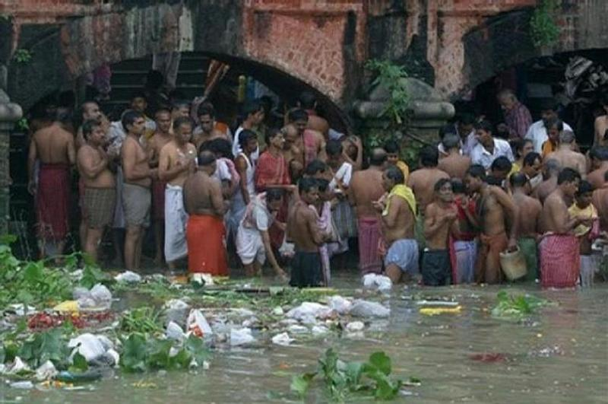(Fig 5. Photo taken from the internet: source CCYYSA)
I have used Mircea Eliade, The Sacred and the Profane. Emile Durkheim, The Elementary Forms of Religious life. Beldon Lane, Landscapes of the Sacred. Jack Hunter, Greening the Paranormal and Nicolas Campion, The Harmony Debates. These books have formed the backbone of this literature review and have assisted tremendously in the creation of this paper.

Further discussions on Literature:
In his book The Sacred and The Profane, Eliade focuses on the sacred, bringing attention to the notion of a sacred place acting as a linear passage and as a portal into the Godly realm. ‘But the irruption of the sacred does not only project a fixed point into the formless fluidity of profane space, a centre into chaos; it also effects a break in plane (between earth and heaven) and makes possible ontological passage from one mode of being to another.’ This book provides great clarity on the concept of the sacred and profane (mundane).
We have a much simpler explanation of the sacred from Durkheim, in his Elementary forms of the religious life. ‘For our definition of the sacred is that it is something added to and above the real’. Durkheim continues to deliver the notion that it is through participation that the beliefs into the sacred are actualised. And more specifically that it’s through a ‘collective consciousness’ or the holding of the of the same belief that validates the sacredness of a place. In the words of Durkheim ‘Now these beliefs are active only when they are partaken by the many.’ Inciting the theory that it is only through ‘collective consciousness’ and weight of opinion, does a place have considered value and sanctity.
The Sacred Journey of the Ganga is very informative and notes how ‘The Ganga basin has been the cradle of Indian civilisation for millennia, ancient cities like Varanasi, Haridwar, Prayagraj, and Kolkata. Its fertile plots supported large agricultural economies, producing staple crops like rice, wheat and sugarcane.’ The article continues with a subtitle of Challenges and Conservation Efforts. ‘1. Namami Gange Program; a flagship initiative to clean and rejuvenate. 2. Public Awareness Campaigns: promoting sustainable practises to reduce industrial and domestic waste. 3. Afforestation Projects: Aimed at restoring ecosystems along the riverbed. Now we are clearly aware of the efforts in place to meet the ecological concerns. You may continue to read under subtitle A River of Worship and Rituals. ‘The Ganga is at the heart of numerous Hindu rituals and festivals. 1. Kumbh Mela, the world's largest religious gathering, occurs along the river, every 12years, drawing millions of pilgrims. 2. Daily Ganga. Aarti ceremonies in cities like Haridwar, Rishikesh and Varanasi; highlight the rivers spiritual importance. 3. Festivals such as Ganga Dussehra and Diwali see devotees offering prayer lamps, and flowers to the sacred waters. ’ This article provides illuminating details on the social function of Ganga.
Next, we have The Sacred Ganga River-based Cultural Landscape. Midway through this article there is the very interesting observation ‘when we see intense exploitation of natural resources from within and from outside; furthermore, rituals of burning and dumping human corpses in the Ganga go against environmental ethics, albeit justified by religious traditions.’ Indicating there may be friction between what is religiously prescribed and the wishes of nature. The article then continues with reference to the natural sanctification of Holy Rivers, ‘With the focal point on Shiva, as the main deity with His abode in the snow clad peaks, a variety of gods and goddesses of the Hindu pantheon are worshipped; the rivers too are worshipped, with the prime position given to the goddess Ganga and Yamuna taking pride of place.’ Hereby providing conclusive evidence that the Ganga is indeed considered a Goddess and as a Being who receives worship.
I shall finish with an article on the dams which prevent the natural flow and healing of the Ganga. River Dialogues: Hindu faith and the Political Ecology of Dams on the Sacred Ganges. The article begins stating its objective, ‘aims to challenge observers of environmental campaigns to acknowledge the contingency, ambiguity, and positive political potential inherent in lived experiences of devotion to sacred entities that are also natural resources.’ Georgina Drew goes on to appeal to the government in New Delhi to prohibit future dam construction. She further pushes the belief and practise of ecological virtues and comments ‘The activists justify their claim that the Ganges is an exceptional river not directly with her importance to Hindu practise of worship, but with their belief that the river was actually created through human intervention; and only after the mythological king Bhaginath did penance for 1,000 years to relieve his ancestors from a curse that prevented them from being reborn, the god Brahma had an understanding and asked his daughter Ganga to descend to Earth and purify their ashes. Out of this exceptional origin story, the line of argument goes, emerges the Ganga’s sacredness and the need to treat her differently from other rivers. Numerous references in Hindu scripture are made to the importance placed on her free flow in order to attain her own purity and sacredness.’ She finally concludes her paper with the remark revealing her persuasion too activism, ‘Political ecology needs more religiously attuned analysis, especially when resources are revered.’ Hereby, concluding our talk of literature.
Field work and discussion:
Personally, I have contracted water born virus, Monomelic Atrophy, following from consuming water collected from Ganges River, in great abundance. This was contracted in the year 2004; when I stayed for three weeks on Tulsi ghat in Kashi, on Ganga. This being the third time I experienced life on the Ganges. On this occasion I stayed with a group of Aghori sadhu’s and drunk cups upon cups of ganga gel (Ganges water) I was fine (understatement; I was soaring high on angelic realism), and unaffected, until after three weeks passed and I feel sick; full dysentery. It was not until I had returned to the UK from India, was I diagnosed as having the condition Monomelic Atrophy; failing to raise my left thumb caused initial concerns. After medical investigation it was found that I had contracted a water born virus, that was now acting in a degenerative fashion. I was told how in the worse-case scenario I could be in a wheelchair by late 40’s; although this was not likely to occur and the symptoms should remain confided to the hand or left arm that was affected. Which in fact is the case, now approaching 45, my left hand has suffered in strength and shape, and there is a slight thinning in my left arm; but that's all for now. This however did nothing to damper my love for Indian religion and culture. How Ganga responded, communicating the awareness of a true, genuine, and permanent reality of Divine Oneness. The awakening of spirit which occurred simultaneous to the dying of nerves in my left hand. This gave way to the realisations that our physical body is far from the reality that we are, we are Atma/ Soul. Or more precisely a wave within the ocean of Divine Oneness. Testament to the claims Ganga is indeed a spiritual entity and a natural phenomenon.
There are many unforgettable experiences spent with Ganga. One evening (January 2013) spent sitting around a dhuni (sacred fire) on the ghats of the Ganga in a sadhu circle. We all partook the sacrament of Chillum, Chai, Om Namah Shivay! Later as the moon displayed Her brilliance, soma (the elixir of the Gods) was distributed. I partook, and within moments I was transfixed, the moon had turned a bright shimmering orange, and Lord Bholenath appeared dancing as Nataraj; a form commonly referred to as ‘dancing Shiva.’ He was on top of a massive alligator; it is of significance to note that Ganga Devi’s vehicle/or animal consort is the alligator. This vision was held for what seemed like an extraordinarily long time (in reality, only a few hours passed), as Bholenath hopped merrily on top of the dwarf (the dwarf is a representation of Ego). Divine transmission, in the form of cosmic guidance, was received. The wonder and total awe of the Divine appearance was firmly embedded in my soul. I was filled with a state of ecstasy and believe I experienced the true nature of reality, in the form of ‘Sat-Cit-Anand,’ ‘the consciousness of spiritual bliss’. As the cosmic dance continued, I was both hypnotised and stunned into an almost catatonic state of wonder and pure delight. Playing the role of Nataraj, the Great tamer of Ganga, the Lord of Cosmic dance and Destruction, who pacifies the torrents of Ganga from drowning the Earth; He caught the flow of Her waters in His dreadlocks (Jeta). As mentioned in Shiva Purana 2.5.2 The Descent of the River Ganga. ‘I (Shiva) held her in the locks of my hair and she remained there for 10,000 more years. Bhagirath requested me to release Ganga so that his ancestors would be liberated. I agreed to release Ganga and Bhagirath took her to the Patalloka where his ancestors had been charred to death due to Kapil’s curse. Bhagirath sprinkled the water of Ganga on the ashes of his ancestors and each of them attained salvation as a result.’ As I returned to my guest room(2/3am) along the ghats of the River, the moon still orange/red and the waters of Ganga coloured silver and created an auric portrayal of their own. I was in a state of total Oneness, and absolute gratitude, full of compassion towards everyone and everything. Below Fig 6 is Nataraj; the form of ’dancing Shiva’ on top of the dwarf of ignorance.
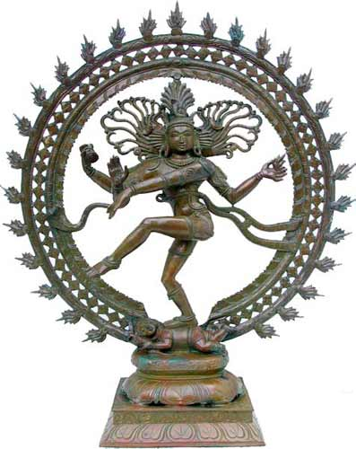

(Fig 6. Nataraj: photo sourced from Internet)

To mention another deep experience, back in 2015, unaccompanied I went on a pilgrimage (‘I peddled’, hitched rides, and walked for countless miles) from Rishikesh up to Gangotri, Gomukh/ Shiva’s rock, the source of the Ganga. After a two-week journey of travelling around the foothills of the Himalaya, I arrived at the small Temple village in Gangotri. Where I was met by a sadhu who escorted me round the Temple, we performed our Danda vats Pranam (translated as lying down as a stick) before the Deities. After this empowering initiative, Babaji took me on a trek, high up the mountain to Gomukh (a further 10-15km). This is the source of the Ganga and is known as Shiva’s rock. As we sat and meditated some time by this natural phenomenon the entire vibration changed. The appearance of Lord Bholenath, in His normal form of 1head, pale blue skin, serpent wrapped around the neck, holding (with four hands) trisula in one hand and damaroo in another, creating a hand gesture of giving blessings with the third, with the fourth arm dropped casually towards the left thigh, smeared in Vibhuti (sacred ash) emanating an almost unexplainable/delightful fragrance, a feeling of genuine love. Lord Bholenath offered a glimpse into His true nature, a Divine manifestation. After the day spent with Shiva Mahadev (Lord Bholenath), Babaji and the glaciers surrounding gomukh, we descended back along the mountain path towards Gangotri. It was late and pitched black by the time we returned, and we relied on the use of torch light and mantra to get us back safely. The stars were creating a golden canopy, and the sky was alive with wonder, a truly magnificent feast for the eyes and soul. Babaji took me to a cave, complete with dhuni/fire pit (a pile of dry wood in corner of cave) couple of blankets handed me a fresh box of matches and he told me I could stay. A time was not agreed too, but I gladly handed Babaji some money (exact amount unknown) and began to set up the dhuni/the sacred fireplace. I stayed up in the cave overlooking Ganga in Gangotri for 7nights. The time spent was inspiring; and makes up some of the greatest experiences in my life. I developed a great love of Ganga, as She displayed all the virtues of a Compassionate and loving Devi/Goddess. However, She was both fierce and loud as Her torrents rolled down the river getting wider and more powerful as the descent takes place. In fact, I remember being in revered awe of Her to the extent where I failed to pose the question about my nerve disease, as I was in such a state of complete Santosh/contentment, Shanti/peace, and Anand /spiritual bliss.
Through these experiences we can detect that the Ganga is Supreme in ways that are beyond human capabilities to even convey. I have personally experienced the Glory and sheer splendour that may be delivered and grasped through Her nourishing waters. She acts as a linear passage or portal to the Divine. A mere sight (Ganga darshan) of her waters brings the mind into a state of calm; the Hierophany is always near and the invitation to experience the Divine is apparent. It is reasonable to assert the claim the Ganga is more than a river, She is a Goddess.
Below is fig7, Ganga Devi, as She receives worship on my home altar.
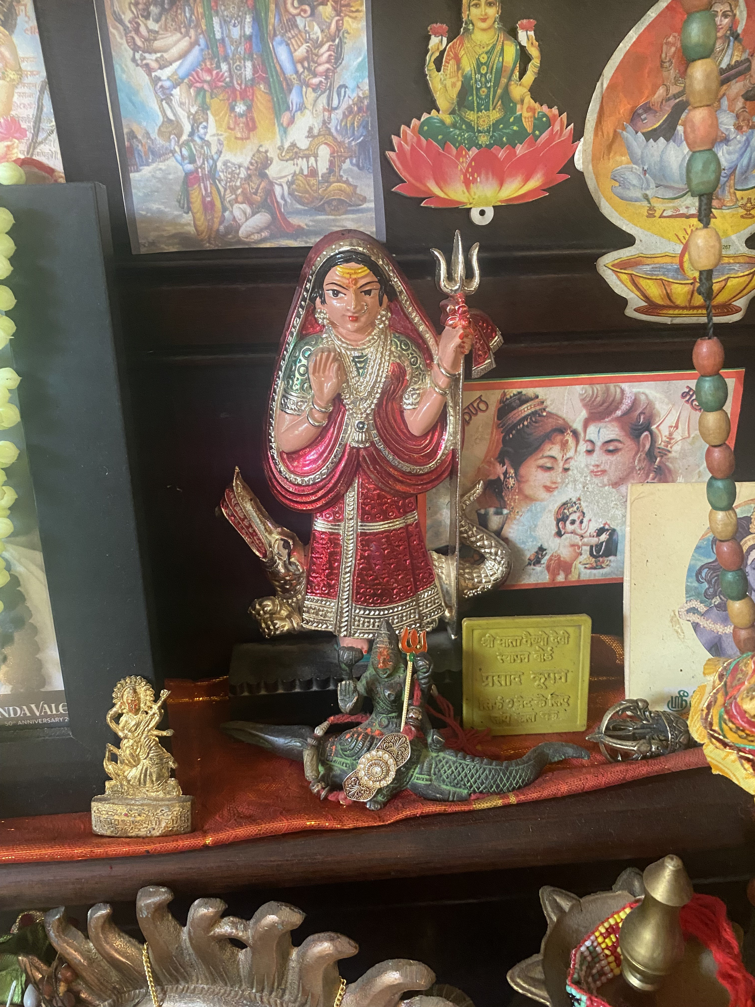

Final Thoughts:
Up where She gives birth in the Himalaya, where the Ganga originates, the waters are pure and clear. She then will flow through Rishikesh and Haridwar; then suffers gross contamination in Bihar, before arriving in Varanasi/Benares (Kashi) and continuing to head SE direction pass Kolkata through to the Bay-of-Bengal and exited out onto the Indian Ocean. Whilst many of the banks are littered with trash, She maintains a sacred energy and Holy position regardless to the layers of filth. Through this is it possible to appreciate Her transcendental qualities and maintain the conviction that She is pure, despite all the evidence which gives rise to concerning facts about her constituents.
Moodi’s 3b dollar clean up proposal must be widely acknowledged and further encouraged; for 10 years on, there are still some substantial steps to be made. Although the policy and the vision is there, the reality is the Ganga remains heavily polluted. The Indian government is bringing awareness to the people and encouraging a more ecological state. We must protect and honour Her rights! The Ganges was the second River in history to be given rights of Personhood, now the time is pressing to further Her rights as the Sacred River Goddess She is.
The aim of this research project was to examine the nature of Ganga; whether Her sacredness is bestowed by humans or is it naturally endorsed. And whether the degree of pollution has had a degrading influence on the claims of Her Sacredness. If one is to adopt Eliade’s perspective, we may argue that Mother Ganga is a natural phenomenon alternatively Durkheim gives weight behind the claim that Ganga is sacred on socially constructed grounds.
Below in Fig7 we have a quote from Sadh Guru encouraging a more ecological and holistic approach to River and River consciousnesses.
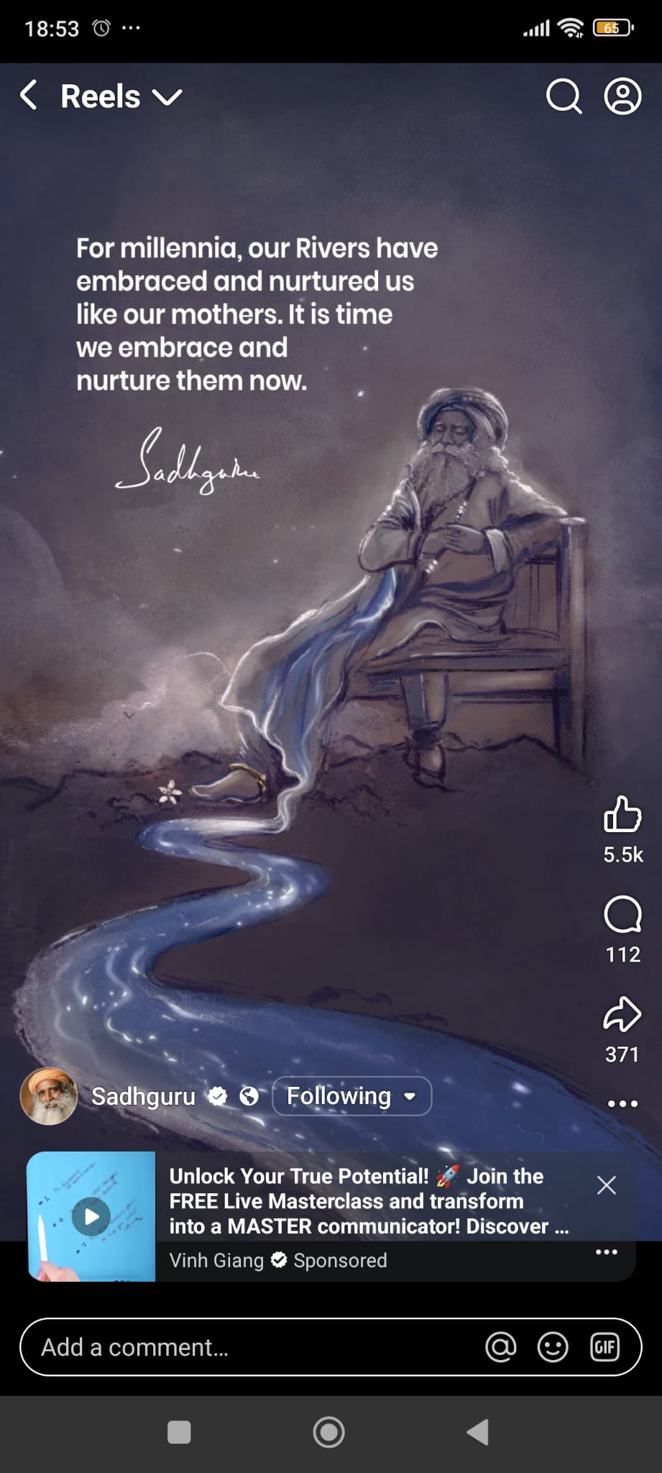
(Fig 7. Sadh Guru quote; sourced from social media)

Conclusion:
To answer the question, whether sacred space is a human construct or a natural phenomenon. It is reasonable to conclude that both factors have a valid significance when deducing the notions of sacredness. However, when they are combined, as in the case of Ganga, we may detect a genuine, authentic sacredness; a sacredness which is truly actualised. I have a strong topophilia towards Ganga. I value Her as a loving Mother; what is more, Ganga is a living representation of the Goddess. This can be justified through both theory and practise; personal experience and shared perceptions, stories shared by others and scripture. Ganga exemplifies Durkheimian/Bruhl belief concerning human participation, acting to consolidate the sacred. Consequently, we could say that the sacredness of Ganga is of a socially constructed nature. However, simultaneously, and perhaps even more available is it evident that Devi Ganga is the hierophany that Eliade refers to. As the Goddess personified, She encapsulates our attention and overwhelms one with the awe-inspiring grace of Her presence. So, both sides of the question are fulfilled; the Ganga is both socially constructed (through the daily practise of rituals) and is to be equally considered a natural phenomenon. Indeed, it is fair to conclude that Ganga is in fact ‘Super Sacred’ and all the criteria which determine the existence of sacredness, are completed through Her Being. ‘We’ are to be held responsible for sanctifying and purifying Her waters; through connecting to Her Divine attributes and seeking to honour Her elements. May the ‘Namami Gange’ project be honoured and used to greater effect. May the calling of Ganga be adhered to and responded by the will of the people to revere Her water and honour Her personhood and Divine attributes. Ganga is a living Goddess, She is sacredness personified and this claim may be supported through all the theories we have examined; regarding the degree and extent of ritual activity, the numbers involved in participation and the sheer magnitude of Divine energy present. Ganga is one of a kind and is unmatched anywhere in this world! Fig 8 (Below) : Shows Shiva Mahadev embedded within the River Ganga and therefore illustrating the intrinsic Divine connection.

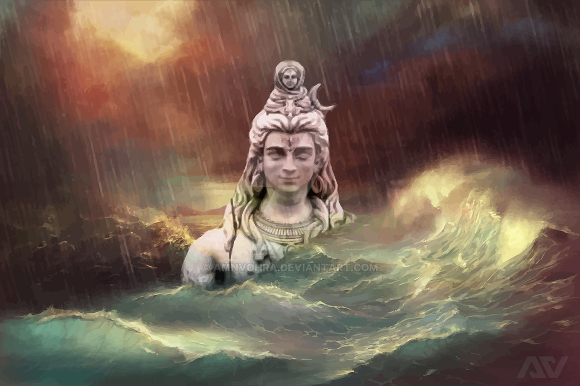(Fig 8. Shiva Ganga: photo sourced from Internet)

Jay Ganga Ma

Bibliography:
Primary sources;
The River Ganges
Academic documentaries
1.Ganges: River to Heaven (director, Gayle Ferraro, Berkeley Media/ Ariel Productions, 2005) https://librarysearch.uwtsd.ac.uk/permalink/44WHELF_UWTSD/11c0l68/alma99100400222102421
2.India’s Effort to clean up Sacred but polluted Ganga River (Publisher: Arlington VA: NewsHour productions, 2020- source Academic video online Premium-UK)
https://youtu.be/5RLZ3EJXCeg?si=p6TbCfpGBW2SNAwz
Religious Scriptures:
Ganga Mahatmya
Ganga Strota
Shiva Purana
Devi Bhagavata Purana
Secondary sources:
Campion, Nicholas. The Harmony Debates (The Sophia Centre Press, Wales, 2020)
Das, Priyam and Tamminga R Kenneth. The Ganges and the GAP: An assessment of Efforts to clean a Sacred River (University of Hawaii at Manoa, USA, 2012)
Drew, Georgina. River Dialogues: Hindu Faith and the Political Ecology of Dams on the Sacred Ganga, (Tucson: University of Arizona Press, 2017)
Durkheim, Emile. The Elementary Forms of the Religious Life (Dover Publications, Inc, Mineola, N.Y, 2008)
Eliade, Mircea. The Sacred and the Profane (Harvest Press, United States,1957)
Hunter, Jack. Greening the Paranormal August night press, U.K and U.S, 2019)
Lane, Beldon. Landscapes of the Sacred (United States, The John Hopkins press, 2002)
RadhaKrishnan, Vinita. Ganga: A Myth or Reality? (Dance conceptualisation and choreographed by Madhumsnti, 2004)
RamaKrishnan, P.S. The Sacred Ganga River-based Cultural Landscape (Published Online, International, 2003)
Vibes, Dharmik. The Sacred Journey of the Ganga: Mythology, Heritage and Significance (Published Online: spiritual app, 2025)

Mircea Eliade, The Sacred And Profane (United States, Harvest press, 1957) p.30.
Emile Durkheim, The Elementary Forms Of Religious Life (Mineola, N.Y, Dover Publications, 2008) p. 204.
Author not credited, ‘The Sacred Journey Of The Ganga: Mythology, Heritage And Significance’ (Online, Dharmik vibes, 2025) p.2.
Priyam Das and Kenneth R Tamminga, ‘The Ganges and the GAP: An Assessment Of Efforts To Clean A Sacred River’ (India, Open Access, 2012) p.1655
Emile Durkheim, The Elementary Forms Of The Religious Life (Mineola, N.Y, Dover Publications 2008) p. 213.
Mircea Eliade, The Sacred And The Profane (USA, Harvest Book, 1957) p.131.
Ibid Eliade, p.105.
Lucien Levy Bruhl, How Natives Think (France, Ravenio Books 1910) p.134.
Beldon Lane, Landscapes Of The Sacred (United States, John Hopkins press, 2002) p.19.
Emile Durkheim, The Elementary Forms Of Religious Life (Mineola, N.Y, 2008) p.205.
Mircea Eliade, The Sacred And The Profane, (USA, Harvest Book Publishers, 1957) p.63.
Emile Durkheim, The Elementary Forms Of Religious Life (Mineola, N.Y, Dover Publishers, 2008) p. 207.
Dharmik Vibes. ‘The Sacred Journey of the Ganga: Mythology, Heritage and Significance’ (Published Online, 2025) p.8.
Ibid Dharmik, p.9.
Ibid Dharmik p.9.
P.S Ramakrishnan,’ The Sacred Ganga River-based Cultural Landscape’, (Taylor and Francis, 2003) p.11.
Ibid RamaKrishnan p.11
Georgina Drew, ‘Hindu Faith And The Political Ecology Of Dams On The Sacred Ganga’ (The George Washington University Institute, 2018) p.55.
Ibid Georgina Drew, p.57.
Ibid Georgine Drew, p. 57.
Purana 2.5.2 The descent of the River Ganga (Kindle complete collection of 18Puranas)

