The Construction of Identity Though the Painted Form:

An examination of artists portraying their identity.

Ryan Vivian Jones
Student number: P146830
Dissertation tutor: Delyth Lloyd-Evans
Submitted in partial fulfilment of the requirements for the degree in BA (Hons) in General Illustration: Swansea Metropolitan University of wales Trinity Saint David
December 2017

Table of contents:

List of paintings 3
Summary of Topic 4
Introduction 5
Chapter one: Salvador Dali 7
Chapter two: Frida Kahlo 14
Conclusion 23
Bibliography 24

(Word count: 5392)

List of paintings:

- Figure one, Salvador Dali, Rose meditative, c. 1958
- Figure two, Salvador Dali, Flower Woman with Soft Piano - Hippies series, 1969
- Figure three, Salvador Dali, Fashion Designer, Lithograph, 1980
- Figure four, Salvador Dali, plate 8 Accommodation of Desire 1929
- Figure five, Salvador Dali, The Hand: Remorse 1930
- Figure six, Philippe Halsman (1906 – 1979) HOW YOU OBSERVE MOTHER’S DAY? [Salvador Dali] Flammarion
- Figure seven, Frida Kahlo, Self Portrait as a Tehuana, 1943
- Figure eight, Frida Kahlo, Diary, “Why do I need feet if I have wings to fly.” 1953
- Figure nine, Frida Kahlo, My Grandparents, My Parents, and I, 1936
- Figure ten, Frida Kahlo, Flower of Life, 1944
- Figure eleven, Frida Kahlo, My Dress Hangs There 1933
- Figure twelve, Frida Kahlo, The Bus, 1929
- Figure thirteen, Frida Kahlo, Portrait of Cristina Kahlo, 1928
- Figure fourteen, Frida Kahlo, The Wounded Table, 1940
- Figure fifteen, Frida Kahlo, Girl with death mask, 1938

Summary of topic:

In this dissertation I will critically evaluate the notion of identity within artworks. Is the act of identity within artwork a form of immortalization? Are there patterns or certain pathways that are common to artists in their visual representation of the self? Such as historical events, childhood emotional afflictions, religion or medical syndromes. I will analyse influential artist of their time such as Frida Kahlo and Salvador Dali.

Introduction:
To construct an accurate argument, one must deconstruct individual identity to its basic forms. I will attempt to evaluate identity through the painted form. This dissertation is an attempt to address the issue of identity and the embodiment of identity within artworks. In our modern society we are undergoing contemporary ideas on identity. The present era in Humanity has sufficiently contributed on society’s definition on identity, be that through Transgender visibility within the media, economic growth brought upon through technological advances. The intriguing action one goes through while defining something as art translates within us all through our identity is this action a possible one to define? My passion for art is directly linked to identity. I find myself questioning what individual thought processes came to visual conclusions. My motivation is connected to my own work as I have struggled with the concept of identity for numerus years. The initial concept of identity originates from adolescents as I am an identical twin, this instigated my pursuit of “difference”. In an article from National Geographic Studies identical twins has been crucial to understanding the interplay of nature and nurture in determining our personalities, behaviour, and vulnerability to diseases as a society. In terms of myself and my twin we share many genetic trait as identical twins we virtually have the same genetic code/makeup. It’s hard to signify what traits are environmentally or genetic as from an outsider’s perspective we have lived the same life e.g. school, collage, friends, tastes, belief system and creativity. As a child it was a significant investment to appearing as one person as it helps us develop social skills. Early on we were imprinted with one identity named “the twins” thus demolishing any aspect of individualism. As we developed the desire to be different became bigger than physicality’s between us which developed into analysation of the self within society.

why identity? Each chosen artist has a body of work that itself reflected (self-portraits)
constructing their identity or just what they want to be viewed?
Are they depicting their reality?
Is the art work an outlet for undesirable qualities within the artist to detach from?
(identity is collaborated by society? (randomization of pre-obtained ideas)
or is it structured by a premade path? Religious beliefs.

In the following section of this dissertation I intend to closely consider/examine some of the more identified members of the academic arts such as Frida Kahlo and Salvador Dali. Touch upon situationism the theory that “human behaviour is determined by surrounding circumstances rather than by personal qualities.” The objective of the research is to use research methods to gain an insight into why certain artist use identity within their work. Is this action a form of immortalization? I intend to explore and identify the attitudes that members of art culture have on identity, I intend to explore if a particular model is relevant or simply situational? The aim of the research is to determine how chosen artists structured visual representations of their identity.

Chapter one:
Salvador Dali:
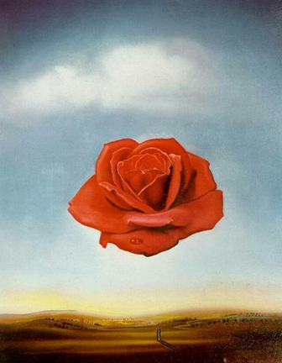
The objective is to diagnose identity; thus, it is vital to look at pieces that do not stick within the artists theme. In which are not typical objectified in the same manner as more identifying pieces by the artist, as this produces an alternative perspective of identity. Rose Meditative 1958 has been tagged as a simple pretty painting and nothing more than that, being said could this piece be a true representative of Dali’s identity?
(Figure one, Rose meditative, c. 1958)
It is to be believed that Dali’s paranoiac method is not apparent in (Figure one), the paranoiac method was developed twenty-eight years prior to its creation. (Figure one) completion coincided with Dali’s new-fangled belief in science and DNA seen within Dali’s published artworks depicting “nuclear Mysticism” where Dali reflects matter floating in space within his artworks. RateMyScience (2012). Science is a universal language that will always have the same conclusion. One could speculate that the piece suggests such notions of a juxtaposed state of mind which is a common attribute of Dali’s work but furthermore augmented in such a way that does not suggest paranoia but suggests tranquillity. Paranoia is a mental condition characterized by delusions, in which the person loses touch with reality (Dr Roger Henerson. (2016) Comparison to other works by Dali, (Figure one) is unpretentious, this piece is abstract but in such a way stays true to a structure within reality. Anatomically correct but augmented scale ratio.

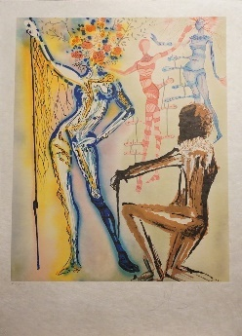
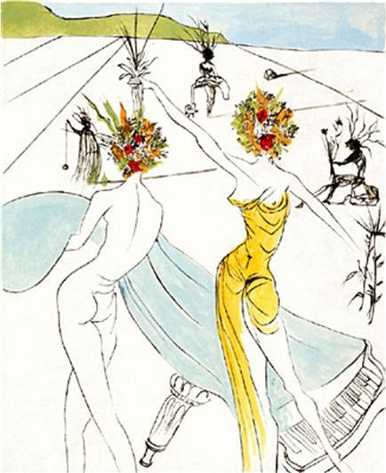

Figure two. Salvador Dali, Flower Woman with Soft Piano - Hippies series, 1969
Figure three. Fashion Designer, Lithograph, 1980
In the years following Dali’s studies of flowers had a substantial increase and where the main subject within many artworks such as (figure two) and (figure three). Dali’s conveyance of flowers evokes metamorphizes causes one to think Dali interprets flowers as sexual enlightenment, such as gender identity and sexual orientation are to apposed ideologies, Dali transfixes flowers as identity itself. It can be interpreted that Dali has used a rose as a symbol of human’s natural reliance on the physical body such as in other works, Dali represents flowers as humanoid entities thus coating an image of immortalization within them. This could be interpreted to be a symbolic reference to love and death as a single rose is to be given. As Dali is a Spanish artist he would acknowledge / celebrates Saint George’s day (lover’s day) on which lover’s exchange blood-red roses. Matthew Tree (2011)

Hallucination
Paranoia was a key factor within Dali’s work thus the adaptation of Dali’s paranoiac method. It is said to be known that Dali suffered from delusional parasitosis, also known as Ekbom’s syndrome in which sufferers manifest an infestation of bugs onto their skin. This had been surmised by Dali’s autobiography (1942: 230) where Dali is quoted “I seized a razor blade, held the tick tightly between my nails and began to cut the interstice between the tick and the skin,” later Dali stated it was nothing other than a mole. Great minds often look at mind-altering substances as a source enhancing inspiration. Dali once stated” I don’t do drugs. I am drugs.” In comparison to this belief system Dali had traits commonly connected to sociopathic tendencies, Aaron Short (2014: 9) such as a childhood incident where Dali throw’s his friend five meters of a bridge. Dali did not show any remorse or guilt, incidentally, his friend survived and Dali just sat calmly and smiled. Dali would also stand on his head until he almost passed out, allowing him to become semi-lucid. This leads one to believe that it was highly likely Dali’s sense of reality would be altered, in this respect hallucinatory tendencies become a dramatic part of Dali’s construction of identity and development of artistic style.

Childhood
As a child Dali struggled with his identity differently than most people as his parents named Dali after their dead son. The LOCAL.es (2016: 2). Dali reflected on this realization though an interview conducted by Spanish journalist Soler Serrano in 1977, Albers (2017) "For the first time in my life, I was shocked to recognize the absolute truth about myself. Being given someone else identity is a critical aspect of conscientious thoughts it makes you ask the question “who am I” which as an artist is vital to develop. This is also seen with Van Gogh’s stillbirth brother in which Van Gogh inherited his name from the deceased that following year.
Religion
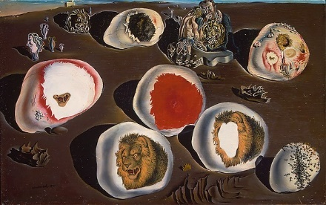
A rose can only repeat the same outcome but can bloom in infinitely different ways, is this symbolic reference to humanity? Is Dali depicting his mind body and soul as the Holy Trinity in (figure one)? The holy trinity represent three distinct individuals but come together to portray one entity. ‘Trinity’ (2017) Matter collided together to subtract a single material, essence or nature using this context “material” is what one is, whereas “matter” is who one is. (Soul) Holy spirit in Christian art has symbolized by a flame is this relayed within Dali’s sunrise. (Body) God the son is typically depicted on the Father's right hand indicating the rose as god the father. This is represented by the humanoid sculpture / statue standing under the rose, Symbolic of Dali the man not the artist. (The physically body Dali possesses). (Mind) god the father maybe relayed through the name of the piece meditative meaning considered thought. Or represented by a halo Dali has shadowed this piece in such a way that creates a circle around the rose furthermore stating the rose is god the father. Dali the enigma the artist that is transcendent of life. The rose as the mind the centre of everyone’s identity, Dali’s work suggests belief with religion as it is the structure of many of his works, Dali shows this through the use of eggs in which are depicted in many of his works e.g. (Figure four).

(Figure four, plate 8 Accommodation of Desire 1929).
Eggs are symbolic of new life, rebirth and fertility in many cultures in particular Christianity where eggs are symbolic of tomb of Christ. It is equally speculated that Dali’s art reveals atheism and religion. This can be backed up from Dali personification of man and god and can be seen within work (figure five).
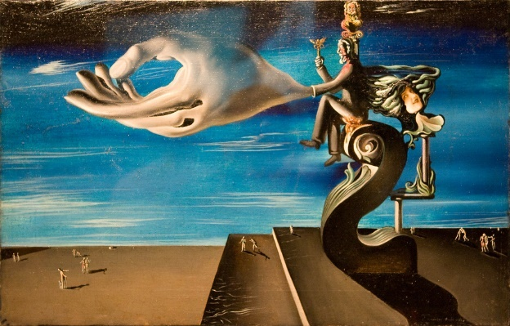

(figure five, The Hand: Remorse 1930).
There is a juxtaposition between the man and the hand, in Christianity the hand represents a symbolic reference to god where the man is depicted with blood indicating he is mortal. The intriguing aspect is that Dali depicts them as one being, this furthermore suggests that Dali is relaying a message of atheism. By depicting this in such a way it is believed Dali is stating god is manmade. The nature of the man being elevated suggests power and antiquity over society that religion withholds, this also can be seen within gold elements embellished on the man. Kumar Nitin (2016) Dali’s parents were divided one side devoted Catholics the other firmly opposed atheists, it’s believed Dali followed in his father’s footsteps and became an atheist Research reveals influential role religion played in Dali’s life. Nora Hamerman (2010) In 1949 Dali publicly returned to the Catholic faith from then on Dali embraced the “classical” combining renaissance with the surreal. Dali’s new founded faith was made possible by nuclear physics, nuclear physics allowed Dali to challenged popular opinion and offered himself Christianity as something that had new justifiable meaning, in which through nuclear physics Dali become a believer. In the aspect of Social identity theory Dali become an outsider, David L, (2015) Tajfel and Turner’s social identity theory explains that part of a person’s concept of self comes from the groups to which that person belongs. Dali’s categorization within religion through his life was in a constant state of paradox thus social identification with in each category lead to adaption of the rules for Dali. Such as Dali only believed in God when he developed scientific traits. With social comparison Dali did not compare against the identity of the Outgroup but simply compared surrealism with classical art. In essence Dali became an outsider for accepting both as factual.
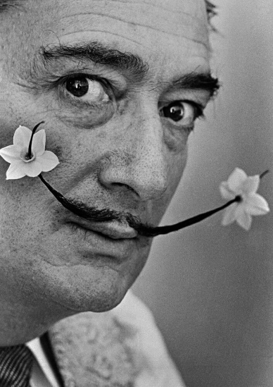
Sexual identity & Femininity

(figure six,) Philippe Halsman (1906 – 1979) HOW YOU OBSERVE MOTHER’S DAY? [Salvador Dali] Flammarion
There was Dali the enigma and Dali the mortal both in a constant state of paradox. It’s not an outlandish statement to say that Dali was the embodiment of the surreal sometimes hard to indicate what was real or fictional as was the charm of Dali and his works. Gender identity of Dali is as exclusive as the artist, as a young man, Dali developed a close relationship with Federico Garcia Lorca a Spanish poet believed to have developed into romantic encounters later denied by Dali himself. (Dali. 1828) David Smith (2007)
At a young age Dali was exploring notions of gender displacement, Invisible Mountain (2011) Dali states “At the age of six I wanted to be a woman cook. “
Hair is directly linked to gender identity equally masculine and feminine it is a key element that conduct a visual representation of a person’s identity. Dali has been photographed numerus times with a flower on his person, (Figure six) typically delicately nestled between his long hair and his ear. The meaning and symbolism of a Roses generally relates to love and passion, (‘Rose (symbolism)’, 2017) the ancient Greeks and Romans associated roses with Aphrodite and Venus, goddesses of love. Used for hundreds of years to convey messages without words, they also represent confidentiality. In this retrospect Dali’s suggests with his use of roses that he is conveying a message of self-acceptance. Hair was vital to Dali and he held it with a high regard as can be seen in numerous artworks. So much so as to produce a book on the subject of hair (Salvador Dali, Philippe Halsman (1994) the same can be said about Kahlo’s obsession with her moustache and eyebrow hair. Hair holds a metamorphosis within the artist this can be seen through his marriage to Elena Ivanovna Diakonova Dalí was disinherited by his Father as a result.
Javier Eder (2010) “I love money tremendously” Salvador Dali held money in a high regard as the quote suggest which furthermore indicates the impact Diakonova had on his life. This altercation lead to Dali relocating with Diakonova, Jackie Fuchs (2014) article suggest Dali used hair as a symbol of love and adaptation by shaving it off and burying it on the beach of Cadaqués Spain. This is a significant part of his identity this stipulates leaving a part of himself (childhood) becoming a man, Dali and Philippe Halsman Dali (1994) Dali answers the question what is ugliness? and what is beauty? Dali answered disorder and harmony. In this aspect Dali’s wild hair becomes a symbolic elucidation of Dali’s changing identity. InvisibleMountain (2011) Dali was asked about a quotation within his autobiography “Salvador Dali Haakon M. Chevalier. (10 May 2017), In which Dali states death is beautiful “everything is erotic “life is erotic therefore ugly, death is not erotic but sublime therefore beautiful”. If one where to summarizes the interview the treatment of death is a form of glorification it creates and enhances individual identity though the livings communicated perceptions. Also within the interview Wallace asked “what do you like spending you time doing the most?” Dali answered “Becoming everyday a little more Dali” exploring the confines of his development suggest a disconnection with social preconception of individual identity.

Chapter Two:
Frida Kahlo:

Art transcends individual lifespan, if the artist portrays themselves within their work does this make them immortal? Kahlo’s work can be bricolage, the act of creation both constructs identity and reflects this. This could be seen through American sociologist Sherry Turkle’s (b. 1948) theory that people use objects to think with. Did Kahlo use her paintings to categorize her life, imprinting her identity within them. In many aspects one can surmise yes. By placing yourself as the subject of many works is Kahlo telling a symbolic story of herself? As we can conclude that Kahlo had a strong sense of identity particularly self-expression through clothing created by and for Kahlo herself through her unique facial hair and painting style. (Carlos Phillips Olmed, Magdalena Rosenzweig (2008) To critically evaluate someone, one must examine the structures of their lives. Kahlo can be categorized into three significant attributes Love, pain and revolution. The English dictionary defines identity as “the fact of being who or what a person or thing is. If identity is a collection of preconceptual ideas and thought processes such as “The unexamined life is not worth living” – Socrates (470-399 BCE) If we are only memories and ideas then if chosen to portray as something physical if so does the said physicality become a stabilized version of our identity?

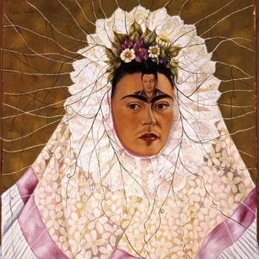

(Figure seven, Frida Kahlo, Self Portrait as a Tehuana, 1943)
This portrait was painted in August of 1940 when Kahlo and Diego Rivera divorced. Kahlo didn't finish this painting until the year of 1943. (Figure seven) is also known by two other names: " Self Portrait as a Tehuana" and "Thinking of Diego". (Figure seven) expresses Kahlo’s desire to possess Diego Rivera, who continues betraying her with his affairs with other women. Kahlo cannot stop thinking about him. She painted a miniature portrait of him on the brow which indicates the obsessive love Kahlo has for the Rivera. In (Figure seven), Kahlo is wearing Mexican traditional Tehuana costume that Diego Rivera is obsessed with. On her head, she was wearing leaves and the root resembles the pattern of a spider's web. It might be Kahlo’s thoughts, that she had Diego trapped. Kahlo’s Perception of love has intrigued me for many years and has impacted my own construction of love be it self-acceptance, deduction, devotion and the absentness of love. The blank expression of Kahlo face and her distant glaze brings a sort of melancholia, thus effecting the overall emotions Kahlo is describing in this piece. Eye contact is a key factor in (Figure seven), if the piece depicted Kahlo gazing at the viewer it would feel as if she was giving herself to the viewer in some aspect, leaving her emotions open for everyone to see. Whereas Kahlo’s use of non-direct eye contact could be interpreted as Kahlo stating her intended audience is herself, closed off but willing to remember love.

Hallucination
“Pain, pleasure and death are no more than a process for existence. The revolutionary struggle in this process is a doorway open to intelligence” ― Frida Kahlo, Sarah M. Lowe. (2006)
Throughout her life Kahlo suffered countless afflictions of the body such as contracting polio and a collision. Thus, one must introject that Kahlo would have been on some form of medication as it is unclear if her death was self-inflicted or a morphine overdose (Fuentes, 1995.) Dr Leo Eloesser a close friend of her family stated Kahlo was a lifelong alcoholic and drug addict, that many of her thirty operations where unnecessary. (Susan Cheng (2014) This suggests Kahlo’s concepts of reality where altered from drug-induced hallucinations as more often, visual distortions occur that alter the person's perception of the world around them. Long term drug use may cause schizophrenia a form of metal fragmentation that causes withdrawal from reality, this also has a significance connection within Kahlo as a self-portrait artist as it causes an enhancement of emotional expression.
We are primed to see faces in every corner of the visual world. It is humanity’s nature to manufacture faces in the natural world, this phenomenon is known as pareidolia. (Kim Ann Zimmermann (2012) An artist’s voice is a physical and visual acquisition that connects and disconnects art and humanity, art has its own language be that through expressionism, emotions, fluidity it creates a story that can be preserved differently.
"I never painted dreams. I painted my own reality". – Frida Kahlo Time Magazine, (1953)
“There have been two great accidents in my life. One was the trolley, and the other was Diego. Diego was by far the worst.” – Frida Kahlo, Imagen de Frida Kahlo, (1951)
On reflection Kahlo values emotional pain in a higher regard than physical. This is a true reflection of Kahlo’s identity.
“My painting carries with it the message of pain.” – Frida Kahlo
If identity is a collection of preconceptual ideas and thought processes such as René Descartes suggests “I think therefore I am” this Is stating contemplation is the highest regard of defining human essence. In many of Kahlo’s work pain within life transcends the painting thus giving a wider sense of identity does this suggest pain is more valid than life. If all we are, are only our memories and ideas then if chosen to portray as something physical, if so does the said physicality become a stabilized vison of our identity?
Lee Price (2014) The Sun newspaper conducted a poll stating belief in the supernatural was common in British culture with almost half the population believing in some form of an afterlife. Virtually all cultures have traditions of ghosts, if we were to surmise that ghosts where a true reality it would be believed that the “spirit” is present because of traumatic incidents of pain that subsequently lead to their demise. Furthermore, pain becomes a collective representation of life in which consequential demoralizes human physicalises.

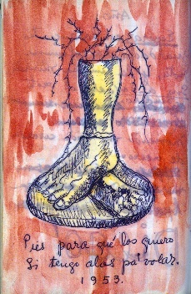
Phantom Limb Syndrome

(Figure eight) Frida Kahlo, Diary, “Why do I need feet if I have wings to fly.”) 1953
Did Kahlo suffer? if so did this alter her view on reality.
Phantom sensations originate in the brain and spinal cord not a psychological problem. Michael Rugnetta (2014) It is highly likely Kahlo suffered such syndrome, which often affects limbs farthest from the body, such as foot of an amputated leg. (Figure eight) Kahlo shows her mentality on such subject in a diary page stating “feet what do I need them for if I have wings to fly”1953, Sarah M. Lowe. (14 Jan 2006) in this statement wings are used by Kahlo as a symbolic reference to her mental capability to withstand pain subsequently stating her mind is stronger than her body. Kahlo depicts two severed feet with nerves/veins on a pedestal using red to signify longing and anger. Kahlo indicates with the use of nerves as a connection with the severed leg, it is intriguing to note the amputation of her two legs suggests Kahlo feels disconnected to the physical world. Such as her use off wings being symbolic of intelligence and understanding thus glorifying herself as more than her physical self. Rivera recalled this altercation of Kahlo’s loss of reality “following the loss of her leg, Frida became deeply depressed.” Diego Rivera, Gladys March (2003), page 178

Clothing Identity & colour
One’s wardrobe reveals one’s polities: it is the story one lives by: it is one’s symbolic self. – Honore De Balzac
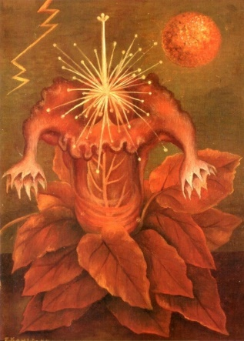
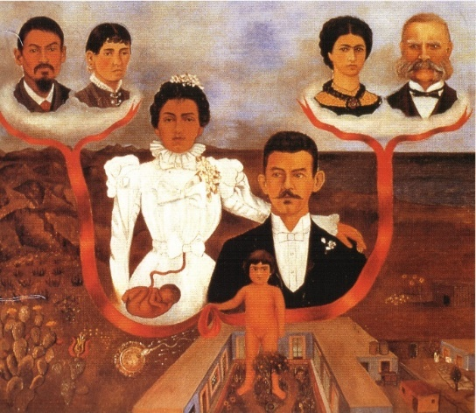
The notion of Kahlo’s favourite colour is yet to be explored but one could speculate red as so. Some form of red pigment resides within the majority of Kahlo’s paintings. This statement could be backed up by numerous paintings that portray red as the consequential colour, such as (Figure nine) where red ribbon/vein holds a significant place within the piece. (Figure ten) where the painting subsequently possesses three pigments black yellow and red, red engulfs the piece within the painted rose/heart.

(Figure nine) My Grandparents, My Parents, and I, 1936 (Figure ten) Flower of Life 1944
One can argue the unsurpassed evidence is within her clothing such as her embroidered red prosthetic boot, something so personal and unique to the individual subconsciously imprinting the object with the person’s identity. Thus, Kahlo’s choice to make it red defines it as herself. Looking at the typography Kahlo embroidered with red thread onto her lace purse as a love token to Diego Rivera. Carlos Phillips Olmed, Magdalena Rosenzweig (1 May 2008) This suggests red is associated as passion and romance within Kahlo’s physical identity. This could be backed up by her wardrobe in which provides many clothes in which red was chosen to be hand embroidered embellishing a sense of originality with in the clothing thus creating one of a kind pieces. Kahlo identifies red with romance, as that being said red is interpreted differently within her art e.g. (Figure eleven) where red is associated with power and danger (thoroughness of capitalism in America.)
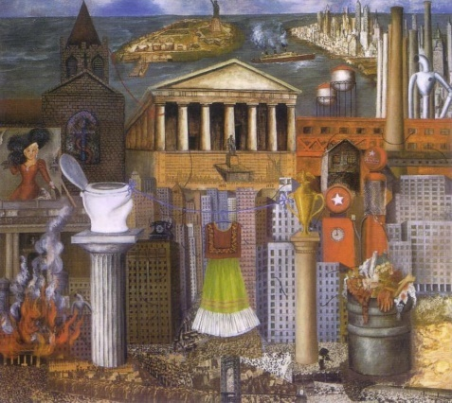
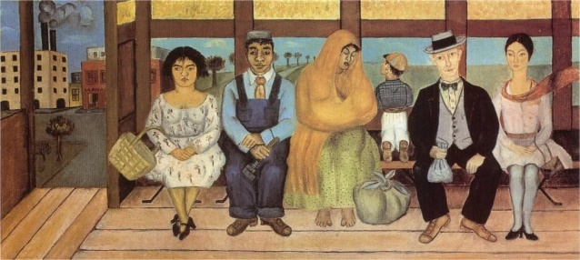

(Figure eleven) My Dress Hangs There 1933 (Figure twelve) The Bus, 1929
Does this signify an alteration within the woman and the artist? Kahlo’s art suggests conscientious thought in which brings the artist centralized within the action of creation. Work is created with the emotional categorization that are within Kahlo at the present time. Such as (figure twelve) in which at the time created Kahlo was coming to terms that it was unlikely that she was going to be a biological mother because of three miscarriages. Within this piece Kahlo is portrayed on a bus as this is a significant attribute to this conclusion, numerous individuals are also within the piece all facing the viewer despite a young child believed to be male looking through the opposed widow. In this retrospect the bus becomes symbolic of afterlife and loss opportunities. Signifying that Kahlo, the woman and artist are one conscientious parallel but insufferable connected. Now on this basis what are the significant traits red possess that connects Kahlo’s identity within them? Red demands the eye towards it, thus red within artwork signifies key elements the artist want attention on. Indicating high sense of visibility within herself, red is courage, rage, sexuality and willpower all traits Kahlo imprints within her work.

Religion
Religion in her work was she religious?
I am in agreement with everything my father taught me and nothing my mother taught me. - Frida Kahlo. Sarah M. Lowe. (14 Jan 2006) Kahlo’s father had a big impact on her life sharing an incapacitating disability. It is also suggested by history that he instigated Kahlo’s involvement with gender fluidity as he encouraged her to play sports that where unsuitable at the time for a girl to play. Frida-Kahlo-foundation (2002-2017) His influence can be seen in her paintings as many have depictions of the natural world such as flowers, cactus, invertebrates and mammals this was taught to Kahlo by Guillermo Kahlo. This suggests that if Kahlo was religious she would sway heavily with her father’s religious background (Judaism) By Kahlo stating that her mother was cruel and fanatically religious thus furthermore suggest Judaism. One can argue Kahlo was an atheist like her father when arriving to Mexico in 1891 changing his name and trades Judaism for atheism. Frida-Kahlo-foundation (2002-2017)
“What I wanted to express very clearly and intensely was that the reason these people had to invent or imagine heroes and gods is pure fear. Fear of life and fear of death” – Frida Kahlo, Sarah M. Lowe. (14 Jan 2006)
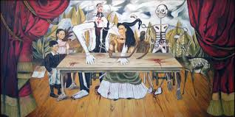
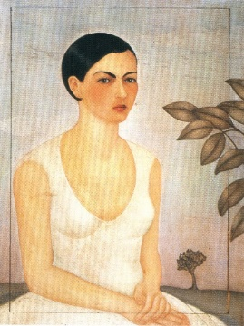
In this statement Kahlo subject’s knowledge of atheism but does not categorize herself within each belief system e.g. belief in nothing/ belief in god.

(Figure thirteen) Portrait of Cristina Kahlo, 1928 ( Figure fourteen) The Wounded Table 1940).
Her work suggests religious belief (Figure thirteen) where a single tree is in the foreground, perhaps the tree of life a widespread archetype within religious and philosophical tradition, in catholic Christianity (the tree of life is a representation of mankind’s priority before the Original sin. The notion of Christianity could be interpreted within other works of Kahlo none as transparent as (Figure fourteen) Leonardo da Vinci's Last Supper what takes place in such work is comparison with the Holy Trinity. Kahlo’s young self-indicted as God the Holy Spirit typically depicted as a dove Kahlo uses loss of childhood in the same respect. God the Father could be seen within the entity surrounding Kahlo, as God the Father is typically not depicted as a plausible entity often symbolised as white light or a disembodied hand. In relation Kahlo’s depiction of a bleeding (wounded) wooden table instinctively reflects the crucifixion of Jesus Christ. This indicates Kahlo as god the son, Kahlo depiction seems parallel to her reflection of the self as she has painted society’s ideas on beauty transfixing depictions of Aphrodite within herself. In terms of belief this does not determine one as so, it merely suggests an interest within religion. Despite many works indicating instances where a belief system seems plausible it is equally plausible that Kahlo identified herself as an outsider that by using religious symbolism in such a way could reflect a cohesive form of spirituality.

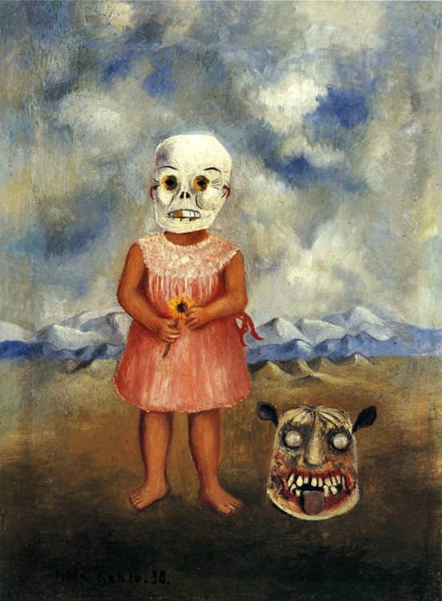
Childhood

(Figure fifteen) Girl with death mask 1938
Can traumatic instance in childhood effectively produce an artist’s voice. Kahlo once commented that in her childhood she would sometimes be present when her father suffered from epileptic seizures and would give him aid. Sarah M. Lowe. (14 Jan 2006) In work such as (Figure fifteen) it could be interrupted that Kahlo is exploring such notions within her later life. Kahlo is imprinting ideologies of herself, by placing a young girl with a Mexican heritage in a deserted and barren place. This creates ideas of a child’s naivety giving Kahlo a vulnerable sense of identity. In this sense this piece is the symbol of death as there is apparent absence of life within this piece such as barren surroundings, sunflower and most importantly the death mask worn by the girl. In women’s art journal (Salomon Grimberg) Kahlo states that she paints flowers so they will not die. The most intriguing element within this piece is symbolic relationship Kahlo has imprinted onto the sunflower, particularly Kahlo paints a sunflower that has been uprooted. The way Kahlo painted (Figure fifteen) indicates the sun is directed at the girl be that through shadowing and the cohesive nature a sunflower possesses. As sunflowers follow direct sunlight through the day, even in death the flower obliges to the sun. could this be a symbolic depiction of the death of her childhood in cohesively with contracting polio. Bare foot suggests a quintessential link with the earthbound such as herself not just a manifestation but a cohesive aspect of Kahlo’s identity. Monster carved into wood accentuate her innocence and hint at the cruelty of her fate.
Conclusion:
I believe my research shows aspects of a formative pattern in conducting self-cohesive representations of the artist, using identity as a key element in their pieces. Furthermore, this dissertation does not suggest artists as a collective behave within the same manner. Merely suggesting construction invertibility’s are present with individualism.
I have learnt Individual eventualities within identity have key aspects that concentrated an artist’s voice into visual interpretations of the self be that religious tendencies, hallucination or the concept of gender within their identity. (Religion)I found that the quest for belief and knowledge coincided within identity that they were intertwined and knotted within the psyche. As society adapts I speculate whether religion will adapt or die, I may us this in future directions. (Hallucination) Each artist in question had some form of manifestation of hallucination, thus this impacted and elaborated within the artist work as a representation of their manifestation of themselves. Thus, structured their mental capacities and individual identity. In this sense reality becomes the voice of society within the artist, thus the impact of hallucination automatically disconnecting from society allowing them to focus and visually constructed their individualism. (Gender identity) Within each artist chosen there were underlining traits connecting themselves to the opposing biological genders, the evidential research helped to signify hair as a considerable factor within the artists construction of physical appearance as it is both personal and public. It was an interesting argument to undergo, the use of clothing as an evidential interpretation of sexuality, as I did not specify identity within clothing and even the practicalities colour portrays within are construction of individual identity. Symbolic of gender, nationality, historical events clothing becomes innervated within identity, one could claim clothing becomes the fundamental evidence of identity.

Bibliography:
Books:
Conroy Maddox (1979) Dali, Publisher: The Hamlyn Publishing Group Limited paperback pages 96
Christina Burrus. (7 Apr 2008) Frida Kahlo: 'I Paint my Reality' (New Horizons), Publisher: Thames and Hudson Ltd; 01 editions
Carlos Phillips Olmed, Magdalena Rosenzweig (1 May 2008) Self Portrait in a Velvet Dress: Frida's Wardrobe, Publisher: Chronicle Books; 01 editions, Hardcover, pages 192
Dawn Ades, Fiona Bradley (1 Apr 1999) Salvador Dali: A Mythology, publisher: Tate Publishing; 01 editions, paperback, pages 168
Emma Dexter, editor Tanya Barson (1 May 2005) Frida Kahlo, Publisher: Tate Publishing; 01 editions, Hardcover pages 224
Gilles Neret (25 May 2015) publisher: TASCHEN GmbH, Hardcover, pages 96
Hayden Herrera (31 Oct 1993), Frida Kahlo The Paintings, Publisher: HarperCollins; Reprint edition, paperback, pages 272
Hayden Herrera (3 Mar 2003) Frida a biography of Frida Kahlo, paperback, Publisher: Bloomsbury Publishing PLC; Film tie-in ed edition, pages 528
Sherry Turkle (4 Oct. 2011) Evocative Objects: Things We Think With, paperback 4 oct 2011 publisher: MIT Press; Reprint editions
Salvador Dali (1828) The Enigma of Desire: Salvador Dalí and the conquest of the irrational. Hardcover Publisher: Taschen America, LLC
Sarah M. Lowe. (14 Jan 2006) The Diary of Frida Kahlo: An Intimate Self-Portrait, Hardcover, Abrams Books; 2nd Revised edition, pages 296
Salvador Dali, Philippe Halsman. (28 Feb 1994) Dali’s Mustache, Publisher: Flammarion; 2nd Ed edition hardcover, pages 128
Salvador Dali, Haakon M. Chevalier. (10 May 2017), The Secret Life of Salvador Dali, Publisher: Exciting Classics, paperback, pages 400
Salvador Dali (1 May 2007), DIARY OF A GENIUS, Publisher: University of Chicago Press; Revised edition, paperback, pages 191

Video:
Albers (2010) Salvador Dali Interview 6/8 ENG-Subs. Available at: https://www.youtube.com/watch?v=pMbncc0h8bk (Accessed:1 December 2017).
Aaron Short (2014) ‘10 Bizarre Facts About Salvador Dali’, LISTVERSE, fact 9 [online]. Available at: https://listverse.com/2014/03/28/10-bizarre-facts-about-salvador-dali/ (Accessed:8 October 2017)
InvisibleMountain (2011) Salvador Dali Mike Wallace interview 1958 Part 2. Available at: https://www.youtube.com/watch?v=fvkon9OW0lc (Accessed: 1 November 2017)
Javier Eder (2010) Dali is crazy about money. Available at:https://www.youtube.com/watch?v=EycMdz4fC0w (Accessed: 4 December).
RateMyScience (2012) ‘Art of the unseen atomic world by Salvador Dali, Rate My Science’ Available at: https://www.youtube.com/watch?v=2yGteC30FyM (accessed: 6 December 2017)

Online articles:
David L, (2015) "Social Identity Theory (Tajfel, Turner)," in Learning Theories, [Online] Available at: https://www.learning-theories.com/social-identity-theory-tajfel-turner.html. (accessed 3 November 2017)
David Smith (2007) ‘Were Spain's two artistic legends secret gay lovers?’, The Guardian, [online]. Available at: https://www.theguardian.com/uk/2007/oct/28/spain.books (Accessed: 12 December).
(Dr Roger Henerson. (2016)’Paranoia’ [online]. Available at: http://www.netdoctor.co.uk/healthy-living/wellbeing/a26778/paranoia/ Accessed: 14 November 2017).
Frida-kahlo-foundation (2002-2017) ‘BIOGRAPHY OF FRIDA KAHLO’, Frida-kahlo-foundation, [online] Available at: https://www.frida-kahlo-foundation.org/biography.html (Accessed 6 December 2017)
Imagen de Frida Kahlo" by Gisèle Freund in Novedades (Mexico City) (10 June 1951)
Jackie Fuchs (2014) ‘10 Depraved Secrets Of Salvador Dali’, LISTVERSE [online]. Available at: https://listverse.com/2014/05/26/10-depraved-secrets-of-salvador-dali/ (accessed: 6 September 2017).
(Kim Ann Zimmermann (2012) ‘Pareidolia: Seeing Faces in Unusual Places’, live science [online]. Available at: https://www.livescience.com/25448-pareidolia.html (Accessed:13 December 2017)
Kumar, Nitin. (2016) Gold in Religious Art and Symbolism, ReligionFacts, [online]. Available at: http://www.religionfacts.com/gold (Accessed: 20 September 2017)
Lee Price (2014) ‘We’re a Brit spooked’, The Sun [online]. Available at: https://www.thesun.co.uk/archives/news/460520/were-a-brit-spooked/ (Accessed: 4 December 2017).
Matthew Tree (2011) ‘St George's Day with a Catalan twist’, The Gurdian,[online].Available at: https://www.timeanddate.com/holidays/spain/st-george-day (accessed: 14 October 2017).
Nora Hamerman (2010) ‘A look at Salvador Dali's religious artwork’, OurSundayVisitor, [online]. https://www.osv.com/OSVNewsweekly/Story/TabId/2672/ArtMID/13567/ArticleID/505/A-look-at-Salvador-Dalis-religious-artwork.aspx (Accessed: 14 November 2017)
(‘Rose (symbolism)’ 2017, Wikipedia, Available at: https://en.wikipedia.org/wiki/Rose_(symbolism) (Accessed: 20 September 2017).
(Susan Cheng (2014) ‘20 Things You Didn't Know About Frida Kahlo’, Complex [online]. Available at: http://www.complex.com/style/2014/05/20-things-you-didnt-know-about-frida-kahlo/ (Accessed at: 3 November 2017)
‘Trinity’ (2017), Wikipedia. Available at: https://en.wikipedia.org/wiki/Trinity (Accessed:12 September 2017).
The LOCAL.es (2016: 2) ‘Six surreal facts from the life of Salvador Dalí’, The Local.es, [online]. Available at: https://www.thelocal.es/20170720/six-surreal-facts-about-salvador-dali (Accessed: 4 October 2017).
Time Magazine, "Mexican Autobiography" (27 April 1953)

Artworks:
Frida Kahlo, Self Portrait as a Tehuana, 1943, oil on canvas
Frida Kahlo, Diary, “Why do I need feet if I have wings to fly.” 1953 acrylic watercolour on paper
Frida Kahlo, My Grandparents, My Parents, and I, 1936, oil on canvas
Frida Kahlo, Flower of Life, 1944, oil on canvas
Frida Kahlo, My Dress Hangs There 1933, oil on canvas
Frida Kahlo, The Bus, 1929, oil on canvas
Frida Kahlo, Portrait of Cristina Kahlo, 1928, oil on canvas
Frida Kahlo, The Wounded Table, 1940, oil on canvas
Frida Kahlo, Girl with death mask, 1938, oil on canvas
Philippe Halsman (1906 – 1979) HOW YOU OBSERVE MOTHER’S DAY? [Salvador Dali] Flammarion, photography
Salvador Dali, Rose meditative, c. 1958, oil on canvas
Salvador Dali, Flower Woman with Soft Piano - Hippies series, 1969
Salvador Dali, Fashion Designer, Lithograph, 1980
Salvador Dali, plate 8 Accommodation of Desire 1929, oil on canvas
Salvador Dali, The Hand: Remorse 1930, oil on canvas

