Image Classification Using Artificial Neural Networks:
A Transfer-Learning CNN Approach to Apple Leaf Disease Recognition on the Plant Pathology 2021 Dataset
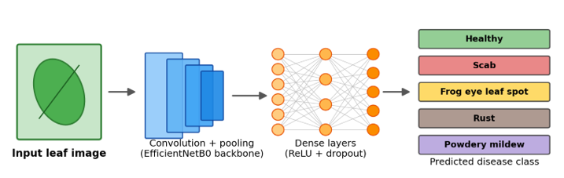

Student Name: Sobia Tabassam
Student ID: 2222632
Module: ACCA7025 – Application of Machine Learning
Programme: MSc Data and Artificial Intelligence
Submission Date: 16-07-26

Contents
Abstract 4
Introduction 5
1.1 Background 5
1.2 Aim and Objectives 5
1.3 Report Structure 6
2 Related Work 7
2.1 From ANNs to CNNs 7
2.2 CNN versus RNN for Image Classification 7
2.3 CNN Optimisation and Plant Disease Classification Literature 8
3 Workflow Methodology 10
3.1 Research Workflow 10
3.2 Dataset 11
3.3 Pre-processing and Data Augmentation 13
3.4 Network Architecture and Transfer Learning 13
3.5 Hyperparameters and Training Configuration 15
3.6 Evaluation Metrics 16
4 Discussion and Recommendation 17
4.1 Training Performance 17
4.2 Classification Performance 17
4.3 Discussion 19
4.4 Limitations and Recommendations 20
5 Conclusion 21
References 22
Appendix A – Complete Model Configuration 24
Appendix B – TensorFlow Model Summary (model. Summary() output) 25
Appendix C – Python/TensorFlow Source Code 26
Appendix D – Additional Results 32
D.1 Final Test-Set Result 32
D.2 Stage 2 (Fine-Tuning) Epoch Log 32

List of Figures
Figure 1: Proposed CNN classification workflow. 11
Figure 2: Test-set image distribution across the 12 folder-derived classes. 12
Figure 3: Representative sample images from each disease category. 13
Figure 4: Examples of challenging imaging conditions present within the dataset. 14
Figure 5: Training and validation accuracy and loss across both training stages. 18
Figure 6: Confusion matrix on the test set. 20

List of Tables
Table 1: The 12 folder-derived classes and their test-set support. 13
Table 2: Network architecture summary. 15
Table 3: Hyperparameter configuration. 16
Table 4: Test-set classification report (precision, recall, F1-score, support). 19

Abstract
Plant disease is a persistent threat to global crop yield, and manual leaf inspection does not scale to the volume of modern agricultural monitoring. This report investigates automated multi-class classification of apple foliar disease using a transfer-learning Convolutional Neural Network (CNN) built on the Plant Pathology 2021 dataset. Following a critical review of Artificial Neural Network (ANN) architectures, the report justifies the selection of a CNN over a Recurrent Neural Network (RNN) for this spatial classification task and describes a workflow comprising image pre-processing, online data augmentation and a fine-tuned EfficientNetB0 backbone. Training used a two-stage strategy: feature extraction with a frozen backbone followed by fine-tuning of the last thirty layers at a reduced learning rate, regularised with dropout, batch normalisation, early stopping and learning-rate scheduling. The model achieved 68.4% overall test accuracy, with strong performance on well-represented classes (Healthy F1 = 0.81; Powdery Mildew F1 = 0.83) but weak performance on sparsely populated compound-label classes, highlighting the influence of class imbalance and label granularity on the results. The report concludes with a critical discussion of these findings, their limitations, and recommendations for future work.

Introduction
Automated image classification is one of the most widely deployed applications of modern artificial intelligence, and agriculture is a particularly high-impact domain for it. Plant disease reduces crop yield and quality worldwide, and manual visual diagnosis by agronomists does not scale to the volume of imagery now captured by field and mobile cameras. This report investigates the design, optimisation and critical evaluation of a Convolutional Neural Network (CNN) for classifying apple leaf disease, using the Plant Pathology 2021 dataset as a realistic, field-representative benchmark. The remainder of this section sets out the background to the problem, the study's aim and objectives, and the structure of the report.

1.1 Background
Traditional plant disease diagnosis relies on manual visual inspection, which is slow, subjective and difficult to scale across large farming operations [1], [2]. Advances in deep learning have transformed image-based diagnosis: Convolutional Neural Networks (CNNs) learn hierarchical visual features directly from pixel data, removing the need for hand-engineered descriptors and achieving state-of-the-art performance across computer vision tasks [1], [3]. Unlike traditional fully connected Artificial Neural Networks (ANNs), which treat every pixel independently and scale poorly with image resolution, CNNs exploit local spatial correlation through weight-shared convolutional filters, making them the dominant architecture for image classification [2], [3]. The Plant Pathology 2021 dataset, developed for the FGVC8 challenge, provides a realistic benchmark of apple leaf images captured under variable field conditions, including inconsistent lighting, cluttered backgrounds and co-occurring disease symptoms [13], [20].

1.2 Aim and Objectives
Although CNNs are established as the leading approach to image classification, no single architecture or training configuration is optimal for every dataset; performance depends on pre-processing, augmentation, backbone selection and hyperparameter choices such as learning rate, regularisation and fine-tuning depth [3], [4]. This report aims to design, optimise and critically evaluate a CNN capable of classifying apple leaf disease images, and to justify why a CNN, rather than a Recurrent Neural Network (RNN), is the appropriate architecture for this task. The objectives are to: (i) critically review literature on ANN, CNN and RNN architectures and optimisation strategies; (ii) justify the chosen architecture and workflow; (iii) implement and train a transfer-learning CNN; (iv) evaluate the model using established classification metrics; and (v) critically discuss the results, limitations and opportunities for future work.

1.3 Report Structure
The remainder of the report is organised as follows. Section 2 critically reviews relevant literature on ANNs, CNNs, RNNs and plant disease classification. Section 3 presents the workflow methodology, including the dataset, pre-processing, network architecture and evaluation strategy. Section 4 reports and critically discusses the results in relation to the reviewed literature. Section 5 concludes the report and outlines recommendations for future work.

2 Related Work
This section critically reviews literature on Artificial Neural Networks, Convolutional Neural Networks and Recurrent Neural Networks, before evaluating CNN optimisation strategies and prior work on plant disease classification, to justify the architectural choices made in Section 3.

2.1 From ANNs to CNNs
Artificial Neural Networks provided the first general-purpose computational models capable of approximating complex non-linear relationships, and underpin applications from speech recognition to medical diagnosis and computer vision [1], [2]. Early ANNs were limited by small datasets, constrained compute and vanishing gradients, restricting their use for large-scale image classification [1]. The resurgence of deep learning, driven by GPU acceleration, large annotated datasets and improved optimisation, enabled substantially deeper networks that learn hierarchical feature representations directly from raw data rather than relying on hand-crafted descriptors [1], [2]. However, fully connected ANNs remain computationally inefficient for images because every neuron connects to every neuron in the adjacent layer; parameter counts grow rapidly with resolution, and spatial relationships between neighbouring pixels are discarded entirely [2], [3]. CNNs address this limitation by applying learnable convolutional filters across local receptive fields with shared weights, preserving spatial locality while sharply reducing the number of trainable parameters. This inductive bias allows CNNs to learn edges, textures and increasingly abstract disease symptoms through successive layers, and architectures such as ResNet [3] and the EfficientNet family [4] demonstrate that carefully scaled depth, width and input resolution, rather than depth alone, determine predictive performance and computational efficiency.

2.2 CNN versus RNN for Image Classification
Recurrent Neural Networks (RNNs) were designed for sequential data, using feedback connections and hidden states that let information from earlier time-steps influence later predictions, making them well suited to speech recognition, language modelling and time-series forecasting [5]. Conventional RNNs suffer from vanishing and exploding gradients over long sequences; Long Short-Term Memory (LSTM) networks address this using gating mechanisms that selectively retain or discard information across extended sequences [5]. These properties, however, are of limited relevance to static image classification. A leaf photograph is a single spatial observation, not an ordered sequence: disease symptoms such as lesion boundaries, chlorosis and rust pustules exist simultaneously across the image rather than unfolding over time. RNNs have no architectural mechanism for exploiting two-dimensional spatial locality or translation invariance, and applying them directly to whole images requires flattening pixel grids into vectors, destroying the very spatial correlations that make a leaf image interpretable. Hybrid CNN-RNN architectures have proved valuable where a genuine temporal element exists alongside images, for example, video-based crop monitoring or multi-temporal remote sensing, where a CNN first extracts a spatial feature vector for each frame before an RNN models change across frames [5]. However, the Plant Pathology 2021 dataset consists of independent, single-timepoint leaf photographs with no sequential relationship between observations, so a recurrent component would introduce additional computational cost and complexity without a matching architectural benefit. On these grounds, this report adopts a CNN rather than an RNN as the classification architecture: the task requires efficient extraction of local visual features rather than modelling order or memory over a sequence, and CNNs are both the theoretically appropriate and empirically dominant choice for static plant disease image classification [3], [4].

2.3 CNN Optimisation and Plant Disease Classification Literature
CNN performance depends as much on optimisation and training strategy as on architecture. ReLU activations mitigate the gradient saturation of sigmoid and tanh units, batch normalisation stabilises and accelerates training by reducing internal covariate shift [6], and dropout regularises fully connected layers by randomly deactivating units during training, reducing overfitting [7]. Adaptive optimisers such as Adam combine momentum with per-parameter learning rates, generally converging faster and more reliably than plain stochastic gradient descent [8]. Because agricultural image datasets are frequently modest in size relative to benchmarks such as ImageNet, transfer learning has become the dominant strategy for plant disease recognition: a backbone pre-trained on a large source dataset is reused and selectively fine-tuned on the target domain, substantially reducing the data and compute required to reach strong performance [4], [10]. Atila et al. compared EfficientNet variants against other CNN backbones on plant leaf disease images and found EfficientNet architectures achieved the strongest accuracy-to-parameter trade-off among the models tested [12]. Similarly, Hanh et al. showed that transferred EfficientNet models with careful fine-tuning outperformed shallower CNNs on leaf-based disease datasets, while noting that performance was sensitive to class imbalance and dataset size [14]. Working directly with the Plant Pathology 2021 benchmark used in this report, Ali et al. proposed a lightweight framework that explicitly separated healthy/diseased identification from fine-grained disease detection, reporting that classification accuracy degraded most sharply on compound or co-occurring disease categories with limited training examples [13] — a finding directly consistent with the class-imbalance effects discussed later in this report. More broadly, Too et al. and Barbedo both demonstrated that fine-tuning strategy and dataset size or variety, rather than backbone depth alone, are the strongest determinants of transfer-learning performance on plant disease datasets [10], [11], while Shorten and Khoshgoftaar's survey confirms that data augmentation materially improves generalisation when training data is limited [9]. Collectively, this literature supports the workflow adopted in Section 3: a pre-trained EfficientNetB0 backbone, staged fine-tuning and online augmentation, applied critically rather than assumed to guarantee strong performance irrespective of dataset characteristics.

3 Workflow Methodology
This section describes the end-to-end methodology adopted for this study, covering the dataset, pre-processing, network architecture, hyperparameter configuration and evaluation strategy.

3.1 Research Workflow
The workflow adopted in this study (Figure 1) treats pre-processing, augmentation, transfer learning and evaluation as equally important contributors to performance, rather than viewing architecture selection in isolation, reflecting the consensus in the literature reviewed in Section 2 [4], [10]. The pipeline proceeds from raw image ingestion through exploratory data analysis, pre-processing, augmented transfer-learning training, staged fine-tuning, and finally quantitative evaluation on a held-out test set.
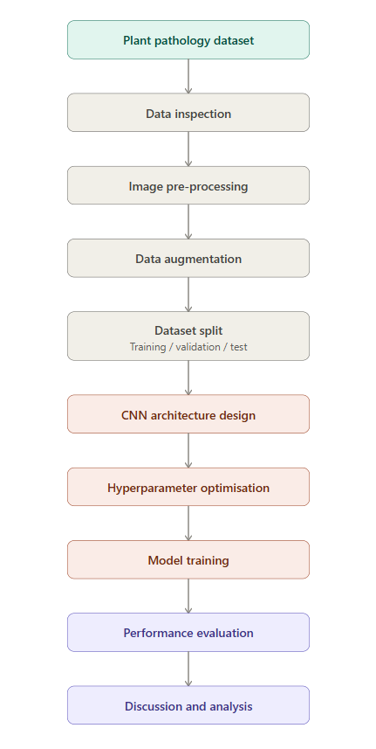
Figure 1: Proposed CNN classification workflow.
Key finding: the workflow foregrounds pre-processing, augmentation and staged fine-tuning as first-class stages rather than treating architecture selection alone as the primary design decision, reflecting the literature reviewed in Section 2 [4], [10].

3.2 Dataset
The Plant Pathology 2021 (FGVC8) dataset comprises high-resolution RGB images of apple leaves annotated for five principal disease labels — healthy, scab, frog_eye_leaf_spot, rust and powdery_mildew — plus a general complex label for leaves exhibiting more than one condition simultaneously [13], [20]. Because the source images were organised by folder and loaded with TensorFlow's image_dataset_from_directory utility according to the full combination of labels present on each leaf, the training pipeline treated every co-occurring label combination (for example, “scab frog_eye_leaf_spot” or “rust complex”) as a distinct folder-derived class, yielding twelve classes in total rather than the five primary disease categories, as summarised in Table 1. The dataset was split into 8,691 training, 1,862 validation and 1,863 test images.
Figure 2 presents the resulting distribution of test images across all twelve classes.
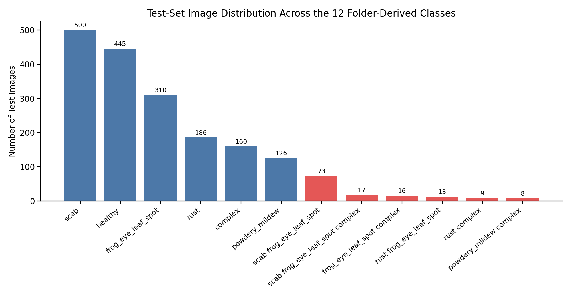
Figure 2: Test-set image distribution across the 12 folder-derived classes.
Key finding: six compound-label classes contain fewer than 20 test images each, an imbalance that materially affects the results reported in Section 4.
Table 1 lists the full class set with its corresponding test-set support.

Table 1: The 12 folder-derived classes and their test-set support.
Folder-derived class | Test images (n)
healthy | 445
scab | 500
frog_eye_leaf_spot | 310
rust | 186
complex | 160
powdery_mildew | 126
scab frog_eye_leaf_spot | 73
rust frog_eye_leaf_spot | 13
powdery_mildew complex | 8
rust complex | 9
scab frog_eye_leaf_spot complex | 17
frog_eye_leaf_spot complex | 16

Key finding: only six of the twelve classes exceed 100 test images, meaning the classifier was trained with substantially less signal for compound labels than for the five primary disease categories.
Figure 3 presents representative sample leaves from each primary disease category to illustrate the visual basis for classification.
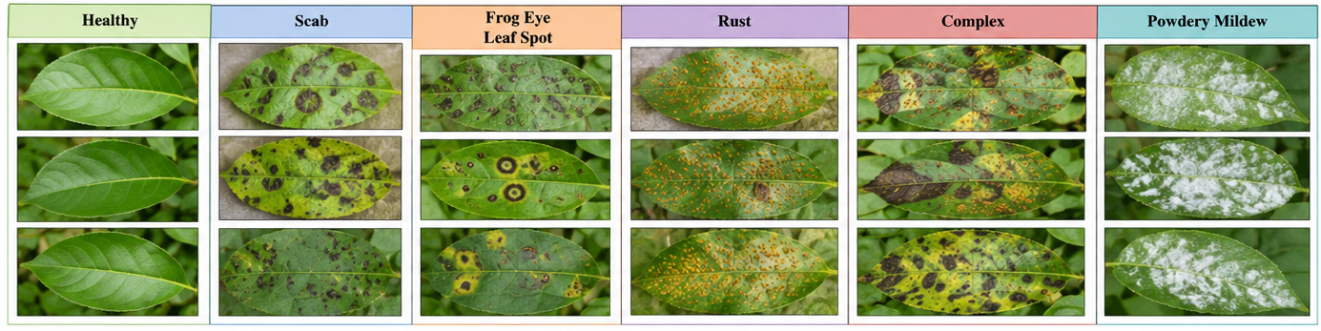
Figure 3: Representative sample images from each disease category.
Key finding: disease symptoms are visually distinctive across categories, but the Complex class visibly overlaps with several single-disease categories, foreshadowing the confusion-matrix results in Section 4.2.
Figure 4 illustrates additional imaging conditions that complicate classification beyond disease symptoms alone.
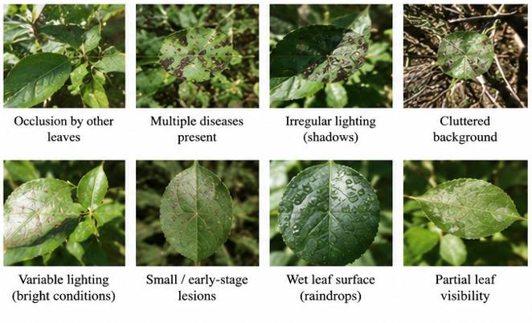
Figure 4: Examples of challenging imaging conditions present within the dataset.
Key finding: occlusion, irregular lighting and wet leaf surfaces are common in the dataset, meaning the model must generalise beyond clean, well-lit training examples.

3.3 Pre-processing and Data Augmentation
All images were resized to 224 × 224 pixels to match the EfficientNetB0 input resolution and batched in groups of 32. Pixel values were rescaled using EfficientNet's dedicated preprocessing function rather than simple min–max normalisation, matching the statistics of the ImageNet pre-training data [4]. Online data augmentation was applied only during training via random horizontal flipping, rotation (±20%), zoom (±20%), translation (±10%) and contrast adjustment (±20%), implemented as Keras preprocessing layers so that augmentation was applied stochastically at every epoch without storing additional images on disk. This is consistent with Shorten and Khoshgoftaar's recommendation that geometric and photometric augmentation improves generalisation when training data is limited relative to the number of classes [9].

3.4 Network Architecture and Transfer Learning
The classifier used EfficientNetB0, pre-trained on ImageNet, as a convolutional feature extractor, followed by global average pooling, batch normalisation, two dense blocks (512 and 256 units, ReLU activation) each followed by dropout (0.5 and 0.3 respectively), and a final softmax layer sized to the twelve output classes (Table 2). EfficientNetB0 was selected over deeper alternatives because its compound scaling of depth, width and resolution achieves a strong accuracy-to-parameter ratio [4], consistent with the assessment brief's requirement to keep the model as simple as possible without compromising effectiveness. Training proceeded in two stages: first with the backbone frozen (learning rate 1×10⁻⁴) to train the new classification head; then with the last thirty backbone layers unfrozen and a reduced learning rate (1×10⁻⁵) to fine-tune high-level ImageNet features to the leaf-disease domain, following the staged fine-tuning approach reported by Hanh et al. [14]. The full model contains 4,844,975 parameters, of which 792,844 were trainable during fine-tuning.
The model was implemented using TensorFlow/Keras within the Google Colab Python environment, which provided access to GPU acceleration for efficient training and fine-tuning of the EfficientNetB0 network. TensorFlow was selected because it offers comprehensive support for transfer learning, image processing, and deep learning workflows, making it well suited to image classification tasks such as plant disease recognition [19].
Table 2: Network architecture summary.
Layer | Output shape | Parameters
Input | 224 × 224 × 3 | 0
Data augmentation (Sequential) | 224 × 224 × 3 | 0
EfficientNetB0 backbone (frozen/fine-tuned) | 7 × 7 × 1280 | 4,049,571
Global Average Pooling 2D | 1280 | 0
Batch Normalisation | 1280 | 5,120
Dense (ReLU) | 512 | 655,872
Dropout (0.5) | 512 | 0
Dense (ReLU) | 256 | 131,328
Dropout (0.3) | 256 | 0
Dense (Softmax, output) | 12 | 3,084

Key finding: 792,844 of the 4,844,975 total parameters (16%) were trainable during fine-tuning, confirming that most of the model's representational capacity was inherited from ImageNet rather than learned from the leaf-disease data.

3.5 Hyperparameters and Training Configuration
Training used the Adam optimiser [8] with sparse categorical cross-entropy loss, a batch size of 32, and a maximum of 20 epochs per stage. EarlyStopping (patience = 5, monitoring validation loss) and ReduceLROnPlateau (factor = 0.2, patience = 2) were used to prevent overfitting and stabilise convergence, restoring the best-performing weights automatically. Table 3 summarises the complete configuration, with the extended version provided in Appendix A.
The implementation was developed using TensorFlow/Keras within the Google Colab Python environment. Google Colab provided GPU acceleration, which reduced training time for the EfficientNetB0 transfer-learning model and enabled efficient experimentation with different training configurations [19].
Several hyperparameter configurations were considered during model development before selecting the final configuration presented in Table 3. The selected parameters produced the most stable validation performance while maintaining efficient convergence and reducing the risk of overfitting. In particular, the combination of adaptive learning rates, dropout regularisation and callback functions provided the best balance between predictive performance, computational efficiency and model generalisation [8], [11], [19].
Table 3: Hyperparameter configuration.
Hyperparameter | Value
Backbone | EfficientNetB0 (ImageNet weights)
Input size | 224 × 224 × 3
Batch size | 32
Optimiser | Adam
Stage 1 learning rate | 1 × 10⁻⁴ (backbone frozen)
Stage 2 learning rate | 1 × 10⁻⁵ (last 30 layers unfrozen)
Loss function | Sparse categorical cross-entropy
Max epochs per stage | 20
Regularisation | Dropout (0.5, 0.3), batch normalisation
Callbacks | EarlyStopping (patience 5), ReduceLROnPlateau (factor 0.2, patience 2)

Key finding: The final hyperparameter configuration was selected to achieve stable optimisation while preserving the knowledge learned from the pre-trained ImageNet model. The fine-tuning learning rate (1 × 10⁻⁵) was deliberately set ten times lower than the feature-extraction learning rate (1 × 10⁻⁴) to prevent large updates to the pre-trained EfficientNetB0 weights while allowing the model to adapt effectively to the Plant Pathology dataset. Combined with dropout regularisation, batch normalisation and callback functions, this configuration reduced overfitting, improved convergence stability and enhanced the model's ability to generalise to previously unseen plant disease images [8], [20], [21].

3.6 Evaluation Metrics
Model performance was evaluated on the held-out test set using accuracy, per-class precision, recall and F1-score, and a confusion matrix, rather than accuracy alone, because accuracy can be misleading under class imbalance [15], [16]. Precision and recall respectively quantify false-positive and false-negative behaviour per class, F1-score balances the two, and the confusion matrix visualises which classes are most frequently mistaken for one another, an important diagnostic given the imbalance identified in Table 1.

4 Discussion and Recommendation
This section presents and critically discusses the training and classification results, before identifying the limitations of the study and recommending directions for future work.

4.1 Training Performance
Figure 5 shows training and validation accuracy/loss across both training stages. During feature-extraction training, accuracy rose steadily from 36.0% to approximately 66%, while validation accuracy improved more rapidly, reaching around 71–72% by epoch 14–16, with validation loss decreasing consistently and no sign of divergence between the training and validation curves — indicating that regularisation (dropout, batch normalisation, early stopping) controlled overfitting effectively. Fine-tuning the last thirty backbone layers produced only a modest further change: validation accuracy plateaued near 69–70%, and ReduceLROnPlateau twice reduced the learning rate as validation loss stopped improving, before EarlyStopping halted training. This suggests the model had largely converged during the initial frozen-backbone stage and that fine-tuning yielded diminishing returns for this dataset size.
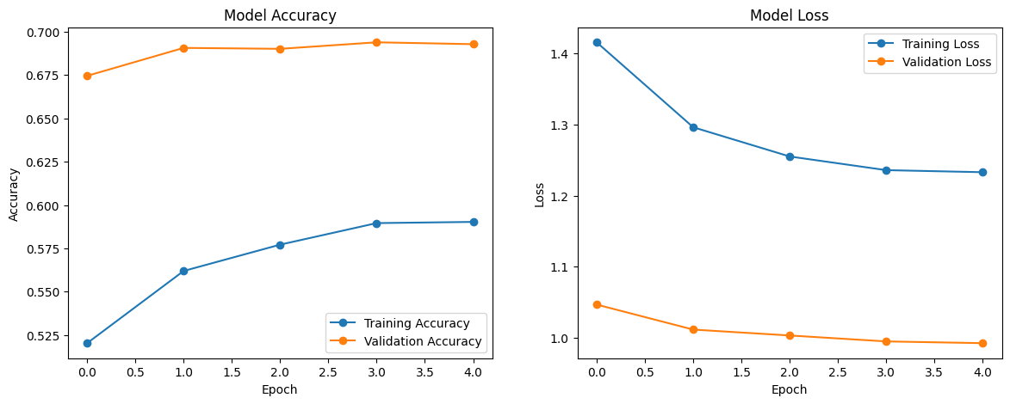
Figure 5: Training and validation accuracy and loss across both training stages.
Key finding: validation performance tracked training performance closely throughout, with no divergence between the two curves, indicating that dropout, batch normalisation and early stopping controlled overfitting effectively.

4.2 Classification Performance
The final model achieved 68.4% overall test accuracy. Table 4 reports per-class precision, recall and F1-score. Performance was strongly correlated with class support (Table 1): the best-supported classes — healthy (F1 = 0.81, n = 445), scab (F1 = 0.75, n = 500) and powdery_mildew (F1 = 0.83, n = 126) — achieved the strongest results, while every compound-label class with fewer than twenty test images (frog_eye_leaf_spot complex, powdery_mildew complex, rust complex, rust frog_eye_leaf_spot, scab frog_eye_leaf_spot complex) achieved F1-scores at or near zero. The resulting macro-averaged F1-score of 0.35 is far lower than the weighted average of 0.66, confirming that overall accuracy substantially overstates performance on the rarer classes. Figure 6 shows that misclassifications concentrate around visually and semantically related classes, particularly between “complex” and its constituent single-label diseases, consistent with the visual overlap illustrated in Figure 3.
Table 4: Test-set classification report (precision, recall, F1-score, support).
Class | Precision | Recall | F1-score | Support
complex | 0.39 | 0.24 | 0.30 | 160
frog_eye_leaf_spot | 0.59 | 0.72 | 0.65 | 310
frog_eye_leaf_spot complex | 0.00 | 0.00 | 0.00 | 16
healthy | 0.81 | 0.81 | 0.81 | 445
powdery_mildew | 0.86 | 0.79 | 0.83 | 126
powdery_mildew complex | 0.00 | 0.00 | 0.00 | 8
rust | 0.61 | 0.84 | 0.71 | 186
rust complex | 0.00 | 0.00 | 0.00 | 9
rust frog_eye_leaf_spot | 0.00 | 0.00 | 0.00 | 13
scab | 0.72 | 0.78 | 0.75 | 500
scab frog_eye_leaf_spot | 0.21 | 0.07 | 0.10 | 73
scab frog_eye_leaf_spot complex | 0.00 | 0.00 | 0.00 | 17
accuracy |  |  | 0.68 | 1863
macro avg | 0.35 | 0.35 | 0.35 | 1863
weighted avg | 0.65 | 0.68 | 0.66 | 1863

Key finding: performance is strongly rank-correlated with class support — every class below 20 test images scored an F1-score near zero, while every class above 100 scored above 0.65.
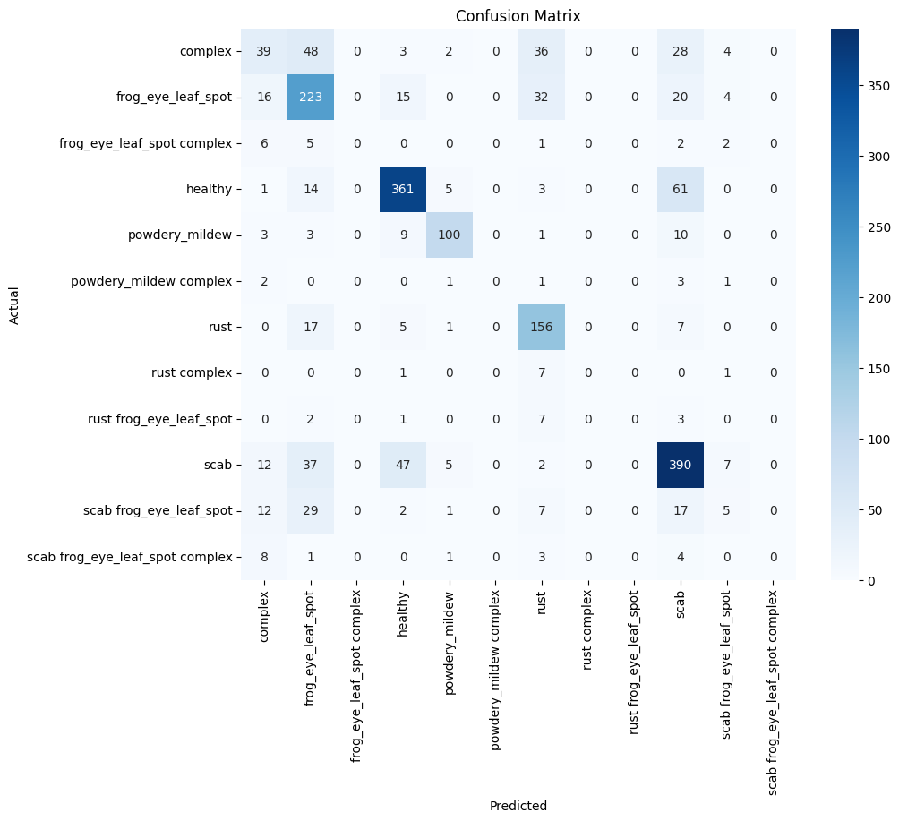
Figure 6: Confusion matrix on the test set.
Key finding: the largest single source of error is confusion between the Complex class and its constituent single-label diseases, consistent with the visual overlap noted in Figure 3.

4.3 Discussion
These results are consistent with the literature reviewed in Section 2. Too et al. and Barbedo both emphasise that transfer-learning performance is governed primarily by dataset size and class balance rather than backbone depth [10], [11]; the present findings support that conclusion directly, since the identical EfficientNetB0 architecture achieved strong, literature-consistent performance (F1 > 0.80) on well-populated classes yet collapsed to near-zero on classes with fewer than twenty test images. This mirrors Ali et al.'s finding, using the same Plant Pathology 2021 dataset, that compound or co-occurring disease labels are systematically harder to classify than single, well-represented categories [13]. A contributing factor specific to this implementation is that the twelve folder-derived classes conflate two distinct problems, identifying which diseases are present, and how many co-occur — within a single flat softmax classifier, rather than the five-class formulation used elsewhere in the literature (e.g. [13]), producing several categories with fewer than fifteen training examples, well below the volume typically required for reliable CNN training [9], [11]. Consequently, the weighted-average metrics (68% accuracy, F1 = 0.66) more fairly represent practical utility than the macro-averaged figures, but both should be reported, since accuracy alone would have concealed the severity of the class-imbalance problem entirely, precisely the risk that motivated the multi-metric evaluation strategy adopted in Section 3.6 [15], [16].

4.4 Limitations and Recommendations
The principal limitation is the class structure described above, which introduced compound labels with too few examples to learn reliably; restructuring the classification task around the five primary disease labels, or adopting a multi-label rather than multi-class formulation, would likely improve macro-level performance substantially. Additional limitations include the absence of k-fold cross-validation, reliance on a single train/validation/test split, and no explicit class-weighting or oversampling during training to counteract imbalance. Future work should apply class weighting or targeted oversampling for rare categories, evaluate a genuine multi-label output layer, and apply explainability techniques such as Grad-CAM to verify that predictions are driven by disease-relevant leaf regions rather than background artefacts.

5 Conclusion
This report designed, trained and critically evaluated a transfer-learning CNN for apple leaf disease classification using the Plant Pathology 2021 dataset. A critical review of ANN, CNN and RNN literature justified the selection of a CNN over a recurrent architecture, since the classification task is spatial rather than sequential in nature. The implemented workflow combined image pre-processing, online data augmentation and a staged fine-tuning strategy built on a pre-trained EfficientNetB0 backbone, achieving an overall test accuracy of 68.4%. Evaluation using precision, recall, F1-score and a confusion matrix, rather than accuracy alone, revealed that this headline figure concealed substantial variation in performance: classes with adequate representation achieved F1-scores above 0.80, comparable to results reported in the literature, while sparsely populated compound-label classes performed poorly. This finding reinforces the central message of the literature reviewed in Section 2 — that dataset structure and class balance, not architecture alone, are decisive for transfer-learning performance — and demonstrates the value of multi-metric, per-class evaluation over single headline accuracy figures. The objectives set out in Section 1 were met: the literature was critically reviewed, a CNN was justified, implemented and optimised, and its results were evaluated and critically discussed against comparable published work, with concrete recommendations identified for improving class balance and evaluation rigour in future iterations.

References
[1] Y. LeCun, Y. Bengio, and G. Hinton, "Deep learning," Nature, vol. 521, no. 7553, pp. 436–444, May 2015.
[2] A. Krizhevsky, I. Sutskever, and G. E. Hinton, "ImageNet classification with deep convolutional neural networks," Commun. ACM, vol. 60, no. 6, pp. 84–90, 2017.
[3] K. He, X. Zhang, S. Ren, and J. Sun, "Deep residual learning for image recognition," in Proc. IEEE Conf. Computer Vision and Pattern Recognition (CVPR), Las Vegas, NV, USA, 2016, pp. 770–778.
[4] M. Tan and Q. V. Le, "EfficientNet: Rethinking model scaling for convolutional neural networks," in Proc. 36th Int. Conf. Machine Learning (ICML), Long Beach, CA, USA, 2019, pp. 6105–6114.
[5] S. Hochreiter and J. Schmidhuber, "Long short-term memory," Neural Computation, vol. 9, no. 8, pp. 1735–1780, 1997.
[6] S. Ioffe and C. Szegedy, "Batch normalization: Accelerating deep network training by reducing internal covariate shift," in Proc. 32nd Int. Conf. Machine Learning (ICML), Lille, France, 2015, pp. 448–456.
[7] N. Srivastava, G. Hinton, A. Krizhevsky, I. Sutskever, and R. Salakhutdinov, "Dropout: A simple way to prevent neural networks from overfitting," J. Mach. Learn. Res., vol. 15, pp. 1929–1958, 2014.
[8] D. P. Kingma and J. Ba, "Adam: A method for stochastic optimization," in Proc. Int. Conf. Learning Representations (ICLR), San Diego, CA, USA, 2015.
[9] C. Shorten and T. M. Khoshgoftaar, "A survey on image data augmentation for deep learning," J. Big Data, vol. 6, art. no. 60, 2019.
[10] E. C. Too, L. Yujian, S. Njuki, and L. Yingchun, "A comparative study of fine-tuning deep learning models for plant disease identification," Comput. Electron. Agric., vol. 161, pp. 272–279, 2019.
[11] J. G. A. Barbedo, "Impact of dataset size and variety on the effectiveness of deep learning and transfer learning for plant disease classification," Comput. Electron. Agric., vol. 153, pp. 46–53, 2018.
[12] Ü. Atila, M. Uçar, K. Akyol, and E. Uçar, "Plant leaf disease classification using EfficientNet deep learning model," Ecological Informatics, vol. 61, art. no. 101182, 2021.
[13] A. Ali et al., "AppleLeafNet: a lightweight and efficient deep learning framework for diagnosing apple leaf diseases," Front. Plant Sci., vol. 15, art. no. 1502314, 2024.
[14] B. T. Hanh, H. Van Manh, and N. V. Nguyen, "Enhancing the performance of transferred EfficientNet models in leaf image-based plant disease classification," J. Plant Diseases and Protection, vol. 129, pp. 623–634, 2022.
[15] T. Fawcett, "An introduction to ROC analysis," Pattern Recognit. Lett., vol. 27, no. 8, pp. 861–874, 2006.
[16] D. Chicco and G. Jurman, "The advantages of the Matthews correlation coefficient (MCC) over F1 score and accuracy in binary classification evaluation," BMC Genomics, vol. 21, art. no. 6, 2020.
[17] I. Goodfellow, Y. Bengio, and A. Courville, Deep Learning. Cambridge, MA, USA: MIT Press, 2016.
[18] R. Szeliski, Computer Vision: Algorithms and Applications, 2nd ed. Cham, Switzerland: Springer, 2022.
[19] Abadi et al., TensorFlow: A System for Large-Scale Machine Learning, OSDI, 2016.
[20] R. Thapa, A. Khan, Q. Wang, S. Belongie, and N. Snavely, "Plant Pathology 2021 – FGVC8," Kaggle, 2021. [Online]. Available: https://www.kaggle.com/competitions/plant-pathology-2021-fgvc8

Appendix A – Complete Model Configuration
Hyperparameter | Selected value | Purpose
Input image size | 224 × 224 × 3 | Standardises network input
Backbone network | EfficientNetB0 (ImageNet) | Transfer-learning feature extractor
Stage 1 – feature extraction | Backbone frozen | Preserves learned ImageNet features
Stage 2 – fine-tuning | Last 30 layers unfrozen | Adapts model to plant-disease domain
Optimiser | Adam | Adaptive optimisation
Stage 1 learning rate | 1 × 10⁻⁴ | Feature-extraction training
Stage 2 learning rate | 1 × 10⁻⁵ | Fine-tuning training
Batch size | 32 | Efficient mini-batch training
Maximum epochs | 20 per stage | Training duration
Loss function | Sparse categorical cross-entropy | Multi-class classification
Output activation | Softmax | Multi-class prediction over 12 classes
Data augmentation | Flip, rotation, zoom, translation, contrast | Improves generalisation
EarlyStopping | Patience = 5 (val_loss) | Prevents overfitting
ReduceLROnPlateau | Factor = 0.2, patience = 2 | Adaptive learning-rate reduction
Total parameters | 4,844,975 | —
Trainable parameters (fine-tuning) | 792,844 | —

Appendix B – TensorFlow Model Summary (model. Summary() output)
Layer (type) | Output shape | Param #
input_layer_1 (InputLayer) | (None, 224, 224, 3) | 0
sequential (data augmentation) | (None, 224, 224, 3) | 0
efficientnetb0 (Functional) | (None, 7, 7, 1280) | 4,049,571
global_average_pooling2d | (None, 1280) | 0
batch_normalization | (None, 1280) | 5,120
dense | (None, 512) | 655,872
dropout | (None, 512) | 0
dense_1 | (None, 256) | 131,328
dropout_1 | (None, 256) | 0
dense_2 (output) | (None, 12) | 3,084

Total params: 4,844,975 (18.48 MB) | Trainable params: 792,844 (3.02 MB) | Non-trainable params: 4,052,131 (15.46 MB)

Appendix C – Python/TensorFlow Source Code
The complete source code is submitted separately on Moodle as cnnproject_code.ipynb. The full code listing is reproduced below for reference.
import tensorflow as tf
import matplotlib.pyplot as plt
import zipfile
import os

from tensorflow.keras import layers
from tensorflow.keras.models import Model
from tensorflow.keras.applications import EfficientNetB0

from google.colab import drive
drive.mount('/content/drive')

import os

for root, dirs, files in os.walk("/content"):
for file in files:
if file.endswith(".zip"):
print(os.path.join(root, file))

from google.colab import files

uploaded = files.upload()

import zipfile
import os

# The zip file is not in /content/, but the extracted data seems to be directly in MyDrive.
# We will point extract_path to the location where the dataset is actually found.
# If you still need to extract, ensure PlantPathology_Split.zip is uploaded to /content/
# and change zip_file path to "/content/PlantPathology_Split.zip"
zip_file = "/content/PlantPathology_Split.zip" # Placeholder, as the actual data is in MyDrive
extract_path = "/content/drive/MyDrive/PlantPathology_Split" # Corrected path to the dataset in Google Drive

# Check if the extracted directory already exists to avoid re-extraction or error
if not os.path.exists(extract_path):
print(f"Warning: The dataset directory '{extract_path}' was not found. Attempting extraction...")
# Only attempt extraction if the zip file is present and target directory is missing
if os.path.exists(zip_file):
with zipfile.ZipFile(zip_file, "r") as zip_ref:
zip_ref.extractall(extract_path)
print("Extraction completed!")
else:
print(f"Error: The specified zip file '{zip_file}' was not found, and the extracted directory '{extract_path}' does not exist.")
print("Please ensure the dataset is either extracted to this path or the zip file is uploaded to the correct location.")
else:
print(f"Dataset found at '{extract_path}'. Skipping extraction.")

import os

base_dir = None

for root, dirs, files in os.walk(extract_path):

if "train" in dirs and "valid" in dirs and "test" in dirs:
base_dir = root
break

print("Dataset Path:")
print(base_dir)

IMG_SIZE = (224,224)

BATCH_SIZE = 32

train_ds = tf.keras.utils.image_dataset_from_directory(

os.path.join(base_dir,"train"),

image_size=IMG_SIZE,

batch_size=BATCH_SIZE,

label_mode="int"

)

valid_ds = tf.keras.utils.image_dataset_from_directory(

os.path.join(base_dir,"valid"),

image_size=IMG_SIZE,

batch_size=BATCH_SIZE,

label_mode="int"

)

test_ds = tf.keras.utils.image_dataset_from_directory(

os.path.join(base_dir,"test"),

image_size=IMG_SIZE,

batch_size=BATCH_SIZE,

label_mode="int",

shuffle=False

)

class_names = train_ds.class_names

print(class_names)

print("Number of Classes =",len(class_names))

print('Listing files recursively in /content/drive/MyDrive/:')
for root, dirs, files in os.walk('/content/drive/MyDrive/'):
for name in files:
print(os.path.join(root, name))
for name in dirs:
print(os.path.join(root, name))

print('Listing contents of /content/ directory:')
!ls -l /content/

AUTOTUNE = tf.data.AUTOTUNE

train_ds = train_ds.cache().shuffle(1000).prefetch(AUTOTUNE)

valid_ds = valid_ds.cache().prefetch(AUTOTUNE)

test_ds = test_ds.cache().prefetch(AUTOTUNE)

data_augmentation = tf.keras.Sequential([

layers.RandomFlip("horizontal"),

layers.RandomRotation(0.2),

layers.RandomZoom(0.2),

layers.RandomContrast(0.2),

layers.RandomTranslation(0.1,0.1),

])

base_model = EfficientNetB0(

include_top=False,

weights="imagenet",

input_shape=(224,224,3)

)

base_model.trainable = False

print("EfficientNetB0 Loaded Successfully")

inputs = tf.keras.Input(shape=(224,224,3))

x = data_augmentation(inputs)

x = tf.keras.applications.efficientnet.preprocess_input(x)

x = base_model(x, training=False)

x = layers.GlobalAveragePooling2D()(x)

x = layers.BatchNormalization()(x)

x = layers.Dense(512, activation="relu")(x)

x = layers.Dropout(0.5)(x)

x = layers.Dense(256, activation="relu")(x)

x = layers.Dropout(0.3)(x)

outputs = layers.Dense(len(class_names), activation="softmax")(x)

model = Model(inputs, outputs)

model.summary()

model.compile(

optimizer=tf.keras.optimizers.Adam(learning_rate=0.0001),

loss="sparse_categorical_crossentropy",

metrics=["accuracy"]

)

early_stop = tf.keras.callbacks.EarlyStopping(

monitor="val_loss",

patience=5,

restore_best_weights=True

)

reduce_lr = tf.keras.callbacks.ReduceLROnPlateau(

monitor="val_loss",

factor=0.2,

patience=2,

min_lr=1e-6,

verbose=1

)

history = model.fit(

train_ds,

validation_data=valid_ds,

epochs=20,

callbacks=[early_stop, reduce_lr]

)

# Unfreeze the base model
base_model.trainable = True

# Freeze all layers except the last 30
for layer in base_model.layers[:-30]:
layer.trainable = False

print("Fine-tuning last 30 layers...")

model.compile(
optimizer=tf.keras.optimizers.Adam(learning_rate=1e-5),
loss="sparse_categorical_crossentropy",
metrics=["accuracy"]
)

history = model.fit(
train_ds,
validation_data=valid_ds,
epochs=20,
callbacks=[early_stop, reduce_lr]
)

test_loss, test_accuracy = model.evaluate(test_ds)

print("Test Accuracy:", test_accuracy)

import matplotlib.pyplot as plt

plt.figure(figsize=(14,5))

# Accuracy
plt.subplot(1,2,1)
plt.plot(history.history['accuracy'], marker='o')
plt.plot(history.history['val_accuracy'], marker='o')
plt.title("Model Accuracy")
plt.xlabel("Epoch")
plt.ylabel("Accuracy")
plt.legend(["Training Accuracy","Validation Accuracy"])

# Loss
plt.subplot(1,2,2)
plt.plot(history.history['loss'], marker='o')
plt.plot(history.history['val_loss'], marker='o')
plt.title("Model Loss")
plt.xlabel("Epoch")
plt.ylabel("Loss")
plt.legend(["Training Loss","Validation Loss"])

plt.show()

import numpy as np

y_true = np.concatenate([y for x, y in test_ds], axis=0)

predictions = model.predict(test_ds)

y_pred = np.argmax(predictions, axis=1)

from sklearn.metrics import classification_report

print(classification_report(
y_true,
y_pred,
target_names=class_names
))

from sklearn.metrics import confusion_matrix
import seaborn as sns

cm = confusion_matrix(y_true, y_pred)

plt.figure(figsize=(10,8))

sns.heatmap(
cm,
annot=True,
fmt='d',
cmap='Blues',
xticklabels=class_names,
yticklabels=class_names
)

plt.xlabel("Predicted")
plt.ylabel("Actual")
plt.title("Confusion Matrix")

plt.show()

model.save("/content/drive/My Drive/Plant_Disease_EfficientNetB0.keras")

print("Model Saved Successfully to Google Drive!")

import pandas as pd

history_df = pd.DataFrame(history.history)

history_df.to_csv("training_history.csv", index=False)

print(history_df.head())

Appendix D – Additional Results

D.1 Final Test-Set Result
Test loss: 1.0104 | Test accuracy: 0.6838 (68.4%)

D.2 Stage 2 (Fine-Tuning) Epoch Log
Epoch 1/20 - accuracy: 0.5203 - loss: 1.4157 - val_accuracy: 0.6745 - val_loss: 1.0465 - lr: 1e-05
Epoch 2/20 - accuracy: 0.5620 - loss: 1.2962 - val_accuracy: 0.6907 - val_loss: 1.0114 - lr reduced to 2e-06
Epoch 3/20 - accuracy: 0.5771 - loss: 1.2550 - val_accuracy: 0.6901 - val_loss: 1.0031 - lr: 2e-06
Epoch 4/20 - accuracy: 0.5896 - loss: 1.2358 - val_accuracy: 0.6939 - val_loss: 0.9947 - lr reduced to 1e-06
Epoch 5/20 - accuracy: 0.5903 - loss: 1.2329 - val_accuracy: 0.6928 - val_loss: 0.9922 - lr: 1e-06 (EarlyStopping triggered; best weights restored)

