

Student Name: Misbah Hafeez

Student ID: 2427255

Module Name: International Marketing

Module Code: LCMB7026

Lecturer’s Name: Tushara Balendran

Term 2

Table of Contents
1. Introduction 5
2. Brand Overview and International Operating. 6
2.1. Comparative Operational Status: US versus India 7
3. Comparison of the Macroenvironment 7
3.1. In-Depth Cultural Comparison (Hofstede’s Dimensions) 8
3.1.1. Advantages and disadvantages of Hofstede framework 9
3.2. PESTLE Analysis 9
Political (P) 9
Legal (L) 9
Economic (E) 10
Social (S) 10
Technological 11
Environmental (E) 11
4. Critical Comparison of Brand’s STP Strategies 12
4.1. Segmentation 13
4.2. Targeting 13
4.2.2. India: The Affordability and Volume Imperative 14
4.2.3. Targeting strategy 14
4.3. Positioning 14
4.4. Perceptual map for the company in USA 16
4.5. Similarities and differences 16
5. Critical Comparison of Marketing Mix (7Ps) Strategies 17
5.1. Market Entry Methods 17
5.2. Product 17
5.3. Price (Revenue Growth Management - RGM) 18
5.4. Place (Distribution) 18
5.5. Promotion 19
5.6. People, Process, and Physical Evidence (The Extended 3Ps) 19
6. Evaluation of Marketing Strategy Performance 21
6.1. Financial Performance Metrics 21
6.2. Market Share and Brand Health 22
6.3. Critical Synthesis of Performance 23
6.4. Customer reviews 23
6.5. Similarities and differences 24
7. Critical Evaluation of Marketing Ethics Practice 24
7.1. The Ethical Framework: Beyond Compliance 24
7.2. The Indian Water Crisis: A Case Study in Ethical Failure 25
7.3. Contemporary Ethical Challenges: CSDs and Health 26
7.4. Ethical Success: Water Stewardship and Circular Economy 27
8. Recommendations and Conclusion 27
8.1. Strategic Recommendations for International Marketing 27
8.1.1. Enhance Revenue Growth Management (RGM) through Data-Driven Hyper-Localisation 27
8.1.2. Dual-Path Innovation: Functional vs. Traditional 28
8.1.3. Strengthen Digital Marketing (Promotion) through Creator Ecosystems 28
8.2. Ethical and Sustainability Recommendations 28
8.2.1. Adopt Proactive Ethical Localism and Stakeholder Governance 28
8.2.2. Link Sustainability to Pricing (RGM) 29
8.3. Conclusion 29
References 30

Figure 1: Overview of Brand (market.us, 2022) 6
Figure 2: Comparison with competitors (Zhechev, 2024) 7
Figure 3: Summary of PESTLE (by author) 12
Figure 4:Coca-Cola’s Market share (Mintel,2024) 15
Figure 5: Coca-Cola US website 20
Figure 6: Coca Cola India Website 21
Figure 7:Growth Statistics (market.us, 2022) 22
Figure 8: Taxonomy eligibility and alignment assessment of Coca Cola (Coca-Cola, 2025b) 25
Figure 9: Protest against Coca-Cola in Kerala (BHRC, 2024). 25
Figure 10: (Zero Sugar Press Release) 26

Introduction
Standardisation or adaptation is a prevalent trade-off that has persistently remained a key issue of concern on the strategic front of multinational corporations (MNCs) operating in the global marketplace (Kotabe, 2022). The dichotomy is especially acute in the case of consumer-packaged goods giants, such as The Coca-Cola Company, the company, the massiveness of which, distributing more than 1.9 billion servings per day, in more than 200 countries, makes the implementation of a marketing mix action especially demanding, but at the same time, flexible (General Facts). This report attempts a critical comparison analysis of the international marketing procedures of Coca-Cola on the totally opposite environment of the United States (US) and India. The US, being a mature, well-saturated, and highly innovative home market experiences issues concerning the necessity to diversify portfolio and stay up to date in the wellness trends, whereas India as a vast, emerging, and highly price-sensitive economy requires a penetration-driven, wellness-based, and complex distribution (The Coca-Cola Company, 2025b).
The main aim of the analysis has two folds. First, it aims to reveal a critical ability to compare the profound effect of cultural and economic differences on Coca-Cola strategic frameworks among macroenvironmental restraints (PESTLE) to operations within market (STP and 7ps). Secondly, and more importantly, the report will examine the current ethical and practical models that the global activity of Coca-Cola is held on especially because of its harsh past of environmental responsibility in India (Karnani, 2023). This also gives the context needed to critically look at the limits of corporate responsibility in a time of increased consumer awareness about sustainability and the management of resources (Mrozek, 2023).
Thus, based on the new data and information engaged in analyzing the strategies' successfulness (i.e. the 2024/2025 financial reports of Coca-Cola, unit case volume indicators, and scholarly studies on digital marketing, Gen Z loyalty, and ethical scandals) the following sections will offer a subtle judgment toward the achievement of the strategies (i.e. the 40 percent GST tax issue in India vs. the FDA labelling pressures in the US) (FDA, 2024). This comparative review will result in generating original findings on the successful management of a globally sized marketing engine and eventually create innovative suggestions of how Coca-Cola can sustain its competitive progression.

Brand Overview and International Operating.
Coca-Cola Company (COCA-COLA) is internationally known due to not only its main product but also as the largest non-alcoholic beverage corporation globally, being a publicly traded company that is based in Atlanta, Georgia (market.us, 2022). COCA-COLA was established in 1886, and it can now reach out to more than 200 countries where it serves about 1.9 billion servings per day which is monumental and indicates its potential in international marketing strategy setting (General Facts). It has a significant financial size with USD $47.06 billion revenue recorded according to the 2024 annual report and more than USD 100.5 billion total assets (market.us, 2022), which prove the statement that the company takes the leading positions in the world non-alcoholic ready-to-drink (NARTD) industry.
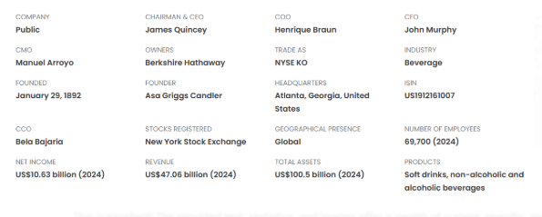
Figure 1: Overview of Brand (market.us, 2022)
COCA-COLA is a critical positioning entity as a total beverage company that is not limited to its CSD origins. With over 500 brands, such as Diet Coke, Fanta, Sprite, Topo Chico, and Minute Maid, it has employed a systematic approach of seeking to get share in the markets of water, juice, coffee and energy (General Facts). This large portfolio is a direct result of the world health trend, in which it needs to be diversified to reduce risks since they face a fall in CSD consumption in developed cities (Zhechev, 2024).
Tactically, COCA-COLA is run under a global franchise strategy, which provides its concentrate to a system of about 225 bottling affiliates (General Facts). It is a model that merges worldwide scale and the local manufacturing and distribution capacities, formalised through its topline growth flywheel model, whereby it targets four interconnected nodes: Marketing, Innovation, Revenue Growth Management (RGM), and Integrated Execution (The Coca-Cola Company, 2025b). This structure is essential to recognize its adaptability to extreme competition with its competitors like PepsiCo, Nestle, and Keurig Dr Pepper (Image 2).
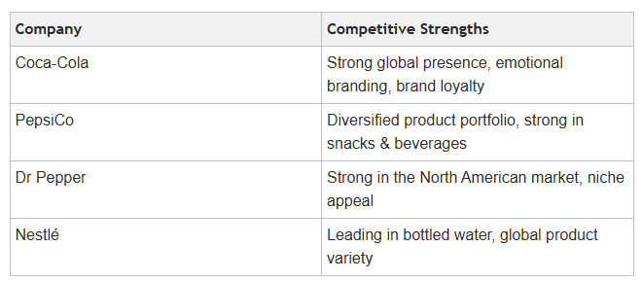
Figure 2: Comparison with competitors (Zhechev, 2024)

Comparative Operational Status: US versus India
Operational Component | The United States (A) – Mature Market | India (B) – Emerging Market
Market Role | Contributes the largest share of revenue. Focus is on Price/Mix and premiumisation (Q4 2024 Results, 2025). | Focus is on Volume and penetration. India, alongside China and Brazil, led COCA-COLA's unit case volume growth in recent reporting (Growth Statistics).
Portfolio Focus | Emphasis on Coca-Cola Zero Sugar (Coca-Cola Company, 2024) and high-margin, functional brands (e.g., BodyArmor, Topo Chico). | Reliance on low unit price packs and key local acquisitions like Thums Up to maintain market relevance in a price-sensitive environment (Dsouza, 2025).
Growth Strategy | Generating revenue through higher pricing and new product categories (+12% Price/Mix in Q4 2024 in North America). | Generating revenue through volume expansion and consumer base conversion (+6% Unit Case Volume in Asia Pacific in Q4 2024).

Comparison of the Macroenvironment
Macroenvironmental asymmetries that are deep-rooted cause the differing business performance of Coca-Cola in the United States (US) and India (Kotabe, 2022). A comparative PESTLE analysis helps to understand that the level of market maturity determines the nature of strategic challenges, which validates De Mooij (2019) in stating that to be successful in marketing, one has to be culturally and contextually adaptable.

In-Depth Cultural Comparison (Hofstede’s Dimensions)

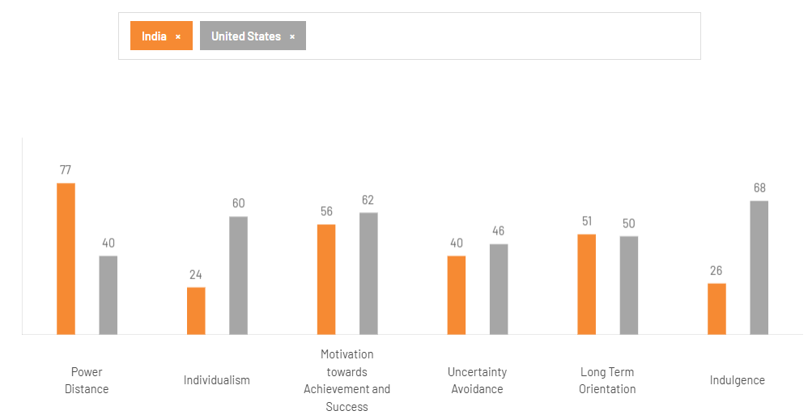
Hofstede Dimension | United States (A) | India (B) | Favourability Assessment
Power Distance (PDI) | Low (Decentralised) | High (Hierarchy accepted) | Favorable / Moderately Favorable
Individualism (IDV) | High Individualism | High Collectivism | Favorable / Favorable
Masculinity (MAS) | High Masculinity (Assertive, competitive) | Moderate Masculinity (Success balanced with cooperation) | Favorable / Neutral
Uncertainty Avoidance (UAI) | Low (Tolerance for change) | High (Need for clear rules/structure) | Favorable / Moderately Unfavorable
Long-Term Orientation (LTO) | Medium-Low (Short-term focus) | High (Pragmatism, perseverance) | Neutral / Favorable
Indulgence (IND) | High Indulgence (Free expression, gratification) | Low Restraint (Control of desires/impulses) | Favorable / Moderately Unfavorable
Overall Cultural Favourability | Favourable (But Mature) | Moderately Favourable (But Complex)

Advantages and disadvantages of Hofstede framework
Aspect | Advantages (Utility in Coca-Cola Analysis) | Disadvantages (Critique of the Model)
Comparative Power | Provides quantifiable metrics for comparing the US and India, objectively justifying the need for high-contrast marketing mix adaptation (Kotabe & Helsen, 2022). | Ecological Fallacy: Risks generalising original findings (based on IBM employees) to the entire national population, ignoring profound intra-national diversity (Kumar et al., 2023).
Strategic Insight | Offers a clear predictive structure for local strategy, explaining why collectivism (India) requires group-focused promotion and low UAI (US) favours rapid product innovation (De Mooij, 2019; Pahlefy et al., 2025). | Static and Dated: The original model is criticised for being culturally static and failing to fully capture the dynamic cultural shifts driven by globalisation and digital technology (Crane et al., 2019).
Managerial Utility | Simplifies complex socio-cultural challenges into a manageable framework, facilitating faster decision-making for marketing managers on standardisation vs. adaptation (Alon et al., 2020). | Oversimplification: Reduces 'culture' to a limited set of scores, potentially overlooking crucial local nuances, religious dietary habits, or traditional substitutes (Mintel, 2024).

PESTLE Analysis

Political (P)
Aspect | United States (US) | India (India)
Primary Tax Challenge | Standard corporate taxes apply. | Punitive 40% GST on aerated beverages (Dsouza, 2025).
Political Risk/Volatility | Low, stable environment for long-term investment. | Greater risk of state-level regulatory volatility and activist scrutiny (BHRC, 2024).
Government Focus | Stable trade agreements and federal lobbying for industry deregulation. | High focus on resource regulation and economic nationalism (Karnani, 2023).

The central limitation on legal factors within the US is the one based on transparency and health regulation. Coca-Cola is also required to comply with strict FDA regulations related to product labeling that demand some dual column nutrition facts that tell the consumer explicitly about the use of multi-serving containers (FDA, 2024). This conformity directly influences the Product and Packaging aspects of the mix, in which greater importance is laid on consumer information.

Legal (L)
Aspect | United States (US) | India (India)
Labeling Requirements | Strict FDA dual-column labeling for consumer transparency (FDA, 2024). | Less stringent, but often complex state-level environmental and operational clearances (Karnani, 2023).
Liability Focus | High liability risk regarding product claims and consumer class actions. | High liability risk regarding resource damage and community compensation claims (BHRC, 2024).

On the other hand, the India political and legal environment is defined by a punitive tax system, which has radically affected the affordability. Soft drinks are a soda that is considered as a sin/demerit product and is subject to an excessively high 40% GST (Goods and Services Tax) (Dsouza, 2025). Such a political decision puts a structural obstacle to market growth, which means that Coca-Cola must concentrate its strategies on lowering the unit price to eliminate the tax burden. Most importantly, instead of what is printed on the label being a crisis in the US, it is the amount of the government dictating the final price that is the Indian crisis (Christie et al., 2023).

Economic (E)
Aspect | United States (US) | India (India)
Primary Growth Driver | Price/Mix (High Margin). Led to +12% Price/Mix growth in Q4 2024 (Q4 2024 Results, 2025). | Volume (High Penetration).
Consumer Price Sensitivity | Low. Consumers tolerate price increases for premium products. | Extreme. 71% of CSD transactions are at ₹20 or less (Dsouza, 2025).
Purchasing Power | High. Supports premium and diversified product portfolios. | Low. Requires focus on low unit price (LUP) packaging.

The most distinct situation is economic conditions. CRM is characterised by a high stable purchasing power, and, in conjunction with it, Coca-Cola can follow a premiumisation strategy, where a strong +12% Price/Mix growth in North America will be achieved in Q4 2024 (Q4 2024 Results, 2025). Price rises are well accepted, and consumers buy high margin products such as water and coffee which are enhanced.
Extreme price sensitivity is the leading factor in the Indian economy (Singaram et al., 2019). The affordability level is decisive, and 71 percent of the CSD transactions were made at each of the 20 or below price points (Dsouza, 2025). This is the economic fact according to which the company should economically sacrifice an elevated percentage per unit in favor of immense volume and penetration, and it is true that volume elasticity is a far better test in this respect than price elasticity.

Social (S)
Aspect | United States (US) | India (India)
Dominant Cultural Trend | Health and Wellness; high demand for low/no-sugar drinks (Zhechev, 2024). | Collectivism (family focus) and vast linguistic diversity (Kumar et al., 2023).
Social Structure | Individualistic (Hofstede). Focus on personal experience and achievement. | Collectivist. Focus on shared/group consumption (Solomon & Behavior, 1994).
Per Capita Consumption | High (Mature market consumption rates). | Extremely Low (9 servings annually), requiring market development (Usage Statistics).

The product and Promotion strategies are basically differentiated by Socio-cultural tendencies. The market of the US is obsessively overrun with health and wellness trends. The consumers require low and no-sugar products, functional drinks, and plant alternatives, and it requires active Product innovation (Zhechev, 2024).
The situation in India, however, is collectivist and characterized by skewness of culture (Kumar et al., 2023). At the same time, as urban health awareness is on the rise, the major issue is to incorporate the brand into various local traditions, languages, and traditional consuming behavior trends (i.e. having to replace the Lassi or local fruit juices) (Mintel, 2024). To do this, there shall be advertising campaigns that are very local and focus on community and family festivals (Solomon, 1994), which is a direct opposite of the US where the message about the digital lifestyle of individualism is in the digital age.

Technological
Aspect | United States (US) | India (India)
Technological Application | Focus on Generative AI for consumer content and marketing efficiency (Recent Developments). | Focus on B2B technology to manage the fragmented distribution channel (Thakur et al., 2025).
Distribution Infrastructure | High capacity for e-commerce and automated distribution centers. | Reliant on B2B apps to manage inventory for 90% kirana stores.

In the technology market, there is also a similarity in that the two markets are moving towards digitalisation, though through a different application. Coca-Cola invests about 65 percent of its media on digital (The Coca-Cola Company, 2025b). It is applied in the US to high-tech consumer data acquisition and personalised marketing by means of AI (Zhechev, 2024). In India, the most crucial element is technological expenditure to activate the fragmented distribution channel (the informal kirana stores) and address the huge mobile-first population (Thakur et al., 2025).

Environmental (E)
Aspect | United States (US) | India (India)
Primary Concern | Packaging Waste and circular economy goals (Mrozek, 2023). | Water Scarcity and Groundwater Depletion (Karnani, 2023).
Ethical Risk Profile | Focus on compliance with advanced sustainability standards (e.g., EU Taxonomy). | Focus on managing severe community backlash and historical ethical failures (BHRC, 2024).

The setting aspect brings into view a vast ethical inequality. The packaging waste and the objectives of a circular economy are pre-eminent in the E-factor in the US (World Without Waste), which is consistent with the advanced EU Taxonomy (Coca-Cola HBC, 2024). The E- factor in India is possessed by the existential crisis of water scarcity and depletion. This puts the company heavily in question concerning its ethical management of resources, which is much more fundamental than packaging and has also led to plant shutdowns and litigations (Karnani, 2023; BHRC, 2024). The environmental crisis changes to resource justice problem in growing India than the waste management issue in the mature US.
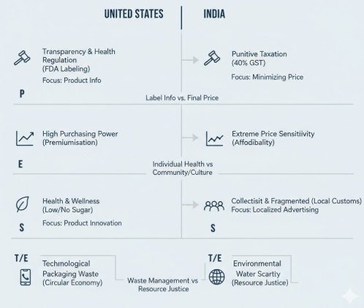
Figure 3: Summary of PESTLE (by author)

Critical Comparison of Brand’s STP Strategies
Segmentation, Targeting, and Positioning (STP) are the pillars that translate macroenvironmental insights into actionable market strategies (Kotabe, 2022). COCA-COLA’s STP shows a strategic divergence based on the market's maturity and economic profile.

Segmentation
COCA-COLA segments markets using a blend of demographic, psychographic, and behavioural variables, but the emphasis shifts profoundly between the US and India.
Segmentation Variable | United States (A) – Saturated Market | India (B) – High-Growth Market | Critical Contrast
Demographic | Highly segmented across age groups for different categories (e.g., Millennials/Gen Z for Creations; older adults for health/tea brands). | Segmentation focuses on low-income groups, with 71% of transactions below ₹20 (Dsouza, 2025), and vast rural vs. urban consumers. | In the US, demographics drive product diversification (functional benefits). In India, demographics (income) dictate price and package size (affordability) (Singaram et al., 2019).
Psychographic | Segments seeking "zero" sugar, natural, organic, or functional benefits. Wellness is a key motivator. | Segments preferring a stronger cola taste (Thums Up) and traditional flavours/formats (Mintel, 2024). Aspirations are a key motivator (Pahlefy et al., 2025). | The US prioritises functional segmentation (what the drink does); India prioritises sensory and traditional segmentation (how the drink tastes/where it is consumed).
Behavioural | Targeted with loyalty programs and exclusive new product trials (e.g., Coke Creations). | Targeted for initial trial, especially in rural areas, via smaller package sizes and low price points (Singaram et al., 2019). | The US focuses on increasing share of wallet among existing consumers; India focuses on increasing penetration and widening the consumer base (Q4 2024 Results, 2024).

Targeting
COCA-COLA's targeting exhibits a move from niche lifestyle targeting in the US to mass market, affordability targeting in India.
    - United States: The Gen Z and Wellness Imperatives
Coca-Cola is an active aggressor among Gen Z (18- 24 age group, 17.01% of users) and young Millennials (25-34 age group, 26.24% of users). This is evident in:
A direct appeal to the next generation is the 2024 campaign, where the question is the 'Best Coke Ever?', in turn, by using AI-produced typography and the TikTok filters are used to allow a shareable experience that is digital native (Zero Sugar Press Release, 2024). This is in line with an initiative towards 65 percent digital media exertion (The Coca-Cola Company, 2025b).
The approach to convince high value buyer It is better to focus on specific need states with new product purchases (e.g., BodyArmor to bodybuilders, Topo Chico to high end mixer buyers).

India: The Affordability and Volume Imperative
The targeted segment is still the mass market, which is the layers of the socio-economic classes in which price is the crucial factor (Dsouza, 2025). Targeting the consumer base where only 9 servings are consumed per capita annually (Usage Statistics), indicating a vast, untapped market for volume growth. The strategy is to convert sporadic consumption into regular consumption through accessible prices (Singaram et al., 2019).
Targeting kirana store owners through co-investments (e.g., coolers, signage) to make COCA-COLA products ubiquitous in the traditional trade channel that accounts for 90% of sales (Dsouza, 2025).

Targeting strategy
Country | Primary Targeting Strategy | Rationale & Evidence (Focus Segments)
United States | Differentiated Marketing | The strategy targets multiple distinct segments with tailored products: Gen Z (18-34) via digital platforms and Creations; Wellness Imperative via BodyArmor and Topo Chico. This approach aims for high market coverage through specialization (Zero Sugar Press Release, 2024).
India | Differentiated / Concentrated Hybrid | Differentiated: Targets multiple segments (urban vs. rural, middle vs. lower class). Concentrated: Exhibits a strong concentration of effort on the vast, price-sensitive mass market (71% of transactions at ₹20 or less) and the kirana store channel (90% of sales) to drive volume penetration (Dsouza, 2025; Singaram et al., 2019).

Positioning
COCA-COLA adapts its brand positioning to resonate with local cultural and competitive dynamics (Aaker, 2020).
Positioning Dimension | United States (A) | India (B) | Critical Critique
Core Brand | "Taste That Speaks for Itself" and "The Original." Emphasises heritage, quality, and the modern, digital-forward experience (Zero Sugar Press Release). | "Thirst-Quenching & Accessible." Positioning is focused on being a celebratory, affordable refreshment that is part of local life and culture (Singaram et al., 2019). | The US position relies on intangible brand equity and high-tech novelty; the Indian position relies on tangible accessibility and strong local relevance (Solomon, 1994).
Functional/Value | Positioned as a premium product in non-CSD categories. Value is captured through size and specific functional benefits (e.g., hydration, energy). | Positioned as a value product in the CSD category. Value is delivered through low unit prices and small packaging to make it an everyday purchase (Dsouza, 2025). | The shift from a Premium/Innovation positioning in the US (focus on price/mix) to a Value/Volume positioning in India (focus on unit case volume) highlights COCA-COLA's strategic agility (The Coca-Cola Company, 2025b).

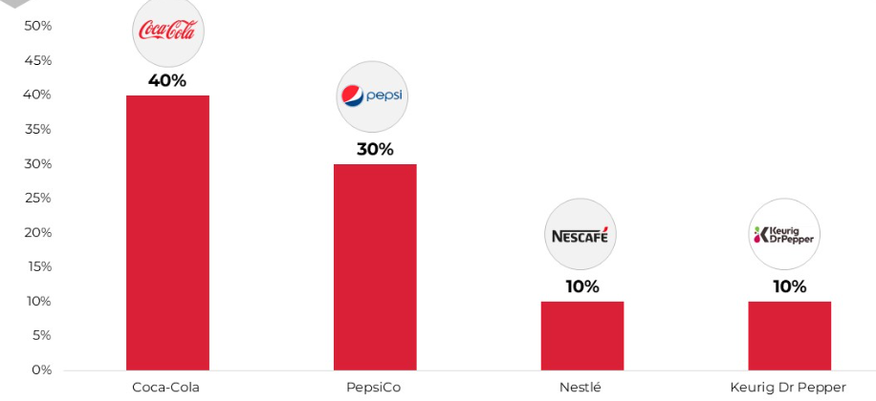
Figure 4:Coca-Cola’s Market share (Mintel,2024)

Perceptual map for the company in USA
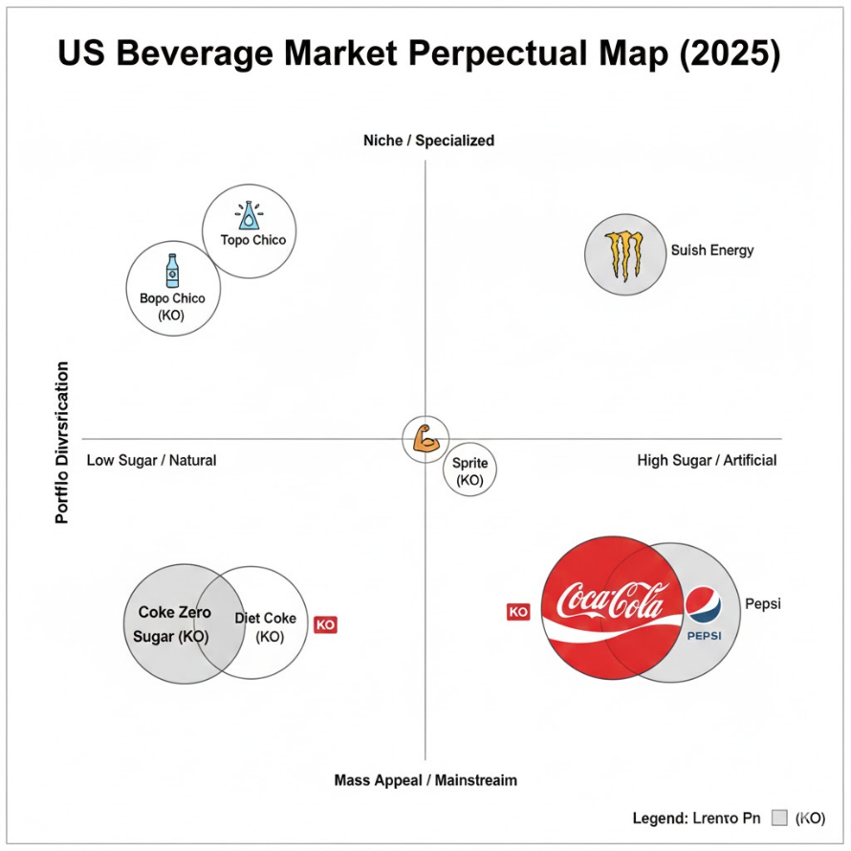

Similarities and differences
STP Component | United States (US) | India
Segmentation Focus | Segments based on low/no-sugar demand, health-conscious trends, and specific lifestyle benefits (Putera et al., 2022). | Segments based on low-income demographics and rural/urban location to drive mass adoption (Dsouza, 2025).
Targeting Strategy | Focus on high-value segments (e.g., BodyArmor) and digital-native youth (18-34) to maximize margin per transaction. | Focus on the vast, price-sensitive consumer base to achieve volume penetration (Singaram et al., 2019).
Positioning Theme | Positioned as a modern lifestyle brand that leads health trends (e.g., Coke Zero Sugar as "Best Coke Ever?" | Positioned as a cultural partner that is universally accessible, emphasizing low price and local relevance (Dsouza, 2025; Kumar et al., 2023).
Strategic Goal | Maximize Profitability and brand equity through premiumization and specialization. | Maximize Volume and market penetration through affordability and ubiquity.

Critical Comparison of Marketing Mix (7Ps) Strategies
The analysis of the 7Ps provides the most detailed evidence of COCA-COLA’s adaptive execution (Kotabe, 2022).

Market Entry Methods
The market of the US is a home market entry/organic growth of Coca-Cola, dating back to its foundation in Atlanta in 1886 (General Facts). Here expansion and entry are based on the constant Innovation and strategic Acquisition of high-growth brands (ex: BodyArmor, Topo Chico) to enter new categories (The Coca-Cola Company, 2025b). The Indian market, on the contrary, has a complicated multi-stage history of market penetration. First moved in 1950s, Coca-Cola had to Exit in 1977 by the government foreign exchange policy, but later Re-enter in 1993 due to economic liberalisation (Karnani, 2023). The current approach in India can thus be characterised as either Acquisition (e.g., Thums Up) and based on the decentralised Franchise/Bottling approach (Singaram et al., 2019). This change of a long-term, organic establishment (US) to a sudden, political re-entry and latter local acquisition (India) introduces the need to adapt to radical marketing.

Product
COCA-COLA’s product strategy adheres to a global core with local wings (Alon et al., 2020), but the nature of the adaptation differs.
Product Element | United States (A) | India (B) | Critical Adaptation
Core Adaptation | Focus on removing calories and adding functional benefits. R&D priority is on CSD flavour innovation (Creations) and acquisitions (Zero Sugar Press Release). | Focus on local taste acceptance and traditional preferences. The continued dominance and promotion of Thums Up (a stronger, local cola) is paramount for market share (Kumar et al., 2023). | The US adaptation is additive (new benefits/brands); the Indian adaptation is substitutive (local brand/flavour preference), proving that sensory experience adaptation is a non-negotiable step in high-contrast markets (Pahlefy et al., 2025).
Packaging | Focus on sustainable materials and clear, large FDA dual-column labels for transparency (FDA, 2024). Packages are typically larger volume. | Focus on affordability and unit size (e.g., 200ml glass bottles). Packaging serves as a critical pricing mechanism to hit the ₹10-₹20 price points (Dsouza, 2025). | Packaging shifts from a sustainability and information vehicle (US) to a core RGM/affordability tool (India) (The Coca-Cola Company, 2025b).

Price (Revenue Growth Management - RGM)
Pricing is where the US Price/Mix strategy and the Indian Volume/Affordability strategy clash most sharply.
Pricing Strategy | United States (A) | India (B) | Critical Contrast
Core RGM | Focus on generating high price/mix growth (12% in Q4 2024) by raising prices on core products and charging a premium for innovative/healthier lines (Q4 2024 Results, 2024). | Focus on maintaining the low price threshold (₹20 and below) through smaller unit sizes to overcome the high 40% GST (Dsouza, 2025). | COCA-COLA’s RGM is deployed to manage value per transaction in the US but to manage affordability and accessibility in India. The price elasticity of demand is vastly different, requiring micro-level pricing for each market segment in India (Singaram et al., 2019).
Pricing Psychology | Promotions are often bundled (e.g., multipacks) or seasonal (e.g., holiday packs), appealing to high purchasing power. | Promotions focus on single-unit price points and visibility at kirana stores to stimulate impulse purchase by low-income consumers (Dsouza, 2025).

Place (Distribution)
Distribution strategy reflects the structural differences in retail infrastructure.
Place Element | United States (A) | India (B) | Critical Contrast
Channel Structure | Highly reliant on organised retail (supermarkets, convenience chains, food service, e-commerce). Bottlers deliver to major distribution centres. | Heavily reliant on 90% traditional retail (millions of kirana stores) that are highly dispersed and often in areas with poor infrastructure (Dsouza, 2025). | The distribution challenge shifts from logistical efficiency (US) to reaching the last mile (India). COCA-COLA must invest significantly in local coolers and dedicated small vehicle networks to penetrate the vast rural market (Dsouza, 2025).
Digital Integration | Seamless e-commerce and direct-to-consumer integration. | Digitalisation is focused on empowering kirana store owners through B2B apps for inventory and ordering (Thakur et al., 2025).

Promotion
COCA-COLA has moved from local advertising to a networked, digital-first marketing model (The Coca-Cola Company, 2025b), but the content remains culturally adapted.
Promotion Element | United States (A) | India (B) | Critical Adaptation
Media Mix | 65% of media spend is digital, leveraging generative AI (e.g., Christmas Ad) and Studio X for global content creation (Recent Developments, Growth Strategy). | While digital is growing (Facebook is 51.23% of social traffic), mass media (TV, Print) remains crucial for non-digital consumers (Traffic Stats). Local celebrities and festivals are heavily used (Singaram et al., 2019). | The US prioritises digital depth and personalised reach; India balances digital breadth (for engagement) with traditional reach (for mass awareness) (Thakur et al., 2025).
Message/Theme | Campaigns focus on product news (Zero Sugar) and the individual experience, often through music and art (Creations). | Campaigns focus on shared consumption moments, family, and local cultural relevance, aligning with the collectivist culture (Kumar et al., 2023).

People, Process, and Physical Evidence (The Extended 3Ps)
The extended marketing mix is vital for service-based elements, particularly in a decentralised global franchise system.
Extended 3Ps | United States (A) | India (B) | Critical Role
People | Focus on innovation and digital expertise (69,700 employees globally, with 8,900 in the US in 2024). Talent acquisition focuses on digital and AI skills (Employee Stats, Recent Developments). | Focus on local language proficiency and relationship management with kirana store owners and local distributors (Singaram et al., 2019). | COCA-COLA’s Human Capital needs shift from technical skills (US) to local relationship skills (India) (Coca-Cola HBC).
Process | Highly automated processes via the $1.1 billion Microsoft Cloud/AI alliance for supply chain and RGM (Recent Developments). Focus on speed-to-market for new launches. | Processes are adapted for complexity, managing inventory and logistics across challenging terrains and fragmented trade channels (Dsouza, 2025).
Physical Evidence | Vending machines (2.8 million worldwide), iconic packaging, and clean, high-tech retail displays. | Crucially, the visibility of the COCA-COLA-branded coolers and local signage at the kirana stores acts as the key evidence of brand ubiquity and availability (Dsouza, 2025).
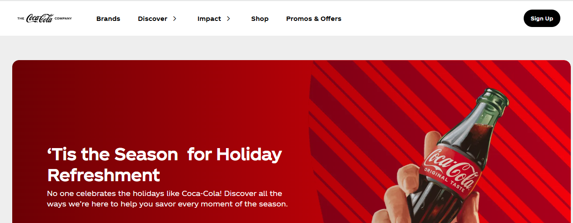
Figure 5: Coca-Cola US website
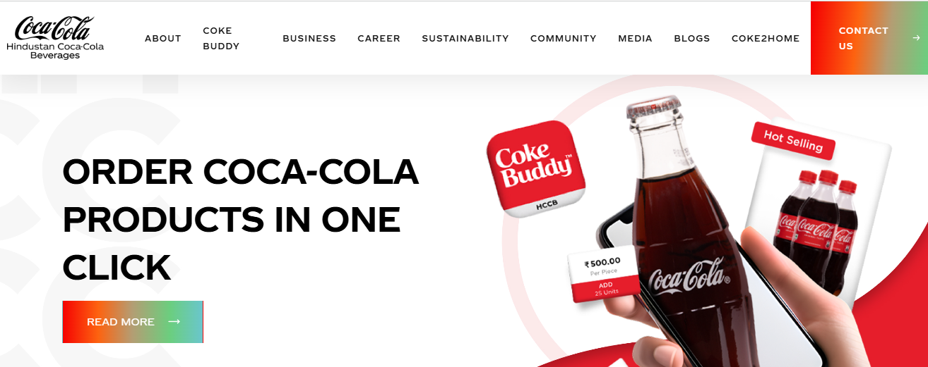
Figure 6: Coca Cola India Website

Evaluation of Marketing Strategy Performance
The success of COCA-COLA’s adaptive strategies must be critically evaluated against measurable market data, comparing the outcomes of the Price/Mix-driven US model with the Volume-driven Indian model.

Financial Performance Metrics
COCA-COLA's recent financial reports provide a clear, contrasting picture of performance drivers (The Coca-Cola Company, 2025a, 2025b).
Metric (Q4 2024) | North America (US) | Asia Pacific (India is a key driver) | Critical Conclusion
Unit Case Volume Growth | +1% (Slow growth) | +6% (Strong growth) | The volume strategy in emerging markets (India) is exceptionally successful, driven by high penetration and affordability strategies (Singaram et al., 2019).
Price/Mix Growth | +12% (Strong growth) | -5% (Decline, driven by unfavourable mix - e.g., sales of smaller, cheaper packages) | North American performance is financially successful due to RGM and premiumisation (Price/Mix), compensating for slow volume growth. Asia Pacific sacrifices Price/Mix for volume dominance (Q4 2024 Results, 2024).
Operating Income Growth | +29% (Highest segment growth) | +24% (Strong, but significantly impacted by currency tailwinds and marketing investments) | The mature US market is the profit engine (high margin per unit), while the emerging Indian market is the volume engine (low margin per unit, high total volume).

Market Share and Brand Health
COCA-COLA has maintained a strong position in the U.S. CSD market since 2000, holding a 42.8% market share (Statista, 2025). The success here is attributed to the portfolio strategy which captures share across adjacent categories (Juice, Water, Coffee).
While specific recent market share data requires local reports (Mintel, 2024), the 6% unit case volume growth (Q4 2024 Results, 2024) and the fact that India, China, and Brazil led global growth (Statista, 2025) confirms the strategic marketing priority is working. The success of Thums Up, an indigenous acquisition, is key to maintaining local brand loyalty against PepsiCo and local competitors (Kumar et al., 2023).
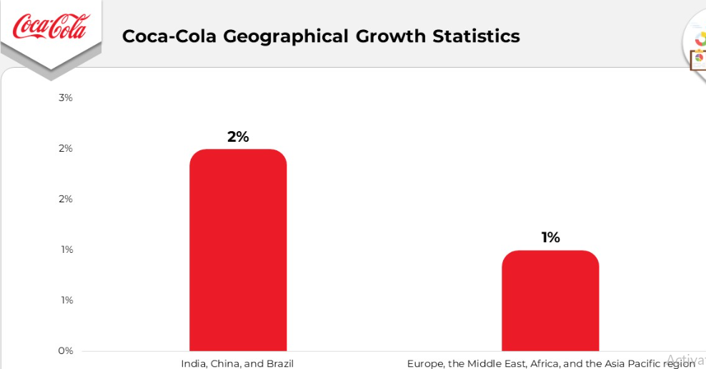
Figure 7:Growth Statistics (market.us, 2022)
8.3. Digital and Consumer Engagement
Online-based promotion strategy demonstrates evident success in the area of engagement that is crucial to target Gen Z (Thakur et al., 2025). Facebook is the leading social media referral platform (51.23%) for coca-cola.com, followed by YouTube (15.75%) (Traffic Stats). This confirms the effectiveness of the 65% digital media spend (The Coca-Cola Company, 2025b).
The use of AI typography and TikTok filters for Coke Zero Sugar (Zero Sugar Press Release) and the success of the Creations platform demonstrate an ability to engage the target 18-34 demographic (User Demographics), driving brand relevance (Aaker, 2020).

Critical Synthesis of Performance
COCA-COLA's marketing strategies are deemed successful, but for divergent reasons:
US Success was achieved through Price/Mix, Innovation, and Portfolio Expansion. The idea will be to maximize profitability in a saturated market by selling more high quality / different drinks to the same consumer.
Volume, Affordability and Penetration Because the objectives of India Success have been achieved. The business aims at maximising volumes by trading in cheap, readily available beverages to a massically converted customer base.
This two-way success highlights the complexity of the integrated implementation model about which local managers can negate the marketing mix and still follow the global RGM objectives (The Coca-Cola Company, 2025b) drastically.

Customer reviews


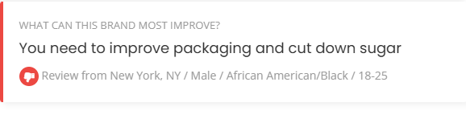


Similarities and differences
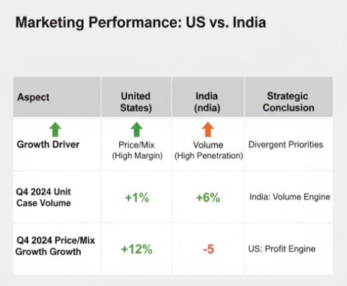

Critical Evaluation of Marketing Ethics Practice
In the case of COCA-COLA, the most urgent ethical issue on the global scale revolves around Environmental Responsibility and the effect it has on the population of its local areas, specifically, the issue of water consumption in the water-stressed countries, such as India (Karnani, 2023).

The Ethical Framework: Beyond Compliance
The moral requirement of a global MNC such as COCA-COLA goes further than the legal requirements (Crane et al., 2019). It must be of higher ethical standard of Corporate Social Responsibility (CSR), in terms of justice in resource usage and stakeholder well-being (Christie et al., 2023). The example of this change is in the EU Taxonomy Alignment, where a company must show a significant contribution to the environmental goals and the absence of substantial harm (DNSH) to the other goals (Coca-Cola HBC, 2024).
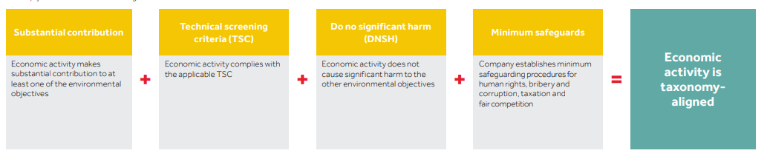
Figure 8: Taxonomy eligibility and alignment assessment of Coca Cola (Coca-Cola, 2025b)

The Indian Water Crisis: A Case Study in Ethical Failure
The worst and long-term ethical scandal that COCA-COLA has ever faced has taken place in India, specifically, at Plachimada, a bottling plant located in Kerala, which was compelled to close (BHRC, 2024).
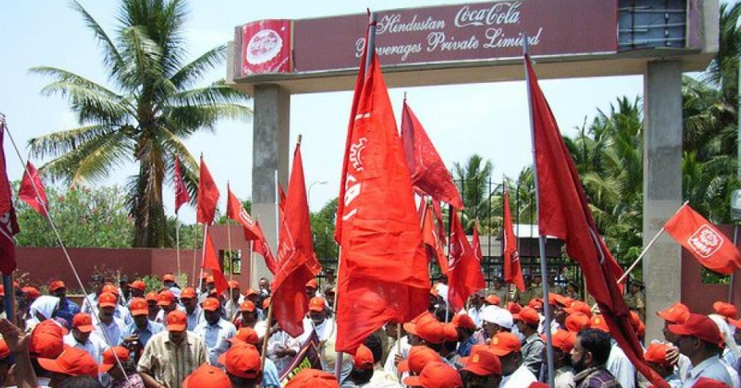
Figure 9: Protest against Coca-Cola in Kerala (BHRC, 2024).
Local communities and NGOs claimed that the abnormal amount of groundwater extraction by COCA-COLA led to critical reduction of water and degradation of its quality harmful to the local agricultural industry, drinking water distribution (Karnani, 2023).
Such is a typical case of a tragedy of the Commons (Karnani, 2023). The real question is whether pursuing corporate profit and volume development, at the expense of human rights and livelihoods of the immediate community, through the exploitation of a common property (groundwater) justify this kind of action?
COCA-COLA out rightly refutes the claims by relying on independent scientific research and stating that the compensation report issued by the Kerala government did not present any scientific evidence and due process (BHRC, 2024).
Although the COCA-COLA Company can now technically justify its stance, the fact that the plant was closed along with the long-running cry among the people indicated a massive ethical failure to implement the marketing mix aspects of the marketing mix namely Place and Process. A marketing process that jeopardizes the natural capital of the community should not be promoted (Karnani, 2023). The crisis highly diminishes the local brand credibility.

Contemporary Ethical Challenges: CSDs and Health
Another, international ethical issue is associated with the advertisement of high-sugar CSDs, especially in the emerging markets, where health awareness and control might be less developed (Karnani, 2023).
The ethical defence that COCA-COLA has against the obesity epidemic is the forceful prescription of Coke Zero Sugar (Zero Sugar Press Release) and the diversification of its portfolio in terms of health. The ethical intervention is government-instigated and is a high taxation (GST) in India (Dsouza, 2025).
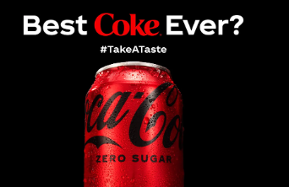
Figure 10: (Zero Sugar Press Release)
The company is responding in a strategic manner through providing growth to its low-sugar business, but it is also using high unit-case growth of core CSDs in emerging markets (Q4 2024 Results, 2024). It is an indication that a difficult ethical juggling process is involved between shareholder value and public health (Crane et al., 2019).

Ethical Success: Water Stewardship and Circular Economy
At the global level, COCA-COLA has already performed some practical ethical investments in CSR (Mrozek, 2023):
The company asserts that it has been replacing 100 percent of all the water in its produced beverages since 2015 (Coca-Cola, 2025b).
On the issue of global plastic crisis, the commitment of picking and recycling one bottle or can in every pack sold by 2030 tackles this problem (General Facts).
This proves that COCA-COLA is a company that is implementing the current, proactive CSR activities towards a circular economy model (Mrozek, 2023). Nonetheless, the historical example of the Indian water crisis has become an influential example proving that even numerous worldwide CSR achievements can be overwhelmed by local ethical shortcomings (BHRC, 2024).

Recommendations and Conclusion
COCA-COLA’s success is currently predicated on maintaining a high-margin premium model in the US and a high-volume affordability model in India. To sustain this trajectory and mitigate growing ethical risks, the following recommendations are critically proposed.

Strategic Recommendations for International Marketing

Enhance Revenue Growth Management (RGM) through Data-Driven Hyper-Localisation
The existing RGM concept is winning, although its simplicity in India (40% GST, 20 price point) is demanding innovation.
Install a new, highly automated AI-based RGM system (based on the investment in Microsoft Cloud) to dynamically regulate the package-price-promotion (3P) formula at the kirana store level (Process). This brings RGM to the level of a segmented approach to a hyper-local, real-time approach (The Coca-Cola Company, 2025b).
The profit maximization capacity will be the greatest with optimal RGM because of the high price elasticity in India (Dsouza, 2025). The demand fluctuations at the 90% kirana store channel will be predicted using AI, and this will maximise the volume growth without the unnecessary compromise of Price/Mix (Thakur et al., 2025).

Dual-Path Innovation: Functional vs. Traditional
To keep up with the market maturity, innovation must go on two parallel lines (The Coca-Cola Company, 2025b).
In established markets such as the US doubled down on Functional Beverages (Product). Target new product lines such as adaptogenic, high-protein plant-based milks, and high-performance waters to attract the wellness consumer, who will have high margins of Gen Z (Putera et al., 2022). In the emerging markets like India invest in Traditional/Regional Product Innovation (Product). Beyond Thums Up, COCA-COLA should acquire or develop more brands based on regional tastes (e.g., Aam Panna, local spice flavours) to directly compete with the strong local substitutes, using the local bottling network for distribution (Mintel, 2024).

Strengthen Digital Marketing (Promotion) through Creator Ecosystems
While COCA-COLA uses digital, it can deepen engagement with Gen Z globally, aligning with the saved objectives on social media trust (Thakur et al., 2025).
Shift a portion of the digital budget from mass social media (Facebook, 51.23% share) to investing in a decentralised content creator ecosystem (Promotion). This is by paying the micro-influencers to organically incorporate the COCA-COLA products in their everyday lifestyle content especially on the Creations platform.
Gen Z believes in the genuine peer driven content (Putera et al., 2022). The proposed approach will increase the awareness of the brand and trust among this group, making the use of social media associated directly with the long-term loyalty (Ling et al., 2023).

Ethical and Sustainability Recommendations

Adopt Proactive Ethical Localism and Stakeholder Governance
The moral criticism in India requires a paradigm in the local philosophy of operation (Karnani, 2023).
Establish an obligatory local Resource Governance Board (LRGB), which is independent of every bottling plant in a water-stressed area. The person responsible should have equal representation by the local community, non-governmental organizations and personnel of COCA-COLA/bottlers (Process/People).
This brings COCA-COLA to a defensive, legally compliant position (BHRC, 2024), instead of that of shared governance and proactive accountability (Crane et al., 2019). It would anticipate crises in future and harmonize the ethical practice with the nature of global sustainability pledges of the firm (Mrozek, 2023).

Link Sustainability to Pricing (RGM)
A clear Circular Economy Surcharge on US and European products, with direct investment of the proceeds specifically to invest in infrastructure projects to promote the World Without Waste in emerging markets (Price/Process). This capitalizes on the increased readiness of the US consumer (US is the profit engine) to pay more to achieve sustainability to finance the environmental investment required on the high growth, infrastructure barren markets of developing countries such as India. This fills the space between the international objectives and the domestic activity.

Conclusion
The Coca-Cola Company has managed to implement an expensive, bifurcated international marketing strategy and excelled in both profit maximising maturity of the US and the volume maximising potential of India. In the US market, innovation, the digital interaction, the high cost are reward, whereas in the Indian market, the market is extremely adaptive in terms of the price, distribution, and the taste of the products. Nevertheless, the long-term ethical shroud of the Indian water crisis is a looming danger to the COCA-COLA international brand equity. The future course requires not only creative product and price policy, but a radical initiative towards vigorous local ethical governance. COCA-COLA can become a really viable and its future global market leader by going to hyper-local RGM, dual-path innovation and stakeholder-driven approach of managing resources. This progressive and dynamic strategy is decisive when an MNC wants to prosper in the long-term the highly contrasting global economic environment that is ethically disputed.

References
Aaker, D., (2020). Aaker on branding: 20 principles that drive success. Morgan James Publishing.
Alon, I., Jaffe, E., Prange, C. and Vianelli, D., (2020). Global marketing: strategy, practice, and cases. Routledge.
BHRC (2024). Coca-Cola statement re compensation. [online] Business & Human Rights Resource Centre. Available at: https://www.business-humanrights.org/en/latest-news/Coca-Cola-statement-re-compensation/.
Castanho, P., (2025). Internationalization and International Marketing: Principles and Literature Issues. In Evolving Strategies for Organizational Management and Performance Evaluation (pp. 381-398). IGI Global Scientific Publishing.
Christie, P.M.J., Kwon, I.W.G., Stoeberl, P.A. and Baumhart, R., (2023). A cross-cultural comparison of ethical attitudes of business managers: India Korea and the United States. Journal of Business Ethics, 46(3), pp.263-287.
Coca-Cola (2025). Coca-Cola Reports Fourth Quarter and Full Year 2024 Results. [online] The Coca-Cola Company. Available at: https://investors.Coca-Colacompany.com/news-events/press-releases/detail/1128/Coca-Cola-reports-fourth-quarter-and-full-year-2024-results.
Coca-Cola Company (2024). Is Coca-Cola Zero Sugar the ‘Best Coke Ever?’ [online] Coca-Colacompany.com. Available at: https://www.Coca-Colacompany.com/media-center/is-Coca-Cola-zero-sugar-the-best-coke-ever.
Coca-Cola HBC (2024). 2024 Integrated Annual Report. [online] CCH Group Website. Available at: https://www.Coca-Colahellenic.com/en/investor-relations/2024-integrated-annual-report.
Coca-Cola (2025b). Sustainability. [online] Coca-colacompany.com. Available at: https://www.coca-colacompany.com/about-us/sustainability.
Crane, A., Matten, D., Glozer, S. and Spence, L.J., (2019). Business ethics: Managing corporate citizenship and sustainability in the age of globalization. Oxford university press.
De Mooij, M., 2019. Consumer behavior and culture: Consequences for global marketing and advertising.
Dsouza, S. (2025). IBA asks finance ministry to reduce GST on aerated beverages to 18%. [online] @bsindia. Available at: https://www.business-standard.com/industry/news/iba-gst-cut-request-aerated-beverages-finance-ministry-125090201262_1.html [Accessed 9 Nov. 2025].
FDA (2024). How to understand and use the nutrition facts label. FDA. [online] Available at: https://www.fda.gov/food/nutrition-facts-label/how-understand-and-use-nutrition-facts-label.
Karnani, A., (2023). Corporate Social Responsibility Does Not Avert the Tragedy of the Commons–Case Study: Coca-Cola India. In Strategic Corporate Responsibility and Green Management (Vol. 16, pp. 39-58). Emerald Publishing Limited.
Kotabe, M.M. and Helsen, K., (2022). Global marketing management. John Wiley & Sons.
Kumar, A., Chadha, P. and Srinivasan, R., (2023). A Comparative Study of India, USA, South Korea and France's Culture Based on Hofstede and Hall’s Cultural Framework. Cross-cultural Business and Management: Perspectives and Practices, p.163.
Ling, G.Y., Yuang, G., Zhicheng, G., Xuan, G.T.X., Maharani, C.D., Genira, C.F., Tyagi, N. and Saidhanyakumar, M., (2023). Analysis of Factors Affecting Brand Loyalty: A Study of Coca-Cola. Asia Pacific Journal of Management and Education, 6(3), pp.16-29.
market.us (2022). Coca-Cola Statistics and Facts. [online] Market.us. Available at: https://market.us/statistics/food-and-beverage-companies/Coca-Cola-company/.
Mintel (2024). India Juice and Juice Drinks Market Report 2024 | Mintel Store. [online] Mintel Store. Available at: https://store.mintel.com/report/india-juice-juice-drinks-market-report.
Mrozek, M., (2023). Sustainable strategies for risk management process of Coca-Cola Company with regard to promote climate resilience efforts and agricultural sustainability. Chosen contexts. Journal of Environmental Management and Tourism (JEMT), 14(3 (67)), pp.778-786.
Pahlefy, M.R., Wenedy, A., Rahman, M.F., Toruan, L.G.O.L. and Camila, A.C., (2025). Cross-Cultural Marketing Failures And Successes: Lessons From Global Brands. Jurnal Adijaya Multidisplin, 3(01).
Porter, M.E., (2008). The five competitive forces that shape strategy. Harvard business review, 86(1), p.78.
Putera, I.M.V.N.B., Atmadhi, R.G., Arpin, N.P.R.L., Susanto, P.C. and Dewi, P.C., (2022). Analysis of Visual Elements and Responses of Generations Z on Coca-Cola'The Great Meal'Advertising Video. SSRN.
Sheth, J. and Sisodia, R., (2022). The rule of three: Surviving and thriving in competitive markets. Simon and Schuster.
Singaram, R., Ramasubramani, A., Mehta, A. and Arora, P., (2019). Coca Cola: A study on the marketing strategies for millenniums focusing on India. International Journal of Advanced Research and Development, 4(1), pp.62-68.
Solomon, M.R. and Behavior, C., (1994). Buying, having and being. London: Prenticle Hall.
Statista (2025). Topic: Coca-Cola Company. [online] Statista. Available at: https://www.statista.com/topics/1392/Coca-Cola-company/?srsltid=ARcRdnq_1x3NIBfIVufp2XQNtnH654G-FKaDIURCQWIxLtaaCWZdgsIf [Accessed 9 Nov. 2025].
Thakur, A., Singla, K., Singla, K., Ansari, A., Mishra, A., Kaur, S. and Kaur, P., (2025). Nurturing sustainability: the interplay among digital marketing communication, online customer experience and sustainable purchase intention. International Journal of Innovation Science.
The Coca-Cola Company (2025a). Annual Filings (10-K). [online] The Coca-Cola Company. Available at: https://investors.Coca-Colacompany.com/filings-reports/annual-filings-10-k.
The Coca-Cola Company (2025b). The Coca-Cola Company. [online] The Coca-Cola Company. Available at: https://investors.Coca-Colacompany.com/about/growth-strategy.
Zhechev, V., (2024). A dive into the marketing trends of 2024: insights to unlocking potential. Business & Management Compass, 68(1), pp.54-65.

