

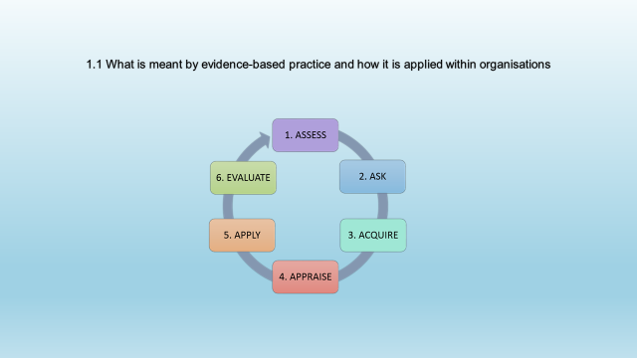
- 1.1
According to CIPD (2022) Evidence based practice is research evidence that is gathered from consumers to give us relevant and valid evidence to help us understand what changes we need to make within the organisation. An evidence-based approach is a continuous, critical assessment of research material to decide what information is reliable and what policies and practises, based on the best available evidence, would be the most beneficial. It also entails stringent quality assurance and assessment to guarantee that evidence-based procedures are duplicated accurately and that novel methods are examined to verify their efficacy. (Wikipedia, no date) In a nutshell, it's about nurturing and establishing best practises and thinking by examining and critically assessing genuine evidence and data about a topic rather than relying on personal subjective judgments or hearsay (The OR briefing,2022)
There are different methods used for evidence based practice, some examples are organisational data collection from customer feedback, employee surveys, scientific evidence. The goal is to have access to the "best evidence" in order to inform practise. The word "best evidence" refers to data gathered from a variety of sources, such as the above. Evidence from these sources makes no decision. Rather, it informs the decision and HR professionals are the best based on their experience and abilities, the thoughts and experiences of other practitioners, data from the organisation, academic research, and feedback from stakeholders, clients and customers. Helps determine the course of action. (The OR briefing, 2022)

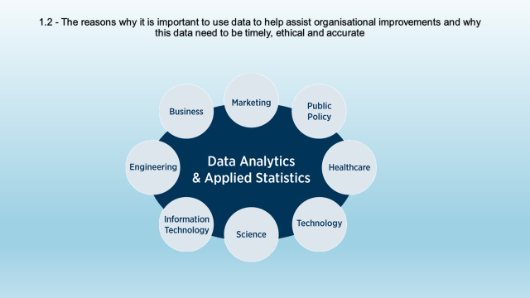
1.2
Without having data we struggle to know who our customers are, gathering data will tell us who our customers are and a better understanding of our business. According to Philipps (no date) a Deloitte report showed “49 percent of respondents said analytics helps them make better decisions, 16 percent say that it better enables key strategic initiatives, and 10 percent say it helps them improve relationships with both customers and business partners.”
Data is knowledge and it helps us to track and analyse from business processes enables us to find performance breakdowns, allowing us to better understand each phase of the process and determine which parts need to be improved and which are doing well, this in hand helps us save time and money and improve on quality. (CQL, No date)
It is essential we maintain accurate data as in the absence of reliable, accurate and timely information people and organisations will make the wrong decisions when implementing a change. The way in which data is collected, and published to be useful in determining the scope of issues or the efficacy of programmes meant to address them, data must be collected and analysed in a transparent, rigorous manner, in line with accepted sampling and other statistical procedures, and devoid of any appearance of pre-determined bias. (Eslake, 2006)
According to Marr (2018) HR is now more than ever a valuable asset when it comes to data. Whilst HR data is used to improve decisions, HR data is used to enhance choices, Keep employees happy, and optimise methods this adds. Having timely data gains advantage against other organisations as it keeps us on the right track to making the right decisions. Data collected must be ethical not bias and legal in how this data will be used, stored and length of time it is kept. We must adhere to data protection laws and legislation when holding such data. (Marr, 2018)

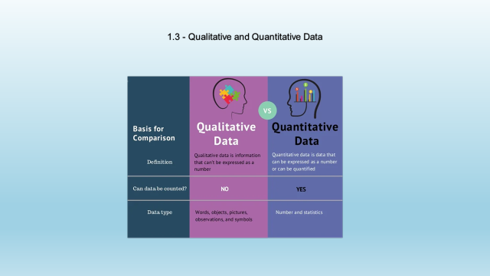
- 1.3
There are two types of data measurement, qualitative and quantitative. Qualitative data refers to qualities meaning description and can be described such as someone has blue eyes or the types of vehicles people drive, any details about something or someone. Quantitative data is anything that can be measured or counted in numerical values. (McLeod, 2019)
There any are many ways of gathering different types of qualitative data such as focus groups, case study, purpose sampling, keeping a journal to document experiences. Quantitative data research can consist of survey research, customer satisfaction surveys, Correlational research and more (Fernandez, 2019)
According to RingLead (no date) Data is the cornerstone of a company's information, knowledge, and, eventually, wisdom for making the right decisions and taking the right actions. This data will aid in the organisation's growth if it is relevant, complete, accurate, meaningful, and actionable. If not, it could become a useless and even damaging asset for a growing business. As a result, data management activities should be implemented in order to improve the data and information quality. Because data is created, stored, managed, used, and even destroyed, organisations must effectively manage the data cycle. The data life cycle begins even before the data is gathered when data management is done correctly
HR can use raw data which has been analysed to look into for example employee turnover to understand the reasons why people are leaving, recruitment to identify the best candidates, employee retention to help us retain our workforce, turnover of profits within the organisation. Having this data information which supports the proof in on making the essential enhancements and plan for future drives. (valamis, 2021)

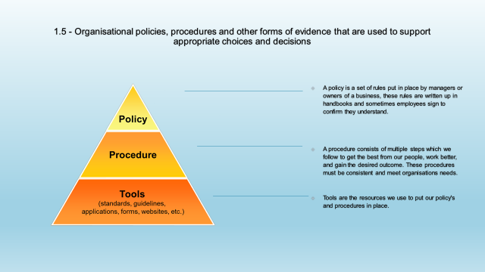
- 1.5
Organisations use policies and procedures to set guidance and rules to adhere to when dealing with problems that arise within the workplace. Policies and procedures are there so employees understand our company values and views. Most organisations have these in place and the purpose is to show employees how we expect them to behave and our procedures we put in place will show the way for us to follow. (Omnisecu, No date)
Having policies and procedures in place is important, it’s a way of communicating our vision and also simplifying our process to follow for all. Having clearly documented policies helps avoid unnecessary events. Managers must enforce these policies and be consistent without bias. (snook, 2021)
According to Sineriz (2019) within organisations having policies and procedures also protects us against law suits, they are consistent for all members of the workforce to follow and be aware of what they should do in any situation. These policies cover a range of matters for example employee time of for dependents or annual leave, health and safety, conduct, pay grades.
Policies and procedures give instruction and explain how things are done, these can be referred to when for example a member of staff requires long term absence from work and they need to know what procedure to follow. They also provide expectations which are clear to all managers and employees, further more they limit the workforce being treated unreasonably. (Sineriz, 2019)

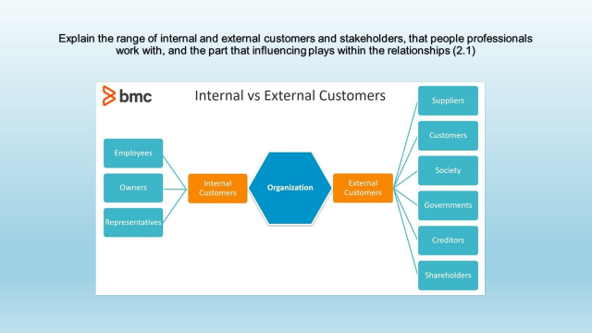
- 2.1
External customers can be customers who pay for our product or services, consumers are customers who can use our product to consume. Such customers include suppliers and creditors. External customers are extremely important as they bring in our revenue. It is important HR employ the right people to give a positive experience to keep customers happy and meet expectations. Also stakeholders and shareholders fall into the same category as internal customers. (BBC, no date)
People Professionals interact with a wide spectrum of stakeholders, including creating and maintaining strong relationships with senior stakeholders in order to promote participation on people problems. This vocation relies heavily on staying current on significant trends and advances in the field. People Professionals play an important role in persuading senior stakeholders and making change recommendations by analysing future workforce trends and providing insight into people analytics. (Institute for apprentices, no date)
HR departments must deliver fully integrated and reinforcing HR policies, practises and processes to provide value for line managers and workers. Line managers and workers want HR teams to integrate HR processes vertically with company objectives. They avoid procedures that are contradictory or inconsistent, resulting in several conflicting goals. (Brockbank, 2016)

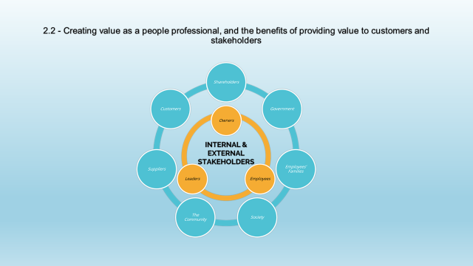
- 2.2
According to Dijk (no date) In organisations many people have a concept that people professionals are there to reduce costs, or manage the workforce, however whist this is true people professionals also have an important job in keeping employees happy and engaged as well as being productive.
The purpose is to create value for employees and the organisation whilst keeping costs down and having the right people in the right roles. Creating value for employees in developing employees from within which in result increased productivity and quality of work, it also makes employees feel like they have a purpose. In terms of organisation value this would be new investments, new customers or expanding business growth as a result. (Dijk, no date)
In order to create value People Professionals must maximise employee potential to keep costs down, determine priorities and identify the most strategically important for each area of the organisation whilst also delivering learning and development to employees and ensuring policies and procedures are kept up to date. (dijk, no date)

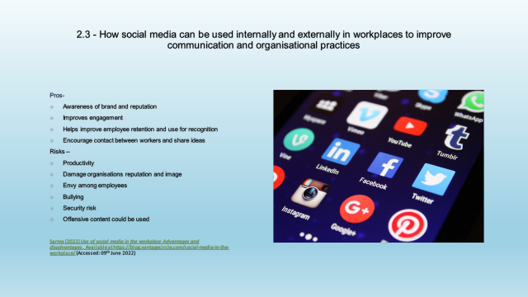
- 2.3
The use of social media within the workplace has many benefits, using social media sites employees can build relationships with people outside of the organisation. They can also create connections, employment opportunities, gather new information and ideas that could help drive change within the business. Social media can also be used for distant learning online training programmes. According to Willbold (2019) there are many disadvantaged individuals who cannot commit to regular classes so having distant learning available online encourages employees to get involved in the programme. He also talks about how communication and collaboration is better used as an outcome and how literacy is improves.
There are two ways of communication within the workplace, this is external and internal. Internal communication happens among the company employees and also between employees and managers, external communication is between employees, managers and customers (webb, 2011) – find ref
Social media has changed the way we communicate, the way we advertise, and the way we look for information. With such platforms such as Facebook, twitter, LinkedIn and many more we utilise such platforms to advertise jobs or simply something for sale, it is also a platform for businesses to conduct training and circulate information to both internal and external audience. (SHRM, 2016)

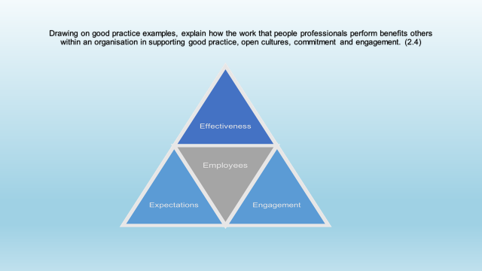
- 2.4
According to Norman (2011) People professional play an important part of any organisation. People professional roles have influence on both external and internal people. Employees benefit from People professionals as they have an open approach to culture which is exceptionally important within a diverse organisation. People professionals have to be approachable and allow employees to have their say. The above makes employees feel valued and that their opinion matters even if it is not acted upon. Productivity is increased in employees who feel valued and appreciated.
The people professional benefit the organisation by creating a better workplace, a workplace where all employees are valued and respected, one where we invest in our people and foster a positive work culture. (Mohdzaini, 2021)
The HR department is responsible for hiring, training, developing & management employees. People professionals support good practices in an organisation by ensuring a safe & healthy work place, creating values which includes a code of ethics that can be used and imbedded in the day to day life of an organisation. (CIPD, 2022)

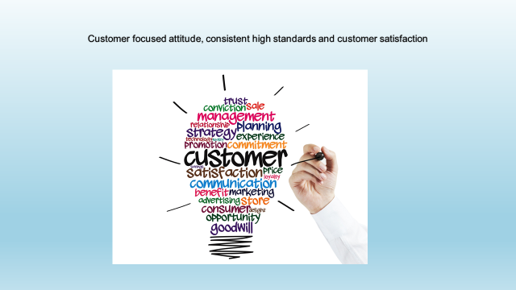
- 2.5
Customer focused attitude is about acting in the customers best interest, think about how you would feel based on the service you are giving. Putting yourself in the customer’s shoes will help to put you in the right mind-set because it helps us better understand the customer and what is likely to form the right solution for him/her. First we must listen to our customers and what their needs are, foster a company culture dedicated to customer satisfaction. Keeping up to date with the industry changes and being able to offer the most competitive resolutions. Consistency is key throughout the customer journey.

Wikipedia (no date) evidence based practise. Available At https://en.wikipedia.org/wiki/Evidence-based_practice (Accessed: 03rd June 2022)
The Or Briefings (2022) The essential guide to evidence based practise. Available at https://oxford-review.com/evidence-based-practice-essential-guide/ (Accessed: 03rd June 2022)
CIPD (2022) Evidence based practise for making effective decision making. Available at https://www.cipd.co.uk/knowledge/strategy/analytics/evidence-based-practice-factsheet#gref (Accessed: 03rd June 2022)
The Or Briefings (2022) The essential guide to evidence based practise. Available at https://oxford-review.com/evidence-based-practice-essential-guide/ (Accessed: 03rd June 2022)
Phillipps (no date) The Analytics Advantage. Available at https://www2.deloitte.com/content/dam/Deloitte/global/Documents/Deloitte-Analytics/dttl-analytics-analytics-advantage-report-061913.pdf (Accessed:03rd June)
CQL (no date) 12 reasons why data is important. Available at: https://www.c-q-l.org/resources/guides/12-reasons-why-data-is-important/ (Accessed: 04th June)
Eslake (2006) The importance of data. Available at: https://www.anz.com/documents/economics/The_Importance_of_Data.pdf#:~:text=In%20the%20absence%20of%20accurate%2C%20reliable%20and%20timely,that%20could%20have%20been%20made%20at%20the%20time (Accessed:03rd June 2022)
Marr (2018) Why data is hr’s most important asset. Available at: https://www.forbes.com/sites/bernardmarr/2018/04/13/why-data-is-hrs-most-important-asset/?sh=5a1d4f346b0f (Accessed: 03rd June 2022)
McLeod (2019) what’s the difference between qualitative and quantitative research. Available at: https://www.simplypsychology.org/qualitative-quantitative.html (Accessed: 03rd June 2022)
https://optinmonster.com/qualitative-research-methods-for-understanding-your-user/
RingLead (No date) the importance of data management in companies. Available at: https://www.ringlead.com/blog/the-importance-of-data-management-in-companies/#:~:text=Data%20is%20the%20foundation%20of%20a%20business%E2%80%99%20information%2C,and%20even%20harmful%20asset%20to%20a%20scaling%20enterprise (Accessed: 09th June 2022)
Valamis (2021) Human resource hr analytics. Available at: https://www.valamis.com/hub/hr-analytics (Accessed: 09th June 2022)
Omniescu secure (no date) organisational policies, procedures , standards and guidelines. Available at: https://www.omnisecu.com/ccna-security/organizational-policies-procedures-standards-and-guidelines.php#:~:text=Organizations%20use%20policies%20and%20procedures%20to%20outline%20rules,what%20will%20occur%20if%20they%20are%20not%20followed (Accessed: 09th June 2022)
Snook (2021) policies and procedures in the workplace. Available at: https://www.i-sight.com/resources/policies-and-procedures-in-the-workplace-the-ultimate-guide/ (Accessed: 09th June)
https://www.i-sight.com/resources/policies-and-procedures-in-the-workplace-the-ultimate-guide/
Sineriz (2019) what are the benefits of policies & procedures. Available at: https://bizfluent.com/list-6524560-benefits-policies-procedures-.html (Accessed: 03rd June 2022)
Dijk (no date) creating value with fact based hr. Available at: https://www.aihr.com/blog/creating-value-fact-based-hr/ (Accessed: 05th June 2022)
Wilbold (2019) Social media in education. Available at: https://elearningindustry.com/social-media-in-education-improve-learning (Accessed: 05th June 2022)
SHRM (no date) managing and leveraging workplace use of social media. Available at: https://www.shrm.org/resourcesandtools/tools-and-samples/toolkits/pages/managingsocialmedia.aspx (Accessed: 05th June 2022)
Norman (no date) the role of hr in workplace culture. Available at: https://smallbusiness.chron.com/role-hr-workplace-culture-10206.html (Accessed: 05th June 2022)
Mohdzaini (2021) people analytics. Available at: https://www.cipd.co.uk/knowledge/strategy/analytics/factsheet#gref (Accessed: 05th June 2022)
Viio (2018) what is customer focus and why is important and how to become customer focussed. Available at : https://www.paulviio.com/what-is-customer-focus-how-to-become-customer-focused/#:~:text=Let%20go%20of%20focusing%20on%20your%20own%20needs,the%20seller%20or%20service%20provider%20makes%20you%20feel. (Accessed: 02nd June 2022)
BBC (no date) stakeholders. Available at: https://www.bbc.co.uk/bitesize/guides/znf7nrd/revision/10 (Accessed: 02nd June 2022)
Institute for apprenticeships and technical education (no date) senior people professional. Available at: https://www.instituteforapprenticeships.org/apprenticeship-standards/senior-people-professional/#:~:text=Senior%20People%20Professionals%20engage%20with%20a%20wide%20range,in%20the%20profession%20is%20critical%20to%20this%20occupation. (Accessed:02nd June 2022)
CIPD (2022) ethical practise and the role of people professionals. Available at: https://www.cipd.co.uk/knowledge/culture/ethics/role-hr-factsheet#gref (Accessed:03rd June 2022)
Marr (2018) why data is hrs biggest asset. Available at: https://www.forbes.com/sites/bernardmarr/2018/04/13/why-data-is-hrs-most-important-asset/?sh=6b5fa31a6b0f (Accessed: 03rd June 2022)

