Name: Zakia Sultana
Business Plan for: Eco-Delux Hotel

Lecturer: | Ben Chong
Date: | 31-05-2024
Team members: | Zakia Sultana (2018895)
Business plan contents
1 Executive summary 4
2 Business details 5
Vision 9
4 The business idea 9
5 Business goals 10
6 What the business does 11
7 What makes the business different (Value Proposition) 11
8 Legal requirements (including regulations and licences particular to your business) 12
Marketing 13
9 Market research 13
10 Profiling customers 13
11 Profiling competitors 14
12 Managing market risks 15
13 Pricing 15
14 Promotion and advertising 16
Running the business 18
15 Staff 18
16 Premises 18
17 Suppliers 18
18 Equipment 19
19 Managing operational risks 20
Finance 21
20 Start-up costs 21
21 Profit and loss forecast 22
22 Sourcing finance 23
23 Managing financial risks 23
The risks that you have identified for your financial forecast are: 23
24 Cash flow forecast 25
25 Conclusion 27
26 References 28

1 Executive summary
(We suggest you complete this section after you have completed the other sections of the Business Plan).
Sustainable tourism and hospitality have received immense attention in recent years. The concept of sustainability has contributed to the development of this business plan. Applying various entrepreneurship approaches, the plan has included some crucial aspects of the business. At first, the business name and location have been determined. The plan is to start a new hotel at Newcastle Upon Tyne and the name of the hotel is Eco-Delux. As the name suggests, the hotel is eco-friendly. The primary objective of the hotel is to serve guests who seek eco-friendly and guilt-free hospitality services. Secondly, the business will also target the luxury customer segment by bringing premium and exclusive services and facilities within the sustainability scope. Thirdly, the business will also provide event-hosting facilities. Fourthly, the hotel will offer restaurant services using ethically sourced products and quality ingredients. All these features of the hotel services will make the business differentiated. To enhance business performance, a qualified management team has been formed. The marketing initiatives are effective in that they can support continuous business growth. Emphasis is given to digital marketing. The startup cost is £610,000. A large portion of the amount will be provided by the owner and other contributions. The business requires investments for raising £210,000 for the start-up fund. The business plan finally, provided the different financial risks of the business.

2 Business details

Company name:
EcoDeluX Hotel

Address:
Newcastle upon Tyne

Primary contact method
info@ecodeluxhotel.com

The business will: (Provide a brief description of what your business will do)
Eco-Delux is a sustainable and eco-friendly hotel. The hotel is located in Newcastle upon Tyne. It offers different services to the guests that include accommodation, hospitality services, and event hosting facilities. The business emphasises on the customer service and customer preferences. Hence, the hotel provides a memorable experience to the guests by taking environmental friendly initiatives within the hospitality services. The business promotes sustainability within the hospitality industry.

3 Key personnel
Details of owner(s):
Name: Syeda begum
Position/main responsibilities: Operations manager
Experience and knowledge of our industry: Having 3 years experience of working in upscale hotels has provided enough knowledge about the UK hospitality industry, Operations manager.
Previous employment: Hotel Receptionist
Key skills brought to the business: Strong leadership, customer service, and operational management skills
Business experience and any training undertaken: Completed courses in hospitality management and event planning.
Academic/professional qualifications: Level 1 and 2 early years child care, International hotel management course
Salary expectations £ 70,000 per year
Name: Abdur Rahman
Position/main responsibilities: Head of Management
Experience and knowledge of our industry: Vast knowledge about the hospitality industry and 2 years of work experience, Indian restaurant Owner of Indian restaurants business
Previous employment: Indian restaurant manager
Key skills brought to the business: Strong organisational skills, attention to detail, and experience in large-scale events organisation.
Business experience and any training undertaken: Operations management and event coordination courses completion
Academic/professional qualifications: Level 2 and 2 early years International hotel management course
Salary expectations £ 60,000
Name: Zakia Sultana
Position/main responsibilities: Head of Finance
Experience and knowledge of our industry: Vast knowledge of financial management of the hospitality industry, Owner of hotel business.
Previous employment: Receptionist and Front office associate in hotel.
Key skills brought to the business: Abilities in accounting, proficiency in cost management, and knowledge of where to find sources of income .
Business experience and any training undertaken: Received training in eco-friendly facilities management.
Academic/professional qualifications: BA (Hons), diploma in Graphic design.
Salary expectations £ 50,000
Name: Ana Maria Bosuioc
Position/main responsibilities: Head of Marketing
Experience and knowledge of our industry: Owner of hotel business
Previous employment: Worked in hotel
Key skills brought to the business: Key skills in social media marketing, content creation, and campaign management.
Business experience and any training undertaken: Received training in digital marketing strategies and branding
Academic/professional qualifications: Pharmacist
Salary expectations £ 55,000

Vision

4 The business idea

Sum up your business idea:

The Eco-Delux Hotel in Newcastle upon Tyne will combine eco-friendly features with high-end comforts. The main idea is to give tourists who care about the environment a sustainable, high-end experience that does not skimp on comfort or luxury. This hotel caters to eco-friendly, high-end, adventure, and family tourists with personalized services. Green rooms are very popular because many tourists want to do eco-friendly vacations. According to Erdoğan et al. (2022), the tourism industry is switching to methods that are better for the environment because customers want them to and the government requires them to. International Business Machines says that tourists are willing to pay more for eco-friendly services, which means that the market for sustainable tourism is still growing.

Eco-Delux stands out because it is committed to sustainability and uses technologies that are good for the earth. The hotel will use renewable energy sources, cut down on waste, and get food products in an ethical way. This strategy helps the hotel's market place by appealing to people who care about the environment and fits with global sustainability goals (Baker, Davis and Weaver, 2013). The hotel has a restaurant with fine eating, a space for events, and deluxe rooms with modern conveniences. Cost-effectiveness and good service are important to the company. With cost-based prices, there will be a balance between making money and charging enough to compete (Burns, 2022). The hotel's digital marketing plan, which includes social media and working with local companies and celebrities, will make customers more interested in the brand and help them remember it (Šagovnović & Stamenković, 2022).

The people in charge of Eco-Delux have a lot of knowledge in the hotel business. There is a head of management, a head of finance, a head of marketing, and an operations boss working on the project. Each of them has their own set of skills. It will likely cost £610,000 to get started, with £210,000 coming from investments. Risk management and predicting profits and losses are both important parts of detailed financial planning that is needed to keep the business financially stable (Williams, 2021). The growing need for eco-friendly high-end hotels could be good for Eco-Delux Hotel. Through a combination of high-quality services and eco-friendly practices, the hotel offers a unique experience that meets the needs of modern tourists. With the help of a strong business plan and a committed management team, Eco-Delux could become a leader in sustainable hospitality, giving investors high returns and having a positive effect on the environment.

5 Business goals
- What do you want to achieve in your first year of business?
- Within the first year of its operations, the hotel will generate £500,000 in revenue.
- The hotel will emerge as a leading hospitality business that is eco-friendly and sustainable.
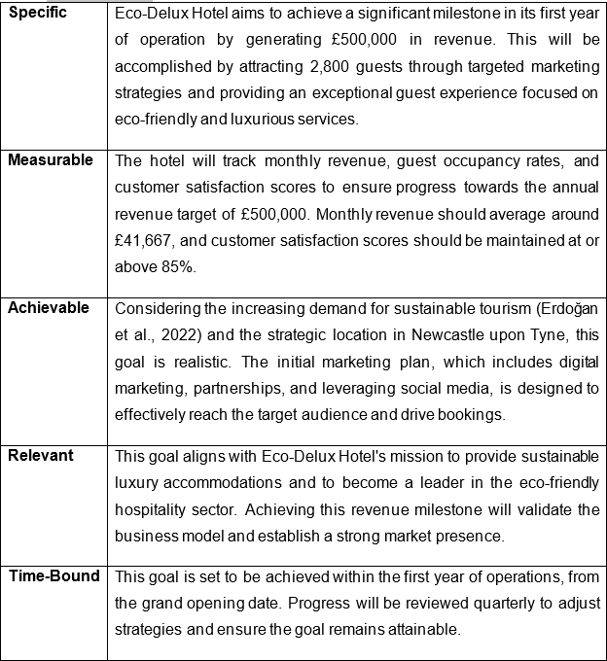

- Where do you see your business in 3-5 years?
- By purchasing new properties, the hotel will expand to new markets. It will present itself as a new tourist destination. The business will ensure a 20% growth in the revenue generation every year (Yencken and Murray Gillin Am, 2006).

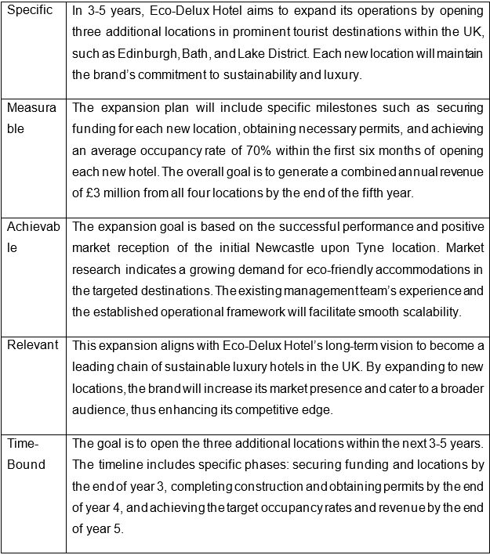

6 What the business does

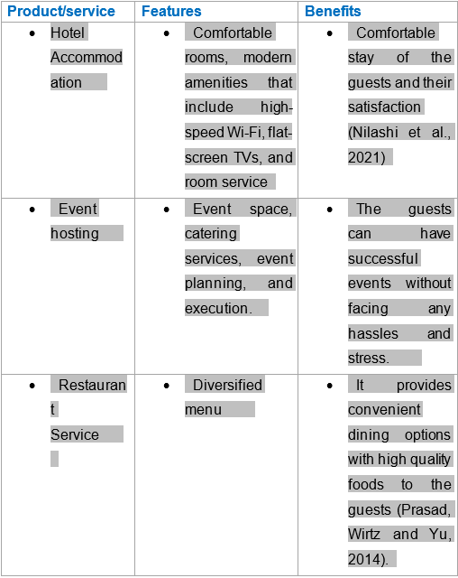

The primary benefit of the accommodation services at Eco-Delux Hotel is guest comfort and satisfaction. High-speed Wi-Fi and modern amenities cater to the needs of both leisure and business travelers, ensuring a seamless and enjoyable stay. Comfortable rooms equipped with necessary modern facilities enhance the overall guest experience. Nilashi et al. (2021) emphasize that the availability of modern amenities such as high-speed internet and in-room entertainment significantly impacts guest satisfaction in hotels. Comfortable accommodations with these features meet the expectations of today’s travelers, thereby improving customer satisfaction and fostering repeat business.

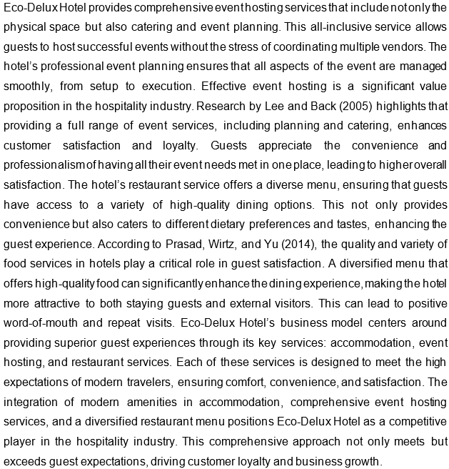

7 What makes the business different (Value Proposition)
Your product/service is unique or different compared with the competition because:
- Eco-Delux differentiates from other hotels through its unique services and eco-friendly accommodation. The hotel offers customised and tailored guest services to make them satisfied (Baker, Davis and Weaver, 2013). It also ensures memorable guest stays at the hotel.

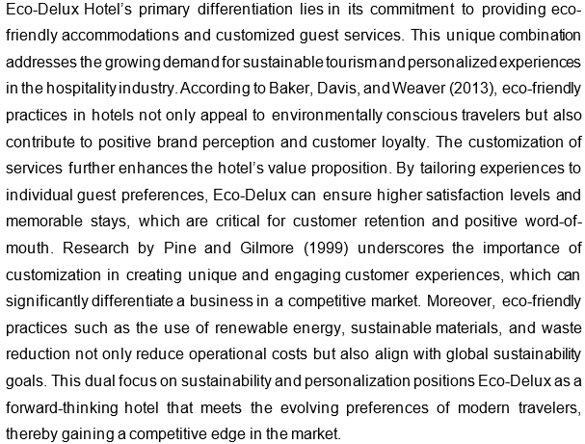

8 Legal requirements (including regulations and licences particular to your business)
The legal and insurance requirements that apply to your business are:
Eco-Delux should consider the following legal requirements for starting the business:
- Licence and Permits: By complying with the local rules and regulations, the hotel will receive the licence before starting the business operations. It should have all the required permits for conducting the operations smoothly (Rahmawati et al., 2021).
- Employment Laws: The hotel must adhere to the legal guidance and legislation to manage the employees.
- Data Protection and Privacy: Data protection regulation, GDPR, must be complied with for the protection of public data and privacy.
- Insurance Coverage: Liability insurance, property insurance, employee compensation insurance, and other necessary insurance coverage should be attained (Robina-Ramírez, Fernández-Portillo and Díaz-Casero, 2019).
You will meet your legal and insurance requirements by:
Eco-Delux must ensure the fulfilment of all the legal requirements. The business can perform this in the following ways:
- Regular Compliance Audit: The hotel will conduct audits regularly to ensure that all legal aspects are maintained.
- Legal Advisors: Guidance from the legal advisors can be taken when the hotel requires it (Kristanti and Jokom, 2017).
- Insurance Policy: Well-recognised insurance companies should be identified for the insurance coverage.
- Staff Training: The staff of the hotel must be well trained so that they understand all legal aspects of the business.

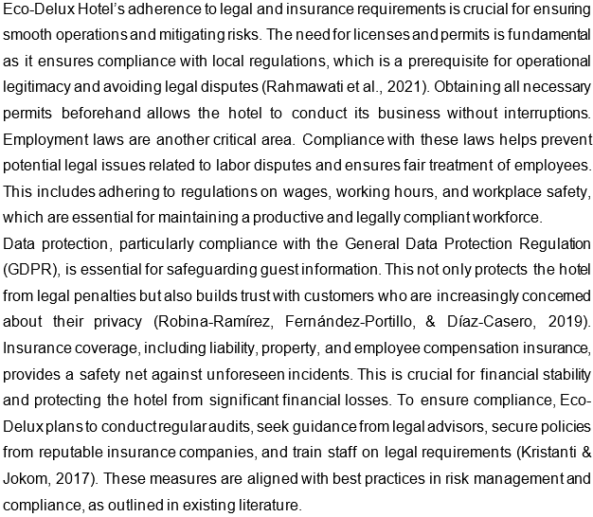

Marketing

9 Market research

Trends in your chosen market are:
The market trends identified are as follows:
- Increasing demand for eco-friendly hotels: The people in the UK are becoming more conscious about environmental protection. The customers are increasing their demands for eco-friendly hotels (Erdoğan et al., 2022).
- Sustainability: Sustainable tourism is the recent trend in the tourism and hospitality industry (Global Data, 2022). Visitors and tourists like to have sustainable hotel services and facilities that have the least impact on the environment.

How you know this:
- The trends are identified based on the analysis of the market reports, online reviews, online surveys, and research journals. Mostly, the secondary sources have contributed to the understanding of the market trend.
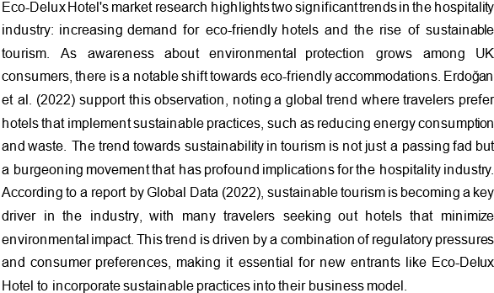

10 Profiling customers

The customer groups you will be selling to are:
The target market segments are explained below:
- Eco-conscious Travellers: This particular customer segment has immense interest in eco-friendly hospitality services such as eco-friendly and sustainable accommodations. They value minimising energy consumption, green technology, and proper waste management (Global Data, 2022).
- Luxury Seekers: The customer segment prefers exceptional and personalised services. They emphasise on quality over prices.
- Adventure Enthusiasts: The customer segment does not care about any luxury services. Rather they prefer to have convenient and functioning hotel services.
- Family Travellers: The customer segment is budget conscious. They choose the hotel based on the online reviews and the evaluation of the value for money.

Your customer research has shown what your customers want is:
- The customers want to have comfortable, convenient, and eco-friendly hotels. They also want personalised services (Burns, 2022). The results are found from the both secondary research and primary research.

How you know this:
- Online reviews and ratings of various hotels provide evidence of what the customers want. Market research published by different sources provides important insights into customer preferences. Moreover, survey questionnaires receive customer's response that explains their expectations.

Number of customers you expect to win in each group and what they might pay:

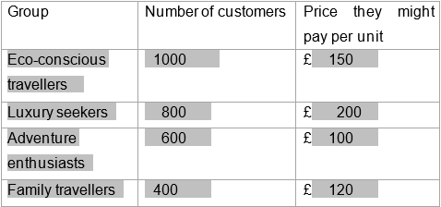
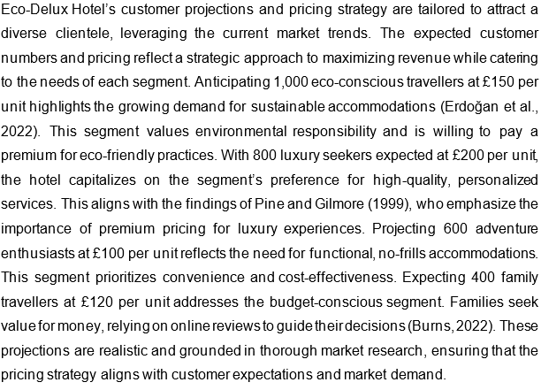

11 Profiling competitors

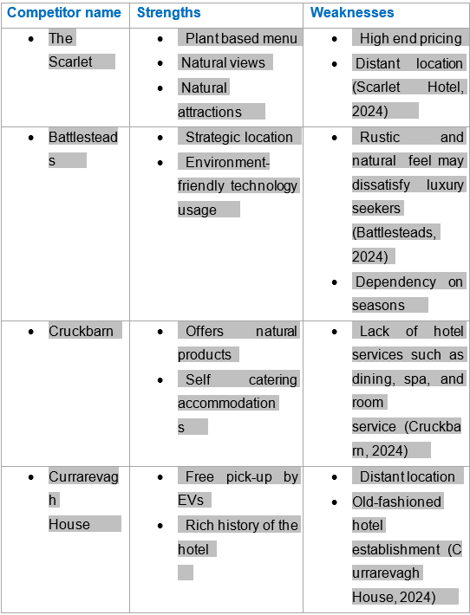

How you can improve on their offer and/or price(s) unique offerings:
- Eco-Delux can offer different types of rooms for different customers. The hotel services should be made customised. It will offer complimentary breakfast and a variety of services to ensure an exceptional guest experience (Chun Wang, Wang and Tai, 2016). The overall activities of the hotel must be eco-friendly and sustainable.

12 Managing market risks

Write down the risks you have identified:
- Over supply of hotel rooms
- Rising energy costs and other costs
- Change in customer preferences

How will you manage these risks so that they become less of a threat:
- The occupancy rate will be higher by conducting a comprehensive analysis of the hotel's location. Based on the analysis, the location should be chosen where demand will be higher.
- The hotel should undertake energy saving measures and cost cutting approaches to overcome the challenges of increasing costs.

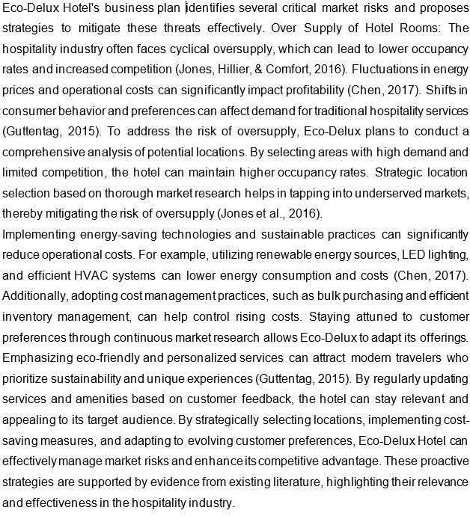

13 Pricing

How you can calculate your prices:
- Cost cost-based pricing strategy should be applied. The pricing method includes the profit margins with the total costs of the business for determining the product prices (Burns, 2022).

How your prices compare with the competition:
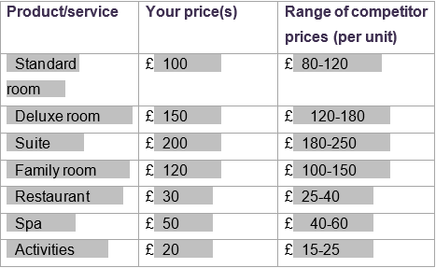

Reasons for the difference between your price(s) and your competitors’ price(s):
- Eco-Delux charges slightly higher prices than lower end hotels because it provides quality services to the guests. The hotel again charges lower prices than the higher end hotels for making its offerings value for money for the target customers.

Eco-Delux Hotel sets the prices of its goods based on how much they cost. With this method, prices are set by adding a profit margin to the cost of the service. Cost-based pricing is easy to understand and makes sure that all costs are met while still making money (Burns, 2022). Standard rooms at Eco-Delux cost £100, which is about the same as £80–£120. It is clear from the prices that the hotel is committed to offering high-quality rooms at reasonable costs. The price of this luxury room is £150, which is about the same as rooms that cost £120 to £180. The prices at Eco-Delux, which run from moderate to high-end, are a good mix of high-end services and low prices. The suite's £200 price is reasonable for people who like high-end services and are looking for something in the £180–250 price range. The family room costs £120, so families on a tight budget can afford it. The prices for these services are reasonable for what they offer, so you can get good services without breaking the bank.
Because Eco-Delux has better service, it costs a little more than lower-end motels. Costs going up leads to better service, more modern amenities, and happy customers. The hotel knows it wants to make luxury more available to more people, so it sets its prices lower than its high-end competitors. Nagle and Müller (2017) say that a good pricing plan makes customers happier and gives them more value. Eco-Delux is able to attract and keep customers who want both value and luxury by finding a good balance between cost recovery and competitive pricing. This way, the company can justify its prices by the quality and uniqueness of its services. The Eco-Delux Hotel's pricing strategy takes into account customer value, competitiveness, and cost. This strategy helps the hotel stay profitable and competitive while also bringing in a wide range of customers.

14 Promotion and advertising

How and where will you promote your product/service?
- Eco-Delux will promote the business using a variety of channels. The hotel can adopt digital marketing strategies. The strategies are very simple. They only require some content to share in the digital platforms that will promote the market offering of the new business. The business will collaborate and partner with the celebrities for getting positive brand recognition (Šagovnović and Stamenković, 2022). The hotel may also consider using local businesses in the promotion campaigns.

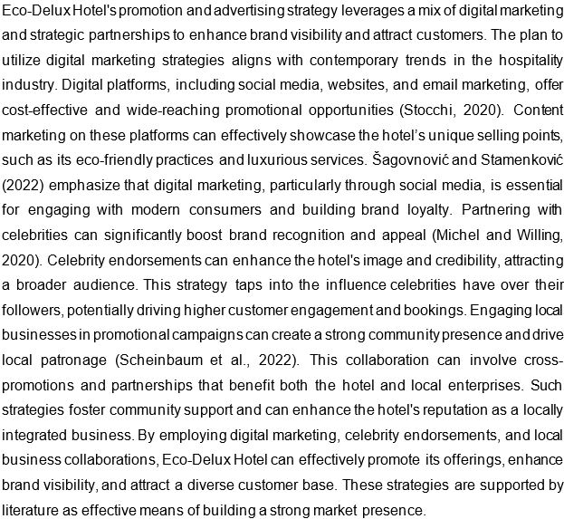

Running the business

15 Staff
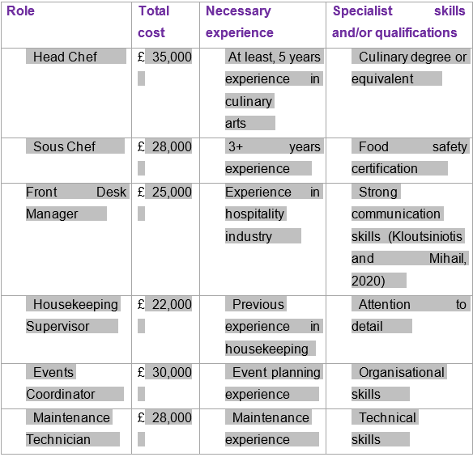

16 Premises

 | Cost £
Premises required at start-up: | £ 200,000
Premises required in the future (if different): | £ 150,000

17 Suppliers

Your key suppliers and their credit terms
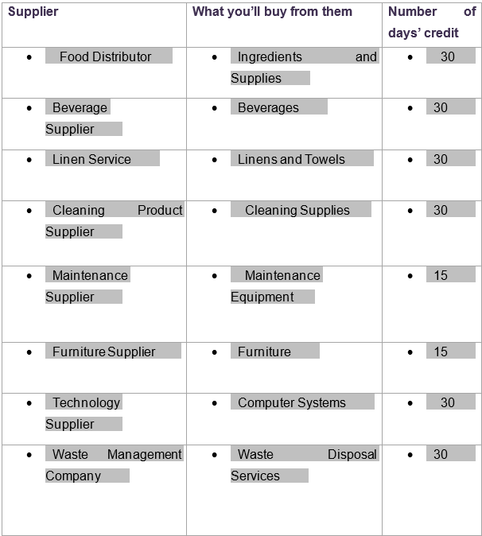
Eco-Delux Hotel’s supplier strategy is designed to ensure a reliable and diverse supply chain, crucial for maintaining operational efficiency and high service standards. The selection of suppliers with specific credit terms supports cash flow management and operational continuity.
  - Food Distributor and Beverage Supplier (30 days credit): Ensures a steady supply of quality ingredients and beverages, essential for kitchen and bar operations. Regular credit terms help manage inventory costs effectively (Williams, 2021).
  - Linen Service (30 days credit): Provides linens and towels, crucial for guest comfort and hygiene. Reliable linen supply is essential for maintaining housekeeping standards.
  - Cleaning Product Supplier (30 days credit): Supplies cleaning materials, ensuring cleanliness and hygiene, which are paramount in hospitality (Kloutsiniotis and Mihail, 2020).
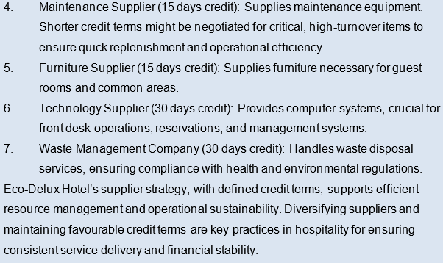

18 Equipment
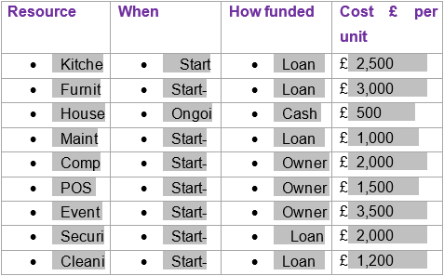

19 Managing operational risks

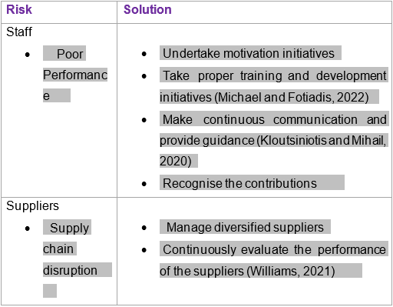

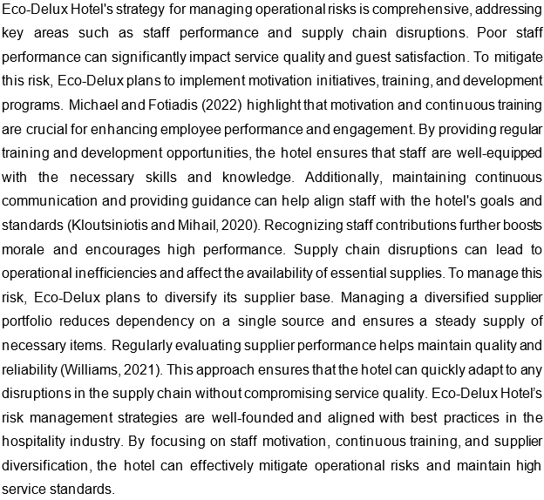

Finance

20 Start-up costs

Calculate how much money you need before you start trading

* Total from here should be used in 22 Sourcing finance below

The Eco-Delux Hotel's start-up costs total £610,000, including key business expenses. This thorough budget guarantees the hotel is well-equipped to run smoothly from the start. Stock, costing £62,000, will be used to equip the hotel. Tool and vehicle prices of £32,000 and £40,000, respectively, demonstrate the need for reliable equipment and transportation for maintenance and logistics.
The £25,000 professional expenses should cover basic legal, accounting, and advice services throughout the first setup phase. Effective regulatory management and thorough financial procedures demand these services (Schaper et al., 2014). Insurance costs £20,000 and protects against risks. Any new business must take this step to protect its assets and operations (Williams, 2021). Rent and deposit total £72,000. Securing the property and finding a good location requires this payment.
Stationery costs £21,000 and marketing £35,000. Brand establishment and promotional initiatives to acquire early customers account for these costs. Brand familiarity and early reservations require good marketing. Consumables cost £32,000 and licenses £3,000. These costs are necessary for corporate operations and regulatory compliance. To ensure hotel staff are prepared and follow service standards, £12,000 has been set aside for training. Service quality must be high (Michael and Fotiadis, 2022).
The £18,000 association fees will presumably cover industry affiliation costs, which give operational benefits and networking opportunities. Wages and recruitment expenses total £109,800, including payroll and attempts to acquire and retain top talent. These costs are essential for the company (Kloutsiniotis & Mihail, 2020). The £15,000 security and health and safety equipment investment protects personnel and tourists. The £32,000 market research costs demonstrate the importance of understanding market dynamics and client preferences for strategic planning and decision-making (Burns, 2022). The thorough study of startup expenses shows Eco-Delux Hotel's rigorous planning and determination to building a fully equipped, secure, and market-ready business. This rigorous budgeting strategy follows the best corporate planning methodologies, addressing all essential issues before operations begin.

21 Profit and loss forecast
This financial forecast aligns with best practices in financial planning, ensuring the business remains viable and profitable. As Burns (2022) notes, detailed and realistic financial projections are crucial for business planning, helping to secure investment and manage operational efficiency. In conclusion, the profit and loss forecast for Eco-Delux Hotel demonstrates robust financial health and growth potential. With strong gross and net profit margins, the business is well-positioned for sustained success, supported by strategic cost management and revenue growth. This meticulous financial planning underscores the hotel's commitment to achieving its business objectives and delivering long-term profitability.

22 Sourcing finance

Total borrowing requirement for the business

23 Managing financial risks

The risks that you have identified for your financial forecast are:
- Fluctuations in the market demand can affect the projected sales. It can reduce the sales revenue and so the hotel will have lower revenue generation than expected (Barringer and Ireland, 2019).
- Economic downturns can also affect the market conditions that the demand for tourism and hospitality services gets declined. As a result, improper forecasts may occur.

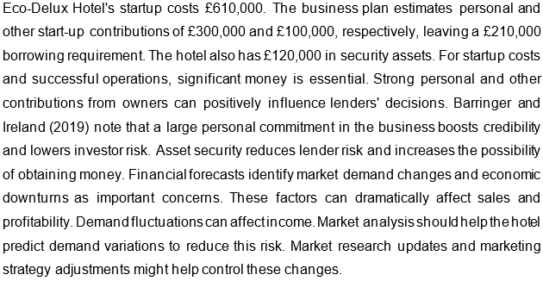

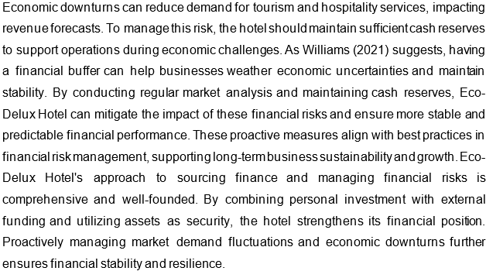

How you will minimise their impact:
The management of the hotel should conduct a thorough market analysis for anticipating the future fluctuations in the demand. Based on the findings, the hotel can manage its revenue. The risk of economic downturn can be overcome by keeping enough cash reserves and resources to support the business activities during the time of economic downturn and crisis (Williams, 2021).

24 Cash flow forecast (Click on the tabs within the Microsoft Excel sheet to view the second 6 months and summary)

The forecast suggests a positive net cash flow each quarter, contributing to a strong financial position. Effective cash flow management is crucial for covering operational expenses and supporting growth initiatives (Burns, 2022).

25 Conclusion
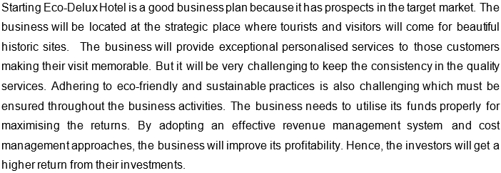

26 References
Alem Mohammad, A., Bin Rashid, B. and Bin Tahir, S. (2013) Assessing the Influence of Customer Relationship Management (CRM) Dimensions on Organization Performance. Journal of Hospitality and Tourism Technology, 4(3), pp.228–247. doi:https://doi.org/10.1108/jhtt-01-2013-0002.
Baker, M.A., Davis, E.A. and Weaver, P.A. (2013) Eco-friendly Attitudes, Barriers to Participation, and Differences in Behavior at Green Hotels. Cornell Hospitality Quarterly, 55(1), pp.89–99. doi:https://doi.org/10.1177/1938965513504483.
Barringer, B.R., & Ireland, R.D. (2019). Entrepreneurship: Successfully Launching New Ventures. New York, NY: Pearson.
Battlesteads (2024) Battlesteads | Book Direct for Best Price Available | Pub, Hotel & Restaurant. [online] Battlesteads - Pub, Hotel & Restaurant. Available at: https://www.battlesteads.com/ [Accessed 26 Feb. 2024].
Burns, P. (2022). Entrepreneurship and Small Business: Start-up, Growth and Maturity. 5th ed. Basingstoke: Palgrave Macmillan.
Ceylan, E.N. and Tülbentçi, T. (2020). Facility operation and maintenance management model for small and medium-sized hotels in Turkey. International Journal of Advanced and Applied Sciences, 7(12), pp.1-18.
Chen, Y. (2017). Energy efficiency strategies for hotels. International Journal of Hospitality Management, 61, pp. 1-9.
Cheraghalizadeh, R. and Tümer, M. (2017) The Effect of Applied Resources on Competitive Advantage in hotels: Mediation and Moderation Analysis. Journal of Hospitality and Tourism Management, 31, pp.265–272. doi:https://doi.org/10.1016/j.jhtm.2017.04.001.
Chun Wang, J., Wang, Y.-C. and Tai, Y.-F. (2016) Systematic Review of the Elements and Service Standards of Delightful Service. International Journal of Contemporary Hospitality Management, 28(7), pp.1310–1337. doi:https://doi.org/10.1108/ijchm-08-2014-0400.
Cruckbarn (2024) CRUCKBARN: Unique Holiday Home in a Herefordshire Woodland Setting. [online] www.cruckbarn.co.uk. Available at: https://www.cruckbarn.co.uk/ [Accessed 26 Feb. 2024].
Currarevagh House (2024) Currarevagh House Oughterard, Galway | Victorian Country House Guesthouse in Galway Ireland. [online] Currarevagh House. Available at: https://www.currarevagh.com/ [Accessed 26 Feb. 2024].
Erdoğan, S., Gedikli, A., Cevik, E.I. and Erdoğan, F. (2022) Eco-friendly technologies, International Tourism and Carbon emissions: Evidence from the Most Visited Countries. Technological Forecasting and Social Change, [online] 180, p.121705. doi:https://doi.org/10.1016/j.techfore.2022.121705.
Global Data (2022) ShieldSquare Captcha. [online] www.globaldata.com. Available at: https://www.globaldata.com/store/report/uk-sustainable-tourism-market-analysis/ [Accessed 26 Feb. 2024].
Guttentag, D. (2015). Airbnb: disruptive innovation and the rise of an informal tourism accommodation sector. Current Issues in Tourism, 18(12), pp. 1192-1217.
Jawabreh, O., Al Fayoumi, T. and Bareya, A. (2022). Customer Satisfaction towards Communication Skills of Front Office Staff at the Hotel (Case Study Five Stars Hotels in Aqaba). Geo Journal of Tourism and Geosites, 44(4), pp.1312-1318.
Jones, P., Hillier, D., & Comfort, D. (2016). Sustainability in the global hotel industry. International Journal of Contemporary Hospitality Management, 28(1), pp. 36-67.
Kloutsiniotis, P.V. and Mihail, D.M. (2020) The Effects of High Performance Work Systems in Employees’ service-oriented OCB. International Journal of Hospitality Management, 90, p.102610. doi:https://doi.org/10.1016/j.ijhm.2020.102610.
Kristanti, M. and Jokom, R. (2017) The Influence of Eco-friendly Attitudes on Tourists’ Intention toward Green Hotels. Springer eBooks, pp.21–29. doi:https://doi.org/10.1007/978-981-10-1718-6_3.
Kucukaltan, B., Irani, Z. and Acar, A.Z. (2020) Business Model Canvas for Humanitarian Operations of Logistics Service providers*. Production Planning & Control, pp.1–16. doi:https://doi.org/10.1080/09537287.2020.1834128.
Michael, N. and Fotiadis, A.K. (2022) Employee Turnover: the Hotel Industry Perspective. [online] papers.ssrn.com. Available at: https://ssrn.com/abstract=4121197.
Michel, G. and Willing, R. (2020). The art of successful brand collaborations: Partnerships with artists, designers, museums, territories, sports, celebrities, science, good cause… and more. Routledge.
Morosan, C. and DeFranco, A. (2016) Co-creating Value in Hotels Using Mobile devices: a Conceptual Model with Empirical Validation. International Journal of Hospitality Management, 52, pp.131–142. doi:https://doi.org/10.1016/j.ijhm.2015.10.004.
Nagle, T.T., & Müller, G. (2017). The Strategy and Tactics of Pricing: A Guide to Growing More Profitably. 6th ed. Routledge.
Nilashi, M., Minaei-Bidgoli, B., Alrizq, M., Alghamdi, A., Alsulami, A.A., Samad, S. and Mohd, S. (2021) An Analytical Approach for Big Social Data Analysis for Customer decision-making in eco-friendly Hotels. Expert Systems with Applications, 186, p.115722. doi:https://doi.org/10.1016/j.eswa.2021.115722.
Pine, B.J. and Gilmore, J.H. (1999). The Experience Economy: Work is Theatre & Every Business a Stage, Harvard Business Press.
Prasad, K., Wirtz, P.W. and Yu, L. (2014) Measuring Hotel Guest Satisfaction by Using an Online Quality Management System. Journal of Hospitality Marketing & Management, 23(4), pp.445–463. doi:https://doi.org/10.1080/19368623.2013.805313.
Rahimian, S., ShamiZanjani, M., Manian, A. and Esfidani, M.R. (2021). A framework of customer experience management for hotel industry. International Journal of Contemporary Hospitality Management, 33(5), pp.1413-1436.
Rahmawati, R., Suprapti, A.R., Pinta, S.R.H. and Sudira, P. (2021) Green entrepreneurship: a study for developing eco-tourism in Indonesia. The Journal of Asian Finance, Economics and Business, 8(5), pp.143-150. doi:10.13106/jafeb.2021.vol8.no5.0143
Robina-Ramírez, R., Fernández-Portillo, A. and Díaz-Casero, J.C. (2019) Green Start-Ups’ Attitudes Towards Nature When Complying with the Corporate Law. Complexity, 2019, pp.1–17. doi:https://doi.org/10.1155/2019/4164853.
Šagovnović, I. and Stamenković, I. (2022) Investigating Values of Green Marketing Tools in Predicting Tourists’ eco-friendly Attitudes and Behavior. Journal of Ecotourism, pp.1–23. doi:https://doi.org/10.1080/14724049.2022.2075003.
Scarlet Hotel (2024) The Scarlet Hotel: Cornwall’s Luxury Seaview eco-hotel & Spa. [online] The Scarlet Hotel . Available at: https://www.scarlethotel.co.uk/ [Accessed 26 Feb. 2024].
Schaper, M., Volery, T., Weber, P., & Lewis, K. (2014). Entrepreneurship and Small Business. Wiley.
Scheinbaum, A.C., Krishen, A.S. and Lacey, R. (2022). The role of faraway fans in sporting event sponsorship: Why sponsor patronage is stronger among fans who travel far to events. Journal of Advertising Research, 62(1), pp.49-61.
Stocchi, L. (2022). The Role of Mobile Technologies in Digital Marketing and Sales. The SAGE Handbook of Digital Marketing, p.256.
Williams, S. (2021) The Financial Times Guide to Business Start up 2021/2023 : the Most Comprehensive Guide for Entrepreneurs. Harlow, England ; London ; New York: Pearson.
Yencken, J. and Murray Gillin Am, L. (2006) The Klofsten Business Platform as a self-diagnostic Tool for New technology-based Small Firms. Innovation, 8(4-5), pp.348–358. doi:https://doi.org/10.5172/impp.2006.8.4.348.

