Targedau / Targets | Sut rydych wedi gweithio ar hwn /  How you have worked on this | Ceir enghraifft ar /  An example can be found on
Targed/Target 1 | Minor errors in the referencing. Use lower case letters for et al. No need to use first initial of authors with in-text referencing. | Page 10
Targed/Target 2 | Deepen the links with Curriculum for Wales. | Page 9
Targed/Target 3

Cycle3: ECAD6008​
Professional and Pedagogic Studies: Leading the Learning: what, how and why am I teaching?

Critically reflect on your progress in planning, preparing and teaching lessons that incorporate the twelve pedagogical principles. (This evidence should be taken from you Professional Learning Passport –PLP.) Identify up to three of these pedagogical principles as an area for development and justify the next steps in your development.

By Jordan Hickey (1702991)

Contents Page

Part A ………………………………………………………………………. 3
Part B - Introduction ………………………………………………………. 9
Critical discussion – Authentic contexts ………………………………… 9
Critical discussion - AfL ………………………………………………….. 11
Conclusion ………………………………………………………………… 13

PART A

Professional Experience Template 1
Pedagogy Standard | Assessment for learning
What did you do and why? | During my PTE 3 experience, there were many AfL strategies observed and used in the classroom. The main strategy that was evident throughout my placement was think, pair, share. This was used in lessons when questions were posed, in order for the children to collate and share answers with their peers, in order to create discussion and create a more detailed answer. This was also effective long term as the children were not assigned a seating plan in the classroom, so they would often sit by a range of their classmates. This meant the discussions held during think, pair, share moments would differ constantly. I used this strategy because it was already a staple in the classroom, so the children were very knowledgeable about this, leading to effective, high-detailed answers and discussions. I also used a randomiser throughout my placement as an AfL strategy to ensure there was a range of answers from the children, as it was apparent that the same children would consistently be answering questions. Another way this strategy was effective was during reading sessions to determine which child would read out loud. This meant a range of children of all abilities had the chance to read in front of the class.
What have you learned? | When using think, pair, share throughout placement, I have learnt that the children do generally collate better answers to questions. By talking to a partner, it eliminates the non-thought through, ‘silly’ answers that you can potentially get as the children have to think and discuss that with their partner. The drawbacks I found to this are if some children are partnered with their friends, there is potential for the children to just chat about unrelated topics during this moment. The other drawback I found is that the noise levels can become quite high as the children are discussing and it takes some time to bring the children back down into silence to receive answers. I also learnt that from the use of a randomiser, you can have a range of questions and a range of level of reading from the children, as appose to the higher ability children always volunteering to answer or read out loud. I found that the drawback to this strategy was that not all children felt confident or comfortable reading out loud, it also occasionally put pressure on children who did not know the answer to questions.
What next? | In the future, I will continue to use think, pair, share as an AfL strategy, as it is effective in producing well thought of answers, and allows for discussion and debate between children and their peers. I will also continue to use a randomiser in the classroom but will express to the children that they do not have to answer the question if they do not want to answer or know the answer. I will also keep the randomiser on an iPad, so the child selected is kept anonymous to the class. This way I can re-randomise if the child selected is a child that is not confident in reading out loud to the rest of the class.

Professional Experience Template 2
Pedagogy Standard | Blended learning experiences
What did you do and why? | During my final placement, I taught a topic lesson based on the application Minecraft Education. This lesson had the focus of DNA sampling, which linked to the ‘I wonder’ statement ‘what makes me special’. This lesson used a mixture of computer-based learning, along with producing work in their topic books. The children had to find and sample the DNA using the application online, then had to create a table and produce results in their books. This gave the children a blended learning experience and allowed for deep learning and understanding, whilst also providing hard evidenced-based results in their books. Another use of blended learning was provided to the children through a maths activity based around the topic of ratio. The children were given physical cards to match proportionate ratio together first, then they were instructed to complete a matching task online where they would compete to complete the task in the least amount of time as possible. I did this because it allowed the children to gain a better understanding of the task by using the physical cards, then completing the activity online gave the benefits of saving their scores and resetting the task quickly and efficiently.
What have you learned? | During the topic lesson, I learnt that the children react well to this blended learning experience as it is interactive and engaging. I also learnt that this is an effective way to deepen the learning and understanding, whilst also providing written evidence in books for book scrutiny.  Prior to the Maths activity, I learnt that this blended learning experience increases engagement and provides children with a balance of challenge and support as this task was completed independently. However, the problem I encountered is that the activity did not provide the children with the corrected answers after they answered correctly so it was difficult for the children to learn from this and improve their answers during the next game. I also could have provided the children with answer sheets for the match up practical task after the children had completed it to ensure children could check their answers. This was a problem as some children thought they had correct answers to help them in the online game, whereas they were incorrect. Consequently, the children answered some questions wrong during their first attempt at the task.
What next? | In the future, I would like to continue to incorporate a range of blended learning experiences into my planning as I believe it provides the children with a plethora of ways to learn and produce work. Using online learning is also currently topical and can be completed or worked on outside of school hours. Combining this type of learning with book-based learning can also continuously show progression and provides hard evidence that can be reviewed efficiently. I would also ensure the children are provided with appropriate steps for success prior to the lesson, as this will make the children aware of the expectations and outcomes they must achieve by the end of the lesson. This mitigates potential of topic searching online and keeps the children focused throughout the lesson. I will also continuously monitor the children’s computers to further strengthen this.

Professional Experience Template 3
Pedagogy Standard | Real life authentic contexts
What did you do and why? | During my PTE 3 experience, I incorporated a range of real life, authentic contexts into my lesson plans, such as a practical maths lesson based on ratio, using squash and water and a litter picking activity in the local community. I set up a practical ratio lesson using squash and water as it gave the children an insight into why they need to learn and understand the concept of ratio. This lesson allowed the children to experiment what their preferred ratio of squash to water, using general household items such as squash, water and plastic cups, this was then recorded in their books using a detailed diagram for each investigation they completed.  Also, during my placement, the children took part in a community clean up, where we walked around the local community picking up litter as a class in an attempt to raise awareness of the amount of litter still being dropped. I did this to give the children a direct insight into one of the main problems on our planet at current times.
What have you learned? | During these lessons I learnt that there has to be complete control and the children must be made aware of the expectations and outcomes of the lesson. This is vital as there is generally less structure to a practical lesson, so these needs must be met in order for the learning to be efficient. I also learnt that during the squash lesson, the children became very excited and animated, as the lesson involved an investigation where they would try different strengths of squash. This could have led to high noise levels and distractions, but the children were made aware at the start of the lesson that if they did not behave appropriately, they could not complete the experiment. I also learnt that conducting an out of school ground activity takes many steps of planning to ensure that the children are safe at all times, and that the learning objective is being met. This activity provided the children with real life, authentic contexts as they were out in their local community, absorbing information about littering, whilst also practically engaging in it. I also learnt that the majority of children are unaware of the amount of littering that takes place in the country. They did not believe that people would just drop that amount of rubbish, leaving it for someone else to pick up.
What next? | In the future, I would like to incorporate many more practical lessons into my planning as it increases the engagement of the children, therefore producing higher quality outcomes. This can only become effective by making the children aware of the expectations and what they outcomes need to be prior to completing the task. I would also like to conduct more out of school activities as it gives the children a different understand of the world around them, along with providing them with a change of setting and activities that they would not have access to inside the school grounds. This provides them with a platform for deeper learning and understanding. Although on the other hand, it does need to be fully thought out and planned to ensure safety and learning are as efficient as possible.

Professional Experience Template 4
Pedagogy Standard | Cross-curricular themes
What did you do and why? | Throughout my planning during my final placement, I looked to include as many cross-curricular themed lessons as possible, to give the children a broad depth of learning. One example of using cross curricular themes was for a topic lesson based on Minecraft Education. The children were tasked with creating a Welsh festival in their groups. This incorporated the DCF skills alongside the use of the Welsh language from the LLC AoLE. Teaching this lesson allowed the children to engage in a creative, practical task online, alongside using their Welsh language skills to make signs, posters and banners in the app. Another use of cross-curricular themes was evident in a science-based lesson about the human body, where children were tasked with creating an accurate body part using materials available to them. This covered the AoLE’s of Science and Technology as the children first had to research key details about the body part, and Expressive Arts, as the children had to use their creative skills to produce the model. I did this because it allowed for the children as a group, to combine their creative skills with their subject knowledge of the human body to produce an accurate model of their chosen body part.

PART B

The purpose of this assignment is to critically reflect on progress in planning, preparing and teaching lessons that incorporate the twelve pedagogical principles (WAG, 2020). This will include Identifying two of these pedagogical principles as an area for development and justify the next steps in development. The two pedagogical principles that will be critically reflected upon, during this assignment are ‘real life, authentic contexts’ and ‘assessment for learning’ (AfL). These two principles have been chosen as they were a key and consistent theme throughout my placement. Throughout this assignment, I will be discussing the use of real life, authentic contexts and AfL in the classroom, and critically assessing its effectiveness and validity, whilst taking into consideration the process of planning, preparing and teaching lessons that incorporate these principles.
I have chosen to focus on real life, authentic contexts as a pedagogical principle as it provides the children with a range of opportunities to link their learning to everyday life skills in order to gain a better understanding of the reasoning behind learning in the classroom. It is also believed that “real-life experiences can enable learners to take the lead in asking questions, identifying problems, taking risks and finding solutions” (WAG 2020). I have also chosen to focus on AfL strategies within the classroom to support pupil progression as it can be used as an effective tool to gage a child’s understanding and progression through the course of a lesson. WAG (2013) is of the opinion that AfL develops a sense of observation, reflection and feedback in order to enhance ongoing learning. This could suggest that the use of AfL in the classroom is key to providing the teacher with a range of techniques to gain information and data about the progression of their pupils. To add to this, pupil progression is arguably an extremely important aspect to the engagement and holistic growth of the child. Black and Wiliam (1998) demonstrated that when teachers introduce formative assessment (AfL) into their classroom practice, then consequently, substantial learning gains are made possible.

Authentic real-life contexts allow children to improve their understanding of a lesson, by providing them with situations to relate to and apply their knowledge to. “These experiences allow students to combine concepts and theories from formal education and apply them to real world practice” (Borthwick, et al., 2007. Pp 60). This is also evident by the work of Herrington (2014), as they believe that authentic learning contexts can potentially be used to improve student engagement and educational outcomes within the learning environment. This could suggest that children may become more engaged within the lesson if authentic real-life context is provided. Keller (2010) adds to this as they indicate that authentic contexts establish interest and relevance, therefore playing a significant role in increasing the leaner’s motivation. However, on the other hand, Zohoorian (2015) is of the opinion that the inconsistency of the use of authentic contexts is apparent, therefore implying that different learners are affected differently, depending on the use of the context. For example, they state that many students believe that authentic materials are less interesting, whilst some students argue that their on-task behavior and motivation increase during the later stages of the task. In Conclusion, they are of the opinion that authentic materials are subject to change in various situations and based on the purposes of the studies. This suggests that real life, authentic contexts have to be relevant and appropriate to the learners in order to have a positive effect on their behavior and motivation levels.
Whilst planning for lessons with the inclusion of authentic contexts, I had to take into consideration a number of variants that could potentially contribute towards the effectiveness of the session. For instance, whether the context was relatable to the children, linked to the learning objective of the lesson appropriately or could provide an engaging aspect to entice and motivate the learners. Koh (2017) voices their opinion, that the use of authentic context within a classroom can become effective when there is consideration for both learning outcomes and authentic contexts when planning lessons in order to fully support student learning. This could suggest that a balance of planning to meet the learning outcomes and creating authentic, real life contexts are an effective way of enhancing the learning for the child. This aspect has transformed throughout my practices as I have become more familiar with and incorporated more authentic contexts into my lesson plans. This was especially evident during my Professional Teaching Experience 3 (PTE) as I used authentic contexts during a ratio lesson, linking it to and basing the practical lesson around, the ratio of squash to water. This was very relatable as people have different opinions about the strength of squash they prefer in their drinks, therefore allowed the children to experiment with this topical activity. Bednar et al. (1992) suggests that learning is an active process that is developed on the basis of personal experiences and need to reanalyze and reinterpret information from the classroom, to use in relation to the real world. On the other hand, Steiner (2016) disagrees with this as they believe that including authentic contexts can become uncomfortable and unstructured in the classroom. They also argue that unmotivated children who are disinterested in the lesson will likely become distracted and will not produce an outcome of the standard they can achieve. This was evident at times during my placement as for example, as part of a theme on “Our Environment” with a learning objective of “ethical informed citizens who show their commitment to the sustainability of the planet”(see appendix 1), the class undertook a litter pick outside of school grounds, a minority of children did not enjoy the activity and believed they should not have to pick other people’s litter up. Bronfenbrenner (1979) disagrees with this point as he argues that a cultural reform strategy should be implemented with focuses on the advantages for student development and should be prioritized over curricular and structural reform models. This could suggest that the structure of the lesson should not take priority, as long as the lesson still meets it’s intended outcome. This was evident during the squash to water ratio lesson during PTE as there was a lack of structure with the children’s experiments, but it took place in a controlled environment, and the children were aware of the expectations and outcomes prior to the lesson.
Whilst conducting assessments of lessons including authentic contexts, I absorbed the verbal feedback from the children that consisted majorly of positive feedback. This has been transformed throughout my teaching placements as I had not received positive verbal feedback in prior experiences. For example, the children commented that they enjoyed creating a model of the human body as it showed an accurate and detailed representation of what is inside their body. Greenstein (2012) is of the opinion that authentic learning and assessment can boost a student’s engagement, as they can become frequently bored and disengaged when they find the work meaningless. This could indicate that the use of authentic contexts has the potential to become vital in allowing the learner to become engaged and relate to the activity,
I have also learnt that throughout my personal experiences, the amount of structure, scaffolding and emphasis on meeting expectations has significantly increased. This was especially evident from PTE 1 to PTE 3 as I did not fully understand the meaning of authentic contexts with regards to classroom learning at the start of Pte 1, whereas by the end of PTE 3, I had provided the children with appropriate structure and ensured they understood the level of expectations that they were required to meet. Stanescu (2016) raises the opinion that in order for unstructured learning to become effective, the teacher must set up a learning environment where pupils can have access to relevant knowledge that links to their desired learning outcomes and current context. This literature is apparent during the previously described lesson as the children were set up in a suitable learning environment, with resources available to support them.

Assessment for learning (AfL) is an assessment tool used by teachers, to show pupil progression in a variety of ways to ensure expectation are met and children are reaching their academic potential. It is conducted using day-by-day interactions with the primary focus of improving the child’s learning (Lysaght et al. 2017). Heitink (2016) adds to this as they believe that assessment for learning plays a crucial role in education by aiming to gain insights into learning processes, using targeted feedback and tailored instruction to support the learning as effectively as possible. This could indicate that AfL is a tool that needs specific focuses in order to become effective, but when conducted properly, it can have a vastly positive effect on the child’s learning. On the other hand, DeLuca (2012) argues that there are many barriers impeding teachers. These barriers include time, class size and lack of effective models for teachers to use for professional development. This could suggest that the effectiveness of AfL depends on the classroom environment and confidence and experience level of the teacher. Smith (2011) adds to this as he believes that teachers must be highly qualified and dedicated in order to fully support their learners’ development through the use of AfL.
Throughout the course of my placements, I have experienced the use of AfL being built and improved upon through every year, as my confidence and ability to use it effectively has increased. For example, the only use of AfL during my first placement was lollypop sticks at the start of the school day to choose a helper, whereas during my final placement, AfL was a consistent theme throughout the course of each lesson. The many strategies used were lollipop sticks, randomizer, think, pair, share, whiteboards, group discussions and post-it notes. I used lollipop sticks to draw children at random to become in charge of the daily ‘Slot Drillio’ sessions, this allowed different combinations of children to work together to ask questions. Howard (2018) believes that lollipop sticks are effective in engaging the children and minimizing noise levels and disappointment when answering questions. This was evident during my placement as it allowed for silence for thought as all children needed to have an answer in mind in case they were chosen. On the other hand, Hartell (2018) argues that lollipop sticks the quieter children in the class become terrified when using this strategy, leading to frustration and lack of quality answers. This was also evident during placement as some children would not enjoy the use of lollipop sticks as they did not want to be called out in front of the class. To combat this, I used an online randomizer to choose children at random as it would be discreet, and if a child was chosen that did not want to be, the randomizer could be re-done. This also ensured that children were not just chosen once, then not asked again for a long time. Andersson and Palm (2017) add to this as they suggest that randomized selection allows for possibilities of generalizing the results, creating a more holistically answer from the class, not just the high ability children answering with their best possible answers. This was a factor I could have improved on during my placement as I used the randomizer to gain a low range of answers if a correct answer was given, whereas I could have asked more children for their opinions to gain a more generalized interpretation of the class’s understanding of the question.
I also used the strategy ‘Think, Pair, Share’ consistently throughout my final placement as the children were very familiar with it and considering the classroom did not use a seating plan, the children were constantly discussing answers with a variety of partners, leading to an array of different discussions and debates. Prahl (2017) agrees with the implementation of ‘Think, Pair, Share’ as they indicate that the technique increases student engagement and understanding, whilst also providing the children with opportunities to practice their problem solving and communication skills. Cooper et al. (2021) disagrees with this as they believe that the share aspect should be eliminated, allowing all children to feel comfortable in discussing without having to share their ideas in front of the class. They suggest that this could be done by having the teacher walk around the class and listen in to the children’s conversations and relaying the answers anonymously to the class. This could have been a useful implementation strategy during my placement and is something I may look to implement in futures opportunities as I did encounter children who were not comfortable with sharing their ideas with the rest of the class.
With considerations for planning lessons, it was within the school’s ethos to include a ‘Purple Pen Question’ at the end of each lesson, to allow the children to reflect on their learning upon completion. This style of questioning uses Bloom’s Taxonomy (1956) (see appendix 2 and 3) to give the learner a purpose to critically evaluate their work. Assally and Smadi (2015, pp. 100) indicate that the use of Blooms Taxonomy questioning can help the pupil “grasp a deep understanding of what they are learning and be more critical and creative instead of merely recalling information”. This could suggest that using questioning in this manner can add context and purpose to reflection for the learner, in order to strengthen the learning. This was apparent during my placement as the children were able to produce high detailed answers to the purple pen questions, as the questioning would vary from lesson to lesson. It also posed a change from simple evaluations as they had to really think about their answers. I found it difficult to produce good quality questions during planning at the start of my placement due to inexperience of this technique, however, with the guidance from the class teacher, I was able to consistently produce effective questioning throughout the latter stages of my placement, where the children benefitted from this, consequently improving their learning. Tooze (2015) adds to this as they are of the opinion that the purple pen method provides physical evidence of reflection and shows that children are consistently and regularly responding to feedback.

Holistically, my approach and execution to producing lessons including authentic, real life contexts has drastically improved throughout my three professional experiences. This could be due to inexperience at the start of placement, as I was unaware of the effectiveness of including these themes within lessons. This was evident during my first placement as I did not include many authentic contexts in my lesson plans as at the time, there were still work schemes I could follow. Whereas during my final placement, I worked fully using the new curriculum to produce effective lessons that included authentic contexts more consistently and met the learning objectives. This was also assisted by the ethos of the school during my final placement as they encouraged this style of learning throughout the curriculum, therefore allowed me to experiment with a range of different lessons. Although, on the other hand, I could have included more authentic, real life contexts during maths lessons, as they seemed to be generally method and sum-based lessons. This could have potentially allowed the children to become more engaged and relate to the work, allowing for a deeper understanding, opposed to just learning the method and working out sums. In the time of future teaching experiences, I will look to incorporate authentic contexts into lessons to provide children with relatable, engaging content to allow them to deepen their understanding and produce as high-quality work as possible to reach their academic potential. Whilst planning, I will also look to continuously include appropriate structure and set up readily available resources to allow the lesson to become effective, albeit suitably meeting the learning objective.
My understanding for the use of AfL has dramatically increased throughout my academic journey as I became more confident and aware of its benefits to learning and pupil progress in the classroom. This was especially apparent during my first placement, as there was an insufficient amount of AfL used in my lessons. For example, lollipop sticks were used at the beginning of the school day to choose a class helper, this was the only consistent use of AfL throughout the experience. Compared to my final placement, where AfL was a prominent factor during lessons and other classroom activities, using an array of techniques to provide the children with variety to ensure learning did not become derivative. Following this, I will look to continue to use a variety of AfL techniques during future teaching experiences, whilst also looking to expand on these techniques to try and find more effective ways of assessing pupil progress, and therefore improving the children’s learning experiences. I will also be looking to improve my effective practice by including the potential improvements found in the critical discussion in the main body of this assignment as I feel this would improve the learning for all children as it takes into consideration, potential drawbacks that some children may react negatively towards.
In conclusion, my approach and execution of the pedagogical principles has vastly transformed throughout my professional experiences. This has been due to a number of different aspects, such as experience, confidence, seeking professional help from others and research. I believe that the experience and confidence to effectively carry out these pedagogies in the classroom has evidently improved throughout my placements as I became familiar with techniques and strategies to improve the children’s learning. Also, seeking professional help from others was essential in transforming my effective practice as it allowed for deeper learning through practical examples, therefore encouraged myself to take this advice and apply it to my own teaching strategies. Furthermore, I am of the opinion that researching specific methods and techniques that have been trialled and tested, with links to literature, have allowed me to have the confidence to apply new strategies within the classroom setting as I know that they have excessive research behind them, showcasing its success.

References
Andersson, C. and Palm, T., 2017. The impact of formative assessment on student achievement: A study of the effects of changes to classroom practice after a comprehensive professional development programme. Learning and instruction, 49, pp.92-102.
Assaly, I.R. and Smadi, O.M., 2015. Using Bloom's Taxonomy to Evaluate the Cognitive Levels of Master Class Textbook's Questions. English Language Teaching, 8(5), pp.100-110.
Bednar, A. K., Cunningham, D., Duffy, T. M., & J. D. Perry (1992), Theory into Practice: How do we link? In T. M. Duffy & D. H. Jonassen (Eds.), Constructivism and the technology of teaching: A Conversation, Hillsdale, NJ: Lawrence Erlbaum Associates, pp. 17-34.
Black, P. and Wiliam, D., 1998. Assessment and classroom learning. Assessment in Education: principles, policy & practice, 5(1), pp.7-74.
Bloom, B.S., Engelhart, M.D., Furst, E.J., Hill, W.H. and Krathwohl, D.R., 1956. Handbook I: cognitive domain. New York: David McKay.
Borthwick, F., Bennett, S., Lefoe, G., and E. Huber (2007), Applying authentic learning to social science: A learning design for an inter-disciplinary sociology subject, Journal of Learning Design, Vol. 2 , No. 1, pp. 14-24.
Bronfenbrenner, U. (1979). The ecology of human development: Experiments by nature and design. Cambridge MA: Harvard University Press
Cooper, K.M., Schinske, J.N. and Tanner, K.D., 2021. Reconsidering the share of a think–pair–share: Emerging limitations, alternatives, and opportunities for research. CBE—Life Sciences Education, 20(1), p.fe1.
DeLuca, C., Luu, K., Sun, Y. and Klinger, D.A., 2012. Assessment for learning in the classroom: Barriers to implementation and possibilities for teacher professional learning. Assessment Matters, 4, pp.5-29.
Greenstein, L.M., 2012. Assessing 21st century skills: A guide to evaluating mastery and authentic learning. Corwin Press. Pp. 16.
Hartell, E., 2018. Assuring a future for design and technology by embedding classroom formative assessment. Fostering design-led innovation capabilities, 2018, p.296.
Heitink, M.C., Van der Kleij, F.M., Veldkamp, B.P., Schildkamp, K. and Kippers, W.B., 2016. A systematic review of prerequisites for implementing assessment for learning in classroom practice. Educational research review, 17, pp.50-62.
Howard, C., 2018. 8 Behaviour management and classroom discipline. Themes and Issues in Primary Education, p.154.
Keller, J. M. (2010). Motivational design for learning and performance: the ARCS model approach. New York: Springer.
Koh, K.H., 2017. Authentic assessment. In Oxford research encyclopedia of education. Pp 1.
Lysaght, Z., O’LEARY, M. and Ludlow, L., 2017. Measuring teachers’ Assessment for Learning (AfL) classroom practices in elementary schools. International Journal of Educational Methodology, 3(2), pp.103-115.
Prahl, K., 2017. Best practices for the think-pair-share active-learning technique. The American Biology Teacher, 79(1), pp.3-8.
Smith, K., 2011. Professional development of teachers—A prerequisite for AfL to be successfully implemented in the classroom. Studies in educational evaluation, 37(1), pp.55-61.
Stanescu, I.A., Stefan, A. and Baalsrud Hauge, J.M., 2016, September. Using gamification mechanisms and digital games in structured and unstructured learning contexts. In International Conference on Entertainment Computing (pp. 3-14). Springer, Cham.
Steiner, H.H., 2016. The Strategy Project: Promoting Self-Regulated Learning through an Authentic Assignment. International Journal of Teaching and Learning in Higher Education, 28(2), pp.271-282.
Tiggy Tooze, 2015. The Purple Pen: How can marking and feedback in Year 7 English be made interactive and more effective for students? The Perse School Action Research Award 2015.
WAG (2020), Implementation and practical considerations. Accessed 30th March 2022. Available at https://hwb.gov.wales/curriculum-for-wales/designing-your-curriculum/implementation-and-practical-considerations
Welsh Assembly Government (2013), Assessment for learning and the National Literacy and Numeracy Framework.
Zohoorian, Z., 2015. Motivation level: A study on the effect of an authentic context. Procedia-Social and Behavioral Sciences, 192, pp.15-25.

Appendices
Appendix 1
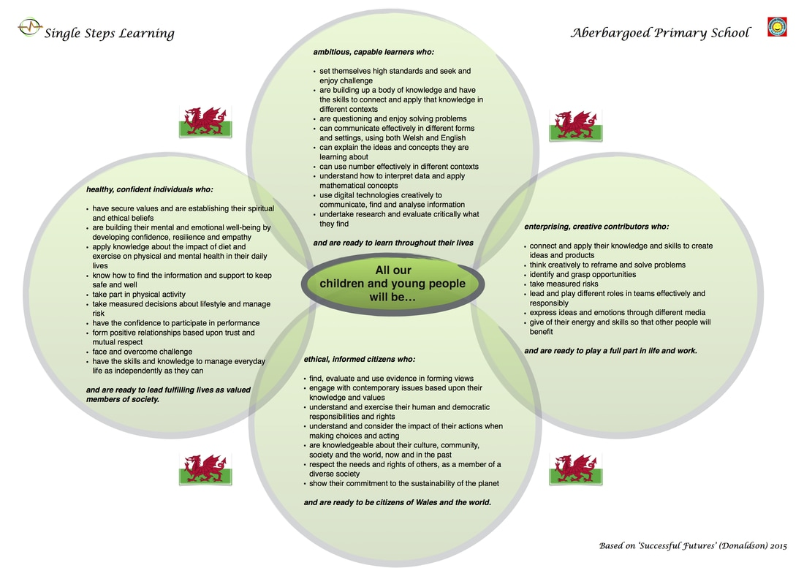

Appendix 2
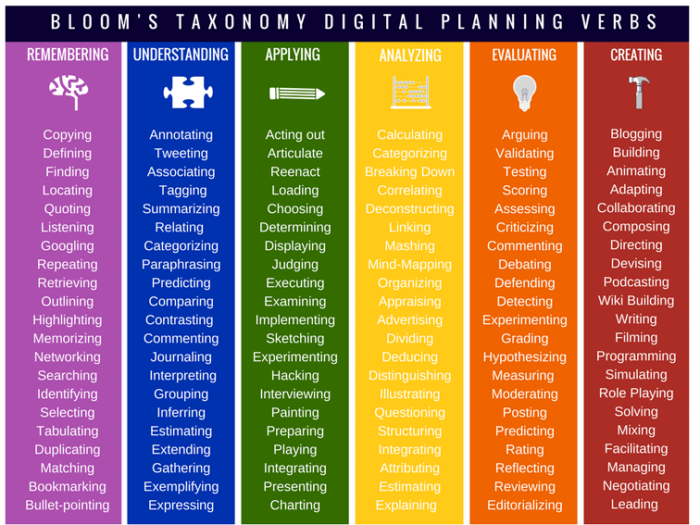
Appendix 3


