Industry 4.0

Assessment 1 – Written Report

Automated Filling and Packing – Manual to Automated Process Technical Report

Submitted by:
Tristan Lee
2240439

Submitted to:
Mahesh Kannath

University of Wales Trinity Saint David

28th April 2023

Abstract

The 4th Industrial Revolution is changing the way in which companies can manufacture, distribute, and improve their products. Integrating technologies, including Cloud computing and analytics, Internet of Things, and AI and machine learning into their production facilities and throughout the rest of their operations.

These smart factories will be well stocked with advanced sensors, embedded software and robotics that collect and analyze data, allowing for more informed decisions to be made. Even higher value can be created by combining the data from production operations with the operational data from ERP, supply chain, customer service and other enterprise systems to create whole new levels of visibility and insight from previously siloed information.

In this report I take a case study where Industry 4.0 ideologies can be introduced into the process in order to add value and improve the overall functionality of the production line. The case study is a Medical Device manufacturer that produces a CO₂ absorbent used in the operating theatre. The current process has quite a few bottle necks in the process that Industry 4.0 can easily iron out. With the help of automation and smart technology the line can be improved dramatically, saving not only time but also money.

Cover Page

1 Introduction 4
1.1 Purpose of the Report 5
2 Aims & Objectives 5
2.1 Study Objectives 5
3 Implementation Methodology 6
4 Conclusion 7
5 Recommendation 8
6 References 9

1 Introduction

The 4th industrial revolution also known as Industry 4.0 (I4.0), is defined as an intelligent manufacturing process which combines technologies such as Internet of Things (IoT), Big Data, Robotics, Machine Learning, and Cyber-Physical Systems to enable the development of a smart factory (Golam, et al., 2020). These technologies aid the implementation of I4.0 to boost the productivity and efficiency of factories as well as supporting companies to effectively respond to new demands and needs in the market (Yeeles, 2020). Medical device manufacturers throughout Wales have gradually started to employ I4.0 technologies, implementing fully automated production processes, while multiple are still making use of methods which can be classified as semi-automatic production processes.

I am currently working at a Medical device company that will be looking into modernizing its production lines and adopting more I4.0 techniques into the manufacturing processes. This means it is the perfect opportunity to use this as my case study for this report. One of our most successful products we produce is a CO₂ absorbent, used in operating theatres.

The CO₂ absorbent cannister (See figure 1) is a device used in operating theatres around the world, providing patients under anesthetic with filtered breathing air throughout their procedure. It allows air to be recycled within the circuit as it absorbs the carbon dioxide exhaled by the patient. Without the use of a CO₂ absorbent there is a lot of waste as exhaled air wouldn’t be rebreathed by the patient, which in turn means the price for the procedure is much higher. The cannister is used in conjunction with an anesthesia machine (See figure 2) within a perioperative environment.

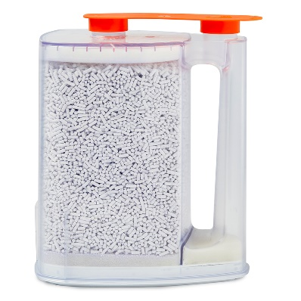
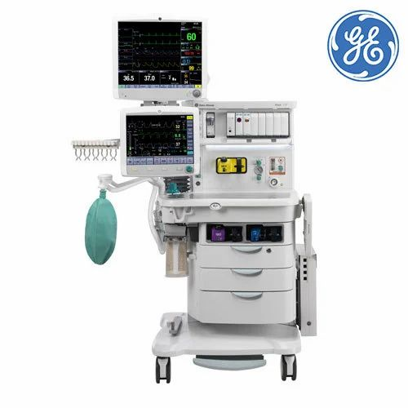
Figure 1 CO₂ Absorbent Cannister
Figure 2 Anesthesia Machine

  - Purpose of the Report

The purpose of this report is to present an efficient method to mitigate the current manual processes of filling and packing the cannisters with the CO₂ absorbent granules. The solution will focus on integrating industry 4.0 processes and ideologies. The report explores:

- Current inefficiencies of the existing filling and packing processes
- Identification of industry 4.0 ideologies that can improve the efficiency of the process

- Aims & Objectives

  - Study Objectives

The objective of this report is to identify and propose an automated method of filling and packing the canisters which considers industry 4.0 ideologies, improves efficiency and throughput, and provides a solution to replace the current manual process currently in place for the fabrication of the device.

The number of operators needed should decrease and the process should become almost fully automatic. Waste should be reduced also as the accuracy of the filling should be improved.

- Implementation Methodology

The current filling process needs to be addressed because the filling aspect of the fabrication causes a bottle neck in the process, where the cannisters cannot be filled quick enough to keep up with the extrusion of the CO₂ absorbent granules. The medical device industry is a sector that is highly regulated where safety, quality, and clinical efficacy are major requirements that companies need to adhere to (Borland, 2021). This is something that needs to be remembered when talking through some suggested actions.

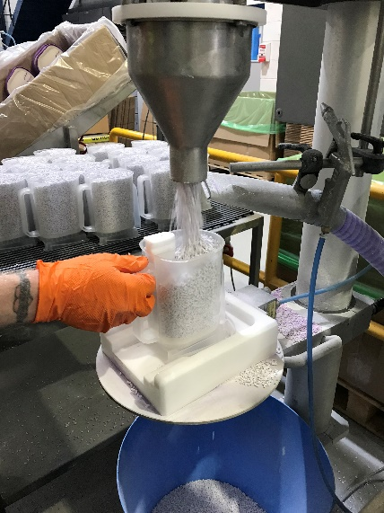
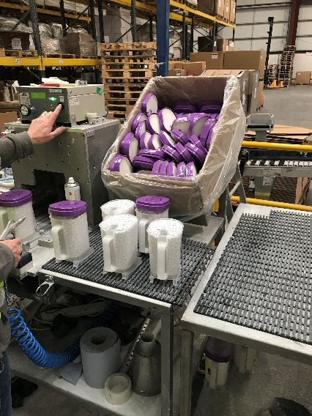
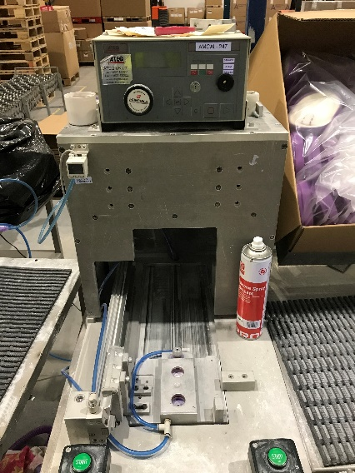
Figure 3 Filling cannister
Figure 4 Manual lid placement
Figure 5 Lid Press

Swgdgdg

As you can see in the pictures above, the process is very outdated and inefficient. The cannister is manually placed under the hopper of granules and then a button is pressed to commence the filling. This full cannister is then manually placed over onto the next station of the line. Here, a lid is placed onto the top of the cannister, and it sits waiting to be placed into the lid press. This presses the lid securely down onto one cannister at a time. This one bit of the process requires two operators full-time and is extremely slow. Not to mention a lot of waste is created as the granules overflow the cannisters and fall down into the blue bucket below, seen above.

I will now demonstrate how I would go about improving this process and what I4.0 ideologies can be imbedded into the process.

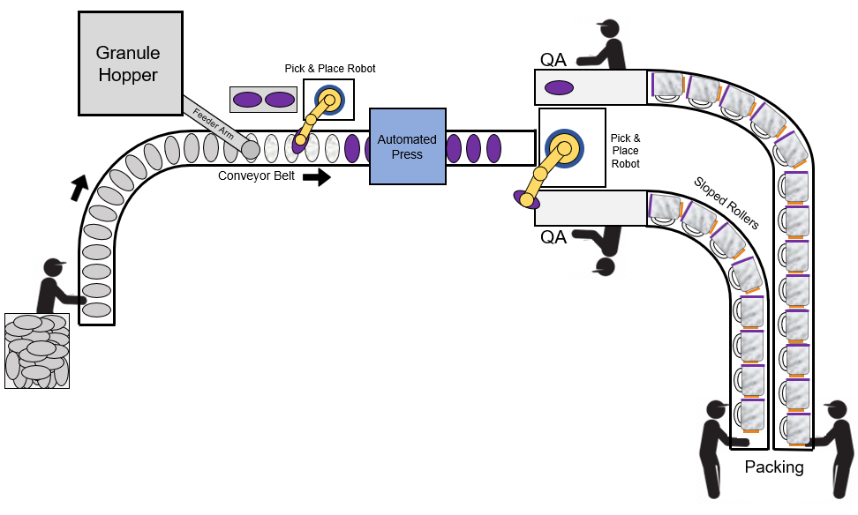

Figure 6 Suggested improvements

With a slow-moving stop start conveyor belt, the cannisters can simply be placed onto it by an operator at the very start and then they can move through the packing line automatically. They will be filled by a feeder arm attached to a large hopper. This will be done using a sensor, when the cannister enters the correct area, the hopper will release the granules. And when the required amount has been fed into the cannister it will shut and stop the flow.

A robot will then pick and place a lid from a stack onto the filled canister. This stack will have to be made by an operator but there will be two stacks next to each other on a rotating table. Which means as soon as one runs out it will rotate in the new one to keep the line moving. This gives the operator plenty of time to restock the stack in between rotations. The lids will be placed with extreme accuracy.

These lidded cannisters can then move into the automated press. As the conveyor stops for the cannisters to be filled, it will also therefor stop inside this press. This gives plenty of time for the press to come down and apply the force to seal the cannister. This press will be finely tuned to apply the perfect amount of force to seal the cannister without causing damage. However, it will apply the required force until it senses the click of the seal being made between the two objects. Learning from each application, and it will improve over time.

These fully filled cannisters will then exit the press and be picked up again by a robotic arm. This time they will be placed onto desks in order to be checked by a QA operator.

All these robots and sensors are part of the Internet of Things. This will connect the digital and physical world, constantly monitoring the flow of the line. Making sure that nothing is out of place or unfunctional. This is also great for health and safety and predictive maintenance. As everything is tracked and the robots will shut off if anyone/anything gets too close whilst they are running. They will also keep track of all the internal elements that make up the machine allowing the business to plan for maintenance and downtime.

Another very beneficial aspect of this is the ability to create Digital Twins. These are virtual replicas of the production line, which can be created by drawing data from IoT sensors, devices, PLCs, and other objects connected to the internet. These digital twins can be used to help productivity and improve the process. The whole process can be simulated allowing the company to test changes to the process to try and help to find ways of minimizing downtime and improving capacity.

4 Conclusion

In conclusion I believe this is the perfect example of a manufacturing process that could be dramatically improved with the application of I4.0 principles. AI and Machine learning allows the company to track downtime and predict future problems or maintenance. The IoT allows the company to make digital twins of the process and run tests to try and improve capacity and accuracy. With the suggested layout, the waste will be dramatically reduced as the new filling arm will be much more accurate, and the output will be increased at least x2 if not more.

- References

Golan, M., Cohen, Y. & Singer, G., 2020. A framework for operator - workstation interaction in
industry 4.0. International Journal of Production Research, 8(58), pp. 2421-2432.

Borland, A., 2021. med-technews.com: Using data better: Accelerating medtech's industry 4.0
evolution. [Online]

Yeeles, M., 2022. med-technews.com: Smart technology: The next stage for medical device
manufacturing. [Online]

