Contents

Part 1 – Timetable – Pages 2-3

Part 2 – Using AI – Pages 4-12

Part 3 – Poster – Page 13

References – Page 14-15

Part 1 - Timetable
 | 6am | 7am |  | 8am | 9am | 10am | 11am | 12am | 1pm | 2pm | 3pm | 4pm | 5pm | 6pm | 7pm |  | 8pm | 9pm | 10pm | 11pm
Mon |  |  |  |  |  |  |  |  | * |  |  |  |  | *
Tues |  |  |  |  |  |  |  |  | L |  |  |  |  | *
Wed |  |  |  |  |  |  |  |  | U |  |  |  |  | T
Thurs |  |  |  |  |  |  |  |  | N |  |  |  |  | E
Fri |  |  |  |  |  |  |  |  | C |  |  |  |  | A
Sat |  |  |  |  |  |  |  |  | H |  |  |  |  | *
Sun |  |  |  |  |  |  |  |  | * |  |  |  |  | *

Code
 | Breaks |  |  | Get Aneurin ready for bed |  |  | Uni
 | School run/travel to work |  |  | Uni research/reading |  |  | Free Time
 | Alarm, wellbeing hour with a cup of tea |  |  | Bed/sleep |  |  | Walk Dogs
 | Wake Aneurin, get ready for school |  |  | Shopping |  |  | Family Time
 | Feed Dogs and cat |  |  | Housework
 | Work from Home |  |  | Uni Assignments
 | Work at Office |  |  | Date Night

The Learning Journey: developing skills for academic success.
Part 2

Using AI
Initial Prompts and outcomes.
I acknowledge the use of Microsoft 365 Copilot (https://copilot.microsoft.com) on 17/09/2026 to research Study Techniques. I used the prompts:
- Study Techniques

. Active Recall
Instead of rereading notes, test yourself regularly.
Examples:
- Use flashcards.
- Cover answers and recall them from memory.
- Answer practice questions without looking at notes.
Why it works: Retrieving information strengthens memory more effectively than passive review.
- 2 hours of maths only
Try:
- 30 minutes maths
- 30 minutes science
- 30 minutes English
- 30 minutes maths review
Why it works: Improves problem-solving and helps distinguish between concepts.

2. Spaced Repetition
Review material over increasing intervals rather than cramming.
Example schedule:
- Day 1: Learn content
- Day 2: Review
- Day 5: Review again
- Day 10: Review
- Day 20: Review
Why it works: Revisiting information just before you forget it improves long-term retention.

3. The Pomodoro Technique
Study in focused blocks with short breaks.
Typical structure:
- 25 minutes studying
- 5 minutes break
- After 4 cycles, take a 15-30 minute break
Benefits:
- Improves concentration
- Reduces burnout
- Makes large tasks feel manageable

- Study techniques to make best us of time

The 80/20 Study Method
Spend your time as follows:

1. Active Recall (50%)
The highest-value activity.
Instead of reading notes:
- Close the book.
- Write down everything you remember.
- Answer questions from memory.
- Teach the topic aloud.
1 hour of active recall is often worth several hours of rereading.

2. Past Papers and Questions (30%)
Focus on how you'll actually be assessed.
Ask yourself:
- What questions come up repeatedly?
- What mistakes do I keep making?
- Which topics are worth the most marks?
This helps you study the material most likely to improve your grade.

3. Target Weak Areas (15%)
Don't spend equal time on everything.
Create three lists:
- ✅ Know well
- ⚠️ Need practice
- ❌ Don't understand
Spend most of your time on ⚠️ and ❌ topics.

4. Review and Planning (5%)
At the end of each session:
- Note what you've learned.
- Write down what needs reviewing.
- Plan the next study session.
This prevents wasted time deciding what to study next.

Avoid These Time Wasters
❌ Reading notes repeatedly
❌ Highlighting entire pages
❌ Copying notes word-for-word
❌ Watching videos without taking action
❌ Studying only topics you already know
These feel productive but often produce little learning.

For Busy Professionals
As a Family Worker, you may find micro-learning particularly useful:
- 15-minute study blocks during quieter periods.
- Audio learning while travelling.
- Flashcards on your phone.
- Reviewing key concepts immediately after training sessions.
This approach often gives better results than trying to find large chunks of study time.
- Adapt this plan for 15 minutes study sessions

- Study techniques for uni whilst busy working mum

The "Busy Mum" Study Strategy

1. Lower the Bar to Start
Don't wait for a free evening or a quiet house.
Instead think:
- "I'll do 15 minutes."
- "I'll read one article."
- "I'll make three flashcards."
Small wins build momentum and are much easier to fit around work and family life.

Use "Micro-Study" Sessions
Instead of waiting for a free 2-hour block (which rarely appears), use:
- 10 minutes before work
- Lunch breaks
- Waiting at activities or appointments
- 15 minutes after children are asleep
In 10-15 minutes you can:
- Review flashcards
- Read one journal article section
- Create a summary of a lecture
- Test yourself on key concepts
These small sessions add up quickly.

Have a Weekly Study Plan, Not a Daily One
Working and family life can be unpredictable.
A daily plan:
- "Study at 7pm every day"
often fails.
A weekly plan:
- 6 study hours this week
- 2 hours assignment work
- 2 hours reading
- 2 hours revision
is much more flexible.

I confirm that I have not presented any AI generated text as my own work. I confirm I have copies of my drafts, notes and other resources I used before, and after the use of AI tools which I may be asked to provide in evidence.
Academic Writing on two chosen study skills
- The Pomodoro Technique (Cirillo, 2018)
This technique was created in 1980, it uses a timer to help manage time whilst completing study tasks, it also includes breaks that will help with a person’s concentration.
It works by setting a 25-minute timer and using that time to concentrate solely on the selected task without any distractions.
The technique then allows for a 5-minute break away from the computer and task before resetting the time and starting again.
It is recommended that this is repeated 4 times before taking a longer break than 5 minutes.
This technique may help people with their studying time management by using the timer to set a specific amount of time for focused work which enables them to be able to concentrate on the current task by taking away any distractions and by breaking up the task into smaller parts. The breaks promote the learner’s wellbeing by ensuring that they move away from their workspace.
The Pomodoro Technique can support leaning in the future by helping the learner to improve on their attention skills, alleviating distractions and will help them to manage their time for other assignments by making them more aware of how long things can take to get done.
- Micro-learning (Hierholzer, 2025)
Micro-learning has a similar concept to The Pomodoro Technique, although it breaks it down into smaller parts within a smaller timescale. The modules are split into single focus parts so that only one area of learning is worked on at one time. It is taught through online platforms like Apps so that it can be accessed at any time making it easier for the learner to apply and practice in the workplace.
Micro-learning can help improve a learner’s study skill as the content is broken down into smaller parts preventing the learner from becoming overwhelmed, its flexible approach allows the learner to study wherever they are able e.g. train ride, lunch breaks.
Micro-learning can help support future learning by enabling the learner to have access to their content continually and letting them focus for a maximum of 10 minutes which prevents fatigue and as they are able to study wherever, they are able to refer back at any time to refresh their memory.
Reflections on AI use
AI, what worked well?
Reflecting on using AI, I found that the more specific the prompts are, the more precise and accurate the information is when retrieved. Starting the searches with minimal information enable AI to offer their own prompts to help narrow down the search criteria to get to the content needed.
I found using AI challenging as its not a learning style that I am familiar with, and it is a new concept to me. I found that it is quite easy to access relevant information and at times it gave so much information that it got quite overwhelming.
The benefits of using AI when studying are having the support for assignment structures, proof-reading as it can clarify where parts many need editing or extending. It can also help generate research that it relevant and that can then be checked by the learner themselves, it can support with a learner’s language barriers for example, research published in other languages.
Ai generated results need to be checked to ensure that they are reliable, peer reviewd and appropriate for academic relevance. It can provide inaccurate information, can be inconsistent and produce copyrighted information which can then result in the learner plagiarising accidentally.
To use AI responsibility, (AI Knowledge Hub, 2025) a learner needs to be able to verify the information that is being provided and have the ability to protect sensitive information to prevent breaches of General Data Protection Regulation (GDPR) (Wolford, 2025)
Adopt a “don’t use it if your unsure” ethic and always declare when AI has been used, where, when and how.

Part 3 – Poster
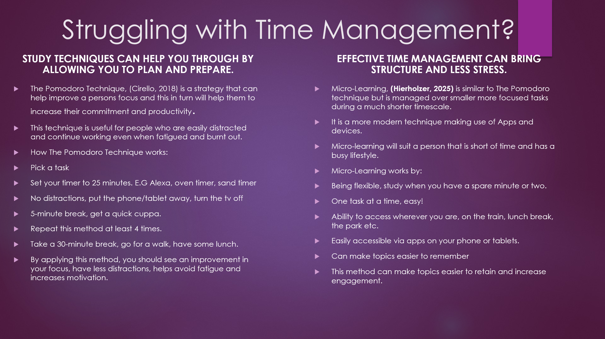

References
Cirillo, F. (2018). The pomodoro technique: The acclaimed time management system that has transformed how we work. New York: Currency.

Gupta, S. (2022). What Is the Pomodoro Technique? [online] Verywell Mind. Available at: https://www.verywellmind.com/pomodoro-technique-history-steps-benefits-and-drawbacks-6892111 [Accessed 17 Sept. 2026].

Scroggs, L. (n.d.). The pomodoro technique — why it works & how to do it. [online] Todoist. Available at: https://www.todoist.com/productivity-methods/pomodoro-technique [Accessed 23 Sept. 2026].

Dr. Erik Albinson | Learning & Performance Coach (2026). The Real Reason The Pomodoro Technique Works (It’s Not What You Think). Available at: https://www.youtube.com/watch?v=eneJG8Ch0mY [Accessed 17 Sept. 2026].

Hierholzer, N. (2025). Revolutionize Workplace eLearning with the Power of Microlearning - Online Learning Consortium. [online] Online Learning Consortium. Available at: https://onlinelearningconsortium.org/olc-insights/2025/02/revolutionize-workplace-elearning/ [Accessed 17 Sept. 2026].

Taylor, A. and Hung, W. (2022). The Effects of Microlearning: A Scoping Review. Educational technology research and development, 70, pp.363–395. doi:10.1007/s11423-022-10084-1.

Leong, K., Sung, A., Au, D. and Blanchard, C. (2020). A Review of the Trend of Microlearning. Journal of Work-Applied Management, 13(1), pp.88–102. doi:10.1108/jwam-10-2020-0044.

AI Knowledge Hub. (2025). Using AI ethically and sustainably. [online] Available at: https://ai.gov.uk/knowledge-hub/how-to/ethics/ [Accessed 17 Sept. 2026].

Wolford, B. (2025). What is GDPR, the eu’s new data protection law? [online] GDPR.EU. Available at: https://gdpr.eu/what-is-gdpr/ [Accessed 17 Sept. 2026].

