Student name:Razvan Laurentiu Enache.

Student number:2241197

Individual Presentation (50%) & Supporting Marketing Plan (50%)

Component A (Marketing plan)
Table of Contents
Introduction 3
Situation Analysis 3
Objectives 7
Strategy 7
Tactics 8
Action 8
Control 9
Conclusion 10
References 11
Appendices 13

Introduction
The purpose of this marketing plan is to highlight the marketing opportunity with regard to the multinational hotel brand Holiday Inn by creating an effective marketing and communication strategy that can lead to profitability and competitiveness in the current business environment. In order to develop the marketing plan for the hotel brand, the use of STP analysis, 5C’s of marketing, PESTLE analysis, 4Ps of the marketing mix, SWOT analysis, and Bowman’s strategy clock has been carried out in a detailed manner.

Situation Analysis
Company: SWOT analysis
Strengths  - Wider market share and extensive physical presence at global terms.  - Higher visibility and market reach due to over 1200 properties in distinct continents, (Ihgplc.com, 2022).  - Product and service differentiation for medium and high-class customer groups. | Weaknesses  - The lack of digital marketing and communication tactics has lowered brand awareness and competitiveness, (Denysenko and Breus, 2020).  - Low penetration in emerging nations.
Opportunities  - Increasing engagement of customers on digital platforms based on feedback and reviews can be influenced, (Gong, 2020). | Threats  - High level of competitiveness.  - Lower disposable income due to the impact of covid-19 crisis can impact travel intention, (Chon and Schuckert, 2020).

Customers: Segmentation and Targeting
With regards to segmentation, Holiday Inn focuses particularly on two income groups which are medium and high in order to differentiate its products and service offerings. In addition, it focuses on customers who want to get away from their hectic and stressful lives, (Rogerson, 2020). Based on the target market, Holiday Inn targets business corporates or professionals and families who want to experience a relaxing time from their stressful lives which assists to attract potential guests from the wider market.
Competitors: Perceptual positioning map and Bowman’s strategy clock
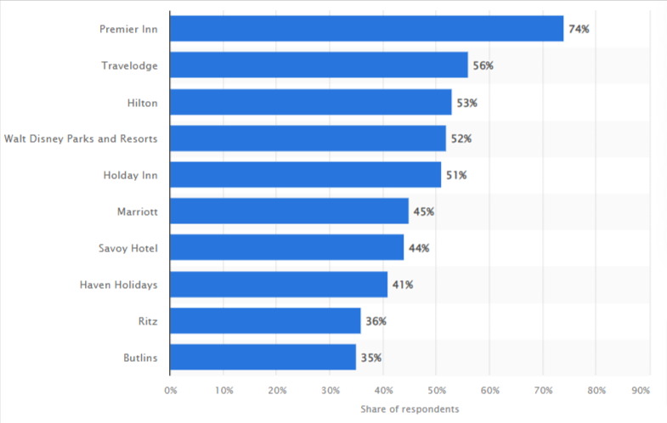
Fig: 1 (Leading multinational hotel brands in the UK)
Source: (Statista.com, 2022)
It has been analysed based on the above figure that Walt Disney Parks and Resorts, Travelodge, Hilton, and Premier Inn are the major competitors of Holiday Inn due to their effective marketing and communication tactics that resulted in increased brand awareness.
With regards to Bowman’s strategy clock, Holiday Inn uses a hybrid pricing strategy as it differentiates its products or services in terms of moderate to high prices for adequately serving guests. In addition, the brand also capitalises on focused differentiation by creating products and services for different income groups of guests that lead to profitability and sustainability. Other than that, the brand offers standard products based on pricing that leads to profitability competitiveness and long-term value proposition. Hence, Holiday Inn’s competitive strategy is based on Bowman’s strategy clock lies on 3, 5, and 6 pointers.
Travelodge
Walt Disney Parks and Resorts
Premier Inn
Holiday Inn
Poor quality service

High quality service
Low Price
High Price
Hilton
Fig: 2 (Holiday Inn’s perceptual positioning map)
Collaborators:
The major collaborators of Holiday Inn are voco hotels, IHG One Reward, Iberostar Beachfront Resorts, and Vignette™ Collection which have offered significant profitability and growth over the years for the hotel brand, (Strutton and Tran, 2020). However, the lack of effective social media and digital advertising efforts has the potential to lose potential collaborators of the brand while affecting its competitiveness.
Climate: PESTLE
Political | The uncertainties of Brexit have affected the number of visitors to the UK, (Lee and Widdows, 2020). (Threat)
Economic | The covid-19 crisis has affected the hotel segment in terms of lower spending behaviour and disposable income of customers, (Špiler et al. 2023). (Threat)
Social | High awareness among customers in terms of hygiene, affordability, and social distancing measures, (Amicarelli et al. 2022). (Threat)
Technological | Increasing the trend of influencer marketing by using social media platforms can attract potential customers within the hotel segment. (Opportunity)  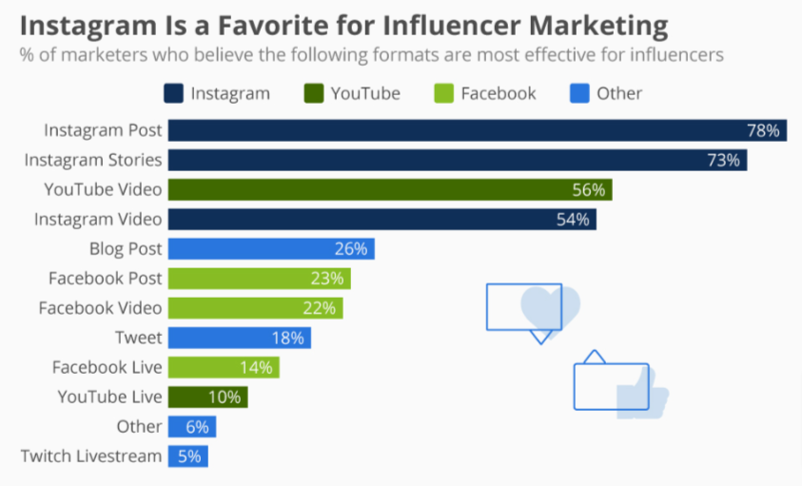  Marketing and communication opportunities for multinational hotel brands  Source: (Feldman and Richter, 2019)
Legal | Changing and stringent regulations within the hotel segment can affect business operations, (Huang and Zheng, 2021). (Threat)
Environmental | Increasing awareness among customers to prefer sustainable brands, (Tong-On et al. 2021). (Opportunity)

Marketing Mix
Product: Holiday Inn’s products and service offerings include modern amenities, technology integration, and luxurious accommodations that comply with unique guest experience, (Ihgplc.com, 2022).
Place: The hotel brand considers both online and offline platforms where customers can easily book their stay or use relevant services offered by the brand.
Price: It has both medium and high pricing strategies for creating differentiation of products to address the issue of lower disposable income and spending behaviour.
Promotion: At present, the hotel uses only digital platforms such as Facebook, YouTube and Instagram, and email to reach out to loyal customers, (Hameed et al. 2021). However, its intention to capture new customers is limited in the technological era.

Objectives
Specific | To enhance Holiday Inn’s reach and visibility by using influencer marketing and communication tactics.
Measurable | The analytics and metrics can assist to measure and monitor the engagement of users.
Actionable | Different social media platforms will be capitalised by contacting significant influencers to promote the brand.
Realistic | It can assist to increase profitability and market share for the brand.
Timely | 2 years

Strategy
The new value proposition for Holiday Inn is it can increase its reach and visibility in the global marketplace by using influencer marketing and communication tactics. In the marketing mix, the promotion element will be modified by adding influencer marketing and communication strategy for targeting the age group of 18-35 years to increase profitability and market share. As the brands’ visibility and reach are highly limited in the present technological era, this strategy can assist to overcome this issue. In terms of Ansoff’s Matrix, Holiday Inn will use a market penetration strategy by capitalising on influencer marketing to increase its sales of existing products and services.

Tactics
RACE strategy
Reach: At present, Holiday Inn has a simple approach to communication including emails and social media but the advent of digitisation and influencer marketing is lacking. As a result, the use of Twitter, YouTube, and Facebook platforms will be capitalised by aligning significant influencers to increase its reach and visibility which it lacks at present.
Act: As customers are inclined towards digitisation and the increasing influence of influencer marketing has been evident, these issues can be mitigated by capitalising the new communication tactics. As a result, close attention to the key metrics and analytics of user engagement towards each influencer marketing amping will be noted, (Khatter et al. 2021).
Convert: By determining the conversion rate for each guest and analysing user engagement, the commercial value of the brand will be established.
Engage: It is a medium-term approach. Hence, the focus on engaging the target market segment is primitive.

Action
Gnatt Chart:
Deliverable | Targets | Completion date
Outreach list of influencers | Determining blog post topics and analysing relevant influencers | May-August, 2023
Outreach emails of influencers | Draft and send emails | September-December, 2023
Blog posts | Copying, designing, and publishing different blog posts | January-April, 2024
Follow-up on the influencers | Drafting and sending social media content for the influencers to share | May-August, 2024
Social media promotion | Posts on YouTube, Instagram, Facebook, and Twitter will be scheduled and shared | September-December, 2024
Measuring the performance | Blog traffic as well as social media shares will be evaluated | January-April, 2024

This marketing channels can assist to increase the reach and visibility of the hotel brand which has been also identified through the situation analysis. Hence, these have informed my decisions.

Control
The following are the steps that have been considered to measure the success of acquiring new customers within the age group of 18-35 years.
- Individual influencer campaigns will be measured using Urchin Traffic Monitor, (Matejić et al. 2022).
- Term codes will be capitalised for tracking visitors’ clicks and to assess new customers.
- The growth in conversion rate can assist to monitor the positive attitudes of customers which can reflect through profit margin.

Conclusion
The only challenge of the marketing plan is its effective compliance. Hence, it is recommended to Holiday Inn comply with the marketing plan for increasing its visibility and reach while accomplishing profitability and competitiveness.

References
Amicarelli, V., Aluculesei, A.C., Lagioia, G., Pamfilie, R. and Bux, C., 2022. How to manage and minimize food waste in the hotel industry: An exploratory research. International Journal of Culture, Tourism and Hospitality Research, 16(1), pp.152-167.
Chon, K. and Schuckert, M., 2020. Hospitality in Asia: The Dawn of a New Paradigm. In The Routledge Companion To International Hospitality Management (pp. 133-141). Routledge.
Denysenko, M. and Breus, S., 2020. Hotel business management in modern business conditions. Economic strategies for the development of society.
Feldman, S. and Richter, F. (2019) Infographic: Instagram is a favorite for influencer marketing, Statista Infographics. Available at: https://www.statista.com/chart/19551/instagram-for-influencer-marketing/ (Accessed: 16 May 2023).
Gong, J., 2020, November. The Enterprise in the Emerging Market Influenced by Coronavirus: Experience From IHG. In 2020 2nd International Conference on Economic Management and Cultural Industry (ICEMCI 2020) (pp. 157-160). Atlantis Press.
Hameed, W.U., Nisar, Q.A. and Wu, H.C., 2021. Relationships between external knowledge, internal innovation, firms’ open innovation performance, service innovation and business performance in the Pakistani hotel industry. International Journal of Hospitality Management, 92, p.102745.
Huang, L. and Zheng, W., 2021. Novel deep learning approach for forecasting daily hotel demand with agglomeration effect. International Journal of Hospitality Management, 98, p.103038.
Ihgplc.com. (2022) Annual report (2022) InterContinental Hotels Group PLC. Available at: https://www.ihgplc.com/en/investors/annual-report (Accessed: 16 May 2023).
Khatter, A., White, L., Pyke, J. and McGrath, M., 2021. Stakeholders’ influence on environmental sustainability in the australian hotel industry. Sustainability, 13(3), p.1351.
Lee, J. and Widdows, R., 2020. Brand Extension Management: Analysis of Industry Trends. Journal of Economics and Business, 3(2).
Matejić, T., Knežević, S., Arsić, V.B., Obradović, T., Milojević, S., Adamović, M., Mitrović, A., Milašinović, M., Simonović, D., Milošević, G. and Špiler, M., 2022. Assessing the Impact of the COVID-19 Crisis on Hotel Industry Bankruptcy Risk through Novel Forecasting Models. Sustainability, 14(8), p.4680.
Rogerson, C.M., 2020. Apartheid hotels: The rise and fall of the ‘non-white’hotel in South Africa. New directions in South African tourism geographies, pp.33-54.
Špiler, M., Matejić, T., Knežević, S., Milašinović, M., Mitrović, A., Arsić, V.B., Obradović, T., Simonović, D., Despotović, V., Milojević, S. and Adamović, M., 2023. Assessment of the Bankruptcy Risk in the Hotel Industry as a Condition of the COVID-19 Crisis Using Time-Delay Neural Networks. Sustainability, 15(1), p.272.
Statista.com. (2022) Published by Statista Research Department. Most Popular Hotel Brands UK 2022, Statista. Available at: https://www.statista.com/statistics/951262/most-popular-hotel-brands-uk/ (Accessed: 16 May 2023).
Strutton, D. and Tran, G.A., 2020. Think intersectionally, act innovatively. Business Horizons, 63(4), pp.565-572.
Tong-On, P., Siripipatthanakul, S. and Phayaphrom, B., 2021. The implementation of business intelligence using data analytics and its effects towards on performance in the hotel industry in Thailand. International Journal of Behavioral Analytics, 1(2).

Appendices


