Knowledge and Information Management Skills
BMSK5006_SWAN

Musammot Sima
1705525
Executive summary
Throughout this report it has been asked to explain the benefits of knowledge management system in two different organisations. It will focus on two different sectors and it will follow with various frameworks, like; Quinn, Wiig, Nonaka, Weggeman and value chain. In this report it will show how two different organisations transfer knowledge and information through tacit and explicit knowledge. Both tacit and explicit knowledge is important in organisation as it shows how well staff communicate with each other and achieve their goal.
The report will therefore conclude with both organisations SWOT. It will mention one of the company’s mission statement and value chain. It will be recommending how the organisation can improve their method to transfer knowledge and update the system.

Contents
1.0 Terms of reference 4
2.0 Procedure 5
2.1 Introduction 6
3.0 Task 1 7
3.1 Tesco 7
3.2 Staff profile of Tesco; 8
3.3 Swot on Tesco: 9
3.4 British Telecom 10
3.5 Staff profile of BT; 11
3.6 SWOT on BT; 12
4.0 Task 2: 13
4.1 BT Mission statement: 13
4.2 Knowledge management models; 14
4.2 Value chain 14
4.3 Quinn Cultural model; 15
4.4 Wiig knowledge model; 16
4.5 Knowledge value chain: 17
4.6 Weggeman knowledge management model in BT: 18
4.7 Information system: 19
4.8 Information system for BT 19
4.9 Management information systems (MIS) 20
5.0 Conclusion: 21
6.0 Recommendation: 22
7.0 Reference list 23

1.0 Terms of reference
This report was requested by Maria Heffernan. This report has been given in the purpose to see if organisation use knowledge management systems in two different organisations. To see if it is people oriented and how much effective the system is. Within this report there is many models on knowledge management systems. The writer has identified some gaps within the organisation and have recommended some other techniques which can be used to improve the system.

2.0 Procedure

To complete this report there has been many referencing methods use. Some are books, journals, websites and online articles. The report consists of different websites and books which has been used for introducing the frameworks.

2.1 Introduction
This report will include an overview of the knowledge management system in two different organisations which will show how they share and create value. There are many frameworks which are used in organisations to share knowledge, which can be divided into two sectors; explicit which is a formal way to share knowledge. It can be written down to share and can be easily spread to all members of staff. tacit which is informal. This is understood by all staff’s activities verbally and shared by personal preference and it is hard to express. (freedictionary.com, 2019). This report will be mentioning Tesco and British Telecommunication Swot on Knowledge Management System and many other frameworks.
The theorist Ikujiro Nonaka works broadly with the thought of sharing knowledge in two different ways. Explicit and tacit knowledge. he suggests that the knowledge creating companies systematically ensure that tacit and explicit feed into each other in a spiral of knowledge. Tacit knowledge is converted into explicit knowledge by articulation and that explicit knowledge is used within an individual’s cognitive understanding by process of internalization. (Mullins, J, p.164).

3.0 Task 1

3.1 Tesco
Tesco is one of the world’s largest retailers. Tesco is located within UK and Europe. They first opened in 1931 in North London. Tesco is a grocery, electrical & clothing retail store and has online shopping facilities. it was launched in 2000. As Tesco is worldwide, they have over 6800 shops in different locations. There is over 450000 employees within the organisation. Tesco have different stores and departments within the company where employees value their customers and colleagues.
Their mission statement is to “be the champion for the customers, helping them enjoy a better life and easier way of loving.”
They intend to create value for customers to earn a lifetime loyalty. (Tesco.plc, 2019).
Knowledge management concentrates on a structured development, transfer and application of knowledge within an organisation. Mathieu Weggeman has developed the Knowledge Management Value Chain model for the management of knowledge in an organisation. (Vliet, 2019).
There are many benefits of having knowledge management system in a business. If full advantage is taken of the system, then it leads the organisation towards success. Certain benefits can help ensure quality and increase profit level of a company. For example;
- Every staff member of the organisation has access to management system it will increase the business revenue.
- Reduce IT cost without having to compromise quality service to internal and external customers.
- Increased customer loyalty, customer’s satisfaction and quality in products to give in return to customers from the organisation.
- The knowledge management system improves staff engagement and communication. (Cracriun, 2014).
According to Cummings (2003), since the 1980 the importance of knowledge management had been recognized by different organisations. Tesco have always acknowledged how to keep up to date with the system and the competition around. The organisation uses both tacit and explicit knowledge by joining both sharing knowledge and how useful it is to manage information. Tesco employ different employees accordingly and it is very useful to manage information. Tesco uses a kms which is based on communication model. Their KMS focuses on employees concerns and they provide employees to make decisions to manage the store whilst the management focus on the bigger decisions. The regional managers use explicit transferring method and the employees use both knowledge sharing methods. Tesco gives training to staff and different methods to help the employees to update their skills and knowledge to serve the customers and keep the company in place.

3.2 Staff profile of Tesco;
There is various departments and staff to work in. each role require certain experience and qualification to get the job. A shop floor assistant needs an entry level two in retail or customer service. Store managers require masters or equivalent and experience at national account. A pharmacy manager needs a Pharmacy degree, membership of GPC and a DBS check. (indeed.co.uk, 2019).

3.3 Swot on Tesco:
Strength  Tesco offers more than 743k for employees worldwide. Tesco has new ideas in their KMS which helps employees to increase efficient access to the database with wasting less time. | Weaknesses  In Jan 18, Tesco made a switch up in the Clubcard scheme which points could have increased doubled but was undertaken without giving prior notice to customers. It faced a massive backlash from angry customers.
Opportunity  If Tesco did joint ventures in regions where they are underperforming. The local organisations can give Tesco market knowledge which can improve KMS. | Threats  With the competition and performance growth in the KMS in other organisation, for example; asda, Aldi etc it can be threatful if Tesco does not act on the right time.

(bstrategyhub.com, 2019).

3.4 British Telecom
BT is the oldest telecom company which was established in 1846. It is the company which first developed communication network worldwide. They operate hardware and software to drive the retail services to their customers. BT consists over 17,500 staff worldwide. The headquarters is in London but there are departments over 180 countries. To maintain the self-belief of the workers both managers and leaders are responsible. They undertake motivational frameworks. For example; Maslow, Mayo and Hertzberg and these lead the organisation gain success as they work as a team and focus on goals together. BT undertakes explicit knowledge so that they can always have the right and accurate detailed information of the knowledge sharing within the employees. It does not concern to what level the employee might be working in. the information shared can be written, openly shared and easily accessed to all members of staff. The explicit process has led the company towards success. They tend to avoid using the tacit knowledge sharing method to prevent from employees not getting the right information at the right time. All employees in BT are significantly important to the success of the company. (btplc.com, 2019).
BT has a system called the BT Cloud where customers can securely back up and share important factors, such as photos, videos, documents etc. in the cloud. It automatically backs up the contents which are chosen from the customer. The Cloud is a way to store data somewhere safe which is easily accessed only by the individual. This is safe from others to share the information. (bt.custhelp.com, 2019).

3.5 Staff profile of BT;
In BT an operator requires a qualification on computer and ability to use the main software. The regional lead project manager needs to have 5+years of work experience in leading projects, experience in trading floor and different use of applications. To work in HR - a minimum of 4 GCSE's at grades 4 – 9 (GCSE C or above) including English Language and Maths is needed. (btplc.com, 2019).

3.6 SWOT on BT;
Strength  BT motivates the staff to share, reuse and apply knowledge consistently through the motivational theories.  The KMS is BT helps get employees to work well together with sharing new ideas and to make any decision together or to solve any issues. | Weakness  The KMS in BT are hard to understand in certain extent for an average worker. So BT provide training for workers to use the system correctly can be costly.
Opportunity  If the KMS is easy for use for all levels of employees, then it is important for BT to keep on motivating for people to share knowledge. | Threats  Ongoing competition. Other new companies investing on technology more to stay up to date.
(reference.com, 2018).

4.0 Task 2:

4.1 BT Mission statement:

BT MISSION
The main purpose of BT mission is to deliver world’s best class telecommunication, products, services and BT wants to develop and exploit their networks via home and abroad so that can provide the needs of customers sustainability growth in earnings of the group on behalf of their stakeholders who are the influence to the community which they are conducting the business.

BT Goals
Goals of BT is to drive sustainability and growth in value.

,,l

BT Values
They tend to be personal, open, simple and give brilliant service.

BT vision:
They want to gain leadership to provide coverage, connectivity, and brilliant service.

4.2 Knowledge management models;

4.2 Value chain
This is a process of organizing different activities like, production, marketing and distribution in order to properly analyses them. The main goal is to get good communication between leaders and every staff in all department to handle each goal efficiently. (Harrison, 2018).
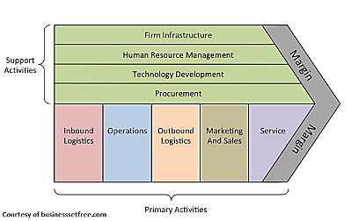
Value chain in BT is important as they have customers all around in the UK and they provide installation, technical support and give support face to face and over the telephone if required. The team tend to work together to give the best to the customers, suppliers and the whole team.
Support activities:
Firm infrastructure; Management, Finance, legal, planning and financially sponsoring to complete the relevant CIMA qualification.
HRM; Professional development, employee relations, first-hand experience of operational HR roles and training programs.
Technology; Integrated supply chain, collaborating networks and production and post technology updates.
Procurement; Real time inventory, communication with suppliers, big budgets work and negotiating with customers.
Primary activities;
Inbound logistics; location of distribution facilities, material handling, engineers going out for jobs.
Operations; calls and queries, BT cloud, staff access to the system
Outbound logistics; order and packaging process, deliver of equipment’s.
Marketing and sales; pricing, communication and low offers.
Service; delivery, installation, repair and customer service focus.

4.3 Quinn Cultural model;
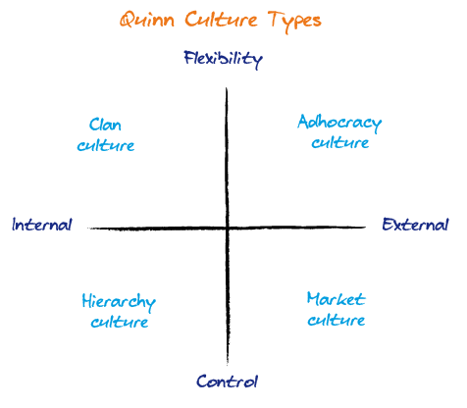
At the start of 1980’s the theorists Robert E. Quinn and Kim S. Cameron started to pay attention to the concept of the culture to organisations so that ignore certain values. They both identify four types of culture.
- Clan culture - A very friendly environment where people connects and make a good team. The main point is for people to work together in a team and collaborate with each other.
- Adhocracy culture - A dynamic and creative working environment. Staff undertake changes to achieve the goals. The organisation encourages individual initiative and freedom.
- Hierarchy culture – a formalised and structural environment. Rules are made for staff to follow. Formal rules and policies hold the organisations together. This culture focuses on the procedures alongside the quality.
- Market culture - focused on the competition and the goal is focused. (Quinn association, 2019).
BT undertakes the clan and adhocracy culture. They keep the staff and the management close together when working so that they can brainstorm ideas to achieve a goal. They work together as a team to achieve their goal. The adhocracy culture makes the leaders to boost up the staff to work well. The leaders give the staff all the changes that take place to get the best out of them. Staff are given freedom in terms of time to understand the tasks given.

4.4 Wiig knowledge model;
Karl Wiig introduced his KM model in 1993 with the purpose that knowledge will be useful if the knowledge is organised. According to Wiig, the ultimate purpose of KM is “to make the organization intelligent-acting by facilitating the creation, accumulation, deployment, and use of quality knowledge.” There are 4 stages of WIIG’s model are:
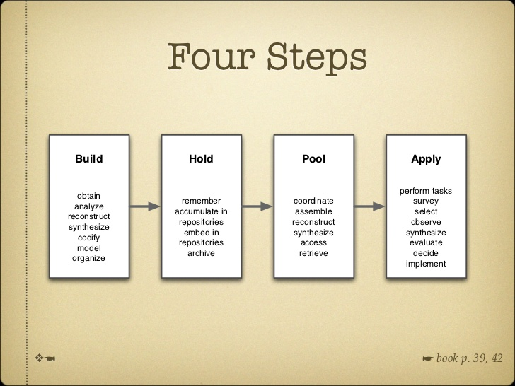
Some of the defining characteristics of the Wiig model are:
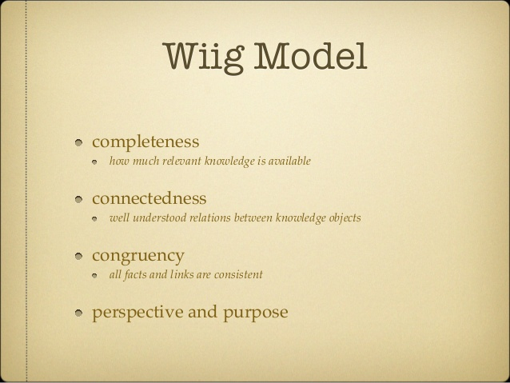
BT undertakes pool knowledge as they let all employees brainstorm ideas in projects. In BT they let all staff aware of the KMS and gives them the opportunity to understand the system itself with their own pace of time.
From the defining elements BT has a purpose and perspective. The knowledge is gained and easy for all staff, leaders and all management to access the knowledge. It is out there for everyone to get hold of any particular purpose. The purpose of having a KMS in BT is to make sharing information easy and clear for the users and makes the knowledge more applicable.

4.5 Knowledge value chain:
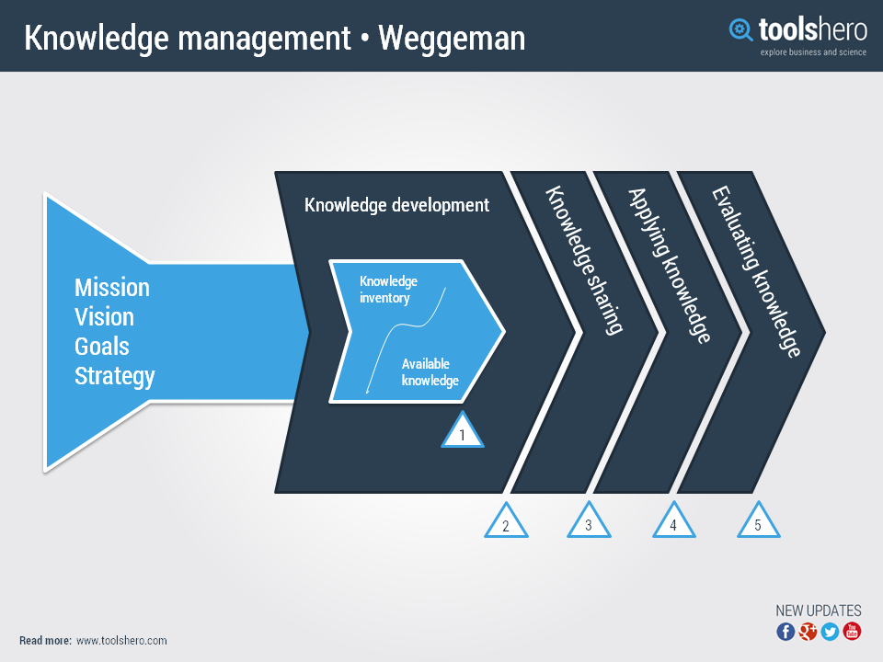
The knowledge value chain was taken introduced by Mathieu Paul Weggeman (1953). His model is effective when it is used on an organisational level. It is necessary that the planned aims of the company are observed. The model consists of five main processes, namely:
Knowledge Inventory
This is where the knowledge available and what needs to be developed. It consists of the technical skills and what attitude is needed in an organisation. The needed knowledge is then compared with the available knowledge so that the ‘knowledge gap’ is made clear.
Knowledge development
This is to identify what knowledge development is required in any organisation. This can be through training staff to purchasing knowledge from any third party.
Knowledge sharing
After knowledge is developed it should be shared within the organisation so that all staff can gain benefit from this and a knowledge value is created.
Applying knowledge
When the right knowledge is applied it will combine well with the organisation. All staff should be familiar with the knowledge system, only then it will be possible to share knowledge within the companies.
Evaluating knowledge
Evaluation is a continuous process and begins in the first stage. This enables knowledge development and possible adjustments.

4.6 Weggeman knowledge management model in BT:
Knowledge Inventory/available knowledge: The management have a structure to complete tasks that needs to be done by the staff, by having a controlled system that shows and determines how the task are planned and completed. In BT the knowledge is out there for all staff to access easily. It is available for people to understand and suggest if any changes or improvements is required.
Knowledge development: To make the right decision-making BT needs to update any new information in order to determine long term objects, polices, resources. They need to inform the employees soon as any changes are required in the system. The organisation can provide better training to improve their technical services.
Knowledge sharing: soon as BT update any information or make any changes it should be shared to all staff. This can give the staff a better understanding of the system and can focus on the customers mainly. To share knowledge BT, have a project called BT cloud for the customers. This gives any individual to share and save data easily.
Applying knowledge: BT apply knowledge by understanding what the customers’ needs are. According to BTplc.com,2019, the managers get the services of what the organisation offer themselves to understand what the customers’ needs are. The company apply knowledge by undertaking surveys to improve their KMS.
Evaluation knowledge: even though this stage is the final one, yet it gives the organisation to make any changes in this stage. BT has a goal to grow in value. Therefore, they follow Quinn’s theory and mainly relates to clay and adhocracy culture. If they did investigate the hierarchy and market culture, they would gain more success. This means if some rules were set in certain departments it would help them gain more efficiently working staff. As well as if they follow the market culture it would give BT to understand the competition around and understand how to improve on their lacking sides.

4.7 Information system:
To get extreme benefits from any organisation the company needs to have a good information system. The most important gears of the system are the people who structure it, maintain it and use it. To increase the information system effectively the organisation can either add or make the data more precise for the staff and customers. A poor information system can be a risk to any organisation in gaining its planned goals. In organisations there are different level to control the information systems. there are four levels in this system:
- Operational Level Systems
- Knowledge Level Systems
- Management Level Systems
- Strategic Level Systems. (Markgraf, 2019).

4.8 Information system for BT
Operational level
This is where it shows how performance of a specific task is set with a strategic idea and the decision is taken by the middle management. It is important to understand how to decide and who can make it possible. The management mainly take the role as decision makers. BT needs to update any information to determine the long-term policies etc. In BT most tasks are functional. The targets are structured in BT. Most of the time tasks are structured and fixed in this level.
Knowledge level
This stage provides new ideas for products and innovation in the KMS. It gives the chance for staff to communicate well with the managers. BT helps staff communicate new knowledge and distribute it to others openly. BT provide staff training for any updates in the knowledge management system.
Management level
This helps to monitor efficient and different way of resources of active units in the organisation. Tasks are semi structured. BT understand that not every task will be formal or informal. As they undertake explicit knowledge, they mainly focus on structure way to communicate.
Strategic Decision Making
In this stage it shows what the resources, long-term objectives and policies are. Certain tasks are not structured. In BT majority tasks given are well structured but some fall in this stage and gives the employees to work individually and show their ability. (UKEssays, 2018).

4.9 Management information systems (MIS)
MIS is mainly need in managing information in different sectors, such as; annual budgeting, investments, sale management system. This system is used to function to plan, control, and decide when deciding at the management level. MIS mainly served managers weekly, monthly but not daily on the activities. BT information management helps every management to access all information and carry and share the knowledge and information. MIS provides managers to answer everyone in a specific procedure. It is beneficial to have a formal and structure method to communicate. In BT the managers have the responsibility to communicate and provide the staff in various departments every information, update and share knowledge and information. (UkEssay, 2018).

5.0 Conclusion:
After analysing this report it has conclude that BT has a very good success through their business venture. They have an excellent strategy to manage knowledge management system and good reputation in maintain staff productivity and performance. BT follows Quinn, Weggeman and Wiig’s frameworks. The organisation constantly is working on how to develop and innovate new products and service for the betterment of the company and the customers. this is possible as they have an excellent knowledge management system as well as the information system. It is constantly being updated to get new techniques into the organisation to improve their services. BT transfer knowledge through Nonaka’s explicit knowledge method which is a technique to let the employees well known of the system formally. This report has shown the value chain on BT, all the primary and support activities are included.

6.0 Recommendation:
BT should acknowledge what the competition is around. As mentioned regarding Tesco, they undertake motivational theories like, Maslow and Mayo etc. If BT undertakes motivational theories it would give more opportunities for the staff to work even better as a team. It will show how the team can perform even better together and the result will be more efficient. There is always room for improvements and growth in any organisation. BT is always thinking of new ways to innovate their system and how to keep customers happy by giving them different offers on packages.

7.0 Reference list
BT (2019) [online] BT Cloud, available at: http://bt.custhelp.com/app/answers/detail/a_id/41948/~/what-is-bt-cloud%3F [accessed: 26.06.19].
BT (2019) [online] BT Plc, available at: https://www.btplc.com/index.htm [accessed: 28.06.19].
Business Strategy Hub (2019) [online] TESCO SWOT Analysis, available at: https://bstrategyhub.com/tesco-swot-analysis-2019swot-analysis-of-tesco/ [accessed: 28.06.19].
Craciun, E. (2014) [online] Benefits of a Knowledge Management System Within an Organization., available at: https://www.linkedin.com/pulse/20141029121125-2108052-benefits-of-a-knowledge-management-system-within-an-organization [accessed: 09.06.19].
Cumming, G. (2013) [online] The New Statistics: Why and How, available at: https://journals.sagepub.com/doi/full/10.1177/0956797613504966 [accessed: 17.06.19].

Easterby-Smith, Lyles, Easterby-Smith, Mark, and Lyles, Marjorie A. The Blackwell Handbook of Organizational Learning and Knowledge Management. Malden, Mass. ; Oxford: Blackwell, 2005. Print.
Essekia (2019) [online] 4 knowledge management models, available at: http://helpiewp.com/knowledge-management-models/ [accessed: 02.07.19].
Freedictionary (2019) [online] Tacit-Definition, available at: https://www.thefreedictionary.com/tacit [accessed: 28.06.19]
Harrison, K. (2018) [online] what is a value chain analysis?, available at: https://www.businessnewsdaily.com/5678-value-chain-analysis.html [accessed: 05.07.19].
Indeed (2019) [online] Store manager Tesco, available at:
https://www.indeed.co.uk/jobs?q=store%20manager%20tesco&l=sa11%203xa&vjk=ca5914167296d81f [accessed: 17.06.19].
Laurie J, Mullins, 11th edition, 2016, p.164. Pearson, UK. (2016) Organisational Behaviour, 11th edn., UK: Pearson.
Markgraf, B. (2018) [online] Importance of Information Systems in an Organization, available at: https://smallbusiness.chron.com/importance-information-systems-organization-69529.html [accessed: 05.07.19].
model2use (2019) [online] Knowledge value chain, available at: http://www.models2use.com/all/management-models-knowledge-value-chain.html [accessed: 05.07.19].
Quinn Association (2019) [online] What are the disadvantages of knowledge management, available at: https://www.quinnassociation.com/en/culture_typology [accessed: 29.06.19].
Reference (2019) [online] What are the disadvantages of knowledge management, available at: https://www.reference.com/business-finance/disadvantages-knowledge-management-8d4c66a2d2b8d626 [accessed: 29.06.19].
sunshine (2019) [online] How Tesco Use Information system, available at: https://eternalsunshineoftheismind.wordpress.com/2013/02/09/how-tesco-use-information-systems-to-their-advantage/comment-page-1/ [accessed: 09.07.19].
toolshero (2019) [online] Knowledge management value chain, available at: https://www.toolshero.com/management/knowledge-management-value-chain/ [accessed: 02.07.19].
UKEssay (2018) [online] Information Management Systems That Support Organizations, available at: https://www.ukessays.com/essays/information-systems/information-management-systems-that-support-organizations-information-systems-essay.php [accessed on 10.07.19].
Vliet, V.V. (2019) [online] Knowledge management Value chain, available at: https://www.toolshero.com/management/knowledge-management-value-chain/ [accessed on 09.07.19].

