

Assessment 1 – Reading Task Template
PART 1: Upload your photo of your A3 in-class notes here:
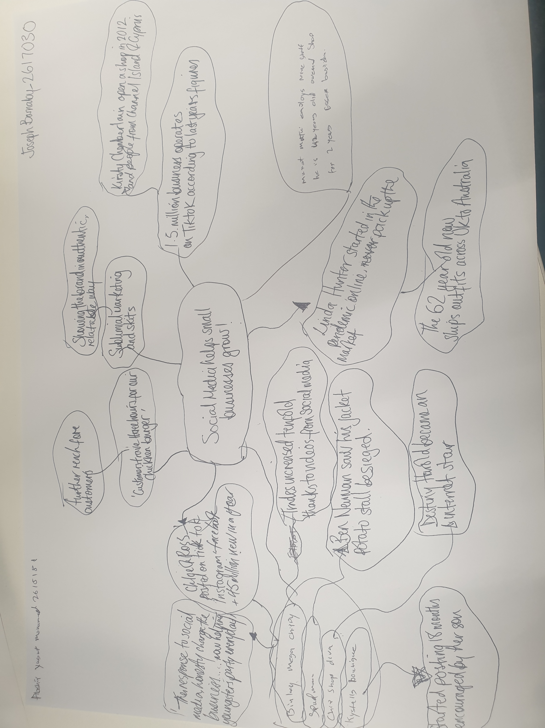

PART 2:
Answer every question below in 1-3 full sentences.
- Use your own words. Do not use generative AI to answer these questions.
- Include a specific detail from the text when asked.
REMINDER
- The main idea is the overall message of the whole text.
- A key point helps to explain the main idea.
- A specific detail or example from the text shows that the key point is true.

- What is the main idea of the whole text?
The main idea of this text is to show the power of social media and the impact that it has done for small business. It also shows the some of the business and people that it has affected.

- What is one key point that supports the main idea, and which specific example from the text shows this? .

‘The governments Business Academy with over than ‘200 million business use Instagram to reach customers’
What supports the main idea is the growth of businesses that are getting recognised around the world and it comes from and ‘1.5 million Uk business operate on TikTok’. Murat Mutlu ‘Hony Sandwich shop’ being tucked away on an industrial estate, to people coming from far to eat there, also taking pictures of the food reposting to friends and family, this is just one example.

- What is a different key point that supports the main idea, and which specific example from the text shows this?
Another key point has grown from Jet2 Holidays ‘upbeat theme music and taglines which has become an internet meme’ and many business have been benefitting from their social media fame with Bingly Mega Chippy saw a trades increase by tenfold.
- Which part of the text do you think is most important, and why?
The part of the text I find most important has come from Faye Martin who is a marketing expert who says, “Subliminal marketing and little skits…are such a good way to showing your brand in a really authentic, relatable way…” which shows a clear strategy to engage with your audience on social media, which intern will build your business.

Reflection:
- What did you find difficult in this task (including in-class components), and why was it difficult?
I didn’t find anything difficult in this task, I understood what was asked from me.

- What helped you with this difficulty, and how did it help you?

N/A

