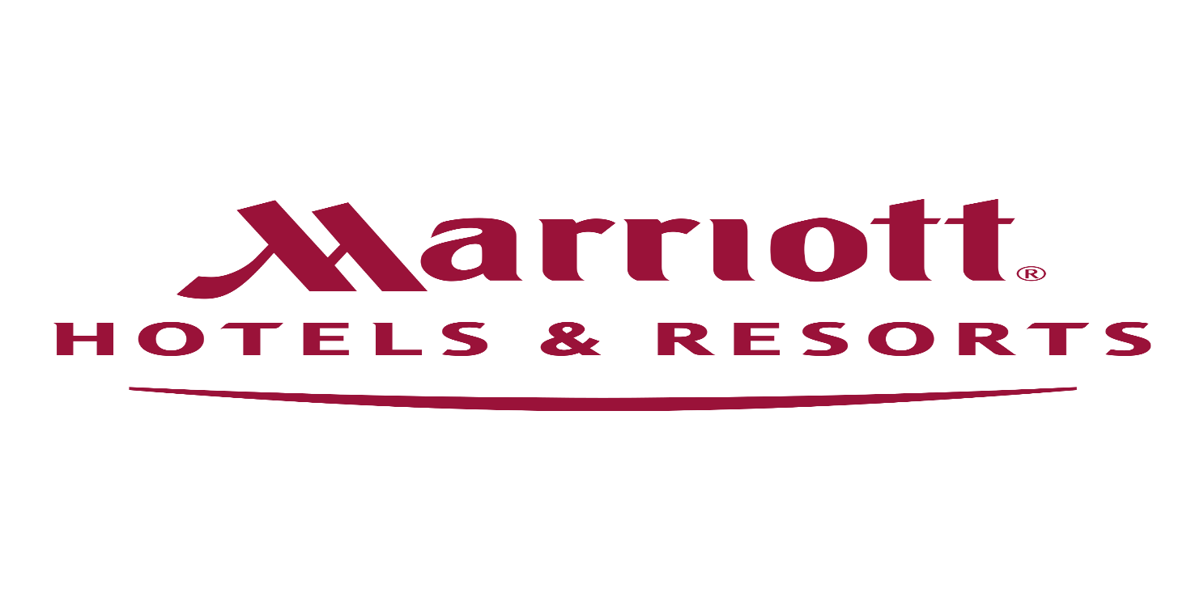

Name: Munteanu Dumitrita
Student number: 1813611
Lecturer: Abdi Rehman
Module code: M5X01921
Human Resourcing research Project on Marriot Hotel Birmingham



Summary:

Task 1
- Introduction
Task 2
- Recruitment and selection
- Application stage
- Interview procedure
- Beginning your journey with the Marriot
- Talented work force theory
- Conclusion
- References

Human Resources Report for the Forest of Arden Marriott Hotel in Coventry.

I have chosen to investigate and interpret how Marriott hotels try to keep on the job market in what way Marriot hotels get fast, diverse and efficient workforce. Marriott Hotel is a huge multinational company that contains more than 6900 hotels worldwide. After the investigations we have conclude that from 2017 to 2018 they made more than 189 thousand employees based on human resources. In evaluating how they make employers associated with the development of the workforce. The most important topics related with the hiring of personnel are the CV and the experience in the field. The Marriott hotel chain offers many possibilities to take personal training courses to gain more experience in the field.

Recruitment and selection
One of the most important departments is HR has the most important role in recruiting the employees in the available positions, it is necessary to respect the requirements of the hiring staff. work, they have to go to different fairs and programs to find candidates.
The Marriot hotel chain has different processes for recruiting and selecting candidates, posting job vacancies are announced through advertising announcements, where you can find all the details such as the location and the date it was posted, which are quite flexible. with students offering the possibility of working part time or only on weekends.
(www.careers.marriott.co.uk)(acsessed 05/12/19 )

The application Process
Making an application requires the applicant to create a user ID and account, they can upload a CV or simply create an application, where they will be asked to complete the online application with all the usual personal data, including the status of the job and the responsibilities at present. After the candidates complete the application, the employer is obliged to complete a preliminary evaluation of the employment. If they are successful the candidates will be invited to attend a face to face interview. If the HR decide they are qualified for the position, the candidates will be invited to attend a trial phase. After this the employer have to take a decision if they will keep the candidates or not.

Interview procedure
Because just after I finished my internship at Forest of Arden in Coventry, I was able to find out more details about the jobs, the available jobs that they have, how they make them available, what qualifications you need to have to get the job. apply for the job will receive all the information necessary to take part in the interview. At the time of the interview, usually a main manager and one from the department for which the candidate has applied. In some situations, the third manager may be present to eliminate discriminations or preferences. As soon as the interview is completed and if all goes well, the candidate will be taken to give him a tour of the department he will be part of. Once he is familiar with this area, one of the employees generally with the most part of experience will begin to offer training that lasts a minimum of 3 days and a maximum of 1 week. The hiring can be done by participating in Skype interviews.

Commencing your expedition at Marriot
The Marriot Hotel in Coventry needs an entire well-trained team and knowing what it is about. Because there are many departments, each one must know exactly what he does, when and where. provide an access account from where all departments can access, where they can see good reviews or complaints. Marriot is a company that really chooses to invest in people, offering training opportunities even if you have no experience but they can see a good worker in you will definitely give you the opportunity to advance in the field. Regarding your position at Marriott you can start like port washer if you are a good and hard worker you can excel in your position you can be move on to other steps which can help you to grow up.

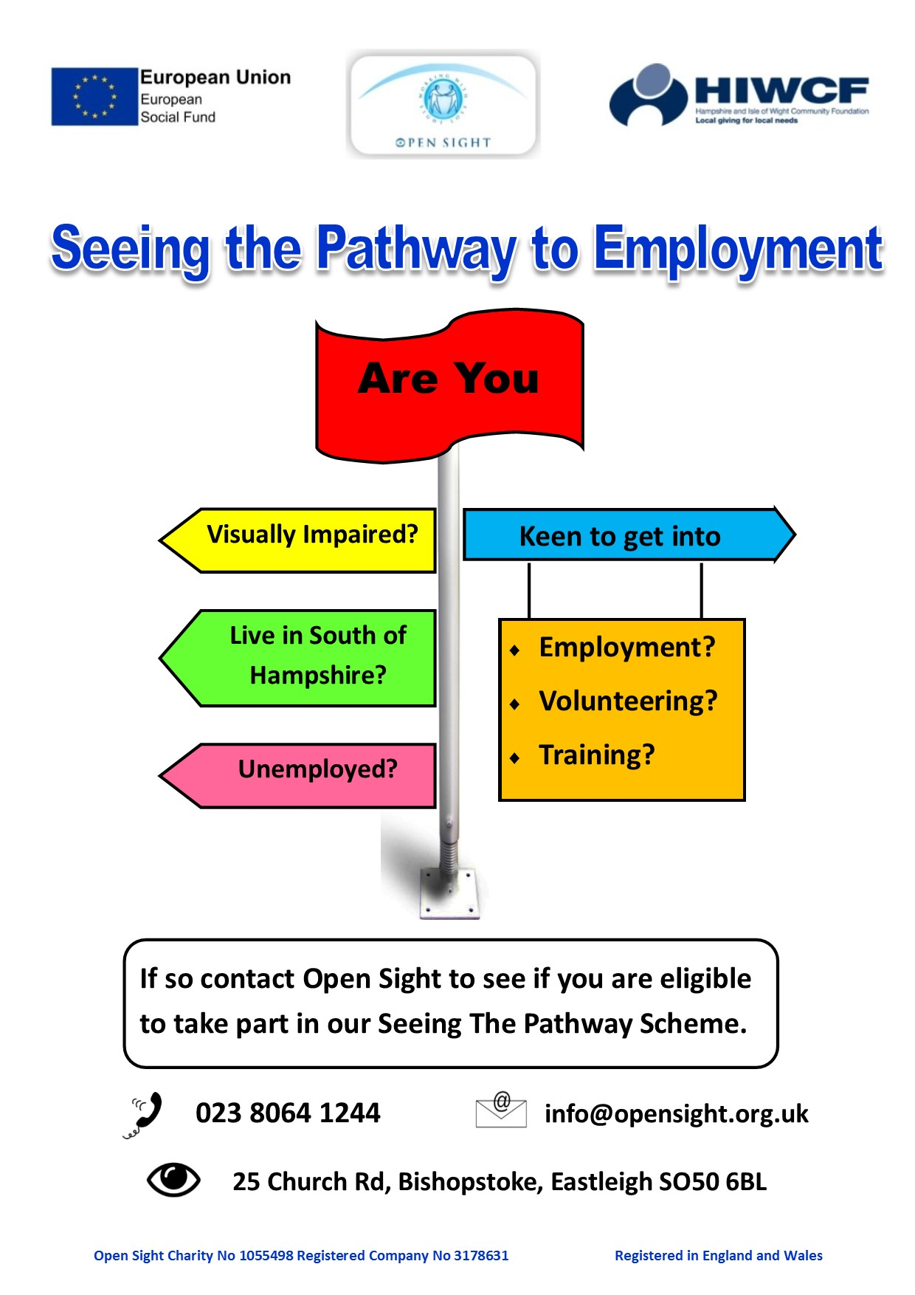

The Chance to progress and to income with new instructions for associates and advance their career prospects is usually helped at the hotel, these information leaflets are on notice sheets in staff areas promoting career progress opportunities.

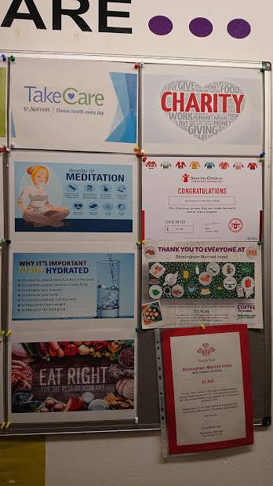

The staff from Marriott is also informed about the charity, so in this way Marriott Hotel is supporting a lot of companies. They try to help people with money, food or clothes.

The scope system is a generic system used throughout the Marriot hotels and allows the associate to acsess and unceasingly develop their skill no matter of which Marriot they work at in the world.
As illustrated in the above pictures the system is user friendly and highlights all aspects of the jobs requirements.

The Brilliant workforce concepts.
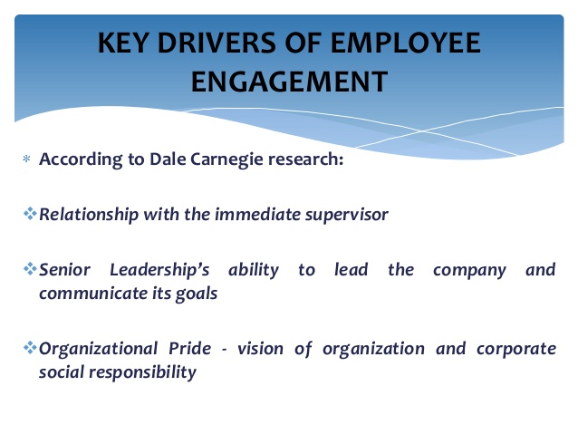

The Philosophy which is supportive of empowered employees can been shown from an employee assignation prototypical shown previously in this report. Which shows the importance of using open communications and reflextion permitting acquaintances to feel involved, content, safe and improve performance so there can future advantage for the business by growing revenues. The Marriott and the Hilton use a theory within their associations, they are working with the workforces to create an location in which they can flourish and rise client allegiance through

Practice at work has made me better recognise what expectations people have from you. If you look online for experiences of people who have worked or who have benefited from our services. You will see good and bad reviews because this is the job market. transparency. Reviewers The evaluation of the highlighted areas is of five stars
• The equilibrium of the professional life of 3.9 stars, the reviews that reflect the hospitality sector can be unpredictable, and certain occasions or situations may require you to sacrifice your personal time.
• Payments and benefits of 3.9 stars, most commentators reported that it could be better, but it was correct.
• 3.9steps The security and advancement of jobs, varied answers and feelings towards this response are mostly positive, but some very negative reviews illustrate the lack of trust in management.
• 3.8-star management, mixed reviews, some reviews suggest poor leadership skills, give up the whole team, which does not promote self-worth in order to progress in the future, and other reviews give management a bright reputation.
• 3.7 stars Culture, diversity and cultural expansion predominate from reviews, which are mostly positive.
These scores are given by previous workers, giving Marriot three points out of five stars, from 19.4k reviewers, this is a respectable score and indicates, even if there are areas that can be improved for most employees as well as they enjoyed working at a Marriot hotel leaving mostly positive feedback. From my personal experience of completing fifteen weeks of placement at the Birmingham Marriot I was pleasantly surprised to see and hear how happy the employees of the Birmingham Marriot were, always working to the best of their abilities and always displaying a positive attitude, I felt that was up to a good combination of people and support management. Examining Hiltons rivals, proposals and feedback suggest slightly declining numbers, with an average of three points out of seven stars out of five, based on 12.4k reviews.
Reviewers The evaluation of the emphasised areas is of five stars
• The effort life balance of 3.8 stars, particularly positive, again emphasizes the unpredictability of the nature of the workplace.
• 3.4 leads pay and benefits, generally satisfied, would like more.
• 3.9 security and progression, being principally granted 3 starts from reviewers who reflect approval, but some indecision.
• 3.7 Management, illustrating from reviews in some places very positive and special examinations and in some adverse reviews of positions, in others brilliant certain locations, attention and progress in the future are needed.
• 3.3 Culture, confident reviews viewing progress and evolution towards the addition of culture and variety.

I personally requested 10 associates the next 9 questions, in-between them in to four areas job satisfaction, development, security and development.
1. Did you enjoyed to working for the Marriott group?
2. In what way are you satisfied in your existing job role?
3. Are the profits and motivations good?
4. Do you feel supported?
Yes
No
5. Do you feel you have job security?
6. Are you given the chance to advance your career here?
7.What is the one thing you liked most about your job?
8. Would you recommend the Marriot to your friends or relative?
9. Please Rate Your Overall Experience working here

The evidence shows 10 out 12 persons I questioned were happy in their current positions and were satisfied with their jobs roles, 7 out of 12 were happy with progress of the job, from the comments I received back it did suggest that if a associate wanted progression in housekeeping for example this could take many years as limited supervisor of management positions held them back. 9 people out of 12 felt secure, I found the older members were securer as opposed to the younger members who did not have permanent contracts. 8 out of 12 felt they were able to advance their skill set and learn new skills; I found the younger members being the majority in this area.

Conclusion
Whilst researching and drawing from my personal experience of working at the Marriot Birmingham hotel, I would conclude as an employer they are committed to enhancing and nurturing the talented work force in to lifelong employment, all the necessary requirements are fulfilled and offered to the staff for future development and career progression. I feel some areas may be improved upon, enhancement of management skills seems to be a clear case according to indeed reviews and in some cases clearer progression paths for outstanding induvials.

References
Cannon J.A., McGee R. (2007), Talent Management and Succession Planning. London: Chartered Institute of Personnel and Development
(https://www.statista.com/statistics/297269/number-of-marriott.)(accessed 05/12/19)
(https://jobs.hilton.com)(acsessed19/11/19)
(www.careers.marriott.co.uk)(acsessed19/11/19)
(www.Hiltoncareers.com)(acsessed17/11/19)
(www.indeed.co.uk) (accessed on 17/11/19)
(https://www.indeed.co.uk/cmp/Indeed/reviews)
(www.Hiltoncareers.com)(acsessed17/11/19)
(https://www.indeed.co.uk/cmp/Indeed/reviews)(acsessed 20/11/19)
Rothwell W.J., Kazanas H.C. (2003), The Strategic Development of Talent. HRD Press
(https://www.researchgate.net/publication/311357150_The_impact_of_recognition_on_retention_of_good_talent_in_the_workforce)
Mngomezulu, Nonhlanhla & Challenor, Martin & Munapo, Elias & Mashau, Pfano & Chikandiwa, Christopher. (2015). The impact of recognition on retention of good talent in the workforce. Journal of Governance and Regulation. 4. 10.22495/jgr_v4_i4_c3_p2.
www.managementjournals.com/journals/ig/vol1/21-1-1-1.pdf

