Network and Cybersecurity Essentials

Module Name: Network and Cybersecurity Essentials
Module Code: ACCA 4024
Student Name: Valerii Vdovin
Student ID: 2510682
Group: 4
Lecturer’s Name: Dr Anum Paracha

Table of Contents
Table of Contents 1
Annotation 2
1. Introduction 2
2. Identification of threats 2
2.1. Internal Threats 2
2.2. External threats 3
2.3. Impact assessment using the CIA model and risk prioritisation 4
3. Security policies based on ISO/IEC 27001:2022 4
3.1. Access Management and Authentication 4
3.2. Network security and network segmentation 4
3.3. Malware protection and data backup 5
3.4. Supply chain and cloud service security 5
3.5. Classification of information and the use of IT assets 5
3.6. Data management and compliance 5
4. Monitoring network activity and responding to incidents 6
5. Staff Training and Awareness Programme 7
6. Conclusion 7
References 8
Appendix 9

Annotation
This report assesses cyber risks arising from SteelForm Manufacturing Ltd's integration of corporate IT, production OT, IoT devices and a cloud MES. It distinguishes threats, vulnerabilities and control weaknesses, and evaluates effects on confidentiality, integrity, availability, safety and production continuity. The recommended strategy combines an ISO/IEC 27001:2022 risk-based ISMS, ISO/IEC 27002:2022 control guidance, NIST CSF 2.0 risk prioritisation and NIST SP 800-61 Rev. 3 incident response. Critical scenarios are IT-to-OT propagation, ransomware, and compromised remote or supplier access. Priority measures are controlled IT/OT segmentation, MFA, passive OT monitoring, immutable backups, data governance and role-based training. Controls are linked to accountable owners, dependencies and measurable outcomes so that residual risk can be reported to the Board. A phased implementation with recovery testing should reduce downtime, intellectual-property loss and unsafe restoration.

Introduction
The digital transformation of manufacturing under Industry 4.0 has integrated physical production processes with information technology. SteelForm Manufacturing Ltd (SFM), which manufactures specialised components for the automotive and aerospace industries, is implementing IoT sensors, robotic systems and a cloud-based MES platform. However, the integration of IT and OT environments simultaneously increases the number of potential points of attack and creates new risks for critical infrastructure [1].
Recent incidents, including the compromise of the procurement department’s email system and attempts to gain unauthorised access to the production network, highlight the need to strengthen security. The main risks are industrial espionage, theft of intellectual property and production downtime. The report proposes a comprehensive approach to SFM security based on ISO/IEC 27001 and ISO/IEC 27002.

Identification of threats
A threat is a potentially harmful event or actor; a vulnerability is an exploitable weakness; and risk combines a threat scenario, likelihood and consequence. In OT, assessment must extend beyond the CIA triad to personnel safety, product quality, equipment integrity and production continuity.

2.1. Internal Threats
Internal exposure includes accidental phishing or credential disclosure, unsafe USB/BYOD use and deliberate misuse by privileged staff. Weakly secured IIoT devices, excessive permissions, delayed PLC/SCADA patching and flat IT/OT architecture amplify these actions by creating paths to production systems. Deliberate insiders may understand where drawings and control assets are stored, while accidental actions occur more frequently; both therefore require prevention, monitoring and rapid revocation. Key controls are least privilege, managed devices, secure configuration, timely risk-based patching and network separation.

2.2. External threats
External scenarios include ransomware and double extortion, targeted phishing, account theft, DDoS against the cloud MES, industrial espionage and supply-chain compromise [2] [3]. Attackers may exploit vendor/VPN credentials, legacy PLCs, engineering workstations, insecure firmware updates or cloud misconfiguration to steal drawings, disrupt production or create unsafe process conditions. A supplier account is particularly significant because trusted connectivity can bypass perimeter assumptions. Physical sabotage and environmental effects must also be considered where cyber compromise can influence machinery.
Risk scenario | Type | Probability | Potential impact (CIA) | Priority
Phishing/BEC in procurement involving the theft of login credentials or the alteration of payment details | External threat + human vulnerability | High | C/I; financial loss | High
IoT compromise via default credentials, weak encryption or outdated firmware | Technical vulnerability | Medium | I/A; quality and safety | High
Unmanaged USB/BYOD devices create a way to bypass security gateways | Lack of supervision | Medium | I/A; the spread of malware | High
A compromised office account spreads across a flat IT/OT network | Architectural flaw | High | C/I/A; stop and safety | Critical
The theft of vendor/VPN credentials provides remote access to OT | Supply-chain / external | High | C/I/A; covert presence | Critical
Lateral malware infection via shared services and accounts | External | High | I/A; rapid spread | High
Ransomware involving double extortion and the encryption of MES/engineering assets | External | Medium-high | C/I/A; prolonged downtime | Critical
DDoS or a cloud-based MES outage | External/Service | Medium | A; impaired coordination | High
Compromise of software, updates or a trusted supplier’s channel | Supply-chain | Medium | C/I/A; trusted path | High
Table 1: SFM cyber risk scenario register, taking into account the CIA, safety and business impact

2.3. Impact assessment using the CIA model and risk prioritisation
Prioritisation is aligned with NIST CSF 2.0 ID.RA-04 and ID.RA-05: the SFM must determine the likelihood and impact scales, document the evidence and assumptions, assign an owner to each risk, and select a treatment — mitigate, transfer, avoid or accept. The final assessment is not a ‘matrix’ prescribed by NIST; it is an SFM-specific methodology that uses the recorded likelihood and impact to allocate resources [3] [4] .

Security policies based on ISO/IEC 27001:2022
ISO/IEC 27001:2022 provides the requirements for establishing, implementing, maintaining and continually improving SFM’s information security management system. ISO/IEC 27002:2022 provides implementation guidance for the security controls selected through SFM’s risk assessment. The following policies translate these standards into practical rules for the company’s IT and OT environments. [5] [6].

3.1. Access Management and Authentication
Access must follow least privilege and RBAC; shared accounts are prohibited, rights are reviewed quarterly and leavers are revoked immediately (ISO/IEC 27002 controls 5.15, 5.18 and 6.5). Service and emergency accounts require named owners, vaulting and monitored use. MFA is mandatory for privileged, remote and cloud-MES access. SFM should adopt risk-based password rules aligned with NIST SP 800-63B-4: at least 15 characters for single-factor passwords or eight when used with MFA, plus weak-password blocklists, rate limiting and phishing-resistant MFA for critical access [7].

3.2. Network security and network segmentation
IT and OT should be divided into deny-by-default zones and controlled conduits. Approved flows traverse industrial firewalls and a DMZ; PLC/SCADA systems have no direct internet access, while administration uses hardened jump hosts, MFA and logged, time-limited sessions (controls 8.20-8.22). Asset and data-flow discovery, vendor constraints and production/safety approval must precede changes; IIoT occupies a separate monitored zone. Firewall rules and exceptions are reviewed against documented operational flows.

3.3. Malware protection and data backup
Centralised EDR protects supported IT endpoints and servers. Agents on engineering stations or legacy OT require vendor approval and compatibility testing; passive monitoring and allowlisting are used where agents create operational risk. Backups include an immutable or offline copy, separate credentials, MES data, PLC logic, recipes and configurations. Service-specific RPO/RTO values are verified through safe restoration tests, not file-read checks alone.

3.4. Supply chain and cloud service security
Suppliers are classified by criticality; contracts set out security requirements, breach notification procedures, audit rights, data location, return and deletion, and the procedure for terminating access. Vendor access is named, MFA-protected, time-limited and monitored. TLS 1.3 is used where supported; for legacy OT systems, TLS 1.2 or a documented compensating control is permitted. Changes to the cloud-based MES undergo a configuration review in accordance with ISO/IEC 27002 control 8.9.

3.5. Classification of information and the use of IT assets
Information is classified as public, internal, confidential or trade secret under controls 5.10 and 5.12. Drawings, formulas and export-controlled data receive labels linked to DLP rules. USB/BYOD restrictions are piloted against CAD/MES workflows; removable media must be authorised, scanned on a dedicated station and logged, with OT-owner approval for exceptions.

3.6. Data management and compliance
The Board assigns Data Owners, while IT/OT custodians implement protection. SFM maintains a data and system inventory covering purpose, minimisation, quality, version control, retention and secure disposal. Trade secrets are encrypted in storage and transit, and access is reviewed. Supplier and cloud agreements govern location, sub-processors, return and verified deletion. Retention evidence and deletion confirmation allow owners to demonstrate that policy is operating. Under UK GDPR and the Data Protection Act 2018, the DPO records personal-data breaches and, where required, notifies the ICO within 72 hours and affected individuals when risk is high [8] [9].
Measure | Owner and term | Dependency / cost | Checking the result
MFA and privileged access | IT Security Manager; 0–3 month | Identity inventory; low–mid | 100% of critical accounts; quarterly review
IT/OT zones and conduits | OT Manager + Network Lead; 0–6 month | Asset/data-flow discovery; mid–high | No direct internet-to-PLC connection; tested allowlists
Immutable backup and recovery | Infrastructure + OT owners; 0–3 month | Storage and recovery environment; medium | RPO/RTO met during the restore exercise
SIEM + passive OT monitoring | SOC/IT Security; 3–9 month | Log onboarding, use cases; mid-high | Coverage critical assets; alert SLA and false-positive trend
Data governance/DLP | DPO/Data Owners; 3–9 month | Inventory and CAD/MES pilot; medium | Retention, access reviews, confirmed deletion
Role-based training | IT Security + HR; ongoing | LMS and simulation platform; low | >95% completion, <5% clicks, <15 min reporting
Table 2: implementation plan
The implementation matrix gives early priority to identity controls and recoverability, then adds architectural separation, detection and sustained governance. Cost bands are indicative because final expenditure depends on asset discovery, vendor constraints and existing licences. Each owner must validate dependencies before approval and report the stated success measure at the end of the phase. Where a target is missed, the owner records residual risk, corrective action and a revised deadline for Board review.

Monitoring network activity and responding to incidents
SFM should centralise relevant server, firewall, EDR, IIoT and critical-system logs in a SIEM under ISO/IEC 27002 control 8.15. Use cases must cover privileged access, IT/OT boundary activity, supplier sessions, malware and anomalous process communications, with coverage and alert-response time reviewed as KPIs.
Incident response is integrated across NIST CSF 2.0 functions in accordance with NIST SP 800-61 Rev. 3 [10]. Before an event, SFM defines CSIRT/RACI roles, severity levels, offline contacts, supplier escalation, evidence handling, OT-safe shutdown criteria and a notification decision tree. Exercises should test communications and decision authority as well as technical recovery. The SOC validates an alert; the Incident Commander coordinates IT, OT/Safety, Legal/DPO, Communications and the system owner. OT containment requires safety approval. Logs and forensic evidence retain chain of custody, while eradication and recovery use verified clean baselines and backups. Production resumes only after integrity, interlocks, PLC logic, MES data and RTO/RPO are verified. Legal/DPO assesses reporting duties, and corrective actions receive owners, deadlines and retesting [10] [9].
1. Preparation  CSIRT, RACI, OT safety | 2. Assessment  verification and severity | 3. Containment  IT/OT-safe isolation | 4. Recovery  clean baseline, RTO/RPO | 5. Improvement  owner, due date, retest
Table 3: Response plan

Staff Training and Awareness Programme
Under ISO/IEC 27002 control 6.3, all employees and contractors complete security induction before full access and an annual refresher. Content covers credentials, email, internet use, removable media and incident reporting. Procurement and accounts receive phishing/BEC training, while privileged IT/OT personnel practise secure administration and incident exercises. Quarterly phishing simulations trigger coaching rather than automatic punishment, supporting early reporting.
The IT Security Manager and HR own the programme and retain completion evidence in the LMS. Managers monitor overdue activity and contractors receive equivalent training before access. Quarterly KPIs include more than 95% completion, fewer than 5% simulated-phishing clicks, median reporting below 15 minutes, confirmed reports and closure of remedial training. Results are compared with a documented baseline so improvement can be demonstrated. Repeated errors require targeted retraining; persistent non-compliance follows the HR process. Content is refreshed after incidents, material threat changes and the annual review.

Conclusion
SFM's smart-factory programme requires an ISMS that connects governance with practical IT/OT safeguards. ISO/IEC 27001 provides the management framework, ISO/IEC 27002 guides control selection, and NIST supports risk and incident decisions. Together, segmentation, strong access control, recoverable backups, monitoring, supplier assurance, data governance and training provide defence in depth without ignoring production safety.
During the first 30 days, SFM should confirm inventories, owners, critical services, risk criteria and budget. Months 0-3 prioritise MFA, privileged-account cleanup, immutable backup and emergency segmentation; months 3-9 complete zones and conduits, passive OT monitoring, SIEM use cases, supplier controls and training. The Board reviews residual risk, incidents, recovery tests, access reviews, training KPIs and overdue actions quarterly.

References

[1] | L. Thames, D. Schaefer, «Industry 4.0: an overview of key benefits, technologies, and challenges,» Cybersecurity for Industry 4.0: Analysis for Design and Manufacturing, 2017, pp. 1-33.
[2] | Dragos, Inc., «2026 OT Cybersecurity Report: A Year in Review,» Dragos, Inc., Hanover, 2026.
[3] | R. Masum, «Cyber Security in Smart Manufacturing (Threats, Landscapes & Challenges),» arXiv, 2023.
[4] | C. Pascoe, S. Quinn, K. Scarfone, «The NIST Cybersecurity Framework (CSF) 2.0,» National Institute of Standards and Technology, Gaithersburg, MD, 2024.
[5] | International Organization for Standardization (ISO), «ISO/IEC 27001:2022 — Information security, cybersecurity and privacy protection — Information security management systems — Requirements,» International Organization for Standardization, Geneva, 2022.
[6] | International Organization for Standardization (ISO), «ISO/IEC 27002:2022 — Information security, cybersecurity and privacy protection — Information security controls,» International Organization for Standardization, Geneva, 2022.
[7] | D. Temoshok, J. L. Fenton, Y.-Y. Choong, N. Lefkovitz, A. Regenscheid, R. Galluzzo, J. P. Richer, «Digital Identity Guidelines: Authentication and Authenticator Management,» National Institute of Standards and Technology, Gaithersburg, MD, 2025.
[8] | GOV.UK, «Data protection: The UK’s data protection legislation,» [Online]. Available: https://www.gov.uk/data-protection. [Accessed: 11 Aug. 2026].
[9] | Information Commissioner’s Office, «Personal data breaches: a guide,» 20 August 2025. [Online]. Available: https://ico.org.uk/for-organisations/report-a-breach/personal-data-breach/personal-data-breaches-a-guide/. [Accessed: 11 Aug. 2026].
[10] | A. Nelson, S. Rekhi, M. Souppaya, K. Scarfone, «Incident Response Recommendations and Considerations for Cybersecurity Risk Management: A CSF 2.0 Community Profile,» National Institute of Standards and Technology, Gaithersburg, MD, 2025.

Appendix
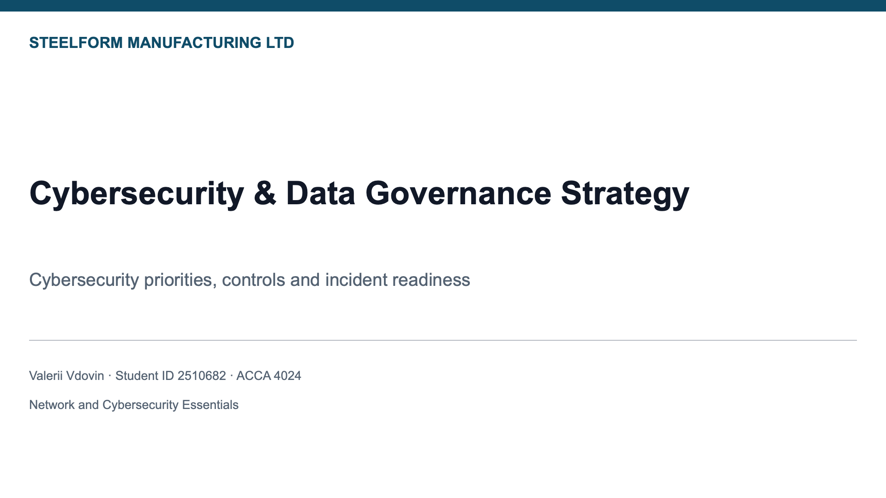
Figure 1: Slide 1
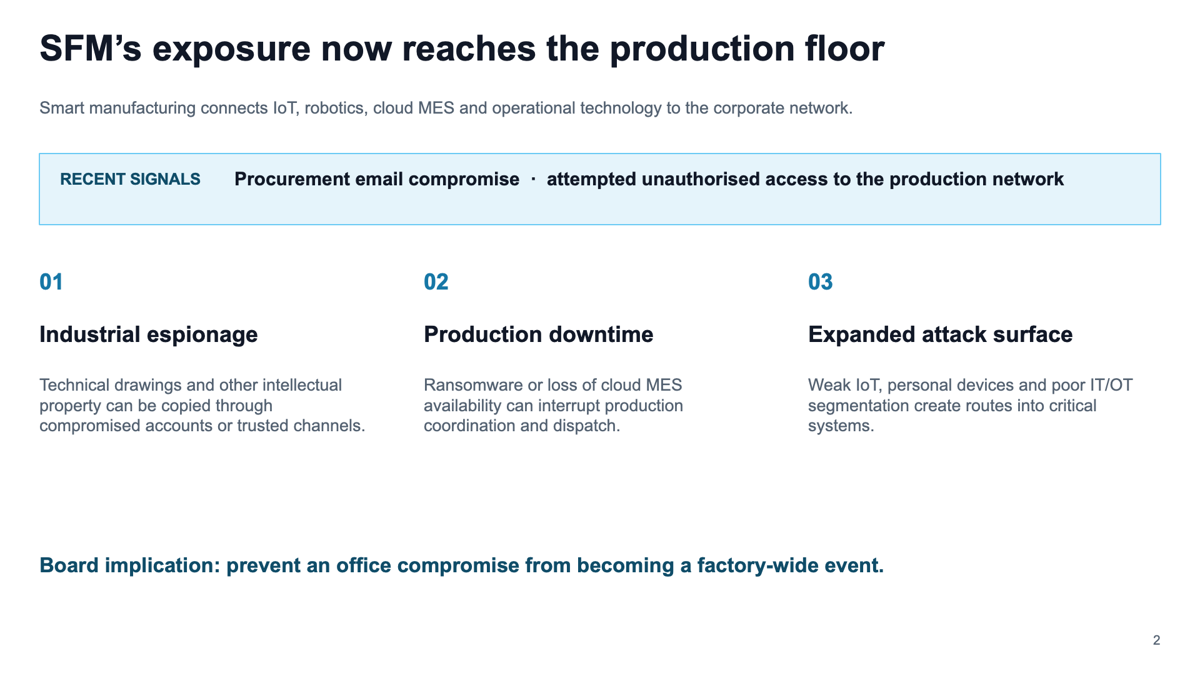
Figure 2: Slide 2
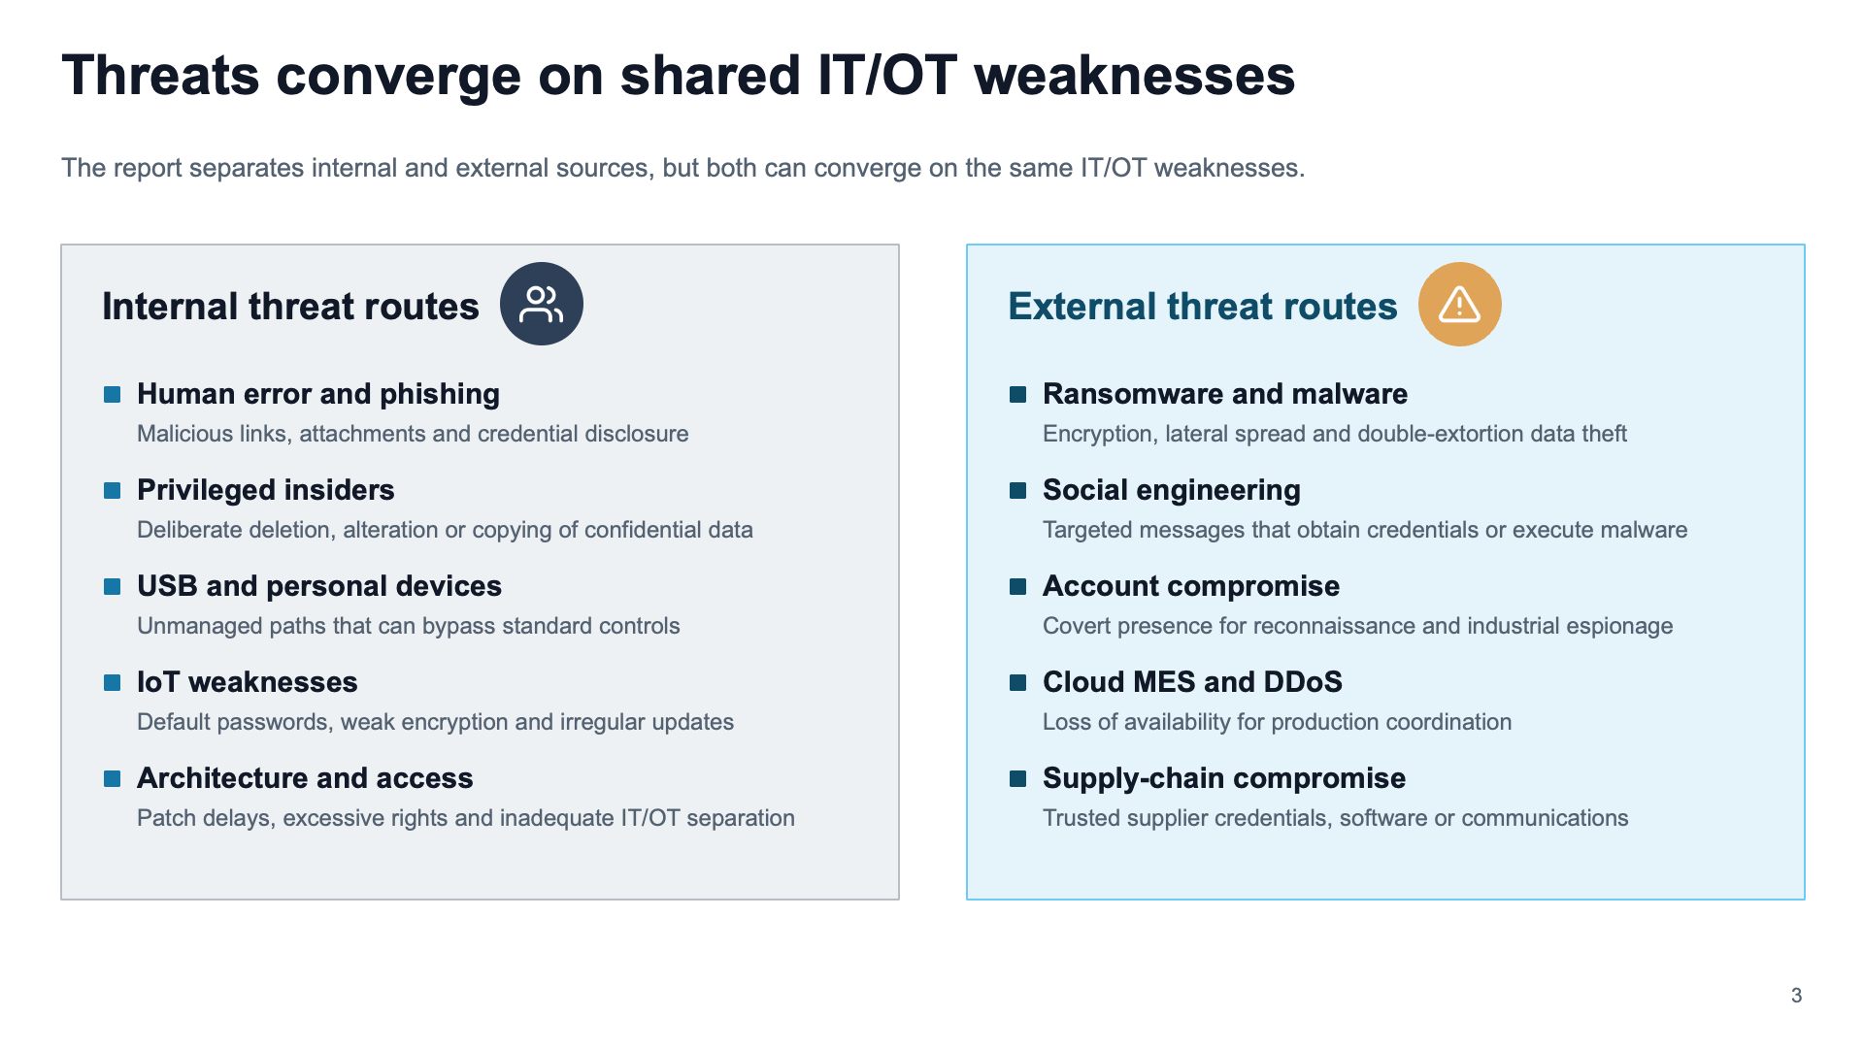
Figure 3: Slide 3
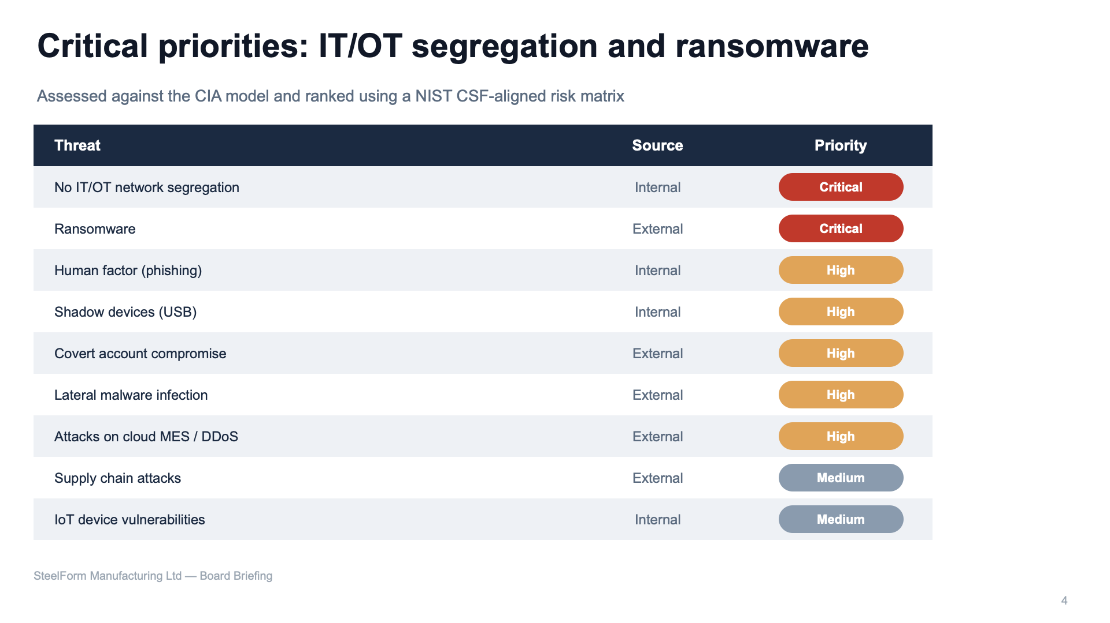
Figure 4: Slide 4
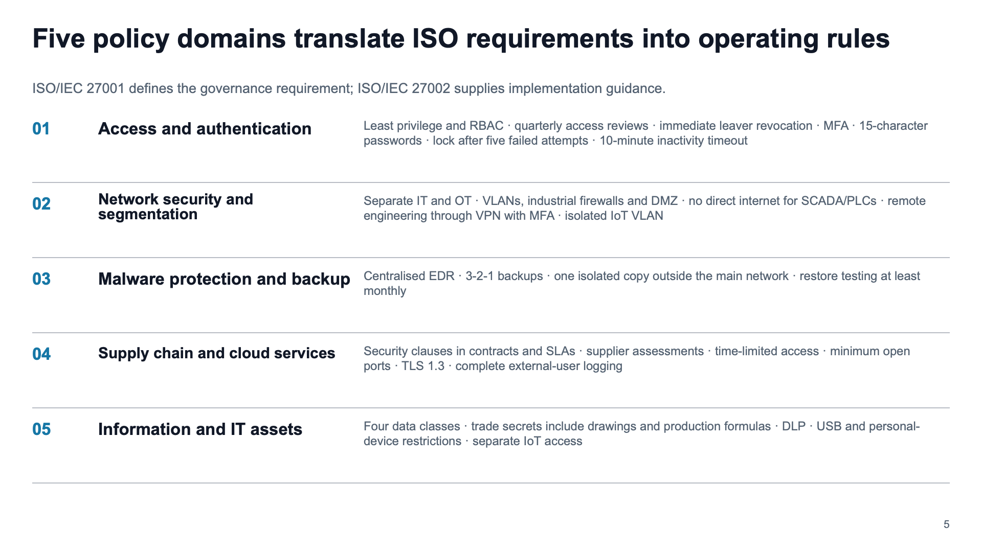
Figure 5: Slide 5
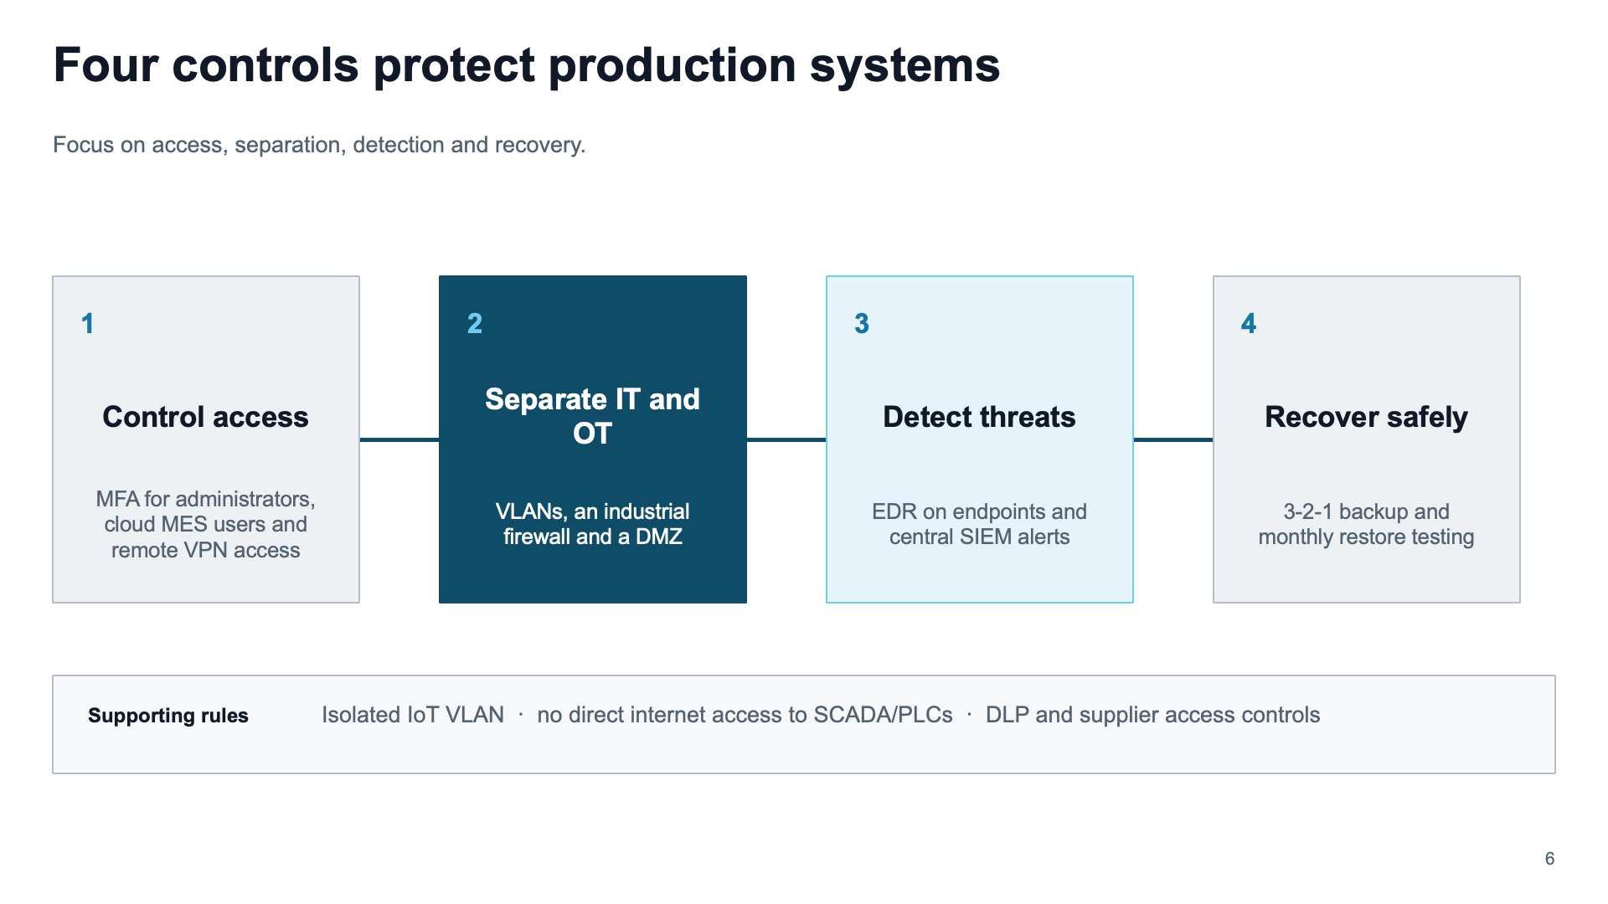
Figure 6: Slide 6
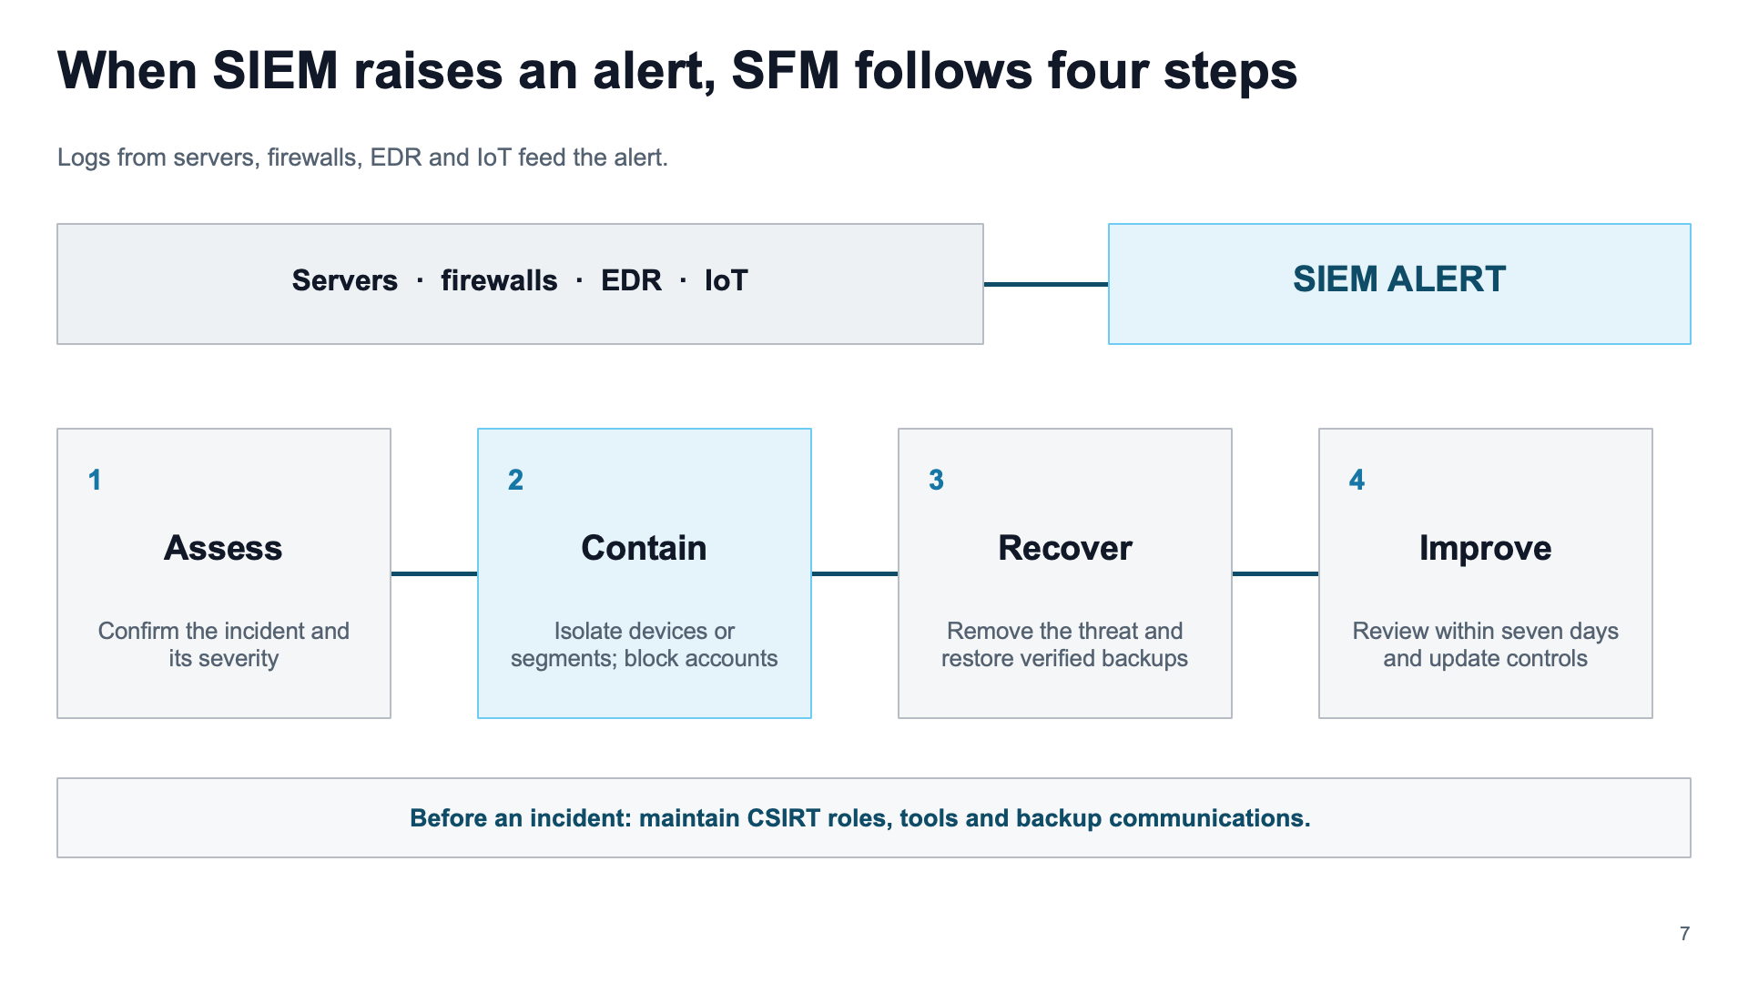
Figure 7: Slide 7
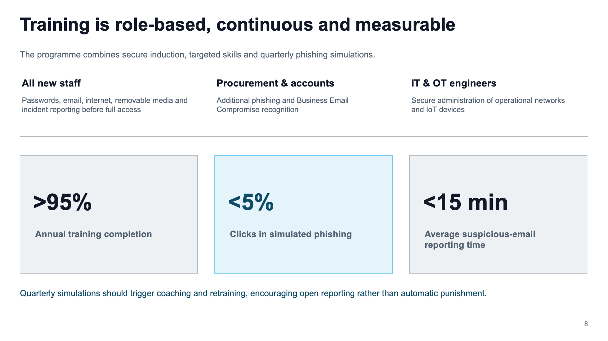
Figure 8: Slide 8
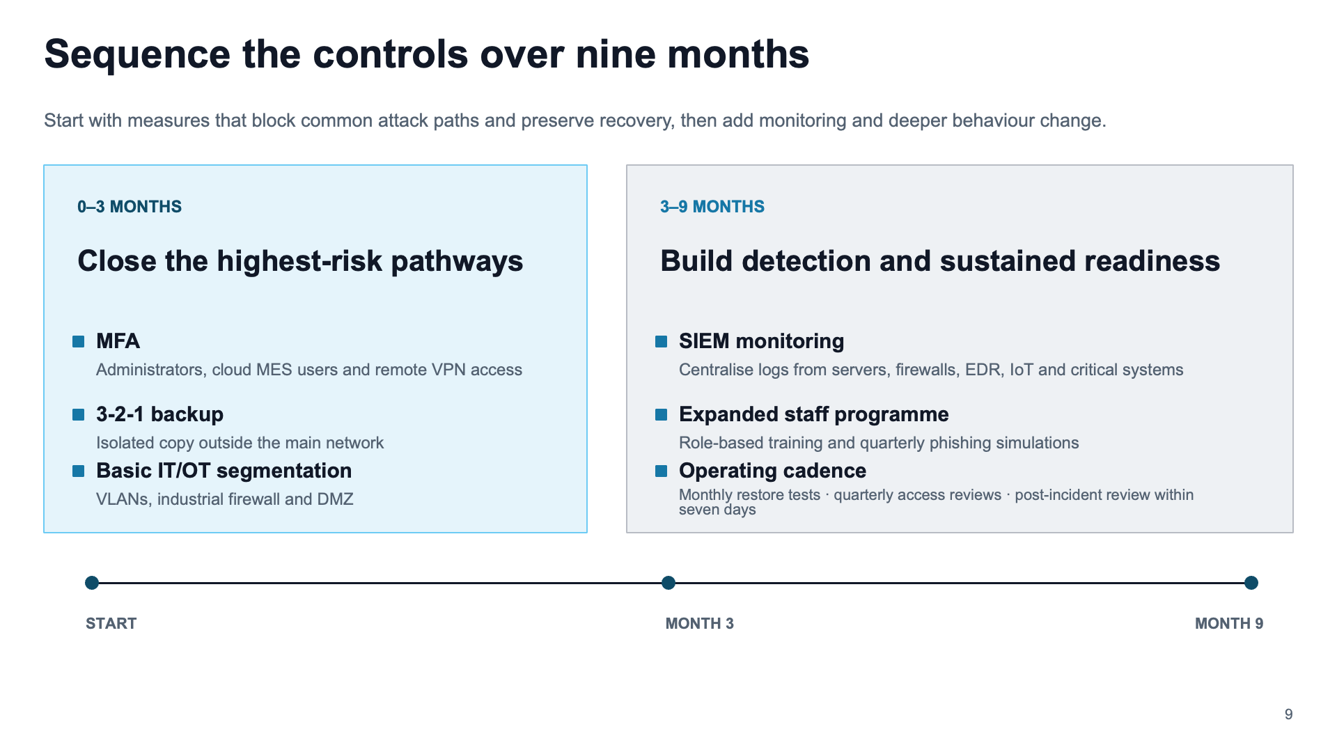
Figure 9: Slide 9
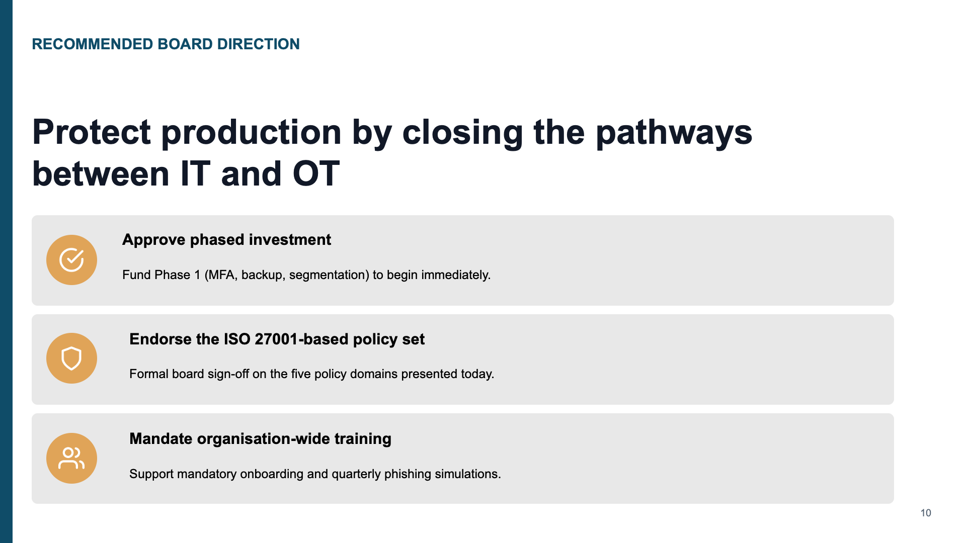
Figure 10: Slide 10

