4/23/2026
University of Wales Trinity Saint David
London Campus

Assignment Title: HTML & CSS Web Development (Assessment 2)
Module Code: ACCA4023

Student Name: ADEYINKA ADEWUMI
Student ID: 2519143

Lecturer’s Name: Anum Paracha

Introduction to Web and Database Concepts (ACCA4023)
Contents
1. Introduction 1
2. Requirements 1
3. Implementation 2
3.1 Structure (HTML5) 2
3.2 Styling (CSS3) 2
3.3 Navigation and Layout 2
3.4 Screenshots 2
3.5 Validation 5
4. Evaluation 5
4.1 Usability 5
4.2 Accessibility 6
4.3 Search Engine Optimisation (SEO) 7
4.4 Website Usefulness 7
5. Website Comparison 8
Website Comparison Table 8
6 References 8
7 Appendix 9

1. Introduction
The design, development, and assessment of Mobile Hub, a responsive e-commerce website made to highlight smartphones and accessories, are presented in this paper. In accordance with current online standards and best practices, the website was created using HTML5 and CSS3.
This project aims to show how web development concepts like search engine optimisation (SEO), usability, accessibility, and responsive design may be applied. There are three pages on the website: the main page, the products page, and the contact page. Every page was created to offer a smooth and easy-to-use experience.

This report describes the website's design choices, implementation procedure, and assessment. In order to further illustrate comprehension of online quality principles, it also compares two current websites and uses academic research to examine important aspects like usability, accessibility, and SEO.

2. Requirements
The Mobile Hub website aims to replicate a contemporary online retail platform for mobile devices and accessories, offering customers a productive and entertaining setting for product browsing and inquiry. The website is primarily intended for online buyers, tech aficionados, and mobile users who regularly access content via smartphones and other portable devices. A design that is both aesthetically pleasing and functionally intuitive is necessary for this varied target group, guaranteeing usability across a range of digital literacy levels.

From a practical standpoint, the website must perform as a responsive multi-page platform that enables smooth navigation between the contact, products, and home sections. Additionally, it needs to have a well-organised, hierarchical product display arrangement that makes it easy for customers to evaluate possibilities. In order to promote user engagement and guarantee that provided data is accurate and comprehensive, a contact form with integrated validation is also required.

In terms of non-functional requirements, the website needs to load quickly in order to minimise user annoyance and lower bounce rates. It should adhere to accessibility guidelines to guarantee inclusivity for people with impairments while also maintaining a uniform design over all pages to promote a unified user experience. To increase visibility and rating on search engines, a structure that is optimised for search engines (SEO) must be put in place. These specifications are in line with accepted usability principles, which prioritise effectiveness, efficiency, and user happiness in online design [7][4]

3. Implementation

3.1 Structure (HTML5)

The website is structured using semantic HTML elements such as <header>, <nav>, <section>, and <footer>, which provide meaningful organisation to the content. These elements clearly define different parts of the webpage, making it easier for both users and assistive technologies to understand the layout and purpose of each section. This approach significantly enhances accessibility, particularly for screen readers, as it allows them to interpret and navigate the content more effectively. Additionally, semantic HTML improves search engine optimisation by helping search engines better index and rank the website’s content. As outlined by the World Wide Web Consortium, using semantic markup is a key requirement for building accessible and well-structured web pages [9].

3.2 Styling (CSS3)
To provide visual uniformity and consistency across all website pages, a single external stylesheet was utilised. By maintaining consistency in design components like colours, font, spacing, and layout, this method improves the overall user experience and makes the website easier to maintain. Efficient development processes are supported because any changes made to the stylesheet are automatically reflected on all pages. In order to give the product page a flexible and responsive layout, CSS Grid was also used. This enhances usability and accessibility by enabling content to smoothly adjust to various screen sizes and devices. CSS Grid offers a potent two-dimensional layout approach for responsive interfaces, as emphasised in contemporary web design methods [6].

3.3 Navigation and Layout
By guaranteeing that the primary navigation menu stays visible at the top of the screen while users navigate the website, a sticky navigation bar was added to enhance usability. This improves navigation by enabling users to swiftly switch between pages without having to go back to the top. The website's general design adheres to a logical and unambiguous visual hierarchy, starting with a large hero section that draws users in and explains the goal of the website. The product display area comes next, where products are arranged in an orderly and aesthetically pleasing way to facilitate browsing and comparison. The user experience is completed with the footer, which offers further details and links. By directing user attention and increasing interaction efficiency, this kind of hierarchical architecture facilitates efficient user experience design [3]

3.4 Screenshots

Home Page

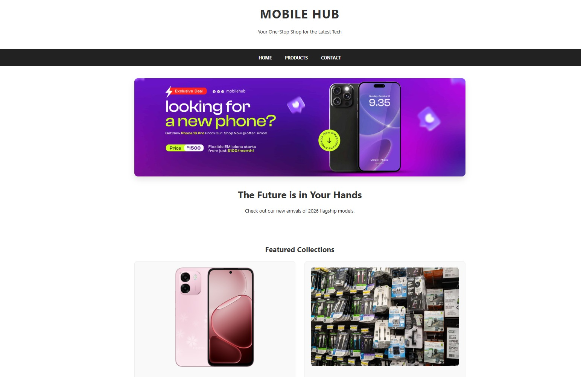
Description: Displays hero section and featured gadgets.

Products Page

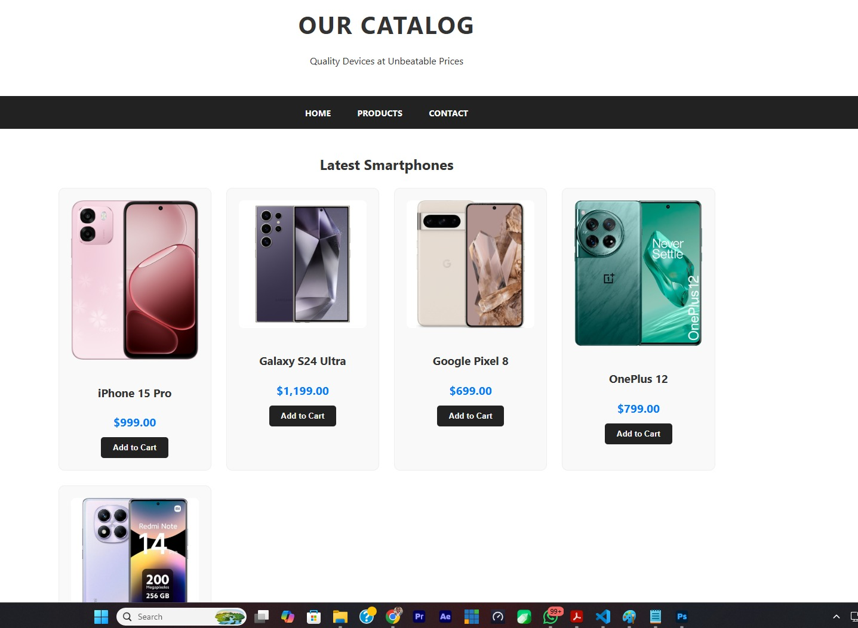
Description: Shows grid layout of smartphones and accessories.

Contact Page
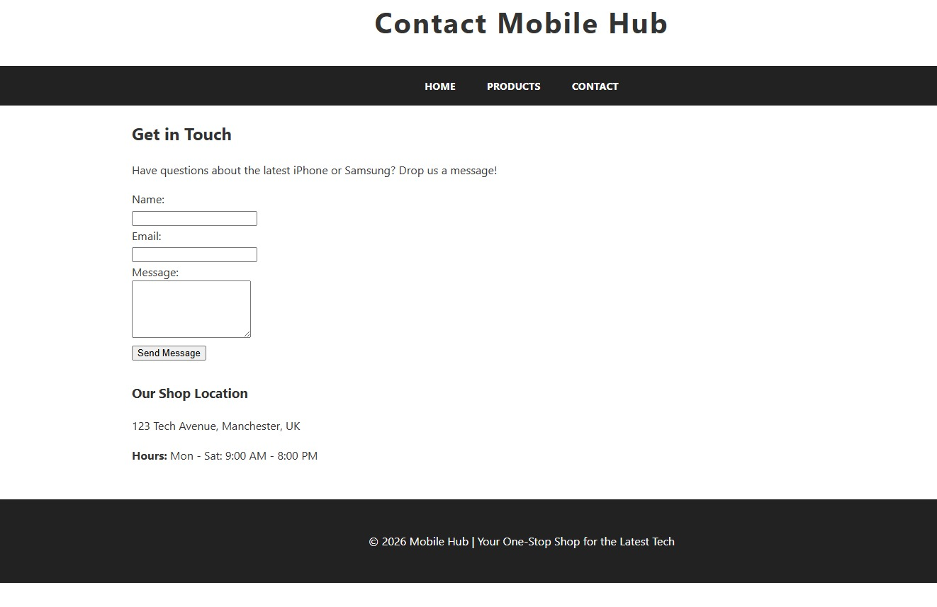

Description: Displays contact form with validation.

3.5 Validation
Standard web development tools, namely the HTML Validator and CSS Validator offered by the World Wide Web Consortium, were used for validation. These tools were used to make sure the website adheres to best practices for coding structure and syntax as well as known web standards. Small mistakes, such missing or incorrectly closed tags, were found throughout the validation process and fixed to increase the accuracy and dependability of the code. Furthermore, a number of CSS property-related warnings were examined and evaluated to ascertain how they affected compatibility and performance [1]. Some warnings were taken into consideration for future improvement even if they didn't need to be fixed right now. In general, validation guarantees increased browser compatibility, enhanced accessibility, and better long-term website maintainability [8].

4. Evaluation

4.1 Usability
The ease and effectiveness with which users may engage with a system and accomplish their intended objectives is referred to as usability [7]. It includes important characteristics including user satisfaction, efficiency, and learnability. Consumers skim web pages for pertinent information rather than reading them in depth, hence simplicity and intuitive design are crucial [4].

Effective websites, according to Krug, should limit cognitive effort by making sure that users don't need to "think" too much while engaging with a page and that navigation is clear. According to his research, complicated navigation systems and crowded interfaces drastically lower usability and user engagement [4].

Good usability is demonstrated by the Mobile Hub website's clear navigation, which makes it simple for users to navigate between pages. Users have a lower learning curve because every site has the same layout, which guarantees familiarity. Additionally, text is easier to scan and comprehend when readable typography and sufficient spacing are used. These design decisions are in line with usability principles, which place an emphasis on efficiency and simplicity.

There is room for improvement, though. While filtering options would enhance the browsing experience by enabling users to narrow down product categories, the addition of a search tool would make it easier for customers to find specific products. These improvements would increase overall usability and bring the website closer to user-centered design best practices [4].

4.2 Accessibility
People with a variety of abilities, including those with visual, hearing, motor, or cognitive limitations, can utilise websites efficiently when they are accessible [9]. The World Wide online Consortium's Web Content Accessibility Guidelines (WCAG) 2.1 serve as a foundation for inclusive online design. By enhancing clarity, navigation, and interaction, accessible design improves the user experience for all users, including those with disabilities [5].

The Mobile Hub website aligns with the four core WCAG principles. Perceivable: Because images offer informative alternative language and content is readily accessible, screen readers are able to comprehend visual elements. Users with different interaction needs can benefit from Operable's user-friendly navigation, which is compatible with both mouse and keyboard inputs. Because of its clear structure, logical layout, and intelligible information, the website is easy for people to comprehend. Last but not least, the website is reliable across platforms because it follows well-established coding practices and works with modern browsers.

Despite these benefits, there is still space for improvement. Improving colour contrast would make it easier for those with vision impairments to read, and ARIA (Accessible Rich Internet Applications) labels would further improve assistive technologies. Implementing these modifications would promote a more inclusive user experience and increase WCAG 2.1 compliance [5].

4.3 Search Engine Optimisation (SEO)
Search Engine Optimisation (SEO) refers to the process of improving a website’s visibility and ranking on search engines such as Google, thereby increasing organic traffic [2]. Effective SEO ensures that a website is not only technically sound but also easily discoverable by users searching for relevant content. A study by Zhen Zhang [8] and Andrew Dimitroff (2005) [8] found that well-structured web content significantly improves search engine rankings, particularly when clear headings, meaningful metadata, and logical content organisation are used. Their research highlights that search engines prioritise pages that are semantically structured and rich in relevant information.
The Mobile Hub website incorporates several foundational SEO techniques to enhance visibility. These include the use of meta descriptions, which provide concise summaries of each page for search engine results. In addition, a clear heading hierarchy (H1–H3) is used to structure content logically, improving both readability and indexing efficiency. The inclusion of descriptive alt text for images further strengthens SEO by allowing search engines to understand visual content.
However, there are opportunities for improvement. The addition of targeted keywords within page content would increase search relevance, while expanding content depth would improve authority and ranking potential. Incorporating these enhancements would align the website more closely with modern SEO best practices and improve its overall discoverability [2] [8].

4.4 Website Usefulness
The website is useful in terms of providing clear and accessible product information, allowing users to quickly browse available mobile devices and accessories. It supports user interaction through a contact form, which enables visitors to make enquiries, send feedback, or request additional information. This contributes to basic functionality that aligns with early-stage e-commerce design principles, where communication between users and website owners is essential for engagement and support [4].
However, despite these strengths, the website has several limitations that affect its overall usefulness. It does not include a checkout or payment system, meaning users cannot complete purchases directly through the platform. This reduces its effectiveness as a fully functional e-commerce system. In addition, the product range is relatively limited, which may reduce user engagement and restrict the ability to meet diverse customer needs. Expanding the number of products and categories would improve content depth and user satisfaction.
Overall, while the website successfully demonstrates core e-commerce concepts such as product display and user interaction, it remains a prototype rather than a fully operational retail platform. Enhancing functionality by introducing transactional features and a broader product catalogue would significantly improve its practical usefulness and align it more closely with industry standards for online retail systems [7].

5. Website Comparison

Website Comparison Table
Area | BBC News | CNN
Usability | Simple layout, easy navigation, clear categories | Content-heavy homepage, more complex navigation
Accessibility | Strong contrast, clean structure, good readability | Good accessibility but more visual clutter
SEO | Well-structured headings and metadata | Strong keyword usage and frequent updates
Mobile Friendliness | Clean, fast-loading mobile layout | Responsive but heavier content slows performance
Overall Experience | Minimalist and user-focused | Dynamic but slightly overwhelming
The comparison between BBC News and CNN demonstrates differences in usability, accessibility, SEO, and mobile responsiveness. In terms of usability, the BBC website offers a simpler and more structured layout, allowing users to navigate content easily through clearly defined categories. CNN, on the other hand, provides a more content-rich homepage, which may appear overwhelming to some users but offers greater variety of information.
From an accessibility perspective, the BBC website performs better due to its strong contrast, minimal clutter, and clear typography, making it easier for users with visual impairments. CNN remains accessible but includes more visual complexity. In terms of SEO, both websites are well-optimised; however, CNN benefits from frequent updates and keyword-rich content, while BBC uses a more structured heading system. Regarding mobile responsiveness, BBC performs better due to its lightweight design, while CNN is more resource-intensive. Overall, BBC provides a more user-friendly experience [7][9].

6 References
[1] J. Duckett, HTML and CSS: Design and Build Websites. Indianapolis, IN, USA: Wiley, 2011.
[2] E. Enge, S. Spencer, and J. Stricchiola, The Art of SEO, 3rd ed. Sebastopol, CA, USA: O’Reilly Media, 2015.
[3] J. J. Garrett, The Elements of User Experience, 2nd ed. Berkeley, CA, USA: New Riders, 2011.
[4] S. Krug, Don’t Make Me Think: A Common Sense Approach to Web Usability, 3rd ed. Berkeley, CA, USA: New Riders, 2014.
[5] J. Lazar, D. Goldstein, and A. Taylor, Ensuring Digital Accessibility. Waltham, MA, USA: Morgan Kaufmann, 2017.
[6] E. Marcotte, Responsive Web Design. New York, NY, USA: A Book Apart, 2014.
[7] J. Nielsen, “Usability 101: Introduction to Usability,” 2012. [Online]. Available: https://www.nngroup.com. [Accessed: 23-Apr-2026].
[8] Z. Zhang and A. Dimitroff, “The impact of webpage content characteristics on search engine rankings,” Information Processing & Management, vol. 41, no. 3, pp. 665–690, 2005.
[9] World Wide Web Consortium, “Web Content Accessibility Guidelines (WCAG) 2.1,” 2018. [Online]. Available: https://www.w3.org. [Accessed: 23-Apr-2026].

7 Appendices: Text listings

INDEX.HTML:

<!DOCTYPE html>
<html lang="en">
<head>
<meta charset="UTF-8">
<meta name="viewport" content="width=device-width, initial-scale=1.0">
<title>Mobile Hub | Home</title>
<link rel="stylesheet" href="css/style.css">
</head>
<body>

<header>
<div class="container">
<h1>MOBILE HUB</h1>
<p>Your One-Stop Shop for the Latest Tech</p>
</div>
</header>

<nav>
<a href="index.html">Home</a>
<a href="products.html">Products</a>
<a href="contact.html">Contact</a>
</nav>

<main>
<section class="hero-section">
<div class="container">
<img src="images/banner.jpg" alt="Premium Smartphone Banner" class="hero-image">
<div class="hero-text">
<h2>The Future is in Your Hands</h2>
<p>Check out our new arrivals of 2026 flagship models.</p>
</div>
</div>
</section>

<section class="featured">
<div class="container">
<h2 class="section-title">Featured Collections</h2>
<div class="home-grid">
<div class="card">
<img src="images/phone1.png" alt="Smartphones">
<h3>Flagship Phones</h3>
<p>Experience power and speed.</p>
</div>
<div class="card">
<img src="images/accessories.jpg" alt="Accessories">
<h3>Accessories</h3>
<p>Quality gear for your devices.</p>
</div>
</div>
</div>
</section>
</main>

<footer>
<p>&copy; 2026 Mobile Hub Shop. All Rights Reserved.</p>
</footer>

</body>
</html>

CONTACT.HTML

<!DOCTYPE html>
<html lang="en">
<head>
<meta charset="UTF-8">
<meta name="viewport" content="width=device-width, initial-scale=1.0">
<title>Mobile Hub | Contact Us</title>
<link rel="stylesheet" href="css/style.css">
</head>
<body>

<header>
<h1>Contact Mobile Hub</h1>
</header>

<nav>
<a href="index.html">Home</a>
<a href="products.html">Products</a>
<a href="contact.html">Contact</a>
</nav>

<main class="container">
<section>
<h2>Get in Touch</h2>
<p>Have questions about the latest iPhone or Samsung? Drop us a message!</p>

<form action="#" method="post" class="contact-form">
<div class="form-group">
<label for="name">Name:</label><br>
<input type="text" id="name" name="user_name" required>
</div>

<div class="form-group">
<label for="email">Email:</label><br>
<input type="email" id="email" name="user_email" required>
</div>

<div class="form-group">
<label for="message">Message:</label><br>
<textarea id="message" name="user_message" rows="5" required></textarea>
</div>

<button type="submit" class="submit-btn">Send Message</button>
</form>
</section>

<section style="margin-top: 30px;">
<h3>Our Shop Location</h3>
<p>123 Tech Avenue, Manchester, UK</p>
<p><strong>Hours:</strong> Mon - Sat: 9:00 AM - 8:00 PM</p>
</section>
</main>

<footer>
<p>&copy; 2026 Mobile Hub | Your One-Stop Shop for the Latest Tech </p>
</footer>

</body>
</html>

PRODUCT.HTML

<!DOCTYPE html>
<html lang="en">
<head>
<meta charset="UTF-8">
<meta name="viewport" content="width=device-width, initial-scale=1.0">
<title>Mobile Hub | Our Products</title>
<link rel="stylesheet" href="css/style.css">
</head>
<body>

<header>
<div class="container">
<h1>OUR CATALOG</h1>
<p>Quality Devices at Unbeatable Prices</p>
</div>
</header>

<nav>
<a href="index.html">Home</a>
<a href="products.html">Products</a>
<a href="contact.html">Contact</a>
</nav>

<main class="container">
<h2 class="section-title">Latest Smartphones</h2>
<div class="product-grid">
<div class="card">
<img src="images/phone1.png" alt="iPhone 15 Pro">
<h3>iPhone 15 Pro</h3>
<p class="price">$999.00</p>
<button class="btn">Add to Cart</button>
</div>
<div class="card">
<img src="images/phone2.png" alt="Samsung Galaxy S24">
<h3>Galaxy S24 Ultra</h3>
<p class="price">$1,199.00</p>
<button class="btn">Add to Cart</button>
</div>
<div class="card">
<img src="images/phone3.jpg" alt="Google Pixel 8">
<h3>Google Pixel 8</h3>
<p class="price">$699.00</p>
<button class="btn">Add to Cart</button>
</div>
<div class="card">
<img src="images/phone4.jpg" alt="OnePlus 12">
<h3>OnePlus 12</h3>
<p class="price">$799.00</p>
<button class="btn">Add to Cart</button>
</div>
<div class="card">
<img src="images/phone5.jpg" alt="Xiaomi 14">
<h3>Xiaomi 14 Pro</h3>
<p class="price">$899.00</p>
<button class="btn">Add to Cart</button>
</div>
</div>

<h2 class="section-title">Essential Accessories</h2>
<div class="product-grid">
<div class="card">
<img src="images/acc1.jpg" alt="Wireless Earbuds">
<h3>AirPods Pro (Gen 2)</h3>
<p class="price">$249.00</p>
<button class="btn">Add to Cart</button>
</div>
<div class="card">
<img src="images/acc2.jpg" alt="Fast Charger">
<h3>20W USB-C Charger</h3>
<p class="price">$19.00</p>
<button class="btn">Add to Cart</button>
</div>
</div>
</main>

<footer>
<p>&copy; 2026 Mobile Hub Shop. All Rights Reserved.</p>
</footer>

</body>
</html>

CLASS.CSS

/* GLOBAL STYLES */
body {
font-family: 'Segoe UI', Tahoma, Geneva, Verdana, sans-serif;
margin: 0;
padding: 0;
line-height: 1.6;
background-color: #ffffff;
color: #333;
}

.container {
width: 90%;
max-width: 1100px;
margin: 0 auto;
padding: 0 20px;
}

/* HEADER & NAV */
header {
background: #fff;
padding: 30px 0;
text-align: center;
}

header h1 {
margin: 0;
font-size: 2.5rem;
letter-spacing: 2px;
}

nav {
background: #222;
padding: 15px 0;
text-align: center;
position: sticky;
top: 0;
z-index: 1000;
}

nav a {
color: white;
text-decoration: none;
margin: 0 20px;
font-weight: bold;
font-size: 0.9rem;
text-transform: uppercase;
}

nav a:hover {
color: #007bff;
}

/* HERO SECTION */
.hero-section {
padding: 40px 0;
}

.hero-image {
width: 100%;
height: auto;
max-height: 450px;
object-fit: cover;
border-radius: 12px;
box-shadow: 0 10px 20px rgba(0,0,0,0.1);
}

.hero-text {
text-align: center;
margin-top: 20px;
}

.hero-text h2 {
font-size: 2rem;
margin-bottom: 10px;
}

/* GRID & CARDS */
.section-title {
text-align: center;
margin: 40px 0 20px;
}

.home-grid {
display: grid;
grid-template-columns: repeat(auto-fit, minmax(300px, 1fr));
gap: 30px;
}

.card {
background: #f9f9f9;
padding: 20px;
border-radius: 10px;
text-align: center;
border: 1px solid #eee;
}

.card img {
max-width: 100%;
border-radius: 8px;
margin-bottom: 15px;
}

/* FOOTER */
footer {
background: #222;
color: white;
text-align: center;
padding: 30px 0;
margin-top: 50px;
}
/* Add this to your style.css if not already there */
.price {
font-weight: bold;
color: #007bff;
font-size: 1.2rem;
margin: 10px 0;
}

.btn {
background-color: #222;
color: white;
padding: 10px 20px;
border: none;
border-radius: 5px;
cursor: pointer;
font-weight: bold;
transition: background 0.3s;
}

.btn:hover {
background-color: #007bff;
}

.product-grid {
display: grid;
grid-template-columns: repeat(auto-fit, minmax(220px, 1fr));
gap: 25px;
margin-bottom: 50px;
}

