University of Wales Trinity Saint David

School of Engineering

Application of Computer Aided Engineering Processes (ACHA 6010)

Nathan Scott Morgan

1902731

18th December 2022

Abstract
In this report, standardised case studies were simulated using ANSYS computer aided engineering tools. The software was tested to validate the accuracy. Results show an error within 1% between analytical solutions provided. ANSYS was proven to be a reliable software, and FEA enhanced the accuracy.
A kinematic simulation was carried out, with thermal influences to access the deformation and stress occurring in the piston. Results show that high deformation has been calculated on the crown region of the piston, this result is expected as the thermal temperature and pressure contacting that region are extremely high. Stress was also calculating to observed weak spots within the design.
Based on this information, design iterations were discussed such as material alternatives, material process alternatives, and geometry alternatives as well as the performance benefits from making suitable changes.
Limitation with CAE software such as ANSYS remain a risk to the design process. Software can become problematic when an issue happens without being seen. This can lead to unidentified inaccuracies. Training and experience can prevent hidden issues and prevent inaccuracies.

Table of Contents
1 Abstract ii
2 Introduction 1
2.1 Aims 1
2.2 Objectives 1
3 Research 2
3.1 Validation and Verification (V&V) 2
3.2 Finite Element Analysis 2
3.3 Mesh 2
4 Results 3
4.1 Analytical Solution (Elastic Bending – Continuous Load) Results 3
4.2 ANSYS Results (Elastic Bending – Continuous Load) 3
4.3 Analytical Solution (Bimetallic Strip) Results 7
4.4 ANSYS Results (Bimetallic Strip) 7
4.5 Piston Thermal Input 8
4.6 Mesh Independence Study 9
4.7 Stress Solution of Piston 13
4.8 Kinematic Simulation, Thermal Influence & Structural Analysis 13
4.9 Improved Design 14
5 Analysis 16
5.1 Mesh Sizing Analysis – Elastic Bending (Continuous Load) 16
5.2 Mesh Sizing Analysis – Bimetallic Strip 16
5.3 Piston Thermal Study 16
5.4 Mesh Independence 17
6 Discussion 17
6.1 Computer Aided Engineering 17
6.1.1 Benefits of Computer Aided Engineering 17
6.1.2 Limitations of Computer Aided Engineering 17
6.2 The Importance of Mesh Sizing 19
6.3 Performance Improvements 19
7 Conclusion 22
8 References 23

Figure 1 - Design Process by Team:Nottingham/Engineering - 2020.igem.org 1
Figure 2 - Analytical Solution for Elastic Bending - Continuous Load by Dlubal 3
Figure 3 - Total Deformation (1mm Mesh) 4
Figure 4 - Total Deformation 2mm Mesh 4
Figure 5 - Total Deformation 2.5mm Mesh 4
Figure 6 - Total Deformation 3mm Mesh 5
Figure 7 - Total Deformation 4mm Mesh 5
Figure 8 - Total Deformation 5mm Mesh 6
Figure 9 – Original Total Deformation Results with Contours (2.5mm Mesh, Coarse) 6
Figure 10 - Total Deformation Results, Side Angle (2.5mm Mesh, Coarse) 7
Figure 11 - Total Deformation Results (5mm Mesh, Coarse) 7
Figure 12 - Analytical Solution for Bimetallic Strip, Total Deformation by Dlubal 7
Figure 13 - Total Deformation Results 0.5mm Mesh 8
Figure 14 - Total Deformation Results 0.25mm Mesh 8
Figure 15 - Material Information Reset 9
Figure 16 - Piston Thermal Conditions Results 9
Figure 17 - Piston Total Deformation (5mm Mesh on Piston Crown, 41443 Nodes in Total) 10
Figure 18 - Piston Total Deformation (4mm Mesh on Piston Crown, 42585 Nodes in Total) 10
Figure 19 - Piston Total Deformation (3mm Mesh on Piston Crown, 45283 Nodes in Total) 10
Figure 20 - Piston Total Deformation (2mm Mesh on Piston Crown, 50255 Nodes in Total) 11
Figure 21 - Piston Total Deformation (1mm Mesh on Piston Crown, 84520 Nodes in Total) 11
Figure 22 - Piston Total Deformation (0.5mm Mesh on Piston Crown, 216823 Nodes in Total) 11
Figure 23 - Piston Total Deformation (0.25mm Mesh on Piston Crown, 727495 Nodes in Total) 12
Figure 24 - Total Deformation Max Accuracy alongside Mesh for Piston 12
Figure 25 - Piston Stress 13
Figure 26 – Project Schematic 13
Figure 27 - Improved Design Approach 1 14
Figure 28 - Improved Design Approach 1 Results 14
Figure 29 - Granta EduPack 2022, 6061-T6 Material Properties 20
Figure 30 - Skirt Ovality by John Baechtel 21
Figure 31 - Left Asymmetrical Piston, Right Symmetrical Piston by John Baechtel 21

Introduction
Computer-aided engineering (CAE) refers to the use of computer software and hardware to assist in the engineering design process (Figure 1). CAE technologies have revolutionised the engineering field by allowing “designers and engineers” (PTC - Digital Transforms Physical, 2022) to quickly create and test multiple design iterations, saving time and resources in the development process by utilising computer aided engineering analysis tools such as simulations. Additionally, CAE tools can help to identify potential problems and optimise designs, leading to improved product performance and reliability.
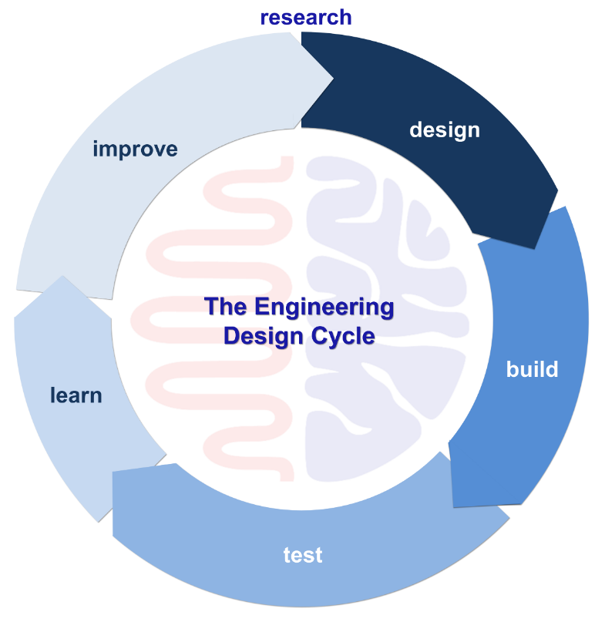
Figure 1 - Design Process by Team:Nottingham/Engineering - 2020.igem.org

Aims
This report sets out the following overall outcomes to be achieved as follows:
- Model an assembly of components
- Carry out a kinematics analysis of the system under realistic operating conditions
- Carry out a static structural assessment of one component within the assembly

Objectives
I have identified the following objectives for this report, related to limitations, validation, and design improvements.
- Identify and explain limitations
- Validate case studies to prove ANSYS provides accurate results
- Suggest design improvements based on computer aided engineering feedback

Research

Validation and Verification (V&V)
“The process of determining the degree to which a model is an accurate representation of the real world from the perspective of the intended uses of the model” (AIAA, 2002).
“Verification focuses on the mathematical aspects of FEA, determining if the solution that has been computed is accurate” (McCaslin, 2021). In this report, verification is used to observe whether the software computational methods are accurate and reliable.
“Validation is the process of determining the degree to which a model is an accurate representation of the real world from the perspective of the intended uses of the model” (Ben H. Thacker, 2004). Validation is often used with verification studies which implement analytical solutions and experimental proven results. A validation can be performed by using standardised case studies (Dlubal, 2022), which provide known solutions. Standardised cases are simple but offer confidence to the user that the software is working as expected.
The studies conducted throughout this report will be the “elastic bending – continuous load” (Dlubal, 2022) and “bimetallic strip” (Dlubal, 2017).

Finite Element Analysis
Finite element analysis (FEA) is a “numerical method” (Markus Michelmann, 2022) used in engineering to “understand and quantify problems” (TWI, 2019) involving complex physical systems. It involves dividing a system into smaller, simpler parts called "finite elements," which can be analysed using mathematical equations. This allows engineers to analyse and predict the behaviour of a system under various load conditions, such as stress, strain, temperature, and displacement. Other benefits of FEA include the ability to model complex geometries and materials, and the ability to identify potential problems and optimize designs before they are built. Overall, FEA is a powerful tool that enables engineers to understand and predict the behaviour of complex systems, enabling them to design and build more reliable and efficient products.

Mesh
In the context of finite element analysis (FEA) and computer-aided engineering (CAE), a mesh refers to a discretisation of a physical domain into smaller, simpler parts called "elements." These elements are used to approximate the behaviour of the system being analysed and are connected at points called "nodes." The process of creating a mesh is known as "meshing." It can “significantly impact the accuracy of the simulation” (Spatial, 2021).

Results
The results presented here cover mesh sizing analysis for elastic bending, bimetallic strip, and a thermal study on the piston component. Showing results on deformation, stress, and temperature.

Analytical Solution (Elastic Bending – Continuous Load) Results
The fundamental principles against which the CAE results will be verified are shown in the equations detailed below in (Figure 2) for elastic bending.
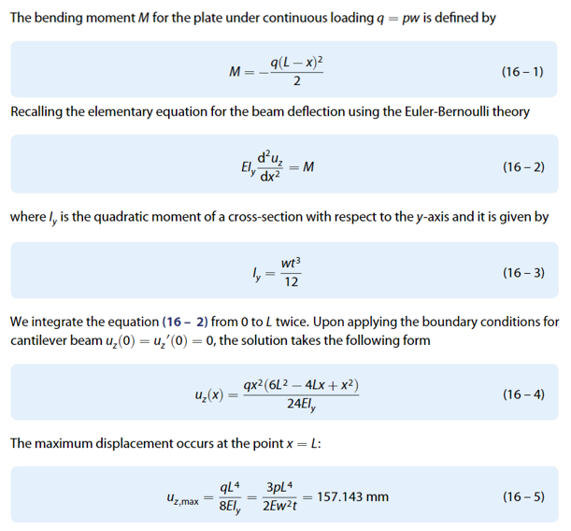
Figure 2 - Analytical Solution for Elastic Bending - Continuous Load by Dlubal
$$u_{z,max}=\frac{{(137.5\text{x1)}}^{4}}{(8\text{x210000x1.302x}{10}^{-12})}=\frac{({3\text{x2750x1)}}^{4}}{(2\text{x210000x}{0.05}^{2}\text{x0.005)}}$$
Equation 1 - Elastic Bending Continious Load Equation with Values

ANSYS Results (Elastic Bending – Continuous Load)
Elastic bending under continuous load was simulated in the software. The key outputs here are the maximum deformation of 157.15mm. Six different mesh sizes were used and the results for each of these simulations is shown in the figures (Figure 3-Figure 8)
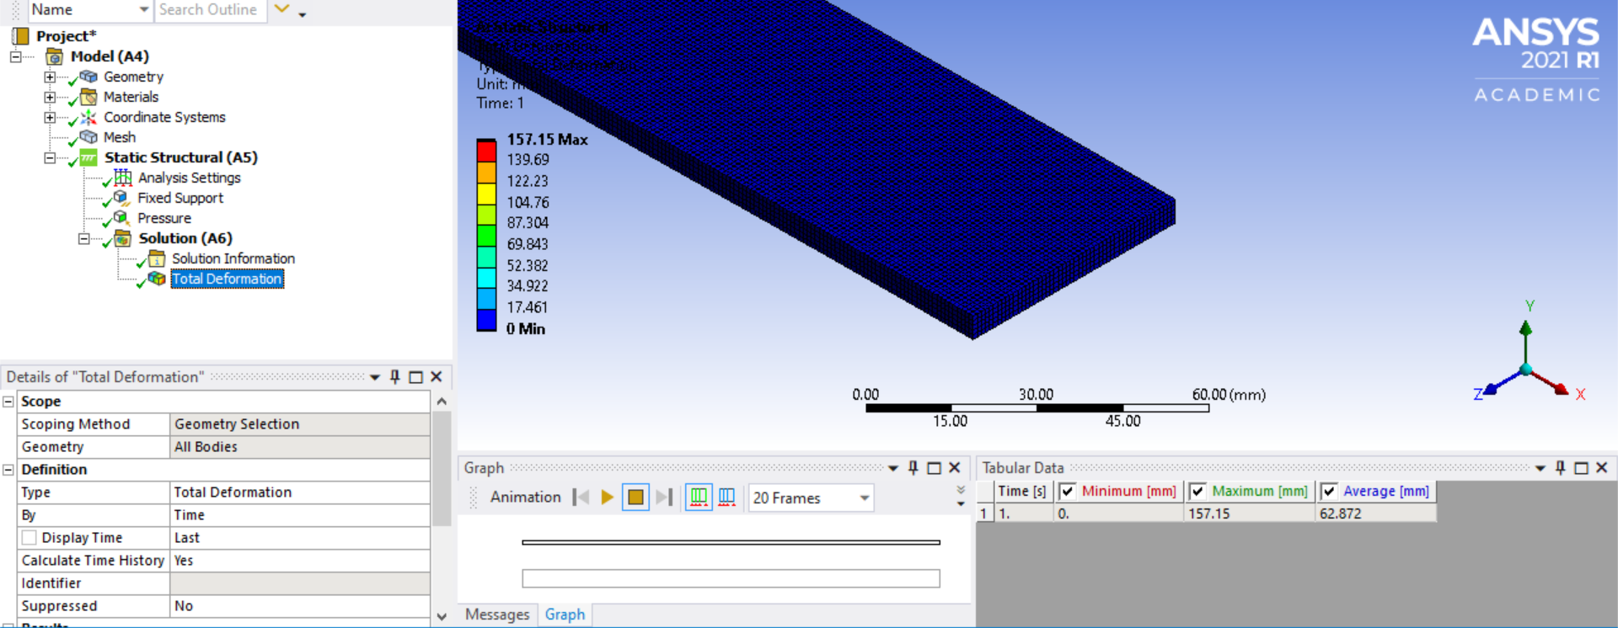
Figure 3 - Total Deformation (1mm Mesh)
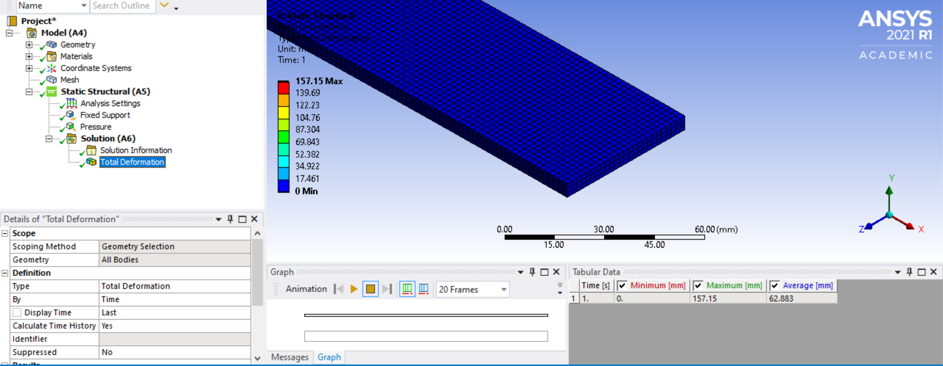
Figure 4 - Total Deformation 2mm Mesh
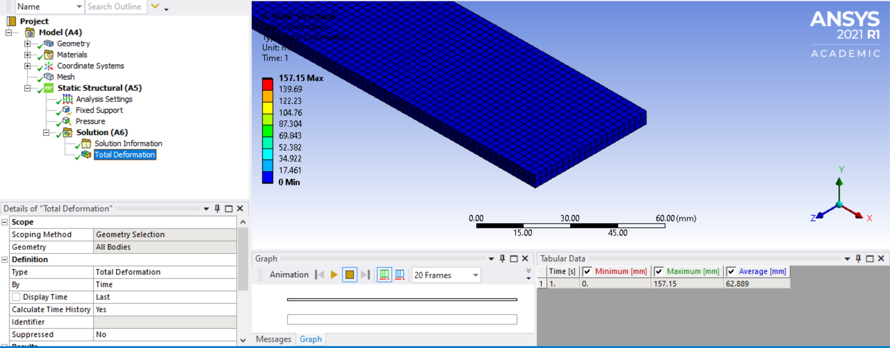
Figure 5 - Total Deformation 2.5mm Mesh
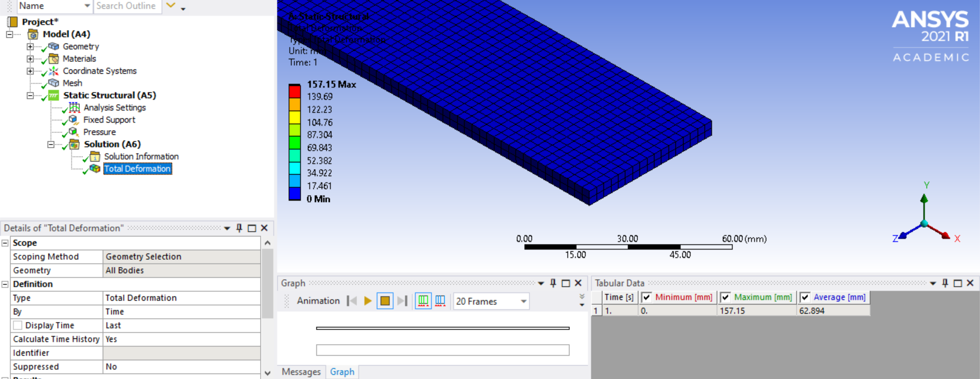
Figure 6 - Total Deformation 3mm Mesh
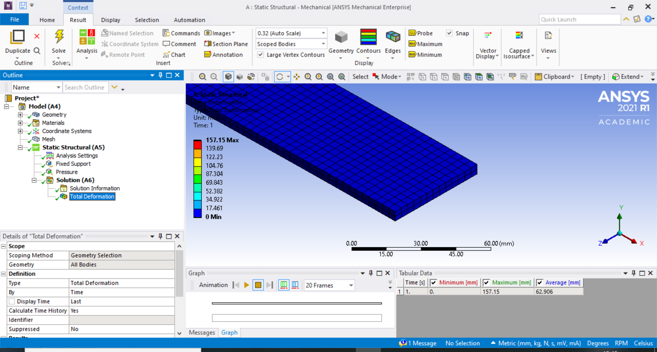
Figure 7 - Total Deformation 4mm Mesh
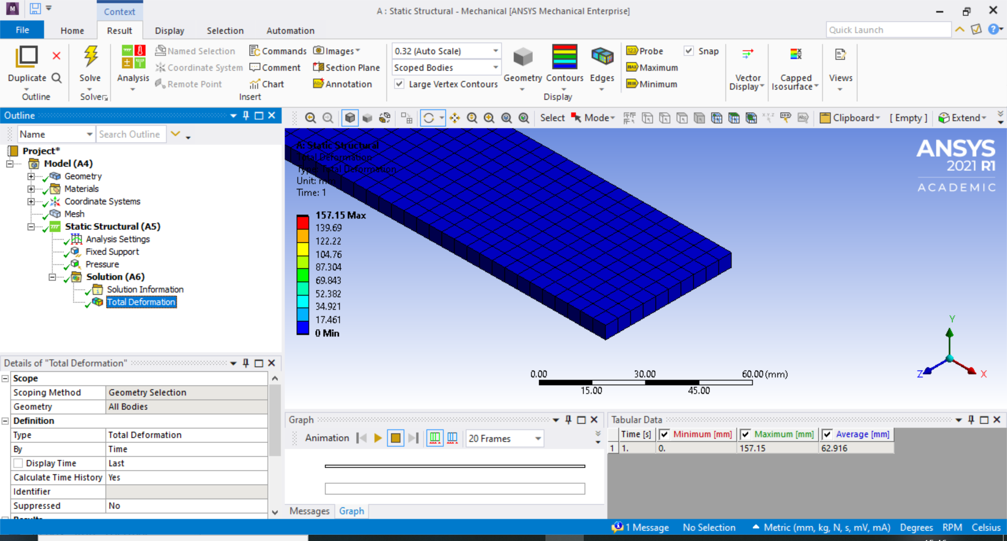
Figure 8 - Total Deformation 5mm Mesh
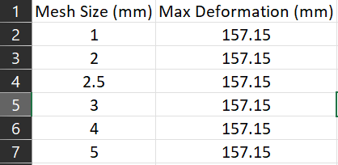
Table 1 - Max Total Deformation Summary
Here is a comparison of the total deformation results. Figure 9 and Figure 10 shows the results with the 2.5mm mesh and Figure 11 with the 5mm mesh, with results at 156.25mm and 157.15mm respectively. I have discussed the results in the analysis in section 5.1.
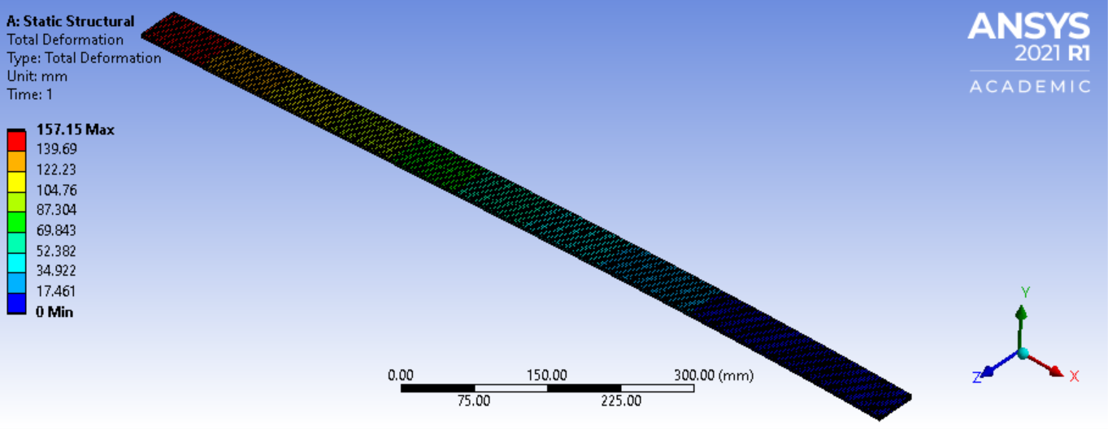
Figure 9 – Original Total Deformation Results with Contours (2.5mm Mesh, Coarse)
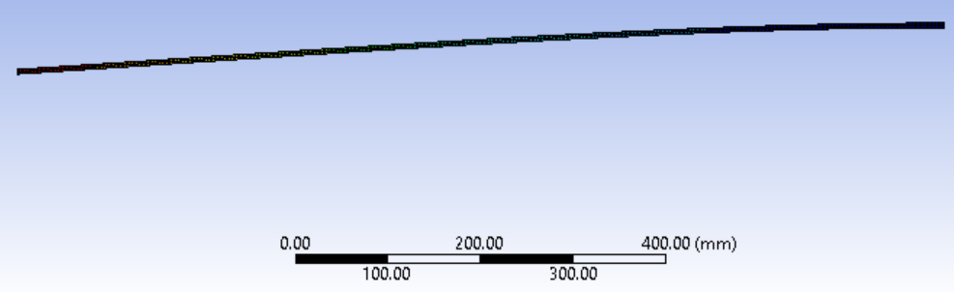
Figure 10 - Total Deformation Results, Side Angle (2.5mm Mesh, Coarse)
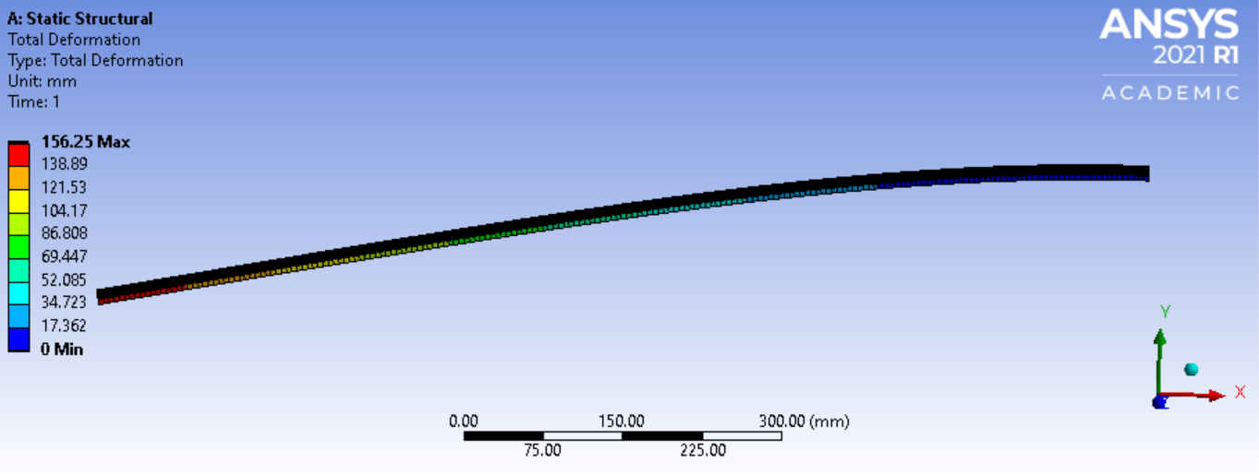
Figure 11 - Total Deformation Results (5mm Mesh, Coarse)

Analytical Solution (Bimetallic Strip) Results
The fundamental principles against which the CAE results will be verified for the bimetallic strip are shown in the equations detailed below in Figure 12.
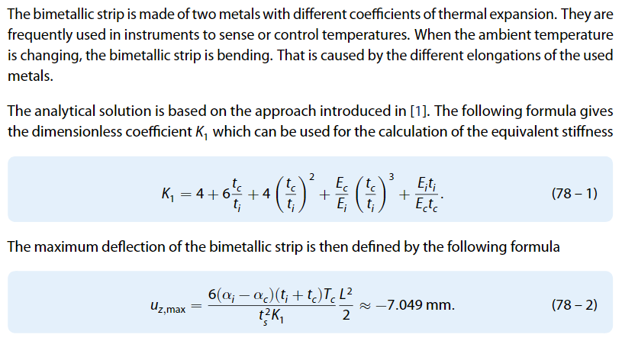
Figure 12 - Analytical Solution for Bimetallic Strip, Total Deformation by Dlubal

ANSYS Results (Bimetallic Strip)
Bimetallic strip was simulated in the software. The key outputs here are the maximum deformation of 7.123mm and 7.1213mm due to uniformly distributed load being applied to the surface. Two mesh sizes were used and the results for each of these simulations is shown in the figures (Figure 13 and Figure 14)
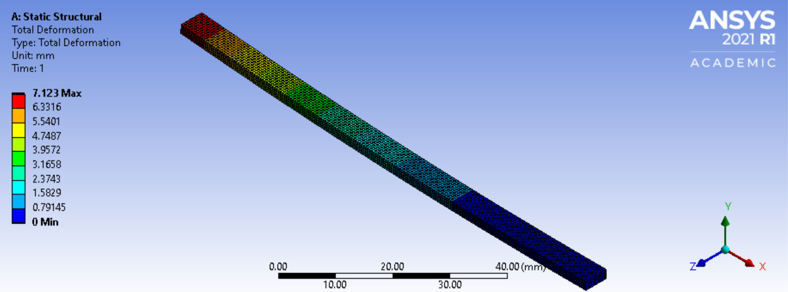
Figure 13 - Total Deformation Results 0.5mm Mesh
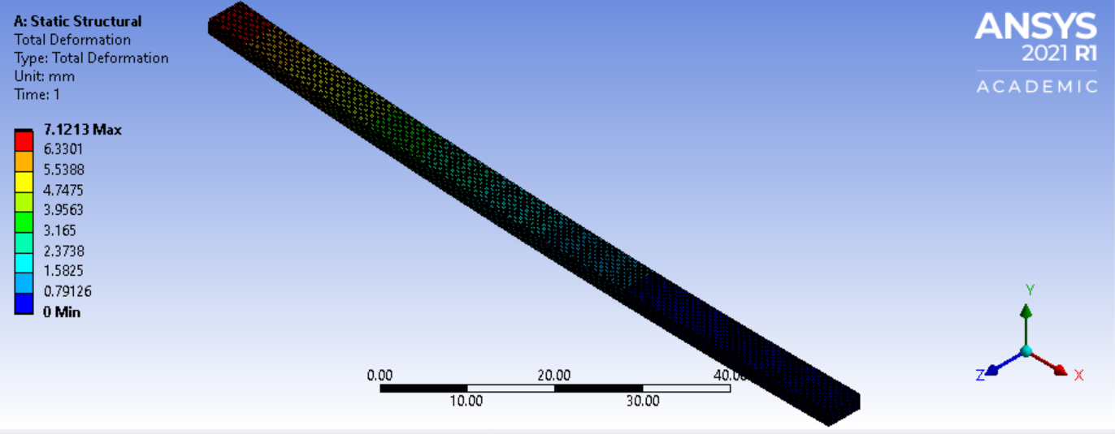
Figure 14 - Total Deformation Results 0.25mm Mesh

Piston Thermal Input
Thermal inputs were assigned to different regions of the piston to feed the static structural study temperature information and the temperature difference between the crown and the underside. The key output here is the maximum temperature observed at 309.37°C (Figure 16).
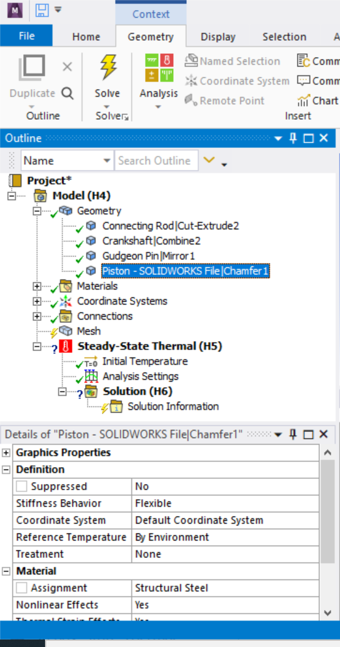
Figure 15 - Material Information Reset
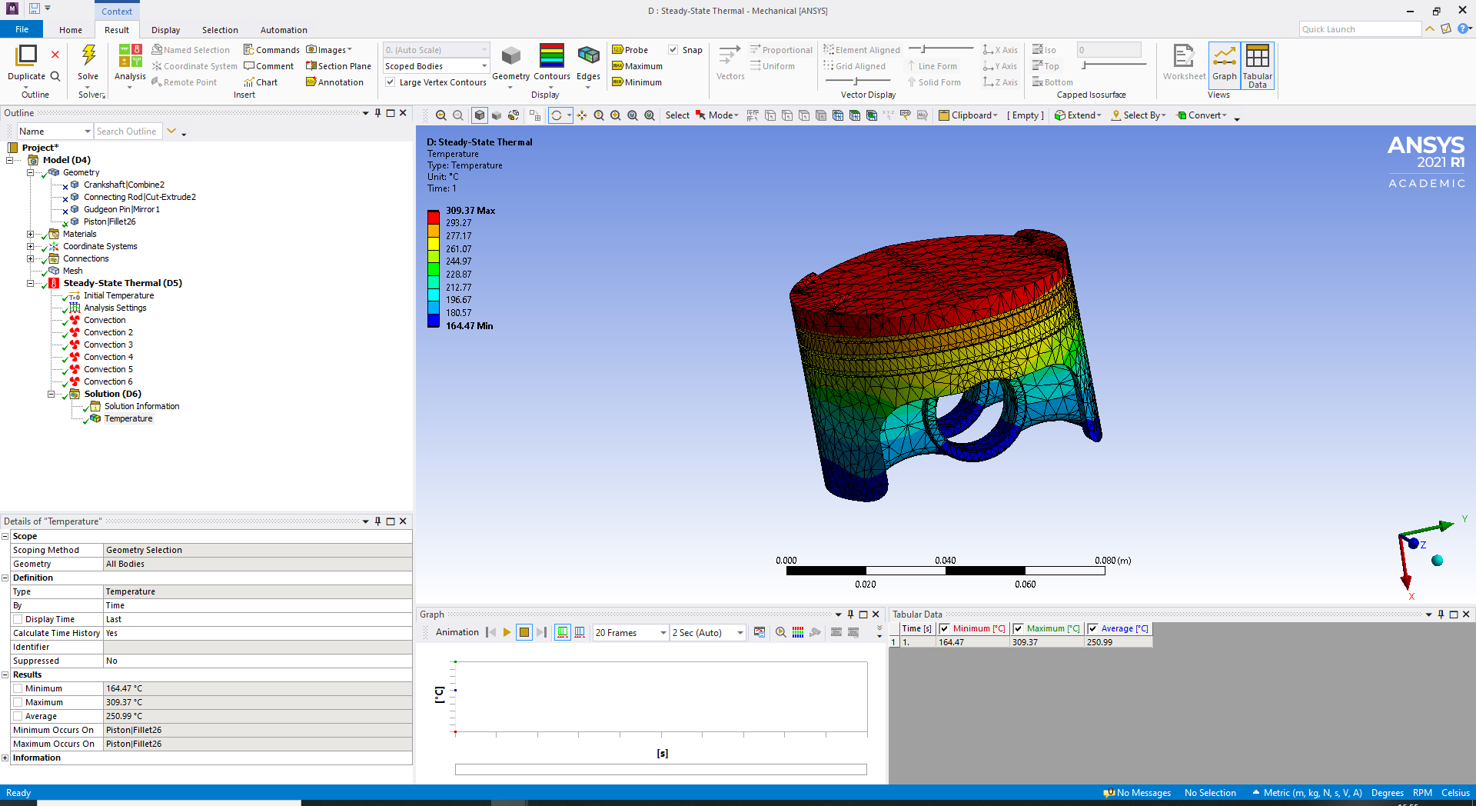
Figure 16 - Piston Thermal Conditions Results

Mesh Independence Study
Mesh independence was utilized to assess the solution output accuracy and computation power needed. Seven mesh sizes were simulated, to analysis the accuracy of different mesh sizes (Figure 17-Figure 23). The mesh independence study was analysis by inputting data into a graph as shown (Figure 24). Thermal conditions stated previously (4.5), were applied to this study.
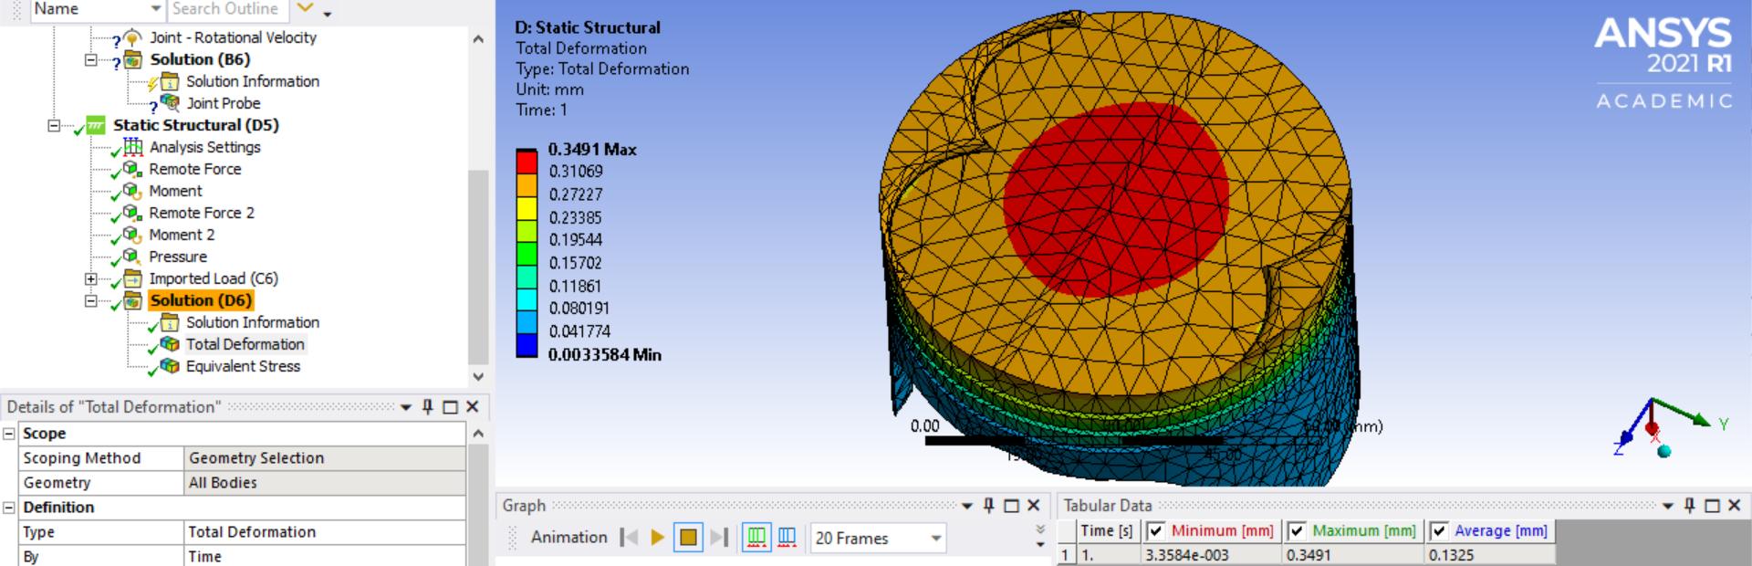
Figure 17 - Piston Total Deformation (5mm Mesh on Piston Crown, 41443 Nodes in Total)
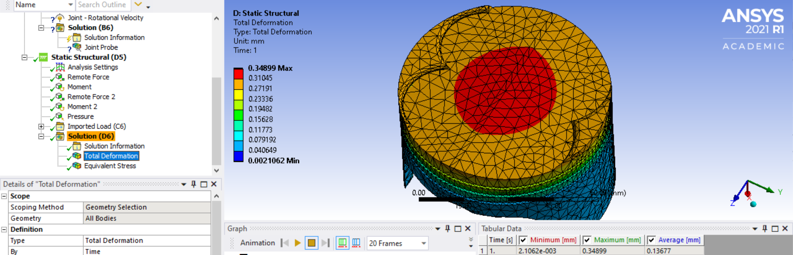
Figure 18 - Piston Total Deformation (4mm Mesh on Piston Crown, 42585 Nodes in Total)
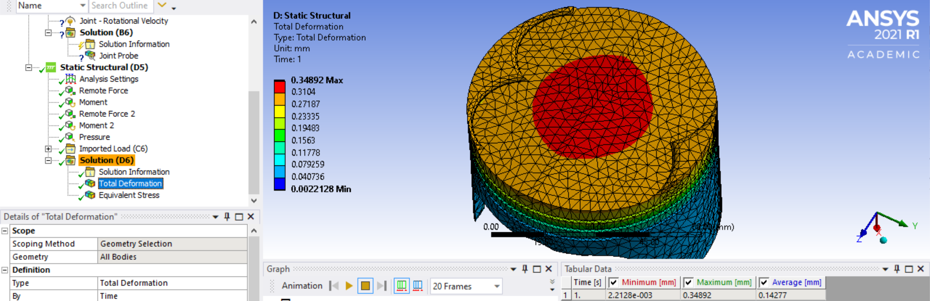
Figure 19 - Piston Total Deformation (3mm Mesh on Piston Crown, 45283 Nodes in Total)
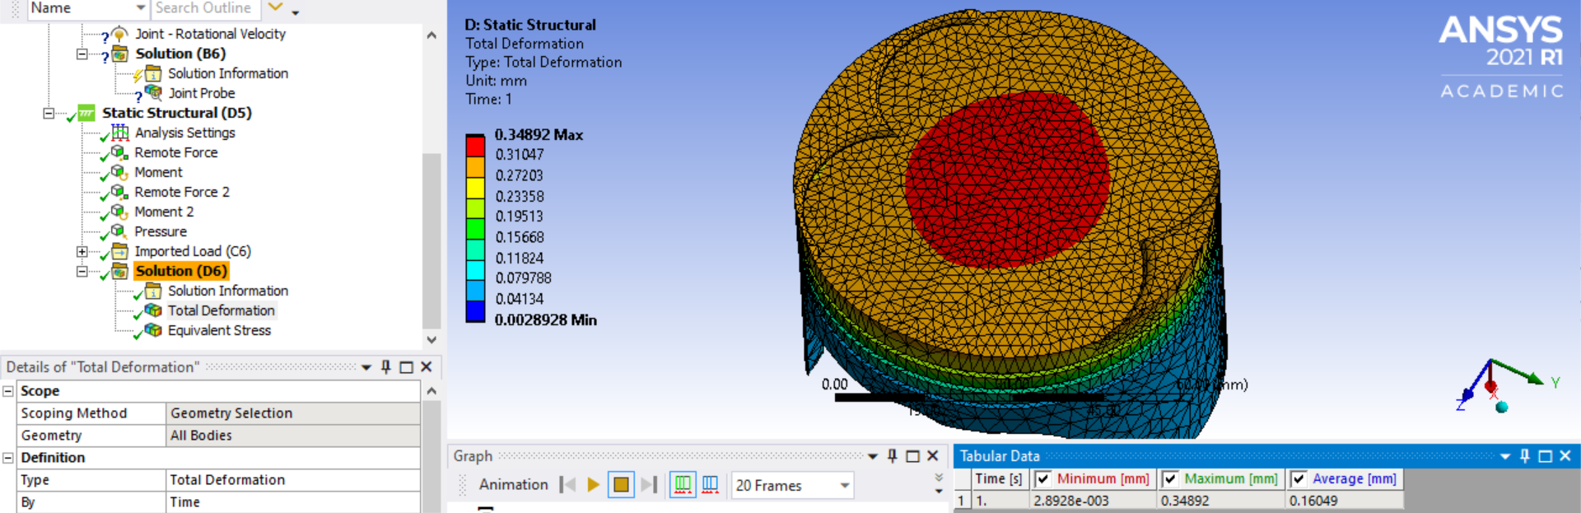
Figure 20 - Piston Total Deformation (2mm Mesh on Piston Crown, 50255 Nodes in Total)
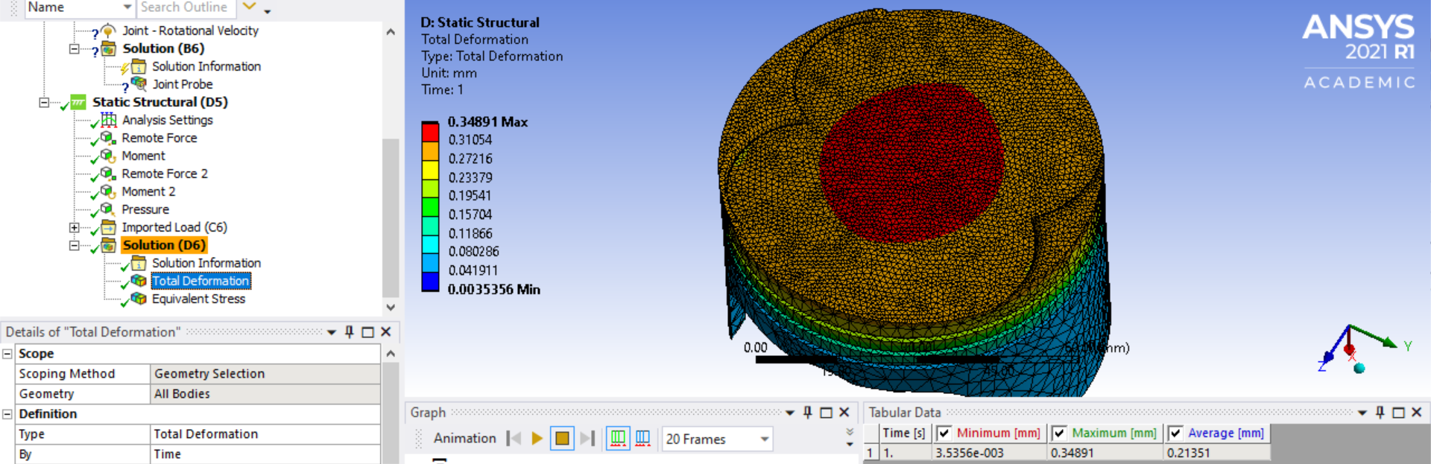
Figure 21 - Piston Total Deformation (1mm Mesh on Piston Crown, 84520 Nodes in Total)
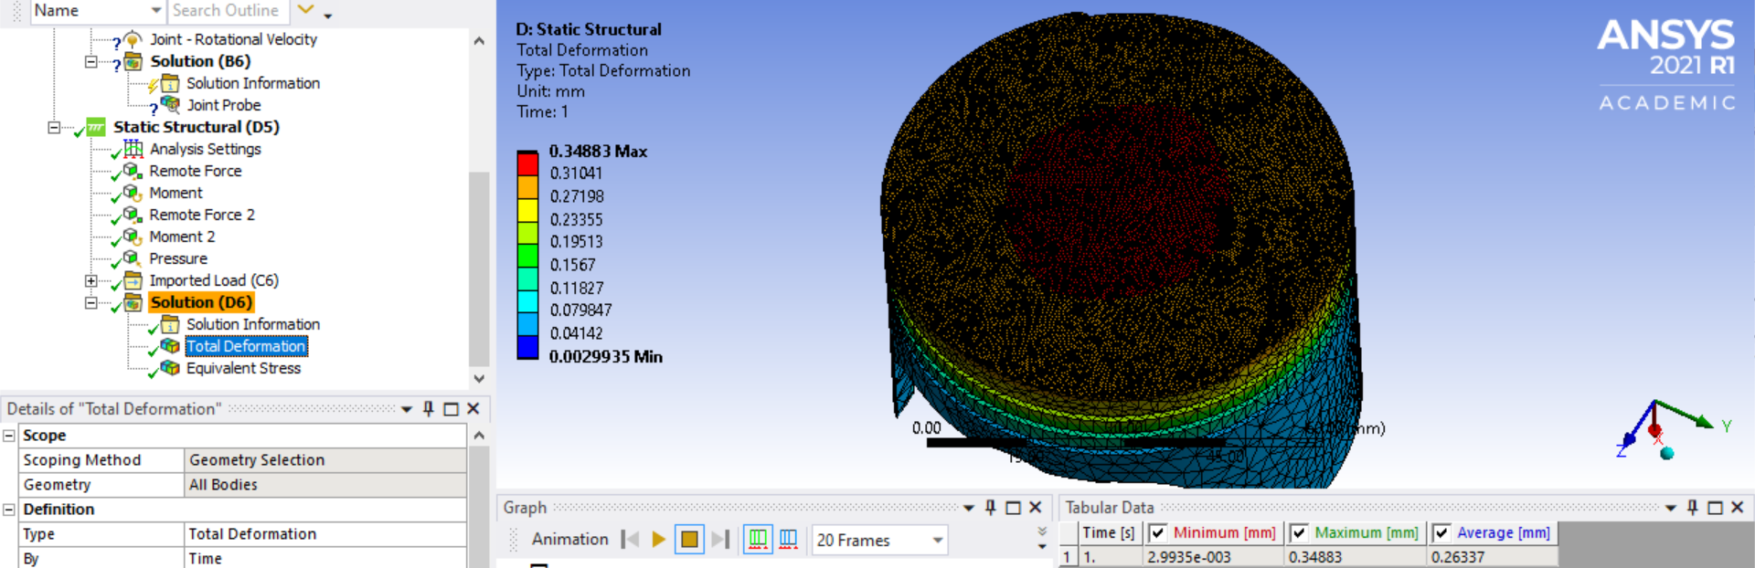
Figure 22 - Piston Total Deformation (0.5mm Mesh on Piston Crown, 216823 Nodes in Total)
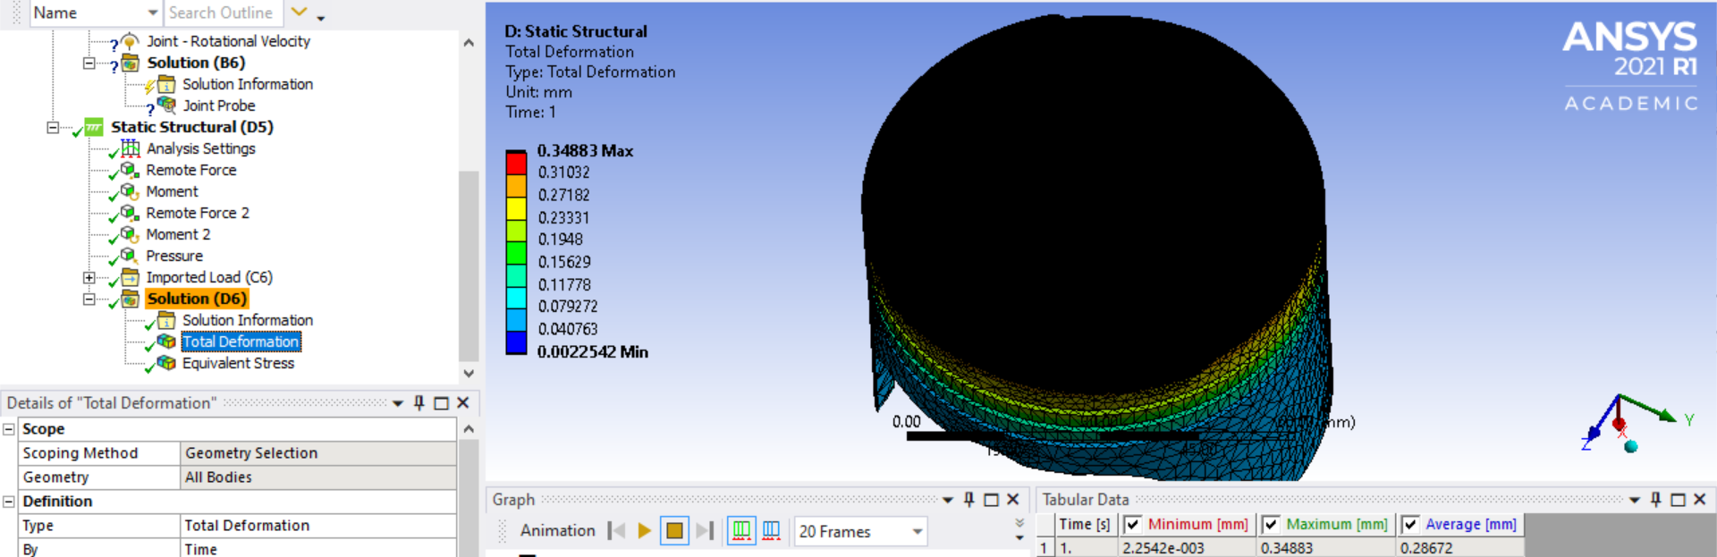
Figure 23 - Piston Total Deformation (0.25mm Mesh on Piston Crown, 727495 Nodes in Total)
Table 1 below summaries the results of deformation of the piston with a range of mesh sizes, and the deformation is also shown in the graph in Figure 24. These deformations are the result of thermal conditions.
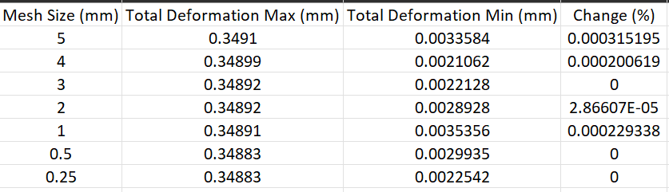
Table 2 - Results of Deformation of Piston, with Range of Mesh Sizes

Figure 24 - Total Deformation Max Accuracy alongside Mesh for Piston

Stress Solution of Piston
The results of stress from the thermal conditions being applied is shown in Figure 25 below using contoured stress plots.
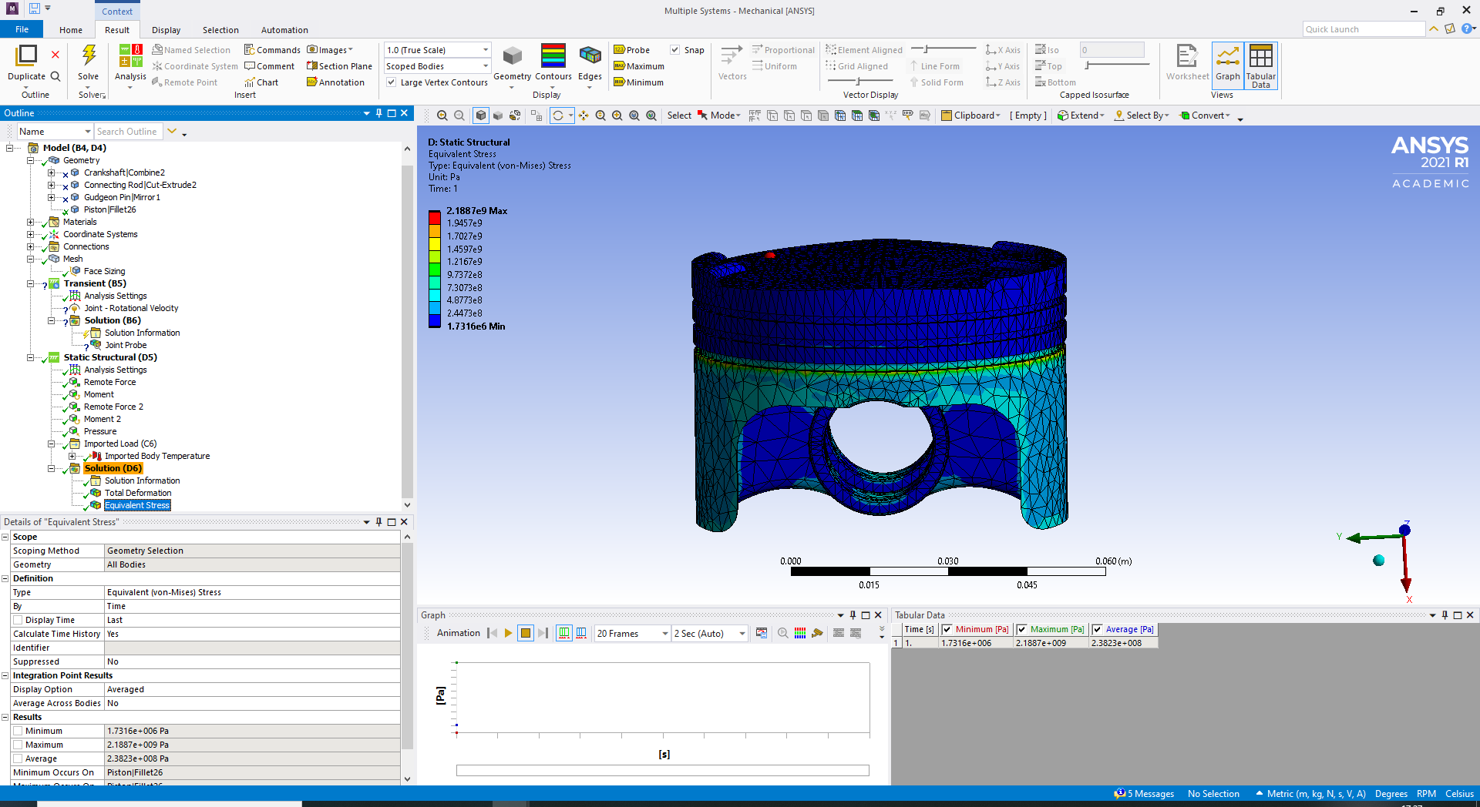
Figure 25 - Piston Stress

Kinematic Simulation, Thermal Influence & Structural Analysis
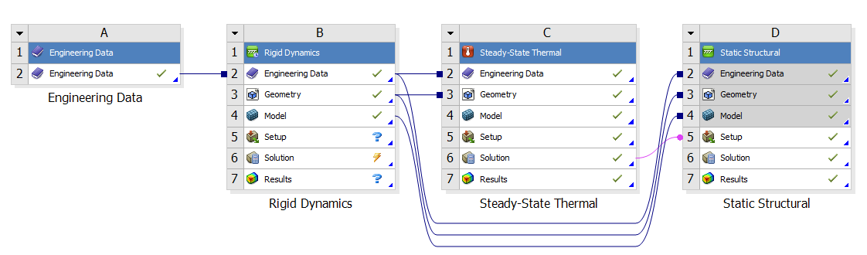
Figure 26 – Project Schematic
Engineering data is the first step in defining what material will be used, including the properties the material has. Once the material information has been set up, a rigid dynamics study can be performed to inform the software of how the parts for the assembly will behave. As this is a rigid study, all components will remain rigid except the piston which will be free, and flexible. The piston will be assessed for deformation and stress in the static structural. The direction and movement will be assigned to each component so the assembly is behaving how an engine would work. Once completed, a static structural will be set up and linked to the rigid dynamics study. The engineering data, geometry and model information will be sent to the static structural study for later assessment. The next step is to produce a steady-state study to define the temperature loadings on the piston, for the static structural study to determine deformation and stress. The last stage will be to link the steady-state study to the static structural study. This will transfer the solution information required by the static structural study to determine the deformation and stress. At the last stage of solving the static structural study, the software will require the piston to be fixed due to the load being applied. However, the piston needs to be flexible to correctly assess and produce realistic results. Weak springs can be utilized to add constraints to the body, while remain flexible.

Improved Design
Figure 27 shows the assembly as a complete kinematic component. The assembly consists of a connecting rod, crankshaft, gudgeon pin and a piston. The piston has analysed through FEA processes and project schematic studies (Figure 26), to simulate the deformation and stresses occurring on the component.
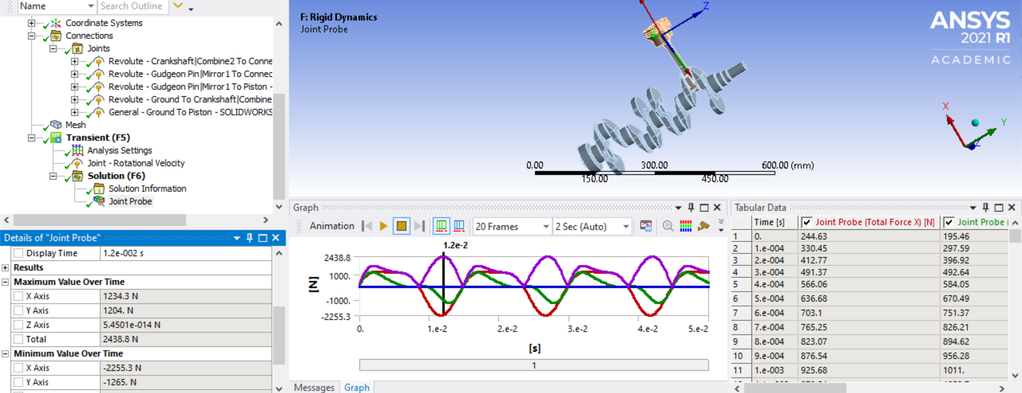
Figure 27 - Improved Design Approach 1
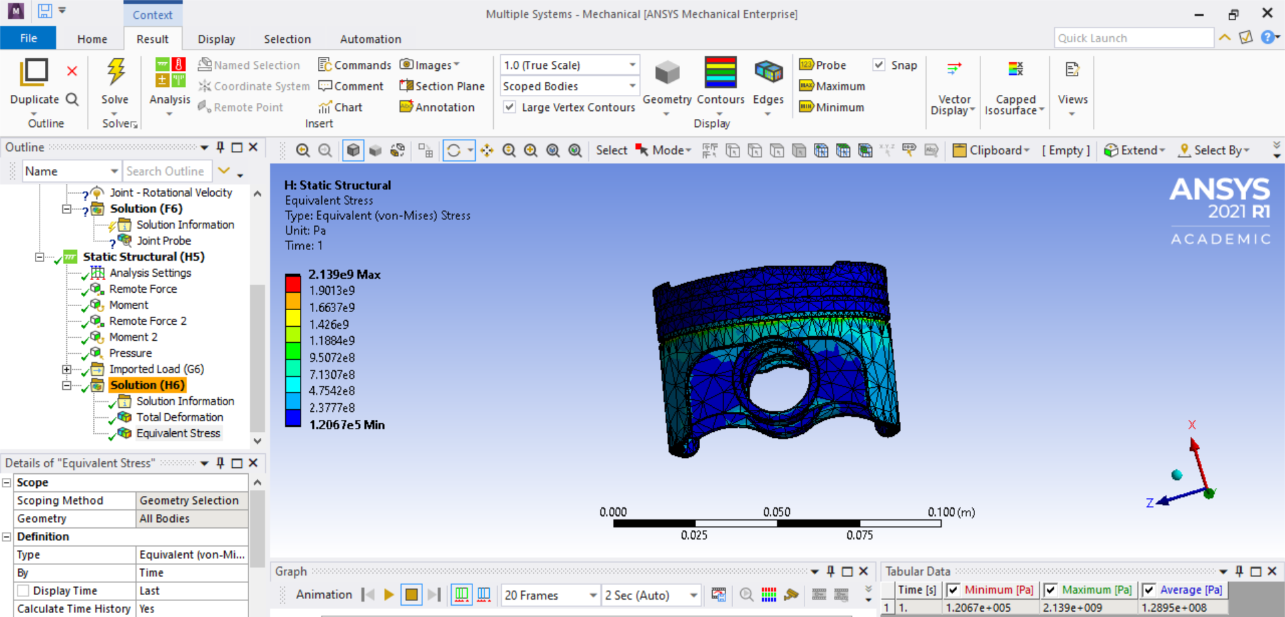
Figure 28 - Improved Design Approach 1 Results

Analysis

Mesh Sizing Analysis – Elastic Bending (Continuous Load)
During the “Elastic Bending – Continuous Load” (Dlubal, 2022) study, mesh sizing contributed to an insignificant difference to the accuracy of the study. A mesh sizing of 2.5mm, provided a max deformation ($U_{z, max⁡})$ of 157.15mm (Figure 9). The ANSYS max deformation results (Figure 9) were then compared to the verification example analytical solution (Dlubal, 2022) of 157.143mm. The range of error is <1% (Figure 2) and the results of the ANSYS analysis can therefore be considered valid.
Changing the mesh sizing from 2.5mm to 5mm (Figure 11), increased the error by an insignificant amount. By doubling the mesh sizing, the range of error increased to 1.006%.
Upon validating the ANSYS results, a second identical study was carried out. For 5mm, the results changed to 157.15mm (Figure 8). Whereas for 2.5mm (Figure 5), the results remained unchanged 157.15mm max deformation. The difference in results could be the software using a different method or human error.
Further investigation was carried out by using other mesh sizes (Figure 3 - Figure 7). All showing and validating the result of 157.15mm.

Mesh Sizing Analysis – Bimetallic Strip
During the “Bimetallic Strip” (Dlubal, 2017) study, mesh sizing between 0.5mm (Figure 13) and 0.25mm (Figure 14) contributed an insignificant amount different to the accuracy of the study, with a difference of 1%. The percentage error between the 0.25mm mesh produced in this report, and the analytical solution is insignificant, with a difference of 1.01%. The difference may be due to difference in computational power, being able to use a finer mesh and time capabilities.

Piston Thermal Study
A thermal study was conducted on the piston (Figure 16), generating a maximum temperature of 309.37°C which can be observed by in the output plots. The maximum temperatures can be seen on the crown of the piston. The minimum temperature of 164.47°C, can be observed by the contour colours. The minimum temperature can be seen on the underside/skirt of the piston.
A thermal study can give us an indication of where deformation will most likely take place during future testing due to the material properties being pushed to the limit. In this case, the thermal study was produced to provide essential data/boundaries for the static structural study further along the schematic (Figure 26).

Mesh Independence
For the piston, the optimal mesh size is 0.5mm (Figure 22). This size will produce an accurate result, with little additional computational power needed compared to the 0.25mm mesh size (Figure 23). Due to the insignificant percentage change between the 7 mesh sizes (Figure 17 - Figure 23), it would be appropriate to choose any of the mesh sizes although coarser meshes would likely result in fast processing time as a result of less resource being required.

Discussion

Computer Aided Engineering
Computer-aided engineering (CAE) is the use of computer software to assist in the design, analysis, and testing of the engineering system. CAE includes a wide range of tools and techniques that can be used in various stages of the engineering process, from initial concept development to final testing and validation. “CAE is the next step not only in product development, but also in supporting of the engineering process, because it allows performing tests and simulation physical properties of the product without a physical prototyping” (Kolbasin & Husu, 2018).
In this report, CAE is used to support, model, and simulate the behaviour of engineering systems, including static structural, rigid dynamics, and steady-state thermal (Figure 26) and validation studies.

Benefits of Computer Aided Engineering
There are several benefits of computer-aided engineering:
- Improved Design
- Reduced Prototyping
- Enhanced Collaboration
- Increased Productivity
- Cost Saving
CAE allows engineers to make informed decisions, more efficient and effective products, and reduce the need for physical testing and prototyping, which leads to lower costs and time saving. Another outcome of not needing prototyping and testing is that more design iterations are possible which allows greater optimisation of the product.

Limitations of Computer Aided Engineering
There are several limitations of computer-aided engineering:
- Dependence on Computer Software and Hardware Processing Capabilities
- Limited to Computer-Simulated Conditions
- Time and Resource Constraints
- Lack of Physical Insight
- Limited to Certain Applications
It is important to provide and compare analytical solutions (4.1,4.3) of a component with computer aided engineering software as dependence on the software can lead to inaccuracies. Computer software can have errors or bugs which can influence misleading results. Human error may also effect results due to poor data entry or selection of incorrect parameters. CAE tools do not offer the same level of physical insight as hands-on experimentation and prototyping, so comparing predictions made by the software with physical insight is necessary.

Limitations within ANSYS
There are several limitations of computer aided engineering within ANSYS:
ANSYS loads default values based off calculated assumptions during the process of opening the model during a study. Dependence on the ANSYS software calculated or default assumptions will create inaccuracies as it does not reflect realistic conditions such as weather, temperature for which the component may be applied to. This requires the user to make appropriate changes to inputs, or risk inaccurate results.
ANSYS will occasionally not recall material data assigned to a component from previous studies and revert to original data such as structural steel (Figure 15). Dependence on ANSYS software to select these values may lead to inaccuracy. Depending on the material that has been replaced, the inaccuracy can be considerable or inconsiderable. This may also be seen on other settings but have not been observed during this report.
ANSYS may at times, recalculate the mesh on the model differently, even with the same sizing. This is most likely due to the computational method being performed by the software being different, resulting in a different output (Figure 11). Recalculating multiple times and looking for mesh independence (4.6) is necessary to produce an accurate and reliable result.
ANSYS provided materials properties do not consider the quality, grade, or specific alloys. User input will be necessary to provide the software with accurate material property measurements. This will be done through experimentation. Other computer aided design and CAE such as SolidWorks will not take this into consideration and requirements vary between software.
In ANSYS, modular studies limit the amount of material information and properties the user has access to. This requires the user to input and change the ‘engineering data’ for each modular study which can complicate the process, reduce productivity, and limit access to essential material property information (Figure 26). ‘Engineering data’ stand-alone systems grant access to all the material information and properties as it is not associated with any specific solder type. Therefore, all material information that will be needed during the entire ‘project schematic’ can be stored into one stand-alone system and linked to solder types later without complicating the process (Figure 26). This becomes increasingly important the larger and more complex the component or assembly becomes.
Testing the software through validation (Dlubal, 2017) (Dlubal, 2022) is essential for evaluating whether the software is accurate. Some software will have minimal amounts of analytical computational capability and the tools associated with CAE but exceed in CAD capabilities and tools such as SolidWorks, which struggle to calculate accurate thermal studies.
ANSYS is highly sophisticated for CAE processes and can go into incredible accuracy. However, to reach such accuracy, more time and computational power is needed to process large volumes of calculations. This can lead to an increase in hardware costs and staff costs. Finding mesh independence (4.6) will generate an appropriate mesh which requires low computational cost and high-speed completion for the calculation which will requires less time resource.
ANSYS will not detect design geometry errors for components or conduct a study whether the body is an accurate representation or not. This will provide inaccurate results, compared to analytical and experimentation results.

The Importance of Mesh Sizing
For small and simple geometries as the ones used in this report (4.2, 4.4, 4.5), mesh sizing wasn’t considerably important. Fine mesh sizes were possible to use without consuming large amounts of time and computational power, which increased accuracy by an inconsiderable amount (Table 1). With larger and more complex geometries and loads, mesh sizing becomes more complicated as the computers will have to perform more complex calculations and would consume a lot of time. ANSYS on several occasions, could not execute its mathematical model due to the large amounts of nodes being placed.
Mesh independent studies can be performed to find an appropriate mesh sizing which has a low computational cost and saves time (4.6). It is also appropriate to choose a coarse mesh where a material or structure will not experience large amounts of thermal loading such as the piston middle grove, oil grove, underside, and skirt (4.5). A mesh independence study can also be used on other loads such as equivalent stress (Figure 25).

Performance Improvements
There are many improvements that can be made to protect the piston from excessive loads such as thermal loading, and pressure. Material selection is an important component for improving the design of the piston as material properties can enhance the resistance of deformation and high stress and strain. An equivalent stress analysis was performed on the piston structure to identify where the piston was experiencing the most stress (Figure 25). The material in use was 6061-T6 Aluminium which has a composition of “1%Mg, 0.8%Si, 0.3%Cu, 0.2%Cr (Figure 29) which is heat treated and relies on age-hardening” (ANSYS Inc, 2021).

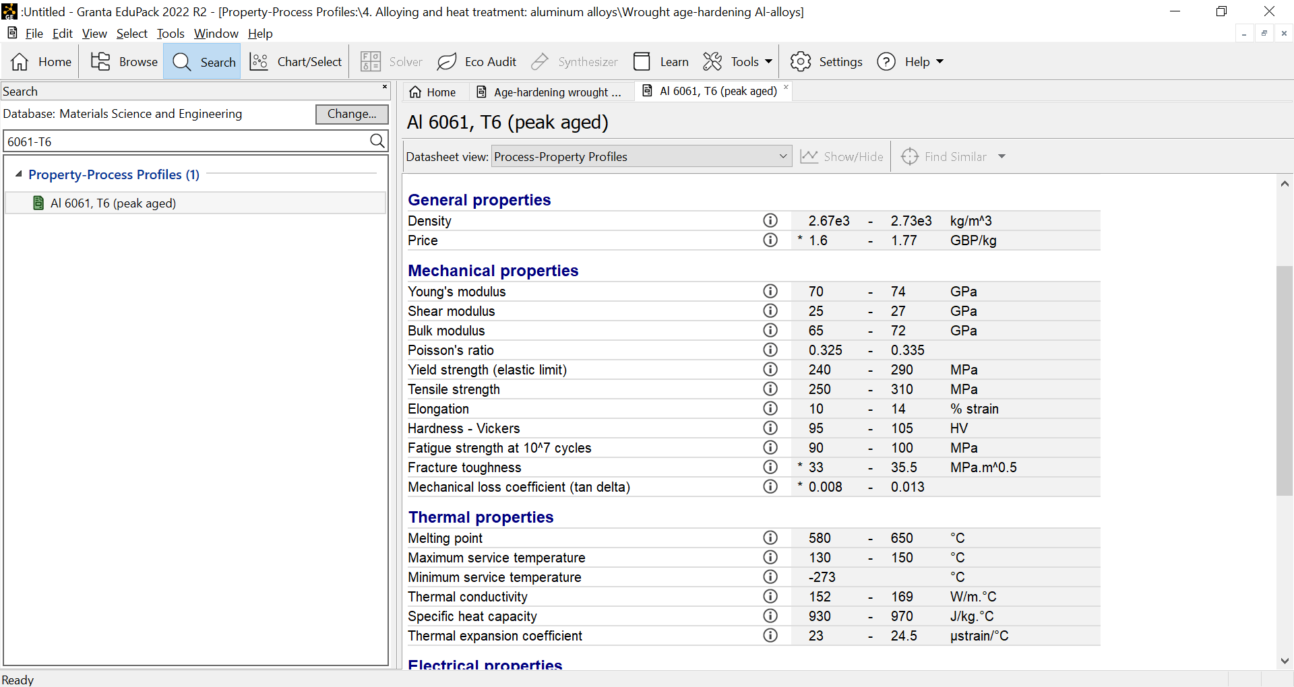
Figure 29 - Granta EduPack 2022, 6061-T6 Material Properties
“Research show that aluminium anodized with copper improves the structural integrity of the aluminium piston while also enhancing its structural and heat transfer properties” (Selvam, et al., 2022). This shows that incorporating desired material properties to improve specific requirements can be beneficial to the overall body.
The equivalent stress analysis (Figure 25) exposed an area of weakness within the body which can be redesigned. By introducing smooth edges, stress can be removed from the edges most affected. Other methods such as minimizing the contact area the skirt is exposed to will further eliminate friction, which will reduce stress. To do this, an “Asymmetrical piston” (Figure 31), should be used as a “means to reduce frictions” (BAECHTEL, 2017). Combining this with “an ultra-low profile, slipper skirt style piston” (Baechtel, 2017), to reduce weight, and minimise contact area. Reshaping the component by introducing ovality (Figure 30) would also reduce the amount of contact area, further reducing friction. In this report the geometry changes could not be made due to a constraint on the analysis.
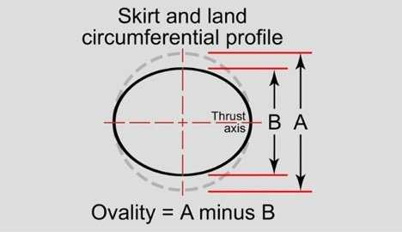
Figure 30 - Skirt Ovality by John Baechtel
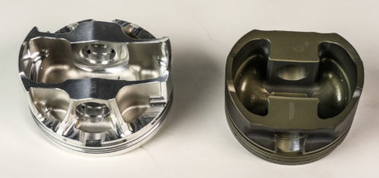
Figure 31 - Left Asymmetrical Piston, Right Symmetrical Piston by John Baechtel
A 0.5mm fillet was implemented into the piston design around the skirt edges (Figure 28) and a 0.5mm chamfer on the bottom oil groove where stress was particularly high. However, the results show that there is an increase in stress compared to the original design.

Conclusion
Mesh sizing during the validation study for elastic bending under a continuous load, proved to be insignificant. Increasing the mesh size, increased the range of error between the analytical solution provided (Dlubal, 2022). A fine mesh decreased the range of error, however, to get a result with no percentage error, more computational power, similar software, or different ANSYS package is needed (6.1.2.1).
The analysis carried out on the validation studies, and the fully linked system were relatively simple. Larger and more complex structures may not be possible to generate a fine mesh due to insufficient processing power or time. Therefore, a coarse mesh may be more appropriate on larger/complex structures to get a balance between computation resources and accuracy of results.
Overall, ANSYS is a reliable CAE software product. The limitations of the software can be decreased if the user is trained and aware of the issues that may appear. As shown by the validation, it is important to support the ANSYS results using analytical solutions and physical insight (4.1, 4.3), before in order to have confidence in ANSYS or any other software being used.
To improve the design to limit the maximum deformation, and maximum stress, other materials should be tested. 6061-T6 Aluminium is a great material, being light weight and with excellent thermal properties. However, other alloys should be explored such as “aluminium anodized with copper to protect its structural body and enhance the thermal aspects” (Selvam, et al., 2022). Reducing the weight and contact area by using an ovality, and asymmetrical design would further decrease the friction, leading to less stress (6.3).
A Mesh independence study is a reliable process in determining the optimal mesh size, to reduce computation power, time, and cost.

References
AIAA, 2002. Guide for the Verification and Validation of Computational Fluid Dynamics Simulations. Virginia: American Institute of Aeronautics and Astronautics.
ANSYS Inc, 2021. Ansys GRANTA EduPack software. [Online]
Available at: www.ansys.com/materials
[Accessed 14 12 2022].
Baechtel, J., 2017. Explained: Symmetrical, Asymmetrical, and Full-Round Piston Skirt Design. [Online]
Available at: https://auto.jepistons.com/blog/understanding-piston-skirt-design
[Accessed 15 12 2022].
BAECHTEL, J., 2017. The Shape Of Things: Why Your Piston Skirts Aren’t Round. [Online]
Available at: https://www.enginelabs.com/engine-tech/the-shape-of-things-why-your-piston-skirts-arent-round/
[Accessed 15 12 2022].
Ben H. Thacker, S. F. M. H. M. A. J. P. E. R., 2004. Concepts of Model Verification and Validation. [Online]
Available at: https://www.researchgate.net/publication/236441120_Concepts_of_Model_Verification_and_Validation
[Accessed 1 12 2022].
Dlubal, 2017. Bimetallic Strip - Verification Example. [Online]
Available at: https://www.dlubal.com/en/downloads-and-information/examples-and-tutorials/verification-examples/000078
[Accessed 1 12 2022].
Dlubal, 2022. Verification Example - Elastic Bending (Continious Load). [Online]
Available at: https://www.dlubal.com/en-US/downloads-and-information/examples-and-tutorials/verification-examples/000016
[Accessed 1 12 2022].
Dlubal, 2022. Verification Examples. [Online]
Available at: https://www.dlubal.com/en-US/downloads-and-information/examples-and-tutorials/verification-examples
[Accessed 1 12 2022].
Kolbasin, A. & Husu, O., 2018. Computer-aided design and Computer-aided engineering. Moscow, EDP Sciences.
Markus Michelmann, J. K., 2022. Finite Elements. [Online]
Available at: https://brilliant.org/wiki/finite-elements/
[Accessed 1 12 2022].
McCaslin, S., 2021. Validation and Verification in Finite Element Analysis (FEA). [Online]
Available at: https://control.com/technical-articles/validation-and-verification-in-finite-element-analysis-fea/
[Accessed 1 12 2022].
PTC - Digital Transforms Physical, 2022. Computer-Aided Engineering (CAE). [Online]
Available at: https://www.ptc.com/en/technologies/cad/computer-aided-engineering
[Accessed 1 12 2022].
Selvam, M. et al., 2022. Influence of copper anodization on structural and heat transfer characteristic of aluminum piston. Materials Today : Proceedings, Volume 59, pp. 1407-1413.
Spatial, 2021. What is Mesh Generation. [Online]
Available at: https://www.spatial.com/resources/glossary/what-is-meshing?hsCtaTracking=1937c820-458d-4e7b-a889-45401743c277%7C0bc26d57-6910-46a3-8111-15514723a1dd&hsLang=en
[Accessed 5 12 2022].
TWI, 2019. WHAT IS FINITE ELEMENT ANALYSIS (FEA)?. [Online]
Available at: https://www.twi-global.com/technical-knowledge/faqs/finite-element-analysis
[Accessed 1 12 2022].

