Destination management



Name: Florinel Marius Guinea
Student number:2108012
Module: Sustainable Hospitality & Tourism Management (BMIH5006)
Module Lead: Ruth Taylor Davies

Table of Contents
Introduction 2
Demonstrating a sound understanding of choosing destination Cotswolds 2
Rationale for choice 2
Evaluate principles of sustainable tourism 3
Three Pillars of Sustainability 4
Link principles of sustainability with sustainable tourism in the development management plan of Cotswolds 6
Outlining Practices based on regulations and organisations responsible for the Implementation 7
Determining the stages Cotswolds has been through using Butler’s life cycle model 8
Doxey’s irridex model 9
Benefits and drawbacks of sustainable tourism and sustainable development in comparison to other successful Destinations 10
Recommendation for future development of Cotswolds 11
Conclusion 11
References 12

Introduction
The report will analyse the case studies of the chosen organisation, Cotswolds, to justify the incorporation of sustainable tourism and implementation of the principles of sustainable tourism in a destination management plan. Additionally, a sound understanding of destination choice will be demonstrated to justify the relevance of destination choice. Moreover, the report will assess how Cotswolds has incorporated three pillars of sustainability in the destinations management plan economic, socio-cultural and environmental aspects. With this, the benefits and drawbacks of sustainable tourism will be analysed by comparing the Cotswolds with other destinations. Additionally, Butler's model of the Tourism life cycle and Doxey's irridex model will be assessed to recognise the stages where the company started and needs to improve further such areas of stages.

Demonstrating a sound understanding of choosing the destination Cotswolds.
Cotswolds is surrounded by a range of hills that stretch 80 miles from northeast to southeast and are surrounded by six countries. Additionally, visitor attractions in the Cotswolds lie on covering Cotswolds Wildlife Park, Cotswolds Water Park, and Capital of the Cotswolds. Relatively, the country outside has an outstanding natural beauty and picturesque towns and villages that could be enabled to attract visitors (Cotswolds, 2022).
Besides, Cotswold has been famous for its good destination management performance, enhancing brand awareness and appreciation. Moreover, the aspect of sustainable tourism has been instigated by Cotswold's conservation board members to implement green tourism in practice (Cotswolds, 2022). In nexus with this, the sociological aspect has been satisfied by communicating with the local enterprise through partnerships that add value to economic development in the region.

Rationale for choice
The fundamental rationale for choosing Cotswolds is acknowledging that the destination has visitor attractions and incorporating sustainability principles across the destination management practices. As denoted by Streimikiene et al. (2021), sustainable tourism has retained the high satisfaction of tourists and is assured of offering a memorable experience to tourists. This has even helped the organisation light the hidden issues associated with incorporating sustainability in operations and emphasised designing mitigating strategies. Additionally, Cotswolds has placed reliance on addressing the key challenges and opportunities for fully embracing sustainable tourism and ensuring the development of the local economy. This insight and actions of Cotswolds have emphasised choosing the destination for satisfying report criteria.

Evaluate principles of sustainable tourism
As a matter of principle, sustainable tourism separates itself from mass tourism, which is the antithesis of sustainable tourism. In the opinion of Goodwin (2011), taking responsibility for tourism is a globally vital need for realising sustainable tourism. It challenges those who organise and sell travel and tourism to those who consume it. The sustainable development management plan should be such that it comprises the principle of environmental sustainability and social sustainability. In the view of Angelevska Najdeskaa and Rakicevik (2012), the principles of sustainability provide cultural development to be attuned to the cultural values of communities and economic development to deliver cost-effectiveness and effective resources to be adequately managed for future generations to reap benefits from it. Has been identified based on the reports presented by Sobre (2018), the principles of sustainable tourism and sustainable development goals as laid down by the UN demand that the legislation in force is respected in every country and an international convention to which the nation is a signatory.
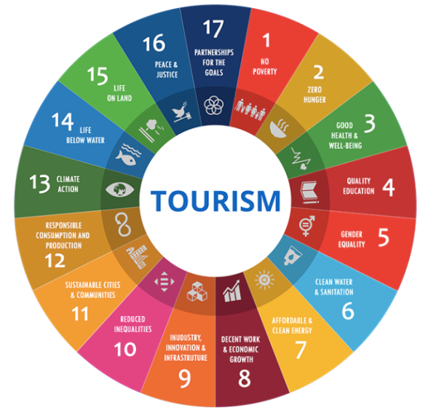
Figure 1: Sustainable Development Goals as laid down by the UN
(Source: Sobre, 2018)

It is also necessary to warranty the rights of the local populations and inspire tourist destinations' economic and social development. The principles include conserving the natural environment and biodiversity and considering cultural heritage and local values (Sobre, 2018).
In every stage of operation, tourism requires adopting practices that have minimum impact on adjacent environments and communities. In addition to this, tourism businesses must certify the quality of processes, products and attitudes besides establishing responsible planning and management (Sobre, 2018). It requires that tourism must be directed towards setting ethical business procedures that engage economic, social, and environmental responsibility, increasing the commitment of suppliers and tourists in terms of sustainability from the amplification goals, strategies and processes of management.

Three Pillars of Sustainability
Sustainability, the concept has been based on enhancing social equity, sustaining economic viability, and ensuring environmental protection. Additionally, this has been the three pillars of sustainability, which an organisation needs to be maintained to comply significantly with sustainability. As denoted by Purvis et al. (2019), three pillars of sustainability has been put the overall sustainability aspect at the centre. Following the above judgment, it has been assessed that Cotswolds has implanted the sustainability aspect within the operations by collaborating with other local authorities hosted by Cotswold District Council and obtaining support from West Oxfordshire District Council regarding the resources. This has been an initiative of the Cotswolds in responding to economic viability.
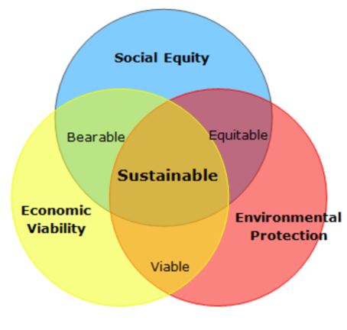
Figure 2: Three Pillars of Sustainability
(Source: Purvis et al., 2019)

Additionally, economic viability has been increased by caring for Cotswolds visitors by providing a scheme, which has been a key driver in attracting visitors. The Cotswolds Conservation Board has planned to arrange social well-being program to enhance social equity. Cotswold District Council (2022) reported that Cotswolds has aimed to combat loneliness and offer services to improve health and well-being to support independent living. Moreover, Cotswolds has paid attention to inspecting the sites, determining the extension of contamination, and assessing whether the site is deemed a particular site with the collaboration of the 'Environment and Enforcing Agency (Cotswold District Council, 2022). This has benefitted in protecting environmental assets.

Link principles of sustainability with sustainable tourism in the development management plan of Cotswolds
The sustainable development management plan should be such that it comprises the principle of environmental sustainability and social sustainability. In the view of Angelevska Najdeskaa and Rakicevik (2012), the principles of sustainability provide cultural development to be attuned to the cultural values of communities and economic development to deliver cost-effectiveness and effective resources to be adequately managed for future generations to reap benefits from its. Goodwin (2011), further reveals that the Forest of Bowland, an Area of Outstanding Natural Beauty (AONB), is globally important for heather moorland, rare birds, and blanket bog. AONB is acknowledged as one of the first protected regions in England to be awarded the European Charter for Sustainable Tourism in Protected Areas. Furthermore, the Charter approach ascertains that businesses, organisations, and local people are working collaboratively to protect areas besides increasing prospects for tourists to discover unique qualities.
As stated by Goodwin (2011), others have been following the lead in establishing partnerships with Green Eden Project, West Pennine Moors and Cotswolds AONB, and there has been awareness in Latvia and Spain.
As realised based on the reports of Cotswolds (2022), the destination welcomes almost 25 million visitors every year, which has a considerable impact on its landscape, communities and heritage. The main objective lies in encouraging visitors to show reverence for the landscape and adjacent communities and encourage participation in the "Caring for Cotswolds" payback scheme. The plan must include working with organisations and businesses to develop engaging novel experiences available around the year to boost the economy and advocate investments in infrastructure.

Outlining Practices based on regulations and organisations responsible for the Implementation
Following the case study of Cotswolds, it is one of the major tourist destinations for travellers in the UK. Apart from this, Cotswolds also organises some award-winning attractions and events (Cotswolds, 2020). For Cotswolds to secure the beauty of its rural countryside, local limestone, vibrant towns, heritage cities, and picturesque villages must account for the principles of sustainability discussed earlier. According to Edgell (2020), sustainable practices have been one of the crucial aspects of tourism in the current scenario. The Cotswolds must consider the Development of Tourism Act 1969 (OECD iLibrary, 2023). The Act will ensure that the Cotswolds encourage the provision and improvements of tourist amenities and facilities across Great Britain through their new destination management plan.
Under Cohen's theory of tourism development, it is evident that the Cotswolds to their major emphasise three major pillars of sustainability, promoting quality and respect for individual rights. In addition, it must also contribute towards economic development and growth as well as be committed to protecting the environment by reducing the risks as well as being able to measure the environmental impacts on companies' activities (Kariuki, 2021).
In order to achieve this, the Cotswolds must ensure that they collaborate with local volunteer groups, entrepreneurs, and local businesses to maintain consistency as mentioned earlier practices in future.

Determining the stages Cotswolds has been through using Butler’s life cycle model
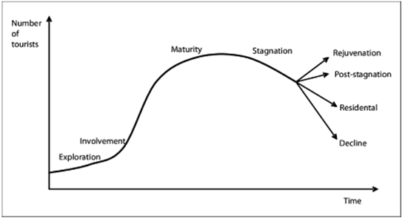
Figure 3: Butler’s life cycle model
(Source: Nordin, 2020)
In the opinion of Sahli (2020), Butler’s Tourism Area Life Cycle (TALC) happens to be a widely utilised model for studying the evaluation of a particular tourism destination. The model reveals that a tourism destination evolves through six main, predictable, and various stages: exploration, involvement, development, consolidation, stagnation and rejuvenation or decline.
The study of the reports of Cotswolds (2022) reveals that the chosen destination shows signs of involvement as the number of tourists visiting the region has been increasing. This is because, with every passing year, Cotswolds welcome about 16 million tourists to the destination, and tourism is worth over £1 billion to the Cotswolds economy. The development stage is also apparent as the destination has gained fame as a tourist attraction, and several best-known attractions are the Cotswold Wildlife Park, Cotswold Countryside and Cotswold Water Park that from the AONB area (Cotswolds, 2022). The assessment reveals that the chosen destination is presently in the rejuvenation stage based on Butler’s life cycle model as manmade attractions have also been gaining popularity, including 270 climbing parks, Wotton under the Edge and Heritage Centre (Cotswolds, 2023).

Doxey’s irridex model
The theoretical justification of Doxey’s irridex model lies in understanding the ways residents felt about sustainable tourism as it became a changing attitude towards tourism and tourists. As opined by Pavlic and Portolan (2015), the Doxey irridex model has comprised four stages and explains that Euphoria, the first stage, where several tourists are small, and the local community welcomes them grandly, while apathy depicts that number of tourists increases. Relationship with local communities has become formalised.

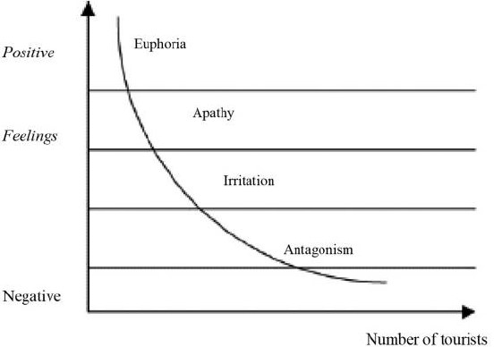
Figure 4: Doxey's irridex index model
(Source: Pavlic and Portolan, 2015)
Additionally, irritation has confronted that residents are concerned about the tourists, and last stage antagonism depicted that tourists are responsible for everything bad which has happened in the host community. In justifying the theoretical aspect of Doxey's irridex model, it has been evaluated that Cotswolds has framed a sustainable community strategy and offered a real and achievable direction to the local strategic partners (Cotswolds, 2017). This has emphasised strategic partners for enriching the economic development that significantly attracts visitors. Furthermore, it can be derived that Cotswolds belongs in the stage' irritation'. In order to achieve the 'Apathy' stage, Cotswolds needs to focus on developing brand awareness among customers to convey the role of the local community in sustainable tourism development.

Benefits and drawbacks of sustainable tourism and sustainable development in comparison to other successful Destinations
According to Young (2013), sustainable tourism is an effective way to create employment, strengthen the local economy and contribute to developing local infrastructure while conserving the natural environment, cultural assets, and traditions. Sustainable development, on the hand, can be accounted for development that ensures it meets the requirements of the present without compromising the ability of future generations to meet their own needs.
However, sustainable tourism is often associated with pollution, littering, waste and strain on natural resources due to poor management. A significant example of this can be witnessed in some of the UK's most polluted beaches destination of the UK such as St Mary's, Lyme Regis Church Cliff Beach and many more (Rathod, 2023). Sustainable development demands higher costs, a significant disadvantage for Cotswolds in their Plan 1 to Plan 2 with sustainable development plans or goals.
Lake District in England, for instance, is the perfect destination for green travel in the UK and shelters some UNESCO World Heritage sites. Cotswolds and Lake District are both accounted to be the UK's most treasured countryside (Olivers Travels, 2012). Unlike the Cotswolds, Lake District has a more comprehensive visit for stunning and sheltering outdoors and beautiful hidden views. On this account, there is a need for the Cotswolds to include more outdoor recreational activities such as trekking, bird watching and many more in this new destination management Plan 2. Here, Cotswolds can incorporate the Diamond Model of sustainable tourism development to ensure sustainable tourism and sustainable development in a new destination management plan. The following model will help Cotswolds in its Plan 2 with independent information that will support unpopular decisions of restricting the number of visitors in compliance with sustainable tourism development.

Recommendation for future development of Cotswolds
Cotswolds can implement the scheme "Ditch Single-use plastics" for its significant enhancement in their destination management plan two. This will help them avoid unnecessary plastic pollutants littering the local areas. It is also crucial for the Cotswolds to recognise their indigenous groups while offering them an opportunity to display their culture and traditions (Ivars-Baidal et al., 2021). This will offer more opportunities for tourists to visit the place while offering them a chance to improve their living standards in their destination management plan 2.

Conclusion
In accordance with the key discussion above as well as from the destination management plan 1 and 2 of Cotswolds, sustainability is the key element in the current scenario. On this, the incorporation of three core principles of sustainable tourism is accounted to be crucial for destinations such as the Cotswolds to secure their age of heritage while promoting new opportunities to locals through tourism. In this process, they must pose some major practices and regulations under the Development of Tourism Act 1969 to lead more successfully.

References
Angelevska Najdeskaa, K. and Rakicevik, G. (2012) Planning of Sustainable Tourism Development, CORE. Available at: https://core.ac.uk/reader/81182250 (Accessed: 09 June 2023).
Cotswold District Council (2022) Contaminated land, Cotswold District Council. Available at: https://www.cotswold.gov.uk/environment/noise-pests-pollution-and-air-quality/contaminated-land/ (Accessed: 09 June 2023).
Cotswold District Council (2022b) Support available in your community, Cotswold District Council. Available at: https://www.cotswold.gov.uk/council-tax-and-benefits/help-if-you-re-struggling-with-the-cost-of-living/support-available-in-your-community/ (Accessed: 09 June 2023).
Cotswolds (2017) Cotswold Sustainable Community Strategy 2008 - 2012. Available at: https://www.cotswold.gov.uk/media/hxip45sl/cotswold-sustainable-community-strategy.pdf (Accessed: 09 June 2023).
Cotswolds (2020) The official Cotswolds Tourist Information Site, Cotswolds. Available at: https://www.cotswolds.com/ (Accessed: 9 June 2023).
Cotswolds (2022) Cotswolds Tourism Destination Management Plan. Available at: https://www.cotswolds.com/dbimgs/Cotswolds%20Tourism%20-%20Draft%20Destination%20Management%20Plan%202022-25.pdf (Accessed: 09 June 2023).
Cotswolds (2022) Destination management plan for the Cotswolds. Available at: https://www.cotswolds.com/dbimgs/Destination%20Management%20Plan%20for%20Tourism%20Across%20the%20Cotswolds%20April%202014(1).pdf (Accessed: 09 June 2023).
Cotswolds (2023) Attractions in the Cotswolds, Cotswolds. Available at: https://www.cotswolds.com/things-to-do/attractions (Accessed: 09 June 2023).
Edgell, D.L. (2020) Managing sustainable tourism: a legacy for the future . Third edition. London :, Routledge Taylor & Francis Group.
Goodwin, H., (2011). Taking responsibility for tourism (pp. 1-256). Woodeaton: Goodfellow Publishers Limited.
Ivars-Baidal, J.A., Vera-Rebollo, J.F., Perles-Ribes, J., Femenia-Serra, F. and Celdrán-Bernabeu, M.A. (2021). Sustainable tourism indicators: what’s new within the smart city/destination approach?. Journal of Sustainable Tourism, pp.1-24.
Kariuki, R. (2021). Effect of Regulation on Curbing Over tourism in East Africa. A Critical Literature Review. International Journal of Modern Hospitality and Tourism, 1(1), pp.44-57.
Nordin, S. (2020) Butler’s Life Cycle Model | Download Scientific diagram - researchgate. Available at: https://www.researchgate.net/figure/BUTLERS-LIFE-CYCLE-MODEL_fig1_265456483 (Accessed: 09 June 2023).
OECD iLibrary (2023) Home, OECD Tourism Trends and Policies 2020 | OECD iLibrary. Available at: https://www.oecd-ilibrary.org/sites/2ac0c5e9-en/index.html?itemId=%2Fcontent%2Fcomponent%2F2ac0c5e9-en (Accessed: 9 June 2023).
Olivers Travels (2012) Cotswolds vs Lake District: Areas of outstanding natural beauty, Olivers Travels. Available at: https://www.oliverstravels.com/blog/cotswolds-vs-lake-district-areas-of-outstanding-beauty/ (Accessed: 9 June 2023).
Pavlic, I. and Portolan, A. (2015) (PDF) irritation index, tourism - researchgate. Available at: https://www.researchgate.net/publication/302424839_Irritation_index_tourism (Accessed: 09 June 2023).
Purvis, B., Mao, Y. and Robinson, D., (2019). Three pillars of sustainability: in search of conceptual origins. Sustainability science, 14, pp.681-695.
Rathod, S. (2023) You may want to skip these 22 most polluted beaches in the UK!, Curly Tales. Available at: https://curlytales.com/you-may-want-to-skip-these-22-most-polluted-beaches-in-the-uk/ (Accessed: 9 June 2023).
Sahli, E. (2020) Tourism Destination Development - Researchgate. Available at: https://www.researchgate.net/profile/Elyes-Sahli/publication/341804244_Tourism_Destination_Development_An_Application_of_Butler’s_1980_Tourism_Area_Life_Cycle_Model_to_Hammamet_Tunisia/links/5ed56656458515294527db81/Tourism-Destination-Development-An-Application-of-Butlers-1980-Tourism-Area-Life-Cycle-Model-to-Hammamet-Tunisia.pdf?origin=publication_detail (Accessed: 09 June 2023).
Sobre (2018) Principles of Sustainable Tourism and Sustainable Development Goals, Turismo Sustentável. Available at: https://alexandregarrido.blog/2018/09/29/principles-of-sustainable-tourism-and-sustainable-development-goals/ (Accessed: 09 June 2023).
Streimikiene, D., Svagzdiene, B., Jasinskas, E. and Simanavicius, A., (2021). Sustainable tourism development and competitiveness: The systematic literature review. Sustainable development, 29(1), pp.259-271.
Young, S.T. (2013) Sustainability : essentials for business . Los Angeles:, SAGE.

