ASSIGNMENT 2 PRACTICAL – LEVELLING COMPUTATION
ACBA4002
DIGITAL SURVEYING

Contents Page
- Introduction …………………………………………………….……………………………………………………..3
- General Overview of Levelling …………………………………………………….…………………………..4
2.1 Levelling Terms …………………………………………………………………………….……………………………….4
- Levelling Equipment ………………………………………………………………………………………………..5
- Levelling Procedure & Booking ………………………………………………………………………………..6
4.1 Levelling Procedure ……………………………………………………………………………………………………….6
4.2 Level Booking ………………………………………………………………………………………………………………..7
- Computation & Level Plotting ………………………………………………………………………………….8
5.1 Data Gathered ……………………………………………………………………………………………………………….9
5.2 Volume of Earthworks ……………………………………………………………………………………………….10-11
- Conclusion ……………………………………………………………………………………………………………..12
References …………………………………………………………………………………………………………………..13

- INTRODUCTION
University of Wales Trinity Saint David Swansea was commissioned by Swansea City Council to undertake a levelling survey along the new proposed route connecting Llandarcy and Neath together.
This report outlines a brief description about level surveying, the equipment used to complete this, the procedure followed, the data gathered and an overall conclusion.

- General Overview of Levelling Surveying
Levelling is a process of measuring the height of specified points on, above or below the surface. This is used in surveying as it establishes the elevation of a point relative to another known point.
Levelling surveys are beneficial for building and infrastructure projects with the construction of buildings to ensure flat gradients are made for foundations and the design of highways and railways. (The Purpose and Importance of Levelling in Surveying, 2021)
Levelling can also be used to calculate the amount of earthworks which need to be undertaken and is used for drainage design to ensure the free flow of water and for contouring site layout plans.
2.1 Levelling Terms
There are various terms associated to levelling and the main ones are as follows: -
- Datum – This is the definition of a set reference point where the other levels of other points are fixed.
- Reduced Level – This is the depth between the level point and datum or the mean sea level.
- Benchmark – A marked point where the elevation either above or below the datum is known.
- Height of Instrument – This is the elevation of the line of sight with respect to an assumed datum.
- Back Sight – This is the initial reading where a sight is recorded on the level staff of a known elevation to determine the elevation of plane of collimation.
- Intermediate Sight – This is sight which is taken in-between the first and last point. These get subtracted from the plane of collimation which allows you to determine the reduced level of different points.
- Fore Sight – This is the final reading recorded from the level staff.
- Change Point - This is the point where both the back sight and fore sight can be taken.
(Mudavath, 2021)

- Levelling Equipment
A levelling survey must be carried out precisely with very little risk of errors. To carry out this survey, the following high quality levelling equipment used can be seen in Table 1 below:-
Image | Equipment Type | Description
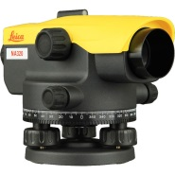 | Automatic Level | An automatic level was used as it automatically sets the horizontal adjustment of the line of sight. This makes it much more efficient and time saving to set up.
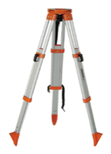 | Tripod | A tripod acts as a stand to support the levelling instrument. You can either get them with adjustable or fixed legs.
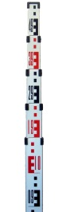 | Levelling Staff | The levelling staff/rod is a graduated aluminium rod which was held vertically to determine the height of points. This can be completed by viewing the figure through the telescope of the level.
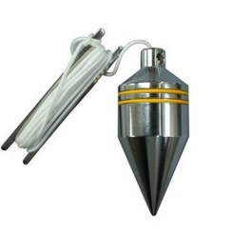 | Plumb Bob | A plumb bob is a pointed weight that is suspended from a string and was used to ensure the instrument was accurately set up over a fixed datum point by creating a vertical reference line.
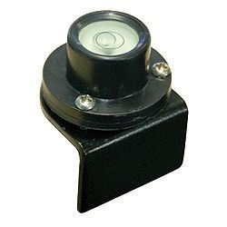 | Staff Bubble | A staff bubble is typically a small circular bubble on a plate which was screwed onto the staff and this ensured that the levelling staff was held vertically and reduces the risk of errors.
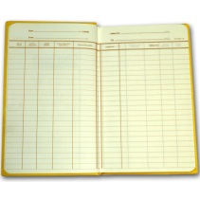 | Field Book | A field book is used to record all important measurements such as the back sight, fore sight etc.
Table 1 – List of Levelling Equipment
(Use of survweying equipment, 2021)

- Levelling Procedure & Booking

4.1 Levelling Procedure
Firstly, a levelling traverse was completed and this includes a series of measurements which were taken on the road and can either finish at the same or at two different known points. This is completed to ensure that the difference in levels of the points can be determined.
The levelling traverse procedure completed on site is the same one that follows below however, the one stated next is written to follow with figure 1.
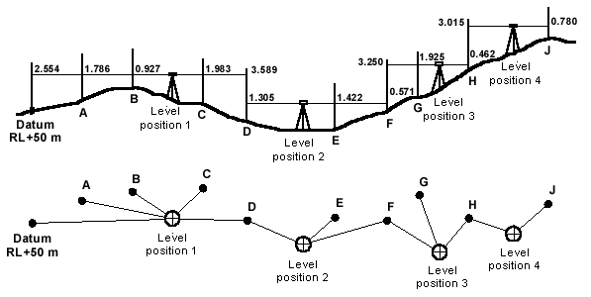

Figure 1 – Levelling Traverse Example
- The tripod is set up at Level Position 1 and the legs adjusted to level the top of the tripod. This is done by eye to start off;
- Place and secure the automatic level to the top of the tripod and use the foot screws to level the instrument. This must be completed to ensure maximum accuracy of the point elevations;
- Next, the staff bubble must be set to the staff to ensure when readings are taken the staff is level;
- Get a colleague/student to hold the staff on the Datum RL +50m and take the reading, as this is the first reading which is taken when the instrument has been set up, this is known as the back sight;
- Move the staff to point A and take a reading, as this is the second reading which is taken this is also known as the intermediate sight;
- Move the staff to point B and take a reading; this is also an intermediate sight.
- Move the staff to point C and take a reading; this will be another intermediate sight.
- Move the staff to point D and take a reading; this will be a fore sight because it is a change point as the tripod and level is moved and set up in Level Position 2. Place a change plate on the ground at point D to maintain the same level;
- Measure and record the distance between the stations in the field book;
- With the staff being kept at point D, take another reading at D; this is the back sight;
- Move the staff to point E and take a reading; this is the intermediate sight;
- Move the staff to point E and take a reading; this will be another intermediate sight;
- Move the staff to point F and take a reading; this is the fore sight as the tripod and level will then be moved to Level Position 3. Place a change plate on the ground at point F to maintain the same level;
- Repeat steps 9-13 with the remaining points (F, G, H and J) and level positions. It is important that the last point taken is a known point to ensure that this levelling traverse is accurate.
(How to do a Levelling Traverse. The Levelling Procedure, 2021)

4.2 Level Booking
All the levels taken in 4.1 were recorded in a field book; levelling sheets can be used too, and written in the appropriate columns. These are typically labelled as: Back Sight (BS), Intermediate Sight (IFS), Fore Sight (FS), Reduced Level (R.L) and the last column allowing for remarks.
These books/sheets must be securely kept and stored, usually in fire-proof storage areas, with clear numbering and are indexed within a register. Other important may be recorded such as site conditions, weather, dates etc.
The way the data is entered into the table is as follow: -
- The first known point is entered into the back sight column with sufficient information in the remarks column which helps identifying which point it is;
- Enter the point’s reduced level from the site register;
- Enter all the intermediate points taken in the IFS column;
- Enter all the fore sight points taken in the FS column;
- When the equipment is moved and re set up, enter that point taken on the change plate in the BS column which is on the same row as where the last fore sight point is;
- Repeat steps 2-5 until all data is recorded.
(Levelling Gerneral Priciples, 2021)

- Computation & Level Plotting
To calculate the levelling computation, two methods can be used:
- Rise and Fall Method
- Height of Collimation/Height of Instrument Method
The rise and fall method uses the data from the back sights, intermediate sights, foresights and benchmarks to calculate the difference in elevation between the points; these are added to the table as new columns. To determine the rise or fall the following equations are used: BS – IFS or IFS – FS or BS – FS. If the equation results in a positive answer then it is entered in the rise column and if the answer results in a negative answer it is entered in the fall column. This information is then used to determine the new R.L by using either equation depending if there is a negative or positive answer: R.L – Fall = New R.L or R.L + Rise = New R.L.
(Rise and Fall Method | Numericals of Rise and Fall Method, 2021)
The height of collimation/heights of instrument method uses the height of the horizontal plane when looking through the telescope on the level. This height is calculated by using this equation: R.L. of Benchmark + BS at Benchmark. To use this to work out the R.L, subtract the IS and FS from the height to get the R.R of the intermediate stations and change points.
(cy, 2021)

5.1 Data Gathered
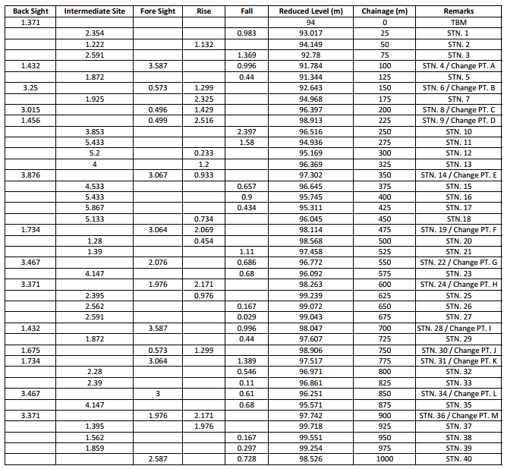
The rise and fall method was used to calculate the computation in this survey and the results can be seen in Table 2.
Table 2 – Survey Data
Errors can easily occur when inputting data and completing simple equations, due to this, an arithmetic check has been completed to ensure maximum accuracy. This is completed by using the following equation:
ΣBS – ΣFS = Last R.L – First R.L
34.651 – 30.125 = 98.526 – 94.000
= 4.526
5.2 Volume of Earthworks
The data collected from the survey is plotted in graph 1 and the volume of earthworks can be approximately estimated from this. This is done by joining the first and last point, any volume below the line represents how much needs filling and anything above the line represents how much needs cutting; this is shown in graph 2.
Graph 1 – Reduced Level vs. Chainage
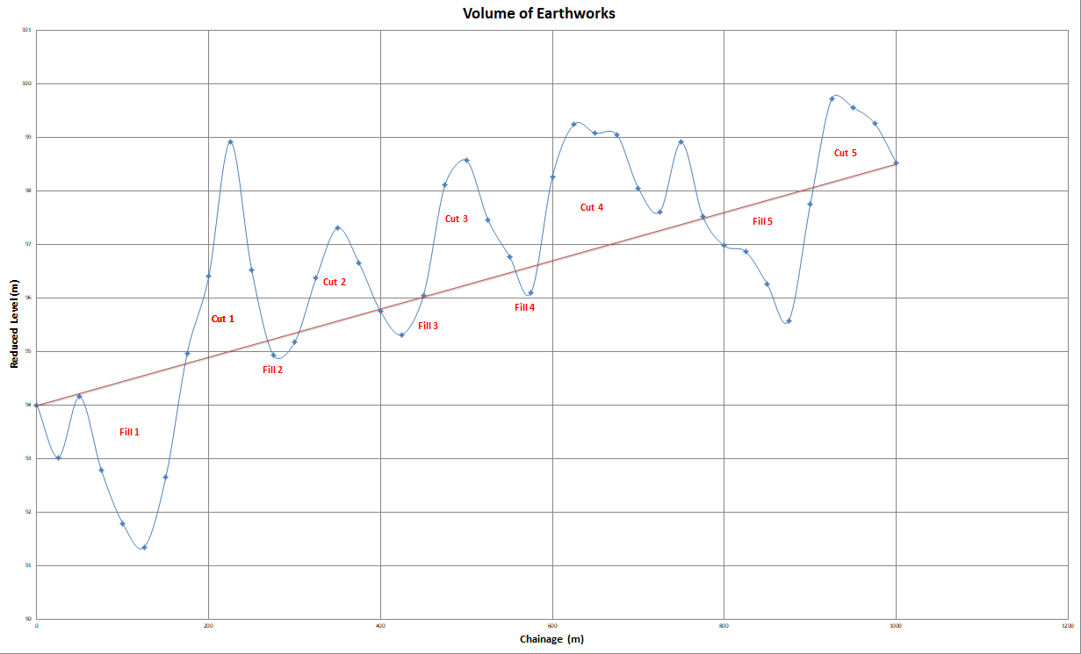Graph 2 – Volume of Earthworks

Using graph 2, the earthwork calculations can made to determine the estimated cut and fill volumes. These can be seen in Tables 3 and 4.
Volume of Earthworks
Cut | Unit | Number | Volume (m³)
1 | 200 | 1 | 200
2 | 200 | 0.5 | 100
3 | 200 | 0.75 | 150
4 | 200 | 1.75 | 350
5 | 200 | 0.5 | 100
Total Volume |  |  | 900
Volume of Earthworks
Fill | Unit | Number | Volume (m³)
1 | 200 | 1.75 | 350
2 | 200 | 0.1 | 20
3 | 200 | 0.15 | 30
4 | 200 | 0.1 | 20
5 | 200 | 0.75 | 150
Total Volume |  |  | 570
Table 3 – Volume of Earthworks – Cutting

Table 3 – Volume of Earthworks – Filling

- Conclusion
To conclude this report, the levelling survey was undertaken at the new proposed route of the connection of Llandarcy and Neath. The survey equipment used was at a high standard to be able to achieve the accurate data needed for works to commence. All data was entered into the correct table under the appropriate columns and was double checked by using the arithmetic method.
By using high quality equipment, this ensured that the levels of the road were precise to ensure that the estimated amount of earthworks needed to ensure that the gradient of the path meets all legislation and regulations.
It was calculated, by subtracting the fill from the cut, that the total estimated amount of earthworks which needs to be completed for this development resulted in 330m³. This does mean that no other material needs to be ordered because the subtraction of the fill and cut resulted in a positive answer. If a negative answer was to be calculated, this means there is not a sufficient amount of material in place.

References
LSSLTD.NET. 2021. The Purpose and Importance of Levelling in Surveying. [online] Available at: <https://www.lssltd.net/the-purpose-and-importance-of-levelling-and-the-automatic-dumpy-level/>
Mudavath, V., 2021. Levelling | Principle, Purpose & Terms used levelling. [online] we civil engineers. Available at: <https://wecivilengineers.wordpress.com/2018/09/11/levelling/>
Level Image - Surveyequipment.com. 2021. [online] Available at: <https://surveyequipment.com/media/catalog/product/cache/1/image/9df78eab33525d08d6e5fb8d27136e95/l/e/leica-na320-level.jpg?1609857063>
Tripod Image - Johnsonlevel.com. 2021. What is a Tripod? How do Tripods for Laser Levels Work? | How To Use Laser Level with Tripod | Laser Levels | Johnson Level & Tool Mfg Company. [online] Available at: <https://www.johnsonlevel.com/News/WhatisaTripodHowdoTripods>
Levelling Staff Image - Smith Surveying Equipment. 2021. DATUM DMS5 5 METRE 5 SECTION ALUMINIUM LEVELLING STAFF | Smith Surveying Equipment. [online] Available at: <https://smithsurveyingequipment.co.uk/shop/surveying-equipment/lasers/laser-accessories/datum-dms5-5-metre-5-section-aluminium-levelling-staff/>
Plumb bob Image - indiamart.com. 2021. Plumb Bob. [online] Available at: <https://www.indiamart.com/proddetail/plumb-bob-14799455597.html>
Staff Bubble Image - Bubble, S., 2021. Screw on Staff Bubble. [online] Surveyorsequipment.co.uk. Available at: <https://www.surveyorsequipment.co.uk/staff-bubble.html>
Field Book Image - https://survey.crkennedy.com.au/, C., 2021. Chartwell 2426 Level without R&F Field Book. [online] Survey.crkennedy.com.au. Available at: <https://survey.crkennedy.com.au/products/92426/chartwell-2426-level-without-r-f-field-book>
Boeingconsult.com. 2021. Use of survweying equipment. [online] Available at: <https://www.boeingconsult.com/tafe/ss&so/survey1/Module4/equipment-s1.htm>
LSSLTD.NET. 2021. How to do a Levelling Traverse. The Levelling Procedure, [online] Available at: <https://www.lssltd.net/how-to-carry-out-a-levelling-traverse-or-run/>
Boeingconsult.com. 2021. Levelling Gerneral Priciples. [online] Available at: <https://www.boeingconsult.com/tafe/ss&so/survey1/level/notes-sur1.htm>
Dream Civil. 2021. Rise And Fall Method | Numericals Of Rise And Fall Method. [online] Available at: <https://dreamcivil.com/rise-and-fall-method/#:~:text=Rise%20and%20Fall%20Method%20is,instrument%20is%20called%20back%20sights.>
cy, t., 2021. Methods of Levelling: 1. Height of Collimation Method 2. Rise and Fall Method. [online] Academia.edu. Available at: <https://www.academia.edu/34982867/Methods_of_Levelling_1_Height_of_Collimation_Method_2_Rise_and_Fall_Method>

