Student Name: Shaera Miah
Student number: 1711954
Lecturer: Domnan Miri
Module Title: Developing Relationships and Workplace Achievement

Content

Introduction..............................................………………………………………………….3
Task 1

Motives and motivation…………………………………………………………………………….3

Performance……………………………………………………………………………………….…….4

Outcomes.………………………………………………………………………………………………...4
Task 2

Assess the benefits of Motives and motivation of NHS and individuals………5

Performances of NHS and individuals…………………………………………………………5

Outcomes of NHS and individuals………………………………………………………………6
Task 3

Develop a plan (continuous professional development plan) CPD using the three vehicles (motives & motivation, performance and outcomes) ...........7 - 9

appendix 1 and 2....................................................................................7 - 9

References.......................................................................................................11

Introduction
This report will be about developing relationships in the workplace of NHS and evolving strategies of how tasks can be achieved within the workplace. I will be included the engagement of the employee of the workplace.
Task 1
Motivation
Motivation is the psychological construct used to describe the mechanism by which individuals and groups choose particular behaviour and persist with it (Mclnerney, 2019). It is a process that initiates, guides and maintains goal-orientated behaviours. There are two types of motivation. For example, intrinsic motivation – where an individual will engage in a behaviour because it is personally rewarding. For example, children love to play and learn. They are active, curious and eager to engage their environments and this way they become intrinsically motivated (Deci and Ryan, 2010). This diverges from outward inspiration. Outward inspiration is when drives practices that are related with outside remunerations, for example, acclaim, higher pay or popularity and basic to maintain a strategic distance from results. Managers can utilize this to impact representatives to adapt new abilities or a subject that they may fundamentally have no enthusiasm for (Longe, 2016). A few specialists have claimed that outer inspirations go about as significant criticism, boosting certainty, upgrading natural inspiration and improving execution.
The reputation of the NHS trust ensures that the highest standard of care and service users achieve the best care, also ensuring that the organization is conducted in a professional and proper manner. the NHS is committed to working jointly with local authorities and a wide range of other private, public and third sector organisations at national and local level to offer and deliver improvements in health and wellbeing. NHS state that good morale and motivation are essential for both for a healthy workforce and for effective implementation of the Government`s plans. Employee engagement is a workplace approach resulting in the right condition for all members of an organisation to give their best and committed to their goals and values motivated to organisational success which increases individual’s performance, productivity and wellbeing (Red Letter Day, 2018).
Individual motives
A successful business make sure that their staff are highly motivated, fully engaged and are always up to speed with the aims, plans, objectives and latest indicatives of the organisations. This involves effective, regular internal communication among other staffs, via a range of understood and adopted paths. Also known as employee engagement which is important because it improves productivity and efficiency and retains customers at a higher rate (Bridger, 2014). A motivated individual are most likely to stay with the organisation A motivated and supported staff who understands where the organisation is heading, would respect their managers and executive team. A motivated individual who also see opportunity for career advancement and who enjoy their work environment, are more likely to stay with the organisation and would participate positively for the future success of company. So hence employees are motivated by making them feel that they are important, appreciate their hard work, reward them, improve the staff skills by rewarding their appreciation and free/reduced health benefit. As well as employees feel motivated by recognition, money, ambition, achievement, goals, flexibility and family.
According to mayo theory, communication is an extremely important factor in motivating employees. So, this may be through one to one discussions with managers, through the company internet or newsletter or through more formal structures such as appraisals. Mayo believed that motivation was improved through making employees feel important and giving them a level of freedom to make choices and recognising their social needs.
Performance of NHS
Another tool that is used within the workplace is performance. Performance management is a whole work system that beings when a job is defined. According to CIPD (2019), performance management is an analytical process that enable the management of an organisation`s performance to achieve one or more pre-selected goals. It is the process of creating a work environment or setting in which employees are enabled to perform to the best of their abilities and contribute positively to the business aims and objectives. It also improves employee’s development and performance in order to build competencies with in the environment and ultimately drive better business result.
Demand for the hospital service continue to increase, with a significant spike related to winter. In quarter 4 their where just under 1.2 million emergency admissions via E&A (type 1) 7.0% more than the same period last year. absorbing from last winter, workers focused on improving facility to ensure patients received high quality care.
The Performance Department of the NHS Foundation Trust ensures that the Trust satisfies national rules and targets set by the part of prosperity. As indicated by Brain Duerden in NHS, making disease counteractive action and control happen viably requires the board duty and moral obligation. The board at all levels needs consistence confirmation dependent on examination information, joined with evaluation result for hand cleanliness, clinical systems, anti-infection recommending etc. Personal responsibility needs to be imbedded in the job description and job plans for all clinicians coupled with compulsory training for all staff and inclusion of infection prevention and control in CPD for all clinic staff. Where maintenance of these standards should be part of appraisal and individual performance reviews for staffs and backed up, were essential by disciplinary measure. Therefore, reward strategy is to provide the motivation towards others and add value to the organization goal.
Outcomes of NHS
Another tool is outcome are the framework of NHS which they drive transparency and equality improvement and outcome measurement through the NHS. (Portsmouth hospital 2019) hospital and outcome measurement through the NHS. A huge collection of information is accessible on social insurance data sources and consumptions; far less is thought about the results that the assets and exercises produce. However, realizing the results accomplished by wellbeing administrations is basic to having the option to accomplish the best advantage, the best patient consideration, from the assets utilized. The adequacy, productivity and responsibility of the NHS all rely upon knowing the results it is accomplishing.
University of Leicester defined critical evaluation as an individual giving their verdict on a piece of statement showing to what extent the information is true or to what extent they agree with the finding. Then conclude, basing your decision on what you judge to be the most important factors and justify how you have made your choice.

Task 2
Assess the motivation of NHS
As a business of the association, for example, NHS it requires increasingly gainful a gigantic determination of aptitudes and experience from its worker base and there is a mind-boggling scope of profession ways accessible with in the NHS. Advantages are great and there are awesome open doors for development and movement. In our NHS workers are outlined by the evaluation focus, were they are surveyed in different manner. (appraisal focus HQ 2019).
Here are the activities that will be anticipated for employees at the NHS assessment centre:
. skills (Numerical reasoning, verbal reasoning, logical reasoning etc.)
. group exercise
. role play
. E-Tray training
. presentation
. formal panel interview

Assessment of the individual and their performance in the NHS
The individual will be assessed by E-learning technology which is provided in the form of content in the form of training courses or bite- sized learning material. The drawback are the needs for learners to be self-motivated. Reward management is another aspect in organisation as rewarding individual by policies that motivate and helps productivity, as being rewarded brings about motivation and engagement strategies. It is about recognition is the way of rewarding individual that makes them feel good. Another system through which an individual is assessed is the 360-feedback process – this is the method of performance appraisal which gathers feedback from a number of sources, including peers, direct reports, more senior colleagues and customers (CIPD, 2018). Brett and Atwater (2001) defined that the 360-degree feedback is a technique in which subordinates, peers and bosses provide anonymous feedback. This variety of feedback can offer line managers a wide-ranging perspectives and help to make performance management a more objective and fair process. 360-degree feedback also known as multi-source feedback, is a process in which someone’s performance is assessed, and feedback is given by everyone in numbers.
Advantages of 360-degree:
Input is capacity to expand representative's mindfulness which gives a thought of a worker's quality and shortcomings. As repudiated by administrative audit, this gets criticism from various edges, for example, friends, and direct report and a self-evaluation by the individual being assessed. For instance, on the off chance that somebody is incredible at dealing with their group, however working together less with senior executive, this has demonstrated out by the criticism they get from the gatherings. (Qualtrics xm 2019).
Disadvantages of 360-degree:
On the off chance that you are approached to communicate somebody on who you truly don't have the foggiest idea, with the vast majority's inclinations is to be sure about that individual yet not in reality unmistakable about it, so this can preference your information and give you a deceptive picture of somebody. Subsequently a lot of administrative oversight can forestall honest criticism as this can make individuals feel less positive about giving honest input regardless of whether their names and job may be covered up and there may be another obvious sign as who gave the criticism. By and by they believe they planned something incorrectly for their associate by just giving criticism by any means (Qualtric xm 2019).
Through performance management individuals are given agreement is to insure were they might be lacking, were they can measure performance by setting targets and bringing some personalise agreement then they can measure or provide or evaluate their performance.
The formal performance measurement system have become an important feature during most of the public sector. The NHS is no expectation and the government is developing and expanding on existing performance data to produce new national stucture which is to be at the heart of the performance-led NHS (Goddard., et al). Clear review delivers on that need by allowing managers or employees to set easily adjustable goals adapting lengths, which can be supported upwards to organisation goals. (clear review 2019)
Benefits of NHS’s motivation of individual
Advantages of working win the NHS is that wherever you join from, employees will be committed to providing the best care and treatment to patients as they will be a part of the most competitive and flexible benefits packages offered by their employer anywhere in the UK. According to Singh (2007) recruitments and selection functions of HRM can provide equal opportunities to when candidate for job vacancies. Equal employment opportunity means providing all participants and employees equal treatment regardless pf their race, colour, sex, religion, national, origin, age or disability. This helps the company understand the different needs off their patients and provide the best possible service. So, anyone who join the NHS is guaranteed a salary that meets with their ability and responsibilities and given every opportunity to increase it through training and progress. On top of this employee will receive many range of other benefits including complemented holiday entitlement of 27 days per year, plus eight general and public holidays, rising to 33 days after 10 years’ service. Other benefits of working in the NHS include training, occupational health service, automatic member-ship of the NHS pension scheme and study leave for sponsored course. (health careers 2019).
Atkinson and Lucas (2011) say that the NHS has adopted a range of HR practices as a means to enhance organisational performance. Policies of department of health, include flexible working which have been promoted in the NHS in an attempt to improve outcomes such as recruitment, retention and employee.

Task 3 professional development plan
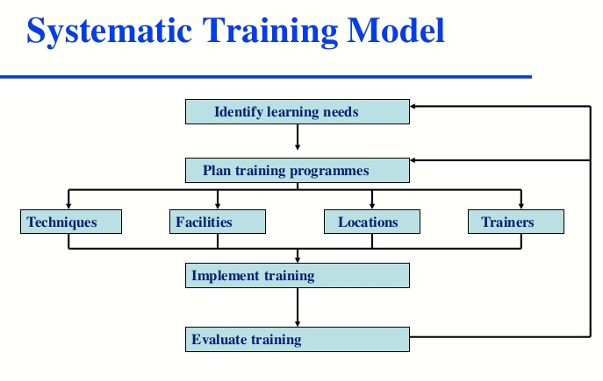

The orderly preparing model backings individual to recognize preparing need and choose what kind of preparing is required to fulfill these necessities. This strategy describes the responsibilities of individual staff and managers in performing key parts of the training cycle and is planned to manage all people in gathering their learning and improvement of requirements and duties. Training tools help training teams demonstrate how they add value and provide cost effective training to their organization. Operational performance, NHS provider vacancies, Operational performance overview , Agency ceiling performance, Accident and emergency, Non-pay cost pressures, Diagnostic waiting times, Efficiency savings, Elective waiting times, Implied provider productivity, Cancer waiting times , Capital expenditure, Ambulance response times, Q4 financial performance overview by integrated care system, Infection control, Year-end financial position, Mental health (1), Financial performance by provider, Mental health, Operational performance by provider, Winter 2018/19, Vacancy position by sector and region and Organisation splits to calculate ICS financial performance(NHS Improvements 2019).
Systematic training process ensures that training begins and ends with the company’s goal. Such as E-learning technology provides content in the form of training courses or bite-sized learning material. The NHS e-learning websites brings together the various national tools and resources to support e-learning in the NHS.
A proposed instrument for the assessment for job satisfaction: the psych Argos introduced new models of beneficial approach to the care of the mentally ill, that required expansion of the existing roles and development of the roles of the health care staff. Therefore, the efficient management of the healthcare workforce in Greek mental facilities was identified as a primary factor of the successful implementation of the program. Primary objective of this study was the development of a research framework for the assessment of job satisfaction in Greek mental health hospitals.
Through workplace relations, organisations create positive and profitable teamwork among and between employees and managers. Laws and policies set the standard regarding how management and employees must treat each other in the workplace. Excellent workplace relations create cooperation that gives an organisation a competitive edge. Workplace relations improve communication – employees involved in establishing company goals can feel they have more stake in the organisation results.
• ensure that unfairness does not influence managerial decisions including recruitment and promotion or access to learning and development
• protect the operation of the Trust’s services
• ensure that issues relating to personal relationships at work are managed in a way that is as unremarkable as possible to the private lives of those involved
• prevent harassment at work (in particular stemming from the end of a relationship)
• ensure that all employees feel confident of fair and consistent treatment
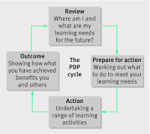
• protect the health, safety and welfare at work of employees
A self-improvement plan gives a structure that you will distinguish the territories of their qualities and shortcomings and concoct a guide that will redress and enhance their current aptitudes and abilities. At the point when an individual is making their self-improvement plan, it can furnish them with that time for self-reflection.31 Aug 2015. Here is the self-awareness plan beneath. Structure: your objectives ought to be explicit, measurable, reachable, pertinent, and Using a self-awareness plan empowers you to: Consider your objectives and how you need to accomplish them. You set out down to earth activities and time periods dependent on a SMART time-sensitive. A self-awareness plan (PDP) is an activity plan that encourages an individual to get composed, distinguishes learning and improvement need to enable them to carry out their responsibility better or help in their vocation, and after that tracks advance.
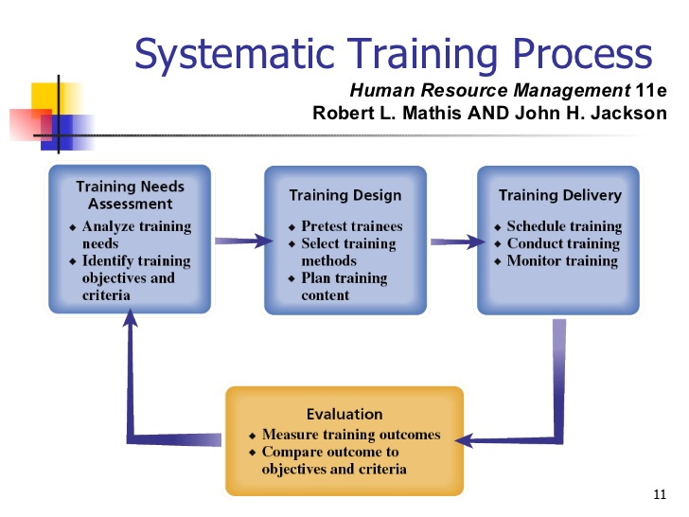
I suggest that it would be better if I use this training system process to motivate people and implement by rewarding and recognition and success factors for successful implementation of just in time training, to evaluate their task by assessing where you are. The justification for training to learn more and get better at what you are doing.
- To be able to do your job according to policies and procedures
- to able to complete and understand organizational target goals
- to handle task
- to perform better at job
Just in time training is another way of assessing the performance of the individual where it provides a learning solution when it actually needed rather then on a different basis. It can be automated, such as web based or having coaches on standby for needs it has a couple of main advantages it eliminates the need for refresher training due to the loss of the newly acquired skills and knowledge if they are not put to use when the learners return to their job. It allows the learners to receive training when they needed it not weeks or months later
In conclusion, using the three major tools is very essential in the workplace and have a big influence on employees’ individuality and how they perform in the workplace. It created an open and honest environment where employees feel like they are being listened to and contribute to the aim and objectives of the company. Additionally, the systematic training process can help employers guide their employees improve their performance and work to the best of their ability. By doing this, employees can work together and build their self-belief to keep learning as they confront greater challenges.

References
Assessment Centre HQ. (n.d.). NHS Assessment Centre 2019 Success Guide. [online] Available at: https://www.assessmentcentrehq.com/nhs-assessment-centre/ [Accessed 28 Jul. 2019].
Atkinson, C. and Hall, L. (2011). Flexible working and happiness in the NHS. Employee Relations, 33(2), pp.88-105.
Benabou, R. and Tirole, J. (2003). Intrinsic and Extrinsic Motivation. Review of Economic Studies, 70(3), pp.489-520.
Brett, J. and Atwater, L. (2001). 360° feedback: Accuracy, reactions, and perceptions of usefulness. Journal of Applied Psychology, 86(5), pp.930-942.
CIPD. (2018). Performance Management | Factsheets | CIPD. [online] Available at: https://www.cipd.co.uk/knowledge/fundamentals/people/performance/factsheet [Accessed 25 Jul. 2019].
CIPD. (2018). 360 Degree Feedback | Factsheets | CIPD. [online] Available at: https://www.cipd.co.uk/knowledge/fundamentals/people/performance/feedback-factsheet [Accessed 26 Jul. 2019].
Chauhan, D. and Sussex, J. (2008). NHS Outcomes, Performance and Productivity. [online] Ohe.org. Available at: https://www.ohe.org/publications/nhs-outcomes-performance-and-productivity [Accessed 4 Aug. 2019].
Goddard, M., Mannion, R. and Smith, P. (1999). Assessing the performance of NHS Hospital Trusts: the role of ‘hard’ and ‘soft’ information. Health Policy, [online] 48(2), pp.119-134. Available at: https://www.sciencedirect.com/science/article/abs/pii/S0168851099000354 [Accessed 4 Aug. 2019].
Kingsfund.org.uk. (2019). Morale and motivation in the NHS. [online] Available at: https://www.kingsfund.org.uk/sites/default/files/field/field_publication_file/counting-smiles-morale-motivation-nhs-belinda-finlayson-kings-fund-1-march-2002.pdf [Accessed 27 Jul. 2019].
Improvement.nhs.uk. (2019). [online] Available at: https://improvement.nhs.uk/documents/5404/Performance_of_the_NHS_provider_sector_for_the_quarter_4_1819.pdf [Accessed 3 Aug. 2019].
“Intrinsic and Extrinsic Motivation.” The Gale Encycolpedia of Psychology, edited by Jacqueline L. Longe, 3rd ed., vol. 1, Gale, 2016, pp 606-607. Gale Virtual Referencing Library. Accessed 30 July. 2019
Milton, J. (1997). Why assess? Psychoanalytical assessment in the NHS. Psychoanalytic Psychotherapy, 11(1), pp.47-58.
Singh, L. (2007). Human Resource Management, Gaining a Competitive Advantage. Lalita Singh.
Triad.uk.com. (2019). Creative Services | Triad | Creative Digital Agency Northampton. [online] Available at: https://triad.uk.com/services/employee-engagement/?gclid=EAIaIQobChMI4o2n7o--4wIVBPlRCh2q4wuyEAAYAiAAEgI10fD_BwE [Accessed 2 Aug. 2019].

