

Assessment 1 – Reading Task Template
PART 1: Upload your photo of your A3 in-class notes here:
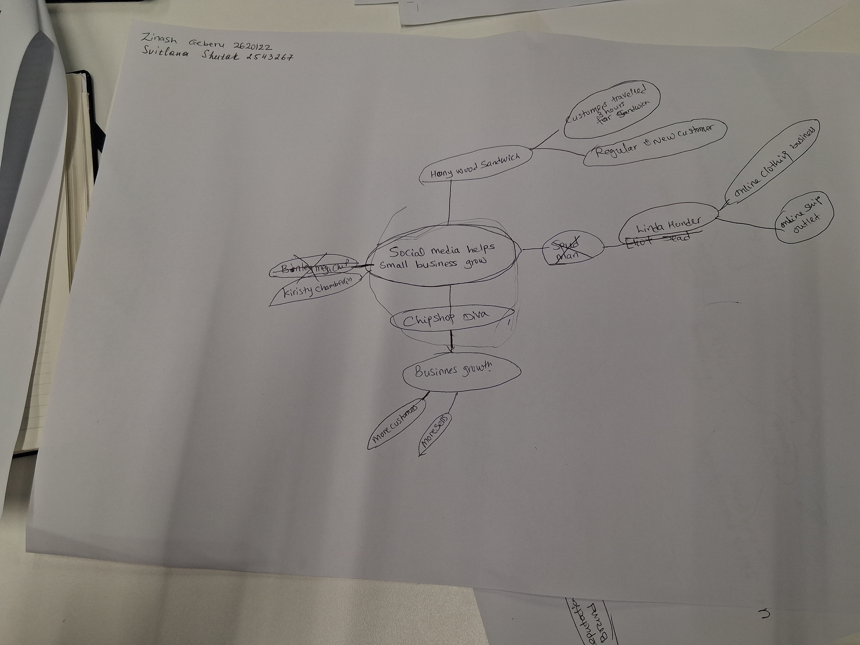

PART 2:
- Answer every question below in 1-3 full sentences.
- Use your own words. Do not use generative AI to answer these questions.
- Include a specific detail from the text when asked.
REMINDER
- The main idea is the overall message of the whole text.
- A key point helps to explain the main idea.
- A specific detail or example from the text shows that the key point is true.

- What is the main idea of the whole text?
Answer: -The main idea of the whole txt are how social media impacts local business allowing them to grow.

- What is one key point that supports the main idea, and which specific example from the text shows this?
Answer: -Social media helps small business reach the world for example Honywood chicken burger, Linda Loo Boutique an online clothing shop, A promo dress shop, all this business known by social media Tik Tok and Instagram.

- What is a different key point that supports the main idea, and which specific example from the text shows this?
Answer: - “Social media platform such as Tik Tok and Instagram have made it easier than ever” to get noticed by the world.

- Which part of the text do you think is most important, and why?
Answer:-I think the most important part of the text is the first paragraph on bold, because it helps the readers more interested to read the whole text or it will make the readers to decided.

Reflection:
- What did you find difficult in this task (including in-class components), and why was it difficult?
Answer: -From this task what I found difficult and confused me was to do a mind map reading. I understand the whole text but somehow, I was a bit struggling, so I must read it again. In class component sometimes I opened the noodles in different places, however I m learning and improving my academic skills.

- What helped you with this difficulty, and how did it help you?
Answer: -My teacher guides me and also, I’ve been practicing, more focus and reading and teamwork, asking questions and practice each time.

