Mikolaj Michalski (1900885)
1900885@student.uwtsd.ac.uk
Network operating systems and services
Assignment 1: Report worksheet 2

Table of Contents
1. Introduction 2
2. Worksheet 2 2
2.1. Pre-requisite tasks 2
2.2. Deploying active directory as a role or feature based on installation 3
2.3. Creating user account objects using ADU and computers snap-in console 7
2.4. Object attributes of interest 10
2.5. Adjoining the domain and testing user logins 12
2.6. Observational tasks 19
2.6.1. What is DNS? 19
2.6.2. Other critical role or feature based installations 19
2.6.3. Different levels of access in network user account groups 20
2.6.4. Microsoft’s recommendations on AGDLP and AGUDLP 20
3. References 21

Table of Figures
No table of figures entries found.

Introduction
This document covers the 2nd worksheet as part of assignment 1. This has both the practical and observational parts as well as the references at the end of the document to see the sources used.

Worksheet 2

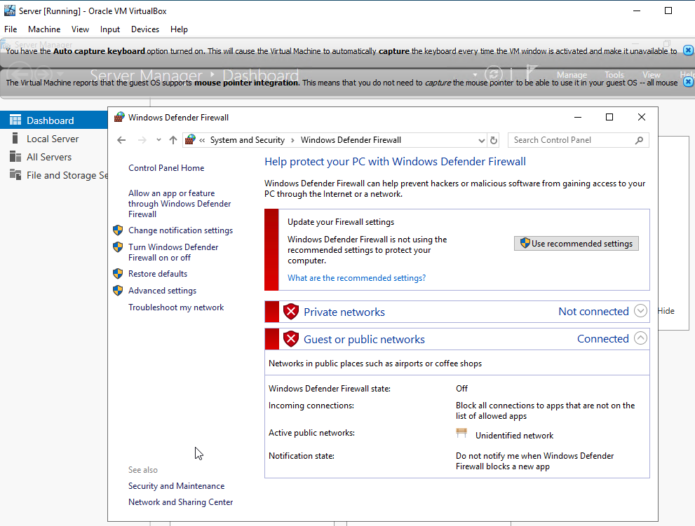
Pre-requisite tasks
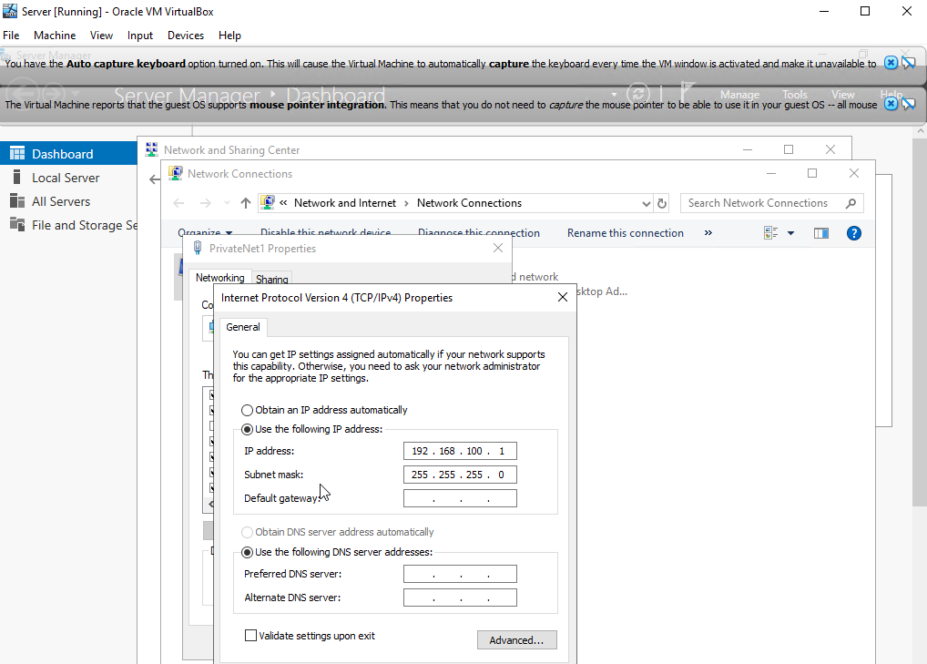
Evidence of firewall and DNS being turned off prior to the task, as well as the server IP being set.
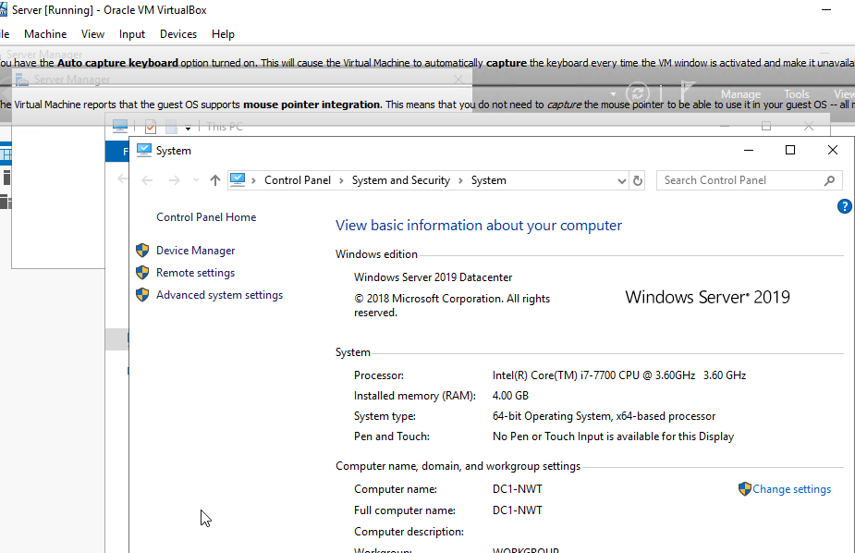
Changed the computer name.

Deploying active directory as a role or feature based on installation
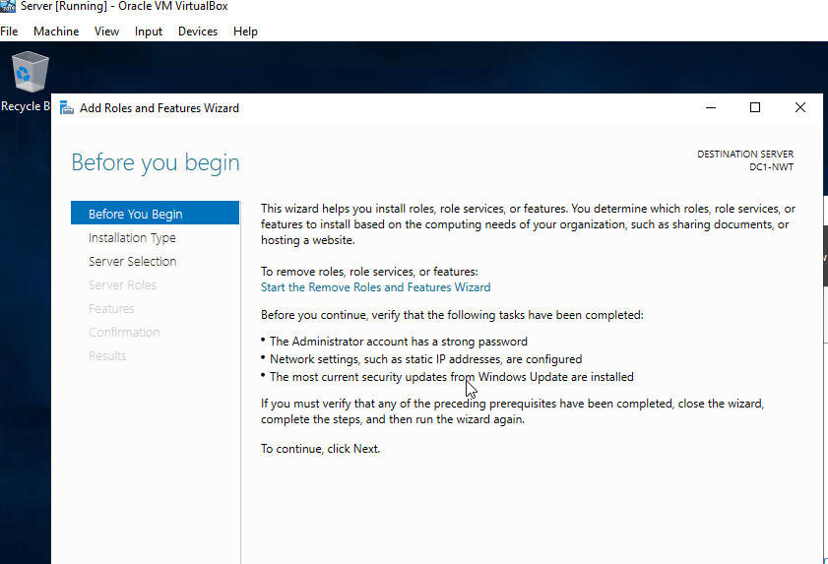
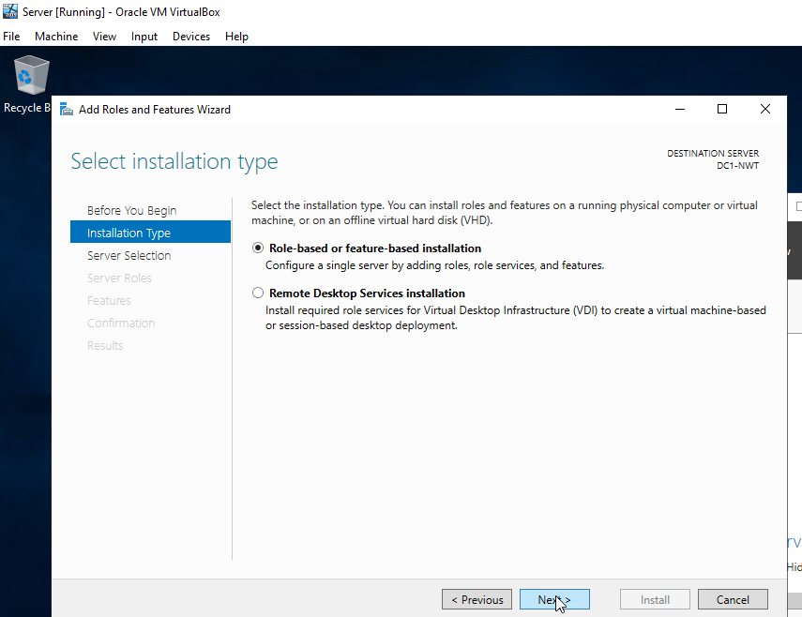
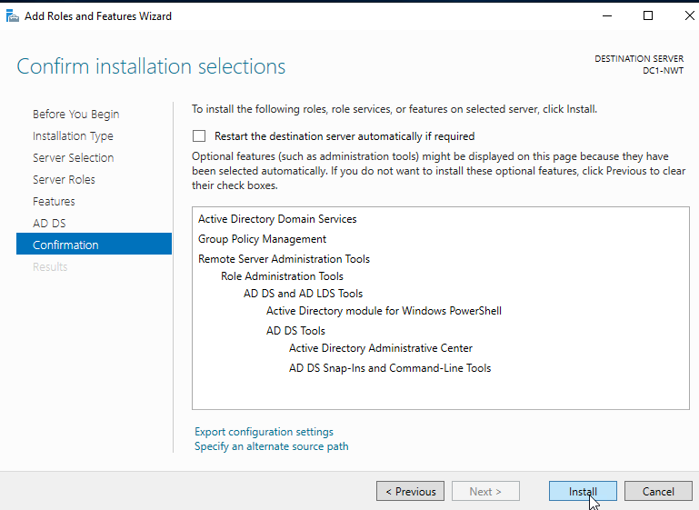
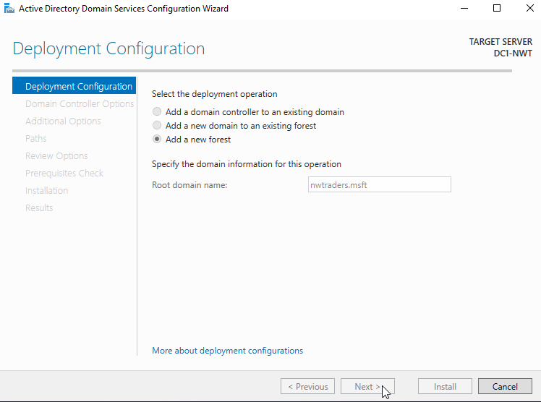
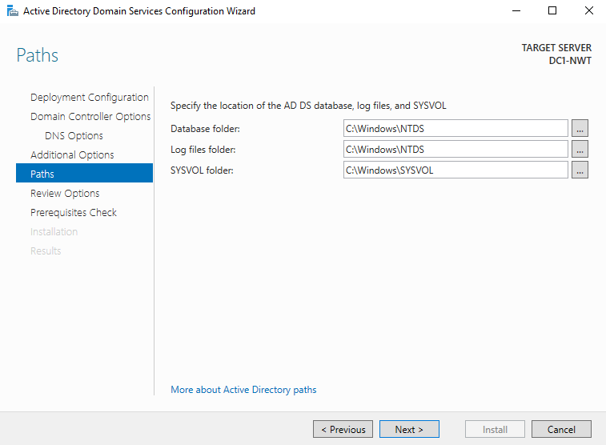
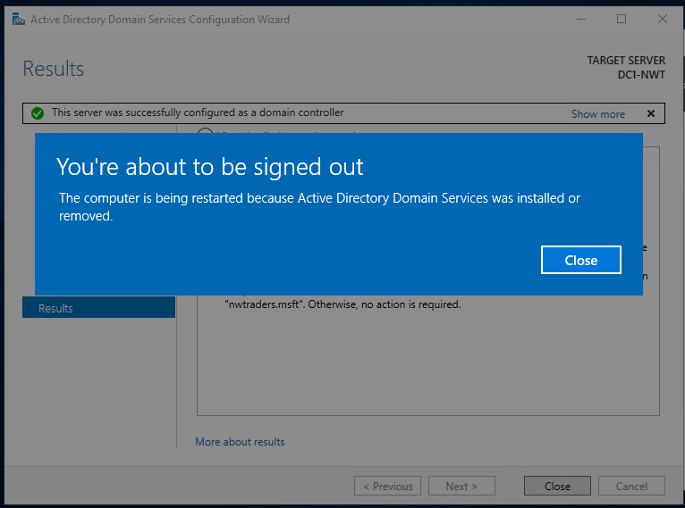
Installing network domain.

Creating user account objects using ADU and computers snap-in console
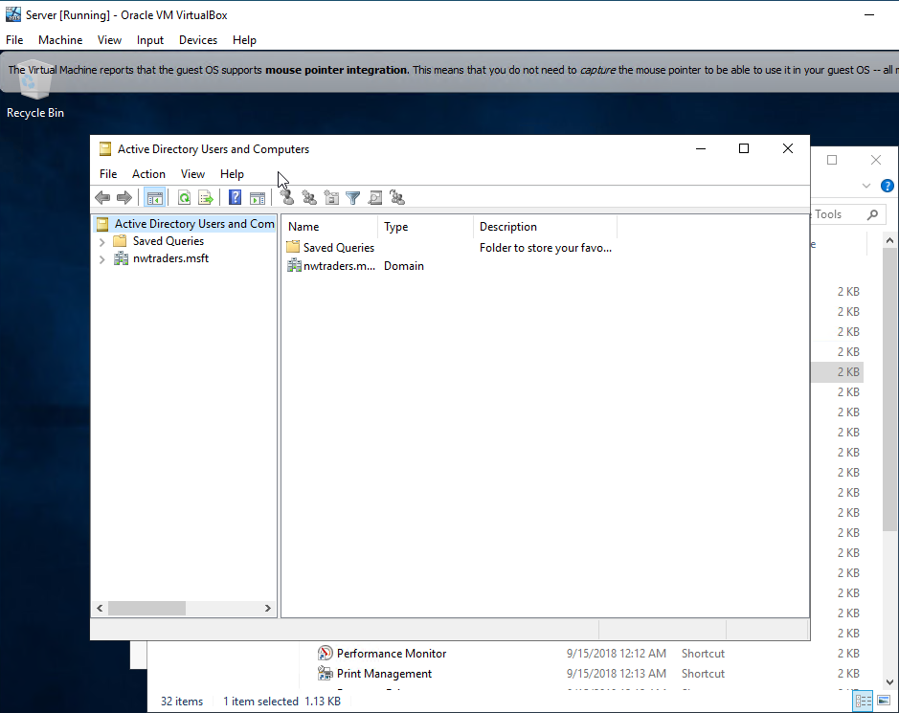
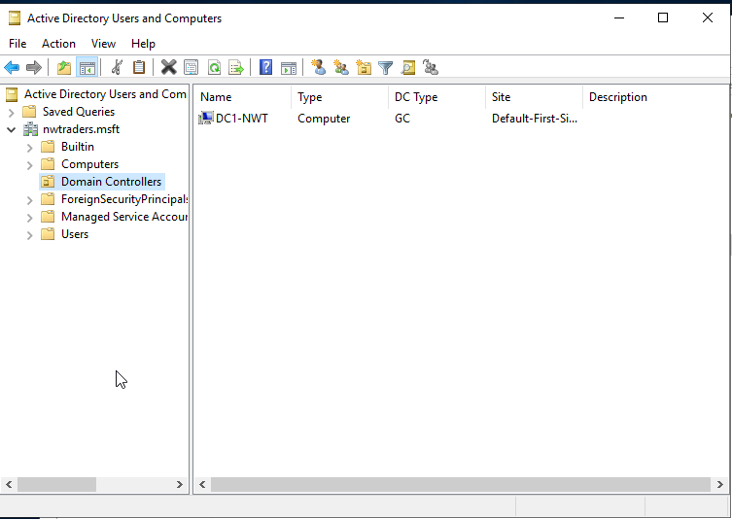
Created server is listed as a controller.
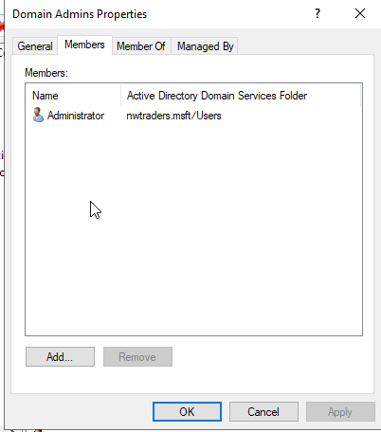
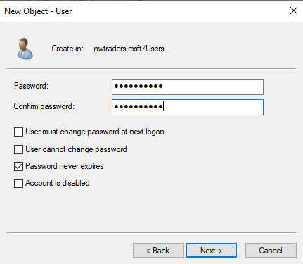
Creating a new user.
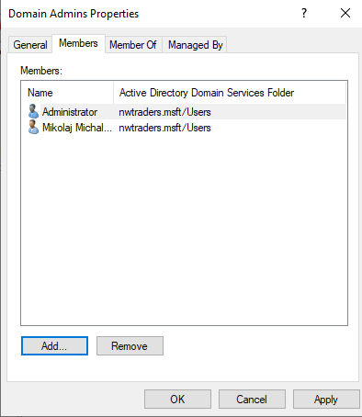
User added as a domain admin.

Object attributes of interest
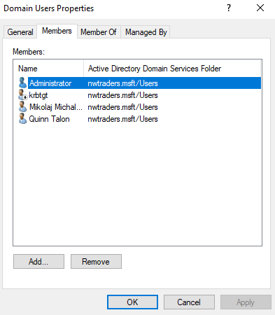
Added new user to domain users.
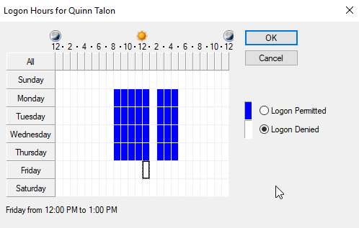
Logon hours for new user set.

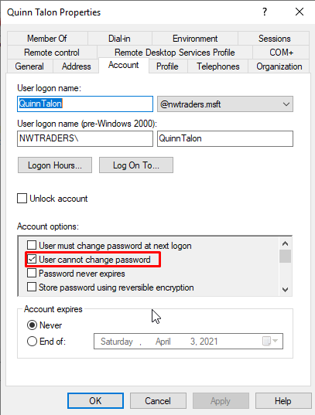
For security user cannot change their password.

Adjoining the domain and testing user logins
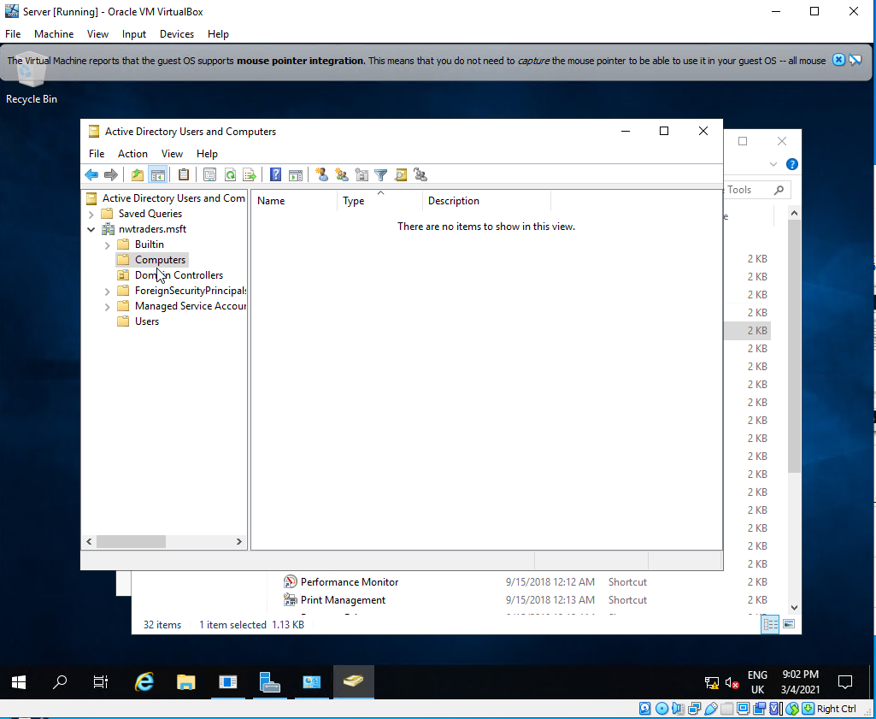
No computer account created for clients.
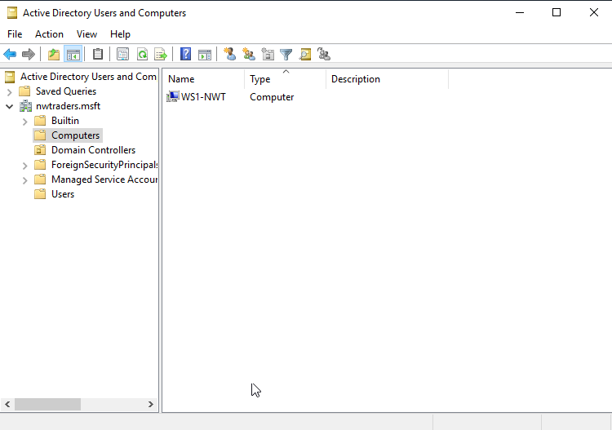

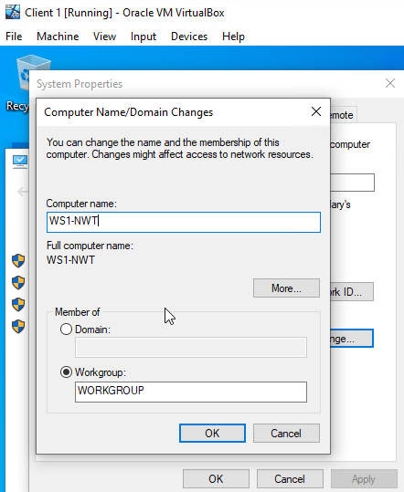
Changed client 1 computer name to WS1-NWT.
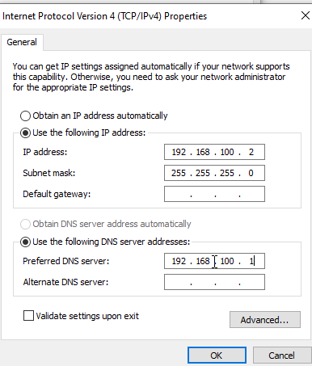
Client 1 DNS server address is added.

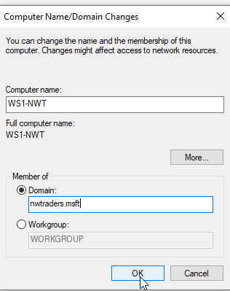
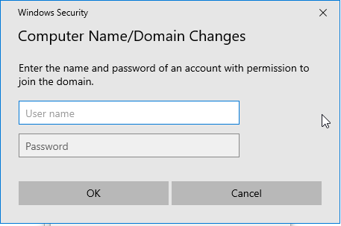
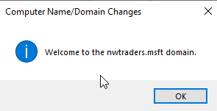

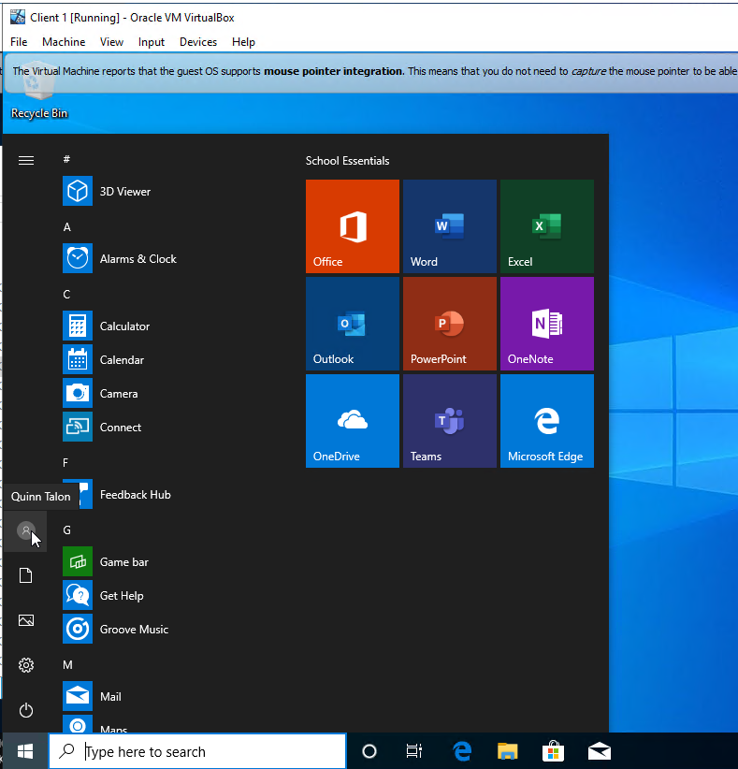
New user account logged in.
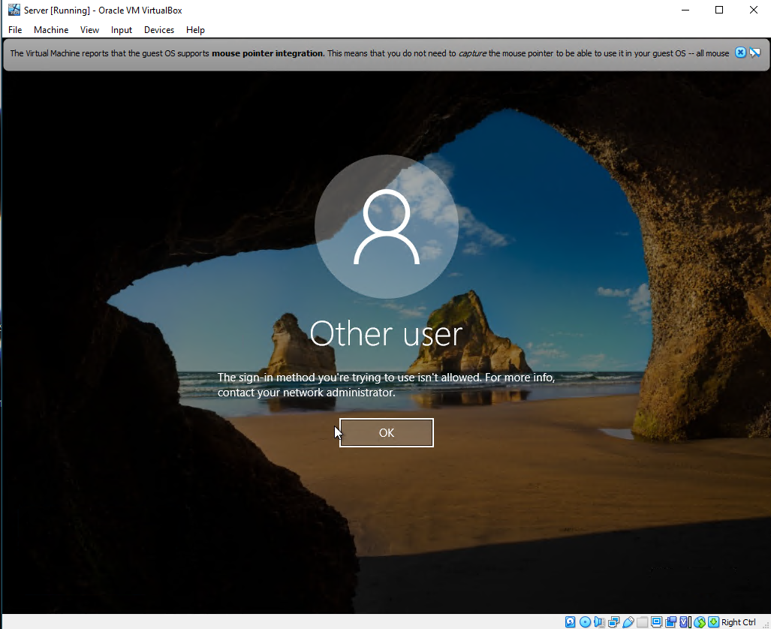
Attempted logon to systems without domain controller role.

Observational tasks

What is DNS?
DNS stands for Domain Name System which is almost exactly what the name states. There are a few different types of DNS servers. One of them is used for naming computers, services, and other connected resources within the private network [1]. Because things such as the web browsers interacts using IP addresses. The DNS then translates the domain names given to the devices into IP addresses. Because of this, it eliminates the need for humans to remember IP addresses and they can simply type in the set name. For IPv4 it was easier to memorise the IP. However, with IPv6 its much harder to do so for humans making DNS very useful.
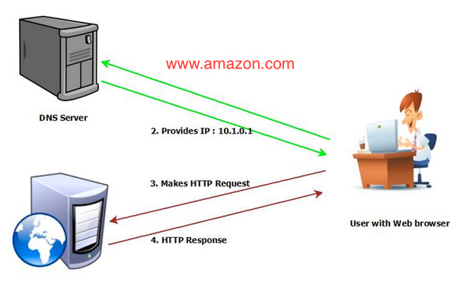
[2]
In a very simple illustration, you can see that the user will request a location. The DNS server then provides the user with the IP to be able to make the HTTP request to connect to the website. This then provides a response either allowing or denying access to the website. That works in simple terms. There is a lot more involved as there are around 4 DNS servers involved when loading a webpage that all do different things [3]. The significance this has with ADDS is that the computers on the network will get given the IP to connect to websites or devices. Without this, the users would have to input separate IPs to connect to a web page or communicate. This helps translate the IP allowing users to know where they are entering.

Other critical role or feature based installations
Other important roles within an enterprise network consist of DHCP and DNS. These roles are important within the network for their reasons. The DHCP server is one of the more critical roles due to its use [4]. With DHCP the server automatically gives IP addresses to the devices on the network. With a lot of organizations using windows server as a DHCP server. Finally, the DNS server is also a very important role as it helps translate the IPs of the web address from numbers to human-readable web address such as www.Google.com [5]. This also goes the other way. Where the user will input the address and it will automatically find the IP related to that name.

Different levels of access in network user account groups
This is very important for several reasons. Different levels of access within the “Built-in” network is for the protection of information alone. This is specifically so the information always stays secure. For example, the domain admin and DHCP admin both have different jobs [6]. There is no need for the DHCP admin to have the level of access just like the domain admin as they will more than likely never need it. Therefore, locking it from them simply makes everything safer as you get to pinpoint who has access to what information. So, when anything goes wrong, or information is leaked. Its easier to find where and how it happened. However, as an overall point, the main idea of having access levels is to protect the information. Users should not be allowed to moderate and configure things like domain admins. There could be a lot of issues that happen. The roles are there for a reason, people are hired into them with experience, so they know how to use everything correctly. A level of safety must be set to ensure others do not mess with things they do not understand.

Microsoft’s recommendations on AGDLP and AGUDLP
Microsoft’s procedures for implementing role-based access within a network run by a windows domain is one to think about [7]. To start things off AGDLP stands for “Account, Global, Domain Local, Permission”. The procedure that Microsoft has pushed forward and recommended consists of this. User accounts (A) are to be set as members of global groups. (G) represents business roles. These both are global groups which are then members of domain local groups who are maintained for access control (DL) which have permissions to resources being (P). Now for this procedure of things, there are advantages that come with it. This procedure makes it quite straightforward to make user and group authorizations, speeding up the process of the overall task. If the correct groups of each resource have already been made, the permissions can be changed very easily through the AD console by adding additional memberships. Access to specific resources can be easily removed by taking the user away from the group. With all these advantages this is a good approach. The only disadvantage is the structures need to be made manually in the active directory console as there are no other management tools that can help do this.

References

[1] | “An Introfuction to DNS,” in Pro DNS and BIND, Apress, 2008, pp. 3-19.
[2] | N. Poojary, “How DNS Works – the Domain Name System (Part One),” Cloud academy, 26 March 2019. [Online]. Available: https://cloudacademy.com/blog/how-dns-works/. [Accessed 05 March 2021].
[3] | S. Adiwal, P. Shetty and B. Rajendran, “Domain Name System (DNS) Security: Attacks Identification and Protection Methods,” in International Conference on Security & Management, Las Vegas, 2018.
[4] | O. Younes, “A Secure DHCP Protocol to Mitigate LAN Attacks,” Journal of Computer and Communications, vol. 04, no. 1, pp. 39-50, 2016.
[5] | S. Castro, M. Zhang, W. John and D. Wessels, “Understanding and Preparing for DNS Evolution,” in Proceedings of the Second international conference on Traffic Monitoring and Analysis, 2010.
[6] | A. Lakbabi, “Network Access Control Technology—Proposition to Contain New Security Challenges,” International Journal of Communications, Network and System Sciences, vol. 05, no. 08, pp. 505-512, 2012.
[7] | “AGDLP,” tenfold, [Online]. Available: https://www.tenfold-security.com/en/wiki/agdlp/#:~:text=The%20abbreviation%20AGDLP%20refers%20to,G)%20that%20represent%20business%20roles.. [Accessed 08 March 2021].

