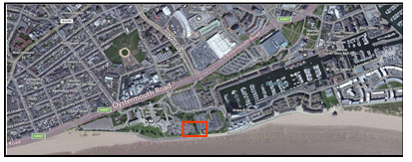
Module: Fundamentals of Construction Technology
Module code: ACBA4001
Lecturer: Allan Nantel

Student: ADAM HASSAN (1802740)
Submission Date: January 2020

Introduction
A site investigation is a vital process by which geological, geotechnical, and other related information is collected of the subsurface condition prior to construction or a building project (Clayton et al, 1995). Problems that may occur at construction projects are due to unexpected ground conditions that could have been avoided if a suitable site investigation was carried out. An entire project is based upon that information gathered at an early stage to avoid the costs of fixing or organising alternative construction methods, or even worse a disaster (Wood & Ashton, 2007). A preliminary investigation or desktop study is, therefore, carried out.
Preliminary desk study
The site
The site is currently part of the car park located between the City and County of Swansea Council building and the Swansea Marriot Hotel (fig.1).
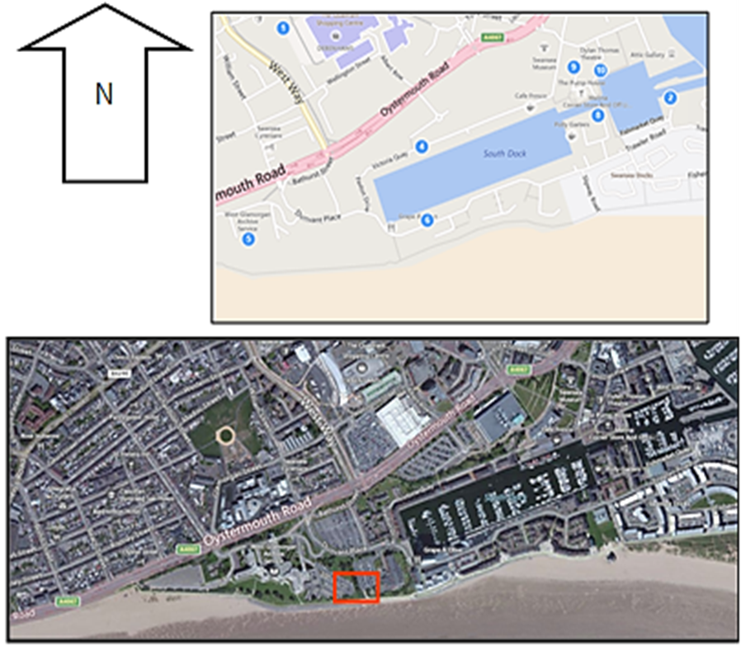
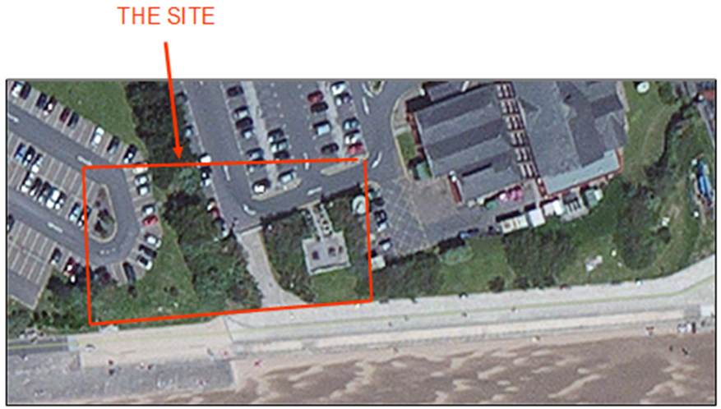
Fig. 1 Aerial view of the proposed site

The building proposed is to include restaurant, café bar, ice-cream parlour, kitchen, food-stores etc at ground floor level, with a Gross Internal Area of approximately 300 square metres. A second floor will have a self-contained manager’s apartment and staff welfare facilities.

Historical background of the site
A search in historical books and ordnance survey maps in the West Glamorgan Archive services, as well as other sources revealed the following:
Up until 1817, the workhouse for the poor was situated at Swansea castle, but then moved to what was the Bathing House on the Burrows on Mumbles Road (fig. 2), which was partly converted for use as a House of Industry and Infirmary as seen from the maps in fig. 3 (Davies, 1988; Gibbs & Morris, 1991). Ordinance maps show the existence of the Infirmary (fig. 4 & 5). The lack of clean water and hygiene resulted in outbreaks of diseases and epidemics, such as Smallpox, Typhus, and Cholera and hence resulted in hundreds of deaths (Wilson-Watkins, 2017) and then yellow fever in 1865 (Meers, 1986).
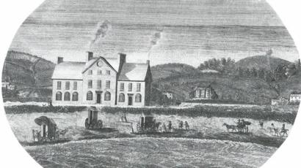
Fig. 2 The Bathing House on the Burrows
Source: Gibbs & Morris, 1991

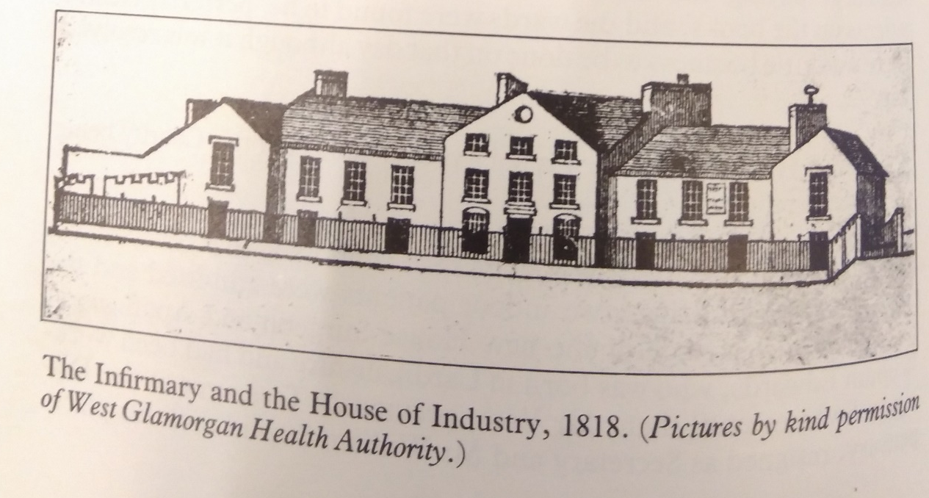
Fig.3 The infirmary and House of Industry
Source: Deeds not words.

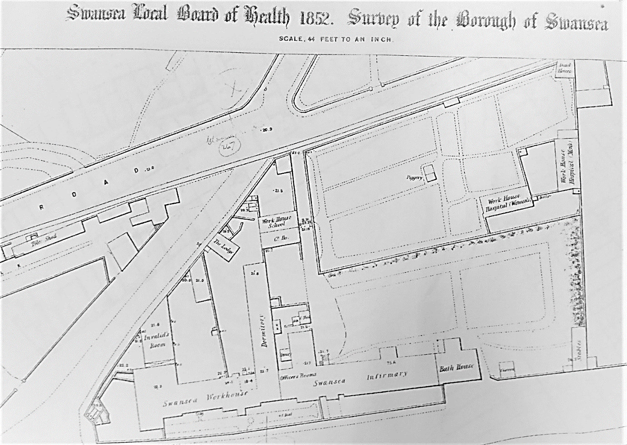
Fig.4 An ordinance survey map showing the existence of the hospital in 1852
Source: National Archives

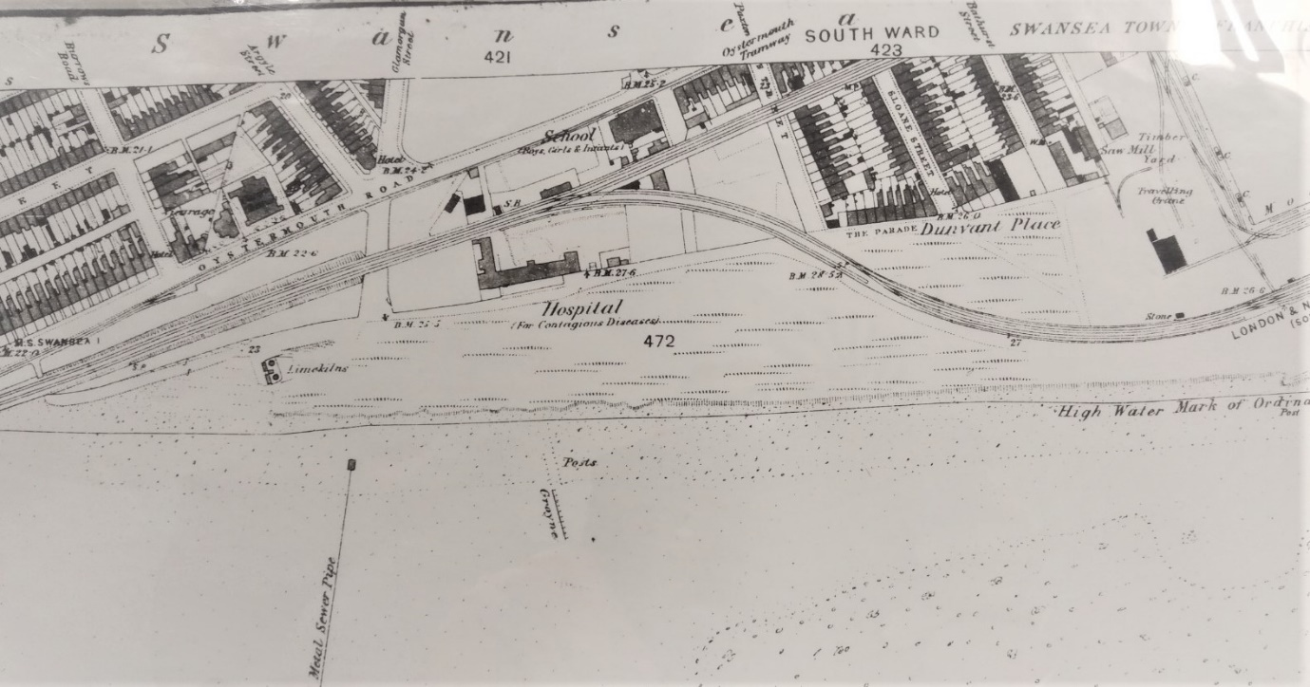Fig. 5 An ordinance survey map showing the existence of the hospital in 1878
Source: National Archives

The docks
In the 18th century, Swansea developed as a major port with the expansion in coal mining, iron production as well as copper smelting. Copper and brass smelting flourished, and by the middle of the 19th century, the majority of the copperworks in Great Britain were in Swansea, hence became known as Copperopolis. Swansea had the great advantage of location, due to its seaboard location and close proximity to the coal mines (Newell, 1990). It was, therefore, necessary to have larger ports to meet the high demands all over the world. A North Dock was created in 1852, followed by the South Dock (West of the River Tawe) in 1859, for the export trade of coal from Aberdare (Fig.6) (Hughes et al, 1992). Bigger ports were later developed east of the Tawe - Prince of Wales Dock, resulting in the closure of the South Dock in 1971. By the 20th century, the copper industry began to decline greatly. In 1982, the local authority cleaned the land and re-developed the South Dock to become known as the Marina (history points, n.d.; Swansea docks, n.d.).
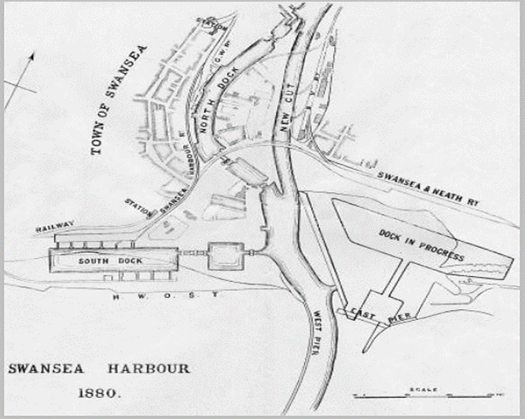
Fig.6 Swansea Harbour in 1880 showing the North and South Docks. The ‘dock in progress’ on the other side of the river became the Prince of Wales Dock.

The County Hall building (as it was known then) near the proposed site was constructed on the site of engine sheds (fig.7A & B). Planning work got under way in 1975, but it was not until 1979 when work began on the site. The first phase of County Hall was completed in 1982 and the second phase two years later (Youle, 2018; Dalling, 2019). On the other side of the car park is the Marriott Hotel which was built in 1989.
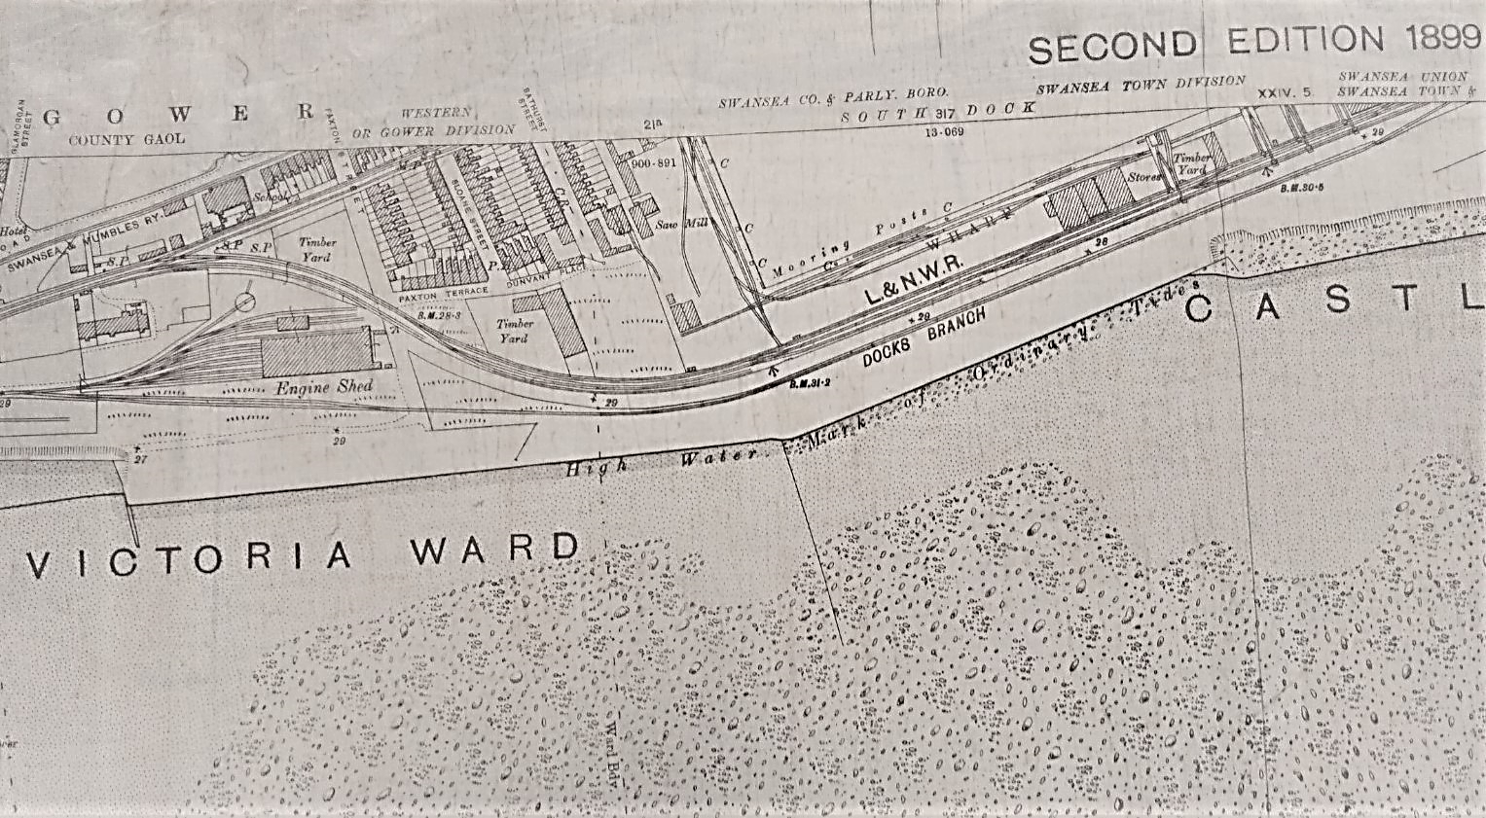
Fig.7A Ordnance survey map published in 1899 showing the area being used as an engine shed Source: National Archives
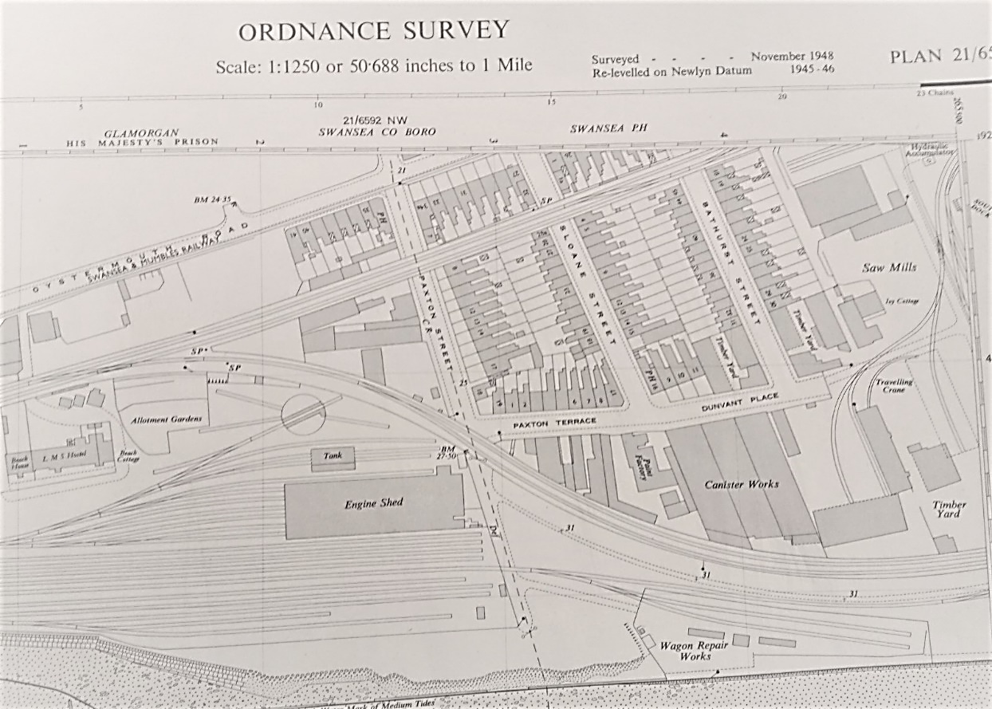
Fig.7B Ordnance survey map published in 1948 showing the area being used as an engine shed
Source: National Archives
The 3 Day Blitz
During the Second World War, in 1940, several bombs were dropped over different areas of Swansea, including the docks, with some exploding, whilst others did not (explore Gower, n.d.). Then, in February 1941, in a three nights' blitz, Swansea suffered heavy bombing raids (30,000 incendiary and 800 high explosive bombs). Bombings lasted for nearly 14 hours, destroying thousands of buildings and killing hundreds of people. Germany was targeting Swansea because of its docks to hinder exports (Dulin, 2016; Winston, 2016).

Topographic and geological maps
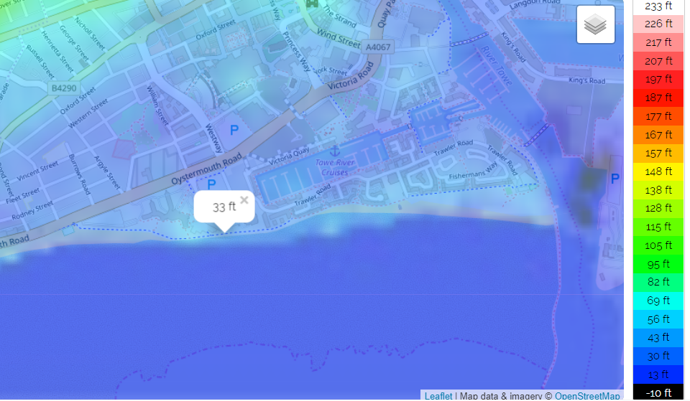
Fig.8 Topographic map of the area
Source: Topoghraphic-map.com

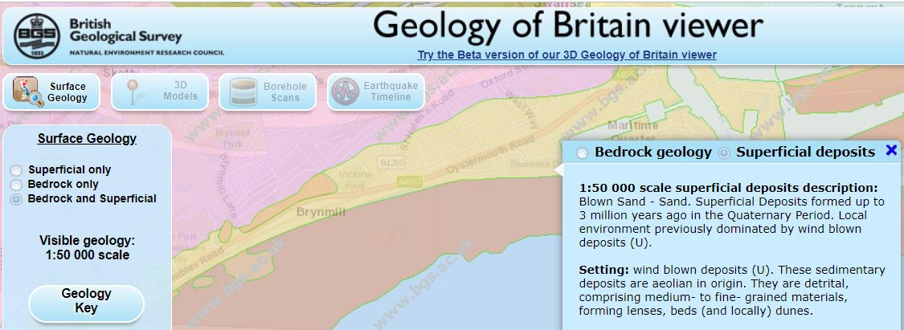
Fig.9A Geological map showing superficial deposits
Source: British Geological Survey website

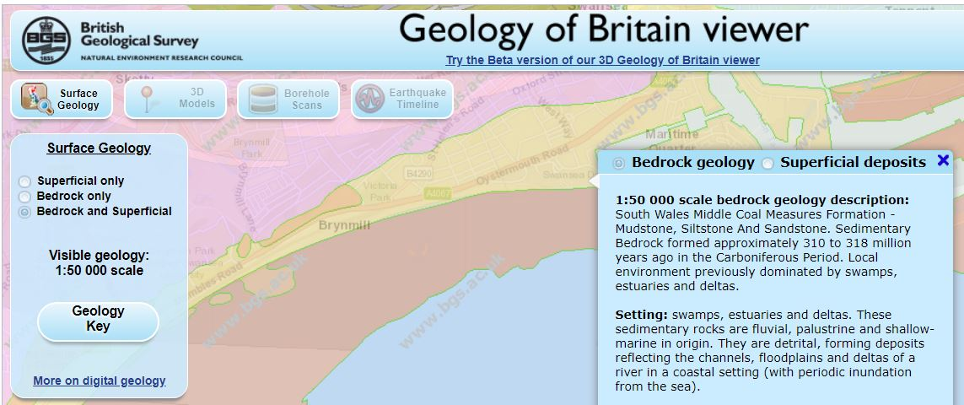
Fig.9B Geological map showing Bedrock geology of the site
Source: British Geological Survey website

Recommendations for detailed site investigation
- Establish site characteristics
The site is by the seafront and hence is susceptible to high winds, blown sand and sea spray, therefore this has to be taken into account when designing and planning the structure.
- Assess potential hazards to health and safety at and around the site
- Keep pedestrians and vehicles apart: separate pedestrian walkways away from site
- Secure the site: Need to define boundaries, where necessary, by suitable fencing.
- Minimise vehicle movements
- Visible signs and instructions

- Appraise surface conditions
- Trees
The area between the two car parks contains trees and shrubs (fig.10A & B), and therefore, should be dealt with appropriately.
The British Standard BS 5837:2005 regarding trees in relation to construction - states that “an accurately measured land survey should be undertaken showing all relevant existing site features. Where trees are present, clearance of vegetation to facilitate the survey process should be undertaken only if strictly necessary and with care using handheld machinery. Where development, including demolition, is to occur, the standard provides guidance on how to decide which trees are appropriate for retention, on the means of protecting these trees during development, including demolition and construction work, and on the means of incorporating trees into the developed landscape.” Fig. 11 shows a flow diagram of the layout of the sequence according to the British Standard.
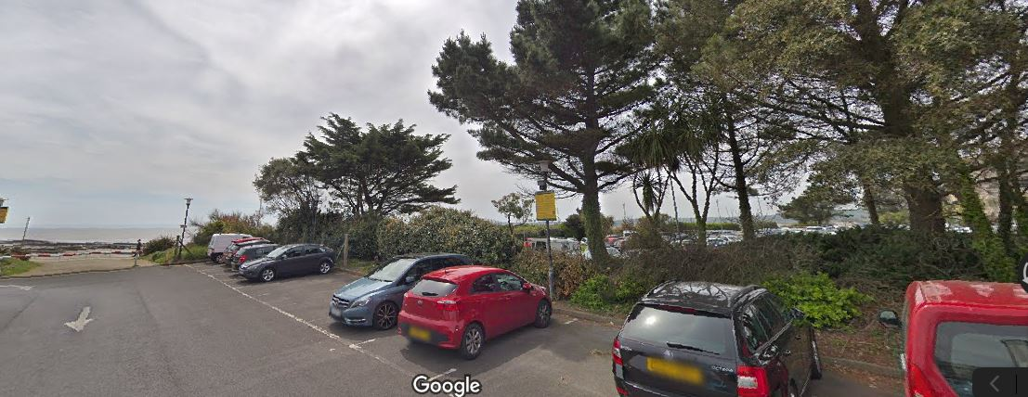
Fig.10A Picture showing trees and shrubs at the proposed site
Source: Google

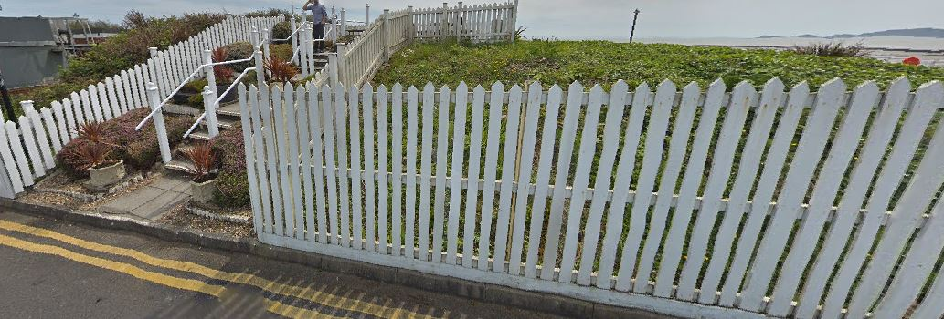

Fig. 10B Picture showing Marriott side of the proposed site
Source: google
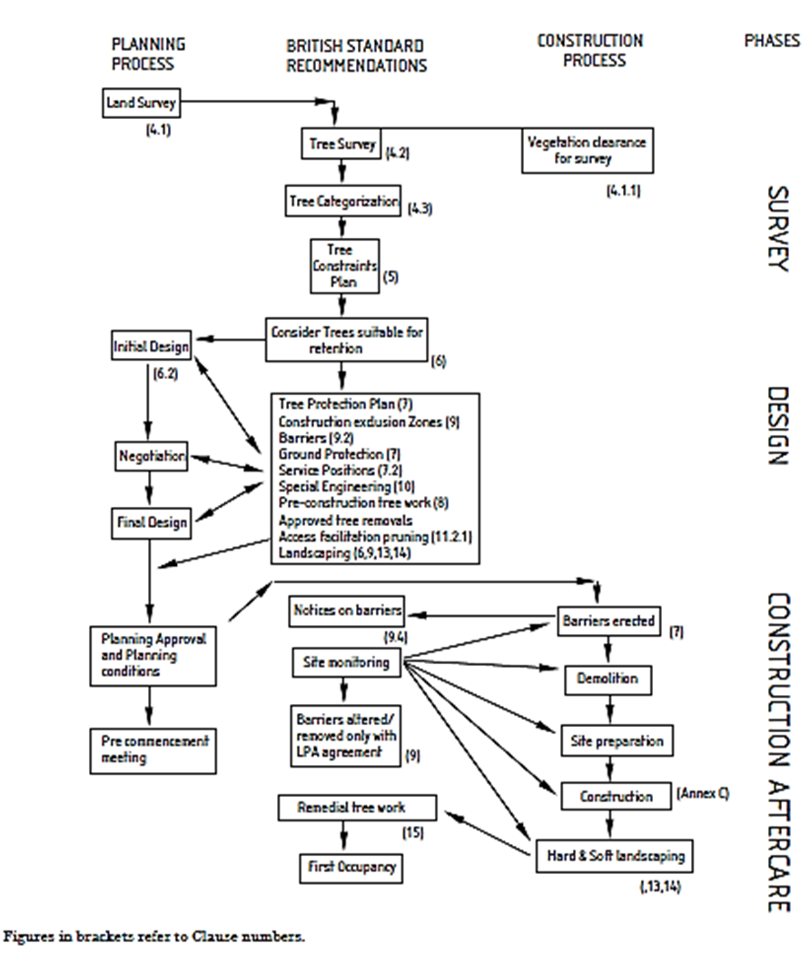
Fig.11 Layout of sequence following British Standard for tree surveying
Source: The British Standard BS 5837:2005
- Appraise ground conditions
- Water table
The depth to the water table changes depending on the time of year. Water in the subsoil can cause many problems, for example, high water table can cause flooding, or problems during excavation works, or cause high humidity levels around buildings, or affect foundations on piles by causing “downdrag” (known as “negative skin friction”) on the pile, which can overstrain the pile and lead to failure.

- Contamination
Due to the fact that the site had a history of several uses in the past, from infirmary to infectious disease infirmary to docks exporting coal, copper, iron and brass, it is recommended that caution and appropriate measures be taken.

- Soil investigation
A borehole investigation should take place for the site to give knowledge of the subsoil.
A search on the British Geological survey website of the area revealed that there were several boreholes undertaken for the construction of the County Hall in 1975 as seen in fig.12A & B.
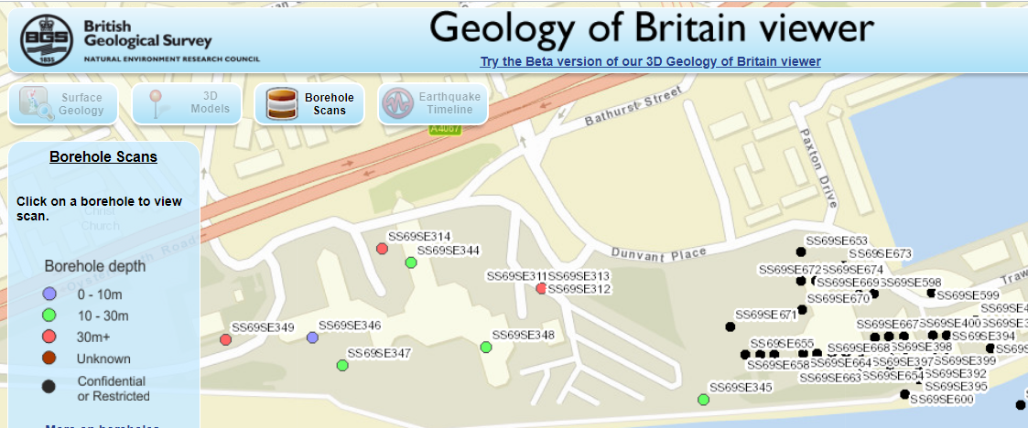
Fig.12A Borehole scans around the proposed site
Source: British Geological Survey
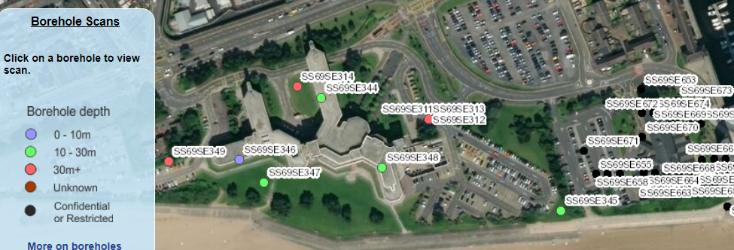
Fig.12B Aerial view of borehole scan points around the proposed area
Source: British Geological Survey website

Of the several borehole investigations undergone for the construction of the County Hall, there was one borehole sample taken that is actually at the proposed site (fig.13).

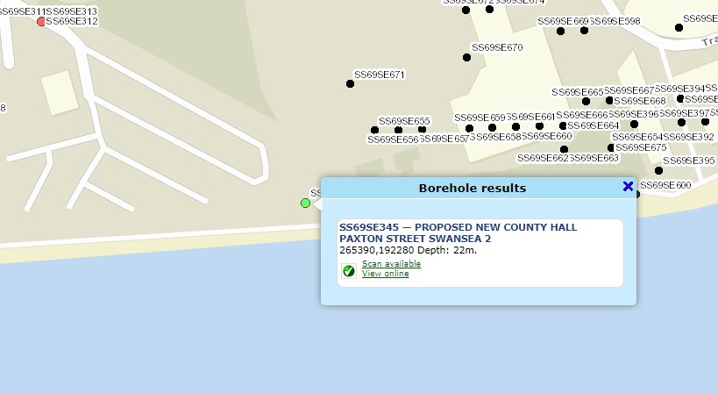
Fig.13 Borehole of interest SS69SE345
Source: British geological survey website

The borehole report in fig.14 shows soft sandy clay and gravel down to 7m. Below 7m the sand becomes denser and the clay becomes more stiff. After 11m the soil settles for a further 5m as very stiff grey gravelly boulder clay.
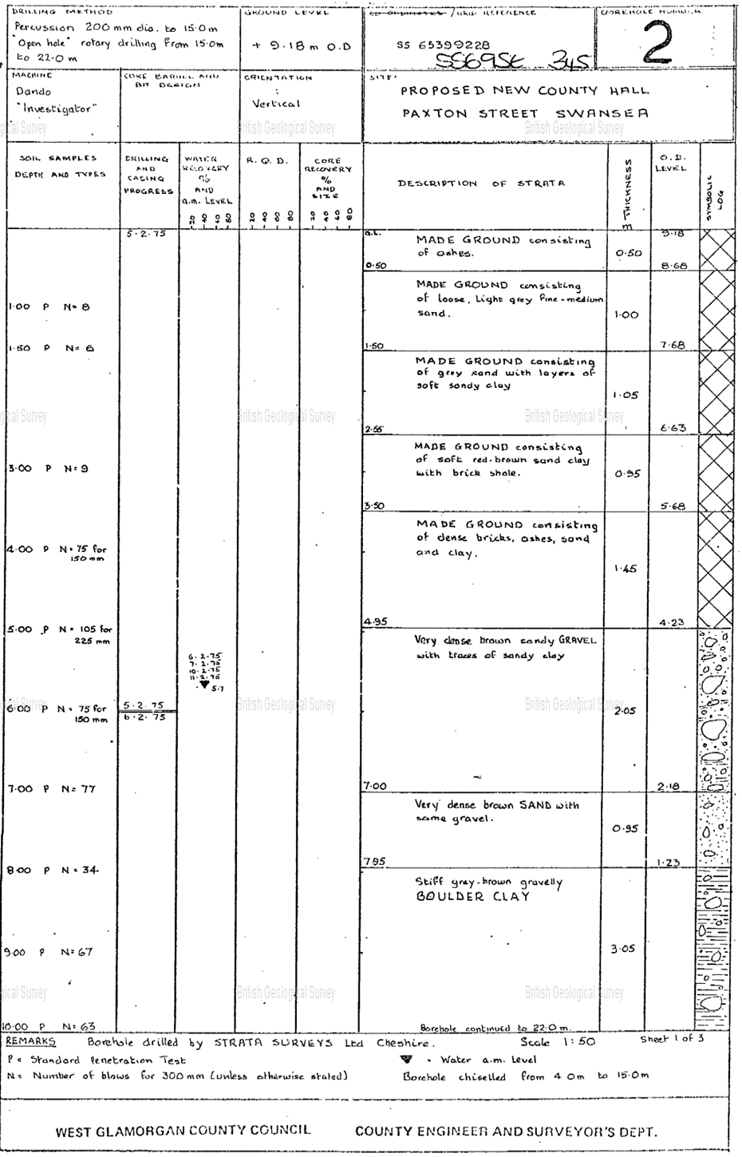
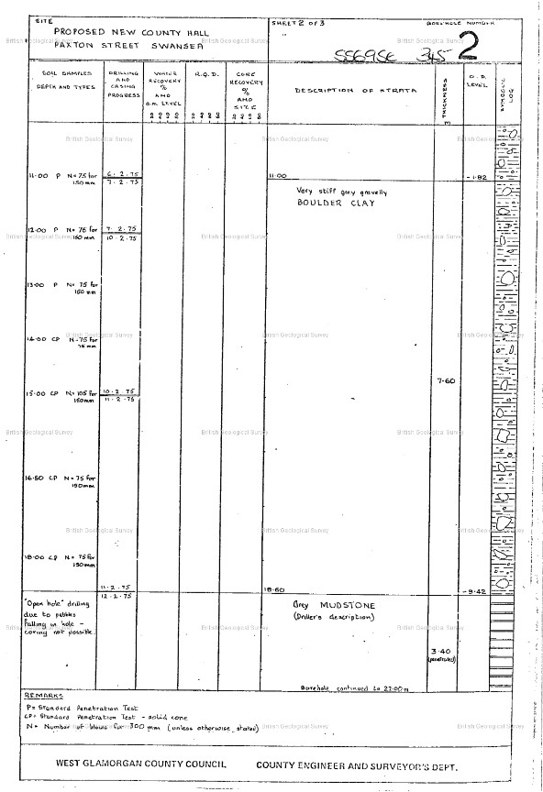Fig.14 Previous borehole report of subsoil

Building regulations/code of practice
Building Regulations are the established minimum national standards that building design, construction and alterations must comply with, to ensure that all relevant building work is carried out to a high standard and meets health and safety guidelines, as well as meeting standards for energy conservation, security and building access.
There are Approved Documents which contain guidance on how to meet these requirements in Wales.
Part A: Structure
Part B: Fire safety
Part C: Resistance to contaminants and moisture
Part D: Toxic substances
Part E: Resistance to the passage of sound
Part F: Means of ventilation
Part G: Sanitation and water
Part H: Drainage and waste disposal
Part J: Combustion appliances and fuel storage systems
Part K: Falling, collision and impact
Part L: Conservation of fuel and power
Part M: Access to and use of buildings
Part N: Glazing
Part P: Electrical safety - dwellings
Part Q: Security - dwellings
Regulation 7: Materials and workmanship

Suitable foundation for the site
Based on the preliminary observations of the proposed site, it is proposed that a raft foundation is suitable.
A raft foundation is a thick slab of concrete that rests on a large area of soil with reinforced steel that has supporting columns or walls to transfer the load of the structure into the soil. A raft foundation is usually used to support residential or commercial buildings where the soil condition is poor, like in this case with sandy soil and clay soil as seen in fig.14. The soil in the proposed area has a low bearing capacity and since the load of the structure has to be distributed over a large area a raft foundation is ideal. A piled raft foundation is the same but is supported on concrete piles, which is used when the soil at a shallow depth is highly compressible and the water table is high. The piles help in reducing settlement and provides resistance against buoyancy (civil today, n.d.). When it comes to end bearing piles the bottom of the pile will rest on a strong layer of rock or soil to transfer the load through the pile and onto the stronger layer of soil/rock. Friction piles work in a different way to end bearing piles as they transfer the load of the structure across the full height of the cylindrical pile onto the soil (fig.15) (understand construction, n.d.).

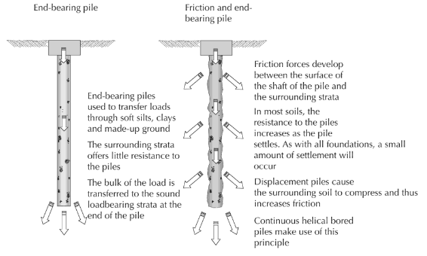
Fig.15 Diagram showing end bearing and friction pile
Source: Emmitt, 2018

Fig.16 Sketches showing a Piled raft foundation

REFERENCES
British Geological Survey website
Available online at http://mapapps.bgs.ac.uk/geologyofbritain/home.html?
[Accessed 18 January 2020]

British Standard, (2015). Code of practice for ground investigations, BSI standards publication.
Available online at https://geotechnicaldesign.info/download/bs5930-2015.pdf
[Accessed 16 January 2020]

British Standard, (2005). Trees in relation to construction — Recommendations, The British Standard BS 5837:2005
Available online at https://www.rbkc.gov.uk/idoxWAM/doc/Other-1592559.pdf?extension=.pdf&id=1592559&location=Volume2&contentType=application/pdf&pageCount=1
[Accessed 18 January 2020]

Civil today (n.d.). Raft Foundation - When to Use, Types, Construction, Civil today.
Available online at https://civiltoday.com/geotechnical-engineering/foundation-engineering/167-raft-mat-foundation-use-types-construction
[Accessed 18 January 2020]

Dalling, R., (2019). Forgotten houses and the birth of one of Swansea's best known buildings captured in fascinating images, Wales Online.
Available online at https://www.walesonline.co.uk/news/wales-news/forgotten-houses-birth-one-swanseas-15905059
[Accessed 18 January 2020]

Davies, T.G., (1988). The infirmary – Early days, Deeds not words - A history of the Swansea General and Eye Hospital 1817-1948, Published by University of Wales Press, pp.19.

Dulin, D. (2016). Swansea still regenerating 75 years after Blitz. BBC | News.
Available online at https://www.bbc.co.uk/news/uk-wales-south-west-wales-35494885
[Accessed 3rd January 2020]

Emmitt, S., 2018. Pile foundations, Barry's advanced construction of buildings, John Wiley & Sons, pp.44.

Explore Gower, (n.d.). World War II, Explore Gower website.
Available online at http://www.explore-gower.co.uk/World-War-II
[Accessed 3rd January 2020]

Gibbs M. and Morris B., (1991). Thomas Rothwell. Views of Swansea in the 1790s, A Glamorgan Archives publication, (edited by Patricia Moore), pp.39

History points (n.d.) Swansea Marina, History points.org
Available online at http://historypoints.org/index.php?page=swansea-marina
[Accessed 13th December 2019]
Hughes, S., Hughes, S.R. and Reynolds, P.R., (1992). Swansea Docks, A guide to the industrial archaeology of the Swansea region, RCAHMW, pp.24.
Meers, P.D., (1986). Yellow fever in Swansea, 1865. Epidemiology & Infection, 97(1), pp.185-191.
Newell, E., (1990). ‘Copperopolis’: the rise and fall of the copper industry in the Swansea District, 1826–1921. Business History, 32(3), pp.75-97.
Swansea docks (n.d.) A brief history of Swansea docks, Retired section Swansea docks, Swanseadocks.co.uk
Available online at http://www.swanseadocks.co.uk/Dock%20History.htm
[Accessed 13 December 2019]

Topographic maps website
Available online at https://en-gb.topographic-map.com/maps/dr1/Swansea/

Understand Construction (n.d.). Pile foundations, Understand construction.
Available online at http://www.understandconstruction.com/pile-foundations.html
[Accessed 18 January 2020]
West Glamorgan National Archives Services for ordinance maps.
Winston, G., (2016). Remembering the Swansea Blitz That Destroyed 11,000 Buildings And Left 230 People Dead, War History Online.
Available online at https://www.warhistoryonline.com/war-articles/remembering-the-swansea-blitz.html
[Accessed 3rd January 2020]
Wilson-Watkins C., (2017). Doctor in the House, The Bay.
Available online at https://www.theswanseabay.co.uk/2017/07/26/9195/
[Accessed 18 January 2020]

Wood, H L and Ashton, P (2007). An investigation to identify the role of pre-construction site investigative information used by small medium sized enterprises (SME,. In: Boyd, D (Ed) Procs 23rd Annual ARCOM Conference, 3-5 September 2007, Belfast, UK, Association of Researchers in Construction Management, pp.703-712.
Youle, R., (2018). Inside the hidden underground room which is full of Swansea's history, Wales Online.
Available online at https://www.walesonline.co.uk/news/wales-news/inside-hidden-underground-room-full-15522848
[Accessed 18 January 2020]

