

Assessment 1 – Reading Task Template
PART 1: Upload your photo of your A3 in-class notes here:
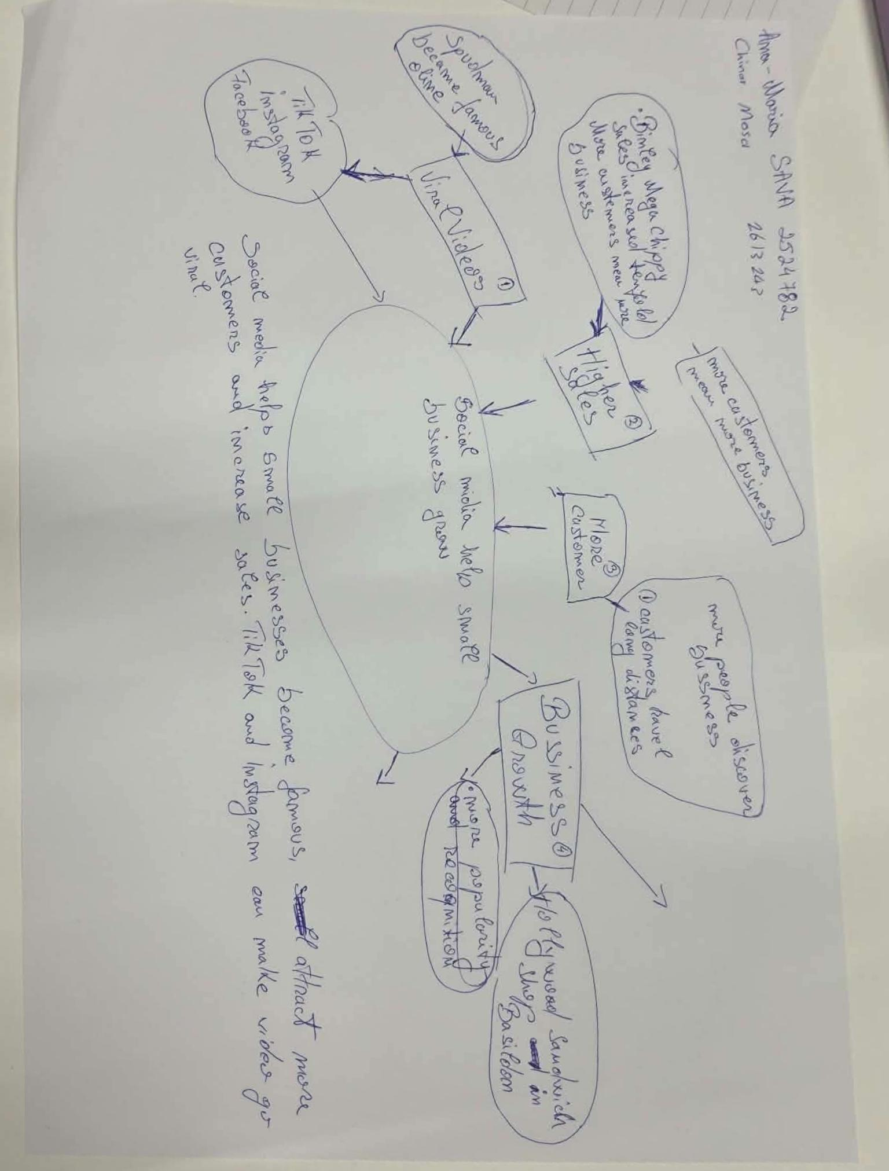

- What is the main idea of the whole text?
The main idea of the whole text is that social media platforms such as TikTok and Instagram can help businesses become more popular and attract more customers. This is beneficial for business owners because it increases sales and they earn more money.
- What is one key point that supports the main idea, and which specific example from the text shows this?
The key point is that viral social media posts can persuade people to visit a business. An example is, Murat Mutlu’s Honeywood Sandwich Shop in Basildon which had drawn attention to many people who travelled up to three hours to try its chicken burger.
- What is a different key point that supports the main idea, and which specific example from the text shows this?
A different key point is that social media helps businesses to reach individuals from different places. The article is mentioning that Honeywood sandwich Shop become popular online, by drawing attention to customers from far away instead of only relying on local customers.
- Which part of the text do you think is most important, and why?
I think the most important part is the example of Honeywood Sandwich shop becoming popular through social media platforms. This is because it shows how an online post can attract real customers and help a business to develop.
Reflection:
- What did you find difficult in this task (including in-class components), and why was it difficult?
What I had found difficult was to find the main idea and separate it from key points. I had found this difficult because the article had different details and examples.
- What helped you with this difficulty, and how did it help you?
With this difficulty what helped me was reading the article carefully and finding the important information this has helped me to understand the main idea. It also helped me to use specific examples from the article to explain my answers more clearly.

