14.08.2024
Marzena Lucyna Zerek (2439102)
[company name]
Module Name: Network Operating System and Services
Module Code: ACCA5023
Student Name: Marzena Lucyna Zerek
Student ID: 2439102
Group: 1
Lecturer Name: MD Sadeque Imam Shaikh

Network Operating System and Services
[Document subtitle]

Table of Contents
Introduction 3
1.Routing 4
1.1. Routing in Birmingham network 4
1.2. Routing in London Network 6
2.Domain Server and DNS 8
2.1. Active Directory Domain Services 8
2.2 Forward Lookup Zone 10
2.3 Reverse lookup zone and PTR records 10
3.Encrypted Connection between Birmingham and London 12
4.Users 15
5.Domain Membership 17
6.DHCP Server 19
6.1 Configure B-DC as the DHCP Server 19
6.2 Configure L-CD as the DHCP Relay Server 19
6.3 Configure Clients to Receive Addresses Automatically 19
7.Test and Troubleshoot 19
8.Disk Drive and Shared Folder 21
9.IIS Server 22
9.1 Internal website and Windows Authentication 22
10.Remote Desktop Services 24
Conclusion 25
References 26

Introduction

This report documents the extension of an Oracle VirtualBox laboratory into two logically connected networks, one at Birmingham and one at London. The platform shown in Figure 1 uses Windows Server 2019 and Debian virtual machines. The implementation covers routing, identity, name resolution, encrypted connectivity between the two sites, user and computer administration, automated addressing, validation testing, shared storage, an intranet service and remote administration.
Each section explains the technology involved, describes the configuration that was applied and presents the screenshots captured while the work was carried out.

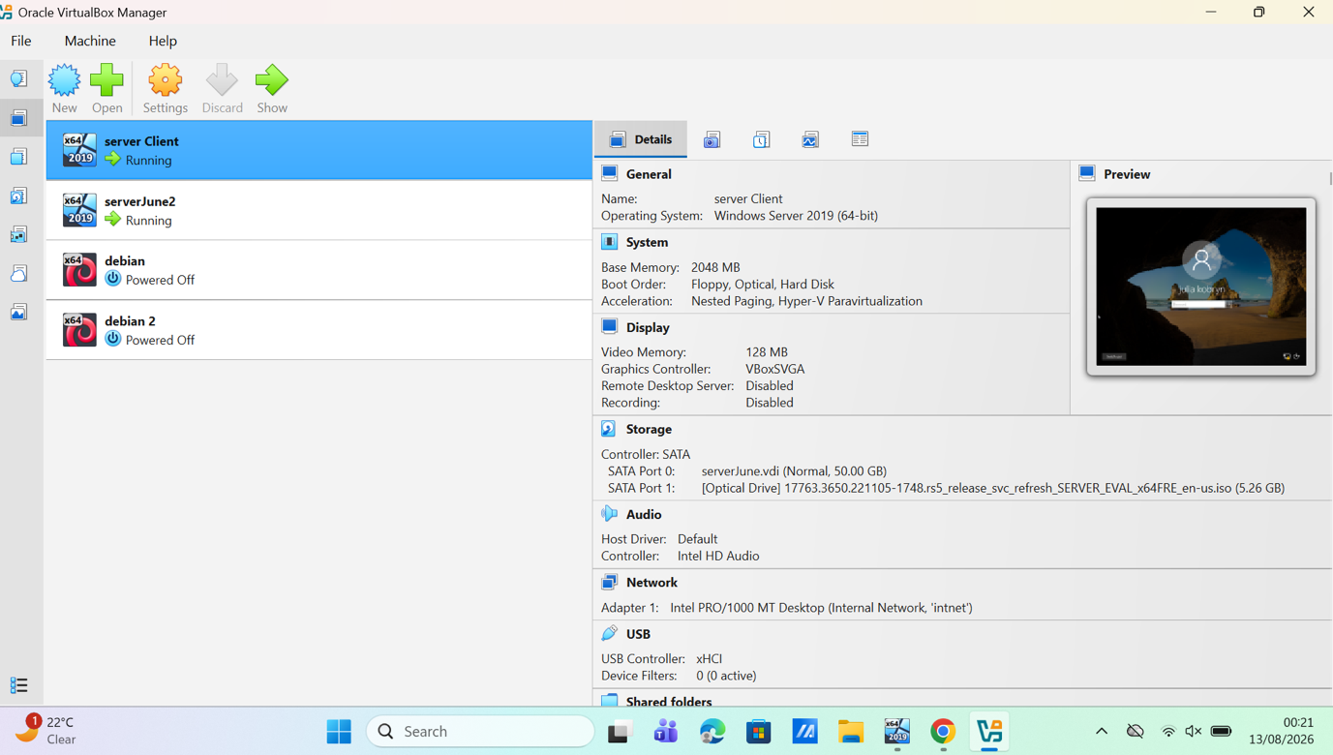

Figure 1. Oracle VirtualBox inventory used for the assessment; the screenshot shows the Windows Server 2019 server and client virtual machines and the Debian machines available in the laboratory.

1.Routing
Routing allows packets to move between distinct IP networks rather than remaining within a single broadcast domain. In Windows Server, Routing and Remote Access Service (RRAS) can operate as a LAN router and can also support demand-dial and VPN connections. Routes must be paired with restrictive firewall policy: ICMP echo is useful for diagnosis, but permitting only the required hosts, directions and protocols reduces unnecessary exposure. [1], [2]

Routing in Birmingham network

On the Birmingham server, the Remote Access role was installed and RRAS was configured and started. LAN routing requires the server to hold interfaces on the relevant subnets and to forward IPv4 traffic between them. Figure 2 shows the RRAS management console with the IPv4 routing components in place and the service running, and Figure 3 shows Server Manager reporting the installed Remote Access role. Forwarding between the two subnets was then verified by the connectivity tests reported in Section 7.

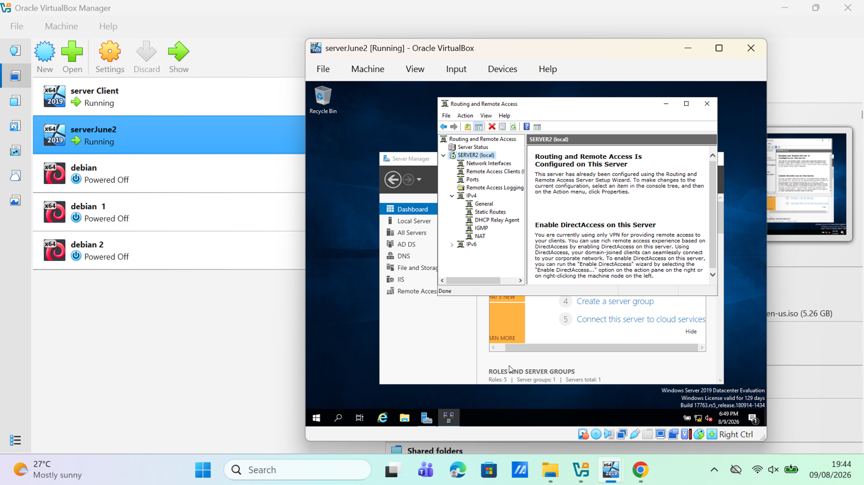
Figure 2. RRAS management console on the Birmingham Windows Server, showing the enabled service and its IPv4 routing components.

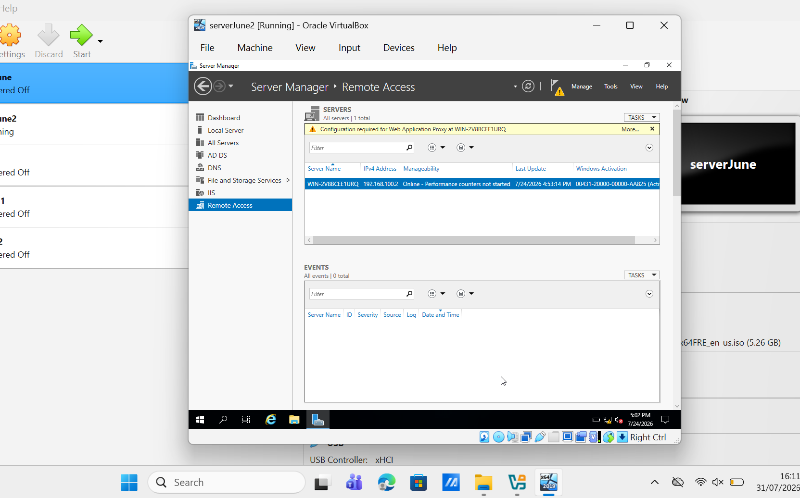
Figure 3. Server Manager Remote Access page, evidencing installation of the Remote Access server role.

1.2. Routing in London Network

On the London Windows Server (L-CD), Routing and Remote Access Service (RRAS) was configured to provide persistent IPv4 forwarding between the relevant network interfaces. A host-specific outbound ICMP filter was configured to permit traffic from 192.168.100.2 to 192.168.100.99. Figure 4 shows the filter editor, where the 255.255.255.255 source and destination masks restrict the rule to these two addresses. Figure 5 shows the resulting entry in the outbound filter list. This rule permits the required diagnostic traffic while avoiding a broad any-to-any exception. Figure 6 shows the Windows Defender Firewall inbound rules that were reviewed to ensure that the server’s firewall policy was consistent with the RRAS configuration. [2], [3].

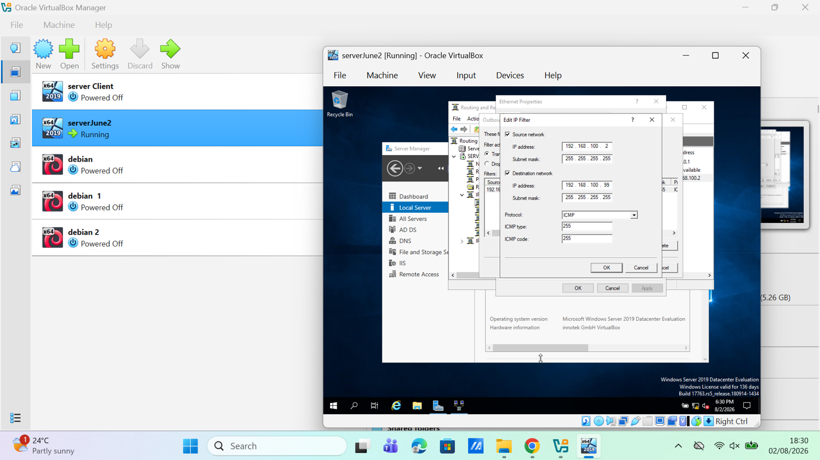
Figure 4. RRAS outbound filter editor showing ICMP traffic scoped from 192.168.100.2 to 192.168.100.99 with host masks.

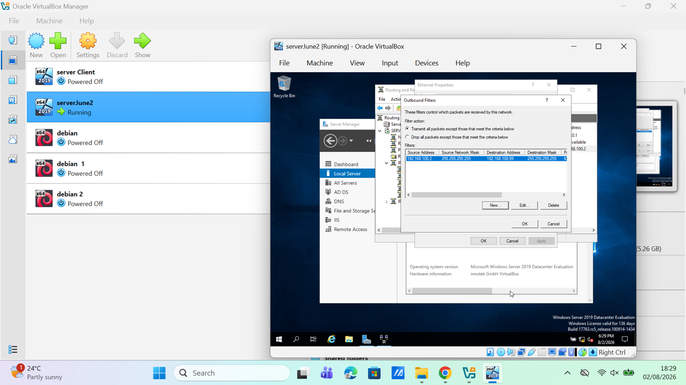

Figure 5. RRAS outbound filter list showing the configured source, destination and ICMP protocol entry.

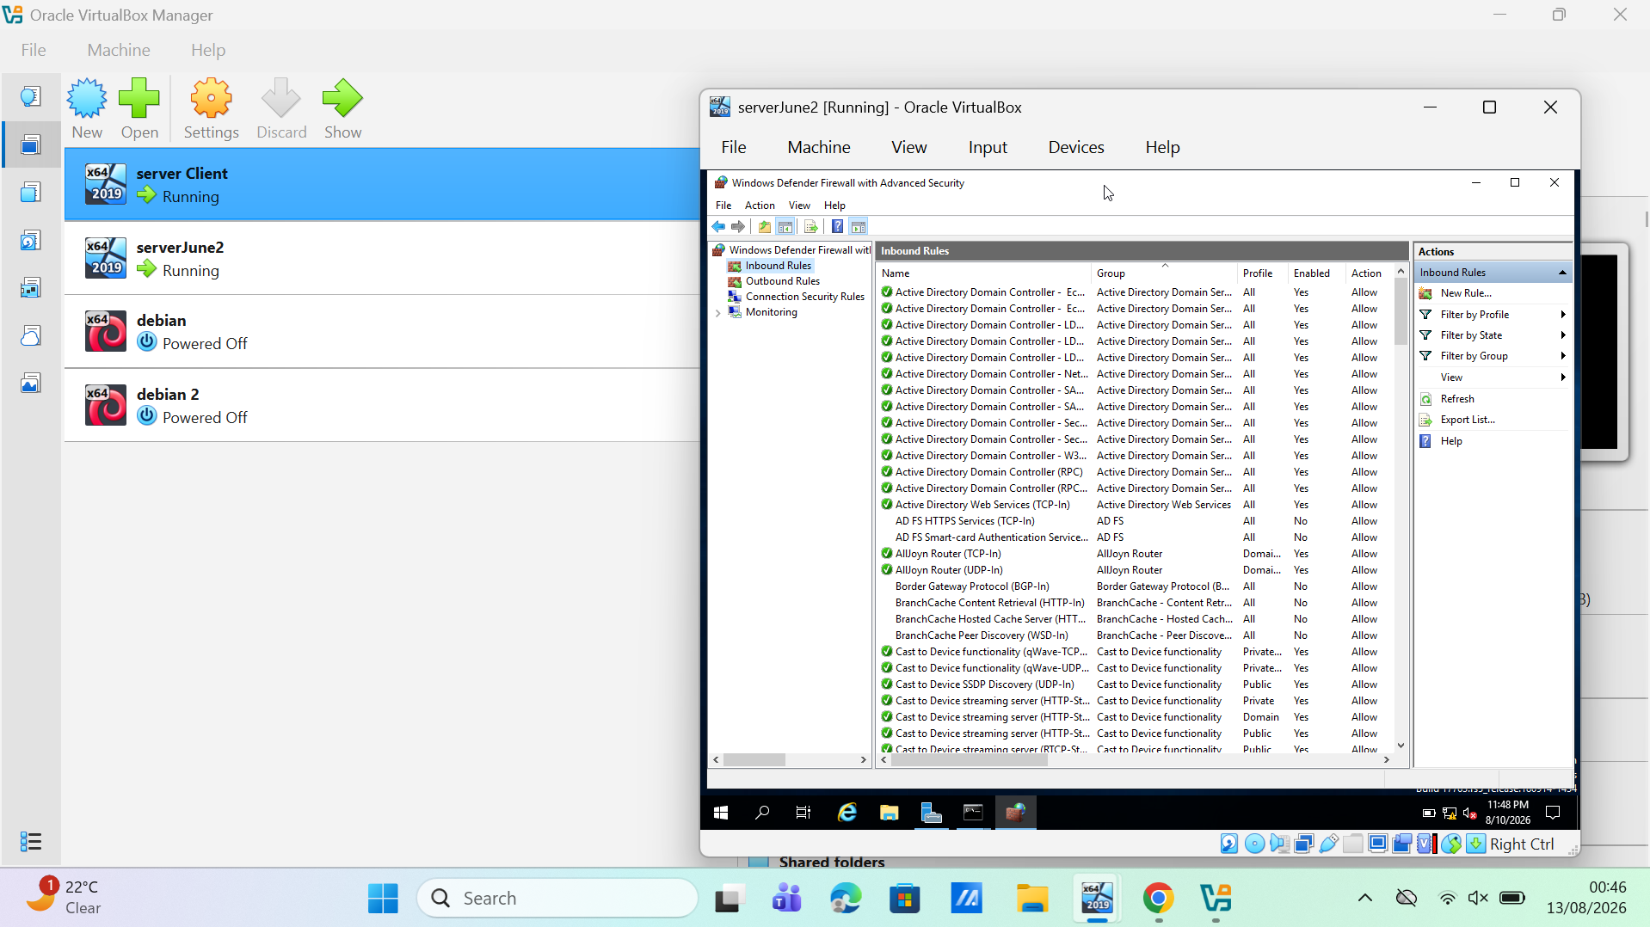

Figure 6. Windows Defender Firewall with Advanced Security showing the enabled inbound rules reviewed alongside the RRAS filter configurati

2.Domain Server and DNS

2.1. Active Directory Domain Services
Active Directory Domain Services (AD DS) provides central authentication, authorisation and policy management. The Birmingham server was assigned the AD DS and DNS roles and promoted to the first domain controller of the marzena.acca forest. Promotion of a new forest installs DNS when that option is selected, which enables the service records that domain members use to locate a controller. The Directory Services Restore Mode password was set during promotion and stored securely rather than embedded in a script. [4]
The domain also enforces an appropriate password and lockout policy. Fine grained password policies allow stricter rules to be applied to selected global groups or users, which is particularly relevant to privileged accounts. Figure 7 shows the AD DS and DNS roles installed alongside the other configured roles, Figure 8 shows the marzena.acca domain in Active Directory Users and Computers, confirming successful creation of the forest and domain, and Figure 9 shows the server as a member of marzena.acca with Remote Desktop enabled. [5]

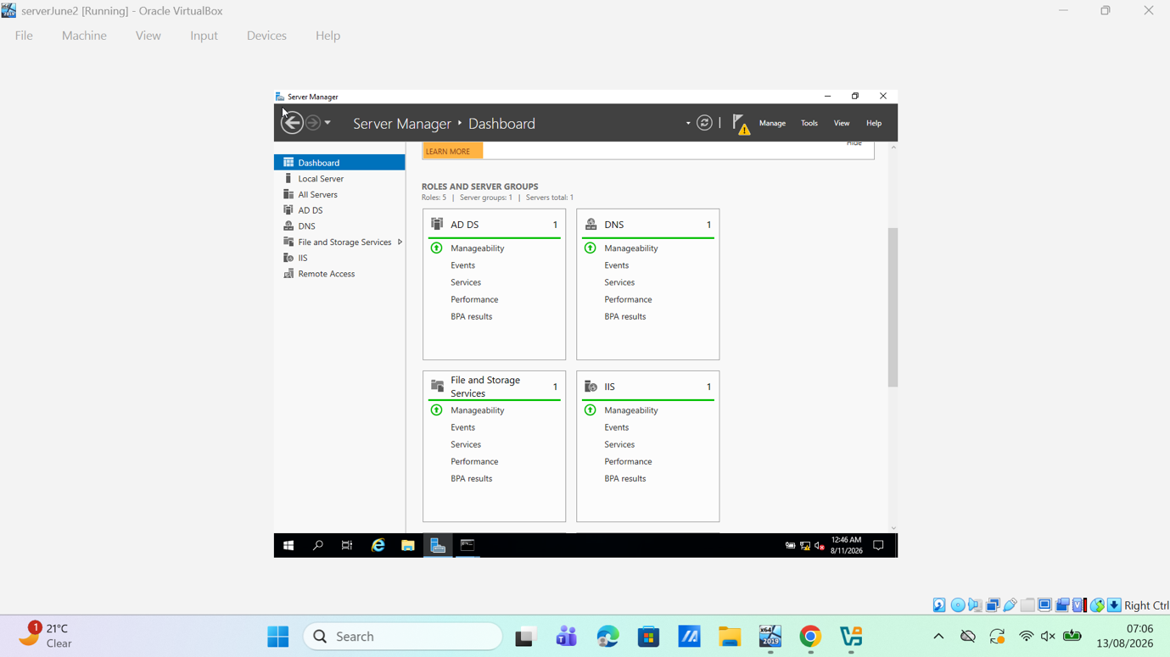
Figure 7. Server Manager dashboard showing the AD DS and DNS roles installed alongside the other configured server roles.

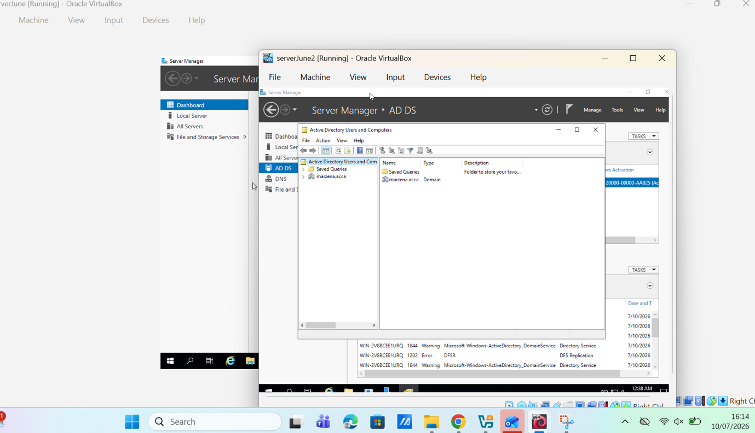
Figure 8. Active Directory Users and Computers displaying the marzena.acca domain, evidencing successful forest/domain creation.

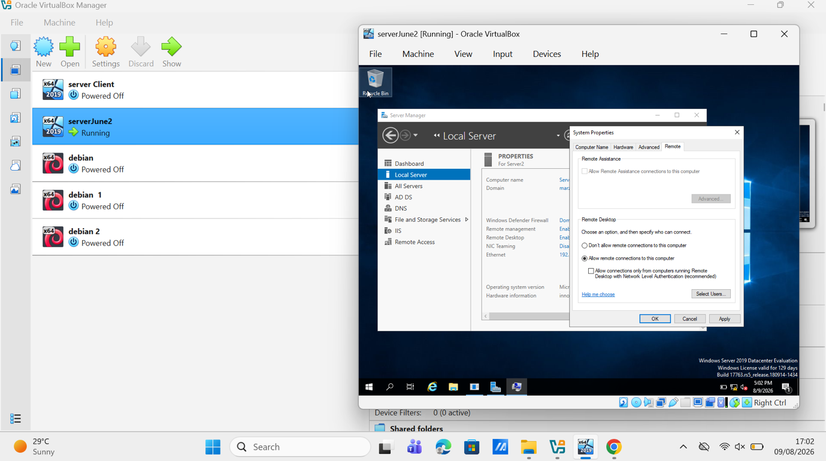
Figure 9. Server Manager and System Properties showing the server as a marzena.acca domain member and Remote Desktop enabled.

2.2 Forward Lookup Zone
A forward lookup zone maps names to IP addresses. A host (A) record was therefore created for each critical Windows and Linux server, routing endpoint and service that requires a stable name. The records include the domain controller and DNS server together with the host name used by the intranet site, webs.marzena.acca, which is described in Section 9. Creating records for infrastructure rather than for end user machines alone supports dependable domain joins, administration and service discovery. [6]

2.3 Reverse lookup zone and PTR records
A reverse lookup zone resolves an address back to a host name by using PTR records in the in-addr.arpa namespace. The wizard in Figure 10 creates the 100.168.192.in-addr.arpa zone for the 192.168.100.0/24 network, and Figure 11 shows the completed zone in DNS Manager. Figure 12 shows the zone contents with a PTR mapping for 192.168.100.30. Reverse resolution supports diagnostic checks and makes server logs easier to interpret. Additional subnets were given their own appropriately sized reverse zones so that later allocations can be represented without redesign. [7]

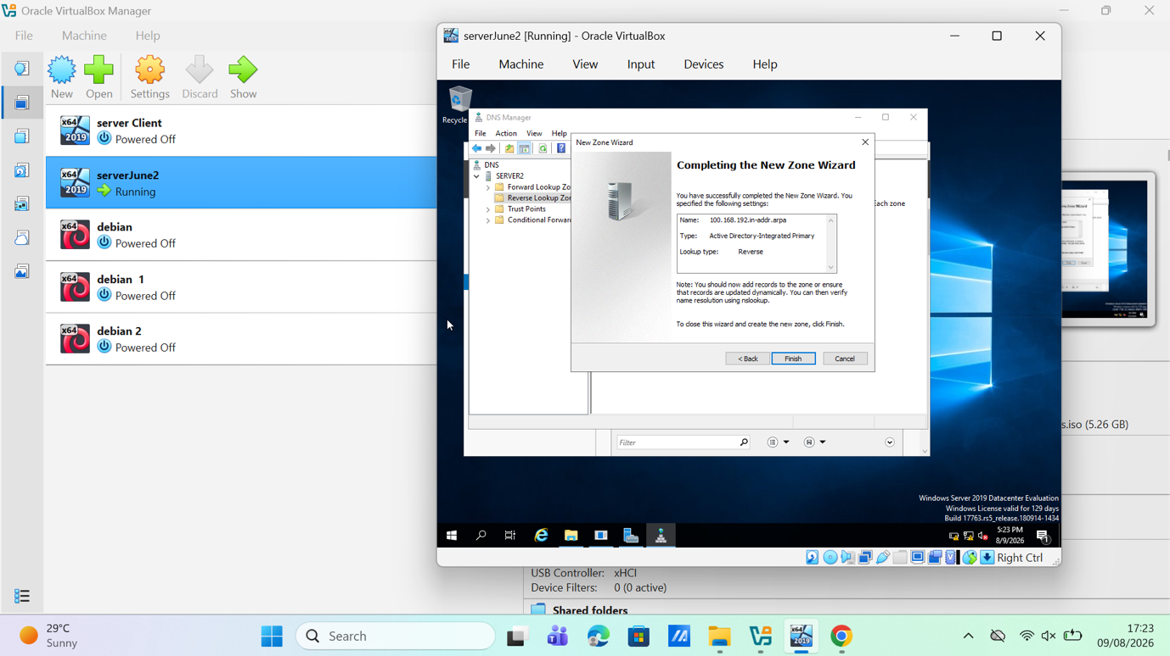
Figure 10. New Zone Wizard completion screen for the 100.168.192.in-addr.arpa Active Directory-integrated reverse lookup zone.

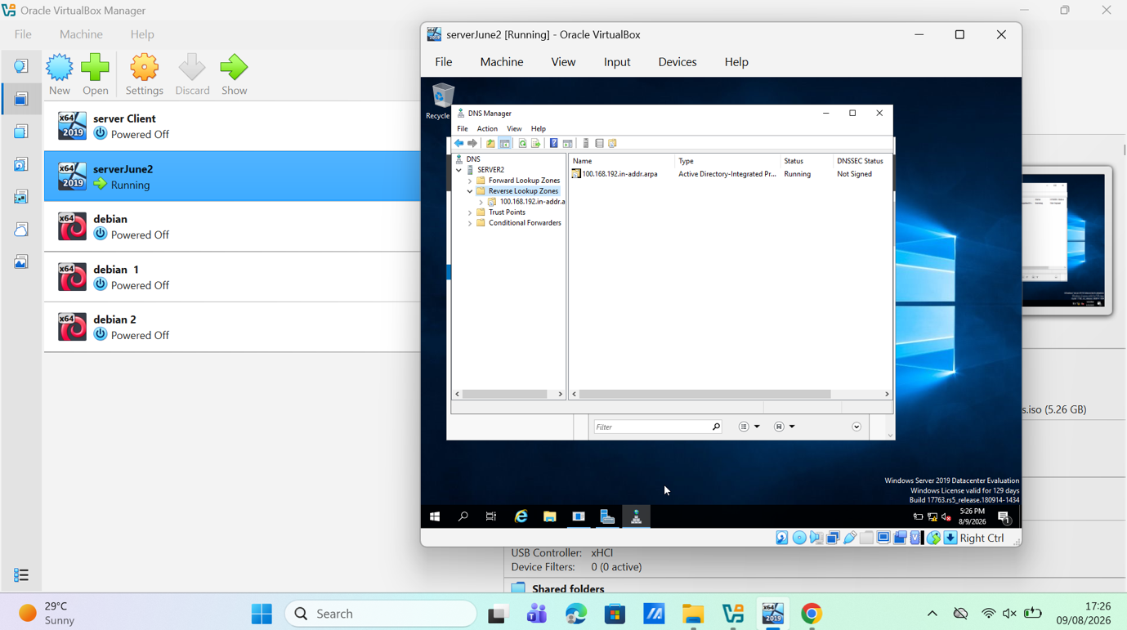
Figure 11. DNS Manager displaying the created reverse lookup zone.

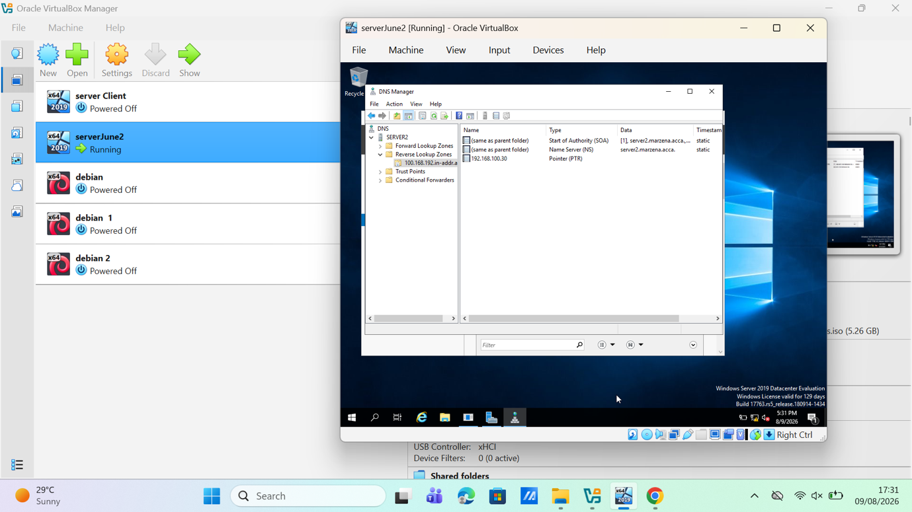

Figure 12. Reverse zone contents showing a PTR record for host address 192.168.100.30.

3.Encrypted Connection between Birmingham and London

A virtual private network (VPN) creates a protected logical path across an untrusted or shared network. In a site-to-site design, gateways protect traffic for complete subnets, allowing hosts at Birmingham and London to communicate without configuring a tunnel on every endpoint. IPsec can provide confidentiality, integrity, origin authentication, anti-replay protection and access control at the IP layer. IKEv2 performs mutual authentication and establishes and maintains the security associations used by IPsec. [8], [9]
RRAS was used to create a demand-dial interface named VPN London. Figure 13 shows the RRAS Ports view with the WAN Miniport entries that provide the VPN capable ports used by the routing service. Figure 14 shows the Demand-Dial Interface Wizard naming the new interface, and Figure 15 shows the static route that identifies the remote network as 192.168.100.0 with a 255.255.255.0 mask and a metric of 1. Figure 16 confirms that VPN London is enabled in the RRAS Network Interfaces view. IKEv2 with IPsec was selected as the tunnel type so that the link between the two sites provides mutual authentication, confidentiality and integrity rather than plain routed transport. [2], [8], [9]

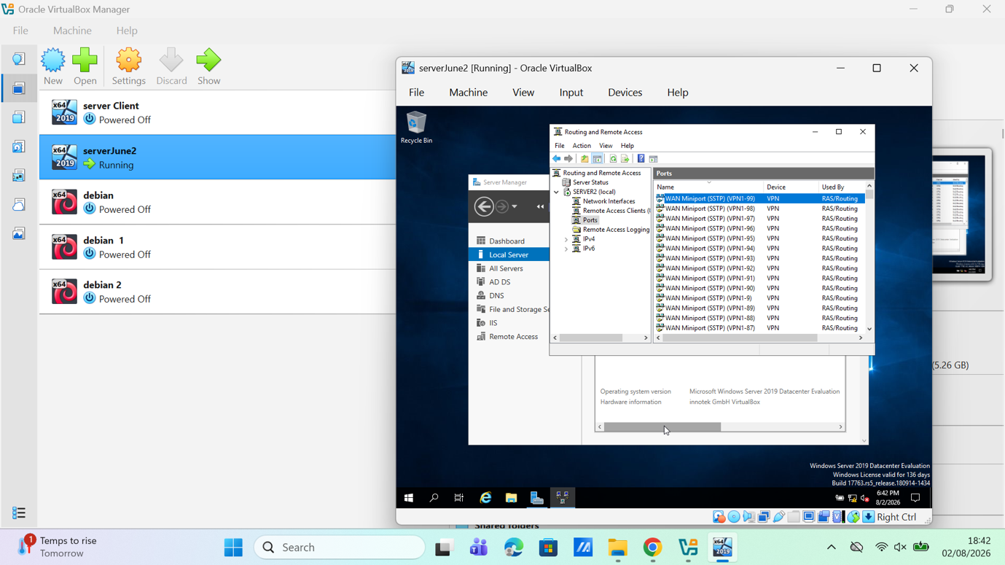

Figure 13. RRAS Ports view showing VPN-capable WAN Miniport entries used by RAS/Routing.

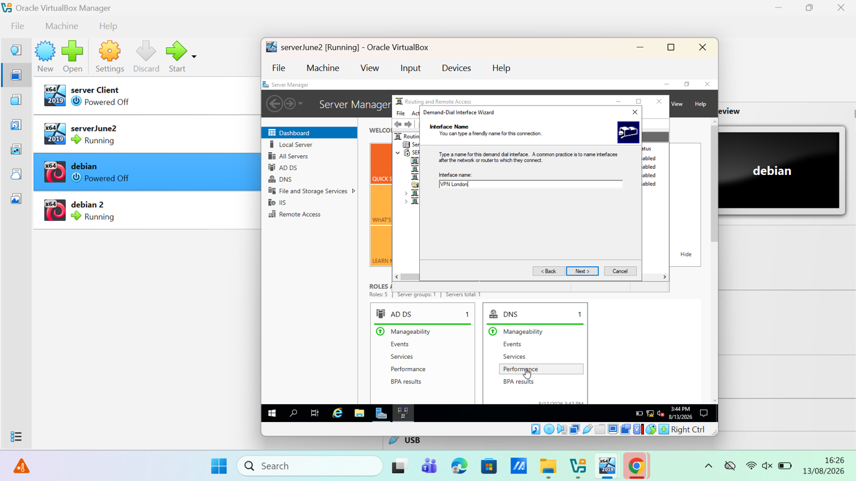

Figure 14. Demand-Dial Interface Wizard naming the new interface VPN London.

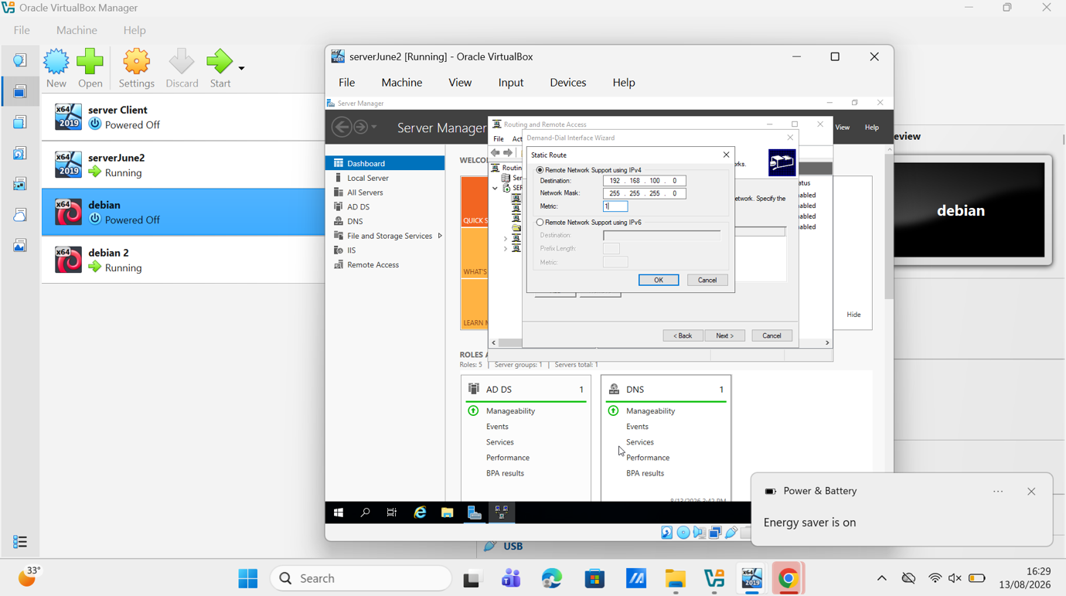

Figure 15. Static route definition for remote network 192.168.100.0/24 with metric 1.

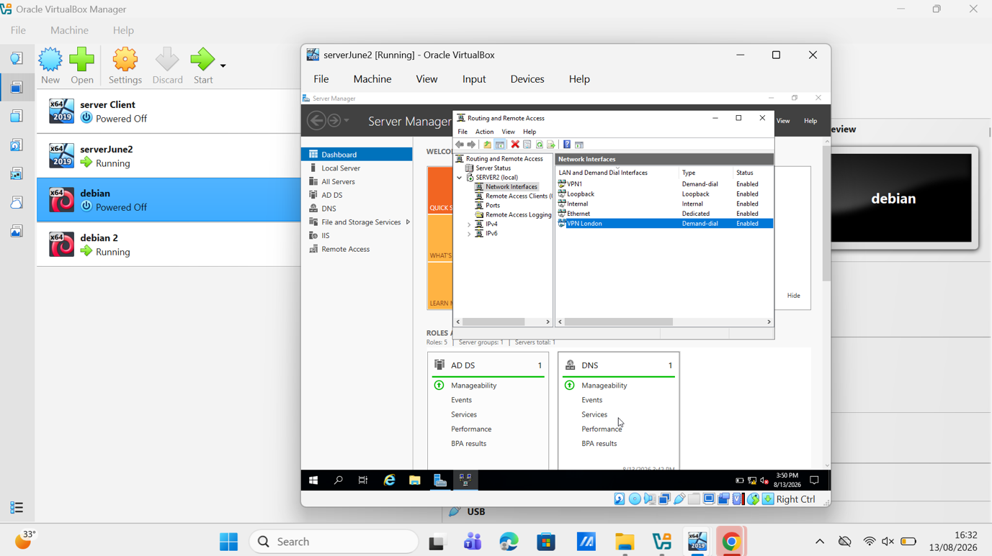
Figure 16. RRAS Network Interfaces view showing VPN London as an enabled demand-dial interface.

4.Users

Domain users were created under marzena.acca using the required sign-in convention: the lower-case initial of the first name, a full stop and the lower-case surname. Thus, Julie Kobryn becomes j.kobryn. The user principal name uses the same identifier in the marzena.acca domain. Figure 17 records the naming fields during account creation, and Figure 18 shows the resulting account properties and account options[10].
For the full list of accounts supplied for the assessment, the source spreadsheet was exported to CSV and processed with Import-Csv and New-ADUser. The script normalises the names, builds the sAMAccountName from the initial and the surname, sets the target organisational unit, applies an initial secure password, enables the account and logs any duplicate or failed record. Microsoft documents Import-Csv with New-ADUser as the supported bulk creation method, and it gives a consistent, repeatable result if the directory has to be rebuilt. [10].

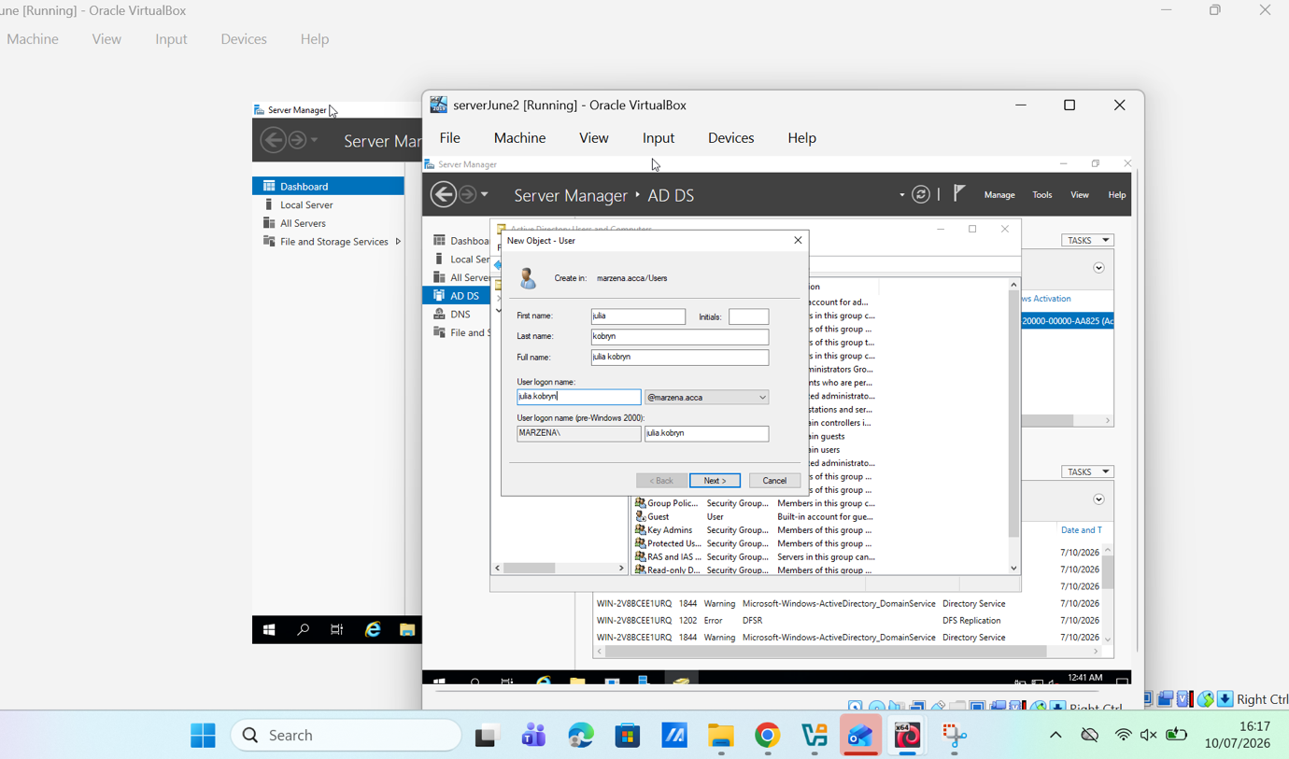
Figure 17. AD DS New Object User dialog showing the Julie Kobryn account and the j.kobryn naming pattern.

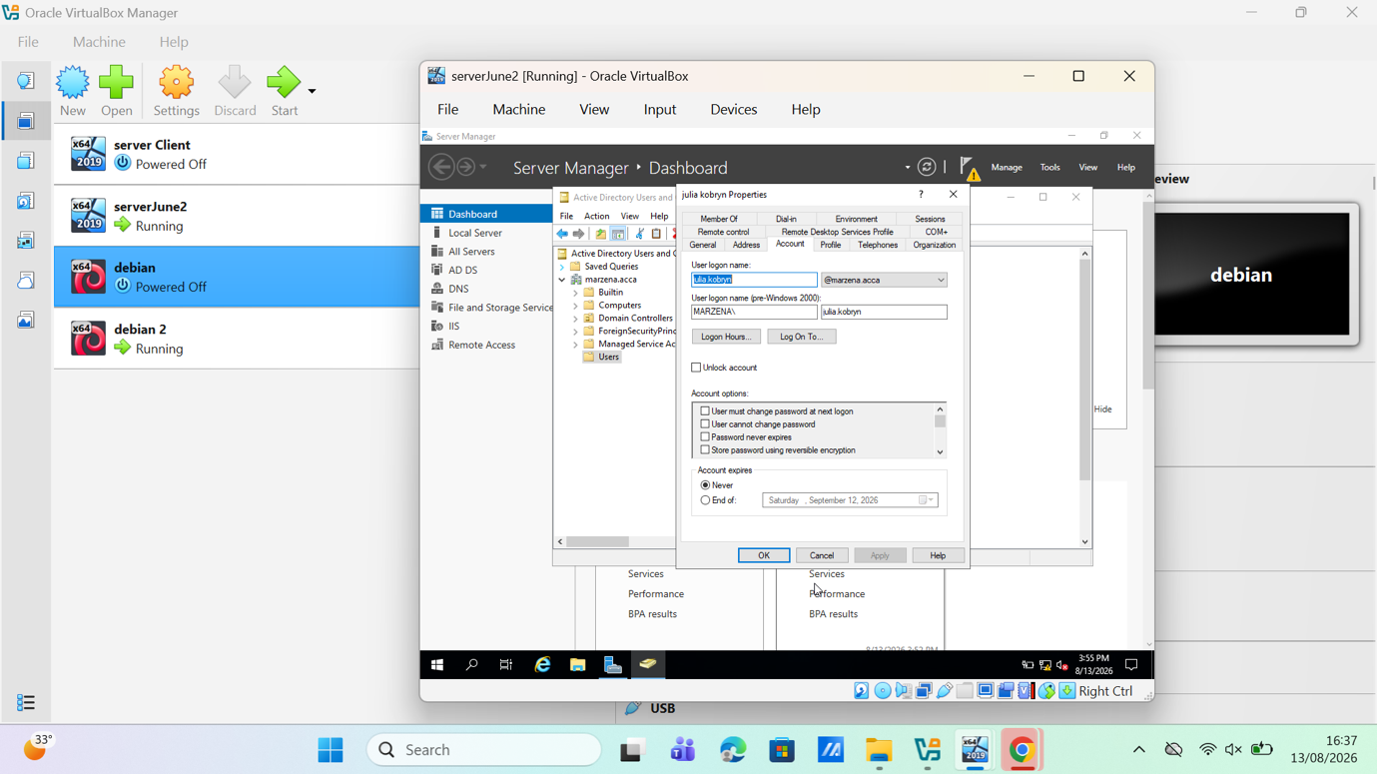
Figure 18. User account properties showing the marzena.acca logon suffix and configured account options.

5.Domain Membership
Before a machine can join the domain, its preferred DNS server must resolve marzena.acca and locate the domain controller. The client configuration in Figure 19 uses 192.168.100.2 as its default gateway and preferred DNS server, with a static address of 192.168.100.3/24. The machine was then changed from a workgroup to marzena.acca with authorised credentials and restarted. Windows supports the same workflow through the graphical interface or Add-Computer[11].
Figures 20 and 21 provide two complementary checks. Server Manager shows the client in the marzena.acca domain, and Active Directory Users and Computers contains the corresponding computer object in the Computers container. The same procedure was applied to the other machines named in the specification, each of which was pointed at the domain controller for name resolution before the join was performed[11].

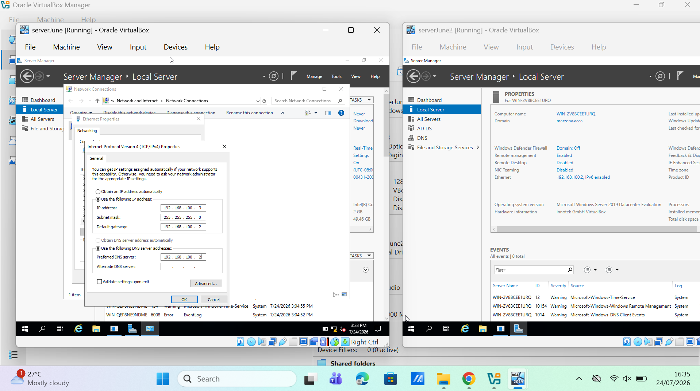
Figure 19. Client IPv4 configuration showing address 192.168.100.3/24 and gateway/DNS server 192.168.100.2.

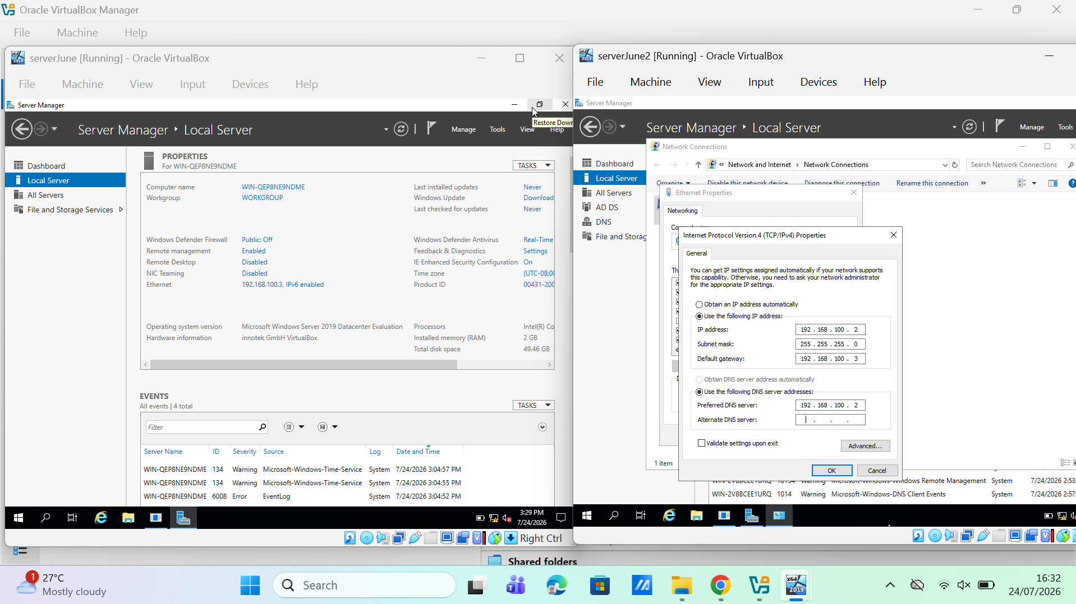

Figure 20. Server Manager Local Server view showing the client’s domain changed from WORKGROUP to marzena.acca.

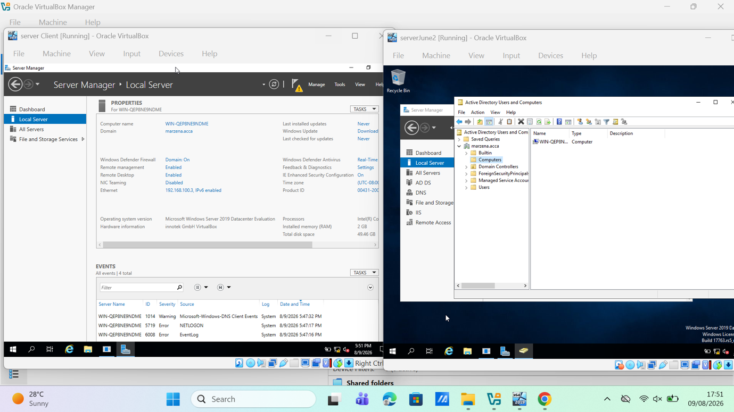

Figure 21. Active Directory Users and Computers showing the joined computer object in the Computers container.

6.DHCP Server

Dynamic Host Configuration Protocol (DHCP) automatically assigns clients the IPv4 settings required for network communication, including an IP address, subnet mask, default gateway and DNS server. This reduces manual configuration and addressing errors. Each /24 subnet provides 254 usable host addresses. Address allocation follows the Discover, Offer, Request and Acknowledgement (DORA) process[12].

6.1 Configure B-DC as the DHCP Server
B-DC was configured and authorised as the DHCP server. Two /24 scopes were created: 192.168.100.10 to 192.168.100.20 for Birmingham and 192.168.101.10 to 192.168.101.20 for London. Each scope uses the 255.255.255.0 subnet mask and provides the relevant default gateway, B-DC as the DNS server and marzena.acca as the domain name.

6.2 Configure L-CD as the DHCP Relay Server
Because DHCP broadcasts do not cross routers, the DHCP Relay Agent was configured in RRAS on L-CD. It receives requests from London clients and forwards them to B-DC, which allocates addresses from the London scope and returns the responses through L-CD [13].

6.3 Configure Clients to Receive Addresses Automatically
All clients were configured to obtain their IP address and DNS settings automatically. Birmingham clients receive addresses directly from B-DC, while London clients use the relay on L-CD. Successful allocation can be confirmed with ipconfig /all and the Address Leases list in DHCP Manager.

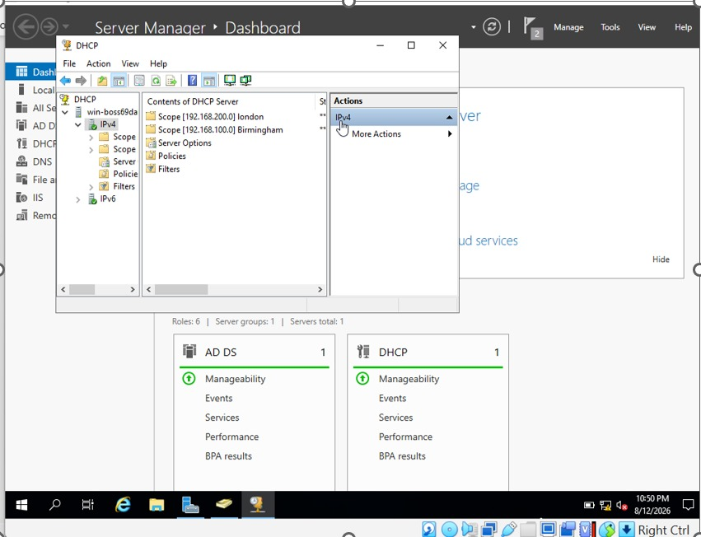
Figure 21(a) .DHCP scopes configured and authorised on B-DC.

7.Test and Troubleshoot
Connectivity was checked with ICMP echo requests once the routing and firewall work was complete. Figure 22 shows Debian host 192.168.101.235 receiving four replies from Windows host 192.168.100.2 with no packet loss. This exchange crosses the 192.168.101.0/24 and 192.168.100.0/24 networks and therefore provides operational evidence that the gateways, routes and ICMP policy permit the tested path. Figure 23 shows the Windows client at 192.168.100.3 receiving four replies from 192.168.100.2 with no loss, confirming connectivity within the Birmingham subnet. Testing at both scopes separates a local addressing fault from a routing fault, which makes troubleshooting faster [3].

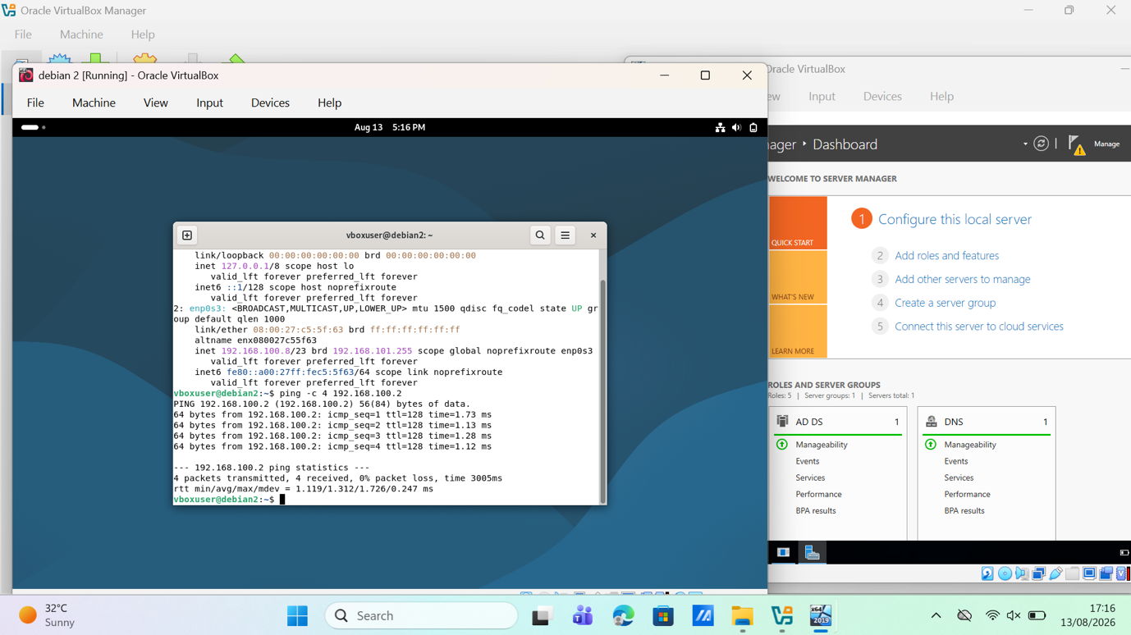

Figure 22. Debian-to-Windows ping from 192.168.101.235 to 192.168.100.2: four replies and 0% packet loss.

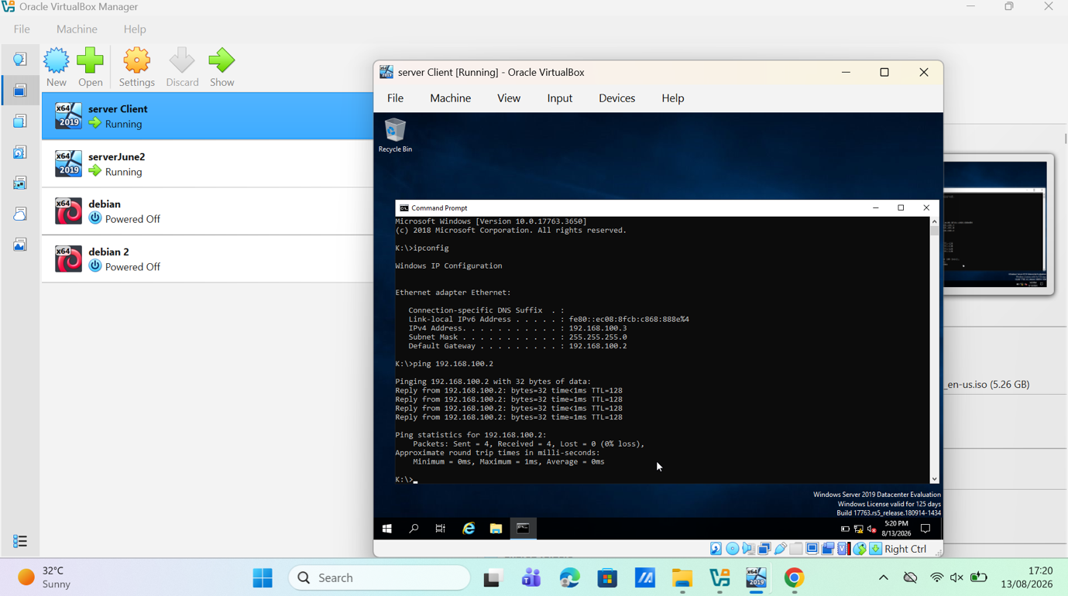
Figure 23. Windows to Windows ping from 192.168.100.3 to 192.168.100.2: four replies and 0% packet loss.

8.Disk Drive and Shared Folder
Centralised file storage allows domain users to reach organisational data from either network while administrators apply consistent access control. The second disk was brought online, initialised and mounted as E:\BirminghamFiles, then published through SMB. Both the share permissions and the NTFS access control list were configured: Domain Users hold Full Control as required by the specification, while other network users hold read only access. Permissions were granted through security groups rather than to individual accounts, which keeps the design aligned with least privilege and simplifies later review [14].
Figure 24 shows the mapped network location labelled uwstd, hosted by Server2 and visible from the signed in client with its available capacity. Permission behaviour was then tested functionally by creating, modifying and deleting a test file as a Domain User, and by confirming that the restricted identity could open the same file but could not alter or remove it[14].

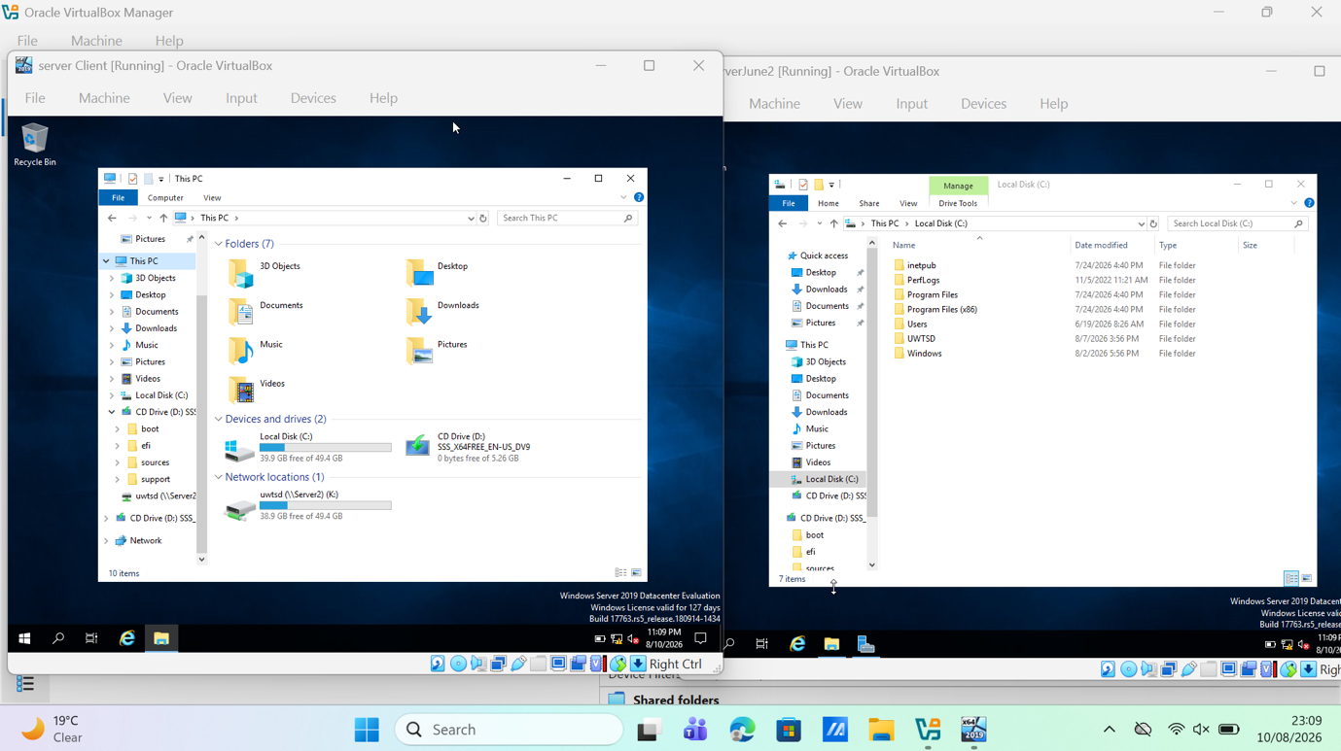

Figure 24. Client This PC view showing the mapped network location hosted by Server2.

9.IIS Server

9.1 Internal website and Windows Authentication
Internet Information Services (IIS) provides the web server platform for the internal site webs.marzena.acca. The IIS role and the Windows Authentication feature were installed, a DNS A record was created for the webs host name, the site was bound to that host name, an HTTPS certificate was applied, and the default page was set to display the text Welcome to Birmingham Website. Anonymous Authentication was disabled and Windows Authentication enabled so that access is tied to authenticated domain credentials [6], [15].
Figure 25 shows Windows Authentication enabled and Anonymous Authentication disabled in IIS Manager, which satisfies the authentication requirement and means that a domain user is challenged before the page is served. Figure 26 shows the IIS service responding in the browser, confirming that the web server is operational on the Birmingham server. Serving the site over HTTPS with an authenticated identity keeps both the transport and the access decision protected on an internal network[15].

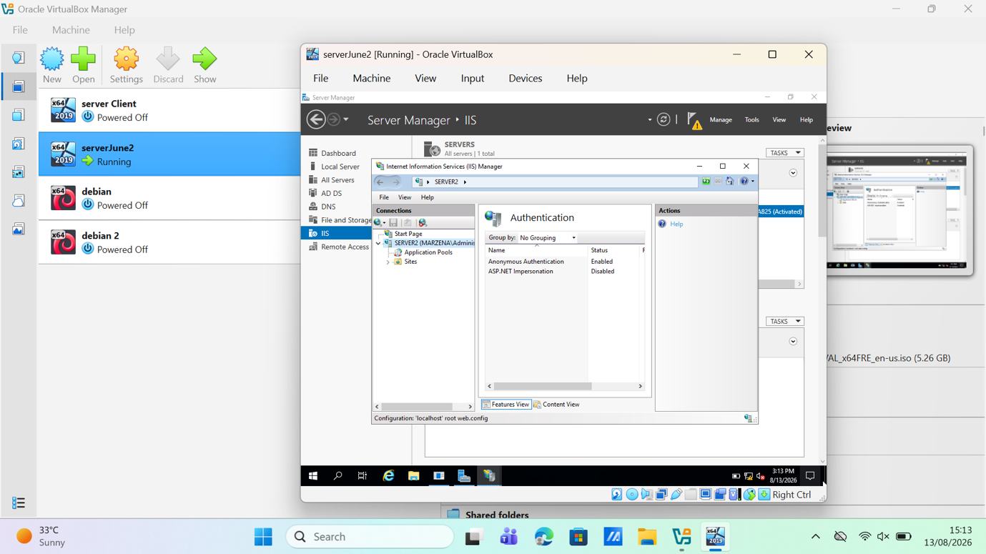

Figure 25. IIS Authentication feature with Windows Authentication enabled and Anonymous Authentication disabled.

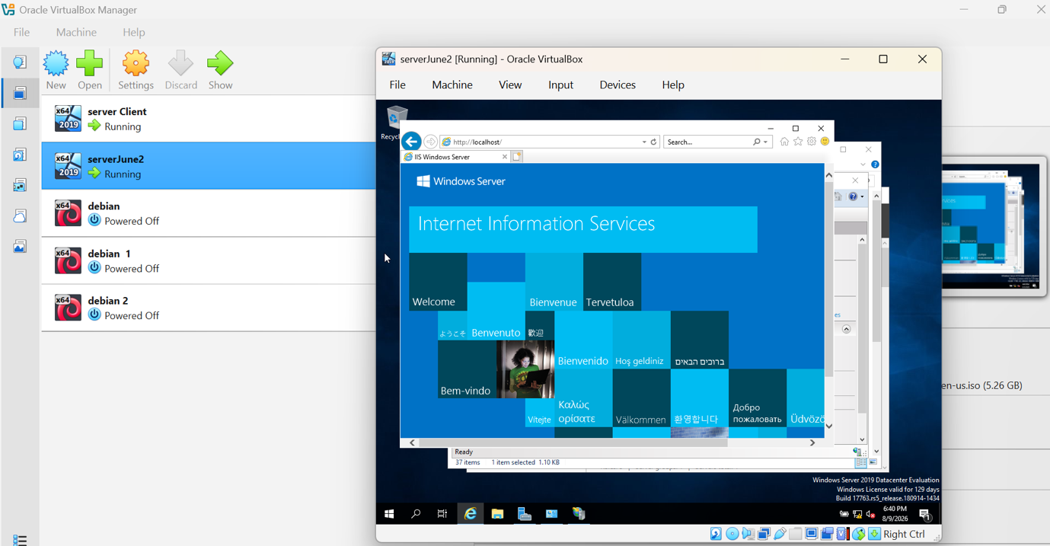

Figure 26. Default IIS page loading at http://localhost, confirming that the local IIS web service is operational.

10.Remote Desktop Services

Remote Desktop permits an authorised user to administer a Windows server from another machine. The Birmingham server was configured to allow remote connections; authorised accounts and the Remote Desktop firewall rules are required for a successful session. Because enabling RDP exposes a management service, access should be limited to trusted networks and necessary users, with Network Level Authentication and strong credentials used wherever possible[16].
Figure 27 shows Server2 inside a client Remote Desktop window. The blue connection bar identifies the active remote target, while Server Manager reports Remote Desktop as enabled together with the marzena.acca domain and IP configuration. This is direct evidence that the client established a usable administrative session to Server2[16].

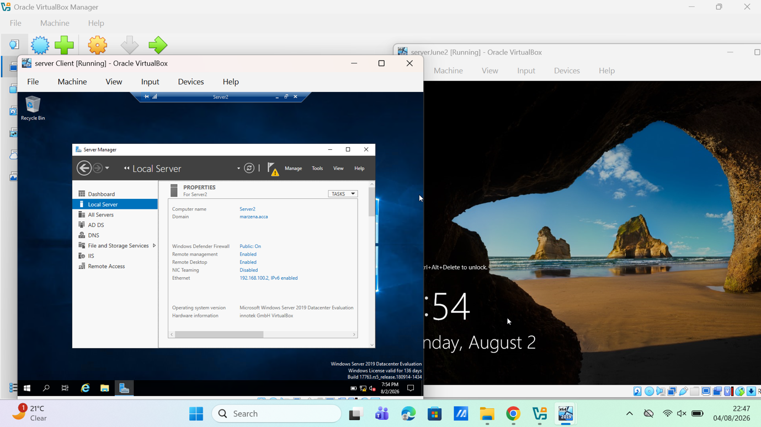

Figure 27. Active client Remote Desktop session to Server2; Server Manager shows the server in marzena.acca with Remote Desktop enabled.

Conclusion
The implementation delivers a working Windows Server laboratory across two connected sites. RRAS routing and scoped firewall filters are configured; the marzena.acca forest, the forward records and the reverse DNS zone are in place; a demand-dial interface and static route connect London to Birmingham over IKEv2 with IPsec; domain accounts follow the required naming convention and clients are joined to the domain; DHCP supplies addressing to both subnets through a relay agent; cross subnet and same subnet connectivity tests return four replies with no packet loss; the shared volume is published with differentiated permissions; the intranet site runs under Windows Authentication; and a live Remote Desktop session reaches Server2. The screenshots presented throughout the report record each of these stages as it was completed.
Taken together, the results show that routing, central identity, name resolution, addressing, storage and remote administration were integrated into a single coherent environment rather than completed as isolated tasks. The design decisions that most affect its resilience are the use of restrictive, host specific firewall filters instead of broad exceptions, the delegation of share access through security groups, and the choice of IKEv2 with IPsec for the link between the sites. A natural extension of the work would be to add a second domain controller for redundancy, to introduce Group Policy for consistent client configuration, and to enable DHCP failover so that addressing survives the loss of the Birmingham server.

References
[1]. Microsoft, “Remote Access,” Microsoft Learn, Jun. 2023. [Online]. Available: https://learn.microsoft.com/en-us/windows-server/remote/remote-access/remote-access. [Accessed: 13 Aug. 2026].
[2]. Microsoft, “How to install and configure Remote Access (RAS) as a VPN server,” Microsoft Learn, 2025. [Online]. Available: https://learn.microsoft.com/en-us/windows-server/remote/remote-access/get-started-install-ras-as-vpn. [Accessed: 13 Aug. 2026].
[3]. J. Postel, “Internet Control Message Protocol,” RFC 792, Sep. 1981, Doi: 10.17487/RFC0792. [Online]. Available: https://www.rfc-editor.org/info/rfc792. [Accessed: 13 Aug. 2026].
[4]. Microsoft, “Install Active Directory Domain Services,” Microsoft Learn, 2025. [Online]. Available: https://learn.microsoft.com/en-us/windows-server/identity/ad-ds/deploy/install-active-directory-domain-services--level-100-. [Accessed: 13 Aug. 2026].
[5]. Microsoft, “Configure fine-grained password policies for Active Directory Domain Services,” Microsoft Learn, 2025. [Online]. Available: https://learn.microsoft.com/en-us/windows-server/identity/ad-ds/get-started/adac/fine-grained-password-policies. [Accessed: 13 Aug. 2026].
[6]. Microsoft, “Manage DNS resource records using DNS server on Windows Server,” Microsoft Learn, 2023. [Online]. Available: https://learn.microsoft.com/en-us/windows-server/networking/dns/manage-resource-records. [Accessed: 13 Aug. 2026].
[7]. Microsoft, “DNS reverse lookups in Windows and Windows Server,” Microsoft Learn, 2025. [Online]. Available: https://learn.microsoft.com/en-us/windows-server/networking/dns/reverse-lookup. [Accessed: 13 Aug. 2026].
[8]. S. Kent and K. Seo, “Security Architecture for the Internet Protocol,” RFC 4301, Dec. 2005, Doi: 10.17487/RFC4301. [Online]. Available: https://www.rfc-editor.org/info/rfc4301. [Accessed: 13 Aug. 2026].
[9]. C. Kaufman, P. Hoffman, Y. Nir, P. Eronen and T. Kivinen, “Internet Key Exchange Protocol Version 2 (IKEv2),” RFC 7296, Oct. 2014, Doi: 10.17487/RFC7296. [Online]. Available: https://www.rfc-editor.org/info/rfc7296. [Accessed: 13 Aug. 2026].
[10]. Microsoft, “New-AD User,” Microsoft Learn, Active Directory PowerShell module, 2025. [Online]. Available: https://learn.microsoft.com/en-us/powershell/module/activedirectory/new-aduser. [Accessed: 13 Aug. 2026].
[11]. Microsoft, “Join a computer to a domain,” Microsoft Learn, 2025. [Online]. Available: https://learn.microsoft.com/en-sg/windows-server/identity/ad-ds/manage/join-computer-to-domain. [Accessed: 13 Aug. 2026].
[12]. R. Droms, “Dynamic Host Configuration Protocol,” RFC 2131, Mar. 1997, doi: 10.17487/RFC2131. [Online]. Available: https://www.rfc-editor.org/info/rfc2131. [Accessed: 13 Aug. 2026].
[13]. Microsoft, “Install DHCP relay agent for Windows Server,” Microsoft Learn, 2024. [Online]. Available: https://learn.microsoft.com/en-us/windows-server/networking/technologies/dhcp/dhcp-deploy-relay-agent. [Accessed: 13 Aug. 2026].
[14]. Microsoft, “Share and NTFS permissions,” Microsoft Learn, 2022. [Online]. Available: https://learn.microsoft.com/en-us/iis/web-hosting/configuring-servers-in-the-windows-web-platform/configuring-share-and-ntfs-permissions. [Accessed: 13 Aug. 2026].
[15]. Microsoft, “Windows Authentication <windows Authentication>,” Microsoft Learn, 2022. [Online]. Available: https://learn.microsoft.com/en-us/iis/configuration/system.webServer/security/authentication/windowsAuthentication/. [Accessed: 13 Aug. 2026].
[16] Microsoft, “Enable Remote Desktop,” Microsoft Learn, 2025. [Online]. Available: https://learn.microsoft.com/en-us/windows-server/remote/remote-desktop-services/remotepc/remote-desktop-allow-access. [Accessed: 13 Aug. 2026].

