Title: Strategic Plan for Café Nero

Student ID: 2133271
Student Name: Pavlina Pavlova

Module: Strategic Management for SMEs
Module Code: BMSW 6104
Lecturer: Dr. Oluwaseun (Olu) Adegbite

Table of Contents

Task 01- Individual Academic Report 3
1. Introduction 3
2. Critical Appraisal of Café Nero’s Current Strategy 4
3. Critical Analysis of Café Nero’s External and Internal Environment 6
4. Stakeholder Analysis of Café Nero 8
5. Strategic Growth Options for Café Nero 10
6. Strategic Recommendations for Café Nero 12
7. Competitor Reactions and Mitigation Strategies 14
8. Conclusion 16
Task 02 – Poster Presentation 17
References 18

Task 01- Individual Academic Report

1. Introduction
Overview of Café Nero
Café Nero, founded in 1997, is a globally renowned coffeehouse chain with over 1,000 outlets operating in 11 countries (Caffè Nero, 2023). The company is celebrated for its authentic Italian-inspired coffee culture, offering premium beverages crafted with high-quality ingredients and served in welcoming environments. Unlike major competitors such as Starbucks and Costa Coffee, Café Nero differentiates itself by prioritizing artisanal coffee-making and fostering a unique sense of community within its stores (Financial Times, 2021).
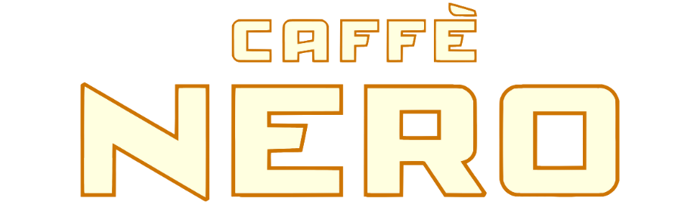
Figure 01. Cafe Nero
Source. https://www.caffenero.com/
Café Nero’s mission is to deliver premium coffee, and a café experience centered around quality, comfort, and connection. Its strategic vision is to increase its operational outlets overseas accompanied by the integration of sustainable strategies to meet the changing customer and legal demands (Caffè Nero, 2023).
Purpose and Objectives
The existing strategic plan of Café Nero is assessed in this report and practical suggestions for development are analyzed. A coffee market is very dynamic, undergoing changes in response to such factors as client demand for environmentally sustainable actions and increased technological involvement. In other words, Café Nero has to meet these trends with the competition brewing.
Objectives:
- To understand the current position of Café Nero more deeply, it is important to use the instruments as Porter’s Five Forces and PESTLE analysis.
- To assess the internal and external environment that drives the market outcome in the organization, including stakeholder demands and sustainable development goals.
- To formulate proposals that would help Café Nero become more competitive and impervious to volatility both at the present and in the future, the following tactics need to be included among the key activities.
Such assessment allows offering the outline for the improvement of Café Nero’s strategic positioning in the competitive global environment.
2. Critical Appraisal of Café Nero’s Current Strategy
Evaluation of Current Strategy
Café Nero is a global player in the coffee market as reflected by its strategic orientations towards delivering quality products and services especially to its valued clients besides promoting the principles of sustainability.
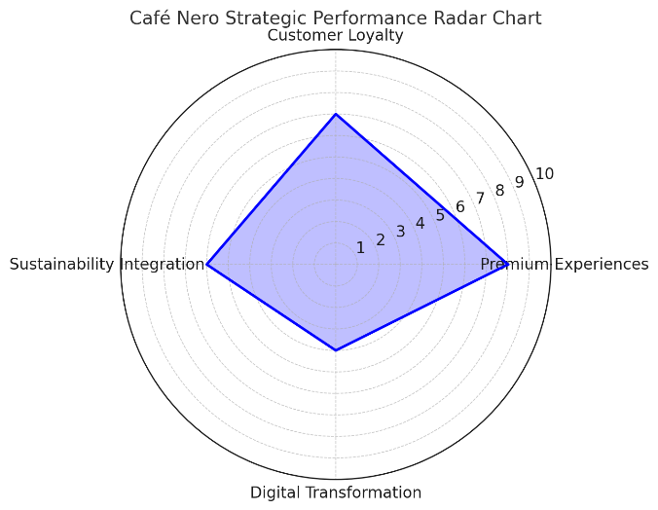
Figure 03. Café Nero Strategic Performance Radar Chart
Source. Self-Created

Above is the radar chart showing Café Nero’s strategic performance ratios.
The customer loyalty program to improve the repeat sales interaction program is a reward and offer program. Also, the brand focuses on the quality of coffee, using the Italian style in interiors (Caffè Nero, 2023). However, its digital transformation journey is slow compared to Starbucks where elaborate new services such as mobile ordering and even personalization using artificial intelligence have already been established by the year 2024 (Forbes, 2024).
While focusing on sustainability, Café Nero has already engaged in cooperation with suppliers for ethical sourcing and cut down on plastic packaging.
Nevertheless, it faces challenges in communicating these efforts effectively to eco-conscious consumers. Its strategy appears moderately aligned with its mission of providing a high-quality, Italian-inspired coffeehouse experience while supporting environmental and social responsibility. However, the evolving competitive landscape necessitates further innovation and differentiation to remain relevant.
Strategic Analysis Tool: Porter’s Five Forces
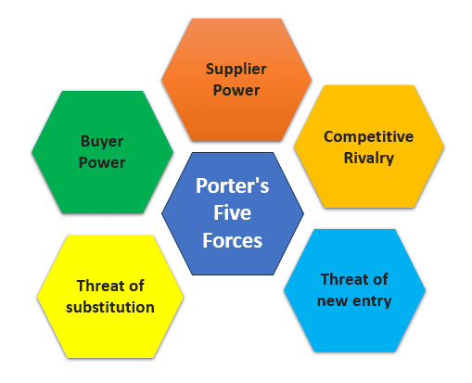
Figure 03. Porter’s Five Forces
Source. https://sixsigmastudyguide.com/porters-five-forces/

- Bargaining Power of Buyers:
Customers in the coffee market hold moderate power due to the wide availability of alternatives. Loyalty programs partially mitigate this by incentivizing repeat visits, but the brand must continuously innovate to retain consumer interest (Porter, 2008).
- Bargaining Power of Suppliers:
Café Nero sources premium coffee beans, which limits supplier options and increases dependence on ethical suppliers. This high dependence enhances supplier power, especially with rising raw material costs (Statista, 2023).
- Competitive Rivalry:
Competition with Starbucks and Costa Coffee remains intense, given their larger market share and superior digital capabilities. Differentiation through quality and authenticity is key to mitigating this rivalry (Financial Times, 2021).
- Threat of Substitutes:
The rise of specialty teas, ready-to-drink beverages, and at-home coffee machines poses a significant threat. Café Nero can address this by diversifying its product range to include innovative and health-focused options (Euromonitor, 2023).
- Threat of New Entrants:
Barriers to entry in the coffee market are moderate. While brand loyalty provides some protection, independent coffeehouses and new chains are entering the market with sustainable and niche offerings (IBISWorld, 2023).
Alignment with Mission and Vision
Café Nero’s current strategy aligns moderately well with its mission to provide a high-quality, Italian-inspired coffeehouse experience. While its focus on quality and customer loyalty reinforces its mission, the growing emphasis on sustainability could be better integrated into its vision to enhance alignment with consumer trends and expectations (Caffè Nero, 2023). Further investments in digital transformation and sustainability initiatives will be crucial for long-term growth and competitiveness.
3. Critical Analysis of Café Nero’s External and Internal Environment
Café Nero operates in a dynamic and competitive coffeehouse market that requires a comprehensive understanding of both external and internal factors influencing its performance. This section examines Café Nero’s strategic environment as played out using the PESTLE and SWOT tools in considering likely prospects and challenges.
PESTLE Analysis: External Environment
The PESTLE framework examines the macro-environmental factors that influence Café Nero’s operations:
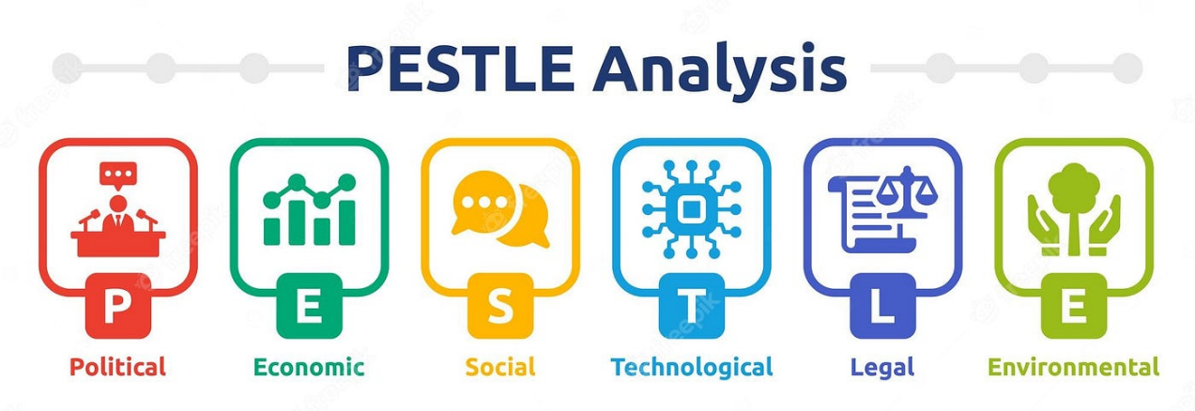
Figure 04. PESTLE Framework
Source. https://medium.com/@anirbanmukherjee1311/pestle-analysis-c6b822164d4
- Political:
State legislation promoting sustainability operations has a major influence on Café Nero. Ethical sourcing policies and directions towards the minimization of carbon footprint are stated in the European Union and the United Kingdom (Fallon, 2020). Café Nero’s current endeavors to source ethical coffee would also best fit such requirements; and could also provide a competitive advantage within compliance environments.

- Economic:
There is inflation and soaring cost of raw material for coffee beans which are potent risks to Café Nero. Global coffee prices have risen by over fifteen percent in one year, and according to the International Coffee Organization, this pressure’s profit margins. This is because economic uncertain factors also impact on consumer expenditure hence affordability is the key to customer retention.
- Social:
Current market trends show that there is a rising interest by the consumers in green and sustainability certified products (Euromonitor, 2023). Consumers of Café Nero’s target group – Millennials and Gen Zs, prefer to patronize establishments that can pass sustainability tests. Another way through which customers demand that Café Nero must meet is through the minimization of the use of plastics as well as other environmental conservation measures.
- Technological:
Digital technology growth has been embraced by the coffee industries as they shift the customer expectations. With application, personalization through artificial intelligence and payment solutions Starbucks has leapfrogged competitors now (Gumbelevičienė, 2016). Nonetheless, Café Nero must be considered as having a quite limited digital marketing strategy which poses a threat to its relative competitiveness if the organization must rely on more technology.
- Legal:
It is important for Café Nero to ensure that the consumers, employees and the organization in general complies with food safety standard, law on employment and laws on protection of data. The GDPR in Europe requires Companies to adhere strictly to measures that would protect customer information which is an issue to Café Nero particularly when it advances on its digital services (Financial Times, 2021).
- Environmental:
The preparation and production of coffee have for a long time come under pressure over its impacts on the environment. To promote the enhanced consumption of sustainable coffee Nero’s strategies of avoiding single-use plastics are crucial to sustaining a competitive position since the market is shifting to be more sensitive to environmental issues (International Coffee Organization, 2023).
SWOT Analysis: Internal and External Environment
The SWOT analysis highlights Café Nero’s internal strengths and weaknesses, as well as external opportunities and threats:
- Strengths: High-grade coffee as well as Italian environment distinguish Café Nero from competitors. Its built sustainability strategies including the ethical sourcing of materials as well as efforts in waste minimization attract green clients. Also, from its sales aspect, the company seems to have established a customer loyalty program to generate stable revenue (Caffè Nero, 2023).
- Weaknesses: While today, Café Nero’s digital solutions are far behind competitors such as Starbucks, capable of providing a completely contactless mobile ordering experience and using artificial intelligence to create personal offers. Some of the few operational efficiencies like reliance on only premium suppliers lead to high cost and exposure to variability. These inefficiencies confined to scaling up rankle its capacity to seize the market opportunities within the shortest time possible (Forbes, 2024).
- Opportunities: Prospects can be viewed in the EMS countries such as Asia and some of the Middle Eastern nations, where the market for coffeehouse environmental experiences steadily grows (Euromonitor, 2023). Additionally, technology continues to grow, and Café Nero can take advantage of it to increase its impacts to the customers as well as increase efficiency. Moreover, the enhancement in sustainability measurement can be the key to Café Nero success as a company as well as its market position: increasing utilization of eco-friendly measures, including making the company’s operations carbon-neutral.
- Threats: Two key threats, namely an increased number of competitors especially players such as Starbucks and Costa Coffee and growth of local coffee shops are major threats facing Café Nero in the market share. Such as, inflation and following reduced consumer spending, as well as other economical instabilities also negatively affect profitability. The trend by evolving a perceptions of at-home coffee solutions, ready to drink beverages, is another challenging factor (Statista, 2023).
Key Insights and Big Picture
The assessment highlights many strategic factors influencing Café Nero. The company's brand image and environmentally responsible practices are strong, but its lack of digital innovation and operational inefficiencies may hurt its competitiveness. External risks include increasing competition, saturation, and new rivals and threats of current competitors developing new products or services provide exciting chances like entering new emerging markets and introducing environmental problems. However, rivals, economic changes, and replacement concerns need early action to strengthen Café Nero's strategic position.
Café Nero lacks technology investment to enhance its equipment and consumer relations. Highlighting its sustainable benefits can help it stand out in a world where sustainability is a competitive advantage. Café Nero can stay competitive by anticipating and overcoming these dangers and keeping its promises.
4. Stakeholder Analysis of Café Nero
And it has to be underlined that Café Nero’s long-term success depends greatly on being able to manage them. What is more, understanding potential stakeholders and their expectations will help the company to work in tune with stakeholder interests and thus guarantee its further development. Furthermore, this work compares Café Nero’s key stakeholders along with the degree of their power and interest and suggests appropriate management actions.
Key Stakeholders and Their Expectations
- Customers: Customers demand quality and delicious coffee, comfortable environment and following principles of sustainability. Global consumers’ awareness of sustainable brands is pinpointed by Deloitte (2021) exists at the level of 55%, which makes Sustainable strategy a significant priority for Café Nero. The roles of personalization also still involve expectations such as personalization by means of retainage programs.
- Employees: Consumers in the workspace expect to be paid what they are worth, permanent employment, and the advancement of their careers. Downloaded from CIPD (2022), it is vine that the rate of employee turnover in the hospitality sector is best determined by the corporate culture and training.
- Suppliers: Ethical coffee suppliers therefore require stable supply deals, timely payments and compliance to the ethical requirements set for coffee production. High-quality material requirements enhance supplier power, especially because reliable supply is critical and requires effective partnership (ICO, 2022).
- Investors: Investors demand profitability, market competitiveness, and a commitment to sustainability. A McKinsey report (2022) shows that businesses with robust sustainability practices are increasingly attractive to investors, reinforcing the importance of environmental and social responsibility.
- Regulators: Regulatory bodies focus on labor law compliance, food safety, and sustainability regulations. Non-compliance can result in legal penalties or reputational damage.
Power/Interest Grid
A power/interest grid classifies stakeholders as follows:
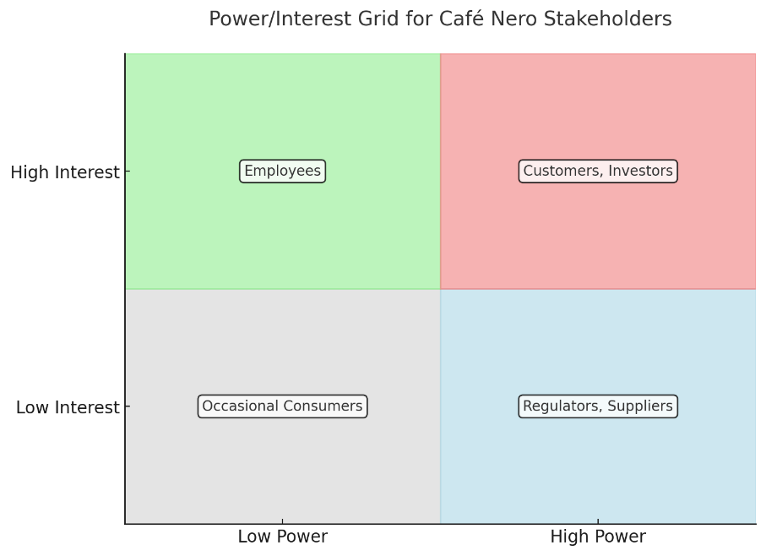
Figure 05. Power/Interest Grid
Source. Self-Created

Stakeholder Management Strategies
- High Power, High Interest: Customers and investors require regular updates. Café Nero should release sustainability reports and refine loyalty programs to engage these stakeholders effectively (Café Nero, 2023).
- High Power, Low Interest: Suppliers and regulators insist on business operation compliance. Ethical sourcing commitment enhancement as well as regulation compliance are key strategies to follow.
- Low Power, High Interest: The people thrown into the process should be encouraged through development deliveries to get satisfaction and motivation (Scott, 2016).
- Low Power, Low Interest: Occasional consumers can be targeted through marketing and promotions that warm them about the company’s seasonal promotions.
In other words, this paper proves that enhancing harmony between Café Nero and its stakeholders can help to maintain its competitive advantage and onboard a favorable image in the global coffee industry.
5. Strategic Growth Options for Café Nero
Café Nero must adopt innovative strategies to maintain its market presence and secure long-term growth. By leveraging the Ansoff Matrix, this section evaluates three potential strategic growth options: market penetration, product development, and market diversification.
1. Market Penetration
Market penetration employs existing items to boost sales in existing markets. Café Nero's rewards program might be optimized and digitally enhanced. Verhoef et al. (2015) found that highly personalized loyalty programs significantly increase recurring consumers. Application interfaces have helped Starbucks and other large competitors (Gallaugher, et al., 2010).
Café Nero may also advertise to young consumers who are infected with sustainable consumerism (Nielsen, 2022). Thus, Café Nero can create ties with loyal customers from sectors where it already implements sustainable measures like ethical food procurement, waste minimization, etc.
The method is effective for maintaining market share but not for growth since the coffee sector in industrialized nations is saturated.
2. Product Development
However, product development introduces new items for current markets. According to Allied Market Research, this market will grow to $44.2 billion in 2021 and 9.7% by 2028, so Café Nero can offer more plant-based and healthy food options. Willett et al. examined worldwide consumption trends and found a substantial correlation between healthier goods and consumer and environmental benefits.
Another apparent market area is ready-to-drink coffee. They expect the RTD coffee industry to expand 7.5% year until 2027 owing to convenience product trends (Ciardulli, 2021). Café Nero may increase sales and diversify its revenue by selling RTD drinks at retail outlets.
This approach meets customers' requirements and boosts Café Nero's competitiveness, but it requires substantial brand and distribution expenditures.
3. Market Diversification
Market development is expanding a firm into new markets for existing items. Café Nero might expand to Southeast Asia, where the specialty coffee industry is expected to rise 11.4% by 2030 (Bozzola, 2021). Joint ventures or franchising would reduce risks and investment while expanding into high-growth sectors.
Café Nero may also offer coworking cafés. Current study by Nkhoma (2020) shows that hotel clients want greater spatial flexibility.
Organic international growth is one of the most profitable strategies, but cultural, organizational, and legal variations in various nations pose huge risks.
- Best Strategic Option
From these alternatives, Café Nero can most easily design products. The expanded plant-based and RTD product line should answer customer demands for convenience and sustainability. He et al.'s (2020) research shows that organizations who innovate goods to catch new trends have higher customer loyalty and profitability.
RTD market enables Café Nero to operate outside retail outlets, reducing dependency on typical café operations and increasing scalability. This approach supports Café Nero's goal of providing creative, high-quality experiences while being sustainable.
Café Nero can expand sustainably by improving its product development approach. It distributes risk and responds to convenience and health food trends, making it smart. Café Nero is best poised to maintain competitive advantage in the heightened global environment with its brand image.
6. Strategic Recommendations for Café Nero
This section presents the major recommendations for Café Nero considering the strategic growth options: Product Development and Sustainable & Digital Implementation. These recommendations are intended to fine tune sustainable competitive advantage while grappling with issues of implementation and change.
1. Expand Product Offerings with Health-Focused and RTD Options
It suggests Café Nero to extend their menu list focusing on vegetarian products and healthy food to respond to new customer preferences regarding eco-friendly and healthy meals. According to Grand View Research 2023 the global market of plant-based foods is expected to be $77.8 billion by 2025 because of the change of consumer behavior. Also, new channels of income and an opportunity to increase brand penetration beyond the physical stores may be achieved by entering the sector of ready to drink coffee market. The RTD coffee market, growing at a CAGR of 7.5% through 2027, presents a lucrative opportunity (Statista, 2023).
Implementation Strategy:
Café Nero can adopt the Kotter’s 8-Step Change Model to guide product innovation and rollouts:
- Create Urgency: Highlight trends in health-conscious and on-the-go consumer preferences through internal communications and market research.
- Build a Team: Form a task force including product developers, marketing specialists, and sustainability experts.
- Develop a Vision: These were to proportionate clear objectives of increasing the organization’s revenues and customer interactions through product differentiation.
- Communicate the Vision: This should be followed by sharing of the roadmap to all the employees, suppliers and other stakeholders.
- Empower Action: Supply teams with information on how to develop menus and information on producing RTD products.
- Achieve Quick Wins: Launch pilot products in key markets to gather feedback.
- Consolidate Gains: Refine product offerings based on consumer feedback.
- Anchor Changes: Incorporate health-focused products and RTD lines into Café Nero’s core offerings.
2. Accelerate Digital Transformation
Building up the online framework is crucial for improving the customer relationship. The time has come to enhance the existing loyalty application with the personalization tools based on artificial intelligence and advanced online ordering can positively impact retention rates among consumers. Wulandari are et al noting that digital innovations enhance the operations satisfaction (2024).
Implementation Strategy:
Use the ADKAR Model (Awareness, Desire, Knowledge, Ability, Reinforcement) to support digital transformation:
- Awareness: Educate employees and stakeholders on the need for digital innovation.
- Desire: Build interest by showcasing competitors’ successes with similar technologies.
- Knowledge: Train employees on new systems and app functionalities.
- Ability: Gradually roll out new tools to ensure smooth adoption.
- Reinforcement: Collect feedback to refine the digital experience.
3. Strengthen Sustainability Efforts
To accomplish this, Café Nero should extend its current execution plans centered on acquiring and serving carbonless coffee and moving toward biodegradable containers. A global consumer survey by Deloitte in 2021 showed that global consumers are 55% willing to pay more when it comes to environmentally conscious products and service, giving emphasis on sustainability.
Implementation Strategy:
Ensure that sustainable targets are factored into KPIs and that sustainable suppliers are sourced for purposes of the business. This can be done by creating and officially issuing sustainability reports from time to time.
The above strategic directions of product differentiation, digitalization, and sustainability will place Café Nero as the industry’s quality, innovation, and responsibility champion. When it comes to implementation issues, therefore, the company can significantly rely on powerful change management frameworks to enable long-term development to be achieved.
7. Competitor Reactions and Mitigation Strategies
The issues that Café Nero has set as its strategic goals may well provoke reactions from competitors especially from Starbucks and Costa Coffee. Addressing all likelihood of such reactions and the measures that should be taken to counter them will be valuable to sustaining competitive advantage.
Competitor Reactions
- Product Diversification:
Currently Starbucks and Costa Coffee have an entry in the ready to drink (RTD) segment and they are expected to increase their activity in line with Café Nero’s entrance. Currently, Starbucks has included new RTD flavors and uses eco-friendly containers (Statista, 2023). Coca-cola whose RTD option, Coca-costa coffee has enjoyed the cooperation of Costa Coffee to expand to reach more consumers. Both brands could leverage pricing strategies or new product offerings as a way of capturing that market share.
- Digital Transformation:
Industry leaders which have adopted more developed digital infrastructures such as Starbucks may continue to improve on their existing loyalty programs or expand on other features of the applications. For instance, Starbucks employs AI to forecast the customer behavior and to increase their interest (Gallaugher et al., 2010). With regards to Café Nero’s improvements in the digital field, Costa may use the same strategies.
- Sustainability Initiatives:
On this account, aware of the increasing trend of consumers choosing environmentally conscious brands, rivals can boost sustainable engagement. More specific information Several major firms Some recent examples Costa Coffee promised to reach net-zero carbon emissions by 2040, setting off the trend of companies vying for environmental supremacy (Alves, 2023).
Mitigation Strategies
Thereby, Café Nero’s key priorities must be innovation and differentiation. For RTD products branding can be specific focusing on a niche appeal such as unusual flavors and authentic Italian look. Visibility will be ensured through a better relationship with retailers and use of advertising to the specific markets. In the shift towards digitalization, having unique, AI-enabled personalized services might do the trick for Café Nero. Thus, Café Nero should counter the actions made by competitors and us sustainability reports as well as consider getting certifications such as Fairtrade or Rainforest Alliance.
This way monitoring of keen competitive strategies ad timely and prompt adaptabilities can ensure a competitive stance for Café Nero while doing continual long term performance improvement.
8. Conclusion
Café Nero must constantly alter its approach to be competitive in an aware and changing coffee industry. This analysis first critically assessed the company's strategy, highlighting strengths like premium segmentation and sustainability and weaknesses like digital business model and operational excellence. Stakeholder mapping revealed conflicts of interest between customers and employees, but the EES also showed opportunities for growth and development of new products and services in response to consumer concerns about personal health and the environment.
The chosen growth strategy for new product development supports the objective of providing innovative experiences by adding health-conscious menu items and ready-to-drink goods. This technique addresses changing client wants and prevents long-term brokering for producers. To resist this challenge and earn stakeholders' loyalty, it may expand its digital capabilities and make Café Nero more sustainable.
Sustainability and digital transformation are essential for SMEs like Café Nero to compete in the developing economy. These factors in Café Nero's strategic development strategy would help the manufacturer meet new customer wants, reduce rivals' risks, and fulfil organizational objectives. They reinforce its position as the authentic provider of excellent coffee experiences while standardizing operational efficiency for sustainable company creation.

Task 02 – Poster Presentation
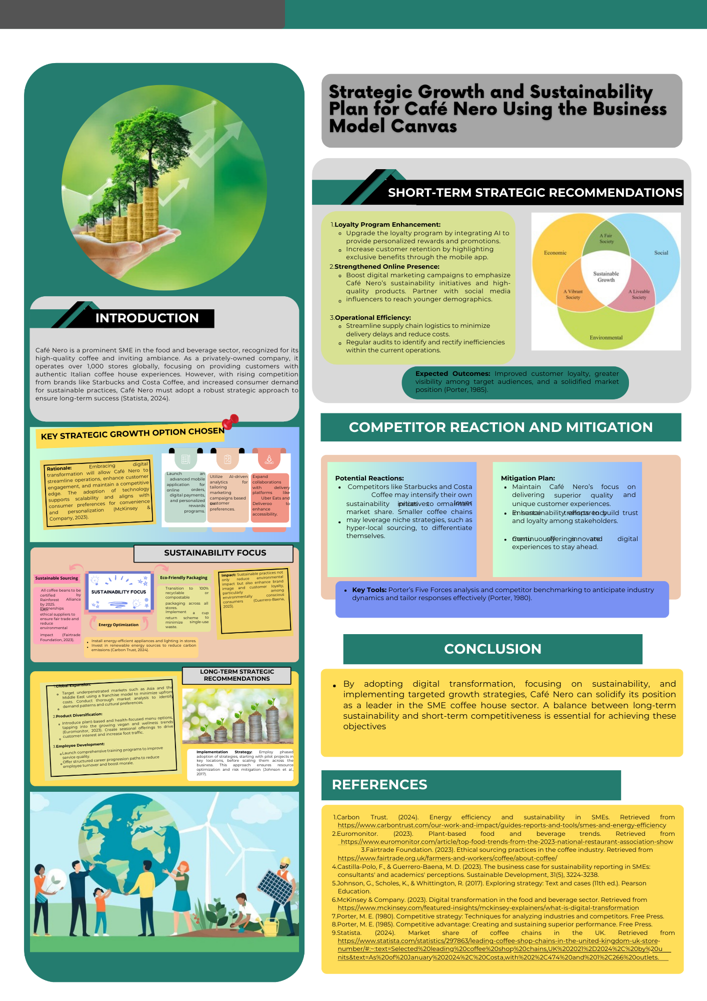
References
Allied Market Research. (2021). Plant-Based Beverage Market by Source and Distribution Channel: Global Opportunity Analysis and Industry Forecast, 2021–2028. Retrieved from https://www.alliedmarketresearch.com/plant-based-beverage-market
Bain & Company. (2018). The Value of Customer Loyalty. Retrieved from https://media.bain.com/Images/Value_online_customer_loyalty_you_capture.pdf
Barreto Peixoto, J. A., Silva, J. F., Oliveira, M. B. P., & Alves, R. C. (2023). Sustainability issues along the coffee chain: From the field to the cup. Comprehensive Reviews in Food Science and Food Safety, 22(1), 287-332.
Bozzola, M., Charles, S., Ferretti, T., Gerakari, E., Manson, H., Rosser, N., & von der Goltz, P. (2021). The coffee guide.
Café Nero. (2023). About Us. Retrieved from https://caffenero.com/us
Ciardulli, M. (2021). The coffee market: competitive strategies and firm performances in a saturated market (Doctoral dissertation, Politecnico di Torino).
CIPD. (2022). Hospitality Industry Retention Report. Retrieved from https://www.cipd.org/en/knowledge/factsheets/turnover-retention-factsheet/
Deloitte. (2021). Global Sustainability Trends Report. Retrieved from https://www.deloitte.com/global/en/about/people/social-responsibility/globally-consistent-esg-reporting.html
Euromonitor International. (2023). Health and Wellness Trends in the Beverage Industry. Retrieved from https://www.euromonitor.com/health-and-wellness
Forbes. (2024). "Starbucks leads digital transformation in the coffee industry." Retrieved from https://www.forbes.com/sites/noahbarsky/2024/03/18/ai-ready-starbucks-is-the-digital-transformation-gold-standard/
Gallaugher, J., & Ransbotham, S. (2010). Social media and customer dialog management at Starbucks. MIS Quarterly Executive, 9(4).
Grand View Research. (2023). Plant-Based Food Market Size, Share, and Trends. Retrieved from https://www.grandviewresearch.com/industry-analysis/vegan-food-market
Gumbelevičienė, J. (2016). The adoption of digital marketing tendencies in coffee chain business (Doctoral dissertation, Mykolo Romerio universitetas.).
IBISWorld. (2023). Coffee Shops in Emerging Markets. Retrieved from https://www.ibisworld.com/au/market-size/coffee-shops/
International Coffee Organization. (2023). Global Coffee Market Report. Retrieved from https://ico.org/#:~:text=World%20coffee%20exports%20amounted%20to,same%20period%20in%202022%2F23.
Khoiri, U., & Wulandari, P. (2024, January). CUSTOMER RELATIONSHIP MANAGEMENT IN THE DIGITAL AGE: A SYSTEMATIC REVIEW OF THE LITERATURE. In Riau International Conference on Economics, Business and Accounting (Vol. 1, No. 2, July, Realesed on Januari, pp. 447-456).
Kotter, J. P. (1996). Leading Change. Harvard Business Review Press.
McKinsey & Company. (2022). Sustainability and Investor Priorities. Retrieved from https://www.mckinsey.com/capabilities/sustainability/our-insights
Nielsen. (2022). Global Sustainability Trends. Retrieved from https://www.nielsen.com/news-center/2022/nielsens-inaugural-brand-sustainability-report-reveals-australian-consumer-perceptions-of-the-sustainability-efforts-of-leading-brands/
Porter, M. E. (2008). Competitive Strategy: Techniques for Analyzing Industries and Competitors. Free Press.
Raimondo, E. (2022). Coffee industry market strategies in developing countries (Doctoral dissertation, Politecnico di Torino).
Rao, N. Z., Fuller, M., Peoples, M., Adams, D., Wilkinson, F., & Fallon, K. (2020). Ready, Drink! Chemical Characterization of Ready-to-Drink Cold Brew Coffee Products. Food Studies, 10(2), 31.
Scott, M. E. (2016). Strategies for retaining employees in the hospitality industry. Walden University.
Statista. (2023). Ready-to-Drink Coffee Market Report. Retrieved from https://www.statista.com/outlook/cmo/non-alcoholic-drinks/ready-to-drink-rtd-coffee-tea/ready-to-drink-rtd-coffee/worldwide
TANRIKULU, C. (2022). Flow experience of consumers in global coffee shops: Evidence from an emerging market. Business & Management Studies: An International Journal, 10(4), 1324-1334.
Truong, N., Dang-Pham, D., McClelland, R., & Nkhoma, M. (2020). Exploring the impact of innovativeness of hospitality service operation on customer satisfaction. Operations and Supply Chain Management: An International Journal, 13(3), 307-319.
Verhoef, P. C., Kannan, P. K., & Inman, J. J. (2015). From multi-channel retailing to omni-channel retailing: introduction to the special issue on multi-channel retailing. Journal of retailing, 91(2), 174-181.
Willett, W., Rockström, J., Loken, B., Springmann, M., Lang, T., Vermeulen, S., ... & Murray, C. J. (2019). Food in the Anthropocene: the EAT–Lancet Commission on healthy diets from sustainable food systems. The lancet, 393(10170), 447-492.

