

BA International Hotel Management
BMIH5004 Management & Organisational Behaviour

Lecturer: Ernest Wavei

Student Name: Nargis Begum
ID: 2212000

Date of submission:23/05/2024

Executive Summary
InterContinental Hotels Group (IHG) is one of the largest companies in the field of hotel services that can be considered as one of the market leaders. Some of the related companies to InterContinental Hotels include Resorts, Holiday Inn, Crowne Plaza, and Kimpton Hotels. IHG is a multinational company that specializes in the provision of hotel and resort services across the globe with headquarters in Denham United Kingdom and has established its offices in over one hundred countries using division structure that sorts brand s and locations. It can enhance IHG’s ability to address the trends that are identified with specific regions while at the same time enhancing the company’s workflow to enable it to serve various segments within the global economy. A segment of the management plan for the company includes the diversification of the global brands the firm aims at attaining a better technological position for the company in the market and prioritizing environmental and social consideration for the guests through the IHG Rewards. A few strategic changes over the years include going-papers-less, developing and expanding various brands, going green, and enhancing operational superiority to support extendable business advancement. Nonetheless, these opportunities might be faced with threats such as the constantly changing economic forces, increased competition in the marketplace, and a revolving door of the regulatory laws. As presented in the SWOT analysis, IHG should continue to focus on its primary strategic assets, its international operations, organizational effectiveness, and its loyalty programs – while avoiding and turning its vulnerabilities into opportunities for growth and future leadership.

Table of Contents
Executive Summary 2
Introduction 4
Organisational Overview of InterContinental Hotels Group (IHG) 5
Organisational structure followed within InterContinental Hotels Group (IHG) 6
Applying Handy’s four types of cultures to evaluate culture within the organisation 7
Identifying hotel group aims and goals for InterContinental Hotels Group (IHG) 8
Strategic changes in this hotel along with driving forces that causing changes 9
Applying SWOT analysis to assess the Hotel group’s current business performance and strategic directions 10
Conclusion 13
Reference list 14

Introduction
InterContinental Hotels Group (IHG) is among the leading organizations in the international hotel business that operates numerous types of hotels in different countries of the world. Founded in Denham, United Kingdom, IHG is known for its Divisional organizational structure. Considering the internal operational structure, it is divided into a brand-based division luxury and geographic division. This structure also helps IHG to organize its brands in a centralized manner, address customers’ needs by adjusting services to the operations within a particular region and optimize their performance. The report's primary focus is on determining the organisational structure that the selected company used to guarantee efficient business operations. In addition, an analysis of Handy's model has been conducted to assess the organisational culture. The company's strategic direction, which directs operational activities within the workplace, is the author's main point of concentration. In order to evaluate the company's advancement towards its ultimate destination, certain objectives and goals have also been identified. Additionally, the author assesses both the short- and long-term development prospects of the organisation with the use of SWOT analysis.

Organisational Overview of InterContinental Hotels Group (IHG)
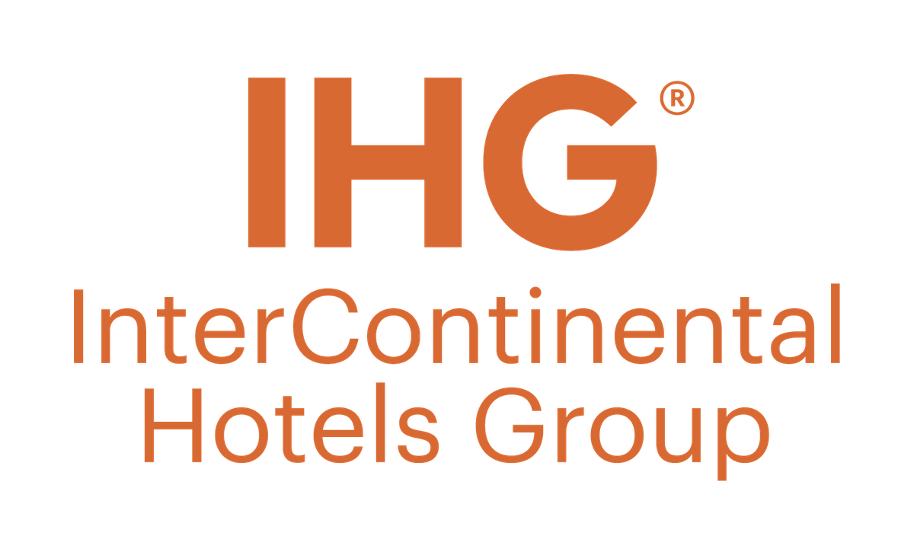
Source: (Intercontinental Hotels Group, 2020).
InterContinental Hotels Group is a company that engages in the hospitality industry and is present in various parts of the world with its headquarters based in Denham, United Kingdom. IHG participates in the management of some of the renowned brands such as InterContinental and Resorts, Holiday Inn, Crowne Plaza, Kimpton Hotels, and many others. This multinational company with its shares traded at the London Stock Exchange as a member of the FTSE 100 Index specialist in managing, franchising, leasing, and owning of numerous varieties of hotel in over one hundred countries (Hopkin, 2019). IHG adheres to the principles of paying a lot of attention to the customer and producing innovative solutions for increasing guests’ satisfaction and satisfaction with services applicable in the company. Focusing on the company’s strategic points of interest, one can mention the plans to grow the brand’s portfolio, the opportunity to use technology to optimize guest experience, as well as the continuous adherence to sustainability and corporate responsibility (Kennedy, 2020). One of IHG’s main customers loyalty programs is the IHG Rewards loyalty program recognized as one of the largest in the world, aimed at the customer loyalty increase and attracting new visitors. This has however been accompanied by steady expansion firmly establishing IHG as a global giant in the hospitality industry.

Organisational structure followed within InterContinental Hotels Group (IHG)
IHG follows divisional organisational structure in which the company is divided into various parts based on certain functions, which work as semi-autonomous entities. By having a clearer structure for its companies, IHG can maximise the potential of each of its vastly distinct brands as well as address the specific needs of certain geographic areas.
Divisional Structure Overview
IHG’s divisional structure follows brand and geographical differentiation. The divisions are standalone business units that are managed independently with their own leadership team, with accountability for driving the business and specifically the brands that fall under it (Mullins and Dossor, 2013). The key divisions within IHG include:
Brand-Based Divisions:
Luxury and Lifestyle: Includes Intercontinental and other luxury brands which include Kimpton Hotels and Restaurants, and Regent Hotels and Resorts (Arnold, 2005).
Premium: IHS also comprises many brands like Crowne Plaza Hotel and Hotel Indigo.
Essentials: It includes well-known names like the Holiday Inn and Holiday Inn Express.
Suites: Sub-brands include those that embrace extended stay facilities such as Staybridge Suites and Candlewood Suites (Brooks, 2018).
Geographical Divisions:
Americas: It serves organisations in North, Central, and South America.
Europe, Middle East, Asia, and Africa (EMEAA): Operates in these various areas of the world with hotels.
China: establishing a distinct division for the Chinese market, as it is experiencing rapid growth and is of significant importance to the company (Huczynski and Buchanan, 2007).
Benefits of the Divisional Structure
The division of IHG as a global organization enhanced the company’s ability to gain competitive advantage through the implementation of various measures in different divisions that corresponds to various regions and customer segments. Key benefits include:
Responsiveness to Market Conditions: Every division is always in a position to respond to regional tendencies and needs; this improves IHG's manoeuvrability in the context of cutthroat competition (Mukhopadhyay, 2016).
Specialized Management: Begging of the military style, divisional managers provide specialized knowledge and attention to their respective spheres in order to contribute to branding and development (Mullins, 2020).
Improved Coordination: The structure of divisions is semi-autonomous, and thus the employees can communicate and coordinate much more effectively within each business unit.

Applying Handy’s four types of cultures to evaluate culture within the organisation
Handy’s four types of cultures include power culture, role culture, task culture, and person culture. While IHG’s culture can be explained using these typologies, one can gain an understanding of the company’s operations and employee relations.
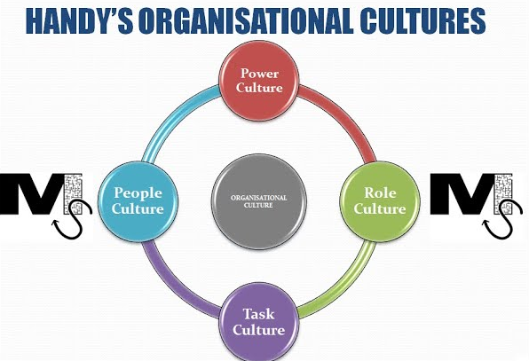
Source: (Palmer, Cockton and Cooper, 2012).
Power Culture: Certain organizational culture characteristics, namely, the power culture can be evidenced at IHG, primarily, in the company's executive management team. Most initiatives tend to be conducted at the organizational pinnacle and are driven by senior managers and administrators (Boddy, 2014).
Role Culture: Based on the facts discussed in the context of IHG, it can easily be noted that role culture has a significant presence in the organization mostly due to its structural divisional culture. It was also noted that each of the subsidiary divisions – be they by brand or geographic locations – has distinct accountabilities and responsibilities (Schein, 2010).
Task Culture: Another facet of the task culture is also highly apparent in IHG, especially in operations where the employees work in project-based teams and participate in patterned organizational activities such as new hotel opening, brand change or technology implementation (Robbins and Judge, 2008). Multifunctional teams are groupings of workers designed as teams to accomplish certain tasks, relying on a variety of abilities.
Person Culture: Although not as pronounced as in-person culture, some ideas related to this category can be observed in how IHG manages talents and promotes the training of its employees. It is paying attention to personal development, providing different trainings and promotion and advancement chances (Mullins, 2016). The focus on employee individual development assists in staffing since that guarantees attraction of the right employees and staff retention to ensure maximum production by the companies given that they have the required motivation and skills.

Identifying hotel group aims and goals for InterContinental Hotels Group (IHG)
Business Aims
IHG has an unobstructed vision to become one of the largest players in the global hospitality market with purposeful growth strategy providing high-quality services and experiences for the guests, developing its brands, and achieving sustainable growth-oriented goals (Weir, 2021). The goals of the company are to increase long-term stockholder value, build up its competitive advantage and function as an exemplary responsible business entity. technology and innovation IHG aim to change with the customer dynamic and strive to consolidate its stake in the market.

Specific Goals
Brand Expansion:
Open ten per cent more new hotels annually, further, paying attention to the dynamic markets in Asia and the Americas. Establish at least two unique brands within the subsequent five years to tap typical market categories in the region.
Sustainability Initiatives:
To reduce the carbon emissions of the company, there should be a 15% decrease of the company’s carbon footprint by the year 2025 across all the properties that the company will own or manage. Applying sustainable solutions such as the IHG Green Engage™ system widely to all IHG branded hotels by 2024.
Guest Experience Enhancement:
Increase AAA Overall Guest Satisfaction by 5%, year-over-year, through service training and enhanced guestroom amenities (P. Crick and Spencer, 2011). Extend the current IHG Rewards program over the next five years and aim to increase enrolment to 150 million members to build a strong customer base loyal to the brand.

Strategic changes in this hotel along with driving forces that causing changes
Strategic changes within InterContinental Hotels Group (IHG)
The above changes are some of the strategic changes that have been implemented by the InterContinental Hotels Group (IHG) due to changing market forces and competitive improvement strategies. These have been strategies that seek to strengthen its market standing, and boost, and enhance productivity for a sustainable performance.
Digital Transformation: IHG has made huge efforts in the recent past to strengthen its digital backbone. This includes designing a unique new single booking portal coupled with improvement of the mobile applications to better fit the guest needs (Kotarba, 2018).
Brand Portfolio Expansion: To appeal to a more diverse client the company has introduced Novotel’s sister brands; Divide Hotels for economy-wise business clients and Vignette Collection for high-end luxurious guests.
Sustainability Initiatives: Managing companies of hotels have pledged their dedication to sustainability and operational changes, IHG has developed the IHG Green Engagement system for all properties, which has significant energy, water, and waste efficiencies, and aims to decrease carbon footprint by 15% by 2025 (Abbey et al., 2016).
Different internal and external factors drive the company to make changes
Several external and internal forces have driven the strategic changes at InterContinental Hotels Group (IHG):
Technological Advancements: The growth of technology and change in customers’ demand for Online presence and interaction requires spending on Digital touchpoints that boost the experience of guests, and optimize business operations (Machado and J. Paulo Davim, 2016).
Market Diversification: In particular, the pursuit of new fields of consumption and changes in customers’ demands requires IHG to continue to develop the brand and broaden its focus.
Environmental Concerns: Cario and Premus one can conclude that new awareness and huge pressure of subsequently legislation force IHG to thinking fundamental about environmental programs (Hall and Bagchi-Sen, 2002).

Applying SWOT analysis to assess the Hotel group’s current business performance and strategic directions
To evaluate the IHG's current business conditions and its management’s future strategies, the SWOT analysis gives a clear insight, into internal and external factors that directly influence the organization.
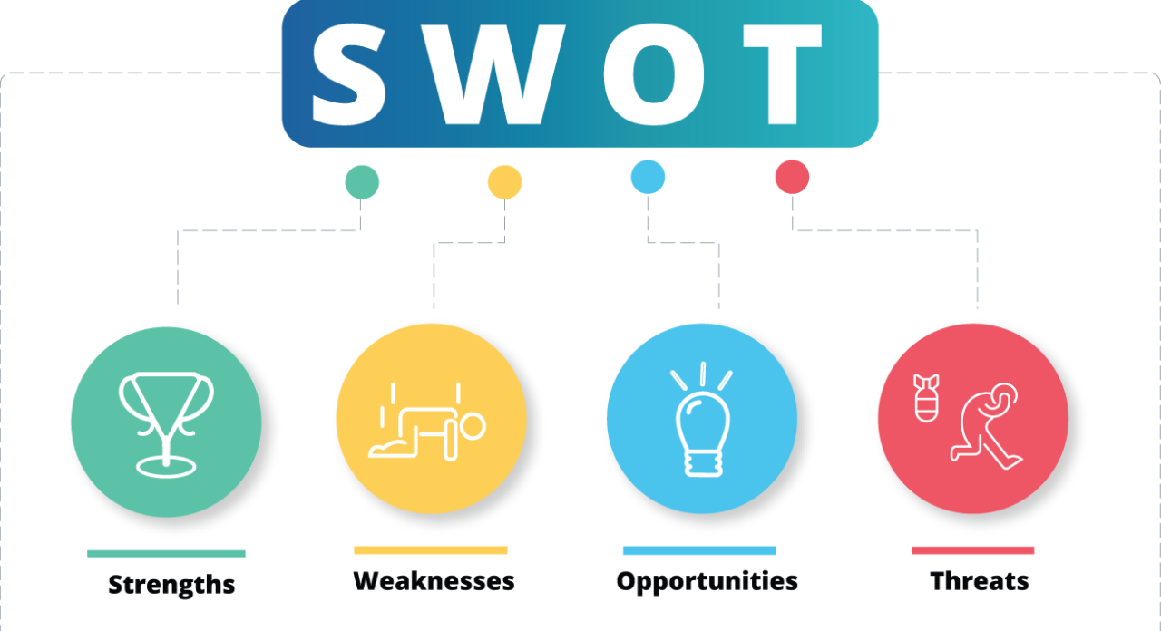
Source: (Shelper, Lyons and Harrison, 2023).
Strengths
Global Presence: IHG has the advantage of operating in more than one hundred countries affording it a strong international presence that expands market coverage and brand penetration (Cullen and Praveen, 2019).
Loyalty Program: One of the globally dominant customer loyalty programs IGH Rewards has been supporting guests’ repeated occupancy of the company’s facilities.
Operational Efficiency: The structure of various divisions along with the simplification of the process plays a significant role in managing and delivering the service (Morrison, 2022).
Weaknesses
Dependence on Franchise Model: A substantial proportion of the IHG revenue is generated through franchised operations which may give less direct control over service quality or even brand compliance.
High Fixed Costs: The hotel industry requires significant initial investment in tangible assets, which translates to significant fixed costs, thus exposing the operators to significant risks during low demand or in cases of economic downturns (Scott, 2018).
Market Saturation: In some areas, competition becomes high for IHG, which often poses a problem in consecutive years, regarding growth and the need for positioning strategies.
Opportunities
Emerging Markets: Since the markets of developed countries do saturate, expansion into high-growth locales in Asia and South and Central America holds substantial revenue growth potential (Mensah, 2021).
Sustainability Trends: The growing interest of the target stakeholders to adapt to green consumerism constitutes prospects for IHG to up the sustainability game as such business’s target environment-savvy customers (Mcnall, Hershauer and Basile, 2011).
Technological Advancements: Implementing advanced technology solutions can additionally bring changes that positively impact guests while enhancing internal performance, offering a valuable competitive advantage (Machado, 2016).
Threats
Economic Uncertainty: Volatility in the global economy and the threat of potential recession situations can be detrimental to travel and tourism as is evident in occupancy rates and revenue levels (Trahan, 2011).
Intense Competition: The competitive structure of the hospitality industry is that there is cutthroat competition in the current market where new entrants as well as the existing ones are trying to grab more as much market share as they can (Fleisher and Bensoussan, 2017).
Regulatory Changes: This is because with time there are changes in the regulations that are implemented in the countries of operation which may complicate compliance and up Champ’s operational cost (Ismail, 2019).

Conclusion
In conclusion, InterContinental Hotels Group (IHG), a major player in the worldwide hospitality industry with a solid presence in more than one hundred countries, is still thriving. IHG has successfully managed its wide brand portfolio and regional operations through its divisional organisational structure, guaranteeing responsiveness to market circumstances and improving operational efficiencies. The organization's commitment to Handy's cultural typology—Power, Role, Task, and Person cultures has promoted a unified corporate culture that prioritises innovation, employee growth, and customer service. IHG's dedication to sustainable development and profitability is demonstrated by strategic initiatives including digital transformation, brand portfolio expansion, sustainability efforts, and operational savings. Even with the difficulties posed by unstable economies, fierce rivalry, and shifting regulations, IHG is still in a strong position to take advantage of new prospects in developing nations, environmental trends, and technology breakthroughs in order to continue its leadership.

Reference list
Abbey, J.D., Kleber, R., Souza, G.C. and Voigt, G. (2016). The Role of Perceived Quality Risk in Pricing Remanufactured Products. Production and Operations Management, 26(1), pp.100–115. doi:https://doi.org/10.1111/poms.12628.
Arnold, J. (2005). Work psychology. 4th ed. Harlow: Prentice Hall.
Brooks, I. (2018). Organisational Behaviour. Pearson UK.
Boddy, D. (2014). Management: An Introduction.
Crick, and Spencer, A. (2011). Hospitality quality: new directions and new challenges. International Journal of Contemporary Hospitality Management, 23(4), pp.463–478. doi:https://doi.org/10.1108/09596111111129986.
Cullen, J.B. and K. Praveen (2019). International Business. Routledge.
Fleisher, C.S. and Bensoussan, B.E. (2017). Business and Competitive Analysis. Pearson Education.
Hall, and Bagchi-Sen, S. (2002). A study of R and D, innovation, and business performance in the Canadian biotechnology industry. Technovation, 22(4), pp.231–244. doi:https://doi.org/10.1016/s0166-4972(01)00016-5.
Hopkin, P. (2019). Fundamentals of risk management: understanding, evaluating, and implementing effective risk management. London; Philadelphia: Kogan Page.
Huczynski and Buchanan, (2007). Organizational behaviour: an introductory text. Harlow: Financial Times Prentice Hall.
Intercontinental Hotels Group (2020). The Intercontinental kitchen. Summerville, Sc: Feeding Frenzy, Inc., Cookbook Division.
Ismail, I. (2019). Regulation changes and their impact on business models in the insurance industry. GRIN Verlag.
Kennedy, R. (2020). Strategic Management. Virginia Tech Publishing.
Kotarba, M. (2018). Digital Transformation of Business Models. Foundations of Management, 10(1), pp.123–142.
Machado, C. (2016). Technological Challenges and Management. CRC Press.
Mcnall, S.G., Hershauer, J.C. and Basile, G. (2011). The business of sustainability: trends, policies, practices, and stories of success. Santa Barbara, Calif.: Praeger.
Mensah, I. (2021). Marketing tourist destinations in emerging economies: towards competitive and sustainable emerging tourist destinations. Basingstoke: Palgrave Macmillan.
Morrison, A.M. (2022). Hospitality and Travel Marketing. Taylor and Francis.
Mukhopadhyay, M. (2016). Quality Management in Higher Education. SAGE Publishing India.
Mullins, J. (2016). Management and Organisational Behaviour 11th edn. Harlow, United Kingdom: Pearson.
Mullins, L.J. (2020). Organisational Behaviour in the Workplace. 12th ed. Harlow, United Kingdom: Pearson Education Limited.
Mullins, L.J. and Dossor, P. (2013). Hospitality management and organisational behaviour. 5th ed. Harlow: Pearson.
Palmer, R., Cockton, J. and Cooper, G. (2012). Managing Marketing. Routledge.
Robbins, S.P. and Judge, T.A. (2008). Organizational behavior. 15th ed. Boston: Pearson.
Schein, E.H. (2010). Organizational Culture and Leadership. Somerset: Wiley.
Scott, P. (2018). Introduction to management accounting. Oxford, United Kingdom: Oxford University Press.
Shelper, P., Lyons, S. and Harrison, S. (2023). Loyalty Programs.
Trahan, F. (2011). The Era of Uncertainty. John Wiley and Sons.
Weir, D.T.H. (2021). Organisational analysis and development: A social construction of organisational behaviour. European Management Journal, 6(4), pp.379–380.

