Company name: Mexicymru Ltd
Team members: Anselmo Tavares 1808280, Khurram Khan 1808278, Nichola Mullett 1809719, Suheba Begum 1806403, Thohura Ahmed 1806406

Log in to weebly.com.
Username Thohura1806406@gmail.com
Password koli1806406
URL https://www.weebly.com/editor/main.php#/

What makes a good web page?
Keep message short & simple
In today’s blog I have outlined what makes an effective web (page) design. I have designed two pages on our website, and these are the ‘recruiting’ and ‘feedback’ pages. At Mexicymru we have taken the initiative of visual more. The reason for this is to entice the readers. Although my webpage is informative, I have kept it short and simple, so it is easy to read and follow. The idea is not to overwhelm your reader with too much information but to keep them interested and entertain their curiosity to look into your company (Campbell. O, 2019).

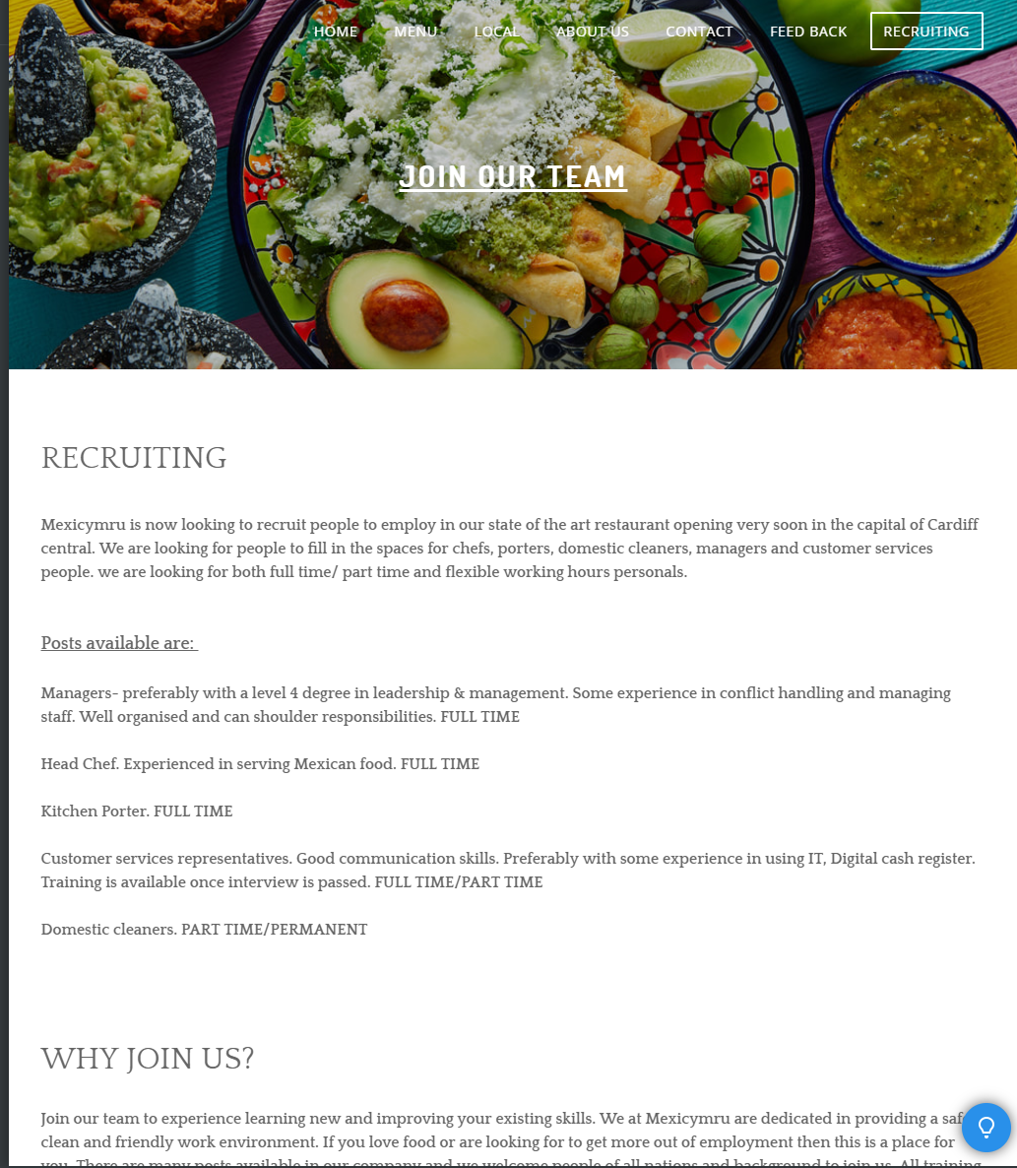

Optimize Search Engines (SEO)
We are all too familiar with the search engine ‘Google Search’. Any search engines will help to locate your company when one or more words are typed in its search box (Aziz. S, 2019). To optimize a webpage, make use of SEO for your page. I have chosen to use words like ‘Mexican food, chef, porters, domestic cleaners, manager, kitchen staff, customer service, authentic, food, St. Mary's street, restaurant, eat out, local, family friendly, Eco-friendly, child friendly, recruiting, feedback, Cardiff central restaurant, food outlet, food business, catering, vacancies’. Whenever one of these words are searched online, information of our company will come up. This is one of the most effective way to get your business noticed by others as search engines can provide higher possibilities of your business search.

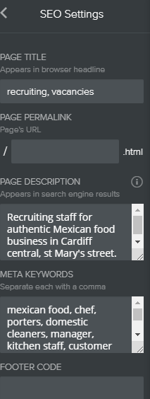

Mobile friendly
Your web page and website should be mobile friendly. According to SearchEngineland, around 60% of online searches are made via mobile devices. A company not having a friendly site may suggest company’s ever-important prospect might not receive the branding, messaging, call-to-actions, etc., as intended or even at all, leaving the site in dissatisfaction (Morgan. J., 2019).

Dedicate a page for feedback
I would say it is essential for companies to receive feedback. This helps the organisation to recognise where they stand in the eyes of their customers. This is a great way to improve one’s products a services from the feedback it receives. Feedback lets companies know the areas they are excelling and areas they need to improve (Moe. S., 2019). I have made a feedback page for Mexicymru which help inform the management in improving the business further. I have kept the questionnaire short and simple with tick box option to answer as I believe people are put off if asked to fill in a lengthy questionnaire. I have used ‘button’ on both the feedback page and recruiting page to direct the readers to the links. Mexicymru will also survey customers for feedback on their mobile devices using texts and emails. This has been done with the customers ease of access in mind. The customers may fill in these surveys at pleasure when it suits them.
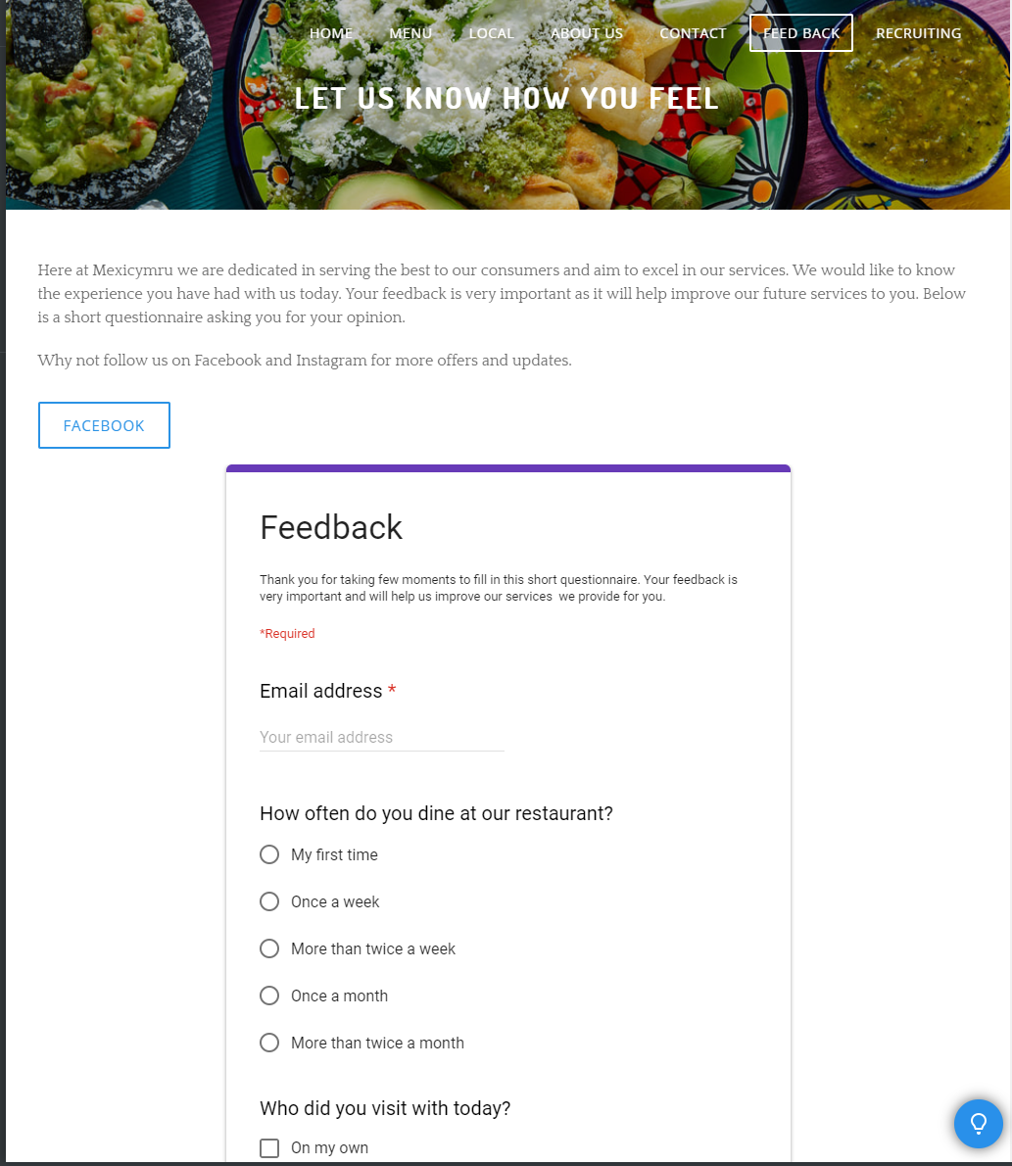
Reference

Campbell. O, (2019) [online] 25 essential elements of what makes a good website
available at: https://fitsmallbusiness.com/what-makes-a-good-website/
Accessed 4-7-2019

Moe. S, (2019) [online] 25 essential elements of what makes a good website
available at: https://fitsmallbusiness.com/what-makes-a-good-website/
Accessed 4-7-2019

Morgan. J, (2019) [online] 25 essential elements of what makes a good website
available at: https://fitsmallbusiness.com/what-makes-a-good-website/
Accessed 4-7-2019

