Advanced Chemistry Lab Report 4 – Preparation of Nitroguanidine

Thomas Appleby (2217664)

Advanced Chemistry of OME (ACDA6020)

Wales Institute for Science and Art
University of Wales Trinity Saint David



Table of Contents
Table of Contents 2
Table of Figures 3
Table of Tables 4
1.1 Introduction 5
1.2 Theoretical Background 6
1.3 Aim 6
2.0 Results 6
2.1 Sample A 8
2.2 Sample B 8
2.3 Sample C 8
2.4 Sample D 9
2.5 Melting Point Ranges 9
3.0 Primary sources of experimental errors 9
3.1 Reaction Initiation 9
3.2 Over flushing the crystal 9
3.3 Amount of reactants 9
4.0 Conclusion 9
References 10

Table of Figures
Figure 1 - Classification of explosive composition by nitration reaction 5
Figure 2 - Image of Sample A 7
Figure 3 - Electron Microscope Set-Up 8

Table of Tables
Table 1- Literature Melting Points 6
Table 2 - Results and Observations 6

1.1 Introduction
The melting point of the methyl-3-nitrobenzoate is the key factor in determining the purity of a sample and whether or not it is contaminated. In order to get the correct results, the method must be uniform and within the required limits. There are specific points where temperature and time are critical elements and if there is too much deviation the experiment will not be valid.
The identification and characterisation of synthesised organic compounds are fundamental practices in analytical chemistry. One of the most reliable and efficient physical constants used for this purpose is the melting point. In this experiment, the purity of a synthesised sample of methyl-3-nitrobenzoate is evaluated using capillary tube melting point analysis.
Undertaking this experiment is relevant as it builds upon knowledge and safe handling techniques when the theory is applied to real world situations. The more chemically pure a substance is, the more stable it is, meaning it’s safer to store and handle and is more resistant to external stimuli such as shock and variations in temperature. This is especially important due to it’s prolific use in the explosives and defence sectors.
The use of this process is known as an N-nitration and is specifically used in the manufacture of certain explosive compounds such as RDX, HMX and in the case of this experiment, Nitro Guanidine. N-nitration is specific as it refers to a nitro group attached to a nitrogen atom. It differs from C-nitration which is used in the manufacture of other explosives such as TNT and O-nitration that is used for PETN production [1].
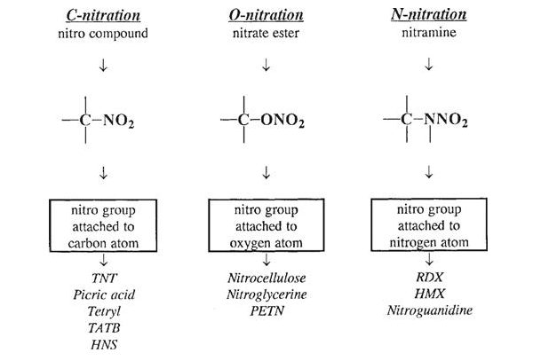
Figure 1 - Classification of explosive composition by nitration reaction

1.2 Theoretical Background
The melting point of a solid is defined as the temperature at which the solid and liquid phases exist in equilibrium at a pressure of one atmosphere. For a pure crystalline substance, this transition occurs over a very narrow range, typically 1-2°C [2]. This "sharp" melting point is a hallmark of high purity because the crystal lattice is uniform, requiring a specific amount of thermal energy to overcome the intermolecular forces holding the structure together.
When impurities are present in a sample, they disrupt the regularity of the crystal lattice. This disruption has two primary effects, collectively known as melting point depression:
- Lowering of the Melting Point: It requires less energy to break the weakened lattice, causing the substance to melt at a temperature lower than the literature value.
- Broadening of the Range: Because the impurity distribution is often non-uniform, different parts of the sample melt at different temperatures, resulting in a wide melting range (e.g. 5-10°C) [2].

1.3 Aim
Methyl-3-nitrobenzoate is an aromatic ester typically synthesized via the nitration of methyl benzoate. The melting point for pure Methyl-3-nitrobenzoate as quoted by literature is 78°C [3].
The primary objective of this study is to determine the experimental melting range of the prepared sample. By comparing the experimental data to the literature value, the relative purity of the product can be assessed. A melting point significantly lower or broader than 78°C would indicate the presence of residual starting materials, side products, or solvents [3].

2.0 Results

 | Melting Point °C
Methyl benzoate | -12.5°C
Methyl-3-nitrobenzoate | 78°C
Table 1- Literature Melting Points

Sample | Appearance | Trial 1  Mp, °C | Trial 2  Mp, °C
A | White crystals  Small in size | 77-78 | 78
B | Off white  Long crystals | 76 | 76
C | Yellow crystals  Large in size | 74 | 73
D | Cream crystals  Long straight needles | 76 | 76
Table 2 - Results and Observations


Figure 2 - Image of Sample A
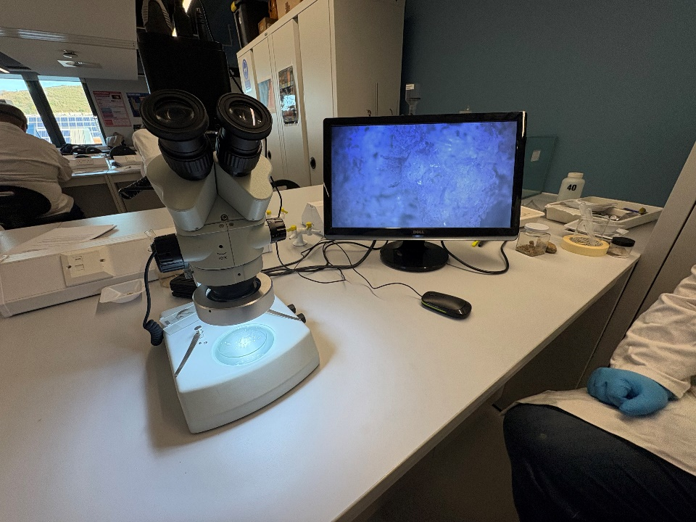
Figure 3 - Electron Microscope Set-Up

2.1 Sample A
Sample A was observed as having white crystals that were small in size with melting points in the 77-78°C range which is concurrent with the results found in literature [3]. This shows that sample was chemically pure as it had a melting point close to that seen in literature. The white colouring indicates a lower amount of contaminant, although the small crystals show that the crystals weren’t given the full capacity to grow.

2.2 Sample B
The melting points of sample B were measured as lower than sample A at 76°C combined with their off-white colour it can be determined that sample B is of a lower purity. However, the longer crystals suggest that they were able to grow more effectively. The melting point temperature is 2°C lower than what is seen in literature [3] which indicates a slight impurity.

2.3 Sample C
Large yellow crystals and a melting point of between 73 and 74°C indicate that the crystals produced are of a very low purity and weren’t grown very well as they clumped rather than formed needles. This suggests that something went wrong during the manufacturing process which then affected the results gained. The melting points were between 4 and 5°C less than what literature suggests as pure. The yellow colour is likely to be due to the presence of sulphuric acid or other sulphur-based derivatives.

2.4 Sample D
Similar to sample B in colouration and melting point (76°C - 2°C lower), the results in sample D indicate that the two were of a near equal purity. The appearance of the needles in sample D were better formed than the others indicating a strong crystallisation phase of the manufacture.

2.5 Melting Point Ranges
The melting point range of sample C is 2°C which is larger than that of the other samples. The larger melting point range is another indicator that sample C contains contaminants as the irregularity within it’s structure means that different areas of the crystal start to melt at different temperatures.

3.0 Primary sources of experimental errors

3.1 Reaction Initiation
During the step of adding the methyl benzoate to the sulphuric acid solution if the reaction temperature exceeds 15°C then the possibility of unwanted by-products being formed increases. Another reason for keeping the reaction below 15°C is to stop thermal run away.

3.2 Over flushing the crystal
Over flushing the crystal (with hot methanol or ethanol/water mix) can cause the crystals formed to be smaller and less needle shaped resulting in a crystal that is more sensitive to shock and prone to breakage making it less safe during storage and transportation.

3.3 Amount of reactants
If too much or too little reactant is added it will have a knock-on effect within the structure of the crystal. If there is not an exact balance, then the impurities will be absorbed leading to a more unstable product.

4.0 Conclusion
The experiment set out to determine the purity of 4 samples of Methyl-3-Nitrobenzoate by the method of analysing the melting point and its range, crystalline structure and appearance. The results showed that the purist sample was A, as this was closest to the recorded value in literature. The whiteness of the crystals again gave confidence in its purity, despite the sample’s higher purity the small crystals show that the sample was not provided the ideal conditions for the crystals to grow as intended. The other samples showed varying degrees of impurity through the above-mentioned criteria. Sample D shows signs of high contamination (yellowish tinge, alarmingly low melting point and large uneven crystals) so would be ideally disposed of immediately for safety concerns as the result would be very unstable and unsuitable for storage. As with all explosive materials, there is a paramount importance to maintain the highest level of purity to ensure an efficient reaction and safe storage. Any deviation from the purity could have significant negative consequences to the final product being produced.

References
[1] J. Akhavan, Chemistry Of Explosives. S.L.: Royal Society Of Chemistry, 2022.
‌[2] G. C. Hill and J. S. Holman, Chemistry in context. Oxford: Oxford University Press, 2014.
[3] E. Hendrina, Book of data. Harlow (Essex): Longman, 2007.

