

Certificate of Higher Education Skills for the Workplace (Health &amp; Social Care)

Digital Skills and Research Methods

Research report

Student Name: Farhana Begum
Student ID: 2225757
Topic: Digital tool used by the students of UWTSD-Moodle

Table of Contents
Introduction 3
Research Design 4
Research Questions 4
Research methods 4
Ethical considerations 5
Results 7
Discussion 17
Conclusion 19
References 20
Appendices 22

Introduction
Contemporary technologies and digital tools refer to the latest technological advancements and software applications that are utilised to increase productivity, efficiency, and innovation in various fields (Bellamy, 2021). These technologies and tools can be used for a wide range of purposes, from communication and data analysis to marketing and entertainment. This research report will be covering the detailed research design consisting of three research questions, used research methods and ethical considerations. The three research questions will be made on the effectiveness of using Moodle as the major and only digital tool by the students of UWTSD in this research report. Along with that, a description will also be made on using the exploratory research design for this specific research conduct to understand the importance of using Moodle as a primary digital tool at UWTSD. The various ethical considerations such as filling out informed consent forms, maintaining the confidentiality and privacy of the participants and their voluntary participation made while conducting this research and preparing this report will also be demonstrated here critically. Furthermore, an analysis will be made on a questionnaire containing 10 questions in this report along with providing a proper discussion on the evaluation of various informative sources of digital tools and skills.

Research Design

Research Questions
1. What is the main purpose of using Moodle as the primary digital tool by the students at UWTSD?
2. What is the efficiency of using Moodle by students as a digital tool at UWTSD?
3. What are the ways of using various digital Tools apart from Moodle for the students of UWTSD?

Research methods
The exploratory research design has been used here to further proceed with this research. The exploratory research design is associated with the type of research method which aims to explore and understand a problem phenomenon in a primary and non-structured manner (Koleva, 2021). The major goal of this research is to gain new insights and generate concepts and ideas used to generate hypotheses for further research investigation. Along with that, this exploratory research design has been used as it takes less time followed by making the research procedure cost-effective. The data has been collected for further precedence using primary and secondary data collection methods. Primary data collection is associated with the research method which consists of gathering relevant information or data directly from the source, rather than using data that has already been collected by someone else (Sileyew, 2019). This can be done through various methods, such as observations, surveys, experiments and interviews. The primary data collection method enables the researchers to gather data that is specific to their research questions and objectives and can provide more detailed and accurate information than the sources of secondary data. The primary data has been collected using the quantitative data collection method followed by making a survey questionnaire. The secondary data collection method is associated with the process of collecting data that has already been gathered and published by other credible sources, rather than directly collecting entirely new data from the primary sources. This secondary data includes a large range of sources including books, journals, academic articles, statistical databases, university reports, government reports, and other published materials (Birkle et al., 2020). Here, various peer-reviewed articles journals and University data sites have been used as the sources of secondary data for the concerned research on the topic investigating the impotence of using Moodle as a free primary digital tool by the students of the university. All the data and relevant information have been collected from the 20 participants in this study and all the participants were the higher education students of this University that are using the free digital tool called Moodle for submitting their various academic assignments and research papers.

Ethical considerations
While conducting research, there exist several ethical codes and considerations that researchers must take into account in order to ensure that their work is conducted in an ethical and responsible manner. The particular ethical considerations were made while conducting this research and preparing this report and they include the informed consent of the participants, maintaining the privacy and confidentiality of the participants and their anonymity and voluntary participation. Consent forms have been filled out by the participants in order to ensure their voluntary participation followed by letting them know about the entire topic of the research. The Data Protection Act 2018 has been followed critically in order to maintain the privacy and confidentiality of participants’ personal data (Gov UK, 2023). Along with that, voluntary participation of the participants has also been considered and the participants can opt out of the research study whenever they want to. This involves providing participants with information about the study's main purpose, related procedures, associated risks, benefits, and the right to withdraw at any given time.

Results
Figure 1:
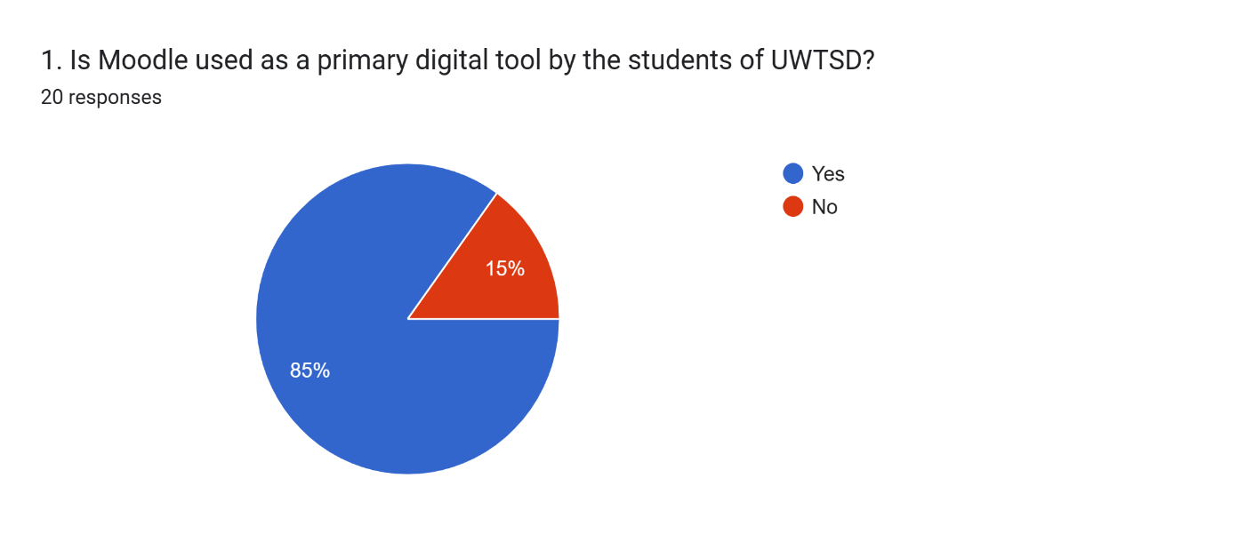
Analysis: The above question is showing that 85% of people are supporting the question and 15% are against the question. This concludes that Moodle is used as a primary digital tool by students. The next question will be about the reason students use Moodle.

Figure 2:
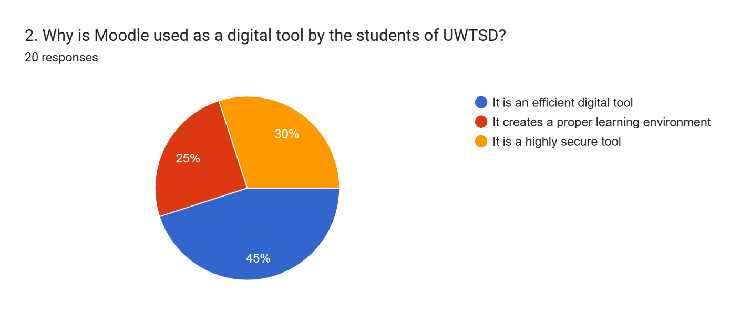
Analysis: The above question is showing that 45% of people are saying it is efficient, 30% are saying it is secure and 25% are saying about the learning environment created by Moodle.

Figure 3:
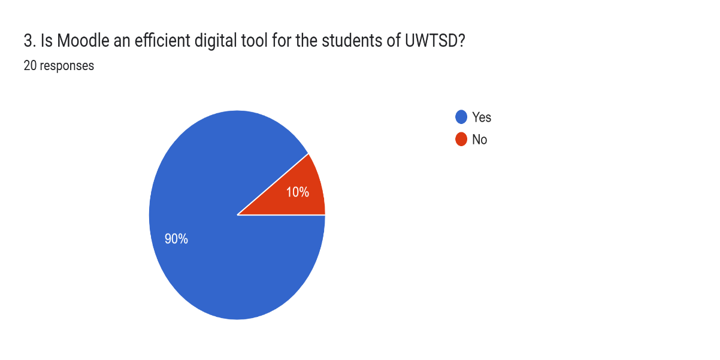
Analysis: It is showing that 90% of people are supporting it and 10% are against it. This shows that Moodle is an efficient digital tool for students.

Figure 4:
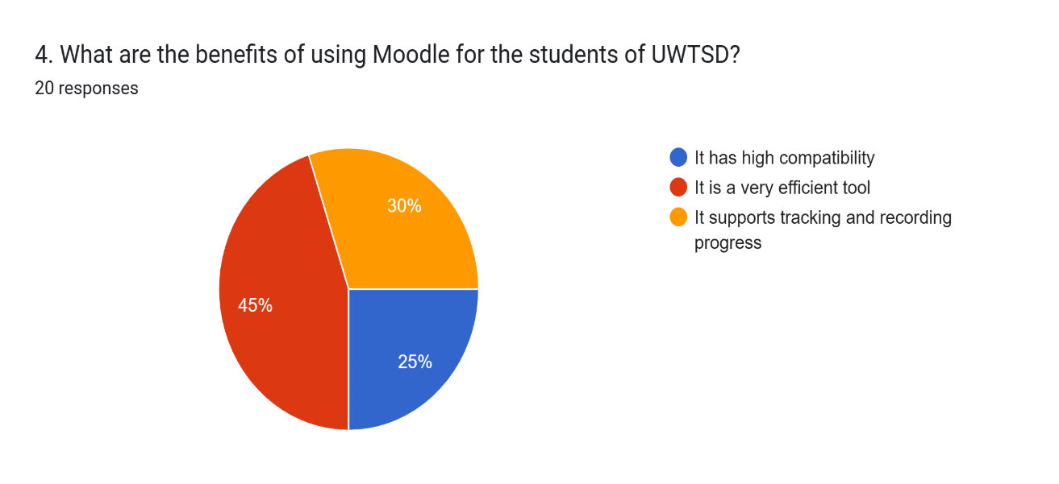
Analysis: The above question is showing that 45% of people are saying it is efficient, 30% are saying about tracking and recording progress and 25% are saying about compatibility. This shows that Moodle is an efficient tool. The next question will be about whether there are any tools better than Moodle.

Figure 5:
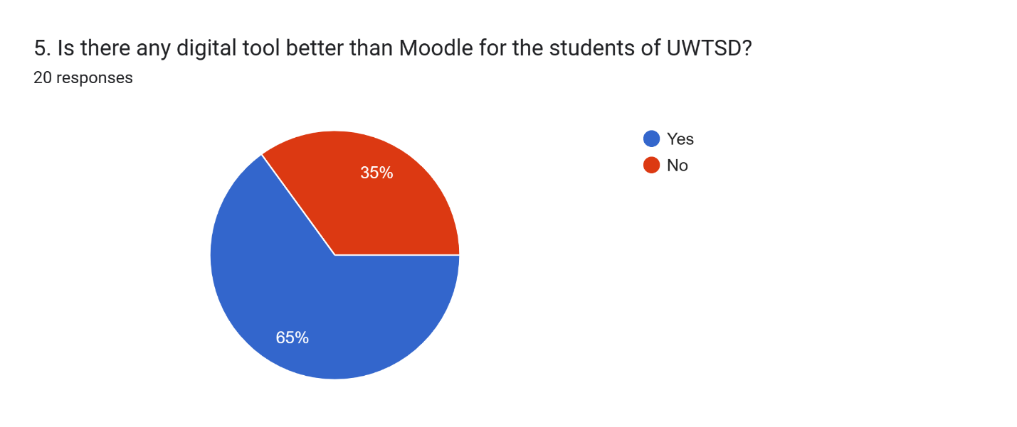
Analysis: The above question is showing that 65% of people are supporting it and 35% are against it. This shows that there are better digital tools than Moodle. For the next

Figure 6:
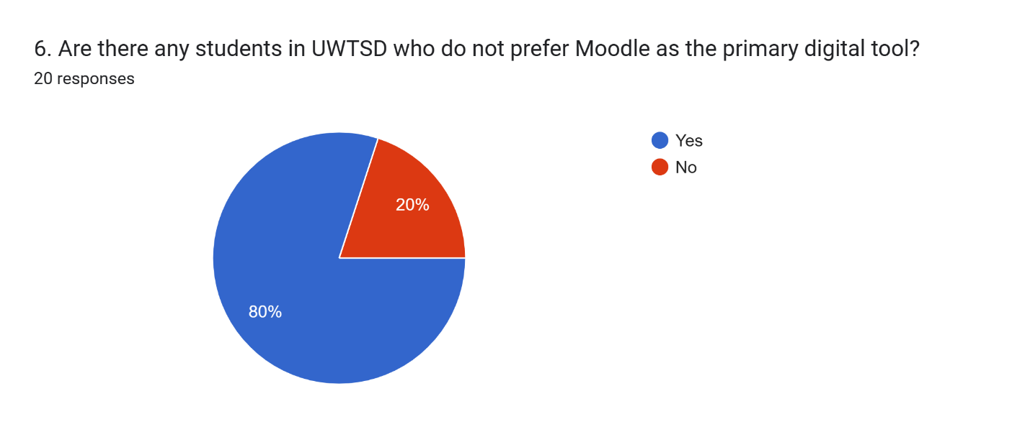
Analysis: The above question is showing that 80% of people are supporting the fact and 20% are against the fact. This shows that Moodle has a low preference among students in UWTSD.

Figure 7:
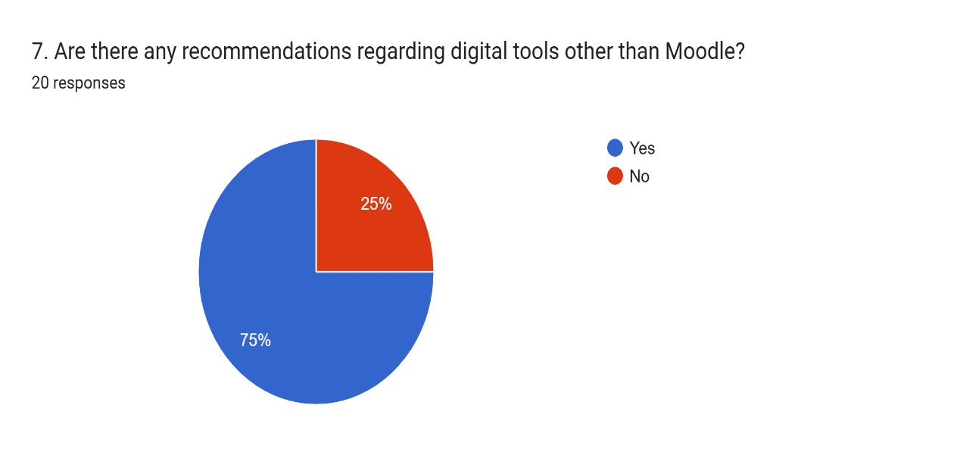
Analysis: The above question is showing that 75% of people are supporting it and 25% are against it. This shows that there are recommendations for tools other than Moodle.

Figure 8:
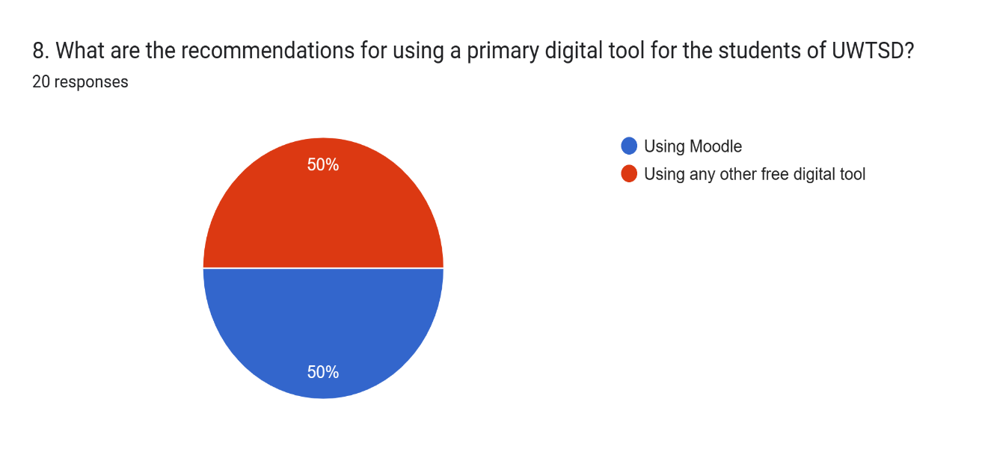
Analysis: 50% of people are supporting Moodle and 50% are supporting other free tools. This shows that there is a neutral recommendation regarding the tools.

Figure 9:
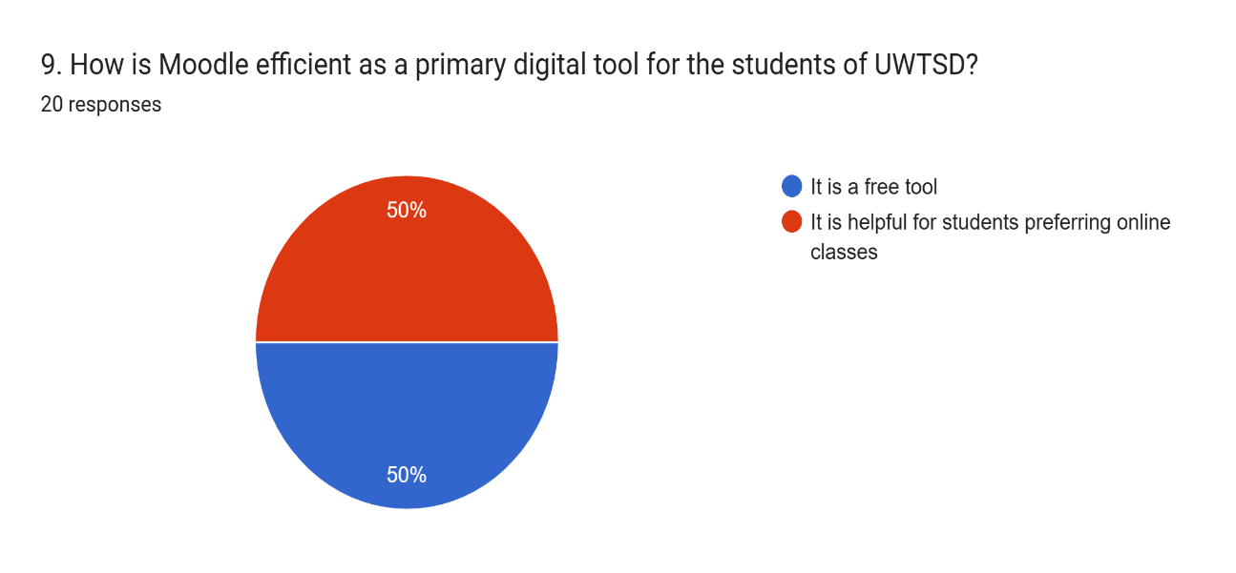
Analysis: 50% of people are saying it is a free tool and 50% are saying it is helpful for online classes. This shows a neutral outcome based on efficiency.

Figure 10:
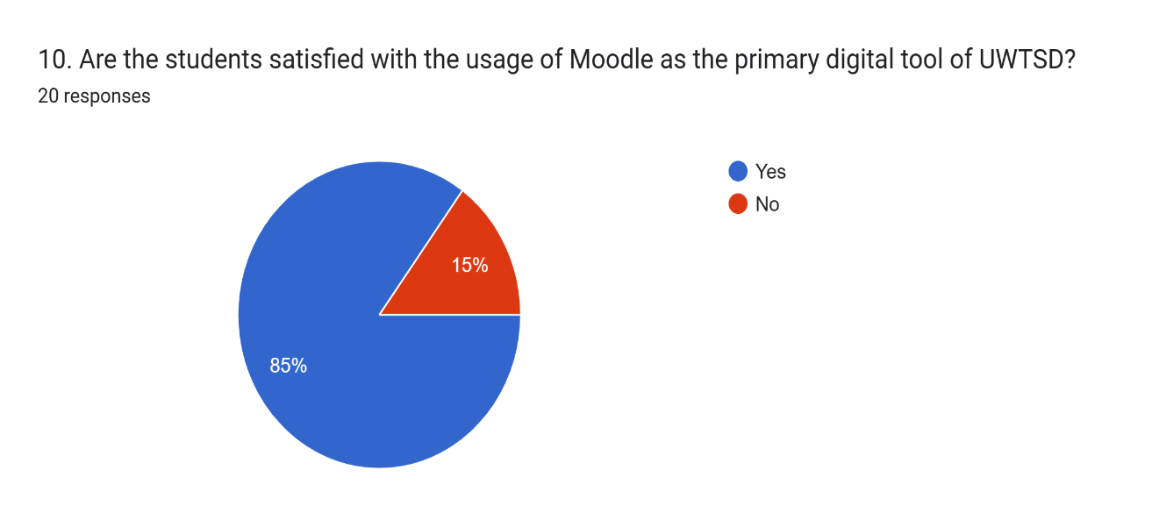
Analysis: The above question is showing that 85% of people are supporting it and 15% are against it. This shows that students are satisfied with the usage of Moodle.

Discussion
Moodle is termed the most efficient tool in terms of learning methodologies. According to Dolak, Moodle uses progress tracking and recording methodologies which is essential to determine student capabilities and performance (Dolak, 2019). The analysis showed that the majority of the people said that Moodle is preferable because of its high efficiency. The analysis based on the students revealed that Moodle is considered to be an efficient digital tool for the university as a whole. Though there have been responses regarding the security of Moodle, the analysis of the survey showed that the majority of people preferred Moodle due to its efficiency only. This is creating a conflict with the results regarding the performance tracking and the responses based on the efficiency of Moodle. Moodle is also known for its high security due to which it is recommended as a learning tool for the majority of universities and institutes (Goetz, 2019). The survey conducted has also shown many people who supported Moodle as a digital learning tool due to its security as it involved sharing of notes and other student data that were sensitive and confidential. The security of the application was a priority for the students which determined the usage of the application as a primary one for the university as a whole. Another benefit of Moodle is its compatibility. Due to this, the tool is reliable for digital learning processes on the majority of platforms (Lima et al., 2019). However, the analysis of the survey conducted revealed that the support based on compatibility was minimum which conflicted with the idea of people supporting the digital tool based on its compatibility benefits. Some updates can be made based on the compatibility which will result in the tool supporting more platforms, leading to an increased engagement of people based on its compatibility and other methodologies in the later surveys. Some recommendations have already been provided regarding other tools besides Moodle in the survey. However, the analysis showed a neutral outcome which concluded that equal numbers of people supported Moodle and other similar tools. Further analysis showed that Moodle was lacking some features which led to people supporting the need for other similar tools as a recommendation for the students. As per the findings of Minotti, Moodle was an open-source application which meant it did not require any payment to be used by the students (Minotti, 2019). However, this posed many threats as some users with fake names can register themselves on the application, leading to data breaches and thefts resulting in a loss of trust and reliability of the tool among the students of the university. So, some recommendations regarding proper user identification must be ensured in Moodle to improve its reliability as a digital learning tool for the students of the university. The analysis also showed that due to these threats, many students preferred other similar tools over Moodle as a result of the misunderstandings. Some improvements regarding the efficiency of the tool can be initiated which will result in a boost in student trust regarding Moodle as an efficient learning tool with improved security methodologies (Barna and Fodor, 2019). The conflicts in the analysis regarding the recommendations and student satisfaction have led to many discrepancies in the survey research. The neutral outcomes have been taken into consideration to analyse the types of recommendations that can be incorporated for proper results. Another analysis can be conducted on similar tools used by other universities to note the differences between Moodle and other platforms. Based on the analysis, the improvements can be incorporated and tests can be conducted among students to note their satisfaction based on the improvement that will be made in Moodle (Mintii, 2020). Though the analysis regarding student satisfaction has shown decent results, the improvements and recommendations made will help further boost the figures based on student satisfaction. These recommendations will help Moodle become a reliable tool (Fernando, 2020).

Conclusion
The report has been effective in discussing the benefits of digital skills and Moodle as a digital tool for use by university students. The relevant research methods have been discussed elaborately in the report. Some questions have been put forward in the report based on the research conducted among the students. Based on the questions made, some ethical considerations have been identified and incorporated into the report. The considerations have been discussed thoroughly with relevant impacts and details on the research conducted among university students. The methods including the involvement of participants have been put forward with proper detailing in the report. A survey questionnaire has also been made up with 10 questions and responses to those questions have also been noted. A critical analysis has also been made based on those 10 questions and responses of the 20 participants on their concept and usage of digital technology tools such as Moodle at submitting their academic assignments. A discussion has also been made on highlighting the questions of the survey and their associated responses. The majority of the responses suggested Moodle as a primary digital tool due to its high efficiency. Along with that, the majority of the students have also suggested that they have been using Moodle widely when it comes to submitting their assignments. The discussion part also showed a mixed review of students recommending other digital tools to increase the efficacy at the university.

References
Barna, B. and Fodor, S., (2019). Complex Gamification Platform Based on Moodle System. International Association for Development of the Information Society.
Bellamy, J., (2021). Contemporary perspectives on language standardization: the role of digital and online technologies.
Birkle, C., Pendlebury, D.A., Schnell, J. and Adams, J., (2020). Web of Science as a data source for research on scientific and scholarly activity. Quantitative Science Studies, 1(1), pp.363-376.
Dolak, R., (2019). Using process mining techniques to discover student’s activities, navigation paths, and behavior in lms moodle. In Innovative Technologies and Learning: Second International Conference, ICITL 2019, Tromsø, Norway, December 2–5, 2019, Proceedings 2 (pp. 129-138). Springer International Publishing.
Fernando, W., (2020). Moodle quizzes and their usability for formative assessment of academic writing. Assessing Writing, 46, p.100485.
Goetz, T.H., (2019). Placement Test Options Within A Moodle Environment. Author Name Paper# Title (Click title to view paper).
Gov UK, (2023). The Data Protection Act. [Online] Available at: https://www.gov.uk/data-protection#:~:text=The%20Data%20Protection%20Act%202018%20is%20the%20UK's%20implementation%20of,used%20fairly%2C%20lawfully%20and%20transparently [Accessed 30 03 2023].
Koleva, P., (2021). Towards the development of an empirical model for Islamic corporate social responsibility: Evidence from the Middle East. Journal of Business Ethics, 171, pp.789-813
Lima, M.M., Brito, G.L. and Caldeira, E.B., (2019). Preference of the Use of Moodle as a Learning. International Journal of Learning and Teaching, 5(4), pp.301-305.
Minotti, T., (2019). A Comparison of Online Teaching Platforms.
Mintii, I.S., (2020), March. Using Learning Content Management System Moodle in Kryvyi Rih State Pedagogical University educational process. In CTE Workshop Proceedings (Vol. 7, pp. 293-305).
Sileyew, K.J., (2019). Research design and methodology (pp. 1-12). Rijeka: IntechOpen.

Appendices
1. Is Moodle used as a primary digital tool by the students of UWTSD?
Yes
No
2. Why is Moodle used as a digital tool by the students of UWTSD?
It is an efficient digital tool
It creates a proper learning environment
It is a highly secure tool
It is a free tool helping in interaction with distance learning students
3. Is Moodle an efficient digital tool for the students of UWTSD?
Yes
No
4. What are the benefits of using Moodle for the students of UWTSD?
It has high compatibility
It is a very efficient tool
It supports tracking and recording progress
5. Is there any digital tool better than Moodle for the students of UWTSD?
Yes
No
6. Are there any students in UWTSD who do not prefer Moodle as the primary digital tool?
Yes
No
7. Are there any recommendations regarding digital tools other than Moodle?
Yes
No
8. What are the recommendations for using a primary digital tool for the students of UWTSD?
Using Moodle
Using any other free digital tool
9. How is Moodle efficient as a primary digital tool for the students of UWTSD?
It is a free tool
It is helpful for students preferring online classes
10. Are the students satisfied with the usage of Moodle as the primary digital tool of UWTSD?
Yes
No

