This document contains the report and screen shots required for the assignment that has been set for the programming 2 module at UWTSD.

Assignment 1
Programming 2
Andrew Cooper (1704746)
1704746@student.uwtsd.ac.uk
Contents
Introduction: 2
Understanding: 2
Testing: 4
Implementation: 8
Exercise 1: 8
Problem solving easiest to hardest. 8
Flowchart displaying how I feel the program should work: 9
How could this be implement this in a program? 10

Introduction:
In this report, the reader will find work that student 1704746 has created and tested for the assignment that he has received. The three main sections that will be covered in this report are:
- Understanding – A brief description of a problem solving technique and some of the benefits and disadvantages of using this method.
- Testing – A program that has been provided by the lecturers will be tested and the problems will be documented and then fixed.
- Implementation – The student has attempted to create the programs that has been asked of him as per the assignment brief.

Understanding:
There are many different problem-solving techniques that can be used to potentially make creating a program easier. When developing a code, having a good problem solving technique can save the developer a lot of time and hassle.
A good technique that simplify and solve problems is subdividing the problems into functions. This is the method of breaking up a larger problem into smaller problems to perform specific tasks and then giving each code block a name relative to what the purpose of the function is.
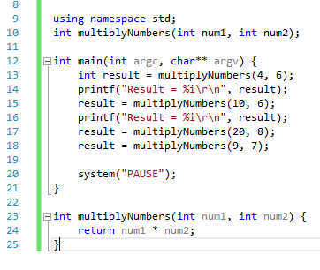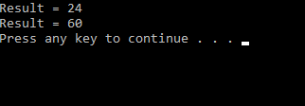
Above is a very basic example of using functions within a program. As you can see from the image, I have created a program that multiplies two numbers together and I have given my function a suitable name “multiplyNumbers”. Having a suitable name will help in the long run as large projects could have many different functions and could cause a lot of confusion for the person developing the code after a while of working on it. From the example above you can see that after creating the function I can then use it as many times as I need this can help remove redundant code, although this is not so much of an issue for my program, it can become beneficial in large programs that are more complex.
Using functions effectively means that there should be less code and clutter in the main section of the program. This can save developers a lot of time because there will be less wasted time looking through the code to fix bugs. On the topic of fixing bugs, another great advantage of using functions is should the programmer need to make changes they will only need to do so in one place. Please see the images on the next page for an example of this.
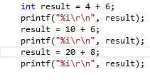
This image shows how the code would look if I was to write these problems in the main section. If I decide later that I should have multiplied these numbers together rather that add then I would have to go through each one changing the addition symbol to multiplication.
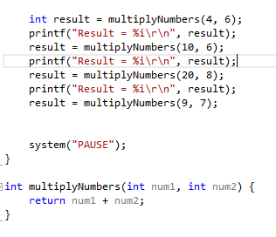
However, using a function I only have to change the symbol in one place for it to work how I expect it to. For larger projects this can save a company a lot of time and money.
Breaking up a problem into functions also means that it is easier to work on projects in a team which means that the separated problems can be delegated out to other people in which you work with.

Testing:

1. | User enters “Yes” to exit the program.
Description |  | The user enters “Yes” to exit the program.
 |  | Test Steps :
1 | User enters “3” to exit.
2 | Message displays asking the user if they’re sure they want to quit.
3 | User enters “Yes” “yes”, “y”, “Y”.
4 | The program displays “quitting”.

Response |  | The program carried on running and returned to the menu screen.
Status |  |  | Date |  |  | Description
Fail |  |  | 16/03/18 14:35 |  |  | The program did not exit when the user entered “Yes”, “yes”, “y” or “Y”.
Pass |  |  | 16/02/18  14:38 |  |  | Passed for all values.

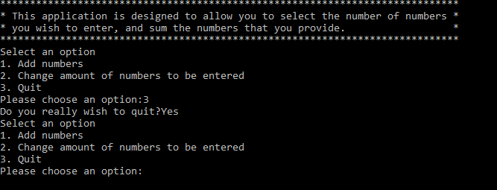
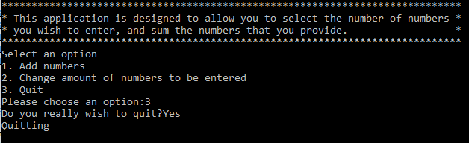

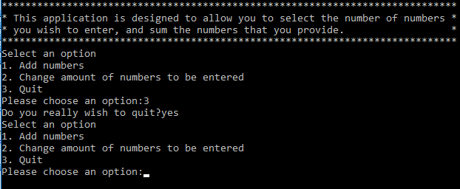
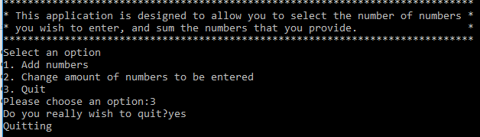

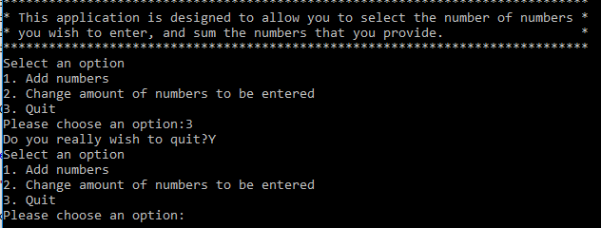1.
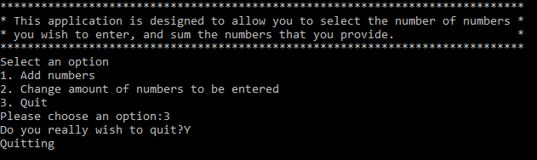

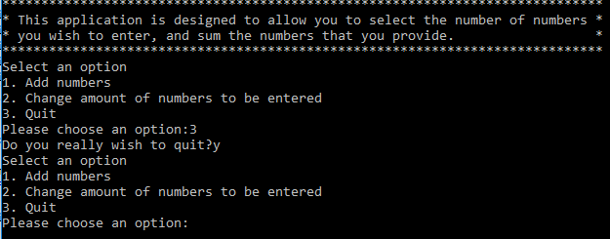
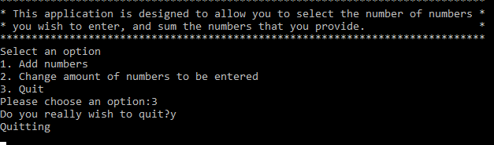

After I performed all of the tests above I was able to fix them by using very simple “OR” operations. Please view the image below to see how I was able to fix the problem.
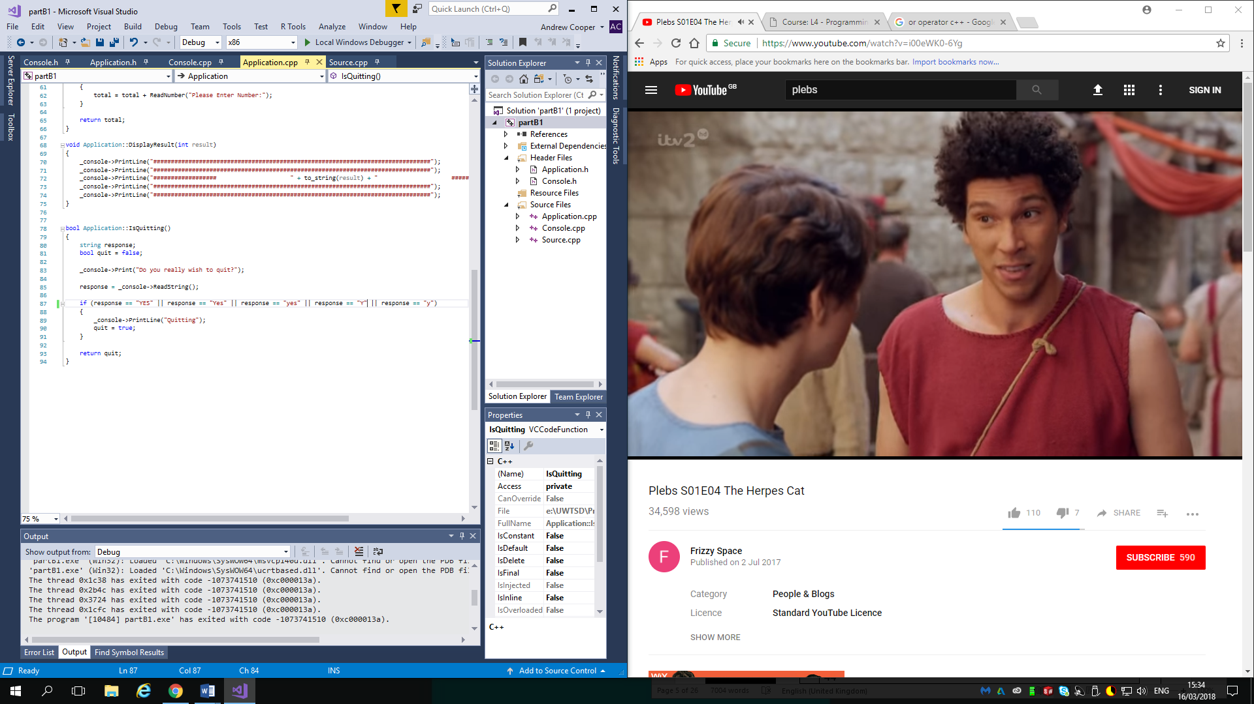
The underlined code is the code that I have added which then made the program work as expected.

1. | User enters invalid menu option
Description |  | The user inputs an invalid option within the menu.
 |  | Test Steps :
1 | Menu displayed asking user to enter an option.
2 | User enters “1a”, “a1”, “a”.
3 | An error message is displayed telling the user they have entered an invalid option.
4 | The menu is displayed asking the user to enter an option.

Response |  | An error message was displayed when the user enters an invalid option with a leading value. E.g. “a1”.
Status |  |  | Date |  |  | Description
Fail |  |  | 16/03/18 15:21 |  |  | An error message was displayed when the user enters an option with a leading invalid option. E.g. “a1” but doesn’t when the user enters “1a”.
Pass |  |  | 16/02/18  15:42 |  |  | Passed

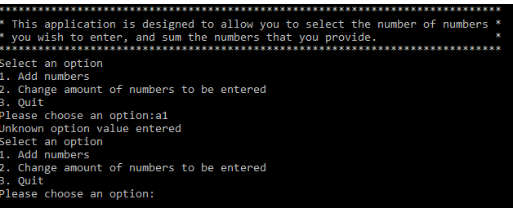
The image above shows that the error message is displayed when the option chosen isn’t recognised as a valid option.
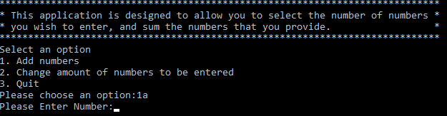
The image above shows that the user is able to enter a valid option followed but a random character. This is a problem.

Implementation:
In this section I will use my current understanding and existing problem solving skills to try overcoming problems that has been set in the assignment.

Exercise 1:
I was asked to create a console game where the users are asked to guess a number between -20 and +20 which the program randomly chooses. There are specifications that I have to implement in the game such as hints being provided if the user fails to guess the number, if the user guesses anything that isn’t a number they lose a life and a hint is not provided and the player only receives fives lives. To complete this task I will use a series of problem solving techniques such as writing the problems down from easiest to hardest and drawing a flowchart to further understand the flow of the program.

Problem solving easiest to hardest.
- Display “win” or “lose” to the player. (printf)
- Input user number. (scanf)
- Checking if user number matches random number. (if statement)
- Add to the amount of attempts the user takes if they guess wrong.
- Display whether the number is positive or negative. (if statement)
- Display how far away the guessed number is away from the random number. (+/- 10, +/- 5, +/- 2)
- Create random number. (between -20 and + 20)
- Checking if what they entered is a number.
- Add to attempt and don’t display hint if the user enters something that isn’t a number.

Flowchart displaying how I feel the program should work:

Start

Program pick random number. (-20/+20)
Add 1 on to attempts.
Display: user is wrong

Display: hint +/- 10
Yes

No
Yes
Is guess within +/- 2?

Yes
Yes
No
No
Yes
Yes
Display message:
You Win!

end
End

Display message:
You Lose! Reveal number

Is user guess == random number?
Read user’s guess.
No

Has the user made 5 guesses?
Display hint +/-5

Display hint +/-2

Is guess within +/- 10?
No

Is guess within +/- 5?
Has the user entered a numeric value?

No

Display message asking
user to enter guess.

How could this be implement this in a program?
Firstly, the program will create a random number between -20 and +20 using the time function to randomize the number; this will give the creator of the program a pretty certain chance that the number is going to be random. A good method that will allow the student to achieve this is by using the “srand((unsigned)time(&theTime)).
Because the programmer knows that they only want the user to have five guesses the best option would be to create a “for” loop. An example of this code could be (for attempts = 0; attempts < 4; attempts ++){code goes here}. This code will perform whatever is inside the curly braces and when the code has reached the bottom of the code block it will increment attempts to 1, 2, 3 then 4, please remember that as programmers we count 0 as a number. By using this piece of code it will save a lot of repeating code and time.
Once the program has entered into the loop it will then display a message asking the user to enter in their first guess. To ensure that the program displays “1” guess, I can take the “attempts” from the loop and add 1. Code that can be used to achieve this is printf(“Please enter your %i guess…\r\n”, attempts +1); This code will be used to display onto the screen the amount of guesses that the user has taken, “%i” is used to tell the program that there will be an integer placed there.
After the user has entered the number they wish to guess, the program will then need a way to store the number. The method that will be used for this is creating a variable given a name such as “userGuess” and using a “scanf” statement to store the number such as scanf(“%i”, &userGuess”);. Again, the “%i” is informing the “scanf” function that it will be expecting an integer value.
To check if the number that the user has entered is the same as the random number chosen, a simple “if statement” can be used. To ensure that the program doesn’t continue to loop if the program enters the correct number the creator can use a “break” and the program will exit the loop and continue with the rest of the program. Using the flow chart from the above page we can see that if the number is correct it will display a message and then end; this will be achievable using the “break” statement.
The next thing that the program will have to check is whether the user has entered a numeric value, anything other than that should be counted as an attempt and no hint given as that is what the specification requires. A possible method for ensuring the user enters a number is by using an “if” statement.
The program will have to be able to display hints based on how far away the user is from guessing the number. As the programmer a way that may work is by using “if” statements and within them if statements using this following piece of code…
if(userGuess + 2 == randomNumber || userGuess – 2 == randomNumber){
printf(“Your’re within + or – 2);
An explanation for the code above is, if the number the user guesses + 2 is the same as the random number that was generated, display the hint. To display for the rest of the hints, a possible solution could be to use “else if” to print whether the user is in within 5 or 10 and lastly “else” if the user isn’t within these ranges.
As mentioned earlier once the program has gone through this code it will then add 1 onto the attempts taken. Once the variable has incremented to the total amount set (in this case 4) the program will display a message telling the user they have reached the total amount of guesses and reveal what the answer was.

