  Innovative Service Plan | Module: Developing Innovation and Creativity for Business Advantage Module code: BMSW6102 Student name: Corina Berco Student ID: 1918420 Lecturer name: Khaza Ahmed

Table of contents

Introduction. 2
1. Innovative service idea. 3
1.1. The Innovation Matrix. 4
1.2. Prices. 4
1.3. Customers. 5
1.4. Unique selling point. 5
2. SWOT analysis. 5
3. Competitors’ analysis. 6
4. Financing. 7
5. Staff. 7
6. Commercial leasing. 8
7. Payment Services. 8
8. Marketing strategy. 9
8.1. Launch promotion. 9
8.2. Digital public relations. 10
8.3. Website. 10
8.4. Promotion. 11
Conclusion. 11
References. 12

Introduction.
The following paper introduces an innovative service idea for Sonia Photography photo studio that is planning to offer a wide range of services and a lot of other surprises for its customers. An explanation of customers’ needs and competitors in the marketplace is presented, together with the PayPal Commerce Platform that will facilitate the payment of services. The list of expenses is presented to show how the funds will be spent.
Do you ever need a picture of high resolution for your business or a large size poster for an event? Or to rent a photo booth, when photographers’ schedule is far away from the date of the event. In this century, consumers like to see things for themselves before deciding on a purchase, so photos allow entrepreneurs to show their customers what they have to offer.
Any type of business with photos will not be considered serious if it is not presented online. The presence of a functional website, as well as activity on Facebook, is an efficient and effective way to reach the target market at the lowest cost.

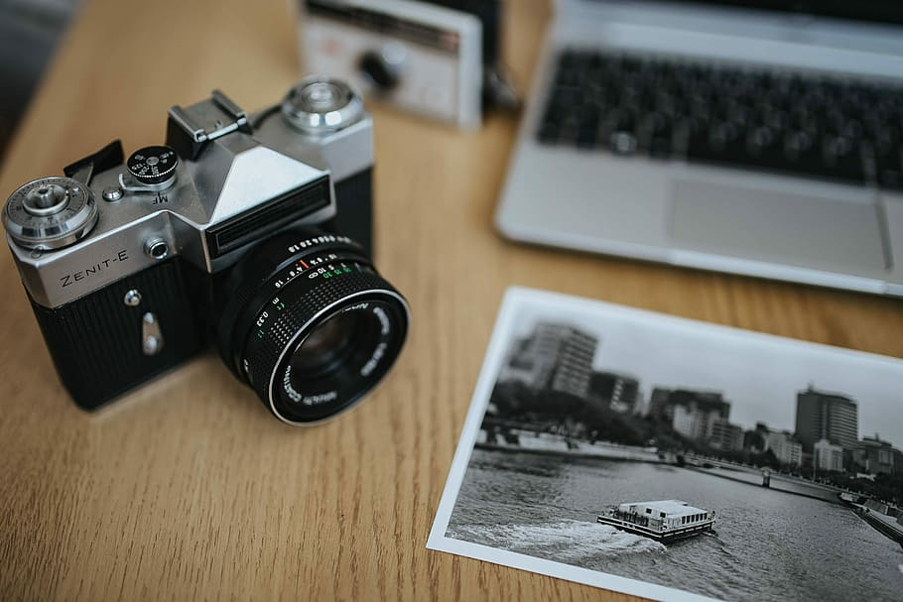
"The camera is an instrument that teaches people how to see without a camera." - Dorothea Lange (American photojournalist).

Every picture tells a story.

1. Innovative service idea.
New business always looks small and modest, so an entrepreneur should come up with an innovative and promising idea for the market. The existing business meets different problems and failures, so a good entrepreneur should learn how to manage a new business to keep it profitable and learn how to survive and innovate in this competitive market (Drucker, 2012).
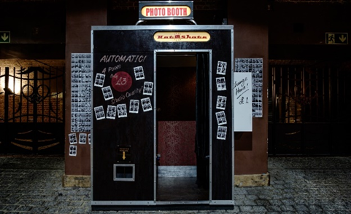
Just before planning to open a business, every entrepreneur should research the demand of the market and take into consideration current trends. The professional photo studio Sonia Photography will offer high-quality in-store and online services. Photos, video spots, and short business videos for product placement on social networks and official websites.
Besides the above-mentioned services, the main innovative service will be photo booths, for those customers who want to experience more, not depend on a photographer.
Source: kevin-grieve-nvjQle4tGI4-unsplash.jpg (4895×3034) (taggbox.com)
Photo booths have become very popular at weddings, christening parties, or corporate events. It is an entertaining kiosk that uses video or digital cameras, controlled by the computer, to make funny memories (In light photo booths, 2020). The photo booths we plan to buy are self-served portable cabins, easy to use, that take a row of photos of the host with the guests. As an additional bonus, the photo booth will have funny accessories and frames.

According to Photobooths (2021) the interest and request for Photo booths in 2021, increased twice, comparable to 2020. After a considerable crisis in the past 2 years, Sonia Photography has a very optimistic plan to have a good profit from renting photo boots, estimated at 2000£ weekly.
Source: 9222b9fdbddff071798917d17dbd7c19.jpg (4272×2848) (pinimg.com)

1.1. The Innovation Matrix.
The Innovation strategy that best fits the business in sustaining innovation. An innovation product or service that already exists but the goal is its further improvement and growth with a clear idea about what to change to make it better (Satell, 2017).
BREAKTHROUGH INNOVATION | SUSTAINING INNOVATION  Sonia Photography
BASIC RESEARCH | DISRUPTIVE INNOVATION
4 types of innovation
A photo kiosk that is used to make photos for passports – Photo Booth is an improved kiosk, with more features and a high-resolution camera. It has a built-in screen where anyone can see the pictures and choose the best one to print.

Source: 4-types-of-innovation.pdf (mvcc.edu)

1.2. Prices.
PHOTO BOOTH RENTAL PRICES
ECONOMY PACKAGE  2 Hours | COMPLETE PACKAGE  4 Hours | PREMIUM PACKAGE  6 Hours
Price: 250 £ | Price: 370 £ | Price: 500 £
Ideal for children's and corporate parties | Ideal for christenings and weddings | Ideal for christenings and weddings
Funny accessories (masks, hats, glasses) | Funny accessories (masks, hats, glasses) | Funny accessories (masks, hats, glasses)
Personalized graphics of the photos (frames, text, decorations) | Personalized graphics of the photos (frames, text, decorations) | Personalized graphics of the photos (frames, text, decorations)
 | BONUS  Photo album book  Fridge magnets | BONUS  Photo album book  Fridge magnets  Memory stick with all taken photos

1.3. Customers.
The huge volume of information available online has changed the way customers have the innovation delivered, which is via smartphone applications that can be found in hundreds of sources. Mobile technology has replaced or reduced whole parts of retail stores, focusing on most marketing achievements on consumable and household goods and difficult to be replaced with digital and technology-enabled products (Ferrell et al., 2021).
Sonia Photography’s customers can be divided into two large groups, this considers the target needs.
- Legal entities that will rent Photo boots for the corporate parties. It is important to know the type of company, turnover, geographical region, and company capital.
- Individuals will use the service for their personal use, to memorize important moments of their life, such as anniversaries or weddings. It is important to know the customer’s age, gender, occupation, hobbies, or needs.

1.4. Unique selling point.
Every entrepreneur should think about - What is so special about the business? What is different and important? Why should customers buy or use your services where there are so many other similar offers?
Sonia Photography's unique selling point that will differentiate its services from other competitors are photographers that have a big value in this area, cheaper prices, as well as the main innovative proposal - photo booths. Researching the market, we propose to offer potential customers better prices and better quality of services and products.
A unique selling point of a product or service has distinction factors, such as cheaper price, an innovative distinctive product, and anything that a trademark has, and the competitors don’t have (Flexadia, 2022). A business with a unique selling point is more famous and best remembered by customers because it is different. It helps customers to make the right choice and increase sales.

2. SWOT analysis.
SWOT analysis is a strategic effective tool for analysing the Strengths, Weaknesses, Opportunities, and Threats of a business that helps to identify the effectiveness of a business planning and implementation (Sabbaghi and Vaidyanathan, 2004).

STRENGTHS (internal)  - High-qualified employees  - Good customer service  - The location of the photo studio  - The highest quality services | OPPORTUNITIES (external)  - More advertisement  - Make promotions  - Free presents and promotions will lead to customer growth
WEAKNESSES (internal)  - New to the market  - Not enough advertisement  - Lack of funds  - Weak social media presence | THREATS (external)  - Pandemic  - Economic crisis  - Change in customer’s preferences  - Corrupt data from memory cards  - Competitors:  - Kamera photography studio  - Dan Foley photography  - Graham Emery Photography

3. Competitors’ analysis.
Nowadays competition is one of the most powerful forces for making things better in many areas of human labouring, hence every company needs a strategy to deliver higher-level value to its customers (Baker, 2014).
Factor | Sonia Photography | Kamera photography studio | Dan Foley photography | Graham Emery Photography
Product and services | Photos, video spots, and short business videos for product placement on social networks and official websites. Videos for weddings or christening. Photo booth. | Wedding, and pregnancy photos. In-studio portraits and on-location shoots. | Maternity, newborn, family session, and Pet Pawtraits. Commercial and events photography. | - Wedding photography.
Location | - A physical photo studio and a website. | - A physical photo studio and a website. | - A small shop to meet potential customers. Website. | - Website.
Marketing strategy | Facebook, official website. Promotion and discounts. | - Facebook, official website. | - Facebook, official website. | Facebook, official website.

Competition does not only come from companies selling similar products and services, but it is also where there is another choice that offers better value in satisfying a customer’s need (Baker, 2014).

4. Financing.
Sonia Photography will have mixed funding. 30.000£ from the total amount will be a loan for small businesses and 20.000£ from savings. Regardless of future customer preferences, photo studios should have enough capital to cover the purchase of equipment, as well as running costs, which will be 50.000£ for the start with future investments.
Expenses.
LIST OF ITEMS | £
Business registration | 1.700
Repair of premises | 4.740
Insurance and licenses | 1.200
Furniture and accessories | 1.500
Photo booths | 11.800
Cameras, adapters, and batteries | 9.620
Stands, supports, shelves, camera lenses | 680
Professional business website | 400
Backdrops and lighting | 480
Decorative background with attachments | 850
Computers, computer systems, and accessories | 5.200
Artificial light sources, shadows in transmission and reflection, softboxes, reflectors | 1450
Launching party | 800
Commercial lease agreement | 9.100
Marketing strategy/advertising campaigns | 580
TOTAL SPENDINGS | 50.000

5. Staff.
To empower a new business to run successfully, the structure and organization must be right, there should be proper relationships and rewards should be present. Finding appropriate staff is a serious decision in a business, which should be made correctly (Drucker, 2012).
Our team will consist of competent and creative young professionals with a high-quality portfolio, and experience in this area. An administrator that will take online and in-store orders. A skilled administrator not only solves any problems but also prevents potential problems on time. Technical staff must be in any studio. Employees should be able to work in shifts with the possibility of substitution if necessary.


6. Commercial leasing.
The photo studio will be located near the Gallagher Retail Park in Coventry, with a lot of commercial properties for rent, where the price competition is high. We found a commercial property with cheaper monthly rent and insurance. Another priority for the location is a bus station and a lot of parking spaces.
Every physical business needs a place to develop its activity. It is important to find a suitable place, that will bring great contribution to the success of the business.
Source: Commercial-Lease-Agreement-Template-04.jpg (1932×2500) (templatelab.com)
To rent a premise all entrepreneurs should agree upon a commercial lease agreement, which is a form of the official obligatory contract made between a business tenant and a property owner. The lease gives you the right to use the premises for business for an arranged period. It outlines the rights and responsibilities of both the property owner and the tenant during the leased period (PallMall, 2021).

7. Payment Services.
To satisfy customers and to increase sales, small businesses implemented payment by card. This benefit comes with extra risks and costs. Payment Card Industry Data Security Standard (PCI DSS) provides more protection for consumers, but it brings as well additional costs for businesses (Morse and Raval, 2008). PCI DSS is a set of security standards for any structure that processes, keep, and transfers cardholder data. It was formed in 2004 as a joint effort between card issuers such as Visa and MasterCard, to protect cardholder data (Clapper and Richmond, 2016).
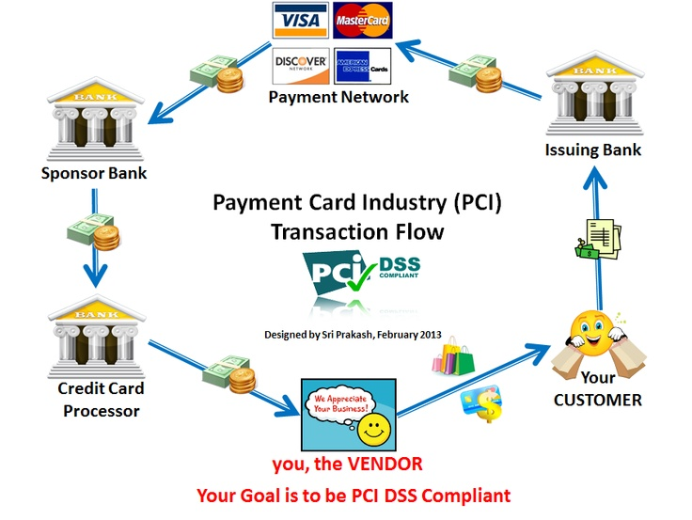
Customers will have the choice of paying cash or by card. And if the order is made online they will have the possibility to pay through PayPal, which is a commerce platform, to make and receive a payment easier. A useful tool for customers is a touch-free payment, just by scanning a QR code using the PayPal application (PayPal Commerce Platform, 2022).

Source: 9f253f26de4b14a20413608817f34327.jpg (736×553) (pinimg.com)

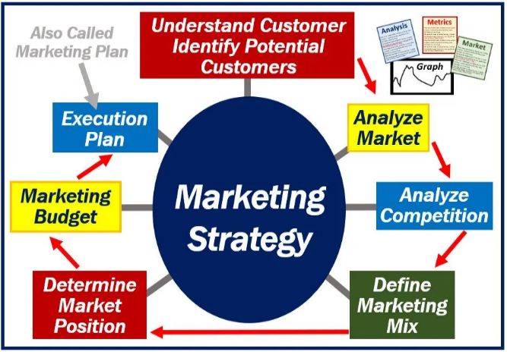
8. Marketing strategy.
According to Baker (2014) marketing is a field like medicine, architecture, or technology that combine knowledge and insights from other single fields as a base for professional practice. A marketing strategy is a combination of products and services, price, distribution, and promotion most relevant to a specific group of consumers (Baker, 2014).
Source: Marketing-Strategy.jpg (934×646) (wp.com)
The successful management of a photo booth business largely depends on an effective marketing plan. The more people know about the business, the more productive it will be. Therefore, the power of advertising should not be underestimated.
Every business should be able to adapt to innovation and market requirements. It must be able to change and develop if it wishes to survive (Trott, 2016).

8.1. Launch promotion.
The Sonia Photography studio will launch its appearance on the market, available for every visitor and special photographer guest that will be invited to present their works. We will introduce our services and will offer 20% off the first service to everyone that will be there, enjoying our launch opening party. Doing a business launch opening correctly will be the key to our progressive success.
The photo studio will launch as well online with an official website and a page on Facebook, which will open access to a very wide range of potential customers. We hope it will fast become a business’s favourite that will be able to target an audience and deliver commercials directly to the people that are most likely to want to buy our products and services (Nations, 2021).

8.2. Digital public relations.
The purpose of digital public relations is to reach a new audience for an existing or future business. A great example for a business to reach new people is using Lookalike Audiences. Potential customers who are possible to be interested in a business because they have similar features to already existing customers. To create a lookalike audience, the system uses information such as demographics and interests from people on social media, to find new people who have similar characteristics (Meta business help center, 2022).
It is as well important to communicate to customers to discover issues of the service/product a business offers, that need to be solved to ensure that the current customers don’t leave. It is ideal to talk to them directly, face to face, or on the phone, to send small questionnaires by email, or use the NPS (Net Promoter Score). It is the most used outcome to evaluate customer satisfaction and estimate the loyalty that is between a business and a customer. A very simple and relevant system in which a score is based on a single question, usually taken just immediately after the service was provided (Zoccante, 2022).

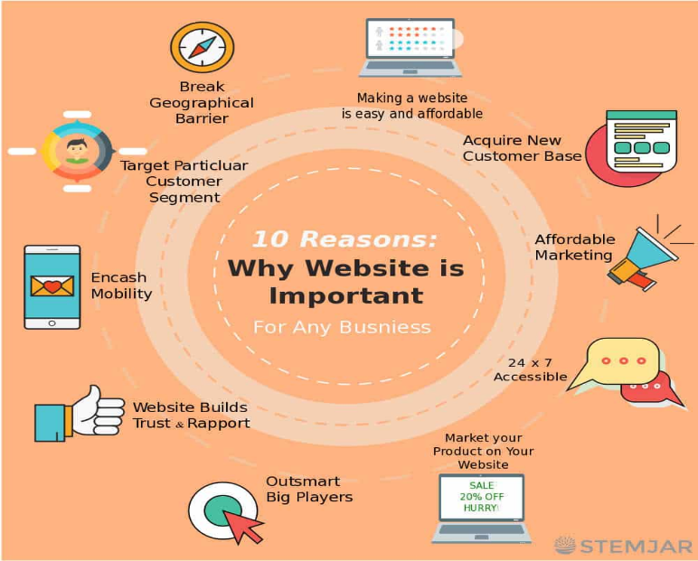
8.3. Website.
The wide range and variety of products and services presented for sale on the internet are surprising. Companies that have followed digital as the main strategy are frequently able to undercut the prices of fixed market brands and introduce new products more quickly (Ferrell et al., 2021).

Source: why-website-is-important.jpg (1000×1002) (stemjar.com)

Photos on a business’ website are extremely important when it comes to making a first impression on customers. Sonia Photography will place on the website high-quality photos that will make it infinitely more immersive. On the website, potential customers will be able to make a booking for a photo session or rent a photo booth. It is the easiest way to promote services or products regardless of the complexity and field of activity of the company.
A good, structured website is the company’s virtual business card and users must have quick and easy access to contact details and addresses. We will try to understand the needs of our customers as relevantly as possible and adapt to any budget.

8.4. Promotion.
Promotion plays an important role in determining whether a customer chooses from two or more competitors. To differentiate Sonia Photography will offer as a gift fridge magnet with a photo of the customer’s choice if they choose to have a photo session, or a wall calendar if the customer chooses a bigger event.
Customers that will make online bookings, will receive a coupon that will offer them a discount voucher of 10% off their next service with the photo studio, and a thank you ticket. It is important to show customers that you are grateful that they bought from you.
To gain trust and loyalty, a business must satisfy or exceed the expectation of the customer, so there should be always contact and feedback to confirm and improve these expectations (Baker, 2014).

Conclusion.
This paper outlines the innovative service plan of Sonia Photography photo studio, which is photo booths. The objective of the photo booth is to capture, with the help of a mini studio, irreplaceable memories that probably happen once in a lifetime, at a certain special event, such as a wedding, birthday, or christening.
As customers struggle when looking for a photo studio that offers good services at decent prices, the above-presented plan will help customers make the right decision in choosing a photo studio. Besides the competitors available on the market, Sonia Photography’s unique selling point will make a difference to potential customers. The business location as well plays an important role for customers, along with promotion strategy, as every customer will be happy to receive a small significative gift. The detailed financial plan and marketing strategy are presented to prove that the photo studio has great potential for the future.

References.
1. 10 Top Reasons Why a Website is Important for any Business [illus.] (ND) Available at: why-website-is-important.jpg (1000×1002) (stemjar.com) (Accessed: 11 July 2022).
2. Baker, M.J. (2014) Marketing strategy and management. 5th edn. United Kingdom: Palgrave.
3. Clapper, D. and Richmond, W. (2016) ‘Small business compliance with PCI DSS’, Journal of Management Information and Decision Sciences, 19(1).
4. Commercial lease agreement [illus.] (ND) Available at: Commercial-Lease-Agreement-Template-04.jpg (1932×2500) (templatelab.com) (Accessed: 19 June 2022)
5. Drucker, P.F. (2012) Innovation and entrepreneurship: practice and principles. Oxford: Butterworth-Heinemann.
6. Ferrell, O.C., Hartiline, M.D. and Hochstein, B.W. (2021) Marketing strategy: text and cases. 8th edn. Cengage Learning.
7. Flexadia (2022) What is a Unique Selling Point (USP)?: Function, Strategy, Tips, etc. Available at: What is a Unique Selling Point (USP)?: Function, Strategy, Tips, etc (flexadia.com) (Accessed: 06 July 2022).
8. Graduation Party photo booth [illus.] (ND) Available at: 9222b9fdbddff071798917d17dbd7c19.jpg (4272×2848) (pinimg.com) (Accessed: 10 July 2022).
9. In light photo booths (2020) What is a Photo Booth? (And why you need one at your next event). Available at: What is a Photo Booth? (and why you need one at your next event) - In Light Photo Booth Rental Company (inlightphotobooths.com) (Accessed: 6 June 2022).
10. Nations, D. (2021) What Is Facebook? Available at: What is Facebook? (lifewire.com) (Accessed: 15 June 2022).
11. Marketing strategy [illus.] (ND) Available at: Marketing-Strategy.jpg (934×646) (wp.com) (Accessed: 20 June 2022).
12. Meta business help center (2022) About Lookalike Audiences. Available at: About Lookalike Audiences | Meta Business Help Center (facebook.com) (Accessed: 17 June 2022)
13. Morse, E.A. and Raval, V. (2008) PCI DSS: ‘Payment card industry data security standards in context’, Computer law & security report 24, pp. 540–554. DOI:10.1016/j.clsr.2008.07.001
14. PallMall (2021) The Basics of a Commercial Lease Available at: The Basics of a Commercial Lease | Pall Mall Estates (Accessed: 1 July 2022).
15. Payment Card Industry (PCI) Transaction Flow [illus.] (ND) Available at: 9f253f26de4b14a20413608817f34327.jpg (736×553) (pinimg.com) (Available at: 15 June 2022).
16. PayPal Commerce Platform (2022) The platform that grows with you. Available at: PayPal for Business | Merchant Services | PayPal UK (Accessed on: 21 June 2022).
17. Photobooths (2021) Photo Booth Statistics - on the rise for 2021. Available at: Photobooths | Photo Booth Statistics-On The Rise For 2021 - Photobooths (Accessed: 05 July 2022).
18. Photobooths [illus.] (ND) Available at: kevin-grieve-nvjQle4tGI4-unsplash.jpg (4895×3034) (taggbox.com) (Accessed: 15 June 2022).
19. Sabbaghi, A. and Vaidyanathan, G. (2004) ‘SWOT Analysis and Theory of Constraint in Information Technology Projects’, Information Systems Education Journal, 2(23). http://isedj.org/2/23/
20. Satell, G. (2017) The 4 types of innovation and the problems they solve. Harvard business review.
21. Satell, G. (2017) 4 Types of Innovation [Table] Available at: 4-types-of-innovation.pdf (mvcc.edu) (Accessed: 10 July 2022).
22. Trott, P. (2016) Innovation management and new product development. 6th edn. United Kingdom: Pearson Education.
23. Zoccante, P. (2022) Net Promoter Score: what is it, and why do you need it? Available at: Net Promoter Score: what is it, and why do you need it? - DataKind UK (Accessed at: 21 June 2022).

