A quantitative study to investigate the effects of sensation seeking and tempo of music on time perception

Abstract
A study was carried out to explore the effects of sensation seeking and tempo of music on time perception in students at the University of Wales Trinity Saint David. Participants were asked to fill in a sensation seeking questionnaire and complete a time perception task using a pink oval stimulus in either a high or low tempo music condition. A control group completed the task with no music in order to compare results. The overall results showed no significance for either sensation seeking or listening to music in affecting time perception, however multiple comparisons showed a significant result when measuring the difference between high and low tempo music on time perception responses. Suggestions have been made to improve future studies such as using a larger sample size.

Introduction
Time perception is considered a crucial aspect in everyday decision making, such as when approaching a hazard while driving (Caird & Hancock, 1994). If external factors can affect a person’s time perception while driving, the consequences could result in an accident, potentially escalating to serious injury or death. For reasons such as these, research into factors affecting time perception is much needed and could potentially save lives. Previous research into time perception has shown a link between music and its influence on over or under estimation by participants of time while playing a driving game (Cassidy & Macdonald, 2010). Yalch and Spangenberg (1990) found that shoppers who listened to unfamiliar music tended to spend more time shopping than when listening to familiar music, and Caldwell and Hibbert (2002) found that playing music from a preferred genre resulted in participants spending more time in a restaurant. These findings would suggest that playing an unfamiliar track from a preferred genre would result in more over-estimation of time. Weisskirch and Murphy, (2004) found evidence to suggest that those scoring highly on sensation seeking questionnaires tend to show a preference for punk and heavy metal music over other genres such as jazz and pop. A study by McNamara and Ballard (1999) found a positive correlation between high levels of sensation seeking and a preference for rock music. This research would suggest a hypothesis that those who score higher on a sensation seeking questionnaire would over-estimate time when listening to high tempo music.

Method
Participants
The participants consisted of a convenience sample of 31 students from the University of Wales Trinity Saint David SA1 Campus with an age range of 20 to 61 (M = 28.77, SD= 10.59), (15 female, 17 male). Participants were approached at random by researchers in the IQ building and Library on campus to take part in study. During analysis of the data collected one participant’s data was removed as only half of the AISS questionnaire was completed.

Design
A between-subjects study was used to investigate the hypothesis. The Independent variables being investigated were the tempo of the music played and Sensation seeking score. Participants were grouped at random into high tempo and low tempo conditions, a control group was also randomly assigned to a no music condition. Sensation seeking scores were also grouped around the mean score, with those scoring 52 or above in the high sensation seeking group, and those who scored 51 or below in the low sensation seeking group. The dependent variable measured was the response times recorded during the time perception task. The time-perception task was carried out in a laboratory environment to control for any environmental factors that could affect the study.

Materials
A printout of the consent form (Appendix A) advised participants that would involve either listening to music or sitting in silence while completing a computer task. The form also gave details of the researchers carrying out the study as well as informing the participant that any data collected would be confidential as well as reminding them of their right to withdraw. The demographic questionnaire (Appendix B) asked participants to write down their age and to indicate what gender they most identified with. A printed version of the Arnett Inventory of Sensation Seeking (AISS: Arnett, 1994) was used to measure participant’s scores of sensation seeking (Appendix C). The questionnaire consisted of twenty questions, with questions such as “when I listen to music, I like it to be loud” using a four-point Likert scale to record responses. This questionnaire was chosen for its recognised high validity (Roth & Herzberg, 2004) and its use in previous sensation seeking studies (Dahlen, Martin, Ragan & Kuhlman, 2005). (Comeau, Stewart & Loba, 2001). Six of the questions on the questionnaire were reverse-coded (Appendix D). The time-perception task (Appendix E) was created using superlab and was presented to participants via computer in the psychology labs at the University. A pink oval was used as the stimulus and was presented in intervals of 400, 800, 1000, 1200 and 1800 milliseconds (ms). The first part of the task involved a test run, with the oval being shown ten time at 400 and 1600 millisecond intervals. The second part of the task was the experiment, the pink oval would be shown at all five speed intervals. Participants recorded responses using the computer keyboard in front of them, marked with red and blue stickers. Both music conditions played 30 second looped instrumental track delivered to participants via headphones connected to the computer. Participants in the no music condition did not wear the headphones. The debrief form (Appendix F) was presented as a printout and contained details of the lead researcher and supervisor, as well as full details of the study and informing the participant of their right to withdraw.

Procedure
Participants were approached by researchers and recruited randomly from the SA1 campus at the University of Wales Trinity St. David and asked to participate in a study in the psychology labs on floor 2 in the IQ building on campus. Participants were then taken into the lab where the study would take place and given the consent form to read and sign. Participants were left alone in the room by the researcher and given the time that they needed to read and complete the form. Participants were asked to knock on the window to inform the nearby researcher when they had filled out the form. The researcher then took the consent form and gave the participant the paper-based demographic and AISS Questionnaires together and asked them to complete them, again the participant was left alone and given as much time as needed to complete both questionnaires. After indicating to the researcher by knocking on the door that they had completed the questionnaires, the researcher took the forms and started the music on the computer (in the test conditions). The researcher then opened the super lab study and entered the participant’s ID number. The researcher informed the participant to put the headphones on when the screen prompted them to do so and advised those in the control condition to ignore the instruction. the researcher at this point instructed the participant to press space as instructed on the computer screen when ready and left the room.
Once the participant pressed space they would be taken to another screen which informed them that they were about to view a pink oval on the screen which would be shown for a short period of time (400ms) or a long period of time (1600ms). The screen asked the participants to press the coloured key which corresponded to what length of time they thought the pink oval was displayed for, the red button for a long time, and the blue button for a short time. The test phase of the study then began showing participants the pink oval a total of ten times on the screen, five times at 400ms and five times at 1600ms. Between intervals of showing the pink oval, participants were asked to indicate whether they thought the pink oval just displayed was on screen for a long or short period of time. Once the practice phase had ended, participants were informed that they were now entering the experimental phase of the study, those taking part in the study conditions were asked to put the headphones on and press the space bar when ready to begin. The pink oval was again shown on the screen, this time for a total of twenty-two occasions consisting of all of the time intervals at random. The 400, 800, 1200 and 1600ms intervals were shown three times each, and the 1000ms interval was shown ten times. Participants were again asked to indicate if the oval was shown for a long time or short time by pressing the red or blue keys. After completing the study, the participants were presented with a screen stating thanking them for taking part, and to inform the researcher that they had finished.
The researcher was watching through a window to see when the participant had finished. Once the superlab study had finished, the researcher re-entered the room and provided the participant with a printout of the debrief form. The researcher asked the participant if they had any questions regarding the study, and if they were happy for their data to be stored and reminded that it would be used anonymously. The researcher thanked the participant for taking part in the study and pointed out the contact details of the lead researcher and supervisor if they had any further questions before escorting them out of the lab.

Results
A 2X3 between-subjects ANOVA was conducted to assess the effect of AISS scores (categorised as high and low sensation seeking) and tempo of music (high tempo/low tempo/no music) on perception of time. Data from the study were analysed using the SPSS statistical software package (Appendix G). The reliability of the AISS was α=0.71 (Appendix H) The descriptive statistics for all variables included in the analysis are shown in table 1. The interaction effect between sensation seeking scores and music condition was non-significant, F (2,25) = 0.75, p > 0.05. The main effect of music condition did not reach statistical significance F (2,25) = 3.45, p > 0.05. However, on review of the multiple comparisons the results showed statistical significance between the High and Low conditions (0.043) indicating that the independent variable of tempo of music did have an effect on time perception in participants. No significant difference was found between any other conditions. The main effect of sensation seeking score did not reach statistical significance F (1,25) = 0.46, p > 0.05. The results of the study do not support the hypothesis that those with higher sensation seeking scores over-estimate time when listening to high tempo music.
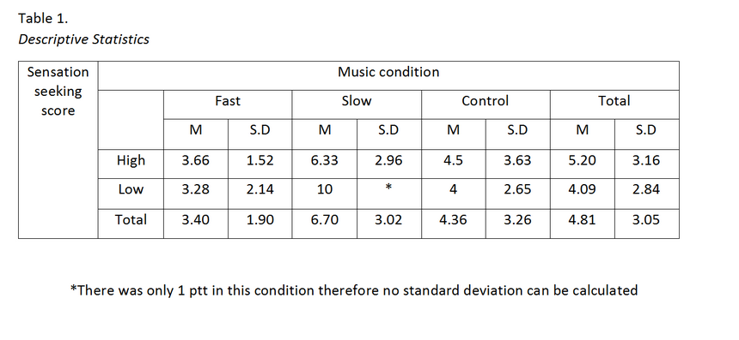

Discussion
The overall findings of the study do not support the initial hypothesis, however the significant result shown between the high and low tempo conditions, indicating that there is potential for further research on the effects of high and low tempo music on time perception. This supports the findings of the research previously stated (Cassidy & Macdonald, 2010), (Cassidy & Macdonald, 2010), (Yalch & Spangenberg, 1990). The small sample size of participants should also be taken into careful consideration before using the results to make generalisations across a wider population. Using data collected from only thirty-one participants will have been a major limitation of the study, particularly when the sample all came from the same institution. To improve future studies, researchers should carry out the test using a much lager sample, that is representative of the target population of the study. A suggestion to reach a larger audience and recruit more participants could be to make the study available online, rather than conduct it within a lab environment, as all aspects of the study could be recorded and collected remotely. Potential changes that could further improve the study could also be to use a wider range of music genres, in order to investigate whether the genre of music, as well as tempo, could have an influence on time perception.

References
Arnett, J. (1994). Sensation seeking: A new conceptualization and a new scale. Personality and individual differences, 16, 289-289.
Caird, J. K., & Hancock, P. A. (1994). The perception of arrival time for different oncoming vehicles at an intersection. Ecological Psychology, 6(2), 83-109.
Caldwell, C., & Hibbert, S. A. (2002). The influence of music tempo and musical preference on restaurant patrons' behavior. Psychology & Marketing, 19(11), 895-917.
Cassidy, G. G., & MacDonald, R. A. R. (2010). The effects of music on time perception and performance of a driving game. Scandinavian journal of psychology, 51(6), 455-464.
Comeau, N., Stewart, S. H., & Loba, P. (2001). The relations of trait anxiety, anxiety sensitivity, and sensation seeking to adolescents' motivations for alcohol, cigarette, and marijuana use. Addictive behaviors, 26(6), 803-825.
Dahlen, E. R., Martin, R. C., Ragan, K., & Kuhlman, M. M. (2005). Driving anger, sensation seeking, impulsiveness, and boredom proneness in the prediction of unsafe driving. Accident Analysis & Prevention, 37(2), 341-348.
McNamara, L., & Ballard, M. E. (1999). Resting arousal, sensation seeking, and music preference. Genetic, Social, and General Psychology Monographs, 125(3), 229.
Roth, M., & Herzberg, P. Y. (2004). A Validation and Psychometric Examination of the Arnett Inventory of Sensation Seeking (AISS) in German Adolescents1. European Journal of Psychological Assessment, 20(3), 205-214.
Weisskirch, R. S., & Murphy, L. C. (2004). Friends, porn, and punk: Sensation seeking in personal relationships, internet activities, and music preference among college students. Adolescence, 39(154).
Yalch, R., & Spangenberg, E. (1990). Effects of store music on shopping behavior. Journal of Consumer Marketing, 7(2), 55-63.

Appendices
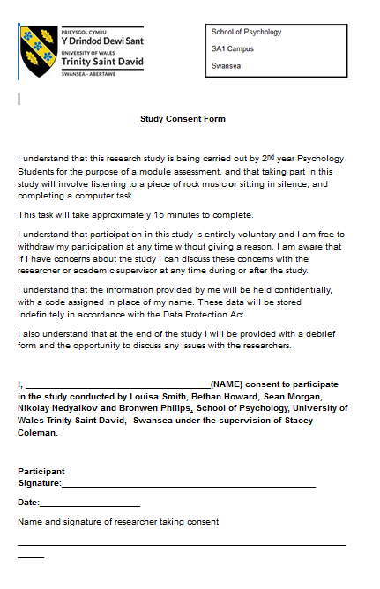
Appendix A)

Appendix B)
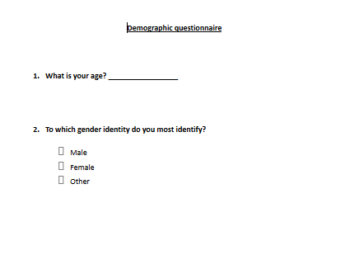
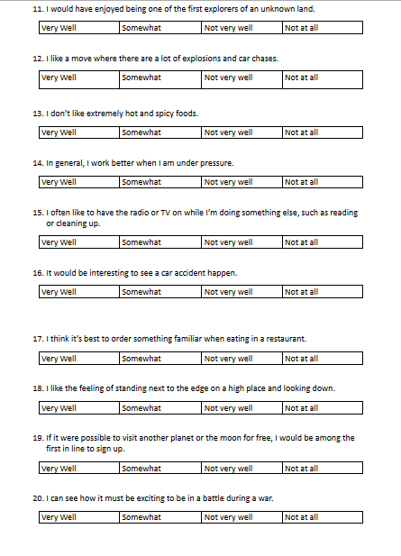
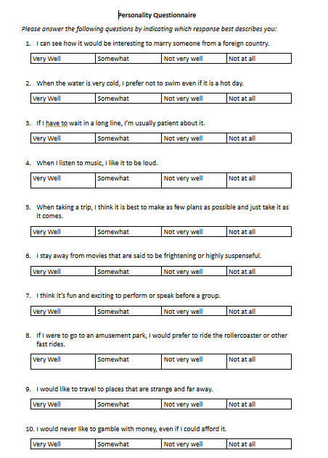
Appendix C)

Appendix D)
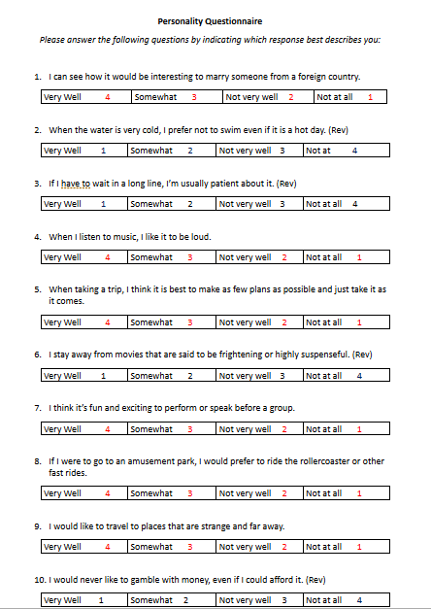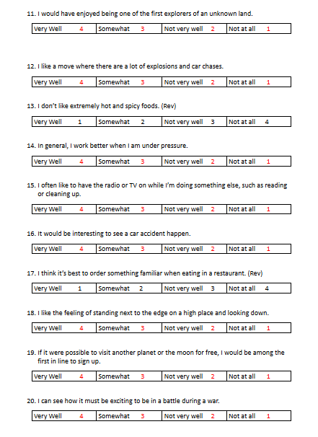

Appendix E)

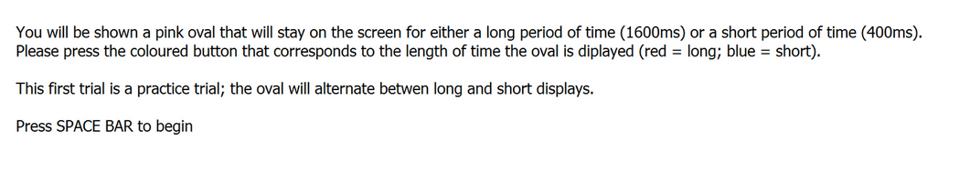

1

2

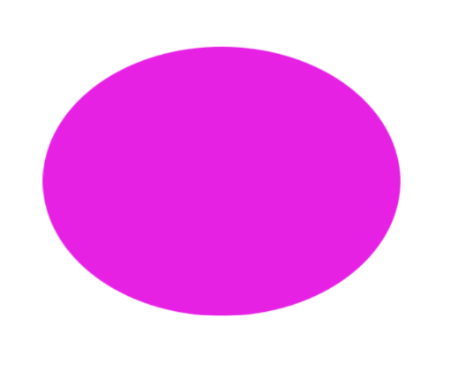
3

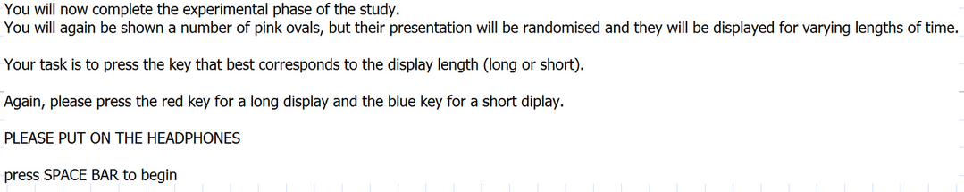
4

5

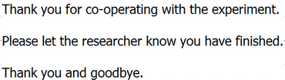
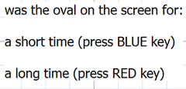
6 7

Appendix F)
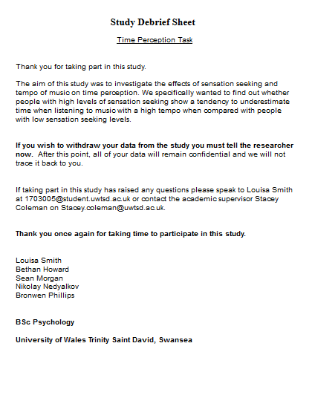

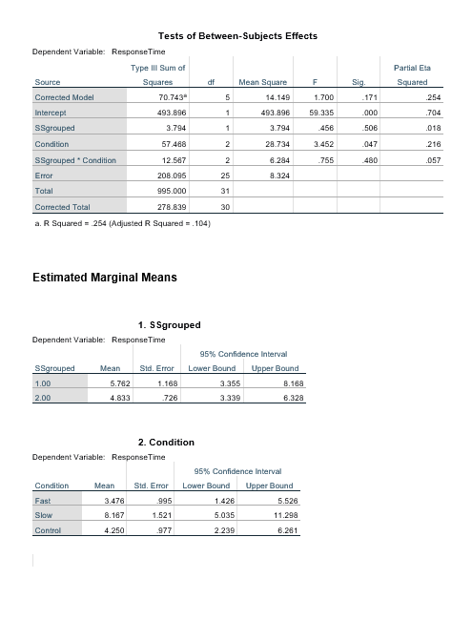
Appendix G)
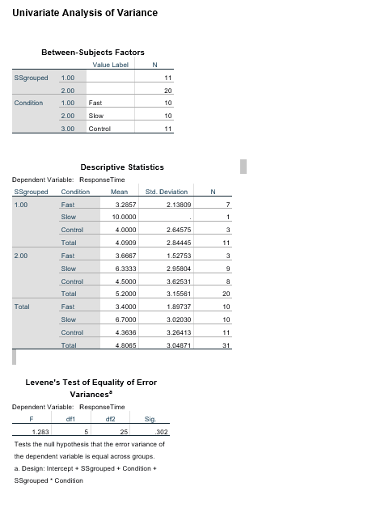

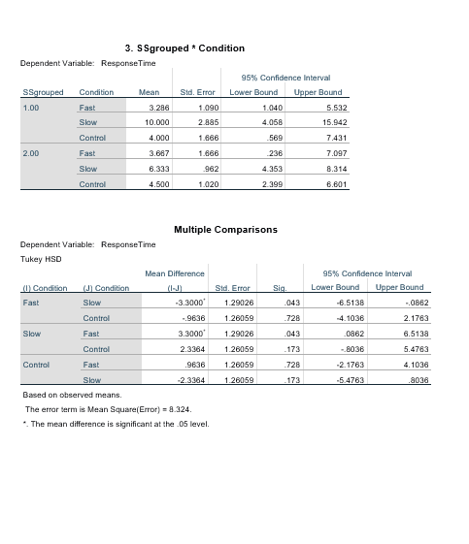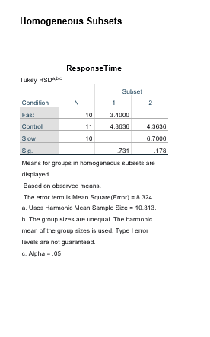
Appendix H)

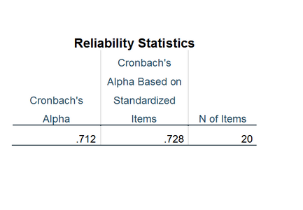

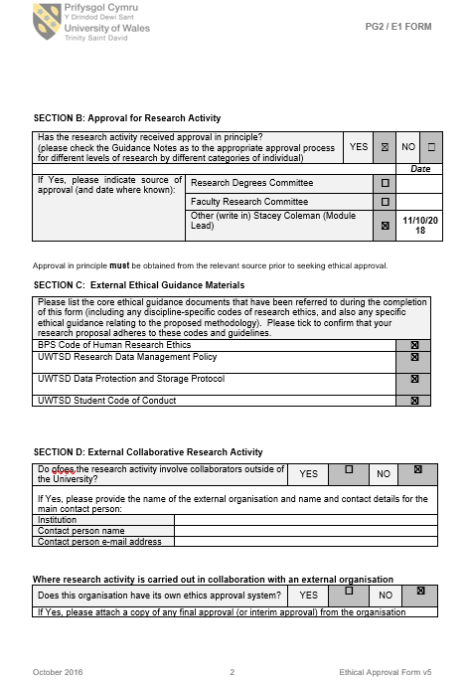
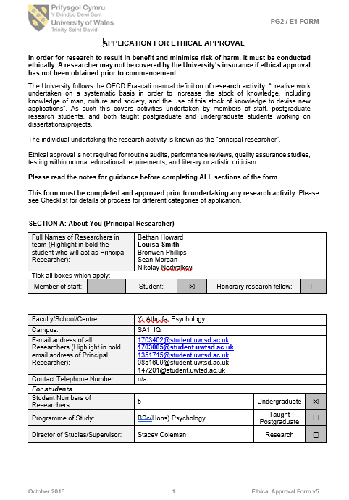
Appendix I) Ethics Form



