Student name: Lavinia Dumitrita Bidasca
Student ID number: 2240974
Programme: BA (Hons) International Hotel Management
Module: Personnel Resourcing and Development
Module code: BMIH5005
Lecturer: Jemma Smith

Assignment Title: Research Project Proposal – Analyze the impacts of socio-economic force on employees’ performance management and monitoring in different work modes: Hospitality HR’s perspective
Word Count: [1982 words]

Table of Contents
1 Introduction and Background: 3
2 Discussion 4
2.1 Premier Inn Hotel monitors employee’s management in different work modes 5
2.2 PESTEL Analysis: 6
2.2.1 Political Factors: 6
2.2.2 Economic Factors: 6
2.2.3 Social Factors: 6
2.2.4 Technological Factors: 6
2.2.5 Environmental Factors 7
2.2.6 Legal Factors: 7
2.3 Industry trend 7
2.4 Potential Solution: 7
3 Evaluation and Conclusion 8
3.1 Recommendation: 8
4 References: 10

Introduction and Background:
Premier Inn is the UK’s biggest brand of Hotel that is growing continuously. Premier Inn provides high-quality accommodation to its guests at an affordable range of prices. Premier Inn has 85,000 rooms all around the UK and also it has 10500 rooms in Germany. These all rooms are located in great areas. In the Premier Inn, there are around 38,000 employees all over the UK and Germany. Every month the Premier Inn serves five million guests, these guests are the heart of the Premier Inn hotel. In addition, in the hospitality industry, the traditional mode of work is predominantly on-site because of the facility of delivery (Premier Inn, 2023). In the hotel industry, the hotel has introduced the use of advanced technologies in their workplace by gaining high customer satisfaction. Socioeconomic factors are one of the significant landscapes for the introduction of the mode of new work like hybrid, remote, or onsite jobs. These help to provide a flexible work environment to their workers (Iranmanesh et al, 2022). Premier Inn uses the socioeconomic and technological advancement landscape to engage its employees as well as customer satisfaction. Therefore the workers' performance improved and they maintained high standards of service.
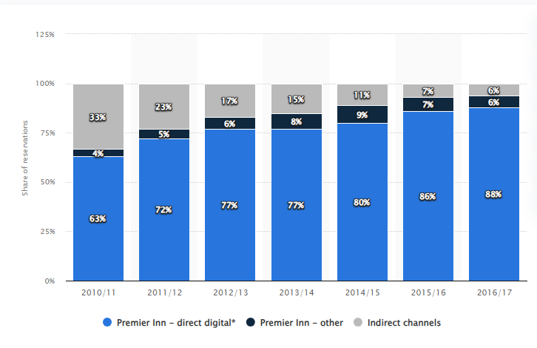
Figure 1: Premier Inn Hotel
Source: (Statista, 2017)
The study aims to analyze the impact of socioeconomic factors on the hotel industry. Moreover, the research will also identify the performance of the employee's management and monitor the various work mode of the Premier Inn hotel like hybrid work mode, office work mode, and flexibility work mode. In the socioeconomic factors economic stability, trends of labor market, and technological advancement are included. In economic stability, the variation in the economy impact on the traveling of the people. The economic variation also affects the revenue of the hotel and the occupancy rates (Liu and Yang, 2021). Therefore, the hotel industry reduces the retention period of the employees and also the management of the hotel changes their performance strategies according to the variation of the economy. Moreover, the employment rate changes, changes in wages, the labor law variations directly influenced the recruitment of employees, the retention period, and also satisfaction. In addition, technological advances are one of the great advances in the use of technologies in the hotel industry that help to enhance the performance of the hotel. The adoption of advanced technologies helps to make the work feasible so the employees can do work remotely. Technological advancement also helps to monitor the performance of each employee and automate customer services.

Discussion
In the study of Odiaka, (2020), socioeconomic forces are the significant force in the hospitality sector that majorly affect the performance of the employees. The socio-economic forces help to manage and monitor the performance of the employees in various work modes. In the sociopolitical force, cultural, demographic, economic, and technological advancements are involved. According to Yacoub and ElHajjar, (2021), in the hospitality industry, economic downturns are the biggest challenge, due to the economic downturns the hotel revenue is reduced which leads to the constraints of the hotel budget of the employee's performance level. Ushakov et al, (2020), the study show that the hotel industry needs to train its staff and arrange the employee's personal and professional development programs. The training programs help to enhance the hotel's growth and development as well as enhance the employee's skills. In the study of Dorta-Afonso et al, (2021), the economic downturn directly affects the performance of the hotel as well as the motivation of employees. Employee motivation becomes low when the organization does not give enough pay to the employees.
Sarwar et al, (2020), in the hotel sector, different employees worked that are from diverse cultural backgrounds. The Human resource (HR) department of the hotel sector needs to adopt effective management practices of performance for the accommodation of various cultural backgrounds in the workplace. According to Načinović Braje et al, (2019), the collectivist culture of the employees should prefer the recognition and the feedback of the group while the individualistic culture should give value to the employee's achievement. Khan et al, (2021) represent that the HR of the hotel industry needs to maintain its attitude and understand cultural sensitivity. The HR should communicate with other individuals effectively.
Technological advancement in the hotel industry plays an essential role in enhancing the growth of the business. In the study by Kansakar et al, (2019), the use of advanced technologies helps to enhance the performance of hotel management. The technologies transform monitoring the employee's performance. Molino et al, (2020), the technologies make the work feasible employees can work from their homes or take hybrid work. This helps to enhance the retention time of the employees in the hospitality industry.
In the Premier Inn, there are different work modes that the employees use, on-site, remote working, or hybrid work settings are performed by the employees. In the on-site employees, the performance appraisals and daily meetings are a necessity for the maintenance of the high standards. The managers also carry out periodic performance appraisals to evaluate achievements and give directions to the employees for enhancement of their performance. The meeting locations are synchronized which helps for effective business practices with the hotel’s performance objectives while data monitoring applications reflect shorter-term goals like guest satisfaction rates or housekeeping performance levels (Premier Inn, 2023).
The Premier Inn uses remote work which is the key performance indicator to support the setting of goals, the measurement of performance, and feedback and communication. For remote work, the hotel uses various digital tools like Zoom and Microsoft Teams to let employees and organizations maintain regular interactions so that remote workers remain as efficient as possible (Premier Inn Hotel, 2024). Additionally, the further outcomes are based on the performance measurement that is determined by the fact that the hotel delivered as well as results against set KPIs and not the number of hours spent in doing the work.
As for hybrid work modes, Premier Inn uses flexible scheduling systems, which control the working on-site and remote hours, and personnel’s compliance with the chosen schedule. Performance metrics systems ensure that the benchmarks used for the evaluation of performance are constant, and collect information from all spheres of work to get a comprehensive picture of the employee’s productivity. A feedback culture is maintained as constant, and professional development is the focus; virtual training sessions with frequency checks and developmental workshops are a part of the daily performance to ensure high-quality performance (Erköse, 2020).
Moreover, to maintain the line of communication and ‘engagement’ with the employees, Premier Inn incorporates work mode investments for the workers. Team-building exercises, organizational reward systems, and spirit-boosting activities are very important in building up a strong and motivated workforce. They are used to monitor progress and growth and recognize people and groups excelling (Galanti et al, 2021). Extended training and orientation programs help to meet the possibilities of work environments to fit all the employees perfectly by improving their competence and productivity.
Political Factors:
- Labor laws and government policies greatly influence the performance management of employees.
- Employees' health and safety regulations are necessary, particularly in hybrid and remote work (Sokolic, 2022).
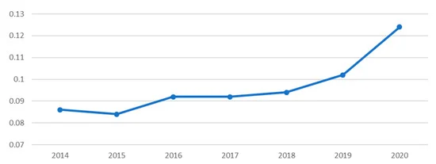
Figure 2: Political Factors
Source: (Lee et al, 2021).
Economic Factors:
- The economic condition influences the organization's budget and also affects performance management.
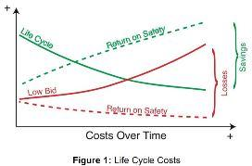
- The investment in advanced technologies may reduce the economy but it enables them to monitor the performance of the employees (Schaupp, 2023).
Figure SEQ Figure \* ARABIC 3: Economic Factors
Source: (OHS, 2018).
Social Factors:
- The cultural changes significantly affect the system of performance management.
- The Gen-Z always prefers regular performance feedback and wants a flexible work environment (Aggarwal et al, 2022).
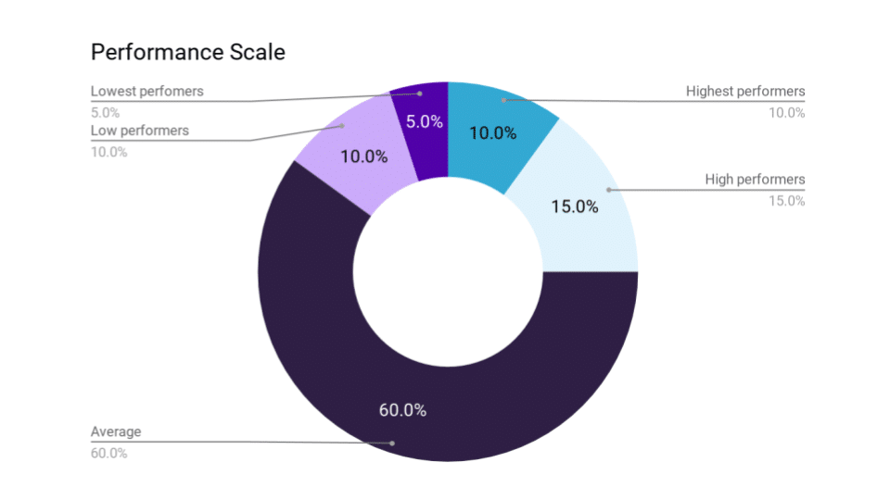
Figure 4: Socila Factors
Source: (Aggarwal et al, 2022).
Technological Factors:
- Technological advancement enhanced work performance.
- The advanced technologies monitor the employees and their work productivity.
- The advanced technologies enable the employees to do work in a flexible environment.
- Technologies provide the facilities for hybrid as well as remote work (Johnson et al, 2020).
Figure SEQ Figure \* ARABIC 5: Technological Factors
Source: (World Economic, 2018)
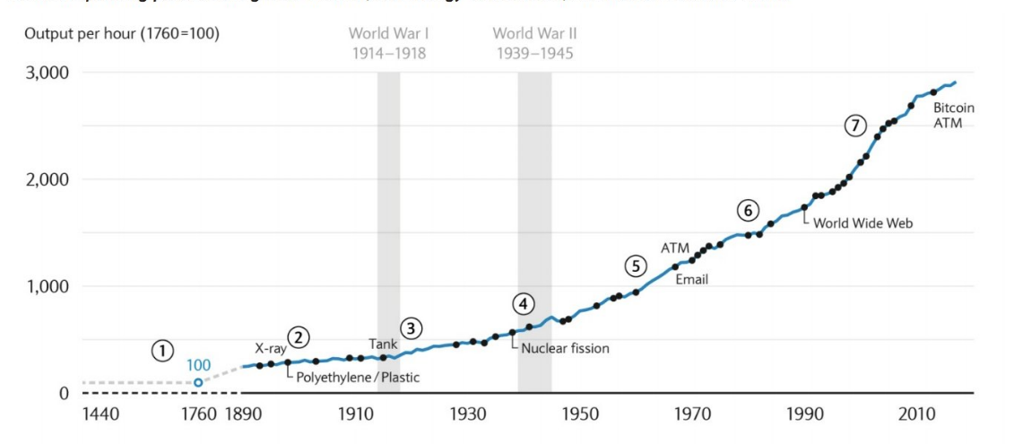
Environmental Factors
- Sustainability initiatives help to enhance the performance management of the employees.
- The remote and the hybrid work facility help to reduce the carbon footprint.
- The policies of the environment may also affect the performance of the employees.
Legal Factors:
- The employment laws influence the performance of the employees.
- Data privacy and the regulation of remote work affect to monitor of the performance of the employees (Wang et al, 2021).
- The legal standards make sure the employee's performance data are confidential and follow ethical considerations (Sokolic, 2022).
In the hotel industry, it is considered that there are high turnover rates that range from 30% to 70%. The turnover rate in the hospitality sector is higher than in other sectors. The key elements that are involved in this trend are low wages, irregular work hours, low career progression, and a lot of pressure. These are the challenges that inhibit to growth performance of the employee. According to Idowu (2020), the employee's performance is enhanced and retention time can also increase if the hotel industry provides flexible working hours. Additionally, the hotel industry needs to invest in the training program for the personal and professional development of the employees. The hotel industry needs to adapt highly advanced technologies to enhance the performance management system. Moreover, the different industries in which Marriott and IHG use advanced technologies in their hotel enhance their hotel performance. These hotels collaborate with different stakeholders to motivate the employees and make the work flexible (Štilić et al, 2023). The trends represent that employee-centric policies help to decrease the turnover rate and increase the retention time of employees.
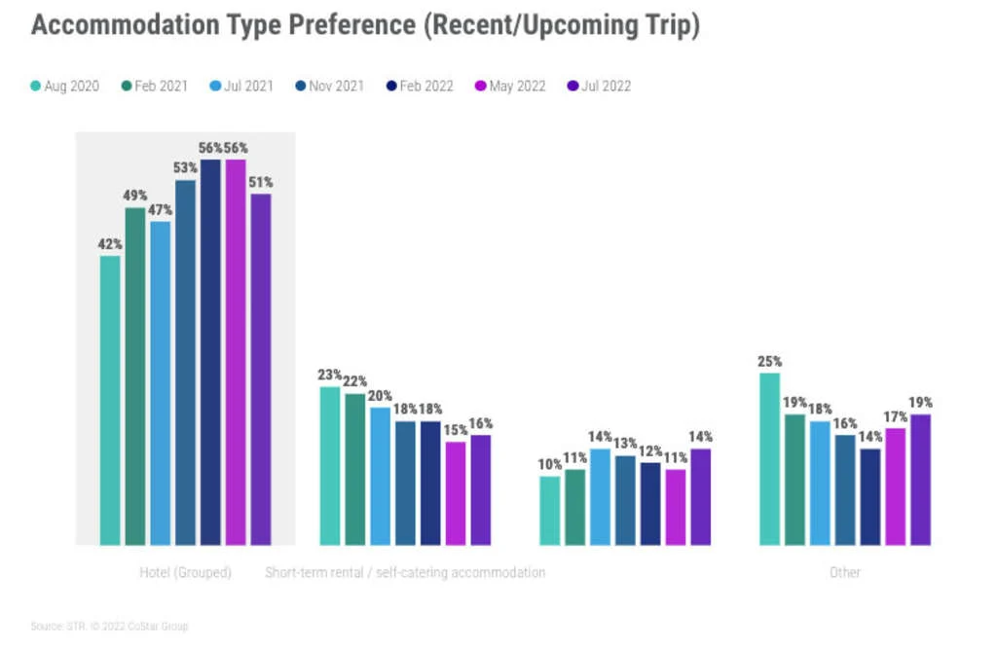
Figure 6: Trends of Hotel
Source: (Hospitality Net, 2022)
The Premier Inn hotel needs to adopt high technological advancement for the better performance of the hotel. This will help the hotel monitor the performance of the employees and make the work feasible for the employees. The use of advanced technologies helps to gain brand recognition around the world (Pham et al, 2023). Moreover, the Premier Inn should collaborate with different stakeholders for the improvement of the hotel and its growth. The hotel should also arrange an employee training program that will help with the development of various skills.

Evaluation and Conclusion
The research seeks to establish the effects of socio-economic on employee performance management in Premier Inn which is the UK’s largest hotel brand. The main implications can be noted to underline that various organizational and environmental factors like economic stability, the nature of employment, and the emergence of technology impact the process and practice of employee performance management. Government policies and instabilities in the economy affect travel and tourism, and in return the occupancy levels and level of revenues that; hotels generate then determine staffing levels and performance indicators. Sometimes due to poor economic returns, organizations have to adopt measures that cut expenditures including the employees’ morale and productivity. Existing research on labor turnover shows that the rate of turnover is normally high within the hospitality industry, usually in the range of 30% to 70% due to low wages, irregular work schedules, and poor career mobility. Technology improvement is also crucial since the implementation of information technologies for working from home, activity control, and client support increases productivity and employees’ contentment. Telecommuting means using digital media like call applications such as Zoom, and Teams to address the team as well as employing outcome-based management rather than time management. These modes address issues such as high turnover intention by offering more flexible working arrangements and implementing continuous training and development programs.
- The hotel industry should implement flexible, hybrid, and remote work strategies for their employees.
- The hotel needs to collaborate with various stakeholders for a better performance management system.
- The hotel industry should use high and advanced technological systems to monitor their employee's performance and for flexibility.
- Hotels should arrange an employee training development program to improve the skills of their employees.
- The hotel industry should develop employee rewards and recognition awards for their high performance and motivation.

References:
Aggarwal, A., Sadhna, P., Gupta, S., Mittal, A. and Rastogi, S., 2022. Gen Z entering the workforce: Restructuring HR policies and practices for fostering the task performance and organizational commitment. Journal of Public Affairs, 22(3), p.e2535.
Dorta-Afonso, D., González-de-la-Rosa, M., Garcia-Rodriguez, F.J. and Romero-Domínguez, L., 2021. Effects of high-performance work systems (HPWS) on hospitality employees’ outcomes through their organizational commitment, motivation, and job satisfaction. Sustainability, 13(6), p.3226.
Erköse, H.Y., 2020. The battlefields of leisure: Simple forms of labor control in the Turkish hospitality sector. New Perspectives on Turkey, 63, pp.4-31.
Galanti, T., Guidetti, G., Mazzei, E., Zappalà, S. and Toscano, F., 2021. Work from home during the COVID-19 outbreak: The impact on employees’ remote work productivity, engagement, and stress. Journal of occupational and environmental medicine, 63(7), pp.e426-e432.
Hospitality net, 2022. Online Available at: https://www.hospitalitynet.org/news/4112329.html. Accessed Date: [30/05/2024].
Idowu, S.A., 2020. Role of flexible working hours’ arrangement on employee job performance and retention in manufacturing industries in Agbara, Nigeria.
Iranmanesh, M., Ghobakhloo, M., Nilashi, M., Tseng, M.L., Yadegaridehkordi, E. and Leung, N., 2022. Applications of disruptive digital technologies in hotel industry: A systematic review. International Journal of Hospitality Management, 107, p.103304.
Johnson, A., Dey, S., Nguyen, H., Groth, M., Joyce, S., Tan, L., Glozier, N. and Harvey, S.B., 2020. A review and agenda for examining how technology-driven changes at work will impact workplace mental health and employee well-being. Australian Journal of Management, 45(3), pp.402-424.
Kansakar, P., Munir, A. and Shabani, N., 2019. Technology in the hospitality industry: Prospects and challenges. IEEE Consumer Electronics Magazine, 8(3), pp.60-65.
Khan, F.N., Sehrawat, N. and Singh, S., 2021. The impact of HR practices on perceived gender sensitivity and gender bias: A multilevel analysis of hotel industry. Jindal Journal of Business Research, 10(1), pp.90-106.
Lee, H.W. and Rhee, D.Y., 2021. Exploring the factors of employee subjective well-being in the midst of health threat: an evidence from the US federal government during the COVID-19. Sustainability, 14(1), p.408.
Liu, C. and Yang, J., 2021. How hotels adjust technology-based strategy to respond to COVID-19 and gain competitive productivity (CP): strategic management process and dynamic capabilities. International Journal of Contemporary Hospitality Management, 33(9), pp.2907-2931.
Molino, M., Ingusci, E., Signore, F., Manuti, A., Giancaspro, M.L., Russo, V., Zito, M. and Cortese, C.G., 2020. Wellbeing costs of technology use during Covid-19 remote working: An investigation using the Italian translation of the technostress creators scale. Sustainability, 12(15), p.5911.
Načinović Braje, I., Klindžić, M. and Galetić, L., 2019. The role of individual variable pay in a collectivistic culture society: An evaluation. Economic research-Ekonomska istraživanja, 32(1), pp.1352-1372.
Odiaka, K.U., 2020. Employee engagement and its importance to HPWPs (High Performance Work Practices), employee outcome relationship in the Nigerian hotel sector. University of Salford (United Kingdom).
OHS, 2018. Online Available at: https://ohsonline.com/articles/2018/10/01/the-economics-of-workplace-safety.aspx. Accessed Date: [30/05/2024].
Pham, N.T., Jabbour, C.J.C., Vo-Thanh, T., Huynh, T.L.D. and Santos, C., 2023. Greening hotels: Does motivating hotel employees promote in-role green performance? The role of culture. In Knowledge Management, Organisational Learning and Sustainability in Tourism (pp. 57-76). Routledge.
Premier Inn Hotel, 2024. Onlien Available at: https://www.premierinn.com/gb/en/business/business-booker-user-guides/reporting.html. Accessed Date: [30/05/2024].
Premier Inn, 2023. Online Avaiolable at: https://www.premierinn.com/gb/en/business-blog/hybrid-working.html. Accessed Date: [30/05/2024].
Sarwar, H., Ishaq, M.I., Amin, A. and Ahmed, R., 2020. Ethical leadership, work engagement, employees’ well-being, and performance: a cross-cultural comparison. Journal of Sustainable Tourism, 28(12), pp.2008-2026.
Schaupp, S., 2023. COVID‐19, economic crises and digitalisation: How algorithmic management became an alternative to automation. New Technology, Work and Employment, 38(2), pp.311-329.
Sokolic, D., 2022. Remote work and hybrid work organizations. Economic and social development: Book of proceedings, pp.202-213.
Statista, 2017. Online Available at: https://www.statista.com/statistics/511382/hotel-booking-channels-whitbread-united-kingdom-uik/. Accessed date: [30/05/2024].
Štilić, A., Nicić, M. and Puška, A., 2023. Check-in to the future: Exploring the impact of contemporary information technologies and artificial intelligence on the hotel industry. Turističko poslovanje, (31).
Ushakov, R.N., Kryukova, E.M., Khetagurova, V.S., Mukhomorova, I.V. and Zelenov, V.V., 2020. Efficiency of hotel management. Training of specialists in hotel industry field. Journal of Environmental Management and Tourism, 11(2), pp.388-395.
Wang, B., Liu, Y., Qian, J. and Parker, S.K., 2021. Achieving effective remote working during the COVID‐19 pandemic: A work design perspective. Applied psychology, 70(1), pp.16-59.
World Economic, 2018. Online Available at: https://www.weforum.org/agenda/2018/04/this-chart-shows-every-major-technological-innovation-in-the-last-150-years-and-how-they-have-changed-the-way-we-work/. Accessed Date: [30/05/2024].
Yacoub, L. and ElHajjar, S., 2021. How do hotels in developing countries manage the impact of COVID-19? The case of Lebanese hotels. International Journal of Contemporary Hospitality Management, 33(3), pp.929-948.

