Innovation and Change in Alibaba Due to Covid 19



Student's Name: Wu Zehong
Course Name and Number:2218753
Lecturer: Marie Pitson
Date: April 25, 2023

Table of Contents
Executive Summary 3
1.0. Introduction 4
2.0. Impacts of Covid 19 on Alibaba 5
3.0. The Changes brought by Covid 19 on Alibaba 6
3.1. Technological Change 7
3.2. Structural Change 7
4.0. Types of Innovation Change in Alibaba 8
4.1. Radical Change 8
4.2. Sustaining Innovation 9
5.0. Key drivers and Factors of Change 10
5.1. Internal Factors 11
5.2. External Factors 12
6.0. Change Management during the Pandemic 14
7.0. Change Resistance Factors 16
8.0. Evaluation of the Innovation Changes 17
9.0. Conclusion 18
Reference 20

Executive Summary
The COVID-19 pandemic profoundly affected many industries, including the Chinese tech giant Alibaba. This paper critically analyzes the changes brought by the pandemic on Alibaba, the key drivers, and the resistance to change. It also examines change models for managing the change and assessing the effectiveness of the change programs. Internal factors, such as customers, suppliers, and competitors, and external factors, such as political, economic, social, technological, and environmental, were identified as the key drivers of change. These factors have led to radical changes, such as introducing new products and services, expanding logistics infrastructure, and sustaining innovations, such as launching an online marketplace and a donation platform. Despite the pandemic's difficulties, Alibaba has successfully adapted to the changing environment and remains a dominant force in the global technology sector. This report also examines how Alibaba utilized Lewin's Change Management Model to manage the changes brought about by the Covid-19 pandemic, including the unfreeze, change, and refreeze stages, as well as the change resistance factors and evaluation of the innovation changes. It concludes that Alibaba, its customers, and society benefited from the company's creative responses to the outbreak, resulting in a significant increase in online sales, demand for cloud-based computing services, and improved customer experience.

Introduction
Alibaba Group Holding Limited, commonly known as Alibaba, is a Chinese multinational conglomerate specializing in e-commerce, retail, internet, and technology services. Founded in 1999 by Jack Ma, it has been observed (O'Connell, 2020)that it is one of the world's largest companies and is considered the most valuable tech company. It is one of the world's largest internet companies, operating in over 200 countries and territories. Alibaba's services include electronic payment, search engines, cloud computing, and retail. In the early years of its operation, Alibaba operated as an online marketplace where buyers and sellers could connect and trade goods and services. It soon began to offer services such as e-commerce, payment processing, marketing, and customer service. As Alibaba's customer base grew, the company expanded into other areas, such as financial technology, logistics, and media. In recent years, Alibaba has shifted its business model to digital transformation.
The global health crisis caused by the Covid-19 pandemic has profoundly impacted the world economy, including Alibaba's business. The company has had to change its business model dramatically to stay afloat during this challenging time. As observed by Lu & Kubota(2022), Alibaba shifted its focus from traditional e-commerce and retail companies to digital retail, digital payments, and cloud computing services. Despite the challenges posed by the pandemic, Alibaba remains a dominant force in the global technology sector and is well-positioned to emerge from the crisis stronger than ever. This paper aims to critically analyze the changes brought by Covid 19 on Alibaba and the critical drivers of change. This paper will also examine the resistance to change and use change models to manage the transition. Finally, the report will assess the effectiveness of the change programs.

Impacts of Covid 19 on Alibaba
The effects of Covid-19 have been felt across many industries and businesses, including the Chinese multinational technology giant Alibaba. The first significant impact of the pandemic was a decrease in consumer demand, which led to a decline in revenue. For Lozić & Fotova Čiković (2022), as the pandemic spread, consumers became more cautious with spending, reducing demand for Alibaba's online retail services . This decrease in demand caused a decrease in revenue for the company, as fewer customers purchased products from the platform. The company had to temporarily close some of its brick-and-mortar stores due to the pandemic, resulting in further losses.
Alibaba issued a warning that the coronavirus that has killed over 1,300 people in China is having a significant impact on customers and merchants in the nation and would negatively affect its economic expansion during the upcoming quarter, observed by Al Jazeera(2020). When asked about the impact of the pandemic on economic output, Alibaba, the first big Chinese technology company to announce results since the outbreak in January, claimed that many people could not get to or perform their duties due to the virus, observed by Han et al., (2022). Consumers are cutting back on non-essential purchases like vacations and dining out. Comparatively, the company lost 5.5 billion yuan during the same period a year ago, while it lost 16.2 billion yuan during the fiscal fourth quarter. According to Alibaba, the company's stock investments in public firms saw price declines.
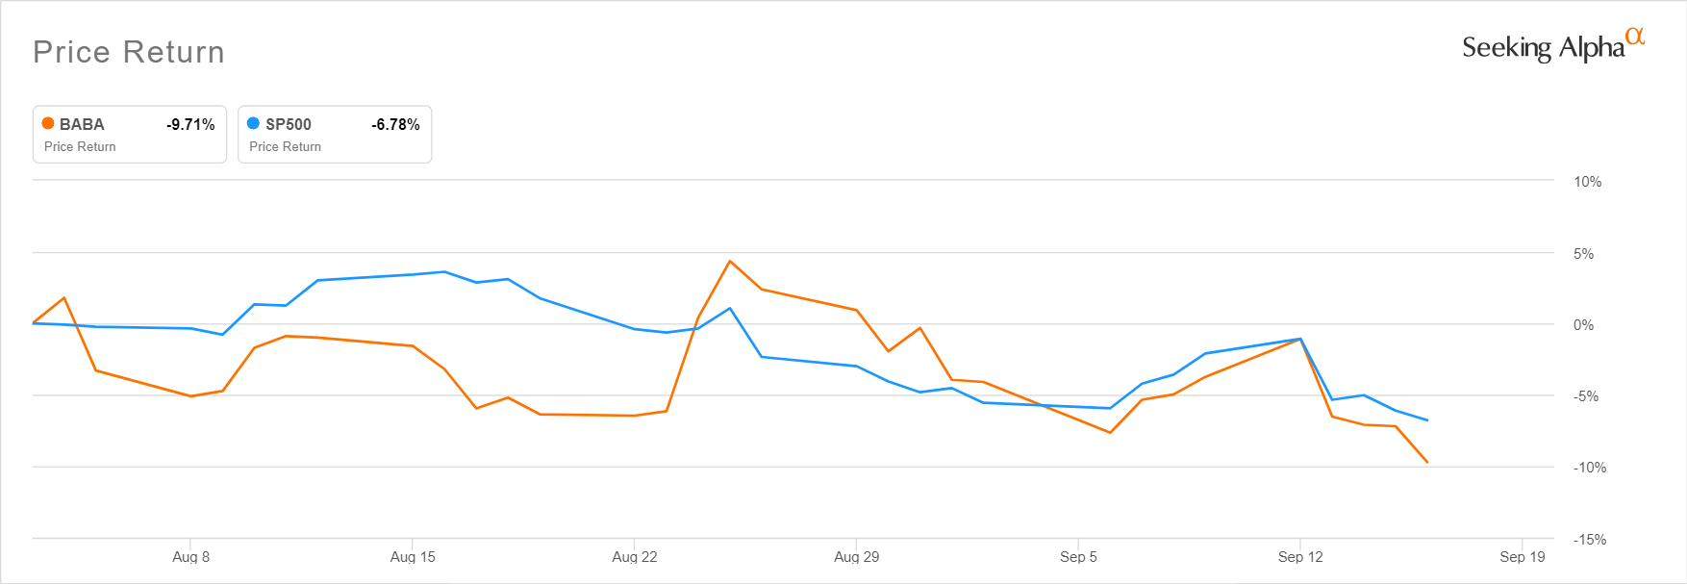
Figure 1 Alibaba Stock Price Performance (Pendulum, 2022)

As observed by Schroeder (2020), in the most recent quarter, Alibaba reported a loss of $1.09 billion in overseas assets due to the infection. This resulted in a loss of revenue for the company, as well as a loss of potential investment opportunities. Moreover, Danilin (2020) think that the slowdown of the Chinese economy was another. The pandemic caused significant disruption to the Chinese economy, resulting in decreased consumer spending and decreased demand for Alibaba's services. It has been observed(Chen & Feng, 2022)that this significantly impacted the company's revenue, as consumers had less disposable income and were reluctant to purchase products online.

The Changes Brought by Covid 19 on Alibaba
As a result of the Covid 19 epidemic, many fields and businesses had to adapt and adjust. Alibaba implemented new products and services during and after the pandemic to boost its operations.

Technological Change
With technological advancement, the same amount of work can provide more results. Due to the widespread nature of the Covid-19 epidemic, Alibaba took precautionary measures by implementing multiple upgrades to its services. The firm introduced innovative services to its clientele in response to changing market conditions. It has been observed(Sun, 2021)that they included a platform for administering e-commerce sites, a platform for hosting teleconferences in the cloud, and a site devoted to selling medical equipment. Moreover, a contactless payment mechanism was created to aid in controlling the epidemic.
The firm also enhanced its use of artificial intelligence and machine learning to understand customer behavior better and improve the overall user experience. By implementing these changes, Alibaba continued its operations during the pandemic, ensuring its customers' safety and keeping its word about providing outstanding customer care in the business. In January 2020, during the height of the coronavirus epidemic, Alibaba introduced a contactless payment method. Mozur et al., (2020) underline that the Alipay Health Code system could tell if a person is in danger of contracting the virus by scanning their QR code. In this way, customers might pay without ever having to handle cash or a credit card. Both brick-and-mortar and virtual shops utilized the system. According to Alibaba's annual report, the company earned over 717 billion yuan (about 109 billion U.S. dollars) in 2021 and had about 1.3 billion, active annual consumers. It has been observed (Faggella, 2022) that as of March 2022, Alibaba has an estimated market valuation of $225 billion and is traded on the NYSE.

Structural Change
The global economy and companies, especially the Chinese e-commerce behemoth Alibaba, were severely impacted by the COVID-19 epidemic. Businesses were forced to adapt to the new reality of social distance and fewer consumers due to the pandemic's disruption of global supply networks. As a result, It has been observed (Zeng, 2020) that Alibaba has made several fundamental changes to how it operates, including emphasizing digital transformation and the customer experience more than before. Before the outbreak, Alibaba had previously been experimenting with a hybrid approach that included offline and online sales. But, the epidemic hastened this shift, and the business now relies nearly entirely on online sales. Because of this, The Economic Times (2022) notes that the firm made significant investments in its logistics infrastructure, building warehouses and distribution hubs around the country to ensure timely deliveries. With the aid of the Chinese government, Alibaba and the rest of the giants in the Chinese IT sector are contributing heavily to the goal of creating a US$ 1 trillion AI business by 2030. Alibaba has seven research laboratories dedicated to developing AI, ML, NLP, and NS technologies and ensuring the safety of their networks. With machine learning and language processing techniques, Muthyala(2021) notes that Smart Selection is an AI-driven system that makes product recommendations to shoppers and alerts stores when they need to restock to meet consumer demand. Because of this, the company has expanded by working closely with clients and merchants.

Types of Innovation Change in Alibaba

Radical Change
The coronavirus pandemic has caused massive disruption to economies and businesses worldwide, and Alibaba is no exception. The Chinese giant has had to make radical changes to keep up with the changing landscape and remain competitive. At the pandemic's start, Alibaba was hit hard, with e-commerce sales falling 30% and retail sales dropping 40%. Cheng (2023)observed that the company launched several initiatives to help businesses and consumers navigate the pandemic. It has been observed (Rana & Horwitz, 2020)that this included creating a "Business Recovery Plan," which provided financial support to small and medium-sized businesses, and launching a "Global Aid Program" to help those affected by the pandemic. Alibaba also worked quickly to adapt its business model to the new reality. The company shifted its focus from marketing and selling consumer goods to providing essential services to help people during the crisis. This included launching a new service called "Alibaba Health," which provided medical supplies, health services and information, and an online food delivery service.
The company also expanded its e-commerce offerings, creating a new platform called "Tmall Global," allowing customers to purchase overseas products. This was a significant shift for the company, as it had previously only sold products from China (Reuters, 2022). Finally, Alibaba also changed its corporate structure, including creating a new venture capital arm and launching a new online marketplace, "Lazada." These moves allowed the company to diversify its income streams and remain competitive in the changing market (Nikkei, 2022).

Sustaining Innovation
One of the most significant efforts made by Alibaba during the Covid-19 pandemic is the launch of its online marketplace, Ling Shou Tong. This platform was created to help small businesses and entrepreneurs navigate the pandemic and stay afloat. Li (2021) considered that the platform provides a one-stop shop for small business owners to list and market their products, services, and ideas. It also offers access to financing, resources, and other support services. In addition, the platform allows connecting with suppliers, buyers, and partners, which can help small businesses reduce the costs associated with running a business (Koe, 2020). Ling Shou Tong is an excellent example of how Alibaba is leveraging its existing resources and infrastructure to support small businesses during the pandemic. Another initiative Alibaba took during the pandemic was launching its online education platform, DingTalk. This platform was designed to help students and teachers stay connected and engaged during the pandemic. It allows students to access educational content, participate in online classes, and collaborate with peers. It also enables teachers to manage assignments and interact with students remotely (Banks, 2020). This platform has been instrumental in allowing students and teachers to continue learning and teaching during this time of disruption and uncertainty.

Key Drivers and Factors of Change
A company must consider internal and external elements contributing to organizational change. Agents of change include technological innovations, shifts in consumer preferences and government legislation, competitive strategies, and supply chain variability.
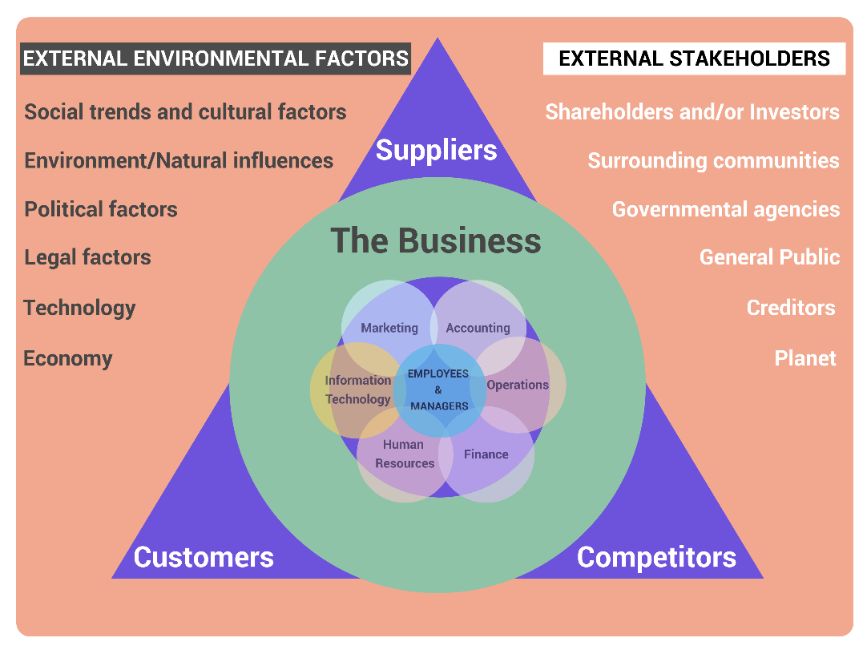
Figure 2 Drivers of Change (Saukkonen & Kirjavainen, 2020)

Internal Factors
The term "internal factors" describes the surroundings close to a company and immediately affect the company's day-to-day activities (Engidaw, 2021). The main internal factors that drove Alibaba to change include customers, suppliers, and competitors.
Customers
Alibaba had to change in response to client needs during the height of the COVID-19 crisis. Several businesses went out of business, and their employees lost their job, and it was risky for anyone to venture outside. It has been observed (Deshpandé et al., 2020) that the company had to adjust to ensure its customers could feel safe utilizing Alibaba's products and services. All but critical goods and contactless deliveries were temporarily halted while warehouses were sanitized and safeguards were tightened for warehouse employees (Alizila, 2023). Despite the pandemic, Alibaba maintained normal operations by implementing these modifications to serve its consumers better.
Suppliers
During the COVID-19 pandemic, suppliers were significant in driving Alibaba to change. With many businesses worldwide shutting down due to the pandemic, the e-commerce giant had to ensure it could continue providing customers with the needed products. To do this, according to Sun (2021), Alibaba had to find ways to continue sourcing products from existing suppliers. Alibaba shifted its focus to finding new suppliers and expanding relationships with existing suppliers. This allowed it to ensure that its customers could still access their needed products. In addition, Alibaba also launched a "Supplier Support Fund" to help suppliers struggling due to the pandemic. This fund provided financial assistance to suppliers to help them continue operations and access other resources such as market intelligence and business training (Alibaba Cloud, 2020).
Competitors
Alibaba's primary rivals include the web retailers such as Amazon, JD.com, Walmart, eBay, and Tencent. They force Alibaba to change with competitive pricing, improved customer service, and new product development. Alibaba made several adjustments during the epidemic to maintain its competitive edge. One of the most significant changes that Alibaba made in response to the pandemic was expanding its logistics network. As demand for online shopping surged due to the pandemic, Alibaba was forced to upgrade its delivery capabilities to keep up with its competitors. To this end, the company partnered with logistics companies such as Cainiao Logistics and SF Express to increase the speed and efficiency of its delivery services (Zhu & Wu, 2021). Another strategy was introducing a new rapid delivery service, expanding its online transaction system Alipay, and introducing a unique platform to encourage small companies (Abonnez, 2022). Alibaba also invested significantly in AI and cloud computing to advance its online marketplace.

External Factors
External factors are outside forces that influence the company in the long run. They include political, economic, social, technological, and environmental (Ebabu, 2021).
Political
Global governments, for instance, the Chinese government, demanded that Alibaba make adjustments during the COVID-19 epidemic to ensure customers could continue receiving products and services while keeping staff safe. Because it operates on a global scale, Alibaba had to comply with laws and regulations passed by countries worldwide. In addition to adopting safety standards for warehouse staff, other measures included stricter cleaning and sanitation practices and a temporary halt in delivering non-essential items (Kharpal, 2022). As a result of these adjustments, Alibaba could keep up with customer service and keep their employees safe.
Economic
Because of the pandemic's effect on consumer spending, Alibaba's revenue dropped significantly. The firm responded by enhancing its digital marketing and expanding its online product selection to satisfy consumers' shifting preferences. According to Wicherts (2021), inflation caused by the epidemic affected Alibaba's manufacturing costs and operations expenditures. For financial reasons, Alibaba reduced its marketing and advertising budget and provided discounts to customers. The epidemic also depressed the Chinese yuan compared to the US dollar, which affected Alibaba's operating expenses (Hoskins, 2022). The firm diversified its income streams and increased its emphasis on international markets to mitigate the impact of currency fluctuations.
Social
One of the most significant changes was the shift in consumer behavior. With the pandemic, many consumers became more cautious about spending and sought ways to save money. Alibaba responded to this shift in consumer behavior by offering discounts and promotions on its products and providing more payment options and flexible delivery services that help customers save money. Additionally, the pandemic caused an increase in online shopping, and Alibaba capitalized on this trend by offering more online services, such as live streaming and virtual events. These events allowed Alibaba to engage more with its customers, build relationships, and promote its products.
Technological
During the Covid-19 epidemic, Alibaba modified its business strategy in part owing to technological advancements that made it possible to ensure the speedy delivery of crucial goods without sacrificing customer safety. One example of how these technological factors enabled Alibaba to pivot during the pandemic is the company's ability to quickly switch to online and digital operations. For example, retail sales of physical products declined significantly due to the pandemic, and Alibaba responded by shifting to a more digital model. This has included offering more online products, such as groceries and delivery services, through its Ele.me platform. In addition, Yi (2020) underlined that Alibaba has also developed its virtual reality platform, Taobao Live, which allows customers to shop remotely while viewing a real-time video feed of the store.
Environmental
The COVID-19 pandemic significantly impacted Alibaba, and the company had to adjust quickly. Due to the rise in the popularity of digital and online purchasing during the pandemic, demand for Alibaba's services skyrocketed. In response to these changes, Alibaba implemented several measures to benefit its business partners and end users. To help businesses reach new customers, it launched initiatives like reduced-interest loan programs, price reductions on services and products, and online marketplaces (Kharpal, 2022). It has also invested in cutting-edge technologies like artificial intelligence, cloud computing, and machine learning to improve the user experience while reducing overhead costs.

Change Management during the Pandemic
Alibaba utilized Lewin's 3-stage Change Management Model in managing change during the pandemic. The model comprises three steps: unfreeze, change, and refreeze (Burnes, 2019).
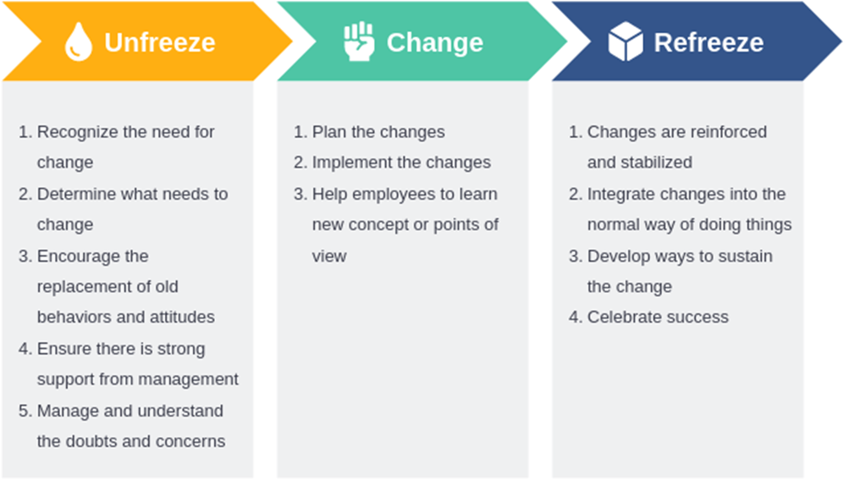
Figure 3 Lewin's 3-stage Change Management Model (Burnes, 2019)
Unfreeze Stage: The Unfreeze Stage is the first stage of Lewin's Change Management Model, and it involves identifying the need for change and creating a sense of urgency. Alibaba Cloud saw increased demand for Cloud services after implementing COVID-19 Circuit Break procedures, particularly among smaller and medium-sized enterprises (SMEs). As the city's broad mobility halted during the lockdown, companies were forced to adopt innovations to continue operating, and demand for these products and services increased by more than 50% (Heyes, 2021).
Change Stage: The Change Stage is the second stage of Lewin's Change Management Model, and it involves creating a vision and a plan for how to achieve it. To do this, Alibaba focused on improving its online payment system, Alipay, and developing a "smart logistics" system to facilitate the delivery of goods. They also invested heavily in cloud computing, artificial intelligence, and big data to optimize customer experience and improve customer service. These changes were designed to make it easier for customers to shop online and enhance their overall experience (Liu et al., 2020).
Refreeze Stage: The Refreeze Stage is the third and final stage of Lewin's Change Management Model, and it involves reinforcing the changes made. For Alibaba, this stage involved providing additional training and support to their employees and customers and developing new customer service initiatives such as a "one-click refund" system. It also continued investing in technology to improve customer experience and maintain customer loyalty. By reinforcing its changes, Alibaba successfully navigated the pandemic and maintained its customer base.

Change Resistance Factors
Alibaba faced various levels of change resistance during the COVID-19 pandemic. Some of the factors that have contributed to this include:
Lack of Proper Digitalization: It has been observed (Antony Das et al., 2020) that Alibaba was slow to adopt digitalization across its operations. This made it difficult for the company to shift to online operations, making it more challenging to adapt to the pandemic. For example, many of Alibaba's retail stores were not fully digitized, meaning they could not offer a full range of online services. Furthermore, the lack of digitalization hindered the company's ability to respond quickly to changing customer needs and demands.
Cultural Resistance: Alibaba had to deal with cultural resistance from different stakeholders, including its employees, customers, and suppliers. This made it difficult for the company to implement changes and fully adapt to the new situation. For example, many of Alibaba's employees were reluctant to embrace the latest digital tools and processes needed to cope with the pandemic. They feared the strategies would fail the company. Similarly, customers and suppliers were reluctant to embrace the new technologies and processes, making it difficult for the company to implement changes.
Financial Constraints: The pandemic caused a decrease in revenue and profits for Alibaba, making it difficult to invest in digitalization and other changes (Antony Das et al., 2020). This resulted in the company scaling back its investment plans and focusing on cost-cutting initiatives. For example, the company had to lay off several employees to reduce costs.

Evaluation of the Innovation Changes
Alibaba, its clients, and society benefited from the company's creative responses to the Covid-19 outbreak. According to the China Internet Network Information Centre statistics, online sales through Alibaba's marketplace increased by 32.2% in 2020. Demand for the company's cloud-based computing services increased by 40.7% after the epidemic began (Lin & Sebastian, 2020). As a result, the firm's bottom line improved. With these advancements, Alibaba's products became more accessible to consumers (Lin & Sebastian, 2020). Due to contactless payment technology, customers can now shop without physically interacting with a cashier or another shopper. An added perk of the drone delivery
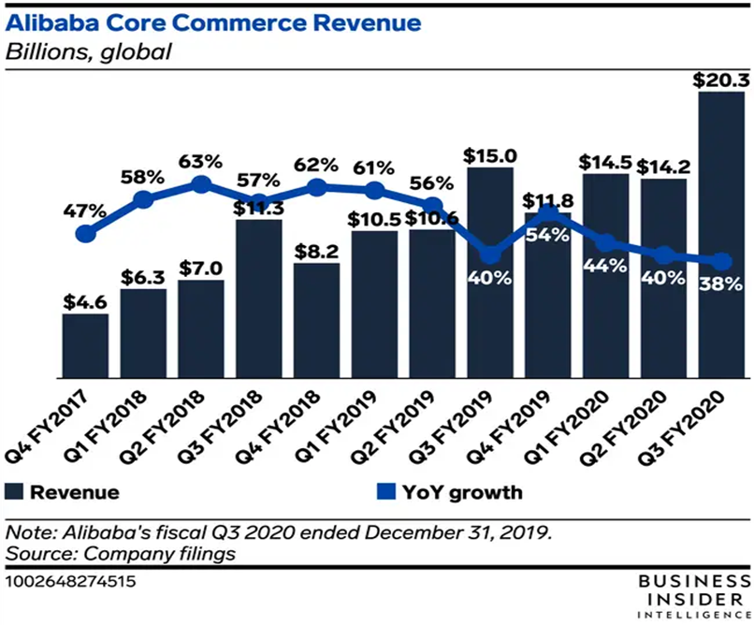
Figure 4 Alibaba Performance (Lin & Sebastian, 2020)

Conclusion
In conclusion, the Covid-19 pandemic profoundly affected the global economy, including the Chinese technology giant Alibaba. The company had to radically change its business model to stay afloat during this challenging time. These changes included technological innovation, structural change, radical change, and sustaining innovation. The key drivers of change for Alibaba are internal factors such as customers, suppliers, and competitors and external factors such as political, economic, social, technological, and environmental factors. Despite the challenges posed by the pandemic, Alibaba remains a dominant force in the global technology sector and is well-positioned to emerge from the crisis more robust than ever. Alibaba's utilization of Lewin's Change Management Model enabled the company to quickly adapt to the changing environment and develop initiatives to meet the needs of its customers during the pandemic. The model allowed the company to identify the need for change, create a vision and plan for achieving it, and reinforce the changes made. These changes have resulted in numerous benefits for Alibaba, its customers, and society, including improved online sales and increased demand for cloud-based computing services. Furthermore, the company's contactless payment technology and drone delivery services have made shopping easier and more accessible for consumers.

Reference
Abonnez (2022) Alibaba and its post-covid-19 solutions, BORDEAUX Business. Available at: https://bordeaux.business/en/alibaba-and-its-solutions-post-covid-19/ (Accessed: March 24, 2023).
Al Jazeera (2020) Alibaba: Coronavirus is broadly impacting China's economy, Coronavirus pandemic | Al Jazeera. Al Jazeera. Available at: https://www.aljazeera.com/economy/2020/2/13/alibaba-coronavirus-is-having-a-broad-impact-on-chinas-economy (Accessed: March 24, 2023).
Alibaba Cloud (2020) Alibaba unveils measures to support businesses during coronavirus outbreak, Alibaba Cloud Community. Available at: https://www.alibabacloud.com/blog/alibaba-unveils-measures-to-support-businesses-during-coronavirus-outbreak_595953 (Accessed: March 24, 2023).
Alizila (2023) Alibaba's Daniel Zhang on growth and digital transformation in the post-coronavirus era, Alizila. Available at: https://www.alizila.com/alibaba-daniel-zhang-growth-and-digital-transformation-post-coronavirus/ (Accessed: March 24, 2023).
Antony Das, P.A.L., et al. (2020) "The rise and fall Alibaba company has encountered throughout their success," Asia Pacific Journal of Management and Education, 3(2), pp. 11–21. Available at: https://doi.org/10.32535/apjme.v3i2.843.
Banks, M. (2020) The good, the not so good and the downright Orwellian - Alibaba's DingTalk take-up during the coronavirus crisis, diginomica. diginomica. Available at: https://diginomica.com/good-not-so-good-and-downright-orwellian-alibabas-dingtalk-take-during-coronavirus-crisis (Accessed: March 24, 2023).
Burnes, B. (2019) "The origins of Lewin's three-step model of change," The Journal of Applied Behavioral Science, 56(1), pp. 32–59. Available at: https://doi.org/10.1177/0021886319892685.
Chen, H. and Feng, Y. (2022) "Analysis of the business model of e-commerce companies under covid-19: Taking Alibaba as an example," Proceedings of the 2022 7th International Conference on Financial Innovation and Economic Development (ICFIED 2022) [Preprint]. Available at: https://doi.org/10.2991/aebmr.k.220307.437.
Cheng, E. (2023) China's online shoppers started the year cautiously, Alibaba says, CNBC. CNBC. Available at: https://www.cnbc.com/2023/02/24/chinas-online-shoppers-started-the-year-cautiously-alibaba-says.html (Accessed: April 5, 2023).
Danilin, I.V. (2020) "The impact of the Covid Crisis on the innovative potential of China's internet platforms," Herald of the Russian Academy of Sciences, 90(6), pp. 779–788. Available at: https://doi.org/10.1134/s1019331620060271.
Deshpandé, R., Mintz, O. and Currim, I.S. (2020) Your customers have changed. Here's how to engage them again., HBS Working Knowledge. Available at: https://hbswk.hbs.edu/item/your-customers-have-changed-here-s-how-to-engage-them-again (Accessed: April 5, 2023).
Ebabu, A.E. (2021) "The effect of external factors on industry performance: The case of Lalibela City Micro and small enterprises, Ethiopia," Journal of Innovation and Entrepreneurship, 10(1). Available at: https://doi.org/10.1186/s13731-021-00147-7.
Engidaw, A.E. (2021) "Exploring internal business factors and their impact on firm performance: Small Business Perspective in Ethiopia," Journal of Innovation and Entrepreneurship, 10(1). Available at: https://doi.org/10.1186/s13731-021-00167-3.
Faggella, D. (2022) Artificial Intelligence at Alibaba - two current use-cases, Emerj Artificial Intelligence Research. Emerj. Available at: https://emerj.com/ai-sector-overviews/artificial-intelligence-at-alibaba/ (Accessed: April 5, 2023).
Han, B.R. et al. (2022) "Covid-19 and e-commerce operations: Evidence from Alibaba," Manufacturing & Service Operations Management, 24(3), pp. 1388–1405. Available at: https://doi.org/10.1287/msom.2021.1075.
Heyes, J. (2021) Alibaba Cloud sees a 50% increase in demand for cloud technologies during the Circuit Breaker period, Alibaba Cloud Community. Available at: https://www.alibabacloud.com/blog/596530 (Accessed: April 5, 2023).
Hoskins, S.T.& P. (2022) Chinese yuan: Currency hits record lows against US dollar, BBC News. BBC. Available at: https://www.bbc.com/news/business-63056680 (Accessed: March 24, 2023).
Kharpal, A. (2022) Alibaba CEO calls last year's external environment the 'most severe in decades', CNBC. CNBC. Available at: https://www.cnbc.com/2022/07/26/alibaba-ceo-last-years-external-environment-most-severe-in-decades-.html (Accessed: March 24, 2023).
Koe, T. (2020) Omni-Channel Presence: Nestlé China taps on Alibaba Ling Shou Tong Model to reach more mum-and-pop stores, food navigator. William Reed Ltd. Available at: https://www.foodnavigator-asia.com/Article/2019/06/06/Omni-channel-presence-Nestle-China-taps-on-Alibaba-Ling-Shou-Tong-model-to-reach-more-mum-and-pop-stores# (Accessed: March 24, 2023).
Li, C. (2021) Alibaba's C2M Strategy helps manufacturers digitize amid covid-19, Alizila. Available at: https://www.alizila.com/alibaba-c2m-help-manufacturers-digitize/ (Accessed: April 5, 2023).
Lin, L. and Sebastian, D. (2020) Alibaba's online orders soar during coronavirus, fueling a sales recovery, The Wall Street Journal. Dow Jones & Company. Available at: https://www.wsj.com/articles/alibaba-online-orders-fuel-sales-recovery-11597924526 (Accessed: March 24, 2023).
Liu, W. et al. (2020) "Factors influencing organizational efficiency in a smart-logistics ecological chain under e-commerce platform leadership," International Journal of Logistics Research and Applications, 24(4), pp. 364–391. Available at: https://doi.org/10.1080/13675567.2020.1758643.
Lozić, J. and Fotova Čiković, K. (2022) "The impact of covid-19 on the Alibaba Platform," ENTRENOVA - ENTerprise REsearch InNOVAtion, 8(1), pp. 200–211. Available at: https://doi.org/10.54820/entrenova-2022-0019.
Lu, S. and Kubota, Y. (2022) Alibaba revenue growth flatlines for the first time as China's Lockdowns Bite, Reuters. Thomson Reuters. Available at: https://www.reuters.com/technology/alibaba-revenue-remains-flat-beats-market-expectations-2022-08-04/ (Accessed: March 24, 2023).
Mozur, P., Zhong, R. and Krolik, A. (2020) In coronavirus fight, China gives citizens a colour code, with Red Flags, The New York Times. The New York Times. Available at: https://www.nytimes.com/2020/03/01/business/china-coronavirus-surveillance.html (Accessed: March 24, 2023).
Muthyala, S. (2021) How does Alibaba use artificial intelligence and machine learning?, Analytics Insight. Available at: https://www.analyticsinsight.net/how-does-alibaba-use-artificial-intelligence-and-machine-learning/ (Accessed: April 5, 2023).
Nikkei (2022) Lazada confident of post-covid growth with Alibaba funding, FMT. Available at: https://www.freemalaysiatoday.com/category/business/2022/09/27/lazada-confident-in-post-covid-growth-with-alibaba-funding/ (Accessed: March 24, 2023).
O'Connell, B. (2020) History of Alibaba: Timeline and facts - The Street, The Street. Available at: https://www.thestreet.com/world/history-of-alibaba-15145103 (Accessed: March 24, 2023).
Pendulum, T.V. (2022) How do new covid-19 lockdown worries impact Alibaba stock? (NYSE: BABA), Seeking Alpha. Available at: https://seekingalpha.com/article/4542054-how-is-alibaba-stock-impacted-covid-19-lockdown-worries (Accessed: March 24, 2023).
Rana, A. and Horwitz, J. (2020) Alibaba warns of drop in e-commerce revenues due to coronavirus, Reuters. Thomson Reuters. Available at: https://www.reuters.com/article/us-alibaba-results-idCAKBN2071HN (Accessed: March 24, 2023).
Reuters (2022) China's Alibaba aims to Double Tmall Global Brands with English Portal, Reuters. Thomson Reuters. Available at: https://www.reuters.com/article/uk-alibaba-china-idUKKCN1TR0ZX (Accessed: March 24, 2023).
Saukkonen, N. and Kirjavainen, J. (2020) "Business environment: Emerging external and internal pressures for sustainable production," Encyclopedia of the UN Sustainable Development Goals, pp. 37–48. Available at: https://doi.org/10.1007/978-3-319-95726-5_1.
Schroeder, P. (2020) Financial firms discussing coronavirus contingency plans with regulators: Official, Reuters. Thomson Reuters. Available at: https://www.reuters.com/article/us-china-health-banks-idUSKCN20L2ZX (Accessed: April 5, 2023).
Sun, Y. (2021) "How the Alibaba Group implements its mission in fighting against the epidemic," E3S Web of Conferences, 253, p. 01017. Available at: https://doi.org/10.1051/e3sconf/202125301017.
Sun, Y. (2021) "How the Alibaba Group implements its mission in fighting against the epidemic," E3S Web of Conferences, 253, p. 01017. Available at: https://doi.org/10.1051/e3sconf/202125301017.
The Economic Times (2022) Alibaba reports the slowest growth yet amid covid-19 outbreaks, The Economic Times. Available at: https://economictimes.indiatimes.com/news/international/business/alibaba-reports-slowest-growth-yet-amid-covid-19-outbreaks/articleshow/91818456.cms (Accessed: March 24, 2023).
Wicherts, J. (2021) "Fast forward science: Risks and benefits in the rapid science of COVID-19," The New Common, pp. 217–222. Available at: https://doi.org/10.1007/978-3-030-65355-2_31.
Yi, D. (2020) Alibaba-owned Livestreaming Platform Taobao live sees rapid growth amid the outbreak, Caixin Global - Latest Business and Financial News on China, U.S. Trade War and Negotiations, Breaking News, Headlines and Developments. Available at: https://www.caixinglobal.com/2020-02-20/alibaba-owned-livestreaming-platform-taobao-live-sees-rapid-growth-amid-outbreak-101518181.html (Accessed: March 24, 2023).
Zeng, M. (2020) Everything Alibaba does differently - and better, Harvard Business Review. Available at: https://hbr.org/2018/09/alibaba-and-the-future-of-business (Accessed: April 5, 2023).
Zhu, J. and Wu, K. (2021) Exclusive Alibaba-backed logistics firm best weighs sale in Strategic Review -sources, Reuters. Thomson Reuters. Available at: https://www.reuters.com/world/china/exclusive-alibaba-backed-logistics-firm-best-weighs-sale-strategic-review-2021-01-20/ (Accessed: April 5, 2023).

