

Programme: Certificate of Higher Education in Skills for the Workplace & Health and Social Care
Module: Problem Solving and Decision Making
Assignment Title: Problem Solving and Decision making (Task-2)
Module code: BMSW 4004
Student Name: Zdenko Tancos
Student Id: 2126704
Submission Date: 29/11/2022

Table of Contents

Task 2: Report 3
Introduction 3
Nature of the problem 3
Impact of the problem on employees and organization 3
PESTLE Analysis 4
Cause-and-effect analysis of the problem (Fishbone Diagram) 5
Alternative solutions to the problem 6
Selected solution 7
Plan of Implementation 7
Success indicators to measure the effectiveness 8
Conclusion 8
References 9

Task 2: Report

Introduction
Organizations operating in different industrial sectors have to face the challenges posed by the covid-19 pandemic in some way or the other. Taking this into consideration the understated study tries to highlight the issues that have been faced by an organisation named TM Lewin. The organization is found to be a reputable firm operating in the clothing industry by selling men's apparel and formal wear. The report would carry out a precise analysis of the problem by the implementation of the external factors that are contributing to the issue and the manner in which it has created an influential impact on the company in terms of both its employees and the Organization.

Nature of the problem
From the provided case study it could be determined that TM Lewin nature problem is related to the financial aspect. This is because it has been observed that as an after-effect of covid-19 pandemic and the kind of restrictions that have been caused due to the concerned issue there has been a significant decline in the purchase of formal shirts by the targeted audience of the company. This has eventually led to a decline in the overall sales of the company negatively affecting the profitability rate. Although there had been a supply disruption as well, the impact on an overall aspect could be observed in the financial context.

Impact of the problem on employees and organization
The problem that has been identified for the organisation of TM Lewin has a major impact on the overall employees and the company as a whole. Financial instability was a major influential aspect of this problem because the decline in sales caused the company to face the challenge of lowered market value and poor sales. The organization was not able to maintain its financial capabilities because of the sales decline which eventually created a credit risk for the company to the same in the long term. The supply chain of the company was also drastically affected because the covid-19 restriction caused the overall disruption in the sourcing and supplier of the raw material leading to delivery of it. In addition to this, the increase in the cost of the value of almost all other commodities existing in the market also increases the Financial Management related to the supply chain of the company (Meyer et al. 2022). Where on one hand the organization had been facing these issues the employees of the company face the challenge of maintaining the sales of the organisation in this crisis situation because the consumers were found to be significantly affected because of the high cost of living. They were under constant pressure of working on their performance as they felt that lowered performance would lead them to get laid off as this was quite common during the pandemic situation because there was increasing pressure on the company as well to increase the labor wages.

PESTLE Analysis
From the external environmental analysis, it could be observed that there have been certain contributing factors that have relevantly developed the above-stated problem that is being faced by the organisation of TM Lewin In political terms, it was the government's lockdown restriction that was imposed as a consequence of the covid-19 pandemic that a physical description was caused to the overall supply chain management aspect of raw materials and manufacturing along with the delivery aspect of the products. followed by this the economic downfall that occurred during that period eventually lead to the rising inflation rate which increases the overall prices of goods and commodities. This was prominently linked with the purchasing behaviour of the consumer. This is because the high prices of the commodities did not motivate the consumer to purchase items beyond their budget as they are required to maintain a cost of living. All of these three factors of the external environment eventually led to the suppression of the consumers which were majorly the men population of the market to drop the idea of purchasing formal shirts from TM Lewin which eventually led to the fall of the financial sales of the company. Followed by this it was also significantly observed from the provided case study that there was no such precise illustration of the fact that TM Lewin had an online platform through which it could easily communicate with its customers during the pandemic and lockdown restrictions as well as other online organizations. In this way, the shutdown of the physical stores and lack of online presence caused financial instability in the company because the supply and demand of the formal shirts were restrictive and deteriorated (Harianto and Sari, 2021). The other contributing factor of the external environment was the rising cost of increasing the labor wage and maintaining environmental sustainability which also caused financial instability in the firm.

Cause-and-effect analysis of the problem (Fishbone Diagram)
From the understated diagram, it could be observed that there have been signed three major causative factors that have eventually led to the problem that has been identified in the organisation . the decline in consumer purchases due to the rise in the cost of the commodities as a result of the covid-19 pandemic inflation was the major reason which caused the eventual decline of the sale of TM Lewin. followed by this the government restrictions imposed in the form of lockdown disrupted the supply chain and made the organization face the issue of improper management of supply and demand capacity resulting in improper financial management in concern to the sales of the product. Lastly because of the covid-19 pandemic remote working came into the framework and therefore there was a limited regular office-going culture which would raise the demand for formal shirts from the targeted consumers. In addition to this, there was also no proper event being held due to the restriction to maintain safety which also negatively influenced the purchasing decisions of the male population of the company's major target audience (Ramli and Jamri, 2021).
This particular cause also had an effect on the company which eventually resulted in a fall in the formal shirt purchase due to the pandemic situation. As the entire industrial sector was facing the challenges of inflation and high court prices the consumers and general public but also in a situation of conflict where they were under pressure of cutting down their expenses. In this way, it was observed that the commodities that were not necessary at the current face were not being purchased by them among which formal shirts became a prominent trend because there was no office-going culture at that time which reduced the sales of TM Lewin. The remote working culture exaggerated the whole situation of the financial decline of the company due to poor sales as there was no necessity for the particular product by the targeted audience. Moreover, the disrupted supply chain and the increasing cost price also created pressure on the company to obtain every particular raw material at higher transport and resource prices along with paying high wages (Armantier et al. 2021).
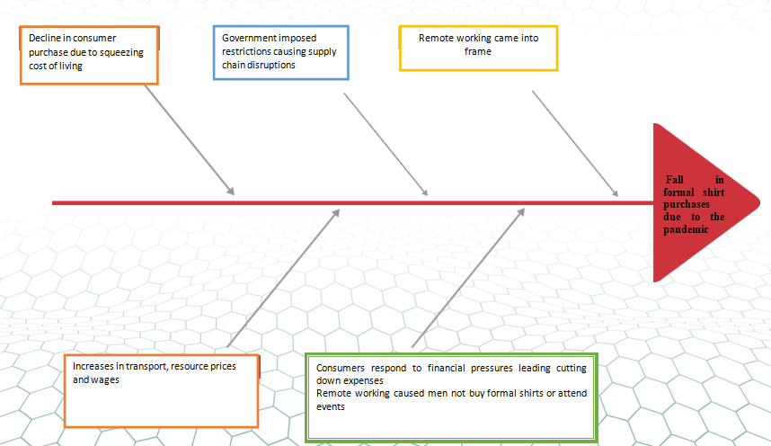
Figure 1: Fishbone Diagram
(Source: Self Created)

Alternative solutions to the problem
In order to mitigate the problem that has been defined TM Lewin could utilise the strategy of developing its own online platform for the purchase of both formal and nonformal shirts as per the requirement of the customers. Although the pandemic situation has created a lockdown restriction and no event could be carried out with the remote working concept to be in the situation there will be demand for casual T-shirts or shirts by the main population of the society. However, as it is observed that the company does not have an official online purchase option facility would provide the company an opportunity to increase its sales of shirts eventually. In addition to this, lowering the price value of its formal shirt would also provide scope to the vulnerable consumers in the current state who are trying to cut down their expenses by compromising on their purchase. The low pricing strategy would motivate them to purchase the product at a reasonable and affordable rate without much thinking and would facilitate the overall sales of the company. Lastly from the provided case study, it could be observed that there is no particular crisis management strategy or plan developed by the organization in order to manage such a crisis or critical situation for the company (LaBelle and Santacreu, 2022).

Selected solution
After a critical analysis of all the alternative solutions that have been outlined in the above-stated section the most appropriate would be the development of an online platform for torque Brands.In this way, the company will be able to communicate with its customers directly and provide them the options of various integrated products that are available for the targeted audience and continue with their business even in a pandemic situation as well

Plan of Implementation
PDCA can be used by the organisation of TM Lewin in order to implement this particular selected solution within its company. Under this particular framework, the company will be utilizing major steps that are planned to check and act in order to facilitate this particular procedure. In the planning procedure, the company could set up the goals related to this online platform development of TM Lewin so that the management, as well as the employees involved, are relevantly able to understand the scope of this particular solution and the provisions that are required to be undertaken by them in the upcoming time for this development. The strategy is related to the online platform you would undertake and develop in this particular stage. Followed by this in the 2nd stage the strategies will be aligned with the standard of operations and continuity of instructions would take place for the development of the line platform. It would be ensured by the management that an alignment is taking place between the goals that have been developed in the planning stage and the actions that are being undertaken in the do stage so that the necessary e modification could be brought into. In the check stage, the management of TM Lewin will try to undertake a formal and informal assessment of the solution being implemented so that its progress of it could be monitored on certain comparative aspects. Lastly, after the formal assessment, the results of it would be developed into proper strategic design and methods which are required to be followed in the final development of the online platform and this particular aspect would be shared among all the employees so that the goal related to the solution implementation could be achieved (Schmitt and Uribe, 2022).

Success indicators to measure the effectiveness
Only the implementation of an effective plan in regards to the solution would not work for the organisation of TM Lewin to understand whether the problem that was identified as being mitigated or not There are some success indicators that are required to be addressed which would help in measuring the effectiveness of the solution in context to the problem defined. In this case, the major success indicators will be the response of the customers towards the online platform of TM Lewin. Their engagement with the online platform would define whether the particular solution has been operating effectively in the long run or not. followed by this the sales increment of the products of the company will also be another particular success indicator to measure the effectiveness. this is because it was because of the sales factor the particular online platform had been designing because earlier the physical store shutdown cause a disruption in the supply chain

Conclusion
Followed by this a set of solutions developed based on the analysis of the problem and a particular solution plan will help TM Lewin to recover from the situation. After the effective analysis of the study, it could be determined that in an organisation it is essential to have a successful and effective problem-solving and decision-making approach. In addition to this, it is also very important that management shows that relevant data in relation to the issues are identified and earlier stage that the causative agent behind it could be identified and the solutions could be based on that.

References
Armantier, O., Koşar, G., Pomerantz, R., Skandalis, D., Smith, K., Topa, G. and Van der Klaauw, W., 2021. How economic crises affect inflation beliefs: Evidence from the Covid-19 pandemic. Journal of Economic Behavior & Organization, 189, pp.443-469.
Epler, R.T. and Leach, M.P., 2021. An examination of salesperson bricolage during a critical sales disruption: Selling during the Covid-19 pandemic. Industrial Marketing Management, 95, pp.114-127.
Fairlie, R. and Fossen, F.M., 2022. The early impacts of the COVID-19 pandemic on business sales. Small Business Economics, 58(4), pp.1853-1864.
Harianto, R.A. and Sari, P.N., 2021. Strategic digitalization of UMKM business as an alternative to survive the COVID-19 pandemic. Linguistics and Culture Review, 5(S1), pp.617-623.
Hoeft, F., 2021. The case of sales in the automotive industry during the COVID‐19 pandemic. Strategic Change, 30(2), pp.117-125.
LaBelle, J. and Santacreu, A.M., 2022. Global supply chain disruptions and inflation during the COVID-19 pandemic. Federal Reserve Bank of St. Louis Review.
Meyer, B.H., Prescott, B. and Sheng, X.S., 2022. The impact of the COVID-19 pandemic on business expectations. International Journal of Forecasting, 38(2), pp.529-544.
Ramli, M.W. and Jamri, M.H., 2021. The impact of Covid-19 pandemic: a closer look at the night market traders’ experience in Penang, Malaysia. International Journal of Academic Research in Business & Social Sciences, 11(1), pp.741-760.
Rangarajan, D., Sharma, A., Lyngdoh, T. and Paesbrugghe, B., 2021. Business-to-business selling in the post-COVID-19 era: Developing an adaptive sales force. Business Horizons, 64(5), pp.647-658.
Schmitt-Grohé, S. and Uribe, M., 2022. What Do Long Data Tell Us About the Inflation Hike Post COVID-19 Pandemic? (No. w30357). National Bureau of Economic Research.

