Physics

Lab

Assignment

Thomas Lumsden OME Physics
2427105

Table of Contents

1 | The Problem | 3
1a | Description of the problem | 3
1b | Problem in model | 3
2 | Materials | 4
2a | Material of projectile | 4
2b | Materials of plates | 4
3 | Simulations | 5
3a | Simulation with plate 1 | 5
3b | Simulation with plate 2 | 6
3c | Graphs | 7
4 | Discussion | 8
4a | Summary of simulations | 8
4b | Limitations or potential error | 9
5 | Conclusion | 9
6 | References | 9

1. The Problem

- Description of the problem

In this report, the problem that will be investigated will be the impact of a high-speed ballistic projectile into a metal plate. Two different materials have been assigned to the plate in this problem to allow the difference to be seen between how different metals react to being propelled into by metal bullets at a high speed. This collision will be at such speed that the bullet, depending on the material should be able to cause deformation and penetration of the plate.
Two simulations will be done, both with a different metal for the plate. Simulation 1 compromised of a copper bullet with a steel plate, and Simulation 2 with a copper bullet and a magnesium plate. All materials used in this problem follow Johnson-Cook parameters. These values for each of the bullets will contain the Density, Young’s modulus, Poison’s ratio, Heat capacity, melting temperature, A, B, n, C & m. The damage parameters for each of the bullets will be stated.

- Problem in model
Here it shows the bullet being fired directly at the centre of the plate at a high velocity:
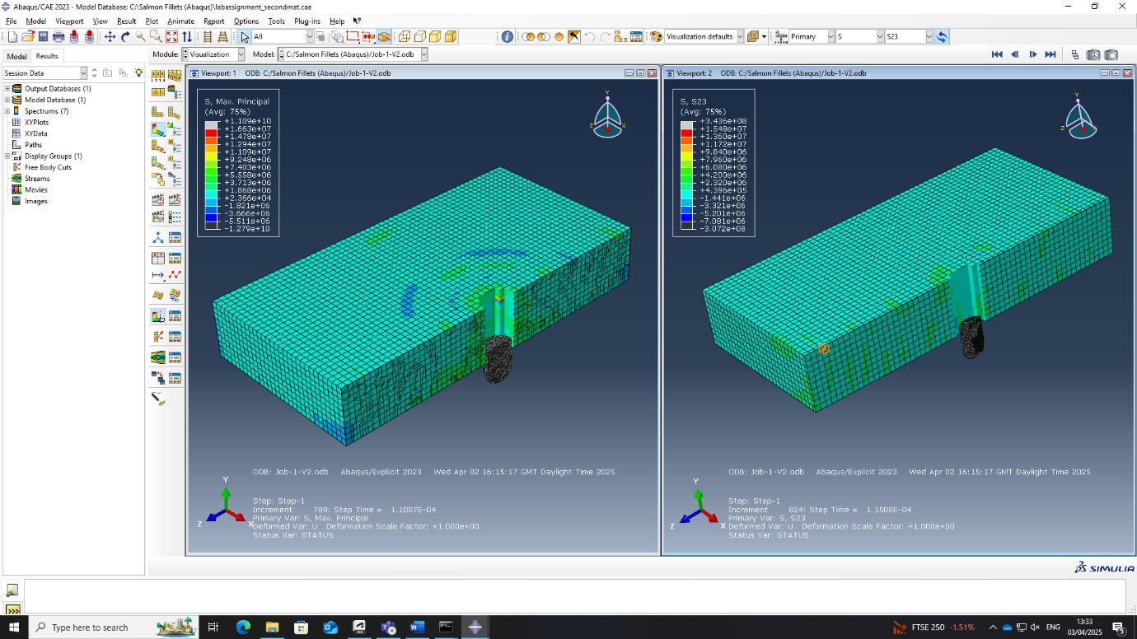

2. Materials

- Material of projectile

Bullet – Copper
Copper projectiles are widely known to be good at retaining their weight upon impact and tend to keep between 90-100% of their mass [1]. Due to this, it allows for deeper and more consistent penetration into the plate compared to that of more commonly used metals for bullets like lead. Copper is also more resistant to deformation when striking steel plates than that of other softer metals, which also results in more penetration of the plate.
The copper used in this simulation’s parameters [2]:
Density (g/cc) | Young's modulus (GPa) | Poison's ratio | Heat capacity (J/Kg·K) | Melting temperature (K) | A | B | n | C | m
8.96 | 124 | 0.34 | 383 | 1356 | 90 | 292 | 0.31 | 0.025 | 1.09

Damage parameters [3]:
D₁ | D₂ | D₃ | D₄ | D₅
0.54 | 4.89 | -3.03 | 0.012 | 1.12

- Materials of plates
Plate in simulation 1 – AISI-1045 Steel
Due to steel being a relatively high-density metal, it can be considered an effective material when performing high speed ballistic impact problems. Steel tends to be effective at resisting penetration of projectiles due to absorbing a significant amount of impact energy.
The steel used in this simulation’s parameters [4]:
Density (g/cc) | Young's modulus (GPa) | Poison's ratio | Heat capacity (J/Kg·K) | Melting temperature (K) | A | B | n | C | m
7.85 | 200 | 0.33 | 500 | 1644.26 | 50.1 | 176.091 | 0.517 | 0.1 | 0.565

Damage parameters [4]:
D₁ | D₂ | D₃ | D₄ | D₅
0.04 | 1.519 | -6.905 | -0.023 | 1.302

Plate in simulation 2 - AZ31B magnesium alloy
Magnesium is a very low-density metal, this leaves it prone to being penetrated when denser metals are being fired at it. The overall resistance of magnesium to projectile penetration is poor compared to that of steel. This also means that the minimum velocity for the projectiles being fired at this plate in order to penetrate it will be generally low since the density difference between most other metals is quite large.
The magnesium used in this simulation’s parameters [5]:
Density (g/cc) | Young's modulus (GPa) | Poison's ratio | Heat capacity (J/Kg·K) | Melting temperature (K) | A | B | n | C | m
1.77 | 45 | 0.35 | 1.02 | 923 | 225.171 | 168.346 | 0.242 | 0.013 | 1.55

Damage parameters [6]
D₁ | D₂ | D₃ | D₄ | D₅
-0.35 | 0.6025 | -0.4537 | 0.4738 | 7.2

3. Simulations

- Simulation with plate 1
In this simulation between the copper projectile and the steel plate, the copper bullet is seen to penetrate through most of the steel plate and then get stuck. The bullet initially penetrates quite easily through the plate but doesn’t get all the way through, and the nose of the bullet gets flattened out when penetrating through the plate. The plate stops the bullet getting all the way through and gets deformed at the bottom as the stress put on the plate is enough to bend the bottom, but not enough to penetrate right through the end.
Figure 1 – Initial penetration point
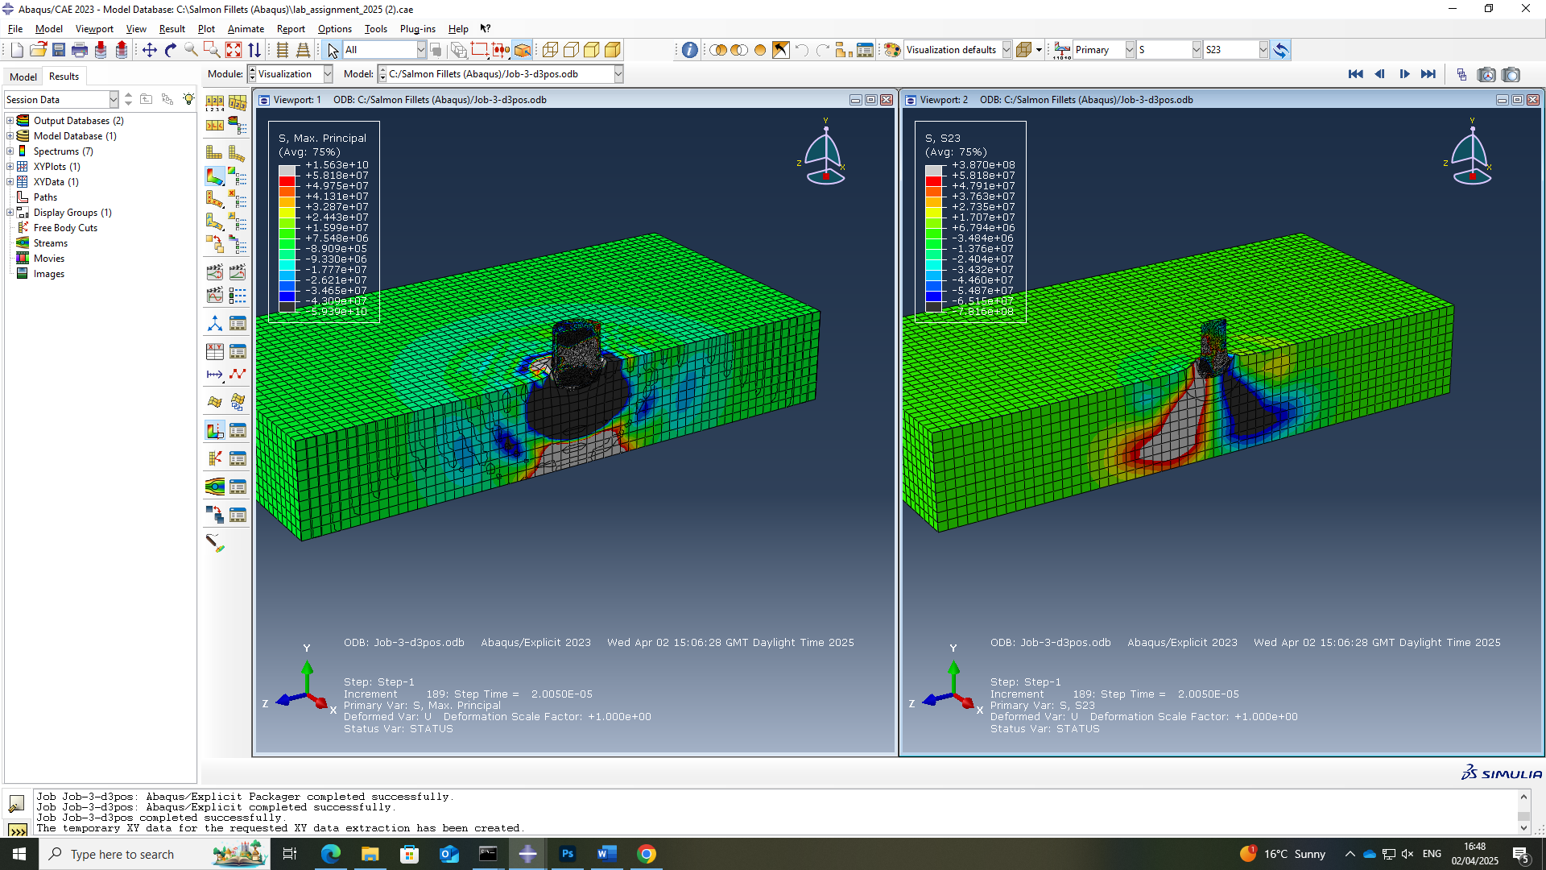

Figure 2 - End point
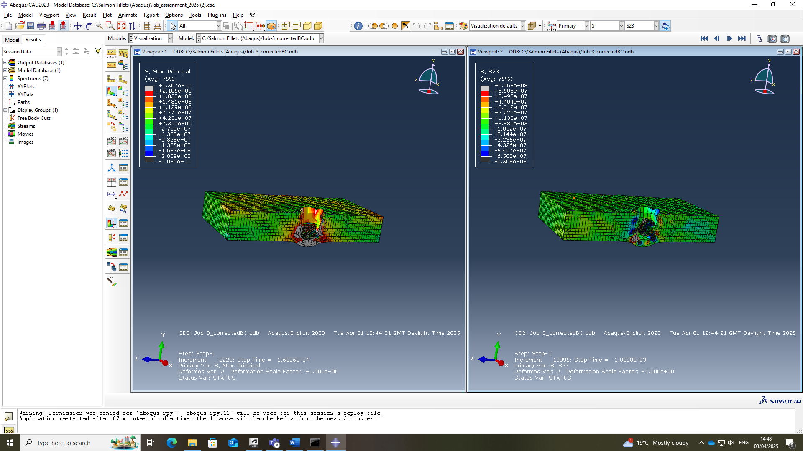

- Simulation with plate 2
The second simulation conducted is between the copper projectile used in the first simulation, and a magnesium plate rather than a steel one. Here we can see that the copper bullet has no issues completely penetrating all the way through the magnesium plate. There seems to be zero deformation of the projectile and just a hole all the way through the magnesium plate.

Figure 3 – Initial penetration point (sim 2)
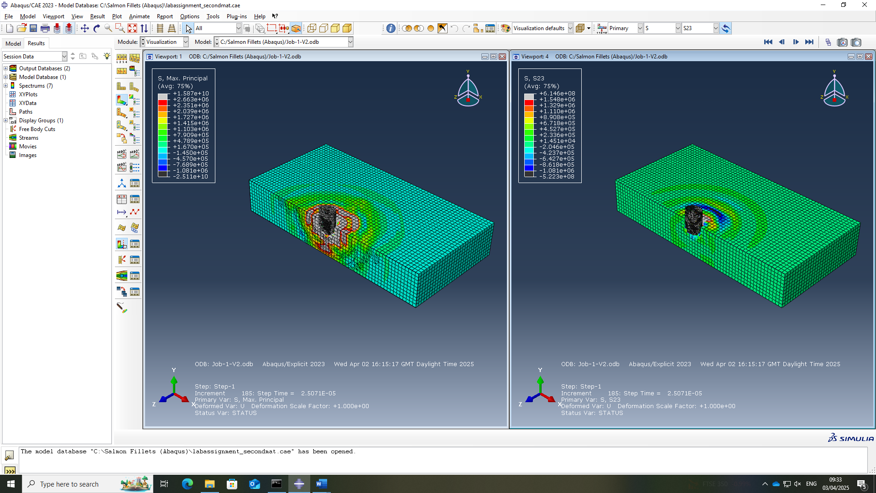

Figure 4 – End point (sim 2)

- Graphs
Here shows the velocity over time graph for simulation 1 between the copper projectile and the steel plate. We can see that the velocity before the initial point of contact is 800m/s, and within 0.2 seconds is at rest. The velocity quickly drops due to the stress the plate is giving to the bullet which is causing it to slow down and then eventually goes down to 0 due to the plate completely stopping the bullet,
Figure 5 – Velocity over time
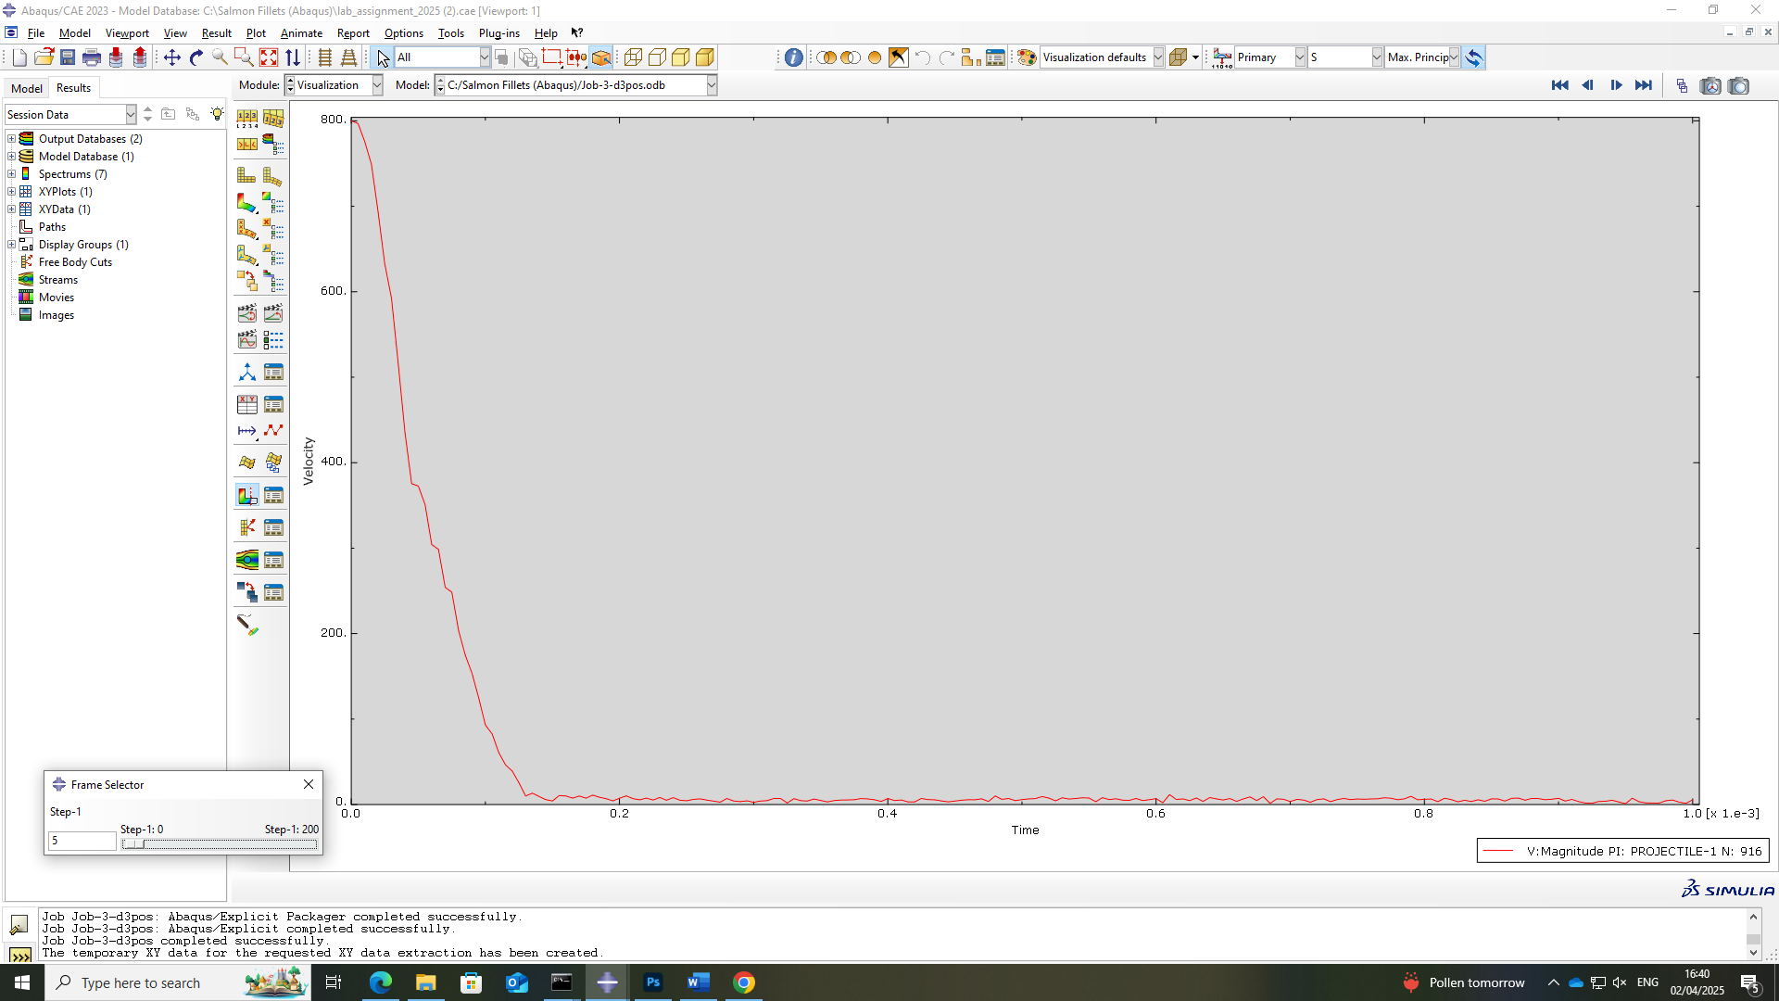

4. Discussion

- Summary of simulations
Simulation 1:
The results in simulation 1 correspond to what was predicted to happen before the simulation was carried out. Due to the steel having a higher strength than the copper, it was able to stop it penetrating all the way through.

Simulation 2:
These simulations results were also expected to have played out the way they did. The fact that the density of copper is much higher than magnesium, and magnesium being considered a very low-density material shows that it was inevitable that the copper bullet was going to penetrate all the way through the magnesium plate, which it did.

- Limitations or potential error

When conducting this problem, there are many avenues for error. Some examples include:
Incorrect input of parameters. It is very easy to make a typing error when inserting the values of the parameters for the metals, this could include putting the values for a different parameter into another place, having the incorrect exponent for numbers, or having unreliable sources for the parameters. This results in incorrect behaviours of how the projectiles react to colliding with the plate.

5. Conclusion

In conclusion, this problem was successfully carried out. The results gathered were consistent with what were predicted beforehand. The copper projectile being stopped by the steel was predicted, and so was the aluminium being completely penetrated.

5. References

[1] Shane, “Lead vs. Copper Bullets: A Comprehensive Comparison - MFG Shop”, April 2025.
[2] R. Chakrabarty, J. Song, “A modified Johnson-Cook material model with strain gradient plasticity consideration for numerical simulation of cold spray process”, 2020, 397.
[3] H.B. Boubaker, A. Moufki, M. Nouari, P. Laheurte, A. Tidu, “Thermodynamically consistent formulation coupling crystal plasticity theory and Johnson-Cook damage model to simulate micromachining of copper”, Procedia CIRP, 2021, 102, p506-511.
[4] Murugesan, M., & Jung, D. W, “Johnson Cook Material and Failure Model Parameters Estimation of AISI-1045 Medium Carbon Steel for Metal Forming Applications”, 2019, 12(4), 609.
[6] Sun X, “Uncertainty Quantification of Material Properties in Ballistic Impact of Magnesium Alloys”, Materials, 2022, 15(19), 6961.

