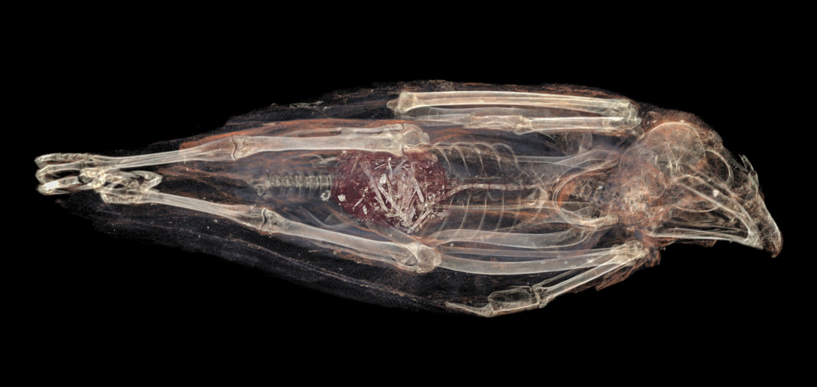
Component A) Critical analysis of two sources.
Figures 1 &2 taken from Fatal force-feeding or Gluttonous Gagging? The death of Kestrel SACHM 2575. Journal of Archaeological Science

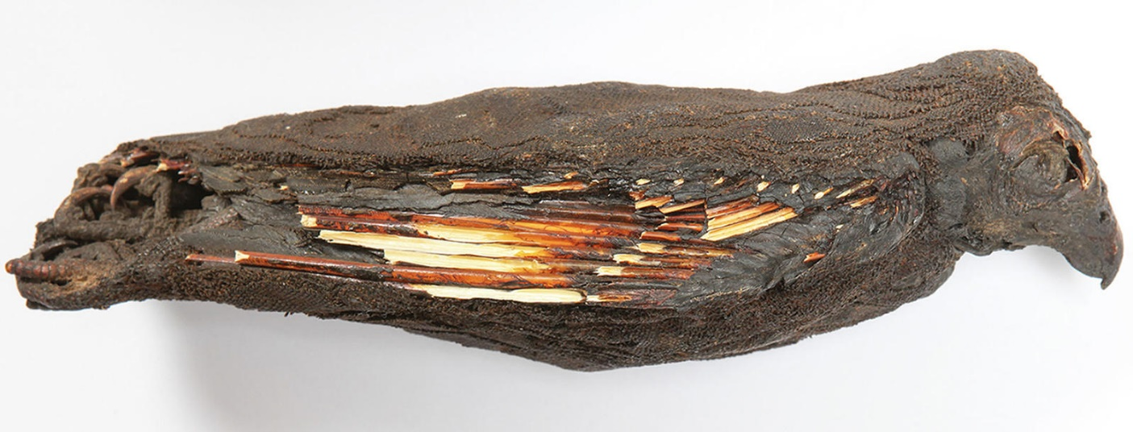
The first Primary source I will be analysing is this mummified kestrel (SACHM 2575). This is a piece found in the Iziko Museum of South Africa which, in 2015 was subjected to a virtual autopsy, thanks to CT scanning, which revealed the species and more importantly the method of death. In revealing that the bird was overweight and force fed, this scan reveals not only evidence for human interference, but also knowledge of basic falconry techniques – thus forming the basis of my argument.
The act of keeping a bird tame by controlling its food is a practice universal and essential to falconry in all eras and civilisations. Modern falconers will control their food to keep their birds at their ‘flying weight’ where they are hungry enough to perform tricks for food, but not too hungry that they think they’ll be better off hunting for themselves. It is interesting that this kestrel proves that the Ancient Egyptians employed the same technique, but instead of finding the ‘flying weight’, they chose to keep this bird ‘fed up’. When a bird is too full they will choose to sit still and not fly in order to preserve energy, but also given this bird’s proportionate weight, it would not be too much of a stretch to theorise that this bird found it difficult to fly, therefore making it even more reliant on humans.
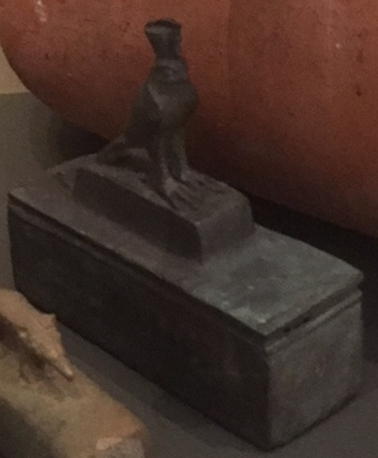
This bird had been fed to death, suggesting that this was the purpose of rearing it all along as it doesn’t make economic sense to give extra food otherwise. Also the fact that it was used to humans providing food minimises fear and inspires trust would mean that it would be easy for the falconers to kill them in other ways, if the overfeeding fails.
Figures 3 & 4 taken at the Ashmolean museum in January 2018 by Jessica Plunkett
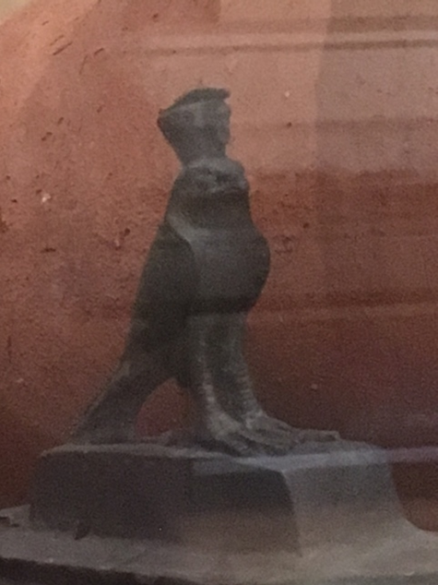
The second object I will be analysing is this falcon coffin discovered in Saqqara, currently on display in the Ashmolean museum (Museum Number). I chose this as an object for critical reflection as I believe it to be an example of how Egyptian falconry was focussed towards a votive nature. McKnight and Atherton-Woolham discuss in their book ‘Gifts For The Gods’ there were three other natures of Egyptian animal mummies found, besides votive we also have evidence for the mummies of beloved pets, ones of a victual nature and those specific animals chosen and worshipped by a cult in life and death, thought to be ‘living representation of the gods on earth’. My belief that this is one of a votive nature stems mostly from the fact it was found in Saqqara, home of many burial sites, including the temple of Nectanebo II which contained 100,000 votive falcon mummies dedicated to Isis, mother of Horus (the falcon god). There is also the design of the coffin, It is very small (approx. 5x3x7cm) leading me to believe that either this belonged to an extinct breed of pygmy falcon related to the modern peregrine, or that it doesn’t contain an entire falcon, rather just parts of one- as has been found in Nectanebo II’s temple. If this is true, it would back up my theory that this is for a votive nature as, it would be more profitable to the falconers for them to split up the remains to sell to different people, also they would save money on the materials to make the coffin for it to be smaller. More evidence for this theory is found in the fact that not all of the falcon mummies/coffins found in Saqqara actually contained falcons. Amongst them as found other birds of prey, but also sparrows and completely empty jars. Is this evidence for forgery and therefore human interference or does it just tell us that the aspect of offering was more important than the bird itself?
In conclusion, these two sources supports evidence for the Ancient Egyptians practicing the art of falconry, specifically of the economic motivation for the job and the votive nature of the work.
Bibliography
- MacDonald, H. (2006) Falcon. London, Reaktion Books LTD
- McKnight, Atherton-Woolham, McKnight, Lidija Mary, & Atherton-Woolham, Stephanie. (2015). Gifts for the Gods : Ancient Egyptian animal mummies and the British. Liverpool, Liverpool University Press
- Ikram, Salima & Slabbert, Ruhan & Cornelius, Izak & Du Plessis, Anton & Colette Swanepoel, Liani & Weber, Henry. (2015). Fatal force-feeding or Gluttonous Gagging? The death of Kestrel SACHM 2575. Journal of Archaeological Science..

Component B) Annotated Bibliography
Sinclair, W. F. “Antiquity of Eastern Falconry.” Journal of the Royal Asiatic Society of Great Britain and Ireland, 1896, pp. 793–796. JSTOR, www.jstor.org/stable/25207815.
This article examines a falconer’s statement that his is an ancient art. The author states that his belief is that this is an unfounded belief as all the evidence for ancient falconry ‘poor’ stating examples from ancient literature to prove this. I didn’t find this article very useful as it is very short and the examples used were not very elaborated on. Even his conclusion is not very definitive, seeming inconclusive, not researched enough and outdated (which is to be expected from an article from 1896). What I did take from this is examples of primary sources (for example the Herodotus passage) that I could do my own research on to use to support my own theories.
Epstein, Hans J. “The Origin and Earliest History of Falconry.” Isis, vol. 34, no. 6, 1943, pp. 497–509. JSTOR, www.jstor.org/stable/225894.
This article examines the history of the sport of falconry (hunting with birds of prey) aiming to look as far back as possible. The author looks at a range of evidence, ranging from an Assyrian bas-relief to the works of Philo. This piece was very useful as although little of it is dedicated to falconry in Egypt, the discussion of falconry practices elsewhere provides an interesting comparison to think about in my own piece. However, it is not too useful as it only looks at the sport of falconry which is country to my piece which examines falconry in its wider interpretation.
McKnight, Atherton-Woolham, McKnight, Lidija Mary, & Atherton-Woolham, Stephanie. (2015). Gifts for the Gods : Ancient Egyptian animal mummies and the British.
The article I found the most useful in this book was written by the authors themselves which aimed to prove that the most common nature of animal mummies as votive offerings. I found this very useful as it gives an example of a motive for the ancient Egyptians to practice falconry and even discusses evidence found of captive animals being kept, not just birds of prey but also other animals too. The inclusion of all animals, while not relevant for my own project, is interesting from a comparative point of view.
Ikram, Salima & Slabbert, Ruhan & Cornelius, Izak & Du Plessis, Anton & Colette Swanepoel, Liani & Weber, Henry. (2015). Fatal force-feeding or Gluttonous Gagging? The death of Kestrel SACHM 2575. Journal of Archaeological Science.
This report concerns the radiology scans of a complete kestrel mummy found with its innards intact so we can see that it has been fed to death. This article proves human interference and was the inspiration for my own research project. It is incredibly useful as it provides an indepth report on the findings as well as background information to the position of falcons in Egypt and inferences on how this particular mummy came about, which I can base my research on.

Component C: Project Summary

Born To Die- A Study Into The Existence And Nature Of Ancient Egyptian Falconry
  - A comparative piece examining evidence for the existence of modern falconry practices in Ancient Egypt.
This essay will be finding and analysing evidence for the existence of falconry in Ancient Egypt in order to prove its existence. Multiple types of evidence will be analysed, including literary, objects and even examining material remains (in the form of animal mummies). These will be compared to modern falconry practices using the authors own knowledge obtained whilst training as a falconer, as well as knowledge obtained from Ryan Stocks, professional falconer and owner of the business Owl Adventures (as seen on BBC’s The One Show). This essay was chosen due to inspiration from the materiality’s movement looking at Ancient History through an Anthropology movement revealing new truths about how things could have functioned, Surely employing a falconers perspective to look at Ancient Egyptian interpretations of birds of prey (with a particular focus on falcons), rather than a historian could yield similar results.
Firstly, In order to look at Ancient Egyptian Falconry, we must first define the meaning of the term ‘falconry’. Contrary to popular interpretations, this essay will not be looking at the medieval sport, but rather the more modern definitions used by falconers in the 21st century- in western civilizations at least. The dictionary definition of the word ‘falconry’ is still something very old fashioned that most modern falconers would have an issue with. The Oxford English Dictionary defines it as ‘The keeping and training of falcons or other birds of prey; the sport of hunting with such birds’ which may have been true in medieval times when the term was invented, however it has greatly evolved over the years and its modern use is something highly different. This is, in itself, due to a change in the nature of falconry. Back in those days the most common definition ‘The act of hunting with falcons’ would have been accurate as that was the only purpose and the only bird used. Nowadays very few people (in western culture) use falcons to hunt- instead favouring hawks- specifically Harris Hawks due to their nature as pack animals making them known as the most intelligent species of birds of prey. But these hunts using birds of prey are mostly personal pursuits, the most commo ways we hear of falconry in use today is in the entertainment business, due to the nature of such thing. People who keep and birds of prey for an occupation still refer to themselves as falconers, even if they have never gone hunting in their lives. This is the mindset that this essay will be utilising, looking at the Ancient Egyptians from the point of view of a 21st century falconer to see similarities and evidence for the occupation of falconry in ancient Egypt, rather than the sport. Therefor, for the sake of this essay, I will be defining falconry as The keeping and training of Birds of Prey.
The presence of birds of prey in ancient Egyptian culture is largely identified when looking at their writing system. The Gardiner list contains 54 birds and 8 parts of birds, many of which are birds of prey (sections G and H). The most common occurrences being the vulture and the owl, which are part of the ‘alphabet’ as such – which transliterate to ‘a’ and ‘m’ respectably. This shows a huge presence of birds of prey in Ancient Egyptian culture, not just for the upper class who would have been able to read and write- but by everyone who would have been able to see public monuments and tombs plastered in them. From this we can postulate that the birds themselves were common-place and seen often in order for the imagery to be so accurate. This can be supporting my theory of Ancient Egyptian Falconers existing as the nature of birds of prey is that they fly very high and fast so you don’t normally see them up close unless they are tame.
The falcon symbol in hieroglyphs is used to represent not a word, but a name. Specifically ‘Horus’ the Egyptian deity who is commonly pictured as a man with the head of a falcon or a falcon wearing the two crowns of upper and lower Egypt. Horus was known as the god of the sky, with the outstretched wings representing the sky and his two eyes representing the sun and the moon. This easily explains the falcon connection as they would have been seen flying overhead faster and more powerful than other birds thanks to their bird of prey status. They are also able to spot medium-sized prey from at least 1 mile (1.6 km) away, which could explain the emphasis on the eyes as an emphasized feature.
However, some scholars now believe that this glyph may also mean ‘the distant one’ or ‘the one who is above’. This translation is tricky to examine, you could see it the same way that Christians prey to their God ‘on high’ which is not too different to the terms ‘distant’ and ‘above’. However, you could compare it more to the flight tendencies of a falcon which is certainly ‘distant’ and ‘above’ which is the entire appeal of modern falconry displays, to give people a close up view of something you only really see from the distance. So why then, if the Ancient Egyptians also thought these creatures to be ‘distant’ and ‘above’ do we not see more of this represented in their art? Why in their Hieroglyphs and Artworks are the falcons nearly always pictured perched peacefully? Could it be that the Ancient Egyptians figured out the same thing that most modern falconers did, that there is economic gain to be found in something thought of as ‘distant’ and maybe even sacred, being brought to be easily seen up close and personal?
However, the temple of Nectanebo II in Saqqara contained the mummies/jars/coffins of over 100,000 falcons, meaning they couldn’t have been too ‘distant’. The temple was dedicated to Isis who, according to Ancient Egyptian mythology was the mother of Horus, so maybe by sacrificing falcons to her, the people were asking for her motherly protection/guidance or protection for their children, for if they were simply asking for her intercedence, surely they would just offer a cow?
Another issue raised in this is the act of animal sacrifice itself. It is difficult to determine the nature of the divine connection between Horus and falcons. We don’t know whether the god was thought to be embodied in the species/a single falcon and if so, if that was temporary or permanently. Or, instead of the gods embodiment, the falcon could simply be symbolic of more ‘intangible divinity’. Ancient Greek author Herodotus paints a picture of elaborate sacrifices on special animals (only those who have been marked by a priest) and anyone found to have killed a sacred animal otherwise condemned to death. The second option seems more plausible however, especially when tying into the fact that purposeful kill of many birds have been scientifically proven, as many of the animal mummies found at Saqqara were found strangled or with their skulls crushed. Modern author David Frankfurter suggests instead that when talking about the Ancient Egyptians, the term ‘sacrifice’ is too narrow to encompass their flexibility and to allow for comparative differences. He suggests that ‘animal killing and blood sacrifice were not central to Egyptian cult practice; rather, the manifestation and procession of the divine image was the more common ritual’. This theory allows for the existence of falconers, though for a different purpose. If it is the image of the falcon that was important rather than the act of killing it, then there was no necessary ritual, the birds could be raised and killed privately and their mummified remains sold to mourners.
Evidence of this can be found when analysing one of the falcon coffins found in Saqqara. This was a tiny bronze box with a statue of a falcon on the lid wearing the double crown of upper and lower Egypt (see figure 1). The pure size of this coffin leads to evidence of human interference as it is only approx. 5x3x7cm, too small to contain a whole falcon mummy, if it contains one at all! There is the possibility of it holding a chick, or some extinct pigmy breed related to the modern peregrine (‘Horus bird’) However, it is much more likely that this could contain an incomplete bird, sold as such for economic gain. This theory was formulated by looking at some of the other coffins and jars at Saqqara which revealed that most were in fact empty or contained a common bird such as a sparrow. The box itself being smaller saves the craftsman money on materials supporting this somewhat cynical theory that the ancient Egyptians were falconers for mostly the reason we are today, for the economic gain. Though there is an interesting contrast between the focus on falconry today as a means to help preserve birds of prey and the Ancient Egyptians seemingly breeding them just to die.
The bred to die theory is backed up by a virtual autopsy performed on a mummified kestrel (SACHM 2575) via CT scan from the Iziko Museum of South Africa. This kestrel is really interesting as unlike many animal mummies found, it is entirely intact, including all its innards- which is the really fascinating part. The scan revealed that this bird had died of overfeeding. This is most likely evidence for human intervention rather than just a hungry bird due to the biological fact that birds of prey struggle to fly when full, therefore when hunting on a full stomach they become slower and not as accurate, leading most birds not to bother flying. This is where we get the modern term ‘fed up’ from, as if a falconer has overfed their bird it will choose to just sit there and not fly. Modern falconers who engage in falconry displays train their birds to do fantastic tricks by use of controlling their weight. Each bird has an individual ‘flying weight’ at which it is hungry enough to want to fly in order to receive food, but not too hungry to think they’d have better chances hunting for themselves. It is interesting that both cultures employ the same training technique but point towards separate goals. While the main purpose of modern falconry displays is to entertain and educate people on birds of prey, this evidence seems to point towards the ancient Egyptian purpose being that they are bred to die. It makes no economical sense to give the birds extra food unless that Is their main purpose. Overfed birds will have difficulty flying and therefore will be tame and fairly trusting of the hand that feeds them so if the overabundance of food doesn’t do it, then it will be all too easy to strangle them or smash their heads.
So, if all this evidence for the existence of falconers exist, then why don’t we hear more about them? It is probable that falconer wouldn’t be their main job, perhaps priests of falcon cults were actually the masterminds behind this? This theory is supported by evidence found in block three sector seven, which was thought to be a hatchery in Saqqara. This was due to the nature of the room, with its high ceilings and terracotta jars containing the remains of eggshells. There was also an Ostraca bearing a bird stamp found at the location. It would make sense for the priests to be the ones rearing, killing and selling the birds of as they are the ones profiting from it. It has been suggested that it wasn’t the priests breeding them but rather certain members of the falcon cults going out and stealing the eggs and bringing them back to be raised by the priests. However, this makes no sense logically. There were over 100,000 birds (or parts thereof) found at Saqqara, to be able to find and loot that many seems unrealistic, rearing and breeding sounds much more plausible- or at least a fair combination of both.
In conclusion, thanks to Ancient Egyptian mythology about Horus, the falcon is a highly popular symbol found again and again in the material culture of Ancient Egypt. This goes against its fairly reclusive and hard to spot nature that we see these birds exhibiting today. Therefore, unless this is a trait bred into them thanks to Darwins theory of evolution, it is only logical to assume that there must have been some form of human intervention and therefore falconry practices in ancient Egypt. Birds of prey are present in the forms of literature (the myth of Horus) and the literary system itself. They are also seen in the form of material remains, analysing mummies is a really interesting practice because unlike most other objectary evidence, these were once alive and there is a real ethical debate about disturbing the dead, even if it is an animal, not a human in this case. Birds of Prey are also very present in the artworks of Ancient Egyptians as they made elaborate bird statues, for example the one analysed int his essay which sit on top of a miniature coffin. All this evidence adds up to a very strong case for the evidence of falconers in ancient Egypt, however, although they seemed to use the same techniques for controlling their birds and the same primary directive of Economic gain, the secondary directives are complete opposites. While modern practices aim towards the conservation of birds of prey, due to a lot of the evidence for Ancient Egyptian falconry being found in a funery context, the falconers themselves being priests and the kestrel being fed to death which would have been a waste of food, we can infer that the main directive of ancient falconry was a religious one, with the birds quite literally being born to die.

Bibliography
- Oxford Dictionaries | English. (n.d.). falconry | Definition of falconry in English by Oxford Dictionaries. [online] Available at: https://en.oxforddictionaries.com/definition/falconry [Accessed 7 Mar. 2019].
- Yourdictionary.com. (n.d.). Falconry dictionary definition | falconry defined. [online] Available at: https://www.yourdictionary.com/falconry [Accessed 7 Mar. 2019].
- Gardiner, A (1927) Egyptian Grammar: Being an Introduction to the Study of Hieroglyphs. London, Clarendon Press.
- Frankfort, H (1978) Kingship and the Gods: A Study of Ancient Near Eastern Religion as the Integration of Society and Nature London, University of Chicago Press.
- Fund, T. (n.d.). Vision | The Peregrine Fund. [online] Peregrinefund.org. Available at: https://www.peregrinefund.org/explore-raptors-vision [Accessed 7 Mar. 2019].
- Meltzer, Edmund S. (2002). Horus. In D. B. Redford (Ed.), The ancient gods speak: A guide to Egyptian religion (pp. 164). New York: Oxford University Press, USA.
- MacDonald, H. (2006) Falcon. London, Reaktion Books LTD
- Herodotus Histories. English translation by A. D. Godley. (1920) Cambridge. Harvard University Press.
- Frankfurter, D (2011) Egyptian Religion and the Problem of the Category “Sacrifice” Available at: http://www.oxfordscholarship.com/view/10.1093/acprof:oso/9780199738960.001.0001/acprof-9780199738960-chapter-3?print=pdf [Accessed 7 Mar 2019]
- Cowofgold.wikispaces.com. (2018). cowofgold - Falcon. [online] Available at: https://cowofgold.wikispaces.com/Falcon [Accessed 22 Feb. 2019].
- Ikram, Salima & Slabbert, Ruhan & Cornelius, Izak & Du Plessis, Anton & Colette Swanepoel, Liani & Weber, Henry. (2015). Fatal force-feeding or Gluttonous Gagging? The death of Kestrel SACHM 2575. Journal of Archaeological Science..
- McKnight, Atherton-Woolham, McKnight, Lidija Mary, & Atherton-Woolham, Stephanie. (2015). Gifts for the Gods : Ancient Egyptian animal mummies and the British. Liverpool, Liverpool University Press
- Epstein, Hans J. “The Origin and Earliest History of Falconry.” Isis, vol. 34, no. 6, 1943, pp. 497–509. JSTOR, www.jstor.org/stable/225894.
- Sinclair, W. F. “Antiquity of Eastern Falconry.” Journal of the Royal Asiatic Society of Great Britain and Ireland, 1896, pp. 793–796. JSTOR, www.jstor.org/stable/25207815.

Fatal force-feeding or Gluttonous Gagging? The death of Kestrel SACHM 2575
McKnight and Atherton-Woolham p10
MacDonald 2006 p51
MacDonald 2006
https://en.oxforddictionaries.com/definition/falconry
https://www.yourdictionary.com/falconry
Gardiner list
Frankfort (1978) p37
https://www.peregrinefund.org/explore-raptors-vision
Meltzer (2002) p164
MacDonald (2006)
Hdt. 2.41.2
Frankfort (1978) p37
Frankfurter (2011)
Frankfort (2011)
https://cowofgold.wikispaces.com/Falcon
MacDonald (2006)
Fatal force-feeding or Gluttonous Gagging? The death of Kestrel SACHM 2575
Frankfurt (2011)
McKnight, Atherton-Woolham (2015) p24
Martin (1981) p27
Ray 1970
Kessler and Nur el-Din (2005) p125-6

