Introduction
The essay will critically evaluate and explain the role and activities of the marketing department within Orchard Care Homes (OCH). Firstly, the essay will identify the role of the marketing department in the organisation as well as the key target markets. Secondly, it will identify the key methods of communication that is used by the marketing department. Finally, the essay will divert its attention to focusing on how effective the marketing campaigns are assessed within the marketing department.
Overview of Orchard Care Homes
Orchard Care Homes runs and manages over 80 care homes across the UK (Orchard Care homes 2018). Primarily, within cities and towns including Blackpool, Birkenhead, Barnsley, Swansea and Bournemouth (Orchard Care Homes 2018). They have a strong reputation in the care home industry and have been running for the past 15 years (Orchard Care Homes 2018).

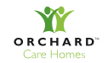

- Identifying the role of the marketing department in the organisational structure
The role of the marketing department has evolved over the years (De Luca and Gima 2017). Previously, marketing department was viewed as a function, however over the years marketing has become as set of values and processes that all functions of the organisation participate in and implement (Hawes et al 2017). This means that marketing become everyone responsibility, and it is just not confined to the marketing department.
At Orchard Care Homes (OCH) the marketing department plays a vital role in promoting its business, mission, vision and values to its perspective stakeholders. Primarily, the department’s key focus is on product management, price management, distribution, communication, market research and market planning (Hawes et al 2017).
The department also helps communicate its unique selling point (USP) to is potential customers, the products the company sells, there pricing strategies and any promotions and offers they currently have on current products and services that they are providing. This means that the department is at the core stone of OCH as it helps drive there sales, cashflow, profitability and turnover. This example therefore nullifies the notion set by Naik et al (2005) who explicitly confirmed that the role of the marketing department has diminished over the years, hence has lost its strategic role and importance.
On the other hand, studies conducted by Sui and Kirby (2011) confirmed that a strong and effective marketing department leads to superior business performance. This means marketing plays a crucial role in implementing and successfully managing market orientation at OCH.

Orchard Care Homes Organisational Structure: Diagram 1
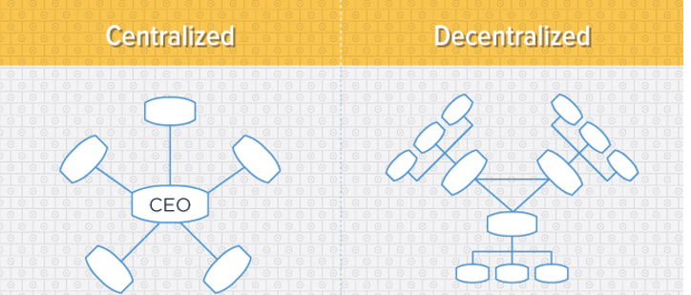

In the past OCH had a centralised organisational structure where there was rigid departmentalisation (RD) (see Diagram 1). This meant that each department e.g. marketing, finance, operations and customer services were highly autonomous, hence there was little interaction or communication between different teams which meant that each department were operating in isolation (Webster 2018).
However, over the years OCH has explicitly adopted a decentralised organisational structure (see Diagram 1) which means that they have adapted a loose departmentalisation which means that each department has more freedom to interact and collaborate with each other, hence enhancing departmental communication (Lovelock and Wirtz 2011). With this in mind the marketing department has an extremely positive relationship the rest of the departments.
The relation between OCH marketing department and other departments takes two key paths. Firstly, when OCH consider developing any products or services, it essentially coordinates the marketing components within its other business functions (Homburg et al). This means that the marketing plans are coordinated with the financial, production, procurement, personnel and r and D department which primarily means each department at OCH are interdependent on each other, therefore cannot operate in isolation.
Identifying the key target markets
In order to identify the key target markets of OCH market segmentation will be used. There are five different ways in which organisations such as OCH identify there key target markets. These include geographically, demographically, psychologically, and also behaviour (Kotler, Adam, Brown and Armstrong, 2003).
OCH mainly identifies its target market through demographics and geographics ( Orchard Care Homes 2018). Primarily, there key target market for OCH are the mainly the elderly (60 years and above) and vulnerable people who are deeply in need extra support in their daily life. OCH micro segment by geographical area as well. This is the reason why majority of there care homes are in areas where the local population is above the average. Majority of there care homes are in cities and towns where there is the oldest average aging population in the UK. These city/towns include Blackpool, Birkenhead, Barnsley, Swansea and Bournemouth (BBC 2018).
The key target market for the marketing department are the key stakeholders within the organisation. Stakeholders can be defined as those groups, without whose support, the organisation would cease to exist. In other words, anyone that is affected by the company and its workings (Kotler 2008). These include customers, employees, suppliers, local community, local authority and the media. For OCH marketing department, the stakeholders can be segmented into primary and secondary stakeholders. The table below outlines the primary and secondary stakeholders of OCH.

Primary Stakeholders for marketing dept | Secondary Stakeholder for the marketing dept
Customers | Community Groups
Consumers - families members of the elderly who have decision making power e.g. Power of attorney and/or deputyship. | NHS
Employees - head office and care home employees | Governmental Bodies
NHS
Suppliers
Shareholders
Local Community
Competitors

Consumers and customers
The marketing function at OCH needs to make sure that they align there marketing activities and focus on there customers and also consumers. By successfully coordinating their marketing activities, campaigns and explicitly targeting it to their target markets, it will help the marketing department at OCH to attract new customers (customer acquisition) and retain their existing customers (customer retention). This will in turn improve the overall market share of the OCH and hence will make them more competitive. From this it can be learnt that the marketing function has an important role to play as they are the face of the organisation and it helps them sell its USP to its consumers which in this case will be providing the best care experience to its customers and consumers.

Employees, NHS and the local community:
Local Community and employees are a key target market for the marketing department. The below example shows that OCH take corporate social responsibility extremely seriously. Using the website as a marketing tool, OCH has shown how it financially supports the “Carers Charity” which is an organisation dedicated to helping to support people who work in the care sector, including current, former and retired care workers in a number of different ways. Any potential customer that visits the website will have a positive feel and image about OCH, when they read the article below. This will portray a positive image in the minds of the customer, hence view them as an ethical business and employer. This means the promotional campaign below was extremely effective because it has helped OCH portray themselves positively in the eyes of the consumers, which will increase the likelihood of more service users coming to OCH and therefore improving there market dominance with care home industry.

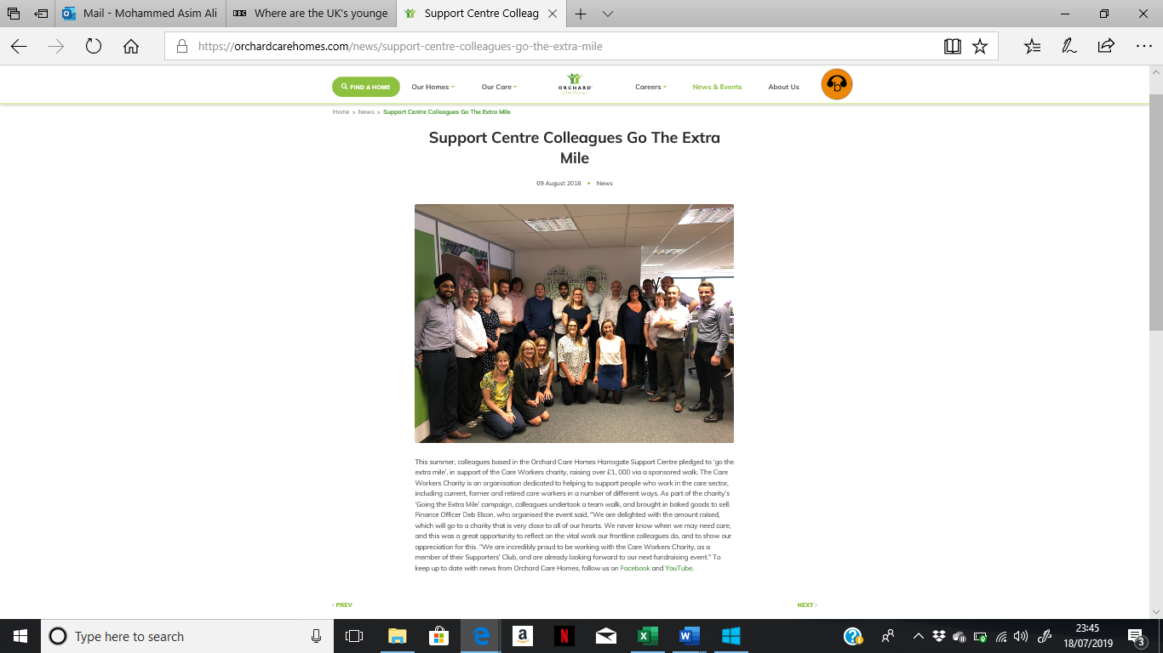
https://orchardcarehomes.com/news/support-centre-colleagues-go-the-extra-mile
The marketing Mix - 4 P’s of marketing:
Product
OCH provide services for various degrees of care. This includes residential and nursing care services. There are 3 types of service users, private, local authority and NHS. LA’s and NHs refer service users to Orchard Care Homes for secondary assessments or directly with orchard care for privately funded residents. Privately funded residents are the most profitable as they can the maximum care home fees.
Price:
For privately funded customers OCH use premium pricing strategy within areas they have distinctive competitive advantage (Kotler et al). This includes areas such as Bournemouth and St Helens where they are market leaders and have majority of the regional market share. However, competitors such as Maria Mallaband (MMCG) have recently diversified in the region and have started to undercutting care fee rates by using penetration pricing strategy as well as using aggressive advertising (Kotler et al). This basically means that OCH will need to safeguard its market share by reducing and changing its pricing strategy (Kotler et al). Psychological pricing strategy would be an effective defensive mechanism which will allow OCH to see off competition from MMCG and keep a foothold on its market share (Kolter et al).
Place:
OCH provides services across England and Wales. They have strong hold within north of England and face stiff competition down south where there are bigger player within the market place such as BUPA and MMCG.
Promotion
OCH use various methods to advertise its products and services. These include internet, social media, email marketing and word of mouth (Kolter et al). These methods are used together as part of their marketing campaign in order to attract potential customer and make customers aware of the different types of products and services that they are providing.
Selection of appropriate media channels
There are various marketing channels that are used by Orchard Care Homes in order to communicate to is respective stakeholders. OCH uses mainly the traditional forms of advertising such as tv, radio and billboard advertising. However, recently due to the advancement in technology and the importance of social media the traditional methods have been put on the back burner (Liu 2012). Instead OCH have started investing heavily in rebranding there website by making it more open, transparent and user friendly. Previously, it was a very poor unattractive and did not appeal to its respective customers and also consumers (Van 2016).
Websites:

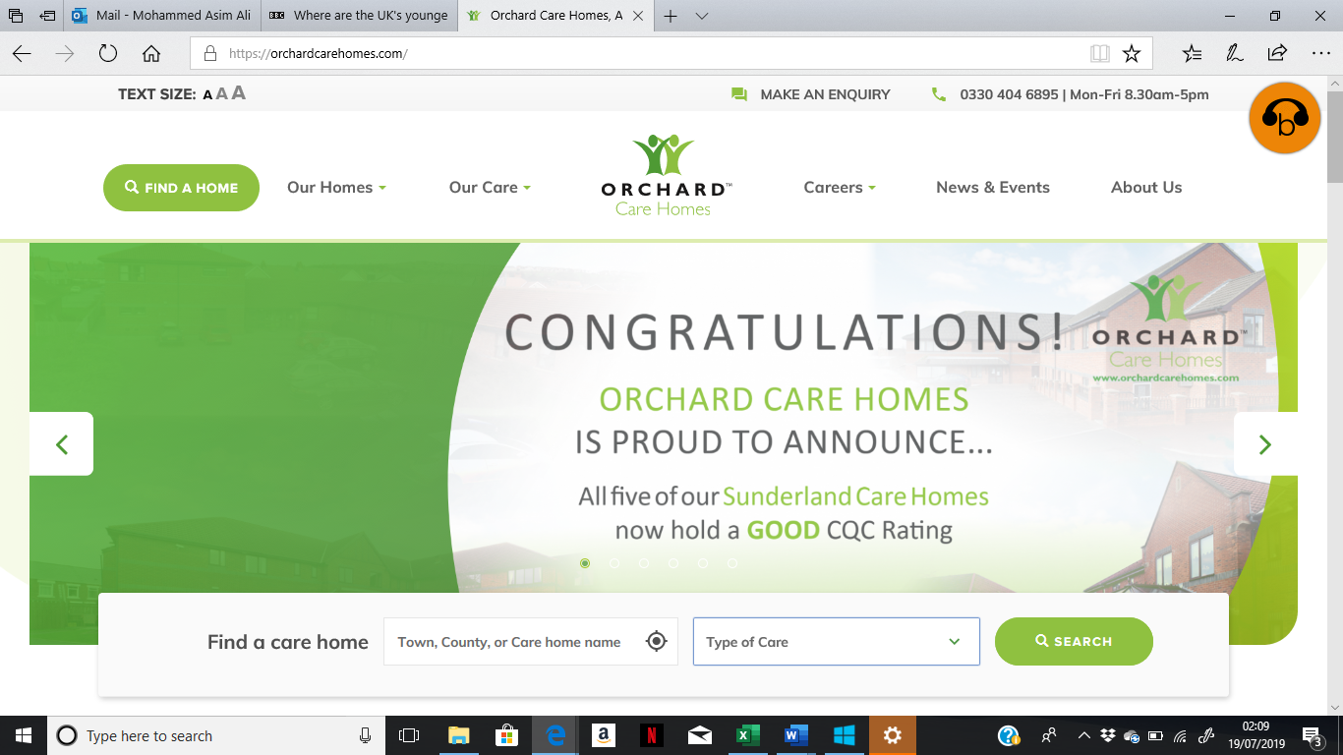

The website above has been considerably improved in terms of making it more user friendly for all its primary stakeholders and target markets. News and events section provides updates to any corporate social responsibility and ethical steps the organisation is taking. Also about any upcoming events.
Social Media:
Orchard Care Homes has significantly underutilised Social Media marketing as a communication tool. They have deprived themselves of improving there brand awareness. This is because social media such as Facebook, YouTube, Instagram and snapchat combined has over 2 billion user worldwide (Stanton 2016). This therefore gives OCH access to big market which it can capitalise upon and increase its customer base. Using social media OCH can find there target audience using the data associated with each profile. This is a significant advantage for brands such as OCH which have a niche and local market (Kamolshotiros 2012).
Another key benefit of social media is that it will give OCH direct access to customers. Social media allows business to connect with your respective target market, prospects and customers at all times. Furthermore, it also increased brand awareness and will help lower OCH’s advertising costs. This is because traditional means of advertising such as TV and radio costs significant money. However, Facebook ad campaigns reach to more people that tv and radio methods. This basically means social media advertising is cost effective, fast, efficient and really effective compared to the traditional methods such as TV and radio advertising which is expensive and less effective. This means that OCH need to immediately implement social media marketing so that it can become more competitive benefit from cost savings.
Advertising
Traditional media is gradually loosing its effectiveness. This has been due to two key factors. Firstly, audience fragmentation and secondly the ability to choose commercial content (McDonald and Sharp 2015). Radio, TV and magazines have become extremely fragmented hence are reaching a smaller and only selective audience(Peterson 2017). With more innovative and ways of communicating consumers are now attracted to interactive and social media particularly the internet. This basically means that Orchard Care Homes needs to adapt and embrace the new marketing methods and try to filter out the traditional methods of communication. This will significantly improve there market share and customer retention which in turn will improve there marketing capability.
However, there will have to be a significant change in working practice and culture within the marketing department if they want this to go ahead. This is because currently, the implementation of traditional methods means that OCH are comfortable within there current practices within the marketing function. They will need to therefore shift towards the modern methods gradually which will take time, effort and also piloting.
Measuring success:
The success of any marketing campaign is assessed upon various factors. These include how well sales targets have been met, brand development and market share. In terms of OCH, the key factor that needs to considered is market share. After rebranding there website they have significantly seen an increase in there market share as well as turnover. This is because they have increased the engagement with customers which has helped OCH develop a unique brand position within the market place and helped them stay par with their competitors. However, a point that needs to be noted here is that OCH only have 10% of the market share which in essence means that they still need to increase there presence within the market place. The only way they are do that is through marketing and increasing there sales targets. They need to increase their market share and develop a strong brand image through utilising social media marketing.

Evaluation
From the analysis above it can bee identified that OCH’s marketing campaigns have been ineffective and poor. This is because firstly, there is no coordination or link within their marketing mix . Secondly, they have been using traditional methods of communication which means that they are not maximising customer awareness hence not enhancing there image, reputation and sales turnover. This means that OCH needs to immediately adapt social media marketing and need to be extremely innovative and effective.
On the other end of the spectrum, OCH’s market segmentation is good. This is because they exactly know who there key target audience are there are able to tailor marketing campaigns effectively. Furthermore, they have also improved upon the communication amongst the various departments. This is due to them going from a rather centralised organisational structure to a decentralised organisational structure. This has meant that coordination, communication and implementation amongst all the departments within the organisations have improved significantly. This means that they will be able to better align there working practices with the goals, vision, mission and objectives of OCH.
Furthermore, OCH need to ensure that they are focusing on really improving the communication amongst there departments. The marketing departments is an interdependent on other departments within the organisation. Good communication will build trust between departments, provide better customer service, improves the flow of information which leads to quick, informed and better decision making.
Conclusion
This essay has crucially evaluated the role and activities of the marketing department. The essay has also identified the key target markets of OCH and evaluated the effectiveness of them. It can stated that overall, the marketing function within any organisation plays a pivotal role. The benefits of having an effective and robust marketing department means that organisations such as OCH will gain significant sales gains, market share and eventually a positive turnover and also profit.
On the contrary, if the marketing department is ineffective then and organisation face significant challenges such as poor customer acquisition and customer retention, sluggish sales and therefore poor market share. This means that OCHMS needs to further strengthen and improve its marketing department so that they can be extremely effective in the long run and ensure that the management.
Finally to conclude, OCM needs to ensure positive communication between all departments so that all departmental goals, aims and objective are aligned to the strategic objectives of the organisation.

Referencing
BBC NEWS (2018). Aging population [ONLINE] Available at: https://bbcnews.com/aging population [Accessed 19 July 2019].
De Luca, L. M. Atuahene-Gima K. (2017). Market knowledge dimensions and cross-functional collaboration: examining the different routes to product innovation performance. Journal of Marketing, Vol. 71, p. 95–112.
Hawes, J. M., Baker, T. L. d’Amico, M. F. (2017). A purchasing perspective of the universal marketing functions. Marketing Management Journal, Vol. 16, Issue 2, p. 107–115.
Homburg, C., Workman Jr, J.P. and Krohmer, H. (2011), “Marketing’s influence within the firm”, Journal of Marketing, Vol. 63 No. 2, pp. 1-17.
Kamolshotiros, P. (2012), A study of consumer behaviour: An exploration of determinants toward decision making for oishi green tea consumption in Thailand leading to consumer loyalty. MSc. Dissertation Submitted to the School of Management, University of Bath, United Kingdom.
Kotler, P., Adam, S., Brown, L. and Armstrong, G. (2003). Principles of Marketing, Edition 2. Prentice Hall: Australia
Kotler, P., Roberto, N. & Lee, N., (2008). Social Marketing, Improving the Quality of Life, Sage Publications: Thousand Oaks
Liu, M. (2012), The effects of subliminal advertising on consumer attitudes and buying intentions. International Journal of Management, 24(1), 3-14.
Lovelock, C. and Wirtz, J. (2011), Services Marketing: People, Technology, Strategy. 7th ed., Prentice Hall, Upper Saddle River, New Jersey.
Macdonald, E.K., Sharp, M.B. (2000), Brand awareness effects on consumer decision making for a common, repeat purchase product: A replication. Journal of Business Research, 48(1), 5-15.
Naik, P. A., Raman, K., Winer, R. S. (2005). Planning marketing-mix strategies in the presence of interaction effects. Marketing Science, Vol. 24, No. 1, p. 25–34.
Orchard Care Homes. (2018).About us . [ONLINE] Available at: https://orchardcarehomes.com/our-care [Accessed 17 July 2019].
Peterson, M. (2017), Basic Marketing Research: A Decision-Making Approach. 2nd ed. New Jersey: Pearson Education.
Siu, W.-S., Kirby, D. (2011). Small firm marketing: a comparison of Eastern and Western marketing practices. Asia Pacific Journal of Management, Vol. 16, p. 259–274.
Stanton, W.J., Etzel, M.J., Walker, J.B. (1991), Fundamentals of Marketing. 9th ed. New York: McGraw-Hill.
Van C.B. (2016), The 4p classification of the marketing mix revisited. Journal of Marketing, 56, 83-93.
Webster, F. E., Jr. (2018). A perspective on the evolution of marketing management. Journal of Public Policy & Marketing. Vol. 24, No. 1, p. 121–126.

